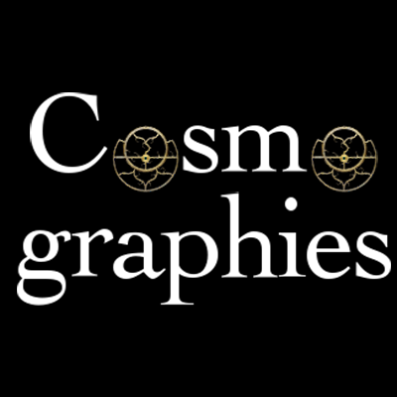

Cosmographies Conference
July 24-25, Falmouth University.
Contents: Campus information and Maps
Guidelines for presenters
Guidelines for chairs
Schedule
Abstract list
Email List

Welcome to Cosmographies 2014!

First of all thank you for your participation in the conference. We really hope you find the papers interesting and informative and that you enjoy your time at Falmouth University. All the key information regarding the conference can be found on the website (www.cosmographies.co.uk) however, during the conference if you have any questions please feel free to ask any of the organisational team. This information form contains the schedule including all locations and times and also the abstract and biographies of all the contributing participants

Cosmographies is supported by Falmouth University’s Academy of Innovation and Research (AIR) & The British Interplanetary Society bringing together scholars from the arts, humanities and space studies, to explore representations of ‘outer space’ in textual and visual culture. The conference will enable cross-disciplinary dialogue in order to establish new ways of investigating the significance of ‘outer space’ as a rich source of socio-cultural production.
We certainly hope the conference is fruitful in allowing you to make connections and possibly create new research interests and possibilities.

Once again thank you for your contribution.
Niamh, Dario and Sarah!

Niamh – Tel: 07970868403, niamh.downing@falmouth.ac.uk, @niamhdowning
Dario – Tel: 07854162583, dario.llinares@falmouth.ac.uk, @dariodoublel
Sarah – Tel: 07818360324, sarah.arnold@falmouth.ac.uk, @season934

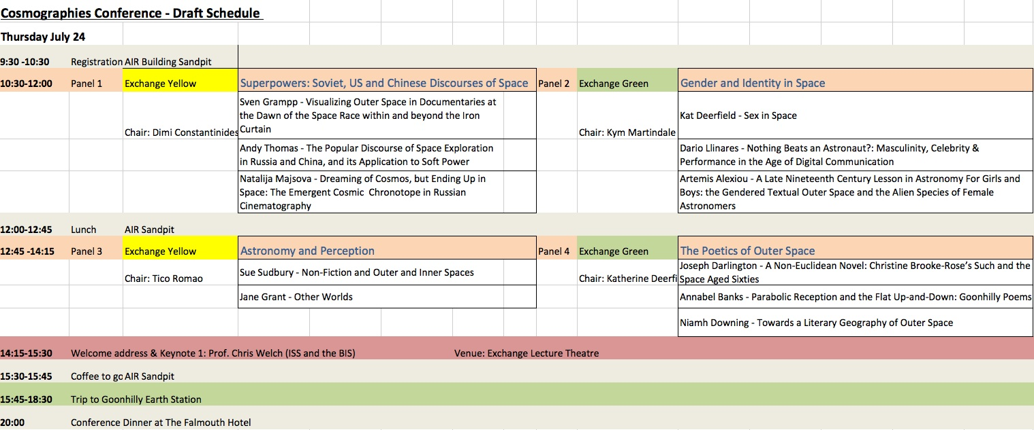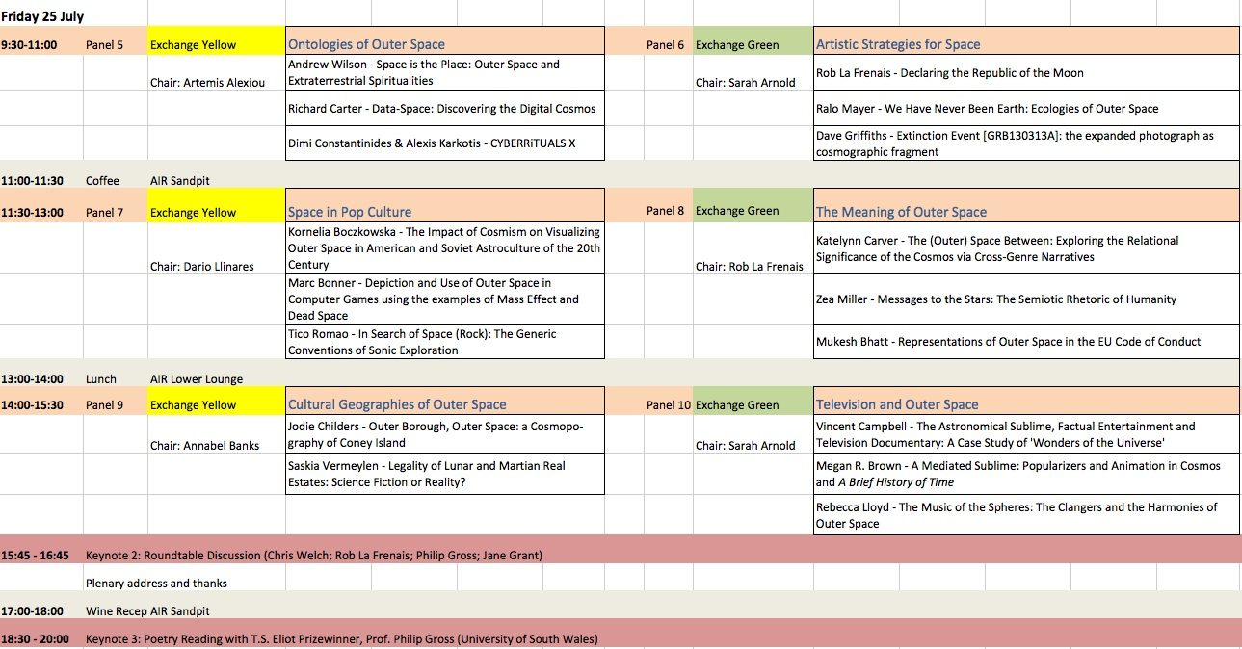
Penryn Summer Apartments Accommodation
Arrival & Departure
Please check-in at the Glasney Lodge reception which is open 24 hours a day, seven days a week. They can be contacted on 01326 253503 (x3503 from your bedroom phone)
Check in:
From 4pm onwards
Check out:
Before 10am
Rooms must be vacated and keys returned by 10am. Failure to do so will incur a charge.
Parking
Penryn Campus is fitted with an Automated Vehicle Recognition System.
On arrival please enter the main barrier system and park in the AIR car Park situated on your right hand side.
All car parks across campus work on a pay as you leave basis.
Before leaving campus please go to the nearest pay station and enter your vehicle registration number. You will then be issued with the appropriate charge.
Please contact a member of the team if you have any queries regarding parking on campus.
Room Key/Card
Please keep your key/card in a safe place. Your room door is not self-locking so please ensure you lock your bedroom when required.
The following charges will be levied for any keys and cards that are not returned to Glasney Lodge on the day of departure:
Keys: £6.50 each plus VAT
Cards: £3.00 each plus VAT
Please note that some flats have two keys and each will be charged at the prevailing rate.

Internet Access
All rooms are Wi-Fi enabled. If you require internet access, please inform Glasney Lodge reception on arrival and they can generate a password and username along with instructions on how to register your device.
Campus Facilities
Campus Shop
Our well stocked shop sells groceries, toiletries, newspapers and all other essential items. Open Monday to Friday 8am-6pm
Stannary Bar
The Stannary is a multi-purpose communal space at the heart of campus. The upper bar is a great place to relax with pool tables, plasma TVs and two projector screens. Open Monday to Friday 10am-10pm, Saturday and Sunday 6pm-10pm.
Glasney Lodge Reception & 24hr Essentials Shop
7 days a week/ 24 hrs a day
Stannary Restaurant
This is the main dining facility on campus and seats up to 250 people. Our chefs use fresh, locally sourced produce where possible and deliver a wide range of excellent value meals, light bites and snacks. Serving breakfast from 8am-10:30am.
Campus Pizza Delivery
7 days a week from 6pm-10pm, last orders at 9.30pm. ext. 4262 or phone 01326 254262
Sports Centre
The spacious and modern sports centre offers the latest fitness equipment, a free-weights area, a fitness studio and a variety of regular exercise classes. Discounted rates apply for residential guests. Please call 01326 370770 or call in to make an appointment. Open Monday to Friday 7.30am to 9.30pm, Saturday and Sunday 9am to 6pm.
Cash Machine
7 days a week/24 hrs a day
Fire Safety Precautions/Procedures
Please familiarise yourself with the fire safety procedures located on the back of your bedroom door. Please note the location of your nearest emergency fire exit in your flat and accommodation block, and indicate which assembly point to attend on site. Please ensure that fire equipment is not tampered with and that all fire doors are shut.
Always evacuate in the event of an alarm unless during the fire alarm testing times below.
Fire alarm testing takes place every weekday morning in the following blocks:
Monday GVA – GVE
Tuesday GVF – GVI
Wednesday K – O
Thursday A – E
Friday F – J
The alarm will sound for a short period. There is no need to evacuate the accommodation during this time.
Additional Information
Building Works
Building may be taking place on the periphery of campus and work commences at 08:00 every weekday. The construction company will endeavour to minimise disruption, but please let us know if you experience any problem.
First Aid
All porters and duty managers in Glasney Lodge have been trained in first aid by St Johns Ambulance. If you require first aid, please contact Glasney Lodge on 01326 253503 or bedroom extension number 3503. If you need to contact emergency services, dial ‘9’ then 999 from your bedroom phone.
Please ensure you notify Glasney Lodge of the call.
Laundry Facilities
These are located in Glasney Parc blocks E, J, K, L & N and Glasney View block H. You can purchase a laundry card for a £3.00 deposit, refunded on return, from Glasney Lodge reception. The card requires an online top-up for use.
Bedding
Towels and bedding are provided in all rooms, enough for two guests sharing one of the double en suite rooms.

Mail
Post can be submitted to Glasney Lodge or the post box opposite main reception. Please ensure post bears the correct postage.
Maintenance
Please report any maintenance issues to Glasney Lodge reception.
Contact Telephone Numbers
Main Reception | 01326 370400 | Room Ext:1400
Campus Security | 07768 557 779 | Room Ext: 3666
Security Office | 01326 253704 | Room Ext: 2704
Conference and Events | 01326 259379 | Room Ext: 259379
 | 01326 370428 | Room Ext: 1428

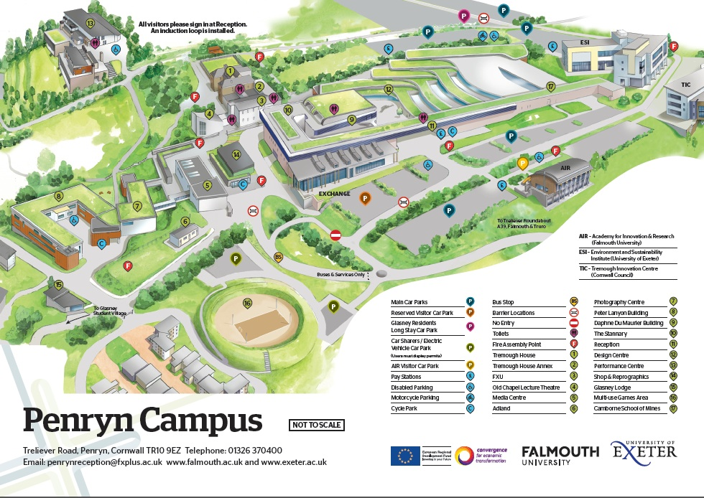
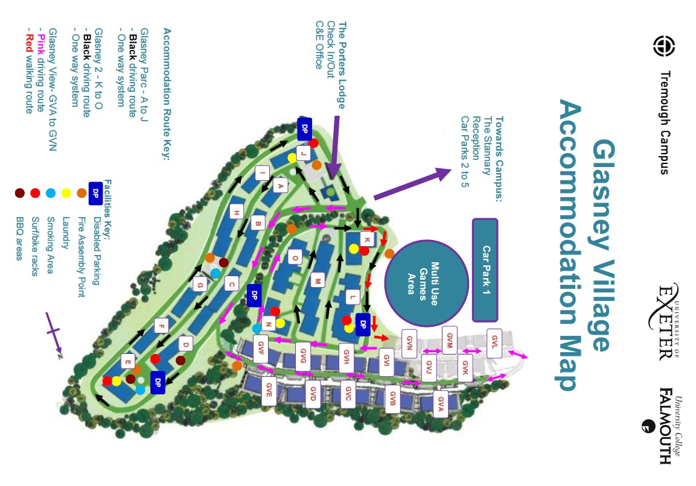
Guidelines for Presenters

- Presentations should 20mins only, please respect your colleagues by adhering to your allotted time
- If you wish to provide your presentation in advance for upload to our servers, please go to http://upload.falmouth.ac.uk and upload the file(s) specifying '1 week' as the expiry time. You will receive a private link which you should email to Nick Young, the AV Development & Support Officer at nick.young@fxplus.ac.uk. You should add ‘Cosmographies Conference Presentation’ in the subject of the email, so that Nick can ensure that your file is saved to the correct folder on the server.
- Alternatively you can bring your presentation on a USB on the day. You will need to upload your presentation to the PC in your panel seminar room, prior to the start of your panel. Conference organisers, AV Support, and your panel chair will be able to assist you with this.
- Another option is to use your own laptop. We can hook up laptops with VGA and Mini Display Port connectors. We can also hook up iPads. If your laptop has a different connection you will need to bring a suitable adaptor. Again, please arrive slightly before your panel, to set up.

The Exchange Seminar Room facilities are as follows:
- PC (with Windows Office suite, internet, Windows Media, Flash & VLC players)
- Laptop plug in point
- Audio sound system
- Projector
- DVD player (Region 2 discs only)
- Blu-ray Player (Region B discs only)
- Visualizer
***Please note, there is no VHS player***

Panel chairs will introduce presenters, and ensure that papers don't overrun 20 minutes each, to allow for questions. Short briefing notes for the chairs will be sent out shortly via email, or can be collected on arrival. There is a water fountain in the Exchange building, and water will be provided for presenters in each panel.

Delegates will also be issued with individual wifi codes for use during the conference, and any extended stay in campus accommodation. These can be collected on arrival when booking into accommodation and/or at registration.

Guidelines for Chairing
Thank you for agreeing to chair a panel. Here are some guidelines to help you in your session:
- Arrive at you designated session at least 15 mins beforehand in order to help speakers load their presentations. Some may already be on the desktop, others will bring a USB stick.

- Please make sure you bring your login information provided as the computers sometimes request that they be re-entered.

- Please check the Av equipment works before the session starts.

- Please introduce each presenter with the full title of their paper

- Please keep to time. The presentations are 20mins with 10mins questions (it is up to you whether you have questions after each presentation or have all questions at the end)

- We will provide a “5mins” notice to help with time-keeping

- Please insure that all questions and discussion are conducted cordially

- If there are any problems please contact a member of the organising team.

Panel 1 – Superpowers: Soviet, US and Chinese Discourses of Space
Venue: Exchange Yellow
Chair: Dimi Constantinides

Sven Grampp, University of Erlangen

Title: Clash of Icons – Visualizing Outer Space in Documentaries at the Dawn of the Space Race within and beyond the Iron Curtain

Abstract:
The Space Race is primarily a battle of pictures respectively the meaning of pictures, which got a great impact on the cultural imagination. From that point of view the Space Race is a Picture Space Race or – to put it more menacingly – a clash of icons, thus a conflict between very different media cultures under condition of global picture circulation and permanent mutual observation. This perspective is crucial for the topic I want to deal with in my presentation.

I would like to present and discuss two documentaries that are produced at the dawn of the Space Race, one is situated within the Iron Curtain, the other beyond. On the one hand, I will analyze three Episodes of the series Disneyland that were dealing with space issues. The episodes “Man in Space”, “Man and the Moon” and “Mars & Beyond” were televised very successful the first time in 1955 and 1956 in the US. On the other hand I will take a closer look at the Russian documentary “Doroga k swjosdam” (“Road to the Stars”), which premiered at the cinemas of the USSR just a few weeks after the successful launching of the Sputnik satellite in 1957.

These two documentaries got ask similar questions: How would it be to land on the moon? What kind of design would have a space station circling the earth? How could life on Mars look like? That means: Both documentaries not just take a closer look at the history of the technical achievements and ideas of space travel, but also a (retrospectively considered) very speculative foresight to the near future of manned space travel. However, much more important than the similarities are the differences between these two documentaries. They offer diverse ways of visualizing outer space. Facing these examples, we can consider how different the future was visualized in the ‘East’ and the ‘West’ during the Cold War. Especially the aesthetic forms of outer space, the composition of the pictures, the narration, and the montage show how different the media cultures imagine the world within and beyond the Iron Curtain. That not just tells us something about thinking of the future within and beyond the Iron Curtain. Much more this tells us a lot of their different state of minds. Offering close readings of the two documentaries, I would like to make this statement plausible and, of course, discussible.
Biography:
1973 born in Ellwangen/Jagst, Germany
1995–2002 Study of German literature, philosophy, media studies and art history at the University of Konstanz; M.A.
2003-2006 Research assistant at the collaborative research center entitled “Norm and Symbol” at the University of Konstanz
2006 Erasmus Lecture at the Charles University of Prague
since 2007 Teaching courses at the University of Erlangen, Nurnberg and Konstanz
2008 Ph. D.
2009 Erasmus Lecture at the Department of German and Slavistic Studies at the University of Minho in Braga (Portugal)
since 2013 Akademischer Rat at the University of Erlangen

Research interests:
media theory, television series, space race

Publications (selection):
Work of Mourning in Marshall McLuhan. Eine Einführung [An Introduction] (2011); Picture Space Race (2012); Rauschen im Fernsehen. Kommunikation mit Astronauten. [The Noise of Television. Communication with Astronauts] In: Mieszkowski, Sylvia/ Nieberle, Sigird (Hrsg.): Noise – Geräusch – Bruit. Medien und Kultur unstrukturierter Laute (2014); (guest co-editor) View. Journal of European History & Culture, Vol 3, No 5 (2014): Television Histories in (Post)Socialist Europe, Online: http://journal.euscreen.eu/index.php/view.

Andy Thomas, De Montfort University,

Title: The Popular Discourse of Space Exploration in Russia and China, and its Application to Soft Power

Abstract: If British understanding of Russia is, as Churchill might have put it, of a riddle, wrapped in an enigma, and shrouded in mystery, our understanding of modern China may be even less. This work-in-progress paper provides an initial overview of a research project that examines the significance of national popular culture in relation to the exploration of outer space. The paper starts from an alternative approach (Thomas, 2010) to existing studies of space programmes relating to Russia as it is considered that studies of space programmes of China and Russia follow, if not directly from the American military-industrial complex, from a view rooted in US attitudes to space exploration, its dominant and domineering view of space systems engineering and its concern with military status.

In undertaking this investigation, the paper examines the promotion of Gagarin by state promulgation in Russia, and the promotion of the Shen Zhou and Chang’e 3 missions in China in the advertising imagery of food products, considering them as popular discourses of texts. The data set and methodological approach makes use of methods of visual analysis, and comparisons of hobby activities by radio amateurs all over the world.

Reference:
Thomas, A (2010) : Kul’tura Kosmosa: the Russian Popular Culture of Space Exploration. http://dissertation.com/book.php?method=ISBN&book=1599423790

Biography: Andy Thomas is a research student at de Montfort University, Leicester, a radio ‘ham’ specialising in satellite communications, and the author of science fiction novels set in space and time around Russia and China. He retired from full-time employment in 2013. His main websites are: http://www.dmu.ac.uk/andrewthomas , http://www.andythomas.eu and http://www.amazon.com/author/andythomas

Natalija Majsova, University of Ljubljana

Title: Dreaming of Cosmos, but Ending Up in Space: The Emergent Cosmic Chronotope in Russian Cinematography

Abstract: During the first decade of the 21st century (2001-2011), Russian cinematography produced 11 feature films addressing the subject of outer space in one way or another, after an almost complete silence on the topic that lasted since the end of the Cold War. Multifaceted contemplations on Soviet space conquest and exploration, and their legacy (e.g. Kosmos kak predchuvstvie (2005), Pervie na Lune (2004), Bumazhnyi soldat (2008)) as well as adaptations of Soviet science-fiction (e.g. Obitaemii ostrov (2009, 2009), Prikliucheniya Alisi (2011)), are the most common contemporary takes on the subject. This seems analogous to the ideology-laden preoccupation with outer space exhibited by Soviet cinematography (over 40 films were shot on the topic in the history of the USSR, covering a variety of genres). However, closer inspection reveals significant differences: not only has outer space been transferred from the utopian to the nostalgic registry, it has also proven to be no guarantee of cosmos. These shifts can in part be accounted for by a change in contexts (USSR vs. Russia in a globalized, capitalist world), but can also be explained in terms of a foucauldian genealogy of the cultural construction of outer space in the Russian milieu. It is with this genealogy as a backdrop that the paper analyses principles of the chronotopical construction of cosmos in contemporary Russian films on outer space, using Kosmos kak predchuvstvie as a case study.

Biography: Natalija Majsova is a PhD student at the University of Ljubljana. Her dissertation (due 2015) explores outer space in contemporary Russian cinema. She is currently guest researcher at the Free University in Berlin (Emmy Noether Research Group: The Future in the Stars). Her main research foci are contemporary aesthetics theory, astroculture studies, and Russian cultural cosmology.

Panel 2 – Gender and Identity in Space
Venue: Exchange Green
Chair: Kym Martindale

Kat Deerfield, Cardiff University

Title: Sex in Space

In both fact and fiction, popular interest in spaceflight often centres on the idea of human sexual behaviour in space. Yet as fascinating as the topic seems to be, it is also a source of much unease. Common concerns include lack of privacy in spacecraft, the impact of microgravity on the physics of thrusting bodies, and the potential danger posed by errant fluids to sensitive equipment. The specificity of these anxieties raises the question: what kind of sex are we talking about?

Drawing upon work in queer theory, I will argue that popularly imagined extra-terrestrial sex is deeply heteronormative, and that extra-terrestrial spaces are overwhelmingly defined as heterosexual spaces. I will examine recent discussions of sex in outer space, drawn from popular media and space biomedical research, and explore the heteronormative assumptions made in these constructions of extra-terrestrial sexuality. Space culture offers a unique opportunity to explore some of the fundamental questions posed by queer theory. What, for example, are the intersections among public space, extra-terrestrial space, and (hetero)sexual culture? And what is the impact of an explicitly procreative understanding of sexuality on discussions of women in space programmes? I will argue that the heteronormativity of spaceflight places limitations on what kinds of bodies are seen as having a place in space, and that these limitations do not exclusively constrain queer subjects.

In this paper, I aim to illuminate a broad cultural construction of outer space as a space of reproductive heterosexuality. This construction is demonstrated in, and upheld by, both the apparent prurience of popular fascination with sex in space, and the apparent scientific detachment of human physiological and psychological research in space. However, the space between prurience and detachment may hold possibilities for expansion upon our ideas of who and what belongs in outer space.

Biography: I am a third-year PhD researcher in the Centre for Critical and Cultural Theory at Cardiff University. My thesis, ‘Heavenly Bodies: Gender and Sexuality in Extra-Terrestrial Culture’ explores sociocultural aspects of outer space exploration, with an emphasis on constructions of the body in extra-terrestrial spaces and futures. My research interests broadly centre on feminist and queer perspectives on embodiment, spatial theory, and time.

Dr Dario Llinares, Falmouth University

Title: Nothing Beats an Astronaut?: Masculinity, Celebrity & Performance in the Age of Digital Culture

Abstract: The iconography of the astronaut has served to represent and embody a range of socio-cultural discourses, which go far beyond the instrumental tasks of space exploration and scientific experimentation. The history of the space race must be contextualised with the parameters of cold war geopolitics and within this the astronaut (and cosmonaut) served as representations of ideological opposition. My own previous work on the mythology of the astronaut interrogates a media construction shaped through a ‘cultural repertoire’ – a set of interrelated signifiers such as bravery, patriotism, family values & religious fervour – which asserted the astronaut as an exemplar of idealised masculinity (Llinares 2011).
The end of the Cold War, a series of spectacular disasters, and questions of economic value have arguably undermined public interest and support in the space programme. Allied to this the arrival of the digital age where advance telecommunications seem to spell the end of the necessity of manned space travel. However, there has been resurgence in interest in space exploration generally, and arguably a recycling of iconography surrounding the astronaut, due in no small part to the communications possibilities offered by social media.
This paper examines the public (self) construction of two astronauts – Commander Chris Hadfied and Felix Baumgartner - arguing that the creation of their celebrity reflects a shifting ideological context where neoliberal self-expression and the embracing of a performance of celebrity defin the contemporary astronaut.

Biography: Dr Dario Llinares is a Senior Lecturer in Film at Falmouth University. He is author of The Astronaut: Cultural Mythology and Idealised Masculinity along with articles on the representation of the astronaut in Apollo 13 (Ron Howard) and in the work of Tom Wolfe and Norman Mailer. He is co-editor of Journals on Austerity Culture and Networked knowledge and is the leader of a research project entitled Interactive Spectatorships, which investigates the effects of digital culture on the concept of the audience. He also has forthcoming articles on Time Travel in the Films of Woody Allen and Masculinity in the Contemporary British Prison Film.

Artemis Alexiou, Manchester School of Art

Title: A Late Nineteenth Century Lesson in Astronomy For Girls and Boys: the Gendered Textual Outer Space and the Alien Species of Female Astronomers

Abstract: This paper is not reporting on any extraterrestrial astronomical discovery and it is not discussing matters of profound astrophysical importance. Rather, this is a late nineteenth century lesson in ‘astronomy’ as told through the pages of the general illustrated The Child’s Companion and Juvenile Instructor, The Girl’s Own Paper and The Boy’s Own Paper; the satirical Pick-Me-Up; and the general feminist Women’s Penny Paper.

The first four publications include various textual and paratextual materials on outer space, which indicates that there was a desire to educate people: beginning this instruction from a young age and continuing up to adulthood. However, in line with Roland Barthes’s Martians, these late Victorian texts and on planets and the stars, and paratexts of imaginary alien communities, were embracing all the stereotypical gendered ideologies that characterized late Victorian societies found on ‘Earth itself’ (Barthes 2013, 39). Boys were directly encouraged to be active: look for the planets and buy a telescope, whereas girls were indirectly advised to remain passive: listen to stories and read about men’s explorations. Could the telescope be the phallic symbol of the male dominant patriarch violating the Moon (a traditionally female symbol, which is always reliant to the male Sun for sunlight)? Could these textual signs be a Victorian kind of Pioneer Plaques’ illustration (1972), which was memorably derided by performance artist Laurie Anderson (1984)? Were women astronomers an alien species; were they the ‘Other’?

In contrast, articles on astronomy found in the Women’s Penny Paper, focus in raising an awareness of the important role of women in the history of astronomy by publishing their life stories or their accomplishments. In the same vain, this is a celebration of the lives and work of women in astronomy, and a discussion of the diverse gendered textual and visual elements found in articles about outer space and the manner in which they are comparable.

Biography: Artemis Alexiou currently works as an Associate Lecturer at the Manchester School of Art. She holds a BA [Hons] and PGDip in Architecture from Oxford Polytechnic and a MA in Graphic Design from London Metropolitan University. She is due to begin her 3rd Year of her PhD reading Graphic Design/Media/Feminist History at MIRIAD, Manchester Metropolitan University. Her thesis debates the design of feminist periodicals of the late 19th and early 20th century England in relation to gender.

Panel 3 – Astronomy and Perception
Venue: Exchange Yellow
Chair: Tico Romao

Sue Sudbury, Bournemouth University

Title: Non-fiction and ‘Outer and Inner Spaces’

Abstract: This research paper has come out of my work over the last four years, researching and developing a feature length documentary film following the team behind the launch of India’s first astronomical satellite in 2015. Thousands of light years away from our sun at the centre of our galaxy, the Milky Way, is a supermassive black hole, several million times the mass of the sun and seventeen light hours across. This is the object that these Indian scientists are hoping to understand. The film will cinematically map the geography of ‘outer space’ in contrast with that of ‘inner spaces’ on earth. During monsoon season, some of the team have to wade through waist-deep muddy waters to reach their place of work. Some live close-by in the slums of Mumbai. Others commute for eight hours a day from outlying villages. This is the team at the heart of India’s space programme. The Space Centre is next to the largest slum in the city, home to over 100,000 people and one of the lead scientists has begun to teach science to some of the children living there; through this, that we are taken in the film into this world to consider our uses of spaces, both inner and outer ones. As part of this paper, I will screen footage from this feature documentary, which demonstrates the way in which these concepts will be considered.

Biography: Sue Sudbury combines her role as Senior Lecturer in the Media School at Bournemouth University with running her television production company, Sequoia Films. As a documentary producer/director many of the series and singles she made for the BBC, Channel 4 and ITV have won prestigious awards, such as Royal Television Society awards, the Prix de Basle and the New York International Film and TV Finalist award. Sue is also currently doing a practice-based PhD entitled The Women Filmmakers of Andhra Pradesh; this is a participatory research project, which will result in a 45 minute film and accompanying thesis.

Jane Grant, Plymouth University

Title: Other Worlds

Abstract: In this paper I will introduce my new film Other Worlds and to contextualise the work I will discuss the research underpinning the practice including early astronomy, physics and science fiction. In early astronomy, observations with the naked eye of the Moon, our nearest celestial neighbour, were drawn from comparisons with our planet. Using the Earth as a reference point, an understanding of physical laws on Earth was utilized in an attempt to understand what was happening in the night sky. The invention of the telescope brought about what Art Historian Martin Kemp calls ‘structured seeing’, a paradigm shift in human perception alongside the ability to see further into the vast depths of space.
Humans are gravitationally bound to the Earth immersed in a changeable, mutable medium, the air -the instrument of relation. Before humans developed the technology to leave our planet it was only from this vantage point that they were able to see into the vast depths of the sky and the objects within it. Confined by the gravitational pull of the Earth, space travel consisted of visual observation, mathematics and imagination drawn from comparisons with the Earth and possibilities of what might have been had the Earth developed under different conditions. The compulsion to discover these other worlds tell of longing and a desire to see further or to temporarily inhabit, if only perceptually these other places, to couple the Earth and its inhabitants to what might have been, to our Earth’s doppelgangers.
These worlds, whether observed through early telescopes or by imagination coupled with an understanding of natural terrestrial phenomena often tell us more about matters on Earth rather than these other worlds themselves. Other Worlds is about the human longing to make tangible our place in the universe, to understand the structure of matter and time through visual observation through notation alongside scientific methodology.

Biography: Jane Grant is an artist and academic and Associate Professor (Reader) in Digital Arts at Plymouth University. Her collaborative work has resulted in award winning projects including, The Fragmented Orchestra with John Matthias and Nick Ryan, winner of the PRSF New Music Award, 2008 and received an Honorary Mention at Prix Ars Electronica 2009. She writes about noise, science and art and the mutability of matter. http://janegrant.org.uk
Panel 4 - The Poetics of Outer Space
Venue: Exchange Green
Chair: Katherine Deerfield

Joseph Darlington, University of Salford
Title: A Non-Euclidean Novel: Christine Brooke-Rose’s Such and the Space Aged Sixties

Abstract: The Sixties saw a huge rise in the adjective “experimental” being used to describe avant garde writing. For the novelist Christine Brooke-Rose this term, deriving from the lexicon of the hard sciences, was entirely appropriate. Captivated by a utopian notion of an emergent “space age”, she aimed to create a new type of novel to break out of mechanistic nineteenth century tradition and inspire a “communication revolution” to match the “non-Aristotelian, non-Euclidean” revolution in science. The result was Such (1966), a novel set during a three-minute heart massage as a psychiatrist who specialises in treating astrophysicists flits between memory and dream. The inner-space of consciousness is metaphorically transformed to reflect quantum theoretical and astrophysical understanding contemporary to the novel’s construction.

Access to the Brooke-Rose archive at the Harry Ransom Centre, Texas, has provided unique insights into the process of research behind the novel. Brooke-Rose’s journals contain notes from numerous lectures on quantum theory, astronomy and the science behind the space race. In her essays of the period, Brooke-Rose demanded an equal level of commitment to scientific understanding from her fellow novelists. At one point she even suggested that, should everyday language not change to reflect the post-Einstein world of relativity, “we would not be equipped to survive the evolutionary process”. To prevent this, Such suggests we treat our minds like a map of the universe. Brooke-Rose later went on to regret this moon-eyed, space aged thinking, yet the novel remains a fascinating example of Sixties positivism.

Biography
Joseph Darlington is a PT Lecturer in English Literature at the University of Salford. He has recently completed a PhD thesis entitled “Contextualising British Experimental Novelists in the Long Sixties”. His research on Christine Brooke-Rose was funded by a Harry Ransom Centre Fellowship and has been published in the Journal of European Studies, amongst other places.

Annabel Banks, Falmouth University

Title: Parabolic Reception and the Flat Up-and-Down: Goonhilly Poems

Abstract: Poetry and the Archive: History, Story, Community is a practice-based creative writing PhD funded by the European Social Fund and supervised by Falmouth University.

Poet Annabel Banks works with the Cornish branch of the Boulton and Watt mining company archive. These eighteenth-century letters provide moments, words and gestures that resonate with narratives of the Cornish post-industrial landscape. These narratives were gathered by qualitative, unstructured interviews with people who live, work, or holiday in Cornwall, as well as by Annabel’s own experiences and observations.

Work with structures of power on the Cornish Landscape (such as engine houses and wind farms) has been important to this work. The satellite dishes at Goonhilly, however, brought their own particular challenges. In this paper Annabel will discuss management strategies she required after work with Goonhilly expanded her project’s scope from under the earth (mines shafts) to above the earth (into space) … and beyond.

Biography
Annabel Banks is a poet and associate lecturer at Falmouth University who is currently writing up her practice-based PhD, Poetry and the Archive. Besides researching and teaching, Annabel runs ChickenBeak Books, (a low-tech, limited-run poetry press) and is co-editor for new writing for the e-Journal Revenant.

Niamh Downing, Falmouth University

Title: Towards a Literary Geography of Outer Space

Abstract: When (or even if) we think of the presence of the extra-terrestrial in twentieth-century poetry this side of the Atlantic, we most likely turn to the 1970s and the Martian poetry of Craig Raine and Christopher Reid, or more compellingly to the work of Edwin Morgan. Although the possibilities of space exploration in the popular imagination are indissociable from the Cold War period, the extra-terrestrial remains a persistent metaphor in more recent poetry. How can we begin to frame or discuss the presence of celestial space and extra-planetary tropes in the work of certain contemporary poets, including Lavinia Greenlaw, Alice Oswald, Philip Gross, Patrick McGuinness and Jamie McKendrick. Moreover how can we account for the lack of critical discussion of this kind of space in a scholarly environment where space, place and landscape have become such a pressing concern? For, if critical accounts of contemporary British and Irish poetry have been significantly influenced by developments in cultural geography and the spatial turn, literary scholarship has yet to fully engage with the emergent field of human geography that is re-imagining “celestial space” in an attempt to establish what geographer Denis Cosgrove calls a “cosmography for the twenty-first century” (35). This paper attempts to chart some of the ways in which contemporary poetry’s engagement with space science and technologies might enable us to begin to think towards a literary geography of outer space.

Biography: Niamh joined Falmouth in December 2012 as Senior Lecturer in English and Writing. Her research focuses on space, place and landscape in 20th and 21st century literature and more recently extra-terrestrial space. She completed her doctoral research at University of Exeter in 2013. Her thesis examines models of excavation in contemporary poetry, specifically in the work of Geoffrey Hill, Ciaran Carson, Geraldine Monk, and Alice Oswald. She has published on women’s travel writing with Palgrave Macmillan and is working on a monograph based on her thesis. Niamh co-organised the Haunted Landscapes Symposium in March 2013 with Dr. Ruth Heholt and ASLE-UKI. She is also editing a collection of essays with Dr. heholt based on the symposium.Twitter: @niamhdowning Web: http://www.niamhdowning.co.uk

Panel 5 – Ontologies of Outer Space
Venue: Exchange Yellow
Chair: Artemis Alexiou

Andrew Fergus Wilson, University of Derby
Title: Space is the Place: Outer Space and Extraterrestrial Spiritualities

Abstract: This paper proceeds from the following proposition: There are two kinds of outer space: as a thing in itself, the subject of astronomy and astrophysics and, in difference - but not always unrelated - outer space as it exists in the human imagination. The proposed paper is concerned with the latter and, in particular, how space has become the location in which an increasing number of narratives of spiritual experience are situated or are believed to have originated from. The aim of this paper is thus to consider the spirituality of outer space and will argue that for those who seek spiritual answers in it are offered a uniquely satisfactory resolution to the tension between religion and science. It is produced through, and of, the modern world and rational, objective forms of knowledge and yet also is marked by countless projections and fantasies of possible futures and forms of existence. It is this duality which provides the opportunity for a peculiarly modern form of spiritual expression to thrive.

Biography: Andrew Wilson is a senior lecturer in Sociology at the University of Derby and has published material reflecting on apocalypticism, nationalism, syncretic prophecies, and spiritual internet cultures.

Richard Carter, University of Exeter
Title: Data-Space: Discovering the Digital Cosmos

Abstract: Contemporary astronomy and cosmology is underpinned by an armada of unmanned craft that are scattered throughout the solar system. Their value as tools of exploration are predicated upon their capacity to communicate through streams of digitally encoded signals, which are picked up by a global network of receivers before then being processed, evaluated, and (in most cases) uploaded onto online databases. From this perspective, Earth’s communications networks can be considered to encompass regions that lie far beyond its immediate orbital plane, bringing electromagnetic signals emanating from alien phenomena into the domain of human understanding and agency. These endeavours do not afford a direct ‘window’ into outer space, but articulate an image of the cosmos that emerges from multiple intersecting vectors of techno-cultural mediation. How can these networks and their affects be evaluated outside the normative paradigms afforded by scientific and engineering pragmatism? One approach might be to consider the question of ‘ontology’: What are the assumptions built into these networks regarding the essential nature of the observable universe, its key primitives and their relations? How might these assumptions affect the way in which astronomical data is processed and distributed, particularly for wider public consumption? And how might they affect the way in which this data is understood culturally? This paper will begin to consider these questions by exploring a key tension between the ontology of ‘being’ that gave rise eventually to digital technology – of a predictable universe that is reducible to a few abstract primitives – and the ontology of ‘becoming’ that is emerging from contemporary scientific and critical accounts – with the universe being seen as a domain filled with unpredictable eruptions of material activity that resists and reshapes human agency. The primary goal of this exercise is to articulate a set of foundational considerations for any cosmographic enterprise.

Biography:
Richard Carter is a postgraduate researcher and PhD candidate at the University of Exeter. His primary research interests encompass the practical and philosophical relations between technology and ontology, particularly as it is expressed through digital computing systems and the cultural forms they convey.

Dimi Constantinides & Alex Karkotis

Title: CYBERRiTUALS X

Abstract: It’s 400 years from now----and still---- no sight of extra-terrestrials from our Solar Systems’ Horizon.

CYBERrITUALS X is the common religion across our digital cloth. Through the borrowed lenses of speculative Near and Deep future Ethnographic texts and extracts, future Space relics and artifacts, potently crafted imagery, void cartographies, Genetically programmed_Culturally educated_Robotically enhanced Humanoids, Anthropoids, Chimeras, Cybors and Realborgs perform their parts in Games and Rituals digitally mediated by the participating audiences, in Mega-Orbital Theatres, high-Strata Penthouses, hidden slums & underground meteor bunkers.

We will be presenting two short stories accompanied by extracts, artefacts, audiovisual presentations, gliding storytelling from one Galaxy to another:

A] The Wife and I/part one: A Lakota warrior riding his horse on Kepler in search of potential ritual sites. The rituals which are described further signify the reemergence on planet Earth of the organise body as total medium and an absolute/obsolete site for experiencing reality outside the Bio-Vertual world.

B] Vicarious:1001-One reality at a time-: Vicarious:1001 is a perspectival, multi-natural, 9D Techno-trans_Club which hosts around 1,500,000 people at its peak hours. It boasts 1001 different Digital Theatres in more than 5550 physical locations around the Earth, as well as eight Digital Theatres on four orbiting space stations and one bio-dome Digital Theatre on the moon.

Biography: Dr. Alexis Karkotis (PhD Social Anthropology, BSc Ecology & Plant
Biology) – Currently leading the Incubation of BAI Lab (BornAnIdea Laboratory).

Dimi Constantinides (MA Design Experience & Interaction RCA, BA
Architectural Design, BSc Food Science) Co-Founder & Director of BAI Lab.

BAI Lab is a London based interdisciplinary creative lab, which incubates ideas from the wet and edgy margins of architecture, product and interaction-based design. The work is committed to the wildly insane speculations of the Near & Far Future to the curious, mundane, and ordinaries of the Past & Present. The design projections, whether industry based or research are formulated to facilitate critical engagement with the accelerated complex and interconnected modern world.

Panel 6 – Artistic Strategies of Space
Venue: Exchange Green
Chair: Sarah Arnold

Rob La Frenais, The Arts Catalyst

Title: Declaring the Republic of the Moon: Some artistic strategies for re-imagining the Moon.

Abstract: This paper will summarise the current state of artistic engagement with the Moon and set out some possibilities for future collaborations between artists and lunar explorers. Sooner or later, humans are going back to the Moon, whether to mine it, to rehearse for a Mars mission or to just live there. But how will human activity there reflect what has happened on Earth since the last moon mission, to reflect the diversity and political and social changes that have happened since? Can artists imagine what it would be like to live on the Moon?
Artists are already taking part in many scientific endeavours, becoming involved in emerging fields such as synthetic biology, nanotechology, ecological remediation and enthusiastically participating in citizen science. There are already artists in Antarctica. It should be inevitable that artists will sooner or later accompany the next visit by humans to the Moon.

But why wait? Artists are already imagining how it would be to live on the Moon, whether in their imaginations or though rehearsals in lunar analogues. In the recent exhibition ‘Republic of the Moon’ a number of visionary strategies were employed, from the use of earth-moon-earth ‘moonbouncing’ (Katie Paterson) to the breeding and imprinting of real geese as imagined astronauts. (Agnes Meyer-Brandis). The Outer Space Treaty and the (unsigned) Moon treaty were re-analysed and debates and even small demonstrations were organised protesting (or demanding) the industrial exploitation of the Moon. Fortuitously, China’s Chang-e mission landed during the exhibition and the life and death of the rover Jade Rabbit brought a real life drama to the Republic of the Moon.

There have been other artistic interventions into lunar exploration, including Aleksandra Mir’s First Woman on the Moon, Alicia Framis’s Moonlife project and of course the historic inclusion of two artistic artefacts into the Apollo missions, Monument to the Fallen Astronaut (still on the Moon) and the Moon Museum, reportedly inserted by an engineer into the leg of the Lunar Exploration Module. With the worldwide race by the Clobal Lunar X Prize teams to land a rover independently of any government agency by the end of 2015 there must surely be a possibility for a real art project to fly in the near future. In the meantime artists will keep working to re-imagine the Moon using whatever strategies they can find.

Biography: Dr Rob La Frenais has been a contemporary art curator for 26 years, working internationally and creatively with artists entirely on original commissions. He believes in being directly engaged with the artist’s working process as far as possible, while actively widening the context within which the artist can work. For the last 17 years he has been based at The Arts Catalyst, a UK Arts Council National Portfolio organisation in London, where, along with director Nicola Triscott he has developed an ambitious artistic programme and built up an unparalleled creative team which has been responsible for some of the most innovative exhibitions and events, based on interactions between art and science, in the world. As well as producing site-based works, The Arts Catalyst collaborates with institutions such as the European Space Agency, the Natural History Museum, the Science Museum, Tate Britain and the Roundhouse. His most recent exhibition with the Arts Catalyst, Republic of the Moon opened this year in Liverpool and is now touring internationally. He was given an honorary Doctorate by Dartington College of Art in 2005 and in 2006 completed a practice-based PhD at Brunel University on issues around curating. Before become a curator in 1987 he founded and edited the influential contemporary cultural journal Performance Magazine in 1979, editing and writing criticism internationally during the eighties. He was also the first curator ever to experience zero gravity, with a group of artists, at Star City in Moscow in 1999 and went on, with the Arts Catalyst to enable around 50 artists (and scientists) to work in an environment previously only experienced by astronauts and space scientists.

Ralo Mayer

Title: We Have Never Been Earth: Ecologies of Outer Space

Abstract: The first film studio in France, bootprints on the lunar surface, LSD, Kurt Waldheim, the tallest cliff in the solar system, cyborgs, the L-5 Society, Ronald Reagan, an eBay listing of Sikhote-Alin meteorites, the dissolution of the Soviet Union, Halocaridina rubra, Biosphere 2, the 2008 real estate crisis, bananas, management practices for improving workplace climate, the Whole Earth Catalog, Steve Job’s presentation of the iPhone, polar bears, Al-Qaeda, debris from the Columbia, Cargo Cults

According to object-oriented theories, a list of things is a simple device to non-hierarchically compile objects, be they human or non-human, living or inanimate, real or imaginary. The disparity of elements in lists might also provoke an awareness of the multilayered networks of possible relations between objects.
As outlined in the example above, my presentation will adapt this structure and assemble various elements of my space-related work. Over the past years I have investigated objects like the Shuttle Program or Space Colonies, exploring relationships between outer space, the short history of its exploration and earthly realities, from geopolitical transformations to everyday life. Space is as much a physical fact as it is an imaginary giant screen for human projections, it’s vast and void, yet full of stuff. Or, deliberately misreading Graham Harman: “In short, space is the name for the fact that things fail to be in direct contact without being outside all contact entirely.”
While my practice results in concrete works of art in various media, its conceptual frame is ecology. Following Bruno Latour, ecology is not restricted to so-called „nature“, but includes biological systems as much as social or political relations, chemical reactions, ideas or fictions. I found this claim substantiated during my extensive research about Biosphere 2: built as a test for self-sufficient space settlements, the closed eco-system was an artificial miniature world of interconnecting networks of plants, animals, machines, humans, scientific data, utopian visions, ancient myths, media coverage, and more.

Biography: Ralo Mayer is an artist based in Vienna. His work investigates vast object dumps like Outer Space, Ecology and post-Fordist Science Fiction. Loosely bound by the series HOW TO DO THINGS WITH WORLDS, his performative research spawns transmedia works in installation, film, performance or text.
http://was-ist-multiplex.info
Dave Griffiths, Manchester School of Art

Title: Extinction Event [GRB130313A]: the expanded photograph as cosmographic fragment

Abstract: Extinction Event [GRB130313A] is an expanded photographic installation that archives a brief cataclysmic happening in a lonely, troubled region of outer space. On 13 March 2013 a gamma-ray burst (GRB) lasting 300 milliseconds was observed exploding in the constellation Serpens. The project resulted from an interdisciplinary residency at Leicester University's X-Ray and Observational Astronomy Group, which studies radiation from distant gamma-ray bursts - among the most violent and epoch-changing events in the Universe. Whilst witnessing the GRB alongside international scientists I tested a new critical approach to photography's indexical problem of resolving the gap between object and reality. I applied a range of methods to document a phenomena impossible to record optically - gathering data, graphs, snapshots and voice-recordings surrounding the GRB discovery to form a composite representation of its historical moment.

A microfiche maps the GRB origin and magnitude, through visualised and textual data representing photon traces recorded in its afterglow. Other images show the astronomers office, their charity cake-sale, and Earth's news on the day. In a teleconference recording, the NASA team verify their detection of radiation from GRB130313A, originating billions of years ago. They plan a shooting script of deep-field observations using the SWIFT telescope. Another voice recording describes the fictional apocalyptic effects of a GRB hitting a biosphere such as Earth.

The project is theoretically framed, firstly, by media archaeology, which traces the historical function of visual technologies in our desire to discover, organise and communicate a unified knowledge of life through deep time. Secondly, Flusserian philosophy of photography depicts such a universe of 'technical images' as a scopic regime that increasingly displaces the written record as our primary means of remembering and communicating. If our accelerating photographic turn increasingly structures society, then will images ultimately archive all creation, existence and extinction events, and how reliable would be the record? As an expanded photograph using microfilm and sound, Extinction Event [GRB130313A] is suspended between stasis and narrative, taking on conditions of the cinematic. It refers to sci-fi myths of death-star scenarios, whilst the space telescope's crew operate as a cinematographic apparatus to shoot durational takes. In navigating and optically uncompressing its details, the microfiche browsers observe light over time, in gestures that enact the durational seeing and speculation inherent to astronomy, cinema and historiography. Through this archive the visual and textual meet in a compressed fragment of our broader cosmographic desire to locate our place in space and time.

Credits: Produced by Dave Griffiths, Manchester School of Art, with images and data courtesy of SWIFT Archive, University of Leicester/NASA. Featuring the voices of Dr Ben Gompertz, Burst Advocate, Dr Kim Page and Dr Phil Evans, Data Centre Scientists (University of Leicester); Professor John Nousek, Mission Director, Dr Boris Sbarufatti, Science Planner, Dr Mike Siegel, Observatory Duty Scientist, and Dr Dave Burrows, XRT Principal Investigator (Pennsylvania State University, USA); Dr Scott Barthelmy & Dr Neil Gehrels, Swift BAT Lead Scientists (Goddard Space Flight Center, NASA). Thanks to Professor Julian Osborne, X-ray and Observational Astronomy Group.
Commissioned by: University of Lincoln, for the 2013 UK touring exhibition Misdirect Movies, curated by Andrew Bracey and John Rimmer.
Supported by: MIRIAD, Manchester School of Art, UK; and X-Ray and Observational Astronomy Group, University of Leicester
Web pages http://www.davegriffiths.info/blog/archives/2690
soundcloud.com/davegriffithsartist/extinction-event-grb130313a

Biography: Dave Griffiths is an artist and curator based in Manchester. His work considers photographic and film archives as observatories through which we locate our being in deep time and space. He co-organises Manchester's Film Material Soup collective, which runs discussion and performance events around artist's moving image. In 2013 Griffiths completed a residency with NASA's X-Ray Telescope team, and in 2012 was included in the first ever video exhibition in Tripoli. Other recent exhibitions include Babel Fiche at Castlefield Gallery, commissioned by Film and Video Umbrella, Manchester; Extinction Event at Phoenix Square, Leicester; and UnSpooling - Artists and Cinema at Cornerhouse. From 1997-2000 he was a member of space-rock anarchestra Whitecube. His work has been profiled in publications such as Art Monthly, Corridor8, The Guardian, Flash Art, Aesthetica and AN. Griffiths teaches at Manchester School of Art, and is represented by Bureau. www.davegriffiths.info

Panel 7 – Space in Popular Culture
Venue: Exchange Green
Chair: Dario Llinares

Kornelia Boczkowska, Adam Mickiewicz University

Title: The impact of Cosmism on visualizing outer space in American and Soviet astroculture of the 20th century

Abstract: In this paper I present the way Cosmism has affected selected visual representations of outer space in 20th century American and Soviet astroculture. Originally established by Russians in the late 19th century, Cosmism is a space-oriented philosophical and cultural movement which aimed to explore the origins, evolution and future prospects of an intrinsic relationship between humans and the universe. Today, the concept seems to have its U.S. counterpart in the form of American Cosmism, the term coined by Harrison (2013) and defined as "a product of science, religion, and national culture, reflected in academic and popular views about our place in the universe, space exploration, and human destiny" (Harrison 2013: 25). The study, conducted on the basis of a visual content analysis, examines a representative selection of American and Soviet/Russian space art works published in a number of popular media since the 1930s, including popular science and general interest magazines, art books, science fiction novels or film industry. The images are investigated both quantitatively and qualitatively according to a set of coding categories, including a scene type depicted; a type and number of status symbols depicted; the size, position and number of humans and space technology depicted; the size and salience of the central object; the relationship between the focal object and the surroundings, etc. The research has exposed the use of distinct cultural and visual codes in the two nations' construction of outer space, including specific differences in the portrayal of extraterrestrial bodies and landscapes, humans or space technology. What is more, these distinct patterns stem from diverse cultural, philosophical and artistic heritage of the two nations, primarily the Russian Cosmists' ideas, the U.S. frontier experience as depicted by American landscape movement of the 1800s or realistic and Idealist traditions in visualizations of science and spirituality.

Biography
I’m a PhD student at the Faculty of English, Adam Mickiewicz University in Poznań, Poland. I hold an MA in Russian (2010) and English (2011) and currently I’m working on my PhD project which is focused on American-Russian cross-cultural differences in the context of 20th century outer space studies. My recent projects involve the study of American and Russian Cosmism as well as a visual investigation of American and Russian space/astronomical art works.

Marc Bonner, University of Cologne

Title: Depiction and Use of Outer Space in Computer Games using the examples of Mass Effect and Dead Space

Abstract: In recent computer games depiction and simulation of science fiction as a Genre-Setting reaches a new accuracy. They are equally inspired by past and present films with a nowadays retro-futuristic aesthetic and by the desire for manned space travel that dominated the space age. Espen Aarseth describes the celebration and exploration of spatial representation as “raison d’être“ of computer games. Therefore the players’ spatiotemporal experiences through interactive gameplay and world simulation turns the computer game into an immersive artefact for mediating outer space.

In the Mass Effect trilogy (2007-2012) the players travel throughout the Milky Way galaxy to fulfil missions by gathering a multi-racial crew and defending the Milky Way from an alien race from far, far away. Instead of the scholarly known arm-taxonomy the diegetic galaxy map which is seen in an isometric perspective or god’s eye view directly is hierarchised in clusters, systems and planets. Between the travel by Mass Relays, ancient alien transit stations that bent the space, chatting with the crew on the starship Normandy and plot driven quests on the planets’ surfaces (all in third-person perspective) the players can scan all planets by rotating them freely in an orbital view and sending probes to mine for detected minerals.

The Dead Space trilogy (2008-2013) seems in parts to be an interactive adaption of films like Alien (1979) or Event Horizon (1997). With its third-person survival horror mechanics and the science fiction Genre-Setting the outer space is mostly seen from within space stations and starships. A characteristic feature of this dark, suspenseful experience is the simulation of zero gravity which complicates solving spatiotemporal puzzles or fighting against mutated entities inside or outside manmade vessels.

Biography: Graduated in art history, history of the modern age and information science from Saarland University (PhD in 2013, lecturer from 2009 to 2013). Since April 2013 Marc has been Lecturer at the University of Cologne at the Institute for Media Culture and Theatre. Research areas: Architecture of the 20th und 21st century; depiction and use of architecture and urban landscapes in computer games and movies.
Tico Romao, University of Gloucestershire

Title: In Search of Space (Rock): The Generic Conventions of Sonic Exploration

Abstract: Space rock as a popular music genre dates back to the psychedelic rock of Jimi Hendrix and Pink Floyd and received its most explicit expression in the early work of Hawkwind. As a musical genre it continues to influence the work of such contemporary bands as the Ozric Tentacles, White Hills, and Spiritualized. In more dispersed forms, space and alien imagery and its associated themes run through a broad range of popular music from David Bowie’s The Rise And Fall Of Ziggy Stardust And The Spiders From Mars (1972), the afro-futurism of Parliament’s Mothership Connection (1975), the ambient-house sounds of The Orb’s U.F.Orb (1992), to the stoner rock of Monster Magnet’s Dopes to Infinity (1995).

Despite its pervasive presence in popular music there has been little sustained attention in charting the generic development of space rock beyond that of Dave Thompson’s informal account in Space Daze: The History and Mystery of Space Rock (2009) and Ken McLeod’s more scholarly study Space Oddities: Aliens, Futurism and Meaning in Popular Music (2003). This paper will contribute to the investigation of this neglected musical genre by establishing its origins in the psychedelic rock of the late 1960s and will demonstrate that its initial development was an instance of aesthetic innovation. In addition, the paper will attempt to map the generic conventions of space rock, be they musicological, thematic, or performance based. The paper will show that one of the enduring legacies of space rock is its use of sonic exploration as a means to express space themes and imagery, which in turn offers the listener musical metaphors of altered states of mind.

Biography
Dr Tico Romao has a BFA from Concordia University, Canada and a PhD from the University of East Anglia, with expertise in American Cinema. He is Head of International Development for the Faculty of Media, Arts and Technology. He has authored several publications and his research interests include cognitive film theory, film style and digital cinema. He is a member of the editorial board of The New Review of Film and Television Studies.

Panel 8 – The Meaning of Outer Space
Venue: Exchange Yellow
Chair: Rob La Frenais

Katelynn Carver, University of St. Andrews

Title: The (Outer) Space Between: Exploring the Relational Significance of the Cosmos via Cross-Genre Narratives

Abstract: A central aim of human existence is to derive meaning from one’s experiences, a project that necessarily involves creative narrativity and storytelling. It is therefore illustrative to highlight how narratives in popular culture treat “outer space” as a theme, specifically by juxtaposing genre-specific (i.e., science fiction) and non-genre-specific portrayals. Genre-specific portrayals (Star Wars, Star Trek) tend to evoke a sense of sameness, in which what occurs “out there” parallels known human experiences. The Galactic Republic/Empire mirror relatable political structures; the United Federation of Planets presents a logically-derived future that is sufficiently Earth- and human-centric to be accessible. The characters are adequately anthropomorphic, and the protagonists’ ethical systems mirror accepted mores enough to be judged by the viewer as reflective of the self, thereby inviting a sense of connectedness to “outer space.” Beyond genre-specific portrayals, however, space is largely treated not as an extension of the self, but as something deliberately outside of the self, something phenomenologically Other. Appearing largely in micronarratives (versus sweeping genre-specific Space Operas), space is described as a place of escape from the known where “we will not feel guilt” (Thomas Merton, Conjectures of a Guilty Bystander); a frame of reference that renders us removed from the confines, expectations, and/or disappointments of lived human reality and represents a degree of isolation/removal from relationship (Alfonso Cuarón, Gravity). At first glance, the former approach appears more favorable to the progressive ideas represented by the drive toward “outer space.” This presentation, however, will instead map the discrepancies between genre and non-genre treatments of “space” and, using various philosophies of relationality and “Otherness”, will highlight how both approaches contribute unique and valuable insights to the collective cultural ethos surrounding “outer space.”

Biography: Katelynn Carver studies the intersection of process metaphysics, spirituality, literature, and neuropsychology, focusing on narrativity and its significance in meaning making. She serves as a Managing Editor for Cult/ure, Harvard Divinity School’s journal of graduate research, she is a signing member of the European Society for Process Thought, and she currently works as an academic consultant for international students studying in Hong Kong and Dubai. She earned her Master of Theological Studies from Harvard University in Cambridge, Massachusetts (2014), and her Bachelor of Arts and Bachelor of Science from Baldwin Wallace University in Berea, Ohio (2011). She will begin her doctoral research at the University of St Andrews in St Andrews, Scotland as of Autumn 2014.

Zea Miller, Purdue University

Title: Messages to the Stars: The Semiotic Rhetoric of Humanity

Abstract: In April 2014, a message in a bottle was pulled from the Baltic Sea. It
contained a postcard. Researchers were able to determine who wrote it from the address, but some of the message is still unclear, for which there will soon be an attempt to interpret the markings. The rhetorical situation that is: What is the text? Who is the author? Who is the audience? What is the purpose? What is the medium? What is the stance?‹of a message in a bottle, therefore can be incongruent or discordant upon delivery: intent is not enough when pitted against reception and time. The postcard and the ocean here serve as compelling parallels if warnings to other messages, for if the ocean can be mapped to outer space, then could our intentional messages to the stars eventually be anything like indecipherable postcards? By moving the medium to outer space, then what responsibility does the author have to the message and to the audience differently than if the ocean? The message semiotic, the author human, the audience unknown, the purpose greetings, the medium electronic, the stance peaceful if scientific, the symbolic rhetorics of these messages at once indicate the significance of priorities and serve to mark absence of what might have been different. The ultimate question then becomes, to what extent are the unexploited symbols insignificant to represent humanity? Conversely, if these messages outlast humanity, or represent humanity to human foreclosed spaces, then to what extent are the used symbols significant to represent humanity?

Biography: Zea Miller is a doctoral student in Theory and Cultural Studies at Purdue University, where he researches the interplay of structure and meaning in cultural artifacts so as to uncover systemic models and rationally
interrogate their coherence.

Mukesh Bhatt, Birkbeck College, University of London

Title: Representations of Outer Space in the EU Code of Conduct

Abstract: The recent issue of the Code of Conduct in Outer Space by the European Union in draft raises questions about what exactly is meant by Outer Space. There being no legal definition, the document intrigues in its ability to discuss and delimit conduct in an environment that is infinite in extent, and infinite in its diversity of possibilities. In following on from and in comparison with the Outer Space Treaties of the 60s and 70s, the Code can be examined for indications as to the preconceptions and prejudices held by those who proposed and drafted it. The code can indicate what Outer Space means, and how it has and is being envisaged, both in its past, and its present. Its configuration in actual space, and the vision held collectively for its actuality and its future are inscribed in the language of the Code. The code further extends existing and proposes new regulatory structures for and in Outer Space, with its consequent impact upon human activities, and the human imagination. The analysis allows comparision with supposed conceptions of Outer Space in the past, present and future as seen by, but not limited to, for example Fontenelle in his *Plurality of Worlds*; the ISS, the telescopes in space, the recent explorations of the Solar System; proposals for exploitation (the "Gingrich constitution, 1981), space habitats and settlements, and ultimately the yearning for alien contact (the Fermi paradox & the Drake equation), as exemplified in divers technical proposals, and extravagantly imagined in numerous science fiction works. In summary, it should be apparent that tteh conopecpetions that have animated previous conceptions of Outer Space are the same that circumscribe the approaches to the future, a case, if it may so described of morphogenetic autopoiesis. This is a work in progress, and hopes indicate a way forward for future work.

Biography: Physics, languages, translation, law: aerospace, materials, human migration and cultures, Earth into Space, Hindu Law, Outer Space Law, Science fact, fiction & philosophies. Disability, ethnicity, friendship, family, exclusion and inclusion. These are the voyages of Mukesh Bhatt, his mission: to explore. Currently docked at Birkbeck College, University of London, School of Law.

Panel 9 – Cultural Geographies of Outer Space
Venue: Exchange Green
Chair: Annabel Banks

Jodie Childers, Queensborough Community College, CUNY

Title: Outer Borough, Outer Space: a Cosmopo-graphy of Coney Island

Abstract: In the construction of Luna Park in 1903, Frederic Thompson and Elmer "Skip" Dundy invoked the theme of outer space as a way of capitalizing on the relationship between Manhattan and the outer boroughs; by playing with the notion of Coney Island as the outer limits of the city, in rides like Take Me to the Moon, they were able to capture the imagination of city dwellers, selling the idea of an escapist playground that resonated within the popular culture and was made visible in songs like “Take me down to Luna, Lena.” For the amusement park goers, Luna Park then represented a type of urban space travel, a way to step outside of the quotidian and explore new, unchartered terrain. However, with the advent of the space race which paralleled the shifting demographics of the city, the tenor of the park became more delusional than escapist. Built in 1962, Astroland, the most ambitious of the space themed amusement parks, featuring the Astroland Rocket, the Tower to the Stars, the Cape Canaveral Satellite Jet, and the Mercury Capsule Skyride was a response to these cultural forces and an apparatus for gilding over the real problems of social inequality and urban decay.

Biography: A New York based writer and documentary filmmaker, Jodie Childers wrote and produced The Other Parade, a documentary, which aired on RTE in Ireland that follows Brendan Fay, an LGBT activist who founded the All-Inclusive St. Patrick’s Day Parade. Her writing has been published in many literary journals including Eleven Eleven, Poetry East, and The Portland Review, and has received numerous awards including two Pushcart Nominations and a Dorothy Sargent Rosenberg Prize. Her video work has been used by nonprofits, educational institutions, and has been included in In These Times. She is currently working on a multimedia exhibition for the UN Women’s Caucus for Art and a feature length documentary film about Pete Seeger’s environmental legacy. She is an assistant professor of English at Queensborough Community College-CUNY.

Saskia Vermeylen, Lancaster University

Title: Legality of Lunar and Martian Real Estates: Science Fiction or Reality?

Abstract: During the Cold War outer space was perceived as a location for scientific experiments and a ‘battlefield’ for competing political ideologies between the United States and the Soviet Union. Outer space in the 21st century is increasingly seen as a potential site for human settlement. Whether it is a Lunar hotel, a Martian permanent settlement or a mining expedition in outer space, it is widely believed that private parties will want to have exclusive property rights over the ‘land’ on which they live or manage their commercial businesses. In this paper I will compare different and opposing legal discourses reflecting whether the Outer Space Treaty (1967) bans private property on the Moon, Mars or other celestial bodies. The legality of extra-terrestrial real estate is not only an issue that has been hotly debated in international space law but it has also been a popular topic in science fiction novels. Distinct literary genres will be explored to get a sense of how extra-terrestrial real estate has been portrayed in science fiction. I am particularly interested in analysing novels that are retelling the frontier myth of the Wild West through space travel and terraforming on Mars, such as the work by John Rice Burroughs (1964), Ray Bradbury (1977) and Ben Nova (1999). I will argue that like the prairie, outer space is explored in these novels as a potentially viable place for the renewal of humanity and a ‘scene’ that can satisfy America’s drive for expansion and domination. I will conclude this paper by showing that children’s books might offer more ethical insights to the extra-terrestrial real estate problem through a close reading of Sonia Levithin’s book Who owns the Moon (1977) which comes closest to the principle of perceiving outer space as a frontier that needs to be protected as common heritage of humankind under the auspices of international law in the Outer Space Treaty of 1967.

Biography: Saskia Vermeylen is a senior lecturer at the Lancaster Environment Centre. Her main research interest focuses upon property theory from a critical socio-legal perspective. She is currently finishing a manuscript wherein she explores the meaning of excludability, exclusiveness and recognition in property theory throughout history. Through a critical engagement with the work of Levinas and Derrida she explores what it means not to have property and whether a more ethical property regime can be developed through the notions of alterity and hospitality. Most of her current work has focused on terrestrial frontiers through her empirical engagement with indigenous peoples’ native title claims but is increasingly interested in exploring legal discourses of extra-terrestrial frontiers and compares and contrasts in her work the political ideologies justifying historical settlement claims on earth with contemporary discourses of neo-colonial Lunar and Martian permanent settlement claims.

Panel 10 – Television Documentary
Venue: Exchange Green
Chair: Sarah Arnold

Vincent Campbell, University of Leicester

Title: The Astronomical Sublime, Factual Entertainment and Television
Documentary: A Case Study of 'Wonders of the Universe'

Abstract: Within studies of recent trends in astrophotography Kessler (2012) has recently argued that contemporary forms of astrophotography, especially images from the Hubble Space Telescope, draw on representational traditions of romantic landscape art, and in doing so can be argued to construct outer space as a particular form of the sublime- the 'astronomical sublime'. This paper aims to apply this concept of the astronomical sublime to the highly successful BBC television documentary series 'Wonders of the Universe', building on a body of work exploring the intersection between documentary traditions and conventions of claiming the real, representational traditions within scientific disciplines, and representational conventions in popular culture that are evident in a contemporary television production environment seeing a shift from traditional documentary to factual entertainment television (Campbell, 2009, 2014). The paper will argue that, through its combination of traditions in space science documentary (such as both explicitly and implicitly referencing the canonical Carl Sagan 1980 series 'Cosmos'), recent traditions in astrophotography, and representational conventions from screen science fiction, 'Wonders of the Universe' both illustrates the trends and tensions in factual entertainment and television documentary as well as the presence of the astronomical sublime within television documentary representations of outer space.

Biography: Vincent Campbell is a Senior Lecturer in the Department of Media and Communications at the University of Leicester. He has published articles on science documentary and factual entertainment television in journals such as Public Understanding of Science and Environment Communication. He is currently writing a book on 'Science, Entertainment and Television Documentary'.

Megan R. Brown, Indiana University, Bloomington

Title: A Mediated Sublime: Popularizers and Animation in Cosmos and A Brief History of Time

Abstract: Following World War II, an undeniable trend in the science documentary emerged. While many earlier science documentaries portrayed the beauty and wonder in a microscopic, erotic sublime, placing a camera in a natural space invisible to the unaided eye, a post-war “popular science boom” fueled a desire for documentary to move toward much more complicated representational extremes. I believe that a shift in the conception of the sublime, prompted by the unveiling and continued presence of an “atomic sublime” throughout the post-war era, functions as a catalyst for the central images and focal points of cosmological popular science documentaries, most visibly in the 1980 PBS series Cosmos: A Personal Voyage and Errol Morris's 1992 documentary feature A Brief History of Time.

The push for documenting or visualizing seemingly “unseeable” natural events and objects (the universe's innate structure, its birth and predicted collapse, and so on) indicates a cardinal transformation in popular inquiry, one which looks beyond the relatively limited scope of terrestrial earth, the modern era and the individual experience. While popular science covers a wide breadth of topics, texts centered on astrophysics, astronomy and cosmology experienced a sizable popularity boost in the late 1970s through the late 1980s. These documentaries included both exceptionally large spatial and temporal images (the known universe's age and scope), as well as invisibly small natural worlds (the quarks and particles building the universe). These topics pose a problem for documentary as they are: 1) theories rather than confirmed fact or truth, 2) attempting to represent events which happened long before the camera's invention and 3) far too large and small for cinematic technology to effectively and completely accurately tackle.

These problems coalesced and re-emerged as the scientist-hosted popular science documentary, presenting a mediated, easily-consumed experience of the scientific (in this case, cosmological) sublime. Spectator pleasure does not derive from the camera's ability to capture the natural world, as in older science films, simply because the camera cannot naturally capture such objects and events. Instead, technology's ability to render visually appealing and simplified representations of the objects and events, and a scientist-star's presence to validate and narrativize the concepts, grounds a sense of the hysterical and irrational sublime on a rational foundation.

Biography: Megan R. Brown is a PhD student and associate instructor in the Department of Communication & Culture at Indiana University – Bloomington. Her research interests include the cinematic representation of science and scientists, the growing industrial and aesthetic relationships between film and videogames, and hierarchies of fan communities.

Rebecca Lloyd

Title: The Music of the Spheres: The Clangers and the harmonies of outer space

Abstract: The Clangers, pink, long-nosed, knitted creatures living on a small blue planet ‘somewhere in space’, first appeared on British television in 1969, the year of the NASA Moon landing. Leading gentle, simple low-tech lives, dressed only in (felt) armour plating as protection from space debris, they communicate by whistling and travel in a space craft powered by the energy of the notes collected from indigenous music trees. They eat Green Soup and Blue String Pudding, the produce of their planet, striving to exist in harmony with their home world and their various visitors.
This paper considers the ways in which children of the late 1960s and early 1970s, a time of the excitement, novelty and possibilities of the exploration of the unknown, were offered a window into an imagined version of that space. Film-makers Postgate and Firmin (probably best known for Bagpuss) presented a domestic but magical vision of outer space, in which the viewer could, safely, be both inhabitant and explorer of the uncharted and unfamiliar. Families could knit their own Clanger, enabling identification with the ‘alien’, a point reinforced in episodes where humans and artefacts intrude onto their planet. Underlying all of this is the philosophy of the music of the spheres, as the literal and imagined sounds of the celestial bodies come closer in a vision of harmonious balance meshing our world and that of the other.

Email List
Artemis Alexiou | Manchester Metropolitan University | A.Alexiou@mmu.ac.uk
Sarah Arnold | Falmouth University | Sarah.arnold@falmouth.ac.uk
Annabel Banks | Falmouth University | AB144272@falmouth.ac.uk
Mukesh Bhatt | Birkbeck College | m.bhatt@physics.org
Korrnelia Boczkowska | Adam Mickiewicz University | kornelia.boczkowska@gmail.com
Marc Bonner | University of Cologne | marcbonner@web.de
Vincent Campbell | University of Leicester | vpc2@leicester.ac.uk
Richard Carter | University of Exeter | r.a.carter@outlook.com
Katelynn Carver | Harvard University | kec559@mail.harvard.edu
Jodie Childers | CUNY University | JChilders@qcc.cuny.edu
Dimi Constantinides | BIA Lab | dimi@bornanidea.com
Joseph Darlington | Salford University | j.a.darlington@edu.salford.ac.uk
Kat Deerfield | Cardiff University | DeerfieldKJ@cardiff.ac.uk
Niamh Downing | Falmouth University | Niamh.downing@falmouth.ac.uk
Sven Grampp | University of Erlangen | Sven.Grampp@gmx.de
Jane Grant | Plymouth University | J.Grant-1@plymouth.ac.uk
David Griffiths | Manchester School of Art | dave.griffiths@mmu.ac.uk
Philip Gross | University of South Wales | contact@philipgross.co.uk
Rob La Frenais |  | roblafrenais@gmail.com
Dario Llinares | Falmouth University | Dario.llinares@falmouth.ac.uk
Rebecca Lloyd | Falmouth University | Rebecca.lloyd@falmouth.ac.uk
Natalija Majsova | University of Ljubljana | natalija.majsova@fdv.uni-lj.si
Kym Martindale | Falmouth University | Kym.martindale@falmouth.ac.uk
Ralo Mayer |  | rrralo@gmail.com
Zea Miller | Purdue University | mill1178@purdue.edu
Tico Romao | University of Gloucestershire | tromao@glos.ac.uk
Sue Sudbury | Bournemouth University | Ssmsudbury@bournemouth.ac.uk
Andy Thomas | De Monfort University | andrew.thomas@dmu.ac.uk
Saskia Vermeylen | Lancaster University | s.vermeylen@lancaster.ac.uk
Chris Welch | ISU, Strasbourg | chris.welch@isunet.edu
Andrew Wilson | University of Derby | a.f.wilson@derby.ac.uk

