CAFE MORTE
www.cafemorte.com
Cafe Morte looks at the way visual and literary culture represents death and dying, mourning and grieving through art, dreams, desires, imagery and poetry.
THE TEARS OF THINGS
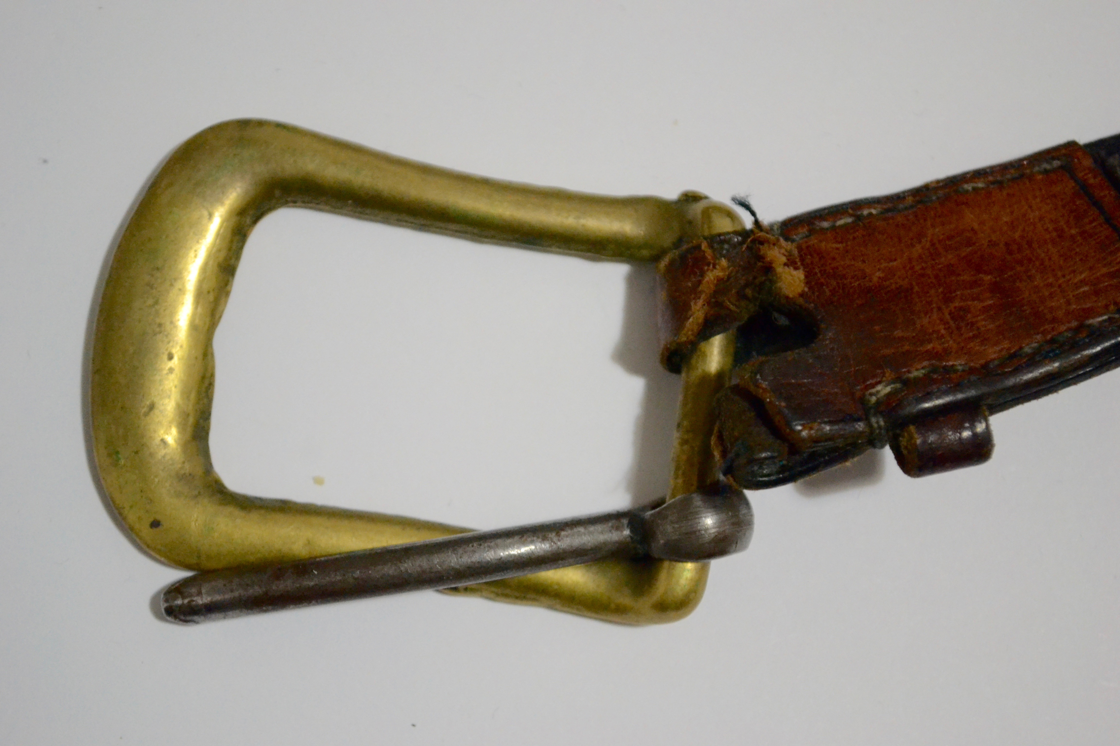
OPENING EVENTS FRIDAY 10TH FEBRUARY
7pm – 9pm
ENGINE ROOM: EXCHANGE GALLERY PENZANCE
Join us for an evening of performance, video, objects, narrative and stories generated by Café Morte to celebrate the life of a broken object.
The Tears of Things is a growing collection of broken objects that will be exhibited in the Engine Room, Exchange Gallery 10th February – 10th March. All the objects collected for The Tears of Things, have lost their original integrity in some way. The collection will form the beginning of a growing body of research relating to death and our attachments to broken objects.
EVENT: SATURDAY 11TH 10.00 – 4.00 BROKEN WRITING OPEN INVITATION
Members of the public are invited to participate by bringing a broken object to the gallery to be documented photographically and to write a short piece of text that will be added to the collection. The collection will form an online museum of broken objects reflecting the power that these objects still hold.
CAFE MORTE is a research group led by Mercedes Kemp and Lucy Willow, senior lecturers at Falmouth University. Its central focus is to discuss the rich and varied themes of death found in art and literature. Objects for Tears of Things have been sourced from artists, students and alumni from Falmouth University, public, academics and Penlee Museum.

