Pictures of new knowledge: a dilemma of fact or fantasy

Abstract. Conducting research through the practice and visual language of illustration has become an important methodology for interpreting new knowledge related to science and culture. This paper examines the means of converting original scholarship given to Evolution and Prehistoric Life with an emphasis on younger children’s education, exemplified by two case studies. Each project offers a distinct context with differing methodologies; literal actuality versus metaphorical conceptualisation. The enquiry will consider how primary research undertaken by the illustrator becomes unique and seminal knowledge and how it can be transformed into engaging and meaningful learning for children. It also examines how the illustrator might commit and adapt their practice and values to an ethical dimension that is increasing.
Keywords: illustration, drawing, science, evolution, taboo

Introduction

The interface between science and visual art represents a symbiosis of collaborative creativity and exploration. These correlations and synergies have facilitated some dramatic, sometimes sensationalist and internationally ubiquitous imagery: exo-planets and astro-zoology; the discovery of enigmatic and rare species; micro biological landscapes. Occasionally, these themes can be considered fantastical and aesthetically romantic.
However, the artist can also exemplify hypotheses and phenomena resultant in primary scientific research by ontological representation. For example, illustrations of morphological and taxonomic detail associated with emergent organic matter by evolution; pictures of fresh information and scholarship related to palaeo-ecology and the origins of life.
These values can be challenged and tested when matched against an educational provision for children. Illustrations should be scientifically accurate and true to the latest research. But, many publishers will prefer imagery that will also engage its young audience by captivation and interplay. However, the real problem is not any enforced semiotic compliance to luridness; it is a question of cultural dictate; religious beliefs and rejection of much scientific proven fact and theory.
The case studies offer divergent circumstances, subject matter and context; the visual reconstruction of a previously unknown organism, Keurbosia susanae from the Ordovician (505 million years ago) and the development and conceptualisation of a book entitled Species: Origin and Evolution, a timeline journey through prehistory from single cells to humankind. The methodology for both requires a profound insight and exposition into the epistemological value of objective drawing. There is a fundamental, academic approach that engages the artist with the subject’s morphology, ecology and biology; an analytical and exploratory scrutiny that leads to imagery of measured and intense precision.

1 Subject matter and context

Evolution is defined as the change over time of one or more inherited traits found in populations of
1
organisms, either by natural selection or by genetic drift. This concept can be inexplicable to a young audience. Even more enigmatic is the phenomenon of abiogenesis; the origins of biological life arising from inorganic matter through natural processes first occurring 3,500 – 2,000 million years ago and giving rise to all living organisms on earth.
Prehistoric life and extinction are themes taught in primary and junior education and are readily comprehended because of contemporary evidences; fossilised remains and skeletal reconstructions facilitated by illustrations depicting the morphology, habitats and behaviours of recognisable taxa. These are dinosaurs, early invertebrates and vertebrates and most are able to depict ubiquitous correlation with comparative species alive today.
An important study has revealed information regarding the possible origins of pre-vertebrate life during the Lower Cambrian, 560-570 million years ago, exemplified by the visual reconstruction of the Protoconodont Protohertzina; a new species and chordate form with a bio-mineralised skeleton and notochord. This suggests that all vertebrates, including humankind, could have evolved from ancestry such as this.
In a primary education context a problem may manifest when teaching the concept of evolution. This is particularly evident regarding an understanding of physical change and adaption to environment; and even more so, the notion of human life developing from primitive origins. It can be argued that literature detailing these concepts should be limited to mature audiences who are more likely to comprehend. However, it could also be argued that the studies of evolution and palaeo-ecology are fundamental principles for understanding the broad sweep of science, the natural processes of the earth and all of its biological and organic diversity preceding everything that has gone before. These epochs of natural history have established the ecological and organic framework that exists today; significant themes as a discourse for children’s education.

2 Methodology

The essence of this work, expounded by both case studies is underpinned by objective and analytical drawing. This is the key to successful visual research and provides for a fundamental analysis of the subject matter. Criteria will include elements essential for accurate representation. Most drawing of this kind is applied to the reconstruction of physical entities, but in order to achieve a comprehensive understanding of the subject, studies should determine its cultural and/or contemporary placing. There are three key aspects; anatomy, habitat and behaviour.
A primary objective is to undertake a synthesis of data by examination of the primary resource materials; the fossilised remains. Collaboration with palaeontologists will engender greater knowledge. The subsequent drawing studies should distinguish between important details and unnecessary anomalies by utilising the visual language of technical realism in order to represent the subject faithfully. Drawing from the specimen will provide a tangency with the subject. Observation and touch facilitates an engagement with the subject’s shape, form, surface texture, ambience and suggested demeanour. This method utilises a drawing strategy of search and change; there are a variety of ways of seeing and the same object can be drawn multifariously, each just as real and true as others. The drawings make a visual statement about the observed object and should form a fundamental underpinning upon which the illustration artworks can be completed.
2

3 Case study one: a literal truth

This project represents an organism, Keurbosia, of which a single specimen was discovered in 1998 from the Soom Shale Ordovician Table Mountain, South Africa. So far an enigma, it has not been possible to identify its nomenclature. The palaeontology team from Leicester University were responsible for this discovery. Collaboration with them enabled preliminary visual and scientific analysis of the fossilised specimen which reveals a creature 40 cm in length and 11 cm at the widest part. The fossil reveals a complex physiology that is compacted and compressed showing much internal anatomy such as thick musculature. There are also a number of lobe-like structures that protrude laterally.
Line drawings were produced facilitating discernment of Keurbosia anatomy. Physical features shown provide hints as to its classification; the muscles branch from a notochord proposing a chordate or early vertebrate unlike any other known to science. It is also bi-laterally symmetrical with articulated segments; this suggests an alternative prognosis; Keurbosia may be an arthropod. Deliberation proposes this as the preferred option. The muscle structure implied a substantial three dimensional organism, its overall body form synonymous with crustacean-like morphology having defined segmentation and lobes as swimming apparatus.
The finished illustration was rendered autographically in water based media with a pictorially realistic stylisation. The Soom Shale marine habitat is depicted with a dorsal view of Keurbosia, its anterior end touching the under surface of the water; there is also an accompanying specimen, side elevation. Free artistic licence was afforded regarding colouration; many present day arthropods possess bright colours and markings and it was decided to suggest corresponding adornment. The completed image was reviewed and endorsed by the scientific community.
To appraise this case study, the value of the illustration is borne by its authoritativeness, afforded by detailed visual research and collaboration. The image was produced primarily for science informed consumption, but its dynamics and ambience could readily captivate a young audience. The problem may be explaining the concept of the subject’s evolutionary origins and its proximity within the geologic time frame of the earth.

4 Case study two: a conceptual truth

This was originated as a proposal for a children’s non-fiction book entitled ‘Species: Origin and Evolution’. The concept is a visual narrative starting with the origin of life through to the emergence of early humans. Designed as a processional left-right sequence with full colour composites comprising appropriate fauna to epoch with vertebrate and invertebrate representation where appropriate; there are twelve principal spreads, each representing a geologic epoch of the earth’s history and to include recently discovered species, new to science and not previously illustrated.
This is a popular and relevant theme, particularly at 5–8 year level for trade and national curriculum publication. Usually, this type of book is dominated by dinosaurs, but the aim here is to present a much broader representation where evolution and morphological development is apparent.
3
The twelve double-page, landscape formatted illustrations are conceptual and designed as a metaphor for evolutionary maturation and growth over a long period from the Pre Cambrian to the Quaternary. Fauna for each spread face the direction of their evolutionary progress and form part of a composite visual arrangement infused by colours and textures appropriate for the epoch in question. The imagery is designed to educate through captivation and discovery; the intensity and complexity of each spread allowing for intense scrutiny, enticing the viewer to proceed to the next page and see what has evolved next. The imagery does not allude to representing scenic or pictorial real space.
The first spread to be researched and produced is the Carboniferous (Figure 1) and visually appropriated to convey the confusion and diversity of life associated with a dense and swampy habitat teeming with life. The majority of organisms are significant forerunners of life today; the earliest invertebrate forms and the first amphibians to evolve two pairs of legs. The left hand section of the spread is dominated by the anterior end of a recently discovered Tetrapod, Pederpes; a large, active predator with six digits on its forelimbs. The reconstruction was produced in collaboration with Cambridge University and is the first published illustration of this species.

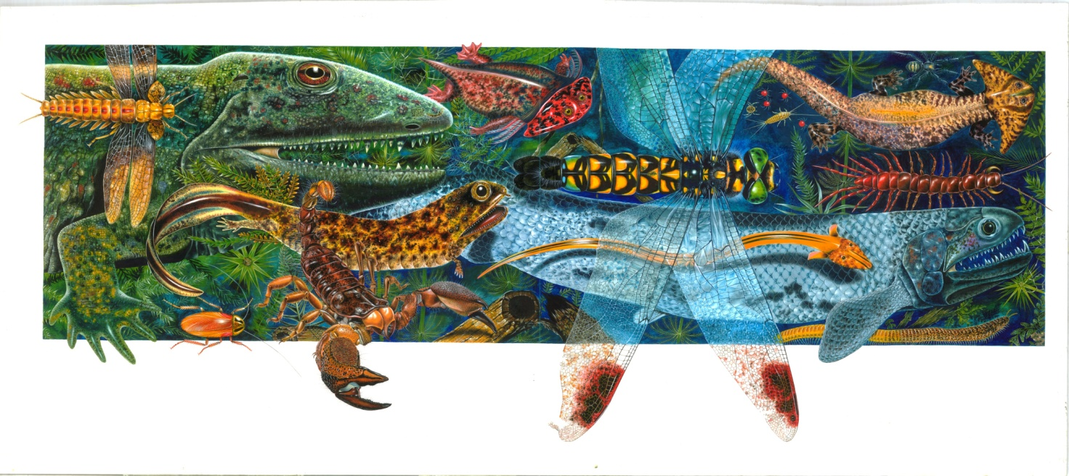
Figure 1. Alan Male, Carboniferous Fauna (2011). One of 12 double page spreads for book entitled Species: Origin and Evolution

Conclusion

This paper has revealed methodologies for the dissemination of new knowledge, specific to the scientific discourse of palaeo-ecology and the evolution of early life. Fauna previously unknown and undiscovered have been given visual identities and shown for the first time.
The illustrations are disparate regarding their context and use; case study one is an image produced by primary scientific research for original and advanced debate and case study two, is imagery produced for children’s educational and diversionary interest purposes. However, the two approaches do converge and contribute accordingly with regards to the imparting of meaningful information. Also, both approaches adhere with efficiency and effectiveness to the prescribed criteria for scientific illustration practice: quality of scientific information disseminated; its tribute to the subjects depicted; artistic processes, aesthetic qualities and technical skill; academic and educational value. However, further analysis points to clear differentiation; this analogy by Bert S. Hall, from the Institute of History and Philosophy, expounds that imagery of this kind can be ‘elegant’ with an emphasis on seduction and charm whilst the other is ‘didactic’ and purely instrumental in communicating raw, factual information. Case study two clearly works to engage and captivate; case study one leans significantly towards truthful representation.
The book is a chronicle; a narrative pace and flow, versatile in its use and authoritative with regards to the theme. The Carboniferous Fauna image is included in New York State Museum’s bi- annual exhibition, Focus on Nature XII, April – December 2012, the foremost juried, international display of scientific illustration. Keurbosia has been given high profile coverage by the international press.
To finalise, the case studies present methodologies underpinning imagery of known and approximated truths; assimilated with scrutiny and integrity and appropriated for educational consumption; its value unequivocal. However, there is deep opposition to evolution in certain societies. Public Policy Polling, 10-11 March 2012, revealed 60% unbelievers and 13% unsure regarding voters across Alabama and Mississippi. The notion of human life in particular, developing from primitive origins is anathema to some. In previous times, artists would divulge subjects in such a way so as not to offend or contradict religious beliefs or cultural mores; taboo avoidance facilitated by imagery of a ‘romantic’ nature, stylistically realistic but overtly fantastical regarding appropriation. Today, the belief in divine creationism has not abated. Contemporary illustrators will have to be increasingly mindful of global ethical concerns, including a regard and attention for cultural diversity. Across the world, education for the young will become more reliant on visual learning with a growth in media and published material to facilitate this trend. In accordance with context and intended audience, illustrators will consider three possible approaches to represent themes such as the origins of life, two of which are exemplified by the case studies: ontology as per case study one; phenomenology or abstraction as per case study two; and imagery that deliberately conveys falsehoods and distortions of the truth in compliance with faith dominated curricula. The drawings and research underpinning the case studies are key objectives to aid the presentation of science informed educational material for children. It would seem that Pictures of new knowledge: a dilemma of fact or fantasy is a conflict of integrity for the truth and objectivity versus duplicity for prostration and acquiescence.

Bibliographical references

Aldridge, R. (1986). The Affinities of Conodonts: New Evidence from the Carboniferous in
Edinburgh, Scotland. Lethaia, Vol. 19, pp. 279-291.
Black, RM. (1998). The Elements of Palaeontology. Cambridge University Press.
Braddy, SJ. (1995). A New Eurypterid from the late Ordovician Table Mountain Group, South
Africa. Palaeontology, Vol. 3.
Briggs, DEG. (1994). The Fossils of the Burgess Shale. Smithsonian Institute Press.
Clarkson, ENK. (1986). Invertebrate Palaeontology and Evolution. Allen and Unwin.
Janvier, P. (1996). Early Vertebrates, Clarendon Press, Oxford.

