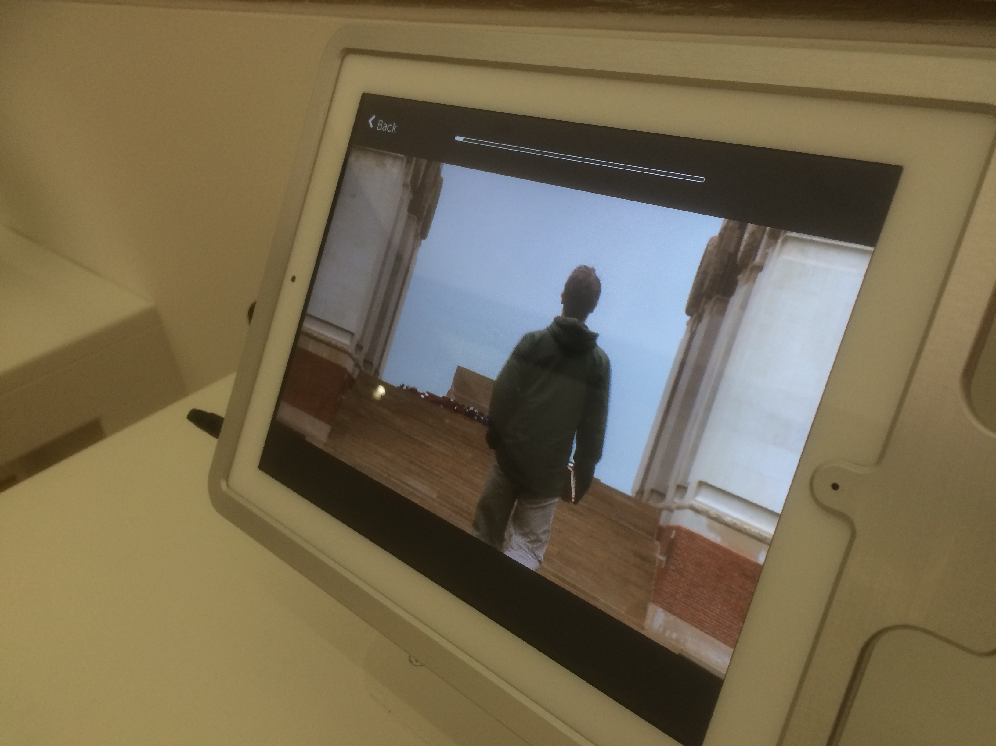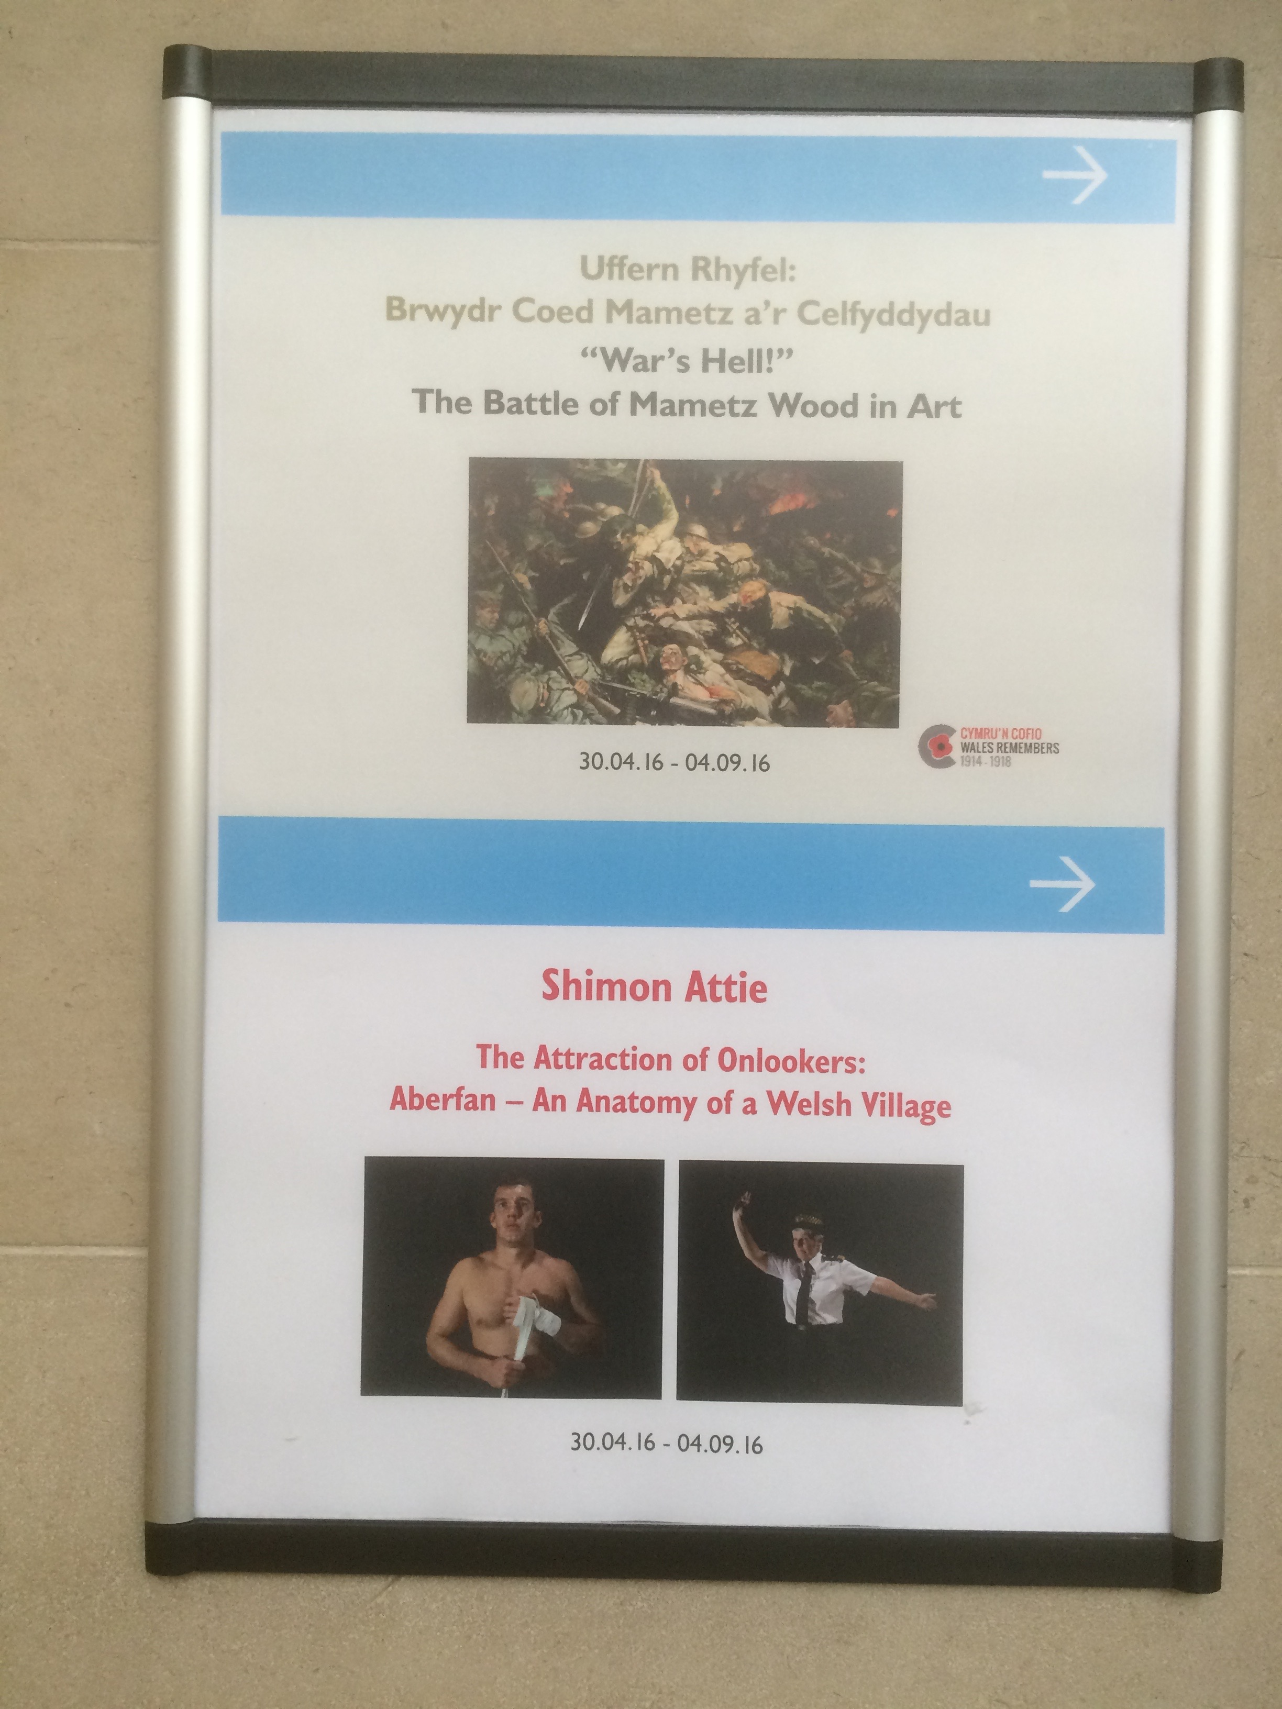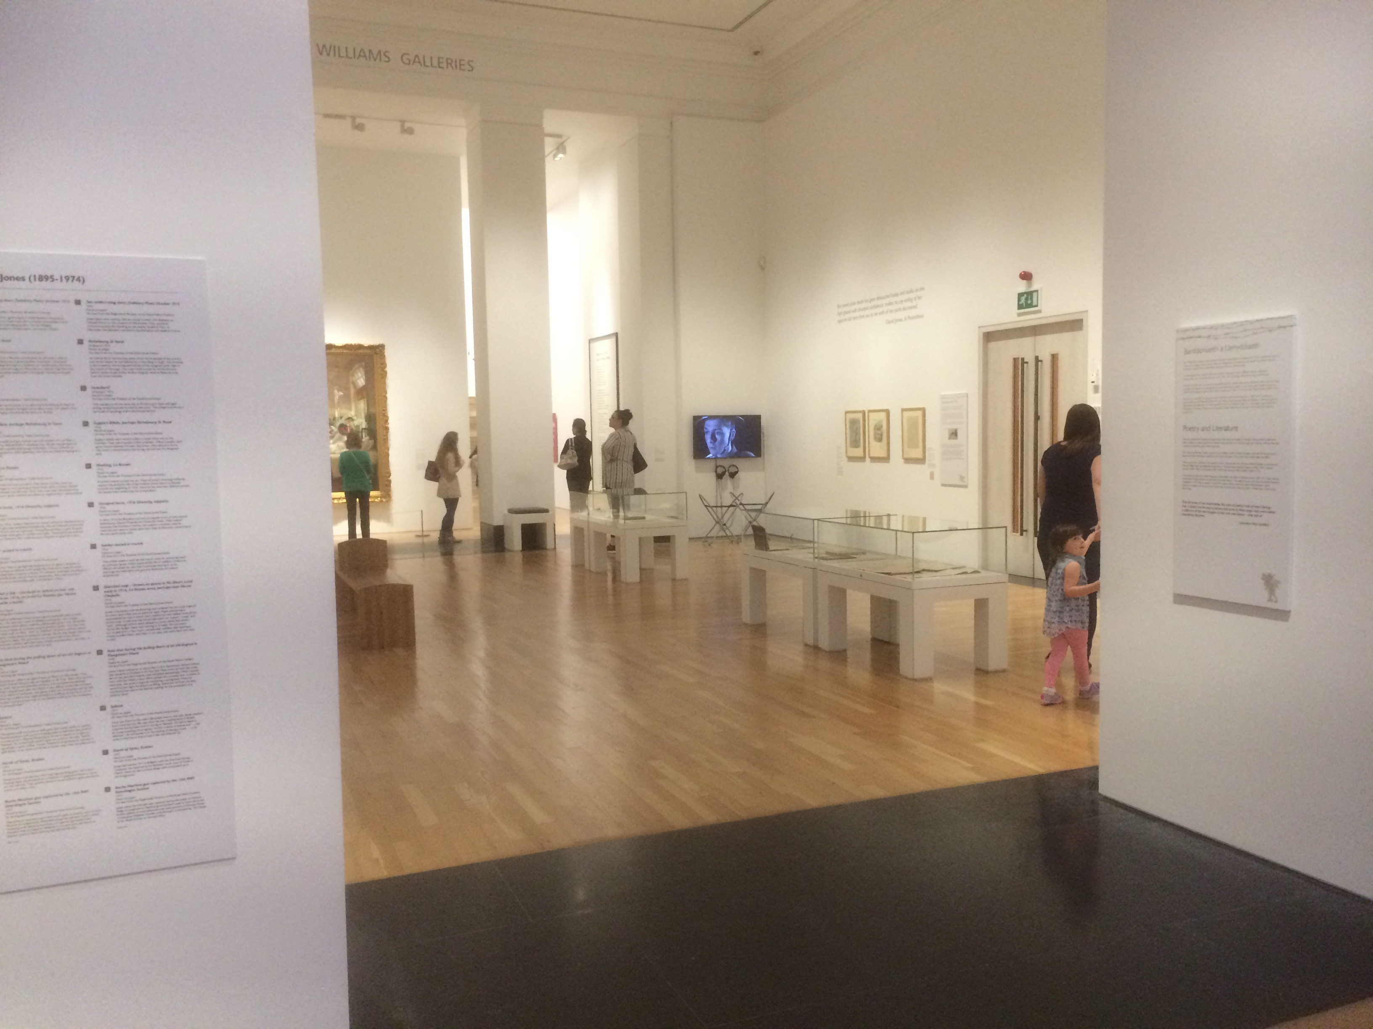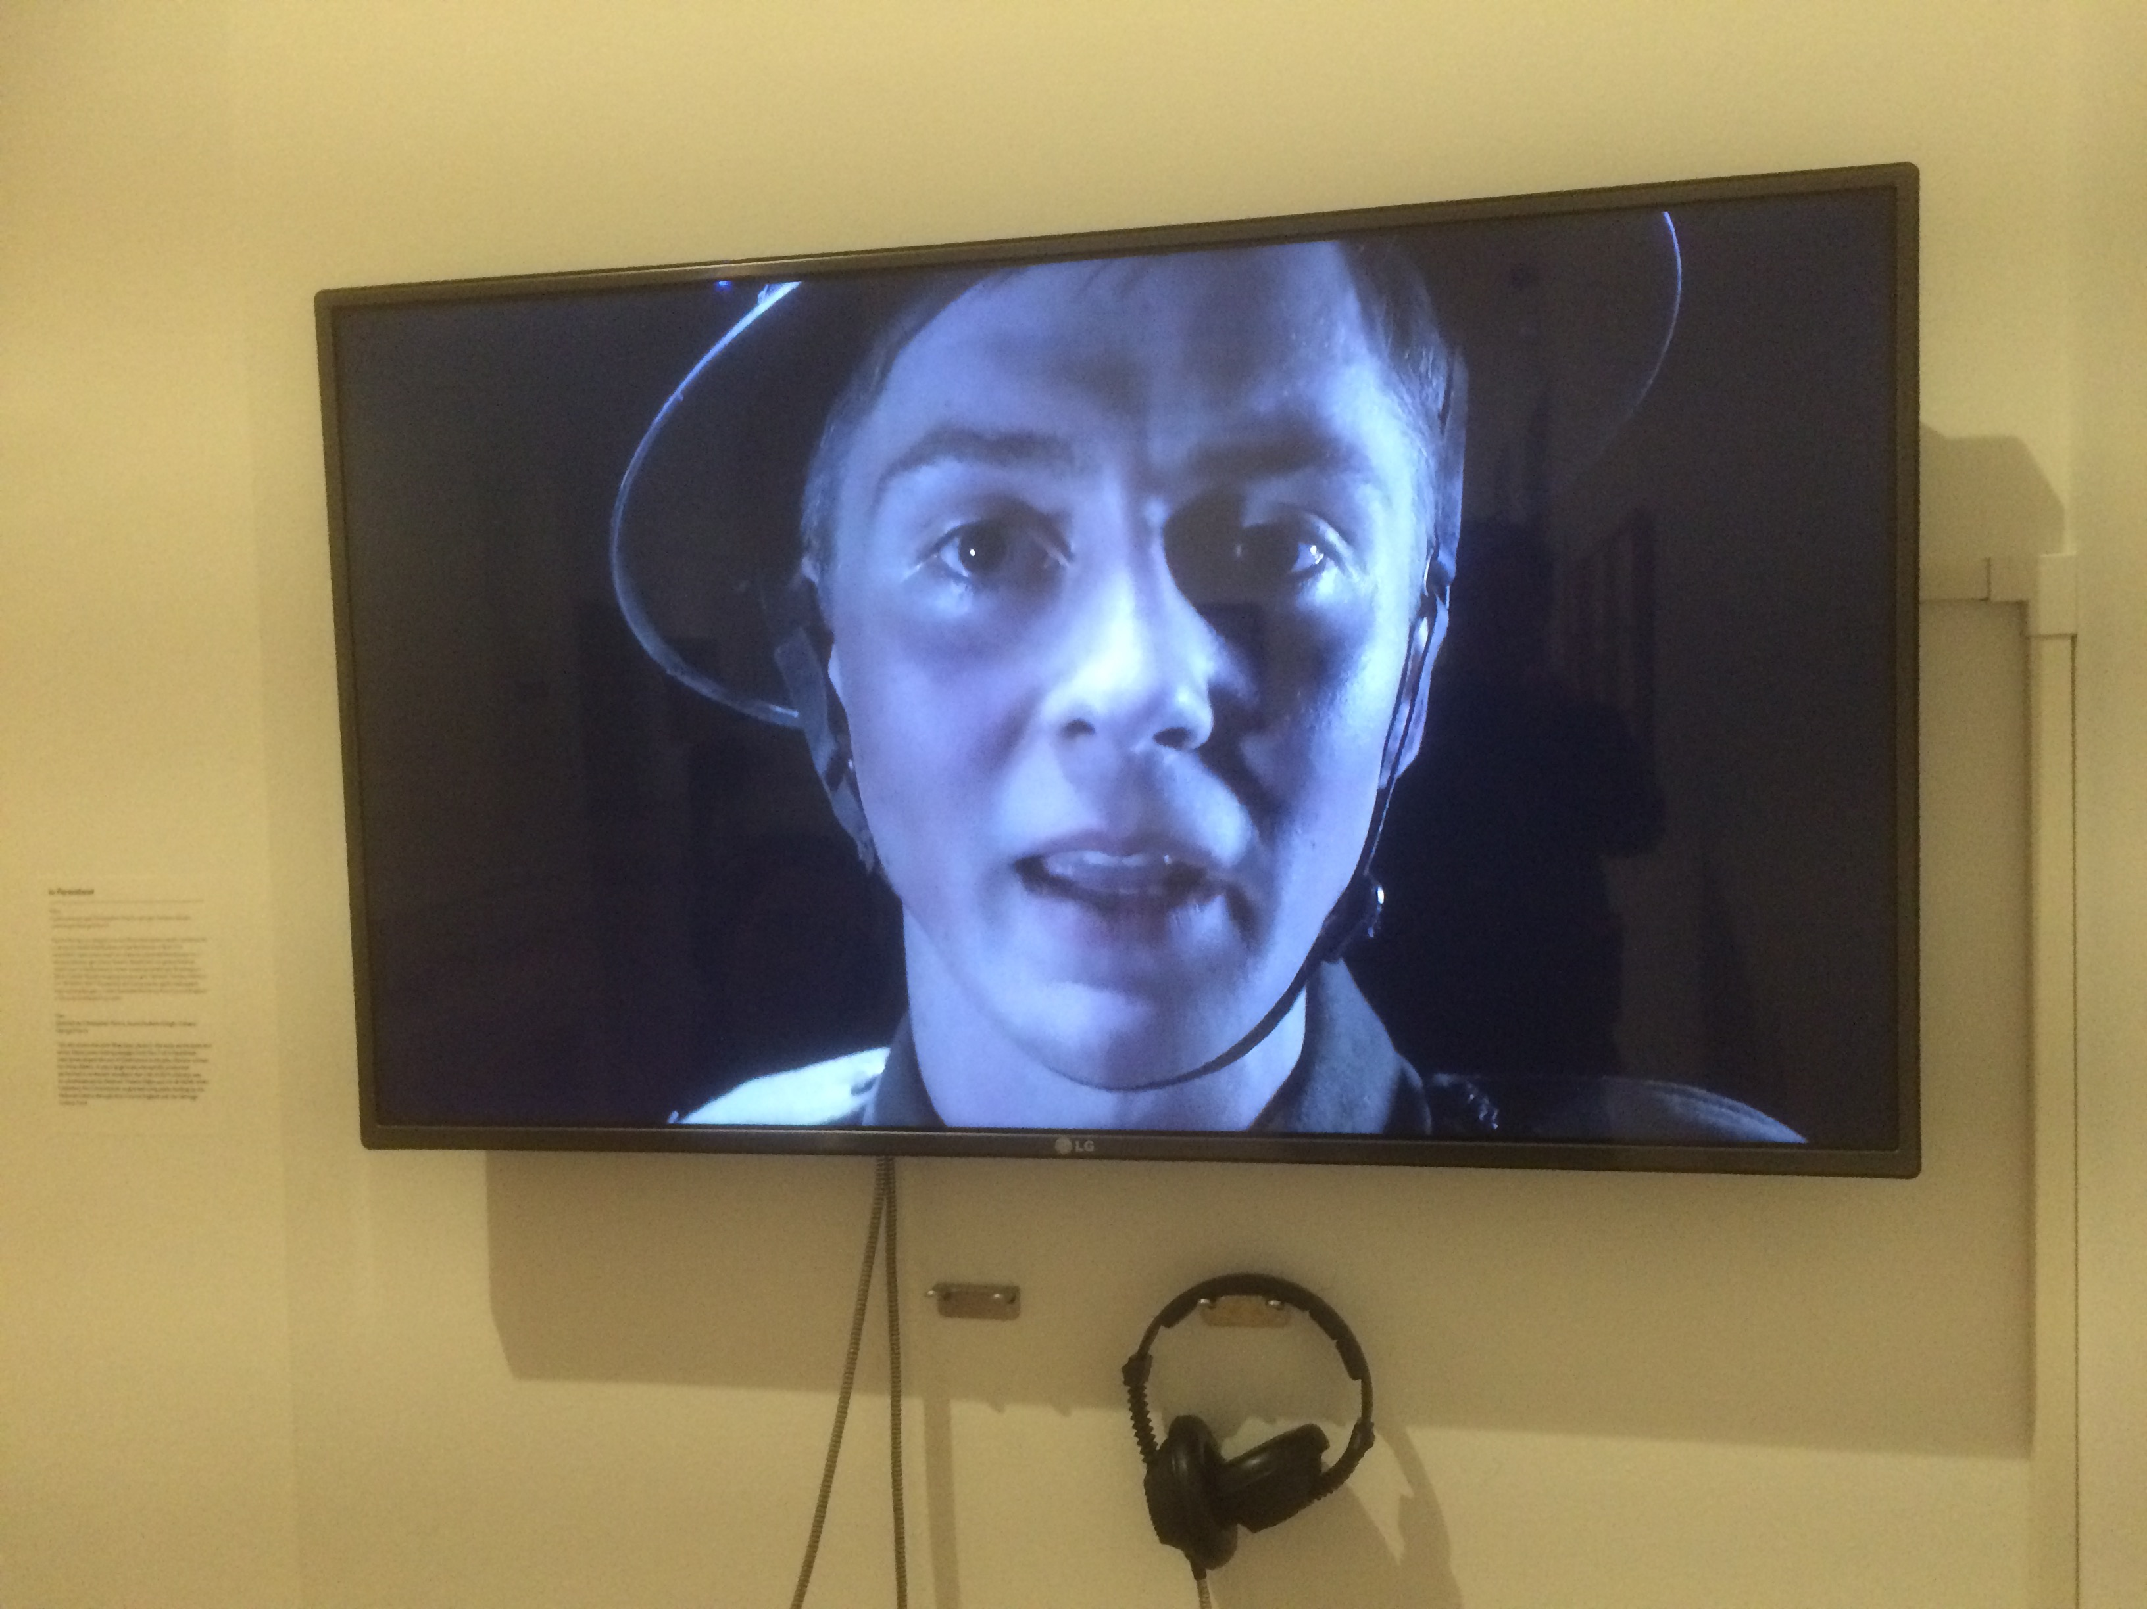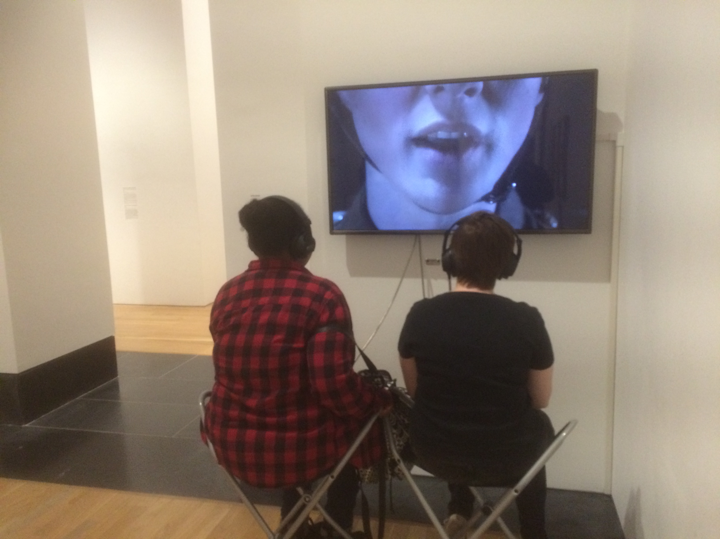

# The National Museum & Galleries of Wales

# Cardiff - 10 April - 4 September 2016

Visual and audio films that I directed and edited for the theatre production of Mametz are included in the centenary exhibition to commemorate Mametz at the National Museum of Wales. This includes an 8 minute film (above) of Rhys Isaac-Jones (as David Jones) reciting a segment of *In Parenthesis*. Secondly two short documentary films (*Wood* & *Stone* - left)I made on the initial research trips to the wood with writer Owen Sheers.

<https://museum.wales/cardiff/whatson/8949/Wars-Hell-The-Battle-of-Mametz-Wood-in-Art/>

“War’s Hell!”

The Battle of Mametz Wood in Art