IT IS AS THOUGH THE PROCESS
HAS GOT STUCK

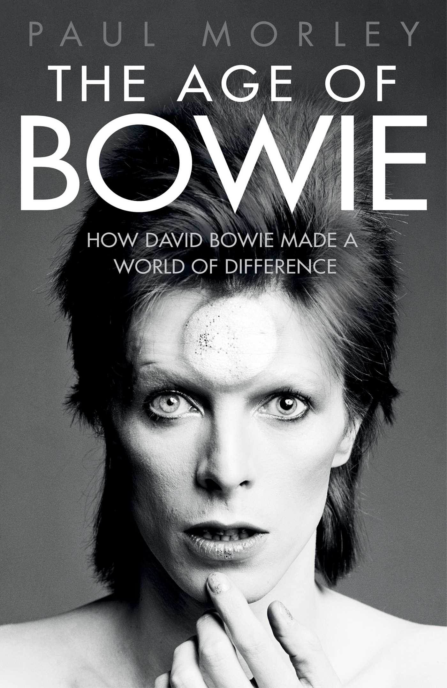

The Age of Bowie, Paul Morley (£20, Simon & Schuster)

Paul Morley is a rock'n'roll journalist from London. It is as though we are now involved in the mastery of another dimension of discourse.

Paul Morley is writing a book about David Bowie, in tribute to the starman. It is as though we have been surrounded by mirrors of hard, distorting glass.

Paul Morley is writing a book about Paul Morley writing a book. It is as though we are looking at the very surface of the story.

Paul Morley is making it up as he goes along. It is as though the music is struggling to be.

Paul Morley is a Professional Northerner and cultural commentator who pops up as on practically every arts programme. It is as though there is no exception.

Paul Morley is a difficult man to categorise. It is as though the fall of the apple to the ground depended on the apple's motives.

Paul Morley is not trying to be objective. It is as though when we talk about the world of the infinite, we think of it as a sort of idealization of the finite world we actually inhabit.

Paul Morley is looking old these days. It is as though he has just recognized himself.

Paul Morley is a pretentious git. It is as though a bill of lading were to acquire a value separate from the cargo.

Paul Morley is on hand to make an entertaining if diverting speech. It is as though everything we wanted to achieve in life has come together at once.

Paul Morley is obviously a huge Bowie fan, but as always he expresses his thoughts in his own unique style. It is as though the words were not only indelible but that they spread out like dye in water and colour everything around them.

Paul Morley is, in my opinion a brilliant writer – the best of his generation, my generation – and a great talker. It is as though someone flipped the switch and the light is on.

Paul Morley is a repugnant opinion-whore who enthusiastically offers a hundred deliberately cryptic, wilfully oblique words on any subject where ten would suffice. It is as though the dark were resolving him out of his integrity.

Paul Morley is asked to fill in a questionnaire about Propaganda and 'A Secret Wish'. He goes outside and punches the doorman. It is as though in the space of ten years we had slid back into the Stone Age.

Paul Morley is an authority on pop music, and he knows his subject matter. It is as though a star throws the whole secret history of its being into its spectrum.

Paul Morley is no slouch. It is as though human beings constantly note, and invent, similarities among the things they want to talk about.

Paul Morley is, and has been for many years, one of my favourite, favourite writers. It is as though my heart cannot regulate itself anymore.

Paul Morley is a sort of Lester Bangs for readers whose life experience owes more to The Human League than to Van Morrison. It is as though we've opened the curtains and can never shut them again.

Paul Morley is quite aware that the bereaved can get away with self-indulgence. It is as though the words travel through the audience, around the whole circle of the globe, and back.

Paul Morley is a former writer. It is as though we fell in love with a completely different man.

Paul Morley is wrong. It is as though this self has been fired in the kiln of anxiety to emerge as something fixed.

Paul Morley is the talking head. It is as though he see things in a completely different way to other people or other people are not taking him seriously.

Paul Morley is undoubtedly a very, very clever individual. It is as though every single surface is the product of some complex algorithmic process.

Paul Morley is a hugely knowledgeable, perceptive if rather self-satisfied former musician, record label boss and now (again) critic. It is as though a single tree branch had grown by itself to a commanding height and is now exposed and shaken back and forth by the storm.

Paul Morley is as much a question as statement. It is as though we searched for the answer first.

Paul Morley is a god for saying it. It is as though the world existed in the word, before it took the shape that it's in now.

Paul Morley is so smart he can even make list journalism shine. It is as though a great fire is burning between two mountains.

Paul Morley is talking about his just-published, highly personal and intoxicating view of David Bowie’s life and artistic legacy. It is as though he were reading our minds.

Paul Morley is offline. It is as though we already know everything.

© Rupert Loydell 2016

[first published in international times]

