Gothic Gaming: Dislocation, Monsters, Otherness
Tanya Krzywinska

Before considering American Gothic features of games, some preliminary consideration of the medium-specific qualities of games is necessary. Games require a physical level of engagement and many are designed to provide players with a sense of presence and agency in the game space and agency. In many cases, gameplay is contextualized within an antagonistic, unfriendly environment over which players are invited to develop mastery.
While making use of conventions and forms found in other media, games also have some very specific properties that affect how such conventions are used. A game is designed to provide structures to support gameplay (often referred to by game developers as “mechanics”). As such, games construct story in ways different from other media. Story has to fit with gameplay and the two are often linked through the journey a player takes through the game. Given that games are principally organized around a set of “ideal” actions to be performed by a player, feedback mechanisms on that performance are important componentry. The organization of feedback mechanisms is central to a game’s design, provided by a game’s computing, its graphics, audio, and interface. Feedback is wide-ranging and includes seeing your own character or an enemy die as a result of your actions, hearing a droopy sound when you fail to complete a task, and the vibration of your controller when a weapon is fired. There are many others.
As King and Krzywinska have argued, games allow players varying degrees of freedom in terms of movement, action, and choice. Player-characters can for example roam around in an open environment as in The Secret World (Funcom, 2012-present), or their movement might be restricted as in arcade shooter franchise House of the Dead (Sega, 1996-present). In each of these games, players must rise to challenges that involve manipulating their characters to enable passage through the game. Even where some latitude for action and movement is afforded as in Alan Wake (Remedy/Microsoft, 2010), it is often the case that player agency does not stretch to alteration of a storyline. We might call this restrictive “on-rails” approach to design the “Ghost Train” format wherein players experience the same predetermined ride. This approach differs from the type of game in which a player’s actions influence the trajectory of story, as is the case with Fable (Lionhead, 2004) or the Mass Effect series. Many games prefer to limit the effects of player choice in order to preserve authorial control of a storyline, and/or to keep production costs down.
Games then have their own distinctive qualities that must be kept in mind when considering their treatment of American Gothic. They are highly structured systems that respond to a player’s activity. These include the moment-by-moment transactions effected as a player moves through a game and which may lead to larger, cumulative loops, represented as achievement points or progress bars. Much as a Skinner box works to affect the behaviors of rats, game loops train a player to understand and learn what a game requires her to do. Player agency and choice (or its lack) are therefore central to the definition of a game. These properties are rich food for the Gothic imagination, with its preoccupation with paralysis and futility and may therefore be deployed to demonstrate that choice and agency, as taken-for-granted staples of games, are illusory.

Gothic Gaming

To address the American Gothic qualities of videogames, a comparison with other media may be initially helpful. Through its ensemble format and blatant postmodern mash-up of Gothic icons and texts, British-made TV serial Penny Dreadful (2014-) neatly encapsulates three core features of American Gothic material that are found in videogames. The first is Monstrosity.
Ethan Chandler (played by actor Josh Hartnett), is one of Penny Dreadful’s main characters. He is an American come recently to Europe to escape the tyranny of his father and a dubious past. Following the transatlantic passage of other werewolves to Europe, he is an American werewolf in London.
Chandler’s father represents American colonial power and is demonstrably linked to the murder of indigenous people; becoming werewolf is an indication that Chandler too is implicated in such brutality. Even as he expresses honorable intentions, Chandler carries within a monstrosity that is blind to civilization and empathy. In Gothic media, monsters come in many forms—some do not know they are monsters, while others are more simply rendered; in games too monsters are multiform. Monstrosity provides not only as spectacle and “flavor” (a term used by game developers to mean theme and/or genre), but as we’ll see, may also serve a game’s mechanics.
As with actor Lon Chaney Jr.’s werewolf in the 1940s Universal Pictures Wolfman films, Chandler’s angst brings pathos to the role of monster. He has the demeanor of a conventional hero, but his monstrosity provides the type of flaw expected of a tragic anti-hero. As a deeply conflicted character and exhibiting behaviors over which he has no conscious control, Chandler’s compartmentalized monstrosity makes him “other” to himself. In the context of Gothic fiction, where opportunities are exploited to create a sense of hostility or discomfort, the “other” is not simply that which is not like us as a form of genial difference. Instead it is a force or presence that works to undermine or harm us. This other might be embodied or not; and, as is the case with Chandler, it might not be characteristic of an antagonist. Otherness then provides a second characteristic of American Gothic characteristics in games.
Chandler also suffers. He has a strong sense of alienation and despair. Displaced and estranged, he has lost his coordinates, seeking solace and redemption. Dislocation is therefore our third feature of Gothic games: characters that have strayed outside of their comfort zone is common in Gothic fiction generally and videogames are no different.
An examination of the ways in which monstrosity, otherness and dislocation can then be used as a means of understanding how games utilize Gothic conventions, as well as providing a framework for the analysis of the key relationships in games among story, character, and game mechanics.

Monsters, You Monster, I Monster!

Monsters hold court in a large variety of games. They are drawn from a host of mythologies and take on a host of guises. Some are demons, others malformed humans. Some are born of twisted moral purpose, others embody rage or lust. Some are material, others made of more gauzy stuff. Some represent voracious appetite; others seek sadistic dominion over earth and humans. Aliens, zombies, and psychopaths are typical American Gothic monsters that populate games of different genres and are available for different platforms.
While in most fictions monstrosity is deployed as a narrative stratagem, in games monstrosity is a guise that gives meaning and form to logarithmic counting devices. These are built around the use of systematic distinctions and categories. Many game monsters are part of what can be thought of as a demonology—a system arranged around strength, behaviors, and representational form. Echoing medieval bestiaries and demonologies, game monster taxonomies are tied into the design of a player’s experience of a game’s design. The strength of The Secret World’s monsters is handily and typically scaled in accordance with the abilities and capabilities afforded to a player as she is channeled to the relevant area of the game. A newly minted player-character arriving with few skill points at Kingsmouth is unlikely to be able to tackle killing the strong monsters that are newly hatched from the sea, but are well-equipped to deal with the weaker zombies that populate the area around the town. As the player-character grows in strength, she becomes able to tackle sea monsters and gain their loot. In most combat-based games, it is plain to see a game-based structure at work in the demonology. In servitude of this process, games take up real world mythological systems and translate them to a ludic agenda.
A close parallel between Christian conceptions of demonic typologies and game monster typologies is therefore apparent, but not because of a universal notion of monstrosity; rather, typology itself gives structure and weight to the realization of a mythology. This aids in giving a fiction greater authority and depth, thereby increasing the potential for player suspension of disbelief. Games rely for their credibility with their audience on their ability to create coherent scaling systems that dovetail neatly with a game’s feedback mechanics. Killing monsters might solicit many different types of pleasures, but at base monsters are convenient game mechanics.
The Cacodemons (Fig. 1) of Doom II: Hell on Earth (idsoftware, 1994) provide an early example—designed, as so many game monsters are, to be simply cannon fodder. Such monsters, however, play an important role. They serve to keep up a flow of action and act as feedback affirmation of a player’s mastery and progress (or not!). Cacodemons are conventional game monsters. They are in effect puzzle-based “obstacles” designed to test a player’s ability to master the weapons and tactics available. Combining elements of demonology with Lovecraftian alien lore, Cacodemons are denizens of Outer Space; as such they are linked to a well-worn frontier mythology. Cacodemons are however principally ludic rather than narrative devices.
Their ludic function is also echoed in their representational form. They float around the game space, providing therefore a less stable target than other monsters in the game. In addition, their wide toothy grins, that open to spit plasma bolts, taunt the unprepared player, upping the emotional ante. Cacodemons are also large enough to nearly engulf a player’s screen, making it hard to master the immediate game space, bucking the trend of the era where small sprites were far more common. Their sequel-evolved form in Doom 3 (id software, 2004) presents a much fleshier body than their colorful predecessors, resembling more closely the medieval demons found in Hieronymus Bosch’s paintings of Hell. As a game franchise, Doom’s demonology can therefore be co-opted as a visual lesson in game graphics technology evolution.
While Cacodemons in Doom are encountered singly or in small numbers, videogames regularly present players with hosts of monsters that move as a massed, repetitious swarming body: Zombies, animated skeletons, or aliens are common cannon fodder in games in which shooting or something equivalent is the core mechanic. Given the reliance on powerful visual feedback mechanisms including spectacle, alongside a ludic requirement to quantify player actions, it is not perhaps surprising that “shooting” legions of de-individualized monsters is called on so regularly by game developers. Massed examples of cannon-fodder monsters that roam any number of games gave rise to the term “mobs” (short for monster mobiles). Such monsters present a threat but also endorse a sense of a player’s agency through their death. It is therefore not much of a leap from rows of space invaders marching down the screen towards a player in the classic Space Invaders (Taito, 1978) to the more visually and behaviorally complex monsters of the latest Playstation 4 big-budget Horror game such as Until Dawn (Supermassive/Sony, 2015).
In the development of Gothic gaming, the slow movement of zombies in particular suited games that had simple Artificial Intelligence (AI). Dead Rising (Capcom, 2006), for example, populated its game spaces with thousands of zombies, making use of the ubiquity of widescreen televisions to create visual impact. Typing of the Dead (Sega, 1999), in contrast, provided a variant of the shoot’em-up format to dispatch its hordes of zombies in which players type words appearing above zombies’ heads to dispatch them. Developments in game AI has generated smarter zombies that respond more receptively and idiosyncratically to situations, as in squad-based shooter Left 4 Dead (Turtle/Rock, 2008) where they create a greater sense of jeopardy and making for edgier game play.

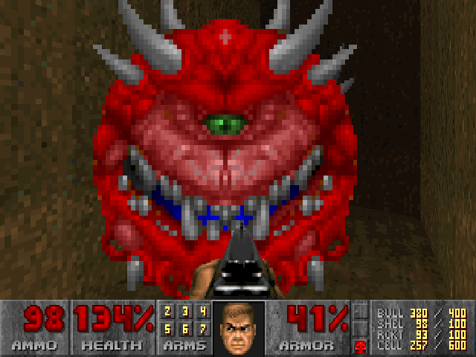
Fig. 1 The Mocking Grin of the Cacodemon in the Doom series.
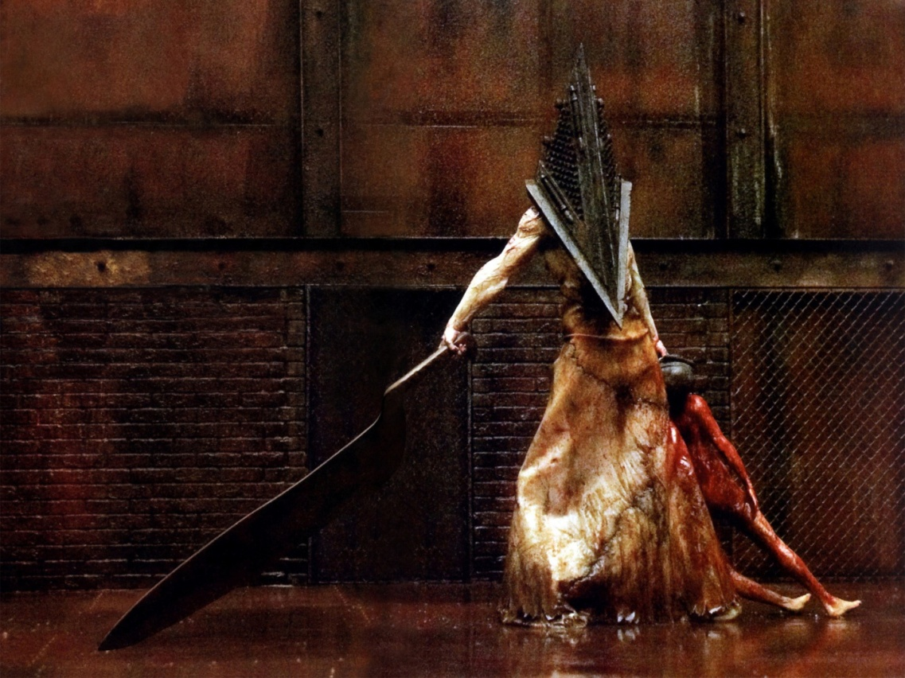
Fig 2. Pyramid Head: Monster Mash-up.

In contrast to the relatively simplistic Cacodemons or easily dispatched legions of walking dead is the “big boss,” the strongest monster in a game. Arguably the most iconic and idiosyncratic of all game monster big bosses is the relentless and unflinching Pyramid Head that stalks the Silent Hill games (Fig. 2). Strings of bulked muscle are juxtaposed with an anonymizing metal, angular helmet; Pyramid Head’s contradictory form powerfully signifies a loss of humanity. He does not see; no facial expression is visible. In him, archetypal aberrational fairy tale monster meets the fearful symmetry of geometry. He is a monster for, and from, the game age: Flesh textures are fused with the polygonal forms that lie at the foundation of all 3D game characters, but which are conventionally hidden to create the illusion of real bodies. Blind to pity, relentlessly dragging his crude, oversized sword along the ground, players hear him before they see him. This is a boss designed not to face but from which to flee. In terms of narrative, and in the franchise’s structural demonology, Pyramid Head remains enigmatic. It is never his story that is told—a narrative absence that strengthens his archetypal bogeyman status. Pyramid Head is therefore a highly individualized monster unlike the Cacodemons and the other cookie-cutter counterparts discussed above.
While principally mechanicals, game monsters are however more than that. Even as simple cannon fodder, they come heavily freighted with myth, meaning, and affect; their bodies speak story, as well as designed to delight, surprise, and disturb. Pyramid Head’s form speaks of dehumanization and biological aberration for instance. In eco-terror games, such as the Resident Evil series, monsters are produced by careless human actions and technologies and their form reflects this often manifesting corruption or the perversion of the natural. Monsters then can be used to represent that which is marginalized or generally overlooked as inconvenient. They are therefore very often deployed in game narratives as cautionary figures and monsters that serve a moral purpose are most common in games with complex narratives. Monsters functioning in this capacity are seen in Alan Wake for example, where a more existential tack is taken rather than the apocalyptic one common to zombie games. While Alan Wake is populated by psychopaths, conjured out of backwoods red-neck horror films such as Texas Chainsaw Massacre (Hooper, 1974) and Deliverance (Boorman, 1972), it is in fact Wake himself, whom the player plays, who is author of the game’s antagonistic force and is therefore monster. A similar case is found in the second Silent Hill game, in which the protagonist is deeply implicated in evil acts of which he is seemingly unaware. In both cases a model of repression is in play, providing therefore a far more genuinely Gothic twist on the usual Manichean mechanics of shoot’em up style games. Here it is the narrative context that throws a certain light on the mechanic—the mechanics are in themselves largely unaffected but the narrative context is what gives these their meaning.
In other instances, narrative mechanics can affect game mechanics profoundly. In Spec Ops: The Line (2012, Yager/2K), narrative mechanics actively work against game mechanics and this produces a very interesting and unusual twist that positions and names the player, not just the player-character, as monster. This game looks at first to be a standard military shooter. The player-character leads a squad on a reconnaissance mission but acts in increasingly psychopathic ways. Over the course of the game, he turns from hero to monster. A player is likely to anticipate that the player-character will once again revert to that of hero. He does not. In this, Spec Ops toys with their players, goading them into not completing the game. Versed in the expectation that game is to be completed, few players give up. Loading screens display messages that are directed explicitly at the player, asking why she is still playing the game given the unconscionable actions of the character (the only way a player has agency over the character is to stop playing). The game strongly and directly positions the player as Monster, implicating her in the deaths on screen and perhaps even on the way that her game literacy desensitizes her to violence. In this, Spec Ops renders the player “other” and “monstrous”—a shift away from the more usual projection of the monstrosity onto other and othered people.
We have then gone from monsters as cheap cannon fodder that are not intended to cause a player any cause for moral concern, to individualized monsters, structurally positioned as “You, Monster,” to a game that calls this precisely into question by positioning the player as “I, Monster.” All these positions can be regarded as modalities of otherness, a concept that has a key presence in Gothic gaming.

other to Other
Otherness is a hot property of the Gothic and is purposed in games to structure narrative, to create atmosphere and stylistic coherence, and to generate emotional engagement. It resides mainly at the level of representation, also informing story and mechanics (although perhaps to a lesser extent). The concept of the other can be divided into two distinctive categories, as is common in post-Freudian psychoanalysis. There is the other with a lower case “o,” which refers to other people—those who are not me and therefore different to me. The property of otherness can however become exaggerated into not just other, but radically alien and different: an Other with a capital “O.” This Other is threatening and terrifying, calling into question our sense of being and purpose. In addition, certain people or groups of people can be “othered,” made more strange and different as means of ostracizing and marginalizing them. The Other is then grounded in our psychological and social relation with other human beings and its properties prove to be a valuable asset for Gothic fiction and games.
Monsters are direct embodiments of the Other, although what form this takes and the degree to which they are Other differs. The otherness of some game monsters is lightly and stereotypical sketched, serving ludic purposes more fully than narrative ones, providing a type of functional otherness. This is the case with cannon-fodder monsters that are designed to provide visual feedback of a player’s mastery of the game, as an embodied form of progress bar. The otherness of zombies lies in their representational status as “no-longer” people; reduced to flesh and dumb appetite they are devoid of identity or humanity. They ask no ethical or compassionate questions of a player. Such functional monsters are infinitely replaceable and unlikely to appeal to empathy; they can therefore be hacked about, slashed, shot, and chain-sawed with wild abandon. Often game monsters call on a visual quality of otherness through their presentation as malformations or perversions, providing therefore spectacle for players. Otherness is not always conveyed through twisted and strangely formed bodies however; it can also be inflected through dress, accents, and or speech patterns, as with the red-neck psychopaths of Dead Rising 2 (Capcom, 2010) or the deadly politeness of Bioshock’s antagonist (2K, 2007). Drawn from cultural stereotypes such cues work to make these characters easy or desirable to “kill.” Otherness in games is therefore laden with meanings that grow out of real-world inter-human relationships.
Otherness becomes most complex in American Gothic where a game’s player-character is herself marked out as Other. This configuration is largely confined to Gothic games and it is perhaps not a coincidence that many such characters are American, as in Silent Hill 2, Alan Wake, and Spec Ops. Manuel Aguirre uses the term “false hero” in Gothic fiction to describe protagonists that exhibit characteristics different from those of a standard hero. This may be a protagonist who does not conform to the rugged white male stereotype and who in some cases is revealed as monstrous in terms of bodies or actions (as in the games listed above). The use of the “false hero” allows otherness and monstrosity to be configured in such a way as to offer a departure from a conventional good-versus-evil narrative, as well as to question some of the norms of gaming, as in Spec Ops.
Gothic games clearly deploy monsters as “othered” obstacles to be defeated. Just as importantly, Gothic games also create mysterious and antagonistic spaces—other worlds—that dislocated players are challenged to navigate successfully. In Gothic games, space and location are themselves habitually rendered as Other. The design of game space is important to the creation of Gothic atmosphere and might be understood as translation of adjectives such as “leprous” or “eldritch” found in weird fictions such as H. P. Lovecraft’s short stories. The challenge for game designers is that space also has to function as a context for action and must be tailored around gameplay. In a ludic sense, environments can also be employed to actively impede a player’s progress through space, acting therefore as antagonist. As such, gamers often use the term “PvE” games to designate player versus the environment, in contrast to “PvP” games in which the contest is player versus player. In representational, narrative, and ludic senses, space in Gothic games becomes hostile and strange, in some cases no longer seeming to serving human agency or purpose. As in Richard Slotkin’s description of the frontier, this can be a place where the known rules no longer function. In games, a player needs to discover and conform to what a space requires of her. In this sense, game space takes on the guise of the (capitalized) Other, operating as an outside force that dispassionately demands strict conformity from a player. Space can therefore be configured in an Othered way to provide players with a keen sense of dislocation through a disturbance from a proper or usual place or state. Otherness is thus a modality deployed in games that affects monstrosity, as well as disclocation, discussed below, , investing each with their emotional and psychological power.

The Place of Dislocation in Games

The pairing of an American game setting with the Gothic usually results in some form of dislocation. As with the American werewolf in London in Penny Dreadful, dislocation is an inherently spatial dimension and game media is especially good at creating literalized spaces that players can seemingly occupy. Gothic games in particular work hard to give a player a sense of being in and inhabiting the space of the game. 3D graphics and first-person perspective heighten perceptual engagement, enhanced by VR headsets or other forms of Augmented Reality, to strengthen a sense of presence and immediacy. Game space is also important to the way story is delivered in games. Story is written in to what the player is asked to do in a game space and cues for such are often found in the visual or auditory design of the space and objects within that space. I have identified three types of dislocation that have are relevant to the American Gothic in games: the cultural, the temporal, and the psychological.
Cultural dislocation is a feature of some games using an American setting. These subdivide into two: games that are made within America that thematize cultural dislocation, as with The Wolf Among Us and the Bioshock series (2K Boston/Irrational, 2007-2013), and games that approach American landscapes and culture from another cultural perspective, such as the Silent Hill series (1999-2012) and Deadly Premonition (Rising Star, 2010) made in Japan. Both forms of cultural dislocation raise questions about just what “America” is, what purposes it serves, and for whom.
Turning first to American games that thematize cultural dislocation, The Wolf Among Us is based on Bill Willingham’s Fables comic book series and is a story-based point and click game. Known as “fables,” the game’s main characters are drawn from European fairy tales and have been forced to immigrate to America. They are required to mask their fantastical identities in order to pass as human. This is expensive and a black market has developed as a result. This economy is linked directly to the fables’ dislocative situation and provides the source of the game’s plot. In order to control frontier life, bureaucracy and law take shape. Bigby Wolf (a werewolf), the player-character, is tasked with the role of Sherriff and tacitly complicit with the process of “normalization”—certainly an upended role for a werewolf and once-upon-a-time Big Bad Wolf! Core then to the plot and overarching mythos is the difficulty of adapting to a new culture and the need to change—not just in terms of daily habits and adjusting to reduced social status but also in terms of embodiment—as a means to fit in and survive at the frontier. As we might expect, the usual cues and roles are no longer in place—a kind of social leveling has taken place that means it is much more difficult to ascertain previously extremely clear moral alignments. Bluebeard is shorn of the power to represent evil for example. Bigby is now able to turn werewolf at will, helping his transformation from false hero to newly minted conventional hero (the reverse of the journey made by Ethan Chandler, the werewolf of Penny Dreadful mentioned at the start of the chapter).
Apocalyptic scenarios common within games also work with cultural dislocation, where norms and roles are disrupted. In The Secret World (2012-present) an elderly woman, Norma Creed, takes on the hero role, holding out against hordes of sea monsters and zombies, as well as acting as helper to new players by providing quests that will improve their standing in the game. In The Last of Us (Naughty Dog, 2013), the heroic status of the player-character is far from a given and whether he has acted heroically or selfishly is very much open to a player’s interpretation. Both these characters enact the roles of Gothic anti-heroes.
A twist on conventional forms of cultural dislocation is present in games made by Japanese game developers that use an American Gothic small-town modality where normality is simply a thin veneer that barely covers over a seething chaos of the unconscionable as in the Silent Hill series and Deadly Premonition, a game that puts the player in the shoes of a psychic detective come from out of town to investigate the ritual murder of girls. There is therefore a transnational culturally dislocative dimension at work lending an additional layer of weird to Gothic games. In the cases of Silent Hill and more specifically Deadly Premonition, elements of American series such as Twin Peaks (David Lynch, 1990-1991) are read and repurposed to strange-making effect through Japanese cultural frameworks.
Temporal dislocation in American Gothic games similarly plays with and questions ideas of American identity and often results from a disturbance to the conventional order of things. Games do of course regularly break with linear time in any case, but this is now accepted as integral to the medium—you “die,” then you respawn and try that tricky task over again. This tends to make death seem less real and therefore less of a temporal dislocation. However, certain games more consciously upend chronological time in aggressive or significant ways. Bother an ancient Indian burial site or find yourself at some kind of frontier (the Arctic, internet, deep space, or black holes) and hell breaks loose, making nonsense of linear organizations of time: ghosts, doubling, time loops, multiple worlds. Deadly Premonition, for example, makes temporal dislocation central to its game mechanic in which players must visit locations at certain times if they are to follow leads. As such, time acts as a strong determining “Other” in the game; the player must obey its dictates.
In American Gothic games, as in other Gothic media, ghosts in particular often function as indications or catalysts of temporal dislocatedness. As a form of small-town American fiction, The Sims series (Maxis/EA 2000 – present) doesn’t seem very Gothic on the surface, but it is nonetheless populated by ghosts. These might be dead Sims and pets, likely killed accidently or consciously by the player, who appear at night if their bodies have not been “properly” buried. Sims’ ghosts are testimony not just to the effects of the games’ internal life cycle and aging (a variable that can actually be turned off), but also act as commentary on the player’s treatment of their Sims, providing a kind of return-of-the-repressed that is directly related to a player’s choices and actions.
Ghosts also appear as emblems of the return of the repressed in other games including Alan Wake, where the eponymous character is haunted, self-referentially, by his own fiction. In Bioshock Infinite (2k Games, 2014), Lady Comstock’s ghost is something akin to Schrodinger’s cat; her various guises are symptomatic of the game’s multiple/parallel worlds concept, thereby drawing on a Weird Science model of American Gothic where time is rarely a stable constant. Lady Comstock’s ghost is not only a demonstration of the concept of the “multi-verse” but also draws on an older, much-used Gothic convention: the return of that which has been repressed or suppressed. In a franchise that draws on the anti-ultraistic work of Ayn Rand, this ghost is testimony to what has been suppressed: ultra-nationalism and religious extremism.
Psychological dislocation, our final variant on Gothic dislocation, often occurs in conjunction with cultural and temporal dislocation. In Max Payne (Remedy, 2001), psychological dislocation occurs through the brutal murder of Payne’s wife and child, which are represented by dislocated dream-like experiences in which the normal rule of space and time do not apply. This sequence, as well as similar scenes in Deadly Premonition, function as spectacle and storytelling devices rather than game spaces within which a player is able to act. These spaces are distinct from “normative” game spaces for orderly and regulated human/player agency—they are then spaces out of time and space and symptomatic of disordered minds.
Psychological dislocation in the general context of Gothic manifests itself very often as a form of paralysis—an inability to comprehend and/or act on a situation. As Eve Kosofosky Sedgwick explains in The Coherence of Gothic Conventions, claustrophobia sums up Gothic’s emotional ethos. Introducing psychological dislocation into videogames creates a problem for game developers as games generally work towards giving players increasing mastery of over events—that is, overcoming paralysis and engaging in effective, goal-directed action. Alternative ways to balance Gothic inaction with engaging audiences as players have to be found. In Call of Cthulhu: Dark Corners of the Earth (Headfirst/Bethesda, 2005), players must avoid going mad. Actions must be surreptitious and measured if madness is to be avoided; if not, the player-character becomes paralyzed and unable to act.
Games that take a weird path often have a slow pace, a mode that frustrates players thrilled by low-effort actions that yield high-octane spectacle and high impact. However, it is common for games that take this left-hand path to use the first-person perspective expected of normative shooter-style games. This is because it is easier to create a more intense, psychologically dislocative experience for the player using first person perspective, enabling, for example, perceptual effects based on a limited vista to be used (less of a case of “it’s behind you!” and “what’s that behind me?!”); examples include all of the Doom games but perhaps most unnervingly in Doom 3 (2004) and Alien Isolation (2014). Limiting a player’s view affords her less control, creating an edgier and more sensation-driven experience. A heightened sense of immersive perceptual proximity is driving the new breed of immersive virtual-reality based games that delight in breaking through the fourth wall, as in the case of Alone (2015). Such games make use of the perceptual qualities of their hardware to enhance the sense of psychological dislocation for the player. In Alone, the player must turn her head to see what is behind her, made possible by the 360-degree immersion effect of the headset, and Lost in the Rift (2014) asks the player to escape a claustrophobic labyrinth creating a strong sense of psychological and spatial dislocation for a player that is not mediated through a character. Given that perspective is in first person, cut-away shots, used often in cinema or television, are not possible. This enhances the sense of presence, and allows no escape from the situation at hand. There is then no time or room for strategic appraisal, unlike in turn-based or strategy games.
In the main, psychological dislocation in games hinges around agency and its loss. Messing with perceptual cues is a core weapon in Gothic’s armory as Gothic games that play with psychological dislocation seek to unbind us from the familiar and the easy. Making choices of what to do next in The Stanley Parable (Galactic Café, 2011/2013), for example, brings the player up short because the game does not employ the usual cue and conventions used within games. In this game, as with the Bioshock games and Spec Ops, the promise of player agency is exposed as a lie. This is built into the narrative of all these games but it extends beyond this to directly affect the player themselves, and not just the games’ lead characters. In each of these cases the effect is to demonstrate that games encourage conformity, with players simply responding by rote to the stimuli proffered. These are then games that are in themselves monstrous and Other. They dislocate and undermine the normative and comfortable pleasures of agency and mastery provided by, and expected of, most other games. As a form of pervasive psychological dislocation, this Gothic gaming seeks to reveal the deterministic nature of the world and bodies we live in, exposing our sense of individuality, mastery, and control over ourselves and our lives as deception. The players of such games are thus staged as dysfunctional and impotent Gothic anti-heroes.

Conclusion

American Gothic of whatever stripe is arguably at its most interesting in games where it departs from stable and melodramatic locations of good and evil and moves toward a secular, dislocative “Weird” that is focused, like Mary Shelley’s Frankenstein (1818), in upon our dislocated selves. Like Penny Dreadful’s Chandler, the player of such games is no longer an innocent bystander or the hero of the day, putting wrongs to rights, but is instead caught-up in her own narrative of self-deception. Monstrosity, Otherness, and dislocation provide the structures that give American Gothic games their character but they can be deployed to very different ends, from providing a strong sense of achievement and mastery of the game world to exactly the opposite. In all cases however, examination of concepts of monstrosity, Otherness, and dislocation raise critical and existential questions relevant to human psychology, metaphysics and morality. Silent Hill 2’s Pyramid Head heraldically presides over this complex space. A collaged exquisite corpse, rendered from Japanese folklore and computer-generated geometry, his estranged flesh speaks through the specific vocabulary of games to our collective desire to transcend both death and our fleshly incarnation. Pyramid Head is never defeated or fully explained across the full set of Silent Hill games; he thus remains supremely enigmatic, preserving his emblematic status as Monstrous Other with the rules of the game his to command.

Works Cited

Aguirre, Manuel. "Gothic Fiction and Folk-Narrative Structure: The Case of Mary Shelley’s
Frankenstein." Gothic Studies 15.2 (Nov. 2013): 1-18.
King, Geoff and Tanya Krzywinska. Tomb Raiders and Space Invaders: Videogame Forms and Contexts. London: IB Tauris, 2006.
Sedgwick, Eve Kosofsky. The Coherence of Gothic Conventions. New York: Methuen, 1980.
Slotkin, Richard. The Fatal Environment. New York: Atheneum, 1985.

Notes

Game mechanics is a term often used within the game development community to refer to the various rules and procedures that determine how a player engages with a game.
Competing with Pyramid Head for preeminent big boss status is Psycho Mantis from the Metal Gear Solid games.

