Two Exceptional Projects from a Multidisciplinary Game
Development Curriculum

J. Pledger1 and M. Chen1

1School of Computing and Mathematics, University of Derby, UK

Abstract

The purpose of this paper is to present two exceptional projects, SS Eternity and Bloom, from a module that is part of an undergraduate Computer Games focused degree. Here teams have developed innovative solutions to the themes they have been set. Both artists and programmers have applied their knowledge gained from previous modules to produce work that has pushed their artistic skills and knowledge to new boundaries of outstanding achievement.

Categories and Subject Descriptors (according to ACM CCS): I.3 [Computer Graphics]: —

1. Introduction

In the UK, an increasing number of higher education (HE) institutions have created video game-related degree programmes since the early 2000s [McG12]. This degree course concentrates on the production of art for computer games where students learn traditional core skills alongside industry standard practice in animation, modelling and texturing. Students are required to create game content and have the opportunity to develop their understanding of games as a visual medium, as well as the technical theory of game art
production.

This is a specialist 12 week undergraduate module that provides students from both the visual arts and games programming disciplines with the core fundamental skills in order to prepare them for a career in the games industry. Implementing a videogame typically requires the students to combine images, sound, level or environment definitions, motion specifications and simulated two-dimensional or three-dimensional
objects into a seamless, interactive whole driven by software.

Both SS Eternity and Bloom, presented in this paper, have been developed during the students’ final year in a Game Development module and represent the culmination of skills learnt during the first two years on the course. Both projects were created using Unreal Development Kit (UDK). The Game Development module explores the issues related to the game development process, including current research and emerging developments in the field.

2. Module aims and structure

This was primarily a practical module that focused on the technical aspects of game development, though students were expected to critically evaluate the process and consider ways of improving it. The module was intended to be shared by game programmers and game artists. The two groups collaborated to produce a game, and thus learn about the game development process and how to work with each other through experiencing it [IGD08]. Teams were split into group sizes of 10 with a 50/50 split of programmers and artists within each team.

We also designated the following three key milestones at which summative assessments were carried out.

1. Concept presentation (Week 2)
2. Prototype demonstration (Week 7)
3. Beta release (Week 12)

These milestones are designed to represent the critical stages of a typical video game production project. In order to focus on our assessment on individual achievement and development, we used the following personal attributes to develop assessment criteria

Technical contribution: the level of proficiency when applying core knowledge and skills; the ability to solve complex problems

Professional contribution: the ability to work and communicate effectively within a multidisciplinary team
Project management: the ability to plan tasks and adhere to strict deadlines

The assessment incorporated a combination of presentation, software demonstration and written report. The first two were team-based deliverables where individual contribution towards the team output was assessed through weekly formative discussion. The written report was a personal post-mortem report that required each individual to critically evaluate and discuss their experience of the teamwork. The primary learning outcomes were:

1. Learn and apply the game development process
2. Develop professional skills in a team of multidisciplinary personnel
3. Create a game of beta-release quality

By addressing the assessment criteria well, students naturally satisfy the learning outcomes above. The two projects shown here solve technical problems by essentially creating the tools they need to achieve their goals. This is in line with what Comninos et al. [CMA10] discuss, where it is not enough for the artist to just use the tools, but also to create the tools that they need to better understand the underlying process. This differentiates from other teams where they have just used the tools provided.

3. Interpreting a theme

Introducing a theme for the students is a way of presenting a problem that needs to be solved within the context of the module. They have to think about ways of incorporating it into their game. The theme is deliberately abstract in nature, thus allowing the team to explore new ideas and be creative.

3.1. Time as a theme

For the first iteration of the module, one of the team’s interpretation involved the idea of time travel. They thought
about how this mechanic could be implemented in a game; their novel solution was to allow the protagonist to find an orb (Figure 1), which allowed them to cross timezones on a derelict ship. Puzzles were solved by jumping back and forth through time using the orb.

The singular technical achievement for the team was the creation of an orb shader. This was a custom shader that used a mask to reveal the timezones. The challenge was to have two environments in two distinct styles running at the same time in real time without a noticable impact on the framerate.

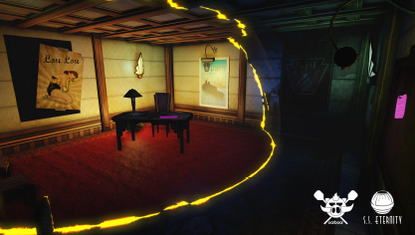

Figure 1: SS Eternity: An orb is used as a timeportal to cross different time zones and solve puzzles on a ship.

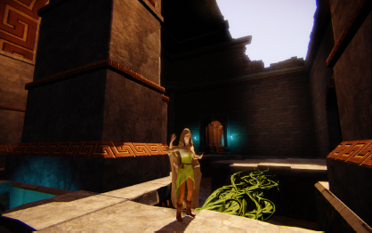

Figure 2: Bloom: The character controls plants in order to solve puzzles

3.2. Chaotic pacifism as a theme

Bloom was developed based on the themes of chaos and pacifism (see Figure 2). Players would solve plant based puzzles in order to progress through the level. Plants could serve as platforms (such as in Figure 3), bombs or bridges to cross gaps. The plants represented a solution to the interpretation of chaos and pacifism. The act of growing plants, administered by the shamanistic female protaganist, provided pacifism; whereas the growth of the vines provided chaos.

The theme presented the team with a number of technical challenges. One of them was creating believable looking plants with chaotic growth. Plants were modelled and textured by the artists but the team also wanted dynamic vines to convey the impression of active growth. A solution was found through the use of morph targets and splines to animate the vine. A modular vine piece was used to snap together lengths of vines and code provided a way of widening and tapering the vine to a point.

As the team had a large environment to complete they decided on a minimalist approach to texturing [Fri]. Seven textures were created for the environment, one of which was a trim texture that was heavily used around the level. This approach allowed less time spent creating new textures and ensured consistency in the art style, a fusion of Romanesque and Persian designs.

The team also adopted a Physical based shader model (PBS) [MHH_12], which allowed them to achieve a consistent and more realistic look. The shader was built up through phong nodes and assigned to a function. This simplified its use for artists, as they would simply plug in Diffuse, Normal, AO, Roughness and Specular maps [LH13]. Existing nodes from UDK were used for the shader creation, which meant there was no extra need for optimisation.

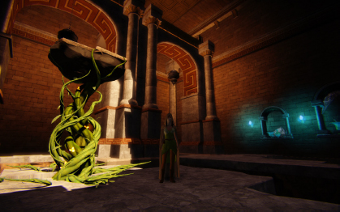

Figure 3: A platform plant in the game Bloom

4. Conclusions

The module brings together students from two different disciplines, artists and programmers, which can often result in a disparity of skillsets. Some students need to get up to speed in order to be useful to the team. More collaboration earlier in the courses could improve this situation. This module takes students on a full journey of Game Development from planning and pitching their games through to showcasing their final work at a game expo. Consequently, it is one of the most popular modules on the course.

5. Acknowledgements
The authors would like to acknowledge the students that worked on the "SS-Eternity" project (Christopher Barnes, Thomas Batsford, Stephanie Carter, Oliver Cullen, Mathew Floyd, Kyle Moody, Lewis Moore, Grant Rule, Ryan Simpson and Jake Woodruff), the team that worked on the "Bloom" project (Benjamin Batty, Kyle Jameson, Adriel Lamann, Piotr Malczak, Damon Sloan, Faye Smith, Ashley Thundercliffe, Robert Voisey, Robert Warner and Peter Wilkes), David Evans and Claire Hampson.

References

[CMA10] COMNINOS P., MCLOUGHLIN L., ANDERSON E. F.: Educating technophile artists and artophile technologists: A successful experiment in higher education. Computers and Graphics 34, 6 (December 2010), 780–790. 2

[Fri] FRICK T.: Amazing one-texture environment. http://www.unrealengine.com/showcase/udk/amazing_one_texture_environment/, retrieved February 9, 2014.
URL: http://www.unrealengine.com/showcase/udk/amazing_one_texture_environment/. 2

[IGD08] IGDA: IGDA curriculum framework: The study of games and game development. http://wiki.igda.org/images/e/ee/Igda2008cf.pdf, February 2008. URL: http://wiki.igda.org/images/e/ee/Igda2008cf.pdf. 1

[LH13] LAGARDE S., HARDUIN L.: The art and rendering of remember me. In Game Developer Conference: Europe (2013). 3

[McG12] MCGILL M. M.: The curriculum planning process for undergraduate game degree programs in the united kingdom and
united studies. ACM Transactions on Computing Education 12, 2 (2012), 1–47. 1

[MHH_12] MCAULEY S., HILL S., HOFFMAN N., GOTANDA Y., SMITS B., BURLEY B., MARTINEZ A.: Physically-based shading models in film and game production. In ACM SIGGRAPH 2012 Courses (2012), pp. 10:1–10:7. 2

