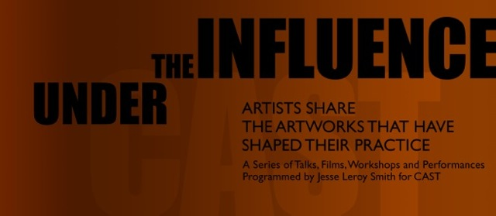
CAST (Cornubian Arts & Science Trust) Passmore Edwards building, 3 Penrose Road, Helston, Cornwall TR13 8TP

7th March 2014

Paper: The Silent Creek at Low Tide
During my recent residency at Kestle Barton in December 2013, I discovered Frenchman’s Creek. It was low tide, a damp mist hovering in a grey landscape of fallen trees sinking into a muddy swamp. It was silent: a fallen creek exposing the limbs of dead trees. The metaphor of low tide echoed an emptiness and transience I found familiar in my work. Returning to the gallery space I began working directly onto the walls making a series of gestural marks suggestive of the environment. Influenced by a recent trip to China the stains were made using blocks of Chinese black ink and brushes to create loose free impressions translating the feeling of the silent fallen creek at low tide. The wall drawings and language of marks are being developed as a setting for an animation of a dying goldfinch to be projected into the drawn landscape.
This body of work has evolved as a result of working with two goldfinches that flew into the window at Kestle Barton two years ago. I have found that through animating drawing with charcoal and graphite I can begin to examine the dead bird. The delicacy and ephemeral qualities are so light they are hardly there at all. It is like drawing with dust. Through animation I can work with the bird from the inside out in a way that explores my relationship to death, melancholy and the emptiness found in what is lost. Working on making a delicate drawing appear and disappear my interest in transitory works continues, exploring the relationship between ephemerality, mourning and loss in my practice.

Influences
In the painting, A Prayer to God, Louis Welden Hawkins (1849–1910) the goldfinch becomes a messenger of prayer exploring the desire for freedom and the unspoken language that exists between humans and birds. Working with a dead goldfinch points to the futility of prayer and becomes a poignant reminder of the transience of everything in life. A melancholic vision of loss, the prayer falls unheard, unanswered, silent and disintegrating.
George Elgar Hicks, The Dead Goldfinch 1878 is also know as ‘all that was left to love’. The history of the goldfinch in painting often reflects the concept of love being something that has tragically been lost. We see this through the dead goldfinch. The goldfinch has become symbolic in my work referencing the desire to hold onto to resurrect and re examine the dead. I feel I can understand a little more about death through holding a dead bird, perhaps because they sit so beautifully in the hand enables us to touch death in a way we are not used to?
Loss
Exploring loss is apparent in all my work. How do we process loss?
“Death enters into the domain of faith….and you do well believing that you will die, This gives you force. And if you were not to believe this, how could you actually endure the life you live?” Jacques Lacan, seminar in 1972.
The belief in death enables the subject to endure the times, If you were not firmly based on the certainty that there is an end, would you by any chance be able to endure this history?
At the same time as this I am also interested in the shift in cultural attitude towards death and explore this in my work through raising questions that seek to confront societies attitudes towards death and the cultural codes, taboos, social norms and morals that surround it. Do these artworks offer a way in which to mourn?
Quote: limitation in the possibility of an enjoyment raises the value of the enjoyment. Freud Transience. 1914
The wall drawings and language of marks are being developed as a setting for an animation of a dying goldfinch to be projected into the drawn landscape. Creating a space where the imagined marks of death blow through you, carrying me on an ephemeral wind to the next series of mark making gestures. Some of these are spacious and light as though the work landed on the gallery walls helped by Chopin, Nocturne No1 in B Flat to create marks that fell in time to the piano notes, others dark and painful. The result is one of falling, fallen moments, and the dance of transient forms. Through exploring impermanence I am looking towards the work to question the emptiness of everything, nothing has any inherent value on its own.
Wider context
The opportunity to show at Kestle Barton has enabled me to develop a new body of work in response to the setting and immediate environment. I have worked with direct drawings on the wall and animation that is entirely new to my practice. The experience has raised my level of ambition in how the final work is realized and been encouraged though conversation and mentoring with Karen Townsend and Ryya Bread. I have been able to develop my ideas and intentions with freedom over a substantial amount of time bringing the work into focus during my recent stay and residency at Kestle Barton. To test ideas beyond the studio and in a gallery setting has been an extremely valuable opportunity and enabled me to understand my practice as a deeper level.
Though lecturing at Falmouth University there is a considerable amount of interest in the show at Kestle Barton with an opportunity to engage students in discussion and debate around transient practice and installation. My ambition for the show is to raise interest and discussion around transient works of art and installation in rural settings finding new ways to engage community with contemporary art practice.
Background to practice
Making sculptural works and installations that respond to a particular site, environment or context the ephemeral, decay and disappearance are at the core of all my work. I am interested in how transience and death can be translated into a visual language through working with materials such as dust, dead animals, rotting fruit and melted plastics. Materials such as dust (household dust, marble dust, pigments) have been used throughout my work to make large-scale sculptural objects, such as ornate carpets and rugs. In Celestial Dust Rug, 2007 (commissioned by Tate St.Ives for Art Now: Cornwall) dust was laid directly onto the floor of the gallery space, existing for a short period time only before being swept away at the end of the exhibition period. Working with the poetry of transient materials reflects the belief that there is nothing lasting, immortal, permanent, within life or us. What value emerges out of impermanence? As Freud suggests it is the fact of death, and loss that creates pleasure and meaning in our lives.

