Cultural Capital Installation
Artist: Glorious Ninth (Kate Southworth)
Curator: Neil McLeod

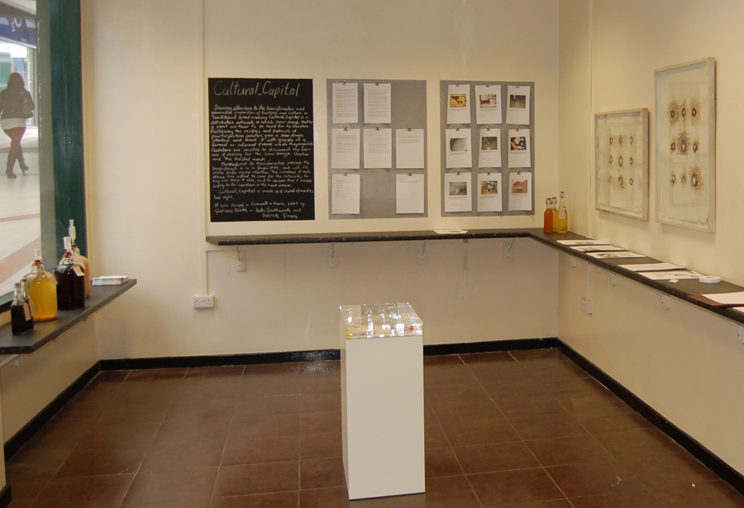
MycoCulture Exhibition, Stroud, 2015
Curated by Dominic Thomas

