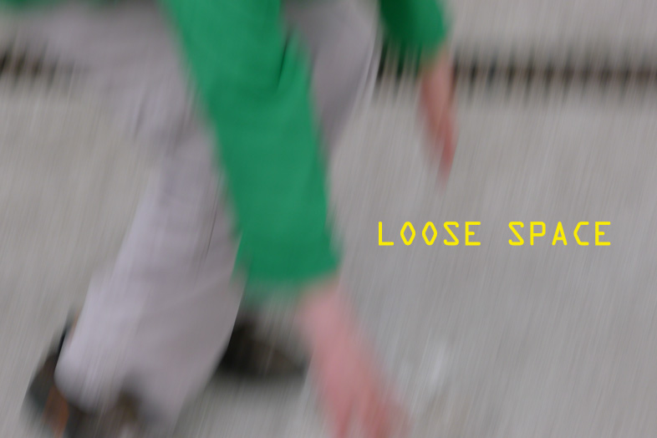
Karen Brett - Jemima Burrill - Michaela Goeltl - Nino Jaeger - Sophie Lee - Claudia Pilsl - Judith Stewart - Daphne Wright
Opening Saturday 9th May – 6pm - artP.kunstverein
Franz-Josef Straße 1a, A-2380 Perchtoldsdorf

Introduction: Ruth Horak

The exhibition runs till 13th June 2015
Opening time: Fr 4-7pm / Sat 10am-13pm / and by arrangement 01/865 23 47, 0699/1865 23 45
Contact: Brigitte Lang / artPkunstverein@a1.net / http://artpkunstverein.wordpress.com /loose space

LOOSE SPACE
Everyday practices, based on their relation to an occasion, that is, on casual time, are thus, scattered all along duration, in the situation of acts of thought. Permanent practices of thought.
Michel de Certeau in ‘The Practice of Everyday Life’
Bruno Latour describes in ‘Paris: Invisible City’ a network that normally goes unnoticed to the ordinary visitor of the city. By focusing, for instance, on street furniture, the lecture schedules of the Ecole des Mines, or the cow’s skin used as seat covers at the Café de Flore, he unravels a membrane of the mundane specific to this city whilst demonstrating how these very different elements are interlinked. Yet this is not done merely for aesthetic purposes, as Latour is a philosopher and the co-developer of Actor Network Theory (ANT) which not only attributes agency to living beings but also to objects. Also in this distinctive take on the social, inequalities are not necessarily seen as results of injustice but of asymmetries within a system of interdependency. For example, in ANT, the minister of justice is no more or less an agent as is a stuffed bird in the Natural History Museum or a teabag in a coffee shop. This is somewhat reassuring, especially if understood along the lines that all things matter in some way.
However, what Latour with his emphasis on an all encompassing agency seems less concerned with is that, even though everything has a place, movement within the network can be limited and human agency is affected by one’s positioning within the system. It could be argued that these restrictions define the very practice of everyday life and are of value as they create a focus on what is there and, adding agency into the equation, what can be and could be there.
Artists are more often than not part of the ever growing group within the population which can be described as ‘precariat’, i.e. those who find their lives regularly led by external denominators. This makes them well-placed to explore the implications of ANT as career choices are frequently made in order to meet the necessities of everyday life such as family commitments or simply having to pay the bills. Yet the very limitations that determine what artists can do in their specific position in life are not only negative in respect of potentially narrowing their artistic practice but also create unique focal points on what might otherwise have been dismissed.
This exhibition brings together eight artists whose focus on the everyday refuses to separate life from art. Their work celebrates how lived reality and the personal demarcations of everyday life can be a source of inspiration and, in fact, can become the ultimate locus of artistic endeavour.

http://www.sophiemeganlee.com/
http://www.karenbrett.com/
http://www.frithstreetgallery.com/artists/works/daphne_wright
www.claudiapilsl.com http://
www.vnjaeger.com/ http://
www.stoprojects.com/judith_stewart.htm http://
www.jemimaburrill.co.uk/
http:/www.michaelagoeltl.com/

David Harvey describes precariat as a neologism obtained by merging precarious and proletariat. I suggest to apply this term regardless of class as it foremost describes working conditions which exist across the classes.

