Title: Dirty Corner’s Elicitations
and, “Myth Today,” today
Dr Carolyn Shapiro, Falmouth University
SEP-FEP
Regent’s University London
25 August 2016

Last summer, in June, the Anglo-Asian sculptor Anish Kapoor exhibited three public sculptures in the gardens at Versailles. One received a lot of attention: it was called Dirty Corner. The sculpture was made of steel and rock. It was 200 feet long and 33 feet high. Kapoor admitted to the installation being “very sexual”, describing it as “…a big vulvalike form sitting watching.”
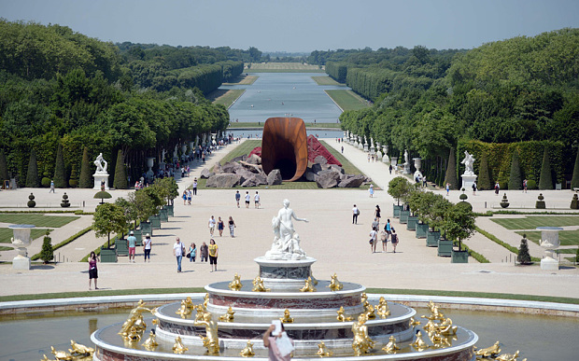

“I hope it’s a mess,” he said of the work. “That’s what I’m after.” (Kapoor on Dirty Corner when it was installed.

This paper seeks to prise apart the knot of myths that have been called forth, to read very closely successive responses, as well as to consider Kapoor’s own ethical responsibility as a public artist. Dirty Corner proved to be highly performative in its convening, whether intended by Kapoor or not, of a powerful set of signifiers and signs which had the effect of bringing forth expressions of misogyny, nationalism, royalism, and Anti-Semitism.

Dirty Corner’s elicitations manifest a bizarre substitutability between Jew and Woman on the part of the vandals; this substitutability happens on the social level of the signifier. I am wondering whether the annexation of the Jew to the Woman in the acts of vandalism fixes what would otherwise be an incapacitating ambivalence at the heart of their misogynist affront.

Dirty Corner was site specific: Kapoor wanted to introduce a piece of art which messed with the order of Versailles itself—in true Marie Antoinette fashion. Reporters in the French press described the sculpture as “the Queen’s Vagina.” “Dirty Corner is like a big queen sitting in court, displaying herself to her courtiers, completely chaotic,” said Anish Kapoor.

Was Kapoor underestimating the repercussions of displaying the Queen’s Vagina? When interviewed by the Guardian about the controversial nature of the sculpture, he stated, “Art is a process of experimentation where certain things arrive and you try to follow them. In the end, one has to trust the work does its own thing.”

The first thing that the work “did” was to receive angry lashings of yellow spray paint, de-facing the sculpture. When the yellow spray paint was removed, it was not long before Dirty Corner did more of “its own thing”:
Kapoor’s allowing for Dirty Corner to do “its own thing” immediately brings to mind what we understand as its “performativity”, which is key to this discussion. While I tend to follow more of a model of “textual performativity” via JL Austin, we can also take into consideration Karen Barad’s agential realist point of view which would see this public art work as “matter” which comes into being in that it is morphologically active, responsive, generative, and articulate. (interview with Barad by Adam Kleinman, Mousse 34)

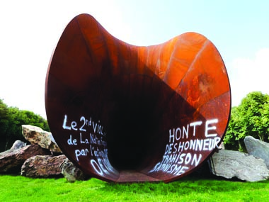

The verb that, for me, characterizes Dirty Corner is “to elicit”—hence my title for this talk. All we need is a good dictionary to understand what is going on:

To elicit: from Latin elicitus, to allure, more at DELIGHT, to draw forth or bring out something latent or potential; to derive (as a truth) by logical processes; to call forth or draw out (a response or relation)
(Webster’s New Collegiate Dictionary)

The Guardian, as did the French press and authorities, attributed the vandalism to the rise in France of the far-right Front National, although it seems even more likely upon close reading of the extensive inscriptions, to be the work of a single upset Royalist individual, perhaps someone from the extremely conservative Catholic town of Versailles.

Let’s look at the rhetoric deployed by the vandal:

Here are some of the key words painted on the sculpture:
Honte; deshonneur; trahison; Satanism”—
(Shame, Dishonour, Treason, Satanism)
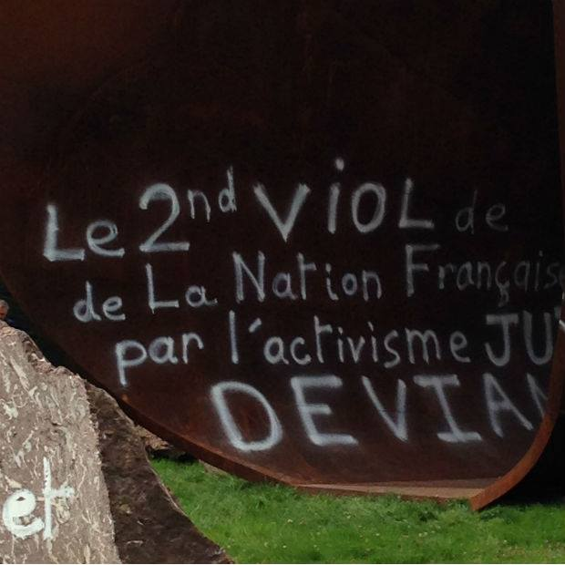
Other words:
“VIOL”*— key word
“Sang” (blood) sacrifice
juif, kabbaliste, Talmud:

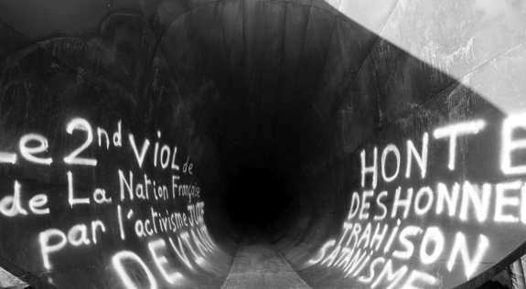

Sang sacrifice:

Kabbaliste (a warning):
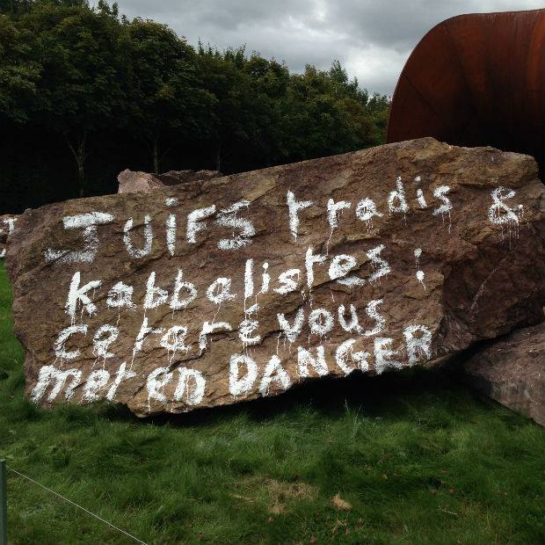
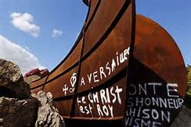

Dirty Corner’s acquisition of the violating words onto its surface complicates its semiotic registers. On the primary semiotic register, the sculpture, although abstracted, signifies a vulva and its interior. Exhibited in context, this vulva is that of Queen Marie-Antoinette, the palace’s most notorious monarch. The sculpture has been placed within the orderly gardens of Versailles, the order of which signifies both the rule of the monarchy and the idealized nation which the monarchy rules. Within this semiotic system, the intervention of female-ness stands in opposition to the order of the nation. This relatively straightforward semiotic analysis is then complicated with a new register of signifiers, this time, words.
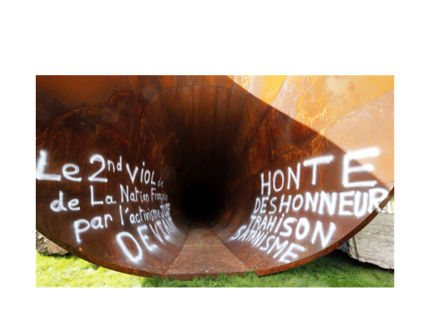

Words do not operate on a representational or iconic level. Words signify and make sense through recognisable social codes, or, following the important work of Roland Barthes, through the production and consumption of myth, thus comprising mythic speech. In Barthes’s semiological critique, “myth” is an act Most importantly for Barthes, “myth” is a speech act which has been systematically emptied of any historical determinants; it has been, as such, de-politicized and naturalized. This fundamentally Marxist materialist critical position establishes semiology as, first and foremost, a social critical framework:

A tree is a tree. Yes, of course. But a tree as expressed by Minou Drouet is no longer quite a tree, it is a tree which is decorated, adapted to a certain type of consumption, laden with literary self-indulgence, revolt, images, in short with a type of social usage which is added to pure matter.” (Mythologies, 1957, 109)

So, what are the ethical considerations of
“myth today”? How do we understand the responsibility of the public artist in today’s hyper-performative semiotics? By “hyper-performative semiotics”, I mean that every material signifying object carries with it the hyper-potential of immediate referencing, immediate circulation, and immediate response.

A close reading of the 2nd vandalist act

When we look at the second act of vandalism and consider the entire semiotic system now in operation, we can see the simultaneity of the two different levels of signification: both on the iconic level of the representation of the queen’s vulva, and on the level of the words overlaid. When they are received as a single system of signifiers, a lot happens.

The first level of signification was immediately characterised by the French press as “the Queen’s vagina.”

On the second level of signification, the extremist words, executed evenly and carefully, and forcefully, as emphasized through upper case letters,
placed strategically on what would be each side of the represented vulva, enacting a rape. The logic of the act is complex: it seems to be a kind of revenge-rape against the rape, or “VIOL” of the Nation perpetrated by Kapoor’s public work of art; the vandal emphatically notes “the 2nd rape of the nation by deviant Jewish activism” by, in turn, violently marking the obscenity of Kapoor’s gesture.

Why would Kapoor’s giant sculpture of Queen Marie Antoinette’s open vulva, set in the middle of the gardens at Versailles, bring forth Anti-semitic vandalism?

Was it because Anish Kapoor himself is Jewish? Most people know of Kapoor as an Anglo-Asian artist. But perhaps the writer looked on Wikipedia and found out that Kapoor has a Jewish mother, an Indian Jewish mother. This fact would be the most literal explanation as to why Anti-Semitic words traversed Dirty Corner. Otherwise, it could be that the radicality of exhibiting the vagina-as-utterance was so excessive that it elicited an excess to its immediate signification; in other words, it brought forth a total overload of interlocking myths.

At this point, we might think about Barthes’ notion of myth as, to apply the ideas of John Fiske in his theorization of fan culture, a repository and an engine of “semiotic, enunciative and textual productivity.” Fiske, like Barthes, recognizes the social performativity of the cultural commodity. A public work of art would be thus potentially be an object which elicits response in its very presentation as commodity.

Let’s look more closely at the break down of charges scrawled in the interior of the sculpture. We can see that there is a particular order to the accusations:
First is “Shame”, then “Dishonour”; then “Betrayal”; culminating in “Satanism.”

I think that the sequence informs the meaning in an interesting way. “Shame” is the first charge, and it points to the word “VIOL” (rape) on the other side. To me, the word “shame,” in this context, indicates something about sexuality, about womens’ sexuality and in particular, the Queen’s sexuality. The misogynist message inscribed on the sculpture itself is highly ambivalent:

“mutiliation sexuelle”:
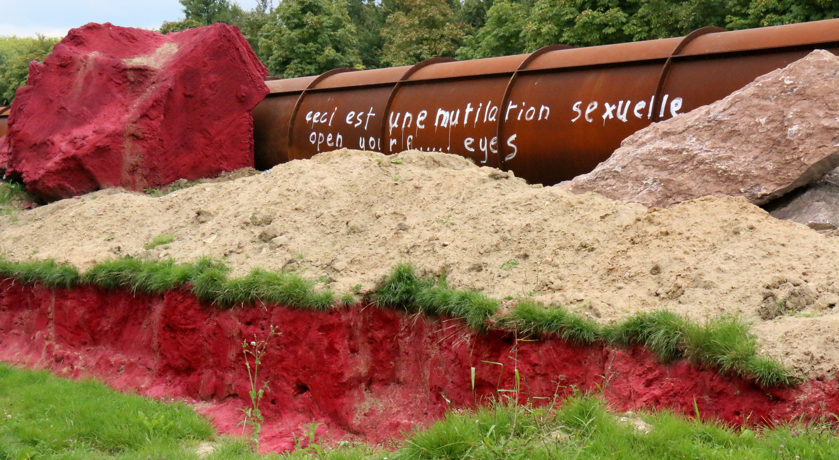
Was the nationalist vandal nobly protecting his late Queen’s honour against Kapoor’s insult to her modesty? or was the scrawler protecting the honour of the nation, profaned by the exhibition of the sexual interior of the Queen? Exactly whose honour is being proclaimed and defended here?

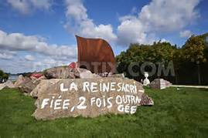
I don’t think even the vandal knows. This inchoate ambivalence is yelling out for an answer.
The only thing that seems to be posited for sure is that the vandal holds Jews responsible for the desecration and “violation” of the French nation.

Thus, I would like to propose that the signifier of The Jew is brought in to anchor the misogynist speech and defend it, making crazy “sense” of it. Kapoor probably predicted that Dirty Corner, in all the scandal of its gaping cavernousness, might freak some people out. Kapoor was playing dangerously with excess and extremity, walking a dangerous line that elicited, in all its dirtiness, what Barthes might have observed as the naturalization of misogyny, whereby the excessive openness of womens’ sexual desire, signified here in both the sculpture and in the irony of its title, “Dirty Corner,” “deserves” to be defaced.

There is a history at the Palace of Versailles of the misogynistic attack upon excessive female sexual desire, but before I get to that, let’s consider the next term in the vandal’s sequence of accusations: trahison, which translates as “treason” and also “betrayal.” “Treason” is the name for an act of treachery towards a government or sovereign, and it encompasses “betrayal” within its definition. Here, “trahison” signifies an offense against the nation, a disloyalty which breaks up the unity of the nation.

sang:

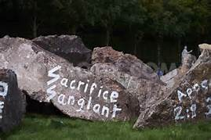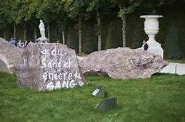

Often accompanying signifiers of “nation” are signifiers of blood—“the nation” tends to embrace metaphors of purity, of pure-bloodedness, with betrayers infiltrating the purity and unity of the national bloodstream. Again, we are deep in the realm of myth, deep into the realm of what Barthes calls “what goes without saying.” It goes without saying that it is le juif which puts the nation in danger, automatically betraying the nation through blood sacrifice. The Jew threatens the cohesion of the nation, violating it into dissolution.

The vandal’s violation of Dirty Corner, an Anti-semitic speech act, is a defensive response to what he reads as an insult to his nation, but his misogynist staging also reads as a defense against the excessive power of the sexualized Queen Marie Antoinette, who was also, like the Jew, a foreign outsider signifying an impure infiltration into the French nation.

In her fascinating book The Wicked Queen: The Origins of the Myth of Marie-Antoinette (New York: Zone Books, trans. Julie Rose, 1999 [1989]),
Chantal Thomas traces this very misogyny perpetrated against the Austrian-born interloper to the throne, whose private sexual escapades were fantasized into a popular pornographic genre of literature at the time Marie-Antoinette was at Versailles and Paris. The proliferation of pamphlet literature depicting “Toinette’s” sexual proclivities, which included lurid illustrations, laid the historical groundwork for popular misogyny in France, argues Thomas, who is also identifying these slanderous pamphlets as mythic speech acts. (Thomas was a protégée of Barthes’) These outrageous stories, circulating between 1787 and 1792, included titles such as:

The Libertine and Private Life of Marie-Antoinette

The Uterine Furors of Marie-Antoinette, wife of Louis XVI

The Royal Dildo

The Austrian Woman on the RAMPAGE, or the Royal Orgy

The Royal Bordello

And many many more!

(see the following link for images from these pamphlets: https://www.google.co.uk/search?q=marie+antoinette+pamphlets&biw=1324&bih=721&tbm=isch&tbo=u&source=univ&sa=X&ved=0ahUKEwjcyvO52bfSAhVjAsAKHVZ6DXQQsAQIGQ)

The pamphlets took as a given the debauchery of the upper classes, but it was Toinette herself who came to embody every possibility of monstrous sexual libertinage. The illustrated pamphlets circulating during and after her reign were already symptomatic of nationalist defense—their xenophobic and misogynic language evinced a defense of the French nation, which was signified by the character of the cuckolded King.

Already, we’ve got a set of interlocking myths at play here:

French nationalism<-> patriarchy/monarchy are under threat by “Toinette”’s very presence in the court and country

I would like to note that the French title of the book is La Reine scélérate, Marie-Antoinette dans les pamphlets (1989), has been slightly mis-translated, or rather, boiled down. The word scélérate does mean “wicked”, but it is a wickedness characterized by treacherous villainy, implying betrayal and treason. This implication of treason manifests again in the nationalist affront provoked by Kapoor’s materialization of Marie-Antoinette’s “rampaging corner”.

So: did Kapoor consciously refer to, or even illustrate, these outrageous pamphlets in his conceptualization of Dirty Corner? I don’t know. I would guess so, although he never mentioned them in the various interviews that I read.

As a final point of discussion, we must ask: does Kapoor himself bear responsibility for bringing forth misogynistic response (i.e. violation and de-facement of a sculpture which indicates, through particular metonymic relation, a woman’s body) into the public realm? Does Dirty Corner really “do its own thing”, as Kapoor stated? The French legal system did hold him accountable, and he was forced, against his will, to remove the violating inscriptions from the sculpture.

Perhaps, following Karen Barad’s proposition,
“’responsibility’ is not about right response, but rather a matter of inviting, welcoming, and enabling the response of the Other…[so] that… what is at issue is response-ability—the ability to respond.” Barad’s working definition of response-ability also includes “accountability for the specific histories of particular practices of engagement,” (Barad, interview in Mousse 34), so it might satisfy Barthes’ historical materialist imperative, which would probably have held Kapoor responsible for re-iterating what was signified by those 18th century pamphlets.

And I think that Kapoor might even take responsibility for re-iterating the misogyny of the pamphlets, because he might have wanted to make us aware of extreme responses elicited by the representation of an open vulva.
He did refuse to remove the Anti-semitic inscriptions because he wanted people to see them in plain sight, to face the words in all their violation.

Did the shocking vandalistic inscriptions overtake any possible feminist motivations of Dirty Corner? Yes, because they succeeded in diverting the public’s attention from the iconic signification of the sculpture.

I can’t help but wonder whether ultimately, Roland Barthes’ exposition of “Myth Today”, published in 1957, already understood that the critical imperative to de-naturalize myth, in order to expose “what-goes-without-saying”, is still the best feminist agent around.

Thank you very much.

Further points of discussion:
Kapoor was held responsible himself for the vandalism; he refused to remove it, but was forced to after 12 days by the French courts.

***

