Julie Ripley

STOKED: surf style and situated bodily practice.

Abstract
The rise of 'surf style' in mainstream fashion in the 1990s made enormous profits for businesses like Quiksilver and Billabong which had begun life as specialist sportswear suppliers to a niche market. Since then the look has become ubiquitous, and now, just as the wearing of military style is not confined to the armed forces, 'surf style' is worn in and out of the water by surfers and non-surfers alike. But this is a look which cannot be reduced to the superficial use of hibiscus flower motifs and surf-related slogans: it is typified by the surfing body.

The surfing body, clothed in brands that convey subcultural authenticity or naked and wearing only sun bleached hair or tribal tattoos came into being in the late 1980s. Against a background of economic growth in the West, a new youth culture emerged. Working visas to the antipodes for under 26s were available along with, in the UK, a student grants and readily available casual work at home to finance the trip and on arriving, to venture into the Pacific Rim. The 1990s gap year phenomenon was born, and with it, the surfing body.

Heels cracked by salt water and sandals, hair knotted by the sea, the surfing body signified conspicuous leisure as clearly as the crinoline-wearing bourgeois wife's of the 19th century. No wonder then that products aimed at creating its simulacra in chilly buttoned-up Britain were so eagerly marketed and consumed. This paper will explore some of the issues around social class and aspiration inherent in the pursuit of the surfing body, examining the gendered consumption of a fashionable look which embodies both activity and idleness.

Note to the reader
This paper is intended to form part of a PhD thesis. Titled, To Catch A Wave: Building an Alternative Culture and Economy on Devon and Cornwall’s Unique Surfing Heritage, the thesis aims to explore the development of surf culture in the south west of England, home to the British Museum of Surfing and synonymous with surfing in the public imagination. Focusing strongly on the visual and material culture of surfing, rather than the activity itself, the research examines clothing, boards, printed material and ephemera associated with surfing activity in this remote corner of the UK. The movement of people, goods and ideas to and from the region since the first form of surfing was recorded here a century ago will be shown to contribute to an emergent surf culture, consumed and produced locally, developing into an important aspect of regional identity.

Paper

In the 1990s, a plethora of surf brands were available in high street stores all over the UK, providing hibiscus flower print boardshorts and shell bracelets designed in Australia to consumers in landlocked cities miles from the sea. In 2013, surf wear giant Billabong, worth $3.45 billion in 2007, was declared ‘worthless’ by Forbes (Brown, 2013). In the same year, Quiksilver declared a quarterly loss of $32million (Jackson, 2013). What might account for the desire of the landlocked citizens of chilly Birmingham in the 1990s to emulate a habitus born in the warm waters of the Pacific? And what factors might have precipitated surf style’s spectacular wipeout?

I want to examine aspects of the social and historical context of the UK in the 1980s, and the discourses around the surfer which contributed to his popularity as an archetype. Making use of Joanne Entwistle’s notion of ‘situated bodily practice’ (2000), I will examine the surfer as the embodiment of certain masculine aspirations around activity and prowess, a body which simultaneously communicates status through what Thorstein Veblen (1899) terms ‘conspicuous leisure’ in a postmodern consumer culture (Featherstone, 1991). Drawing on the archives of British surfing magazine Wavelength, I will explore surf style’s journey from specialist equipment to mainstream fashion through the 1980s and 1990s, and its retreat into the niche market in the early noughties.

In 1975 the Australian government began to issue working holiday visas to encourage extended vacations and with them, increased income from tourism. The visas permitted the holders to take up to four months’ continuous employment in seasonal or casual posts for a maximum of twelve months in total and proved enormously popular. They were granted to people under the age of 26 from Commonwealth member states who met certain other conditions, namely proof of financial support, usually in the form of a bank statement indicating the applicant had sufficient funds to avoid destitution during the visa period, and a pre-paid return ticket home. These measures were in place to avoid the state having to fund living or repatriation costs for those who were not Australian nationals, and required a sizeable capital investment by the young applicant and effectively ensured a largely middle class uptake. Casual weekend work was a means for many students to slowly acquire the necessary funds, since they were able until the mid-1990s to rely on maintenance grants to cover living expenses while they studied; others took a year out of studies to save, and those even more fortunate might depend on the generosity of parents who were enjoying the on-and-off prosperity of the Thatcher years.

The duration of the permit and the distance travelled encouraged most applicants to take up the full year, giving rise to the phenomenon of the ‘gap year’, in which young people took a year off to travel before starting university or before embarking on a full time career. The relative ease of access to from Australia to the Pacific Rim provided opportunities to travel to far flung locations, far removed from the well-known tourist hotspots of Europe. Tracy Schaffer (2004), discussing her own backpacking experience, describes it as ‘an almost obligatory rite of passage among middle class and upper middle class…adults’ (2004:140) , a ‘liminal performance between childhood and adulthood’ (2004:148). Those sufficiently privileged to tarry between these two states would eventually be impelled to return to the UK, enter the adult world and close the gap. But not without a tale to tell; they came home with stories, souvenirs and style acquired on their journey which marked them out as having spent, perhaps wasted, a year, before pursuing financial stability.

Meanwhile in the UK interest in Australiana was piqued by a flood of imported Australian popular culture. In 1988 there was extensive coverage of the Tall Ships voyage from the UK and the Queen’s visit to commemorate the bicentenary of the first European settlers’ arrival in Australia. Australian soaps appeared on British screens with increasing frequency throughout the 1980s, and soon the stars of Neighbours (first broadcast on BBC1 in 1986) and Home and Away (first broadcast on ITV in 1989) were household names. Spin-off media products such as appearances on UK chat and game shows supported the emerging comedy, film and pop music careers launched by former soap stars like Russell Crowe, Guy Pearce and Kylie Minogue. Australian bands including Crowded House and INXS also enjoyed success in the UK in the 1980s and 1990s, and films from the Antipodes began to make an impact at UK box offices at the same time, with Crocodile Dundee (1986) propelling its star, Paul Hogan, to international fame, and Strictly Ballroom (1992) launching the film career of Australian playwright and theatre director, Baz Luhrman. A new generation of Australians were shaking off the ‘Cultural Cringe’ and presenting their homeland as a confident, prosperous and exotic location in which young people could enjoy a laid-back, fun and healthy lifestyle.

The benefits of this vast, sun-drenched playground were in evidence, it appeared, in the successes of Australian athletes winning a record 107 gold medals on their home turf in the Brisbane Commonwealth games of 1982, as well as regular Australian wins in tennis, rugby and cricket, and of course, surfing.

According to Australian professional surfer and wrier Nat Young, in the late 1970s Australian surfing had ‘come of age’ (1983:127); the 1980s ‘were to give us the fully integrated professional surfer, earning enough cash on a world tour to rival the golf or tennis circuits’ (1983:201). Young, and fellow Australian surf champs were propelled into the international spotlight in the 1980s with increased television coverage of the sport and corporate sponsorship elevating their public profile and earning potential. In common with many sports in the 1980s, coverage of surfing focused almost exclusively on men’s events such as Australian Open in Manly, Sidney, ignoring the small number of female surfers competing at the time. Representations of the surfer, then, developed an archetype that was avowedly masculine: a tanned, athletic figure, surrounded by bikini clad girls as he emerged victorious from the waves to collect big prize money.

The archetype of the surfer is necessarily embodied, since it is defined by a physical activity rather than an intellectual pursuit (unlike for example, the poet). Pictured onshore or in the sea, clothed or naked, the surfer is easily identified with the activity which defines him. His tanned skin and sun-bleached, unruly hair are embodiments of the time spent in the waves, the lean physique acquired from the exertions of swimming and controlling the board. Strength, power and mastery of the physical environment are connoted by this body, suggesting an uncomplicated, ‘unreconstructed’ masculinity, ‘elided with an image of Australianness. It is the outdoor body and the exercising body, a body that is confident to tackle the natural elements’, according to Australian fashion historian, Jennifer Craik (2009:429). Australian pro-surfer Barton Lynch (figure 1), pictured here in UK surf magazine Wavelength in 1987 after winning the French Open, exemplifies this look. He is surrounded by signifiers of masculine success, from the champagne shower to the admiring smile of the attractive woman on the podium. His muscular physique in nonchalant pose, the on-trend hot pink singlet by surf brand Ocean Pacific offsetting his deep tan, and his sun-bleached hair all point to the activity which has allowed him to acquire these trappings of power and success.

As Joanne Entwistle points out, ‘bodies are socially constituted, always situated in culture and the outcome of individual practices directed towards the body: in other words “dress” is the result of “dressing” or “getting dressed”.’ (2000.11) She describes how ‘the individual and very personal act of getting dressed is an ongoing practice, requiring knowledge, techniques and skills’ (2000:31) ‘As a boy hangs with the older blokes he begins to move and behave like them through the gradual, often unconscious, absorption of their knowledge through continual exposure,’ explains surfer and cultural geographer, Clifton Evers (2009:901). As the young surfer or ‘grommie’ picks up expertise in surfing, he additionally develops consumer expertise by observing the brand preferences of the established elders. The surfer’s body articulates what Pierre Bourdieu would term his ‘habitus’, the ‘durable, transposable dispositions’ (2013.95) that are produced in his milieu. Expertise and taste can be further developed through study: in the UK, Wavelength magazine provided a reliable source of information on the technical aspects of surfing as well as the social and the cultural, and its archive provides a lens through which to view the rise and fall of mainstream surf style’s wave.

Figure 2 is part of a feature on surf fashion from Wavelength magazine number 14, published in 1988. First distributed in 1982, Wavelength was the first specialist surfing magazine in the UK, founded and edited by surfing enthusiast John Conway. Based in Newquay, Cornwall, ‘surf city UK’ (Mansfield, 2011:8), the magazine responded to a growing interest in surfing that had hitherto been catered to by imported publications such as the American magazine Surfer and locally distributed amateur newsletters and fanzines. Figure 2 is the first fashion feature run by the magazine, and the artless composition, lack of models, sets or even any information on manufacturers, stockists or prices suggests the photographic and editorial staff were more comfortable with standard sports coverage as in figure one, and had little knowledge of the conventions of fashion photography. In the image, clothes are laid out flat on a studio floor along with specialist surf kit such as a bodyboard, a wetsuit and a swim cap, as well as signifiers of the active outdoor lifestyle: a Sony Walkman, Frisbees, a waterproof watch. The clothing and accessories are casual, colourful and sporty and include T-shirts, flipflops, boardshorts and hats. The featured brands are manufacturers of surfboards and wetsuits, rather than simply apparel: Ocean Pacific, Wavekraft, Gul. Their appeal to the readers of the magazine, whose circulation was at its peak only around twenty six thousand (interview with Steve Bough, 2015), was their established connection to the minority interest activity of surfing. This connection was to be exploited by surf brands to achieve mainstream fashion retail success and the ubiquity of surf style in the 1990s.

Rip Curl wetsuits, based on Australia’s Gold Coast, home of the annual Bells Beach Classic, began sponsoring the event in 1973 and ‘mounted a vigorous advertising campaign based on giving free suits to all the top surfers’ (Young 1983:135). By the early 1980s, the company, founded by two local surfers, was exporting wetsuits worldwide and diversifying into clothing. A similar trajectory, from specialist surf apparel to mainstream fashion items, was taken by Billabong, founded in 1973 by surfer Gordon Merchant, also on the Gold Coast. The ‘boardshorts’ with which Merchant found his initial success distinguished themselves by their durable triple stitching, but like all ‘boardies’ they were designed with the specific needs of surfers in mind, being long enough to prevent the wax on the board from tearing out hairs from the sensitive inner thighs. These longer length shorts, along with surf branded t-shirts and accessories were quickly adopted as casual wear by surfers and non-surfers alike, providing meteoric success for the brand which listed its value as $225 million Australian when listed on the Australian stock exchange in 2000. Another Torquay wetsuit specialist was founded in 1969 by surfer John Law, renamed Quiksilver in 1973 when partner and fellow surfer Alan Green entered the picture, proved to be the strongest exporter of Australian surf style with corporate success falling hard on the heels of lucrative licencing and sponsorship deals. According to company website, Quiksilver and its subsidiaries, including Roxy and DC Shoes, were worth over a billion US dollars in 2004 (www.quicksilver.com). The enormous profits made by surf brands in the 1990s derived not from sportswear sales but from mainstream fashion apparel and accessories, from the widespread adoption of surf style in the late nineties in the UK, often far from any beach. The sharp marketing strategies of what were once kitchen table surf wear enterprises, riding on the wave of popularity of surfing as a sport and Australian pop cultural exports, can account to some extent for the widespread adoption in the UK of surf style in the 1990s. But how can the attraction of surf style to non-surfers in this period be theorised?

Thorstein Veblen’s analysis of American bourgeois society in the late nineteenth century has been widely discussed in the twentieth and twenty first and provides a perspective on the surfer as an aspirational figure and driver of gendered consumption. The Theory of the Leisure Class’(1899) proposed that the social practices demarcating and maintaining status at the time of writing were derived from predatory desires in early, or ‘barbaric’ cultures. He suggests that the physical strength and aggressive temperament of men leads to the gendered division of labour, domination of weaker men including slaves, the possession of wealth and the development of a social hierarchy, which is naturalised through its continued existence. However, according to Veblen, ‘in order to gain and to hold the esteem of men it is not sufficient merely to possess wealth or power. The wealth or power must be put in evidence, for esteem is only awarded on evidence.’ (Veblen, 2007:29).

The ‘conspicuous consumption’ of goods is one means of providing evidence of ‘pecuniary strength’, and is a practice which has been the focus of most the subsequent scholarship on Veblen (Souiden, M’Saad & Pons, 2011). Drawing from his observations of contemporary bourgeois mores, Veblen asks the reader to consider why a flamboyantly large or pointlessly small ladies hat might be more desirable than a functional bonnet, or why particular materials and foodstuffs acquire value through rarity. Whilst the extrinsic value of such items may have derived in the distant past from intrinsic qualities such as beauty, he explains, their social value has accrued from their more or less exclusive use by an elevated social group, and moreover by the display of this use. The ‘conspicuous consumption’ of items made desirable in this way provides an ‘invidious distinction’ between strata of society, and is universally practiced: ‘no class of society, not even the most abjectly poor, foregoes all customary conspicuous consumption’ (2007:85). He points out that trinkets of some description are owned and prized above useful items by all classes. The conspicuous consumption- and waste- of those items deemed more desirable creates an ‘invidious distinction’ between those who can do so and those who cannot. Thus, to return to surf culture, a twenty dollar T-shirt commemorating a surf competition held in Sydney could conceivably be intrinsically beautiful, but its true value, using Veblen’s model, lies in the implied consumption of related high status products, such as the costly long haul flight required to take the wearer to Sydney in the first place.

For Veblen, fashion itself arises from the ‘pecuniary emulation’ of the consumption practices of those of higher status by those of lower status, and the consequent efforts by the former to distinguish themselves from the latter leading to rapid change. In respect of fashion scholarship, the sister concept of ‘conspicuous leisure’ has been less widely discussed, but is, I believe, central to an understanding of the ubiquity of surf style in the 1990s. Conspicuous leisure is for Veblen, another form of consumption: ‘a non-productive consumption of time’, arising from ‘a sense of the unworthiness of productive work, and…as evidence of the pecuniary ability to afford a life of idleness’ (2007:33). Fox hunting, the costly and ostentatious pursuit of inedible quarry, is considered to be a higher status activity than fishing. Can the same be said of surfing?
For nineteenth century missionaries in Hawaii, where surfing was first observed by Westerners, the activity was one of several traditional pastimes which sat uncomfortably with Calvinist Christianity’s moral code and work ethic, being enjoyed by both sexes in a state of undress and taking place in daylight hours, often accompanied by drinking and gambling (Westwick & Neuschul, 2013). An activity practiced by and overseen by Hawaiian kings, surfing required entire communities to abandon productive endeavour in the pursuit of pure pleasure, and was widely discouraged by American settlers in favour of literacy and industry. The demise of surfing and native Hawaiian culture as a whole was predicted, perhaps prematurely, by missionary Heirham Bingham in 1829, when he wrote “the slate, the pen and the needle have in many instances been substituted for the surf-board, the bottle and the hula.” (Westwick and Neuschul 2013:19). Today, surfing continues to depend on the vicissitudes of natural conditions and commitment to developing expertise in the activity is therefore not fully compatible with a nine-to five job.
But the pursuit of leisure ‘does not commonly leave a material product’ and requires ‘the exhibition of some tangible, lasting results of the leisure so spent’ (2007:34) in order to function as a status marker. Sporting trophies function as proof of leisure, and Wavelength magazine devotes much of its content to coverage of competitions, profiles of professional surfers and upcoming amateur contests. However, medals and cups are not sufficiently portable as to be displayed on the body and publicly viewed. Also, surfing is not just a competitive sport but an activity practiced by many, who know they will never even enter a competition, with the dedication and enthusiasm of would-be professionals. The pursuit of excellence is rewarded, for the vast majority of surfers, with nothing more than a slap on the back- if another surfer is there to witness it. Veblen argues that conspicuous leisure is an effective status marker in a small community, where a reputation for the non-productive consumption of time is sufficient evidence to convince subordinates of their place, but in a larger group, conspicuous consumption of goods is a more immediate, visual and concrete. Writing at the advent of mass communication and consumer culture, Thorstein Veblen could not have predicted a context in which the human body could so forcefully communicate the commodification of leisure.

Over a hundred years after The Theory of the leisure Class, Mike Featherstone’s Consumer Culture and Postmodernism (1991) discusses precisely this theoretical and historical context. The book explores the ‘the current phase of over-supply of symbolic goods in Western societies and the tendencies towards cultural disorder and de-classification (which some label postmodernism)…[and the]…wider implications for our conceptualisation of the relationship between culture, economy, and society’ (1991:13). Marshalling a huge range of philosophical and theoretical perspectives, Featherstone builds a case for an ‘epochal’ break with Modernity and the culture that Veblen so astutely analysed. Contemporary surf culture exists in a postmodern context, dominated by mass-media and advertising, in which consumers must negotiate fluid, unstable and complex meanings attached to goods and practices.

The first full page advert for surf apparel in Wavelength magazine appears in 1988 (figure 3). Like the fashion spead in figure 2, the advert's main focus is surfing itself, embodied in the large central panel by a photograph of Australian surf champon Tom Curren. The photograph has been manipulated to appear more dynamic and active by the use of successive overlaid repeats of the image, suggesting the rhythmic quality of the foaming waves. Curren's OP branded surfboard appears to be about to fly out of the frame, its angle echoed by the strap line, "wear the lifestyle". The imperative commands the viewer to consume the surfer’s habitus, to visibly demonstrate his taste both in and out of the water. Beneath the image, the brightly coloured and tropical printed casual wear is laid out flat, much like the garments in the magazine’s own spread in figure 2, implying an empty lifelessness whose inert signifiers the active physicality of the surfing body can invest with meaning.
The connotations derived from wearing surf style as street wear are implicit in the strap line, ‘wear the lifestyle’. Catching a wave and riding it by controlling a board is a rare and precious thing for even the most competent surfer, but the ‘lifestyle’ is conducted at all times. This habitus, even when not actively partaking in the sport and thereby avoiding industry, is primarily one of leisure. Hours are spent, or as Veblen would have it, wasted, waiting for the right wave. The right waves only occur in particular locations, many of them so far from home that a ‘surfari’ is required to find them, a worldwide quest romanticised in Bruce Brown’s film The Endless Summer (1966). Australia, home of the best known surfers of the 1980s and 90s, offered only short term, casual and often part-time work to those who travelled there to hone their skills at an activity that would never provide material reward. The rewards were memories, of beach parties and barbecues, budget travel from one surf spot to another, romance and adventure. They were also embodied: the sun-blistered shoulders, the cracked feet and the tribal tattoo acquired in the 90s gap year were signifiers of conspicuous leisure as clearly as the crinoline in the 19th century.
The surfing body then, communicated both agency and idleness through ‘situated bodily practice’ (Entwistle 2000). It consumed and displayed its habitus through signifiers of authenticity, including the street wear produced by authentic surf brands sold in the same shops as boards, leashes and wax. The motifs adopted by these brands, such as sharks, tropical flowers and sunsets suggesting surfing locales, and subcultural argot adopted and adapted from the Pacific were soon to be found on ‘inauthentic’ fashion brands with no connection to the activity. As Australian popular culture flooded the UK scene, not only apparel but accessories like Brea watches and grooming products such as Aussie brand haircare were marketed to a British public, keen to emulate the embodiment of conspicuous leisure represented by the surfer. As Dorothea Mink puts it, 'the unhalting transfer of the cultic produces a surplus of symbols, which can quickly lead to the decline from cult to commonness’ (Mink, 2007:276). Surf style had achieved ubiquity and its wave of popularity was cresting before a bomb devastated the Sari Club, a nightclub in Kuta, Bali, frequented by surfers. The wave began to crash with the financial collapse of 2008 and subsequent recession, with heavily branded surfwear making way for subtler forms of display. Influential figures known to enjoy surfing, such as Prince Harry, continued to take a gap year, but with a focus more on charity work than pure pleasure. Surfing itself continues to be practiced on beaches all over the world, but the aspiration to emulate its embodied form has ebbed away for those whose flip flops never did have sand on their thongs.

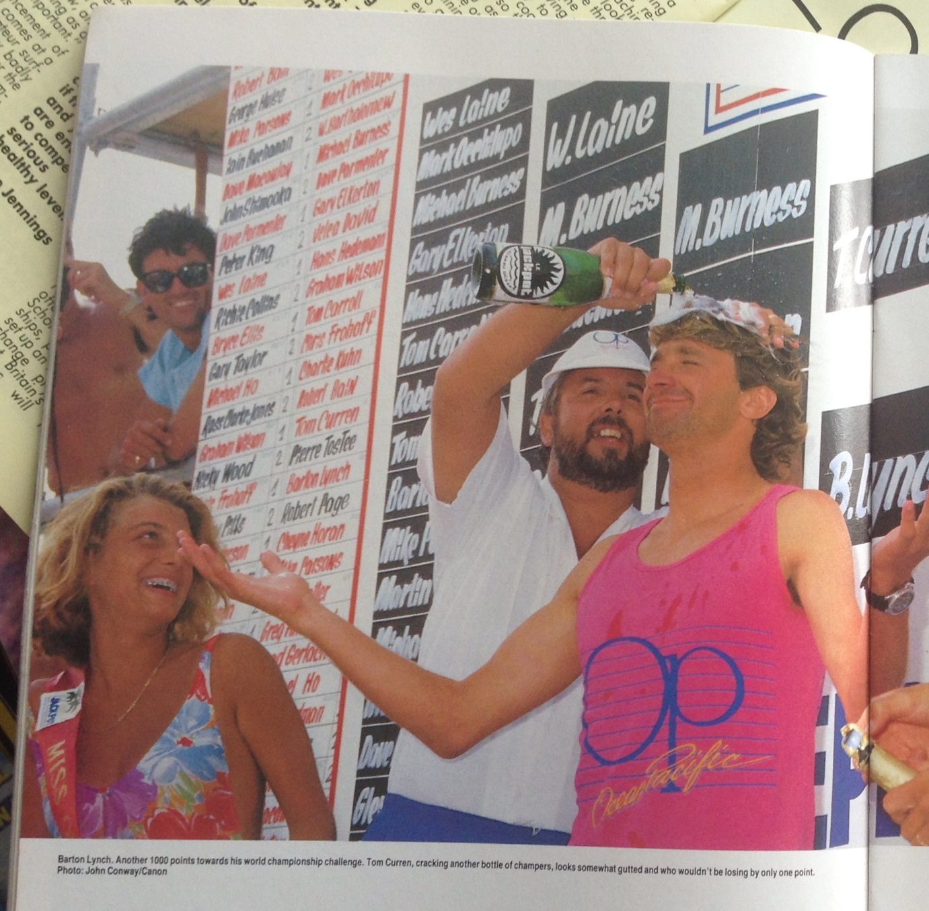

Figure 1. Surfer Barton Lynch pictured in a feature on the French Open Surfing Championships (image cropped by the author) in Wavelength Magazine, Vol 2, issue 11. Oct/Nov 1987

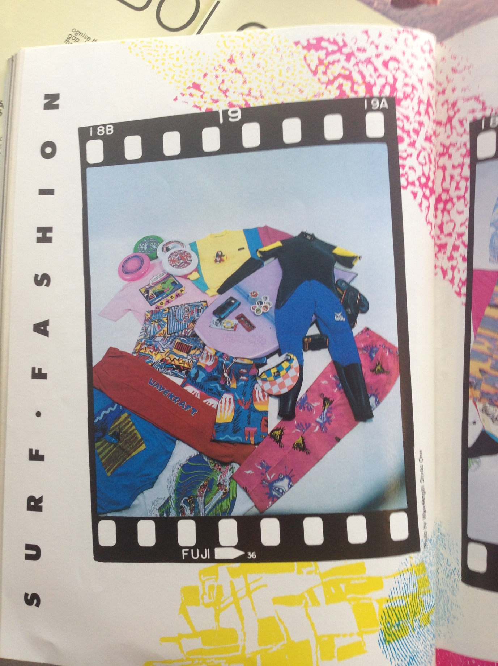
Figure 2. Photograph of a ‘fashion shoot’ in Wavelength Oct/Nov 1988. Note the lack of any information on prices, manuafacturers or retailers.
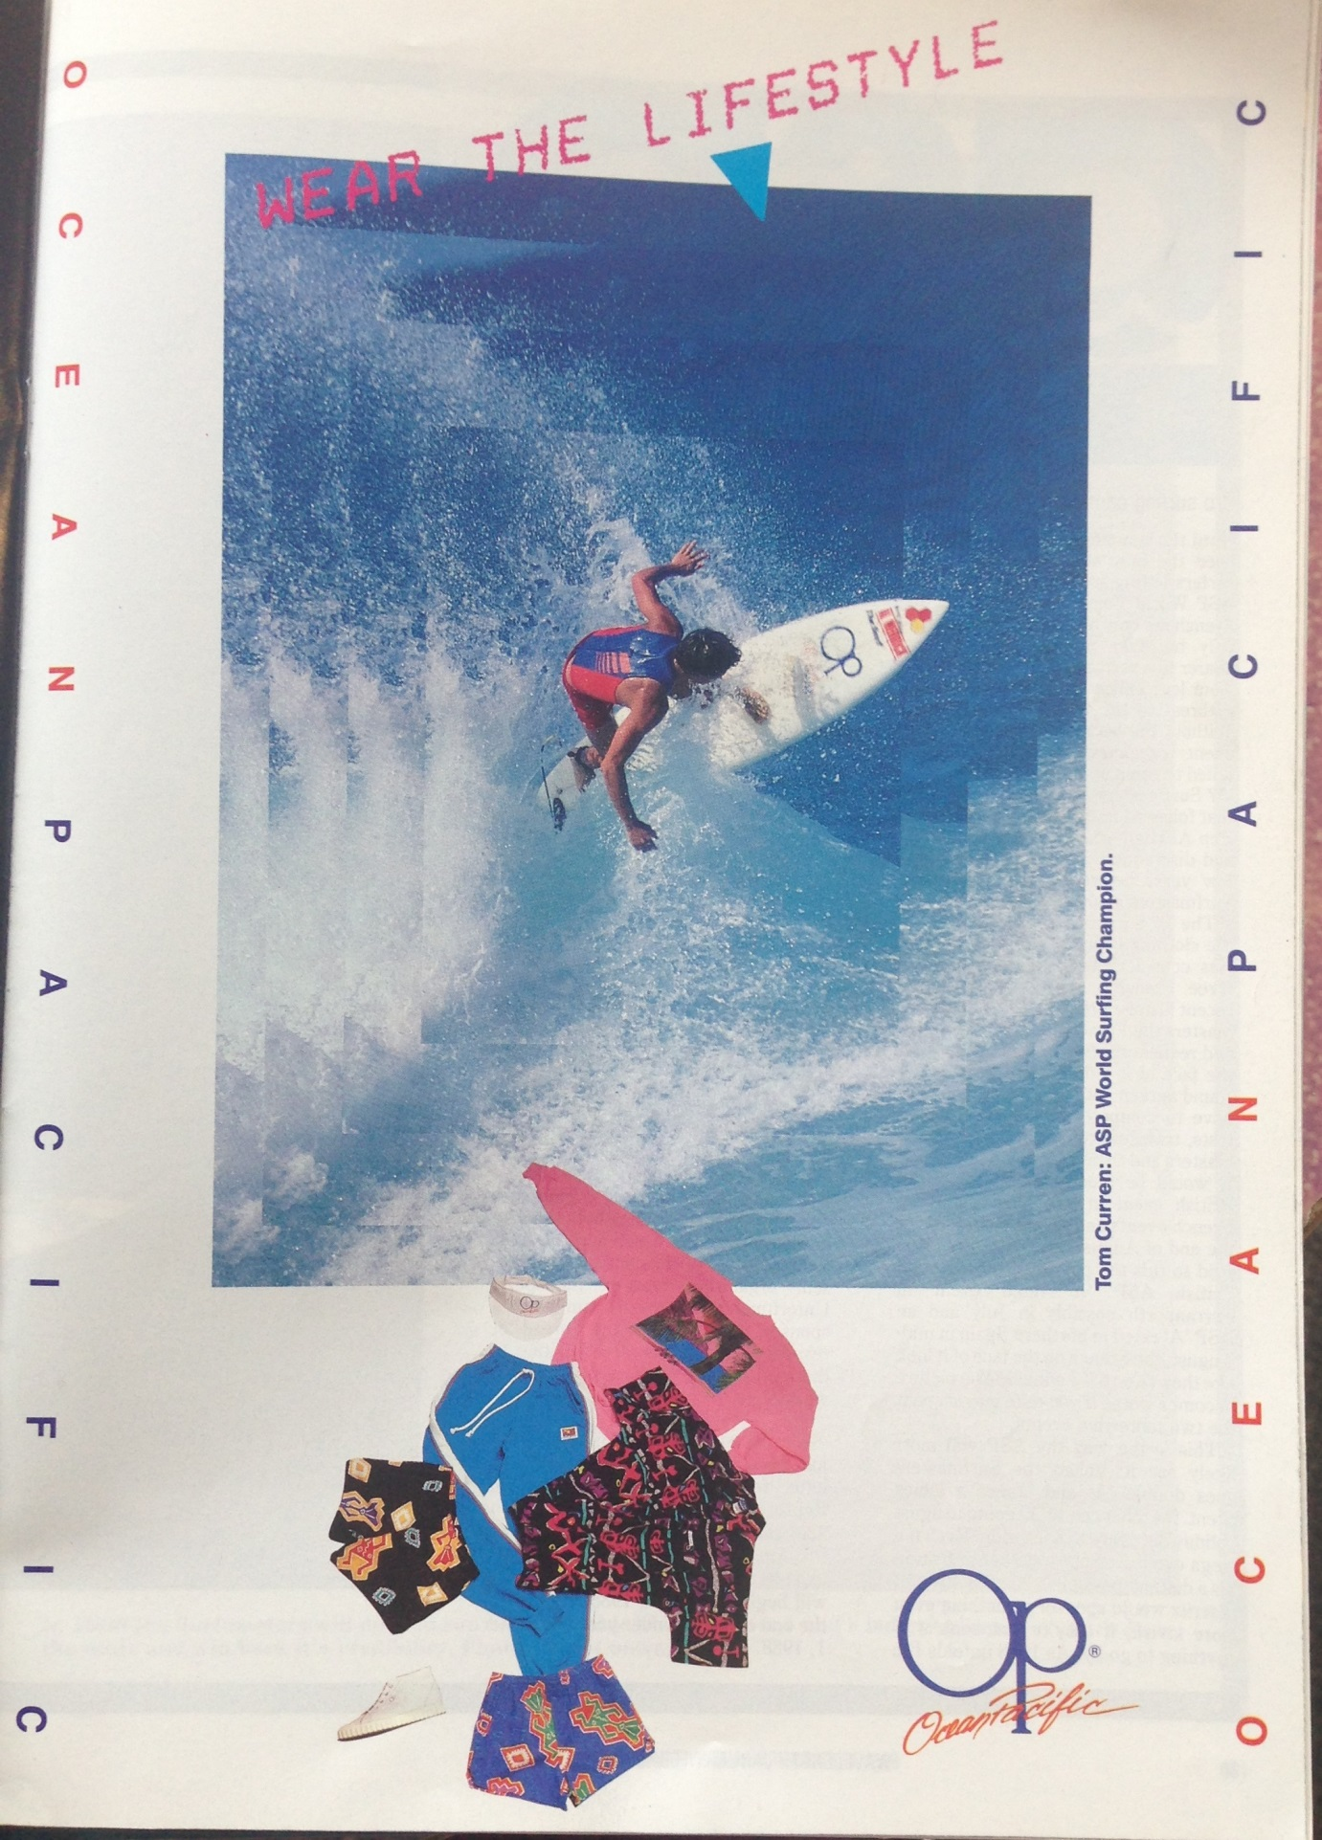

Figure 3. Ocean Pacific advert featured in Wavelength magazine, February/March 1988
Bibliography.

Bourdieu, Pierre (2013, first published 1979) Distinction: A Social Critique of the Judgement of Taste. London: Routledge

Brown,Adam. (2013) A 40-Year-Old Surf Company Declares Its Brand Is Worthless http://www.forbes.com/sites/abrambrown/2013/08/27/a-40-year-old-surf-company-declares-its-brand-is-worthless/. Forbes, 27/08/2013. Last accessed 14/04/2015

Brown, Bruce (1966) The Endless Summer (film) USA:

Campbell, Colin 2003. The Desire for the new: its nature and social location as presented in theories of fashion and modern consumerism. Eric Hirsch, Roger Silverstone (2003) Consuming Technologies: Media and Information in Domestic Spaces London:Routledge,

Craik, Jennifer (2009). Is Australian Fashion and Dress Distinctively Australian? Fashion Theory, Volume 13, Issue 4. Berg.

Entwistle, Joanne (2000) The Fashioned Body: Fashion, Dress and Modern Social Theory. Cambridge: Polity Press
Evers, Clifton. 2009. ‘The Point’ surfing, geography and a sensual life of men and masculinity on the Gold Coast, Australia. Social and Cultural Geography, vol 10, no 8, December 2009

Featherstone, Mike (1991) Consumer Culture and Postmodernism. London: Sage
Finkelstein, Joanne (2007) The Art of Self Invention: Image and Identity in Popular Visual Culture. London: IB Tauris
Jackson, Russell (2013) Billabong’s demise is emblematic of a wider crisis in the surfwear industry. http://www.theguardian.com/business/2013/nov/08/billabong-demise-crisis-surfwear-industry The Guardian, 08/11/15. Last accessed 22/04/2015
Knight, Elizabeth (25 February 2012). "Billabong's wipeout is a tragedy of errors". Brisbane Times (Fairfax Media). Last accessed 14/04/2015
Luke, Hannabeth (2012) Shock Waves: Finding Peace After the Bali Bomb. Published in the UK by the author.
Mansfield, Roger (2011) The Surfing Tribe: A History of Surfing in Britain. Newquay: Orca Publications
Mink, Dorothea (2007) Fashion: the language of the self. In Bippus, Elke & Mink, Dorothea (2007) Fashion Body Cult. Arnoldsche Art Publishers, Stuttgart & University of the Arts, Bremen
Phillips, Arthur Angel (January 2006). A. A. Phillips on the Cultural Cringe. Melbourne University Publishing.

http://www.quiksilver.com.au/about-us last accessed 14/04/15
Schaffer, Tracy Stephenson (2004). Performing Backpacking: Constructing ‘Authenticity’ Every Step of the Way. In Text and Performance Quarterly, Vol 24, No 2 April 2004. Routledge.
Souiden, Nizar, M'Saad, Bouthaina and Pons, Frank (2011) A Cross-Cultural Analysis of Consumers' Conspicuous Consumption of Branded Fashion Accessories in Journal of International Consumer Marketing. 2011, Vol. 23 Issue 5, p329-343
Veblen, Thorstein, (2007, first published 1899) The Theory of the Leisure Class. Oxford University Press
Wavelength Magazine, published by WavelengthMedia UK.
Westwick & Neuschul, (2013) The World in the Curl: An Unconventional History of Surfing. New York: Crown Publishing
Young, Nat (1983) The History of Surfing. Angourie, NSW: Palm Beach Press

