From hype to reality: Blockchain grows up

Jan Kietzmann
Gustavson School of Business, University of Victoria, PO Box 1700 STN CSC, Victoria, BC, Canada, V8W 2Y2
jkietzma@uvic.ca
+1 (250) 472-5996

and

Chris Archer-Brown
Falmouth Business School, Falmouth University, Penryn, Cornwall, UK TR10 9FE chris.archerbrown@falmouth.ac.uk
+44 01326 370400

From hype to reality: Blockchain grows up

Gartner, one of the world's leading research and advisory companies, argues that each and every new technology follows a similar pattern of maturity and adoption (Panetta, 2018). Their main argument is that over time, the level of performance expectations goes through predictable patterns of ups and downs (see figure 1). When a technology is first heard of, possibly when stories break about prototypes or proofs of concept, these technologies are commonly unproven and commercially unviable. However, especially in the case of disruptive technologies, these innovation triggers cause high consumer anticipation and beliefs of imminent changes to the status quo. The hype quickly grows, but soon people realize that they expected more than the technology, in its first generation, can actually deliver. At the peak of inflated expectations, a turning point is reached at which people recognize that the technology is not all it was made out to be. Interest reaches a low, and expectations fall to a trough of disillusionment. Over time, though, as these technologies improve, more and more use-cases emerge for how their adoption can benefit organizational buyers and personal consumers. Eventually, usually in their second or third generation, at the plateau of productivity, high performing technologies become a reality and reach mainstream adoption. At different speeds, Gartner argues, do all technologies go through these phases. Blockchain is no exception.

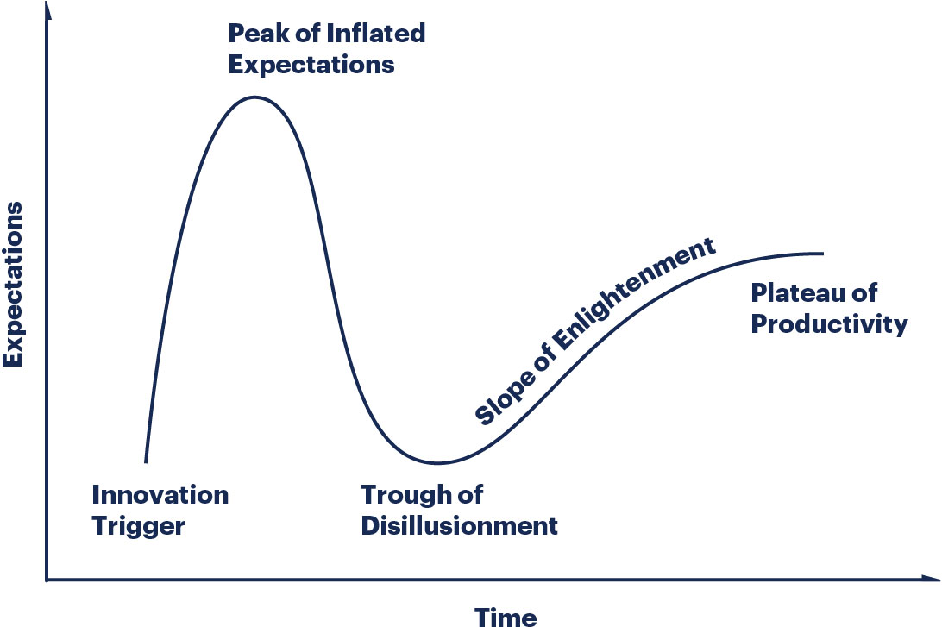
Figure 1: Gartner Hype Curve

Bitcoin, the first blockchain application, was introduced in a white paper written by Satoshi Nakamoto in 2008. Immediately afterwards, speculation about the potential of Blockchain applications increased sharply, and with it did expectations of how the new technology would disintermediate many traditional services (mainly financial services). Blockchain quickly climbed up the initial slope of expectations and investors jumped on the blockchain bandwagon. Interestingly, the news agency Reuters found that when firms, even those that had nothing to do with blockchain whatsoever, changed their name to include the words “blockchain”, their average share price rose more than threefold (Pal, 2018). Soon after, though, the SEC and investors discovered that many of these start-ups actually provided no value and simply capitalized on the blockchain frenzy. It became obvious that the technology needed further refinement when, ironically for technical reasons, The North American Bitcoin Conference in Miami stopped accepting payments in Bitcoin in 2018. The fact that presumably secure cryptocurrency systems were hacked a number of times led to a sharp decline in the Bitcoin value, from a high of nearly $20,000 at the beginning of 2018 to a low of $5,500 at the time of this article. Clearly, blockchain expectations have been sliding and we are now approaching the trough of disillusionment, where consumer confidence in and expectations from the technology are at a low. But, as the Gartner Hype Curve suggests, blockchain’s second coming (i.e., the slope of enlightenment and the plateau of productivity) is around the corner. In the trenches, ambitious start-ups are already working feverishly to develop refined blockchain technologies and industry applications that actually deliver value to firms in innovative ways. The top ten of Forbes’ Global 2000 list of public companies in the world are also exploring blockchain (del Castillo, 2018a), and at least 50 of the biggest organizations featured have developed their own blockchain products based on the technology first inspired by Bitcoin (del Castillo, 2018b).

Business Horizons, as the journal’s title suggests, is about introducing and discussing what’s on the horizon for a wide business audience of academicians and practitioners. The blockchain and bitcoin hype is over and it’s time to discuss how the technology can truly benefit organizations. In this spirit, we publish four articles on blockchain in this issue of Business Horizons. Hughes et al (2019) dispel some of the confusion surrounding blockchain by explaining blockchain principles, outlining its benefits and mapping out its current and future organizational applications. Montecchi et al. (2019) discuss how blockchain can improve “provenance knowledge” so that the information about products’ origin, production, modifications, and custody can inform customer purchasing decisions. Morkunas et al. (2019) then focus their work on how blockchain’s impact on organizations, specifically on their business models and how they create and deliver value. Working with a value lens as well, Angelis and Ribeiro da Silva (2019) explore four distinct blockchain stages of increased maturity, including those focused on transactions, smart contracts, decentralized applications, and the introduction of artificial intelligence supporting decentralized decision making.

We hope that these four articles encourage researchers to examine the extent to which existing business models and “our ways of doing things” are affected; for example, how the potential removal of existing trusted intermediaries affects transactions between parties. The platform economy is dominated by intermediaries who provide assurance on quality of supply and underwrite the risk of fraud, sometimes in the simplest of ways: if an e-Bay purchase is not as described by the seller, the buyer can claim the money back from the platform; if passengers are worried about the reliability of their Uber driver, they can look to the platform for reassurance. If a central promise of blockchain is delivered and true peer-to-peer transactions are facilitated, how are social interaction and the economy overall affected? Is it possible that we are moving closer to a technology that can deliver one of the early promises of the Internet revolution, where power is decentralized and inefficient markets are improved (Levine et al, 2009)?

On the technological side, as blockchain approaches the slope of enlightenment and makes its way toward the plateau of productivity, its future promises to be bright. However, new blockchain technologies and applications will continue to emerge and currently unknown combinations of technologies will pave the way for exciting new business application. Blockchain, as a highly encrypted and decentralized technology and artificial intelligence, a highly centralized technology, is already discussed by serious entrepreneurs, venture capitalists and academics as a way forward for a broader distribution of the data and algorithms that will determine the future development of artificial intelligence (Popper, 2018). Likewise, the integration of blockchain with the internet of things (IoT) can lead to a verifiable, secure and permanent method of recording data processed by “smart” devices. Quantum computing is, on the one hand, discussed as a potential killer of blockchain, since its enormous computing power could be used to break the cryptography that conventional blockchains rely on (Federov et al. 2018). On the other hand, a fully quantum version of a blockchain (a “quantum blockchain”) is seen as a possible way to defend against malicious attacks (Emerging Technology from the arXiv, 2018).

From these technological, organizational and social examples, it seems clear that while one type of blockchain is approaching a high level of maturity and usefulness, newer types are just entering the hype curve. It is our hope that the four articles in this issue of Business Horizons, and some of the ideas presented in this editorial will inform managers and inspire more articles grounded in blockchain scholarship.

References:
Angelis, J. & Ribeiro da Silva, E. (2019). Blockchain adoption: a value driver perspective. Business Horizons, 62(3).

Del Castillo, M. (2018, June 6). The 10 Largest Companies In the World Are Now Exploring Blockchain. Forbes. Retrieved November 20, 2018, from https://www.forbes.com/sites/michaeldelcastillo/2018/06/06/the-10-largest-companies-exploring-blockchain/#d5fcd2d1343d.

Del Castillo, M. (2018, July 3). Big Blockchain: The 50 Largest Public Companies Exploring Blockchain. Forbes. Retrieved November 20, 2018, from https://www.forbes.com/sites/michaeldelcastillo/2018/07/03/big-blockchain-the-50-largest-public-companies-exploring-blockchain/#3121abf12b5b.

Fedorov, A., Kiktenko, E., & Lvovsky, A. (2018, November 19). Quantum computers put blockchain security at risk. Nature. Retrieved November 20, 2018, from https://www.nature.com/articles/d41586-018-07449-z.

Hughes, A., Park, A., Archer-Brown, C. & Kietzmann, J. (2019). Beyond Bitcoin – What Blockchain and Distributed Ledger Technologies Mean for Firms. Business Horizons, 62(3).

Levine, R., Locke, C., Searls, D., & Weinberger, D. (2009). The Cluetrain Manifesto. Basic books.

Montecchi, M., Plangger, K., & Etter, M. (2019). It’s Real, Trust Me! Establishing Supply Chain Provenance Using Blockchain. Business Horizons, 62(3).

Morkunas, V., Paschen, J., & Boon, E. (2019). How blockchain technologies impact your business model. Business Horizons, 62(3).

Nakamoto, S. (2008). Bitcoin: A Peer-to-Peer Electronic Cash System. Bitcoin. Retrieved November 20, 2018, from https://bitcoin.org/bitcoin.pdf.

Pal, A. (2018, February 8). Blockchain name-grabbing has echoes of dotcom bubble. Reuters. Retrieved November 20, 2018, from https://uk.reuters.com/article/us-blockchain-companies/blockchain-name-grabbing-has-echoes-of-dotcom-bubble-idUKKBN1FS1F3.

Panetta, K. (2018, August 16). 5 Trends Emerge in the Gartner Hype Cycle for Emerging Technologies. Gartner. Retrieved November 20, 2018, from https://www.gartner.com/smarterwithgartner/5-trends-emerge-in-gartner-hype-cycle-for-emerging-technologies-2018/.

Popper, N. (2018, October 22). How the blockchain could break big tech’s hold on AI. The New York Times, Retrieved November 20, 2018, from
https://www.nytimes.com/2018/10/20/technology/how-the-blockchain-could-break-big-techs-hold-on-ai.html?partner=rss&emc=rss.

Emerging Technology from the arXiv (2018, May 1). If quantum computers threaten blockchains, quantum blockchains could be the defense. MIT Review, Retrieved November 20, 2018, from https://www.technologyreview.com/s/611022/if-quantum-computers-threaten-blockchains-quantum-blockchains-could-be-the-defense/.

