Cornwall Council Customer
Web Use/Design Project
Phase 1 & 2 Report

Falmouth University

(Dr. Julia Kennedy)

2018

If quoting from this work, please cite as: Falmouth University for Cornwall Council Customer Web Use/Design Project, Phase 1 & 2 Report, 2018
In-text: (Kennedy, J., Falmouth University for Cornwall Council, 2019).
Bibliography: Kennedy, J. (2019) Cornwall Council Customer Web Use/Design Project Phase 1 & 2 Report 2018. Falmouth University for Cornwall Council.

Please contact Professor Paul Springer (paul.springer@falmouth.ac.uk) or Dr. Julia Kennedy (julia.kennedy@falmouth.ac.uk) at Falmouth University with further queries

CONTENTS

INTRODUCTION ……………………………………………………………………………… 4

RESEARCH AIMS AND QUESTIONS …………………………………………………….. 6

PHASES AND OUTPUTS …………………………………………………………………… 7

LITERATURE REVIEW ……………………………………………………………………… 8

The Contemporary National Landscape ..…………………………………………… 8

The Cornish Landscape ……………………………………………………………….. 8

Issues in Rural Communities …………………………………………………………. 9

Whole System Thinking ………………………………………………………………... 9

Getting Transactional services online

Transparency: A key Enabler ………………………………………………………… 9

Designing for Smart Phone Access …………………………………………………. 10

Motivating Change: Incentivizing Trust ……………………………………………. 11

Adult Digital Behaviours Accessing UK Government Services:

The Bigger Picture ……………………………………………………………………. 11

Reasons for Non-Engagement ………………………………………………………… 12

Digital Inclusion National and Local

Horses for Courses: Variations across service areas …………………………… 14

Channel Shift: Case Studies in Council Digital Transformation………………… 14

Camden Council ………………………………………………………………………… 14

Making the Change: Cornwall Council’s Story ……….…………………………… 14

METHODOLOGY …………………………………………………………………………… 16

FINDINGS: DISCUSSION AND ANALYSIS

WORKING WITH EXISTING CC DIGITAL UPTAKE DATA…………………………… 23

CC Digital Uptake and Design Histories ……………………………………….. 23

The View from the Team …………………………………………………………… 23

The Telephone Questionnaire …………………………………………………….. …… 26

Going Straight to the Telephone:
Callers not accessing website prior to calling ………………………………… 26

Going Online First:
Callers resorting to phone after visiting website ………………………….. 31

The Bigger Picture …………………………………………………………………. 36

Device Type Used for Access ……………………………………………………. 37

Findings by Age Range …………………………………………………………… 38

Findings by Gender ………………………………………………………………… 43
Findings by Service ………………………………………………………………... 44

PHASE 1 & 2 Summary and Sample Selection for Phase 3 …………………… 50

CONCLUSION & CONSIDERATIONSFOR CC …………………………………… 57

BIBLIOGRAPHY ……………………………………………………………………….. 58

APPENDICES …………………………………………………………………………… 60

INTRODUCTION

Developing online channels and encouraging ‘digital first’ approaches, where appropriate, remains an important element of councils’ digital strategies – recognising that more people want to carry out their daily business online, at a time and place convenient to them, and also that local government needs to take advantage of the potential cost savings of delivering information and transacting online (Curran, 2016)

In the current financial climate, there is huge appetite for making savings through ‘channel shift’ – serving customers through online services instead of more costly telephone and face-to-face interactions. In Socitm’s ‘BetterConnected’ review of Council websites, (2016-17) 42% received a 3 or 4-star rating, indicating that citizens are now able to manage a significant amount of transactions online in many areas. However, the remaining 58% of English councils achieving only a one or two-star rating, show that there is till a good deal of work to be done in improving user experience and engagement across the UK Council network.

According to the Better Connected website, Cornwall, a unitary council with a population of 532,273, received a 3 star rating overall in 2016-17, with a ‘fail’ for its ‘mobile standard’ category (see figure 1 below):

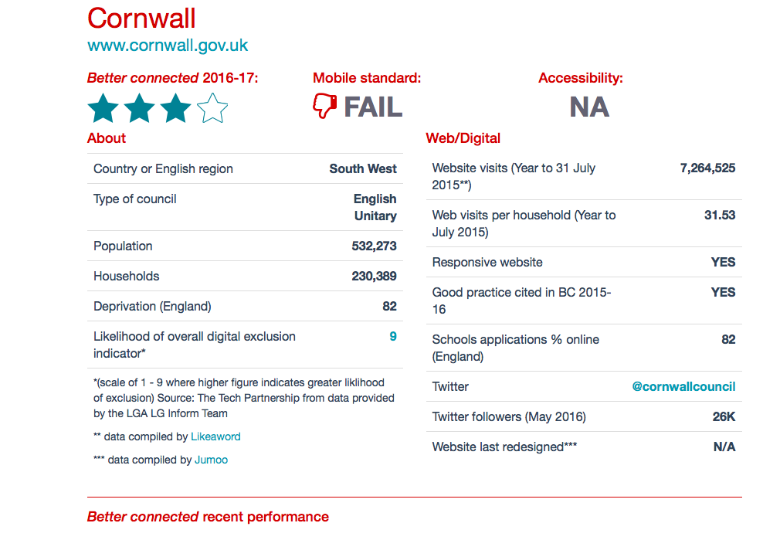

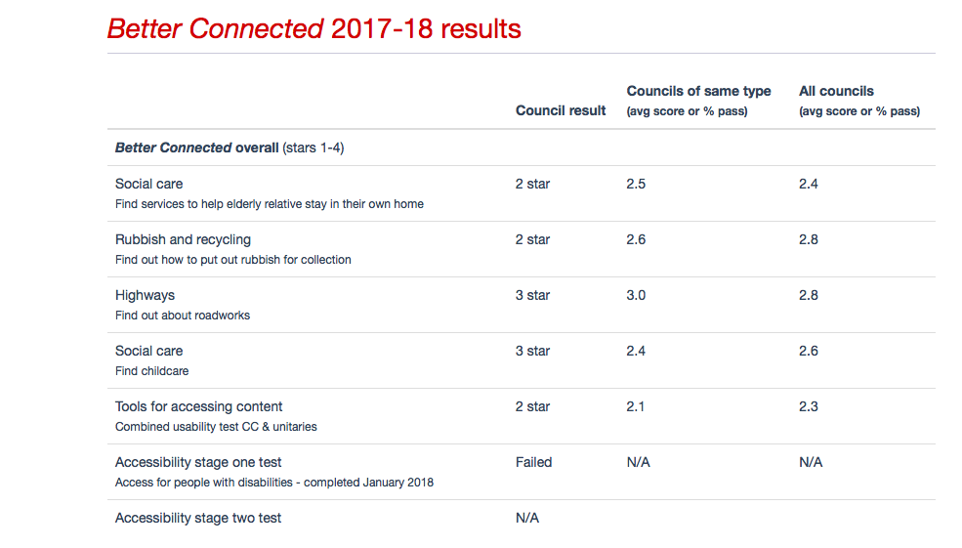

Figure 1: Results for Cornwall Council in the Socitm Better Connected Survey, 2016-2017-18.

2017-18 figures again put CC at a 3 star level.

Despite the commendable 3 star review however, figures from the Council indicate that 80% of citizens could access the web, yet 40% of that 80% consistently fail to use digital council services. It is this cohort with which the project is primarily concerned. How might we identify their reasons for staying offline, and encourage change?

RESEARCH AIMS AND QUESTION

CC specifically are concerned with the following aims:

- Identifying and targeting Residents/customers that aren't accessing the key services online.
- Understanding the barriers to engagement for these customers, and working to address them.
- Identifying customers who are engaging online initially, but then logging off to use the telephone anyway.
- Identifying and working with the barriers to completing transactions and information seeking online.

Very broadly, this aim can be subdivided into two overarching research questions:

- What are the barriers to digital engagement among CC customers currently able to access online services but actively choosing not do so, and how might they be addressed to improve uptake?

- Why do some customers logging on to CC services online end up completing their transactions via telephone, and what measures might enable those transactions to be completed online?

In designing a method to gain qualitative and quantitative data at local level that draws on existing local council experience in rolling out digital services, and considers it against the bigger picture of UK and global council channel-shift, the work aims to highlight areas where change may be implemented to improve user experience and engagement in Cornwall.

Effective results will have the potential not only to improve day-to-day communications and transactions between citizens and the council in the county, and impact positively on local council economics, but also to work towards a bigger vision of vibrant digital democracy for the country as a whole.

PHASES AND OUTPUTS

This is envisaged as a multi-stage project, currently structured in a four-phase model, each with specific outputs feeding into the next phase.

The initial output we are working towards for the Council is a research report setting out an analysis of user responses in relation to the above broad questions in the context of the relevant literature from a number of sources.

Phase 1 will collate relevant primary and secondary data from CC and a range of external institutions and scholars to inform the range and framing of data capture and analysis.

Phase 2 will triangulate quantitative and qualitative methods to scope out user demographics (taking into consideration specific services and their range of users), behaviours, preferences and experiences of interfacing with the site where appropriate (assessed through an initial telephone questionnaire). Dr. Julia Kennedy of the School of Writing and Journalism at Falmouth University will provide academic input on phase 1, underpinning this Phase 1 Report. Results will inform:

Phase 3 which will draw on findings to sample for and design the focus group phase, working directly with selected user groups and utilising the user interface and navigation experience data to inform:

Phase 4 whereby prototype design modifications to the site will be led by Bryan Clark of the School of Communications and Design at Falmouth University.

Approaches to the distinct phases will be discussed in further detail in the methodology section.

LITERATURE REVIEW

Like the best tech companies, councils are lean, agile and data-driven. Acting as brokers or enablers, they sit at the centre of a large web of innovative partners, providers and community groups (Benton and Simon, 2016: 5)

For many councils struggling with the reality of local governance in a landscape of austerity and budget cuts, Benton and Simon’s vision of a fully realized e-governance landscape by 2025 (from their 2016 report, Connected Councils) may seem decidedly utopian.

The Contemporary Landscape

Challenges notwithstanding, the potential for effectively connected councils to operate as vibrant hubs in networked local communities is evident, as are the economic and operational benefits of digital citizenship. Copenhagen now manages 80% of transactions online (ibid: 6) and the following four key areas in which digital transition could help UK Councils have been identified:

- Further simplifying services by moving transactions online and automating back offices.
- Helping labour intensive services – such as eldercare, social care, and childcare – save costs and deliver better outcomes for service users by: intervening earlier, helping people manage their own conditions, and engaging a broader social network to provide care and support.
- Enabling councils to shape places in ways that were previously impossible, especially by engaging citizens in new, more meaningful ways and helping the local economy to grow.
- Radically transforming the way that councils work – including how they organise internally and manage resources – to become open, innovative and collaborative organisations (ibid, 6).

Radically transforming concepts and practices of e-citizenship has far reaching implications for future local governance, but perhaps the most visible practical and economic impact of digital technologies in local councils to date has come from moving basic transactions online:

It has been estimated that moving all transactional services online – from paying a new bill, renewing a parking permit and applying for a passport, to submitting a planning application – would save the government between £1.7 and £1.8 billion every year. Similar estimates for local government savings from digitising have been equally promising: Socitm estimated that the average cost of digital transactions was 15p in comparison to telephone and face-to-face costs of £2.83 and £8.62 respectively (Benton and Simon, 2016: 8).

Local Landscapes: Cornwall Council

Issues in Rural Communities

Cornwall occupies a particularly specific geo-economic location of coastal/rural communities, combined with a fluctuating population due to temporary tourist and term-time student residents across the county. The Rural White Paper in 2000 acknowledged that many rural communities faced challenges:

Basic services have become overstretched. In traditional industries such as farming, incomes are falling and jobs are disappearing over the past 20 years we have seen Post Offices disappearing, Council houses being sold off, rural schools closing, building on green fields and rural bus services cut (Rural White Paper 2000).

Perhaps nowhere is it more evident than in Cornwall that “The often attractive and affluent appearance of the countryside can mask the underlying difficulties that affect many people in rural areas” (Evaluation Trust and South West Foundation, 2008). Whilst poor accessibility to services in rural locations has always been an issue, the Rural White Paper acknowledges that these problems are exacerbated by increasing demand on services across the board. Add to this a range of residents with additional needs such as low incomes and mobility issues, and quality of life and community engagement are likely to suffer significantly in these areas:

The lack of services provides decreasing opportunities for people in rural areas to meet up and connect with their community. It also leads to a lack of opportunity for networking and the sharing of information and experiences. This also increases the need for good accessible provision of information and advice (The Evaluation Trust and South West Foundation, 2008).

This work will explore to what extent these issues might impact on digital engagement with council services at a day today level.

Whole System Thinking in Digital Transformation

In the first instance, the Falmouth University/CC responses to the current web challenge might be seen primarily to address the key area of service simplification. As acknowledged in local government app design, “users want to be able to access services designed around their particular needs and interests” (novoville, 2017).

However, the importance of ongoing digital delivery rollout operating in an ethos of “whole system thinking” (ibid) is significant. In practical terms, the gargantuan task of trying to shift engagement across the several hundred discrete services a council might operate at any one time may at best a high-risk strategy, and almost certainly unachievable:

In contrast to many central government departments, which deal with a small number of transactions at high volumes, local councils typically deliver a wide variety (700+) of low-volume services. It is therefore very difficult for any individual council, however pressing its needs, to put together a sustainable business case to support the end-to-end integration of specific services – from a website or CRM front-end, to the council’s back-office systems, to the systems used by external delivery partners (Curran, 2016).

Fragmented approaches to digital transition based on legacy thinking and practices in specific service areas however, could be more effectively be implemented by a radical overall approach to digital transformation based on customer-centred design decisions. The potential for this to engender a sense of value and involvement in users is important if we acknowledge that translation across digital transformation networks can often fail where poor marketing and roll-out communications are observed. An example of this might be where “simple and understandable language about what changes are happening, why and how they will impact on people, is compromised by jargon or an assumption that people will ‘just get it’” (novoville round table discussion, 2017).

Transparency: A Key Enabler

Transparency has been identified as a key enabler across the board of digital take-up, not only in terms of access to information and transactional services, but in the process of using data to make information available about the inner workings of councils and their performance. A need for councils to ‘move closer to their citizens in general was highlighted as a means of improving engagement through responding to preferences and needs in a process of “co-design and delivery of services” (ibid).

A Council in my Pocket: Designing for Smart Phone Access

The novoville round table discussion in 2017 produced strong consensus on the importance of designing for smart-phone access (mobile apps) in line with the concept of a “council in my pocket”. This ties in to the aim of enabling users to access required services on the go according to their specific needs and preferences in an individually tailored menu. In a survey of UK citizens run by novoville, users expressed clear platform/channel preferences, with 45% preferring council interaction through social media, and over 80% saying they would interact using a smartphone (novoville, 2017).

Such figures are further broken down into demographic groups by Ofcom in their 2017 report on adult digital behaviour in the UK:

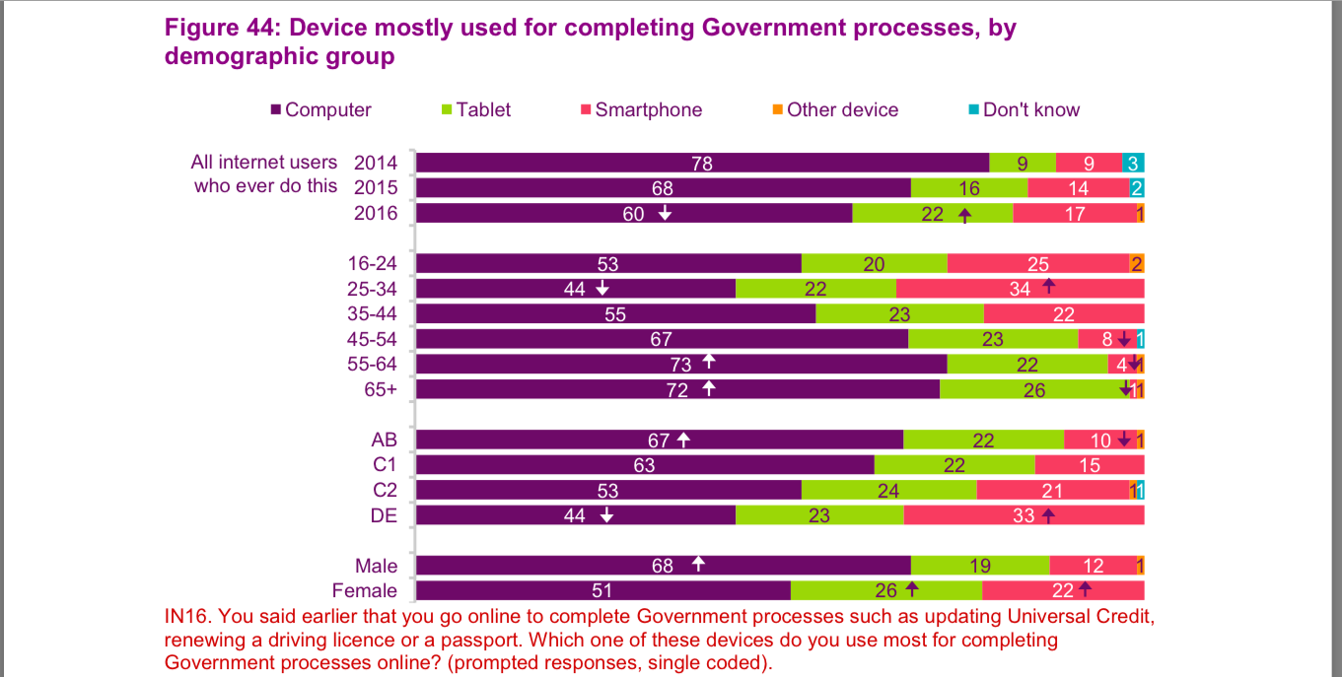

Figure 2: Extract from Ofcom table Figure 44: Device mostly used for completing government processes, by demographic group in the Adults’ Media Uses and Attitudes Report, 2017, p71.

Points of particular interest in the variables noted are summed up as follows:

One in three 25-34s (34%) say they mostly use a smartphone, which is higher than the UK average (17%). Less than one in ten of over-45s say they mostly use a smartphone, lower than the UK average.
Those in AB households who complete Government processes online are more likely to say they mostly use a computer for this activity, compared to the average (67% vs. 60%), and are less likely to say they mostly use a smartphone (10% vs. 17%). In contrast, adults in DE households are more likely to mostly use a smartphone (33% vs. 17%) and are less likely to use a computer (44% vs. 60%) (Ofcom, 2017: 71).

In 2014, Manchester City Council redesigned its website using 'mobile-first' principles enabling citizens to contact the council using smartphones and free wifi in many areas across the city. Savings of £500,000 were recorded in the first six months alone. Methods behind the project included a cross-departmental team from the council and developer (Jadu) reviewing how people asked for services, reported problems and made transactions. The site is designed to be equally functional on phones and tablets as desktops, tested by “asking ordinary local people from a range of backgrounds and ages to perform various tasks on different devices to see how easily they could do things” (Olsen Bedford, 2014). Accessibility-experts and organisations representing blind or partially-sighted people also tested the site.

Motivating Change: Incentivizing Trust

The big question faced by all councils, and one of this project’s key research questions, is how to motivate and incentivize change in citizens’ habits and behavior patterns surrounding their communicative relationship with their local council. Interestingly, the most obvious incentive of economic efficiency keeping down council tax is not always seen as a powerful enough driver in its own right to motivate and sustain digital engagement. A more important emphasis is placed on demonstrating how citizens might actually benefit in tangible ways from changing their habits. This benefit-driven motivation combined with an ethos of transparency may well be reflected in the fact that over 85% of UK citizens surveyed by novoville claimed to be prepared to share personal data where digital services were perceived to be useful, and reasons for data collection and potential benefit made clear.

Quantitative data from novoville in 2017 revealed that over two thirds of citizens had interacted with the local council more than three times in the last 18 months. Whilst some of this figure was made up of the need for repeat visits following service failure, 50% of it came from citizens satisfied with their experiences, giving weight to the nature of public demand for digital services going forward.

Adult Digital Behaviour in Accessing UK Government Services: The Bigger Picture

Ofcom’s annual report on adult digital behavior is also a useful source for a broad snapshot of what people are doing online in the UK, and has a section (6.5) devoted to Accessing Government services/ public/ civic activities. Of four activities grouped under this heading, one (number 3) is specifically concerned with transactions such as “paying online for council tax or for another local council service (parking ticket, congestion charge etc). In 2017, Ofcom report that “Close to half internet users (46%) have ever paid for their council tax or other local council service online” and, in the last week, “Around one in ten internet users have paid their council tax or other local council service online (11%). Age variations are significant in these numbers though, as demonstrated in the extract from the Ofcom table shown in figure 3 below:

Figure 42: Use of public or civic services online, by age
Adults’ Media Use and Attitudes – Report 2017
All internet users |  | 16-24 | 25-34 | 35-44 |  | 45-54 | 55-64 | 65-74 | 75+
Pay online for your council tax or for another local council service (parking ticket, congestion charge etc.) | 46% | 28% | 57% | 59% |  | 47% | 48% | 31% | 19%

Figure 3: Extract from Ofcom table Figure 42: Use of public or civic services online, by age, in the Adults’ Media Uses and Attitudes Report, 2017, p69.

The significant decline in take-up in the 65-74 and 75+ age groups is a challenge for widespread digital engagement in a County such as Cornwall, with a large elderly population.

Socio-economic group and gender produce variables in take up too:
Figure 43: Use of public or civic services online, by socio-economic group and gender
All internet users |  | AB | C1 | C2 | DE | Male | Female
Base | 1553 | 394 | 521 | 300 | 338 | 745 | 808
Pay online for your council tax or for another local council service (parking ticket, congestion charge etc.) | 46% | 59% | 48% | 42% | 32% | 46% | 47%

Figure 4: Extract from Ofcom table [Figure 43:] Use of public or civic services online, by socioeconomic group and gender, in the Adults’ Media Uses and Attitudes Report, 2017, p70.

Again, the sharp drop of uptake in in DE households is potentially relevant, given that the IMD (Indices of Multiple Deprivation) Report 2015 showed that 17 of Cornwall’s neighbourhoods are in the most deprived (worst 10%) in England (an increase of 9 neighbourhoods from the previous data in 2010). 44 of Cornwall’s neighbourhoods are in the 20% most deprived in England (previously this was 33).

Reasons for Non-Engagement

Ofcom’s research identifies a number of reasons why people fail to take up digital approaches to completing government processes online, ranging from a preference for pen and paper communications or verbal contact through reluctance to share information online and lack of awareness of online services to dissatisfaction with websites and app interfaces:

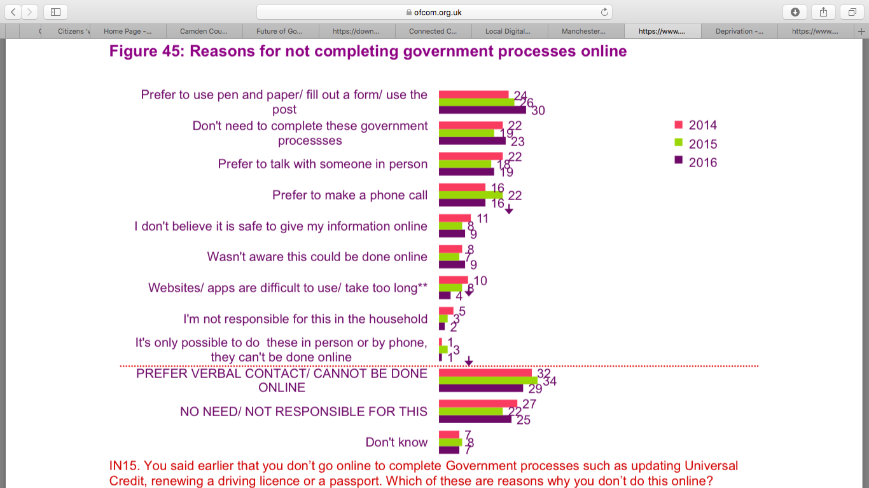

Figure 5: Figure 43 - Use of public or civic services online, by socioeconomic group and gender, in the Adults’ Media Uses and Attitudes Report, 2017, p72.

The data shown in Figure 5 can be summarized as follows:

Three in ten who have never completed Government processes online say it is because they prefer to use pen and paper/ fill out a form/ use the post
…30% of this group say they don’t complete any Government processes online because they prefer to fill in a form and use the post. Around one in four (23%) say it is because they don’t need to complete Government processes, and one in five (19%) say they prefer to talk with someone in person. One in six say it is because they prefer to make a phone call (16%) (Ofcom, 2017:72).

A preference for verbal communication is significant overall, with three in ten (29%) internet users who don’t complete Government processes online saying it is because “they prefer some kind of verbal contact, either by phone or by talking to someone in person, or because they think the process cannot be done online” (Ofcom, 2017: 72).

Inherent in these statistics is a need for further research, to find out exactly why users feel that a verbal interaction would be preferential, and why they believe the process they need to carry out is not achievable online. This will be addressed in the research design, and set out methodology section in relation to the CC/FU project, but some general observations on channel shift failure in local government have been made and are worth considering at this stage. James Curran acknowledges the overall successes in local governance channel-shift, but acknowledges that there remain some serious challenges:

- A significant minority of people and organisations (estimated at 10.5 million UK adults) do not have the basic digital skills, desire, trust or confidence to embrace technology and digital access to services
- While some local government services lend themselves to online resolution (eg making a booking for a leisure facility), others such as adoption demand a range of different types of contact
- Many council services (including customer contact itself) are now provided through shared service or outsourcing arrangements or involve a mix of partners from the private, voluntary and community or wider public sectors in the delivery chain (Curran, 2016).

In addition, a number of additional organisational barriers in digitising services were identified. These include the range of legacy IT systems, external restraints on service delivery and data sharing and a lack of skills for implementing digital solutions (ibid).

Leading web and digital platform company GOSS, who describe themselves as “the market leader in delivering web and digital self-service technologies in Local Government” (GOSS, 2018), have compiled a list of key factors in channel shift failure which is worth visiting for the insightful nature of the observations made in relation to our own project (see Appendix 1). These factors or barriers to access were listed under 5 categories, and key points extrapolated below:

Content: This was seen to be often burdensome in volume, poorly organised for access or articulated in the kind of:

jargon-laden 'council-speak' will cause people to abandon the website and make a call instead. That not only increases the transaction cost (from 15p to £2.83, according to Socitm), but also means the visitor is less likely to use the website next time (GOSS, 2018).

Personalisation: Tailoring services to the web user’s particular location using account log in or postcode entry form obviates a necessity for them to wade through long lists of irrelevant material in order to find what they want (with its attendant high drop-off rates as users lose patience and reach for the phone). According to the report, ‘personalisation delivers a dramatically improved experience for the citizen’, significantly increasing ‘channel shift savings for the council’ (Goss, 2018).

Forms: The Goss report found that approximately 80% of forms they tested ‘didn’t work properly on a smartphone…preventing visitors from completing the form’. They also noted that some were so complex that they made calling seem easier, and others left out vital information that inevitably led to the council having to call the client back.

Payment: The GOSS research team drew attention to a frequently clunky interface between online forms and ‘legacy payment’ services which often didn’t work, were not optimised for mobile payment and often looked and felt different from the overall web design style producing counter-intuitive clashes for users.

Mobile: The team’s research of nearly 100 council websites showed that ‘support for mobile devices is not only hampering channel shift efforts, but has actually reduced customer satisfaction with council websites in the last year’ (GOSS, 2018). This was seen to be largely the result of some councils being two slow to ‘engage responsive design architectures’ (ibid) which, given the increase in mobile device use to access council sites “from 30% to over 40% of visitors in the last 12 months (and [the prediction that it] will extend to over 50% of visitors in the next 12 months)” (ibid) is a factor that clearly needs addressing urgently in some locations.

Reading these considerations against the Ofcom reasons for lack of digital interaction with Government services online, it may be possible to begin to begin to tease out some of the factors influencing a preference for verbal interactions, and lack of trust in online transactions. Close consideration of these issues at local level will be incorporated in the methodological design for this project.

Channel Shift: Case Studies in Council Digital Transformation

In 2014, Leeds City Council pioneered its webchat services to help citizens coming online to find exactly what services they needed, with excellent results:

Before implementing the LivePerson webchat facility some 15-20% of monthly callers to the council had already been to the website but had not found what they needed. Webchat was chosen to plug this 'leakage' and to boost productivity, because chat allows staff to handle several enquiries simultaneously. Of the residents who now happily use webchat to order services, 70% would have phoned, 20% would have emailed and 5% would have gone to see a member of council staff in person - all significantly more expensive resources to the tax-payer (Olsen-Bedford, 2014).

The successful introduction of use of webchat at Leeds is useful as a potential comparison for Cornwall’s own introduction of a webchat facility in 2014. Of further interest will be the extent to which webchat satisfies customer desire to talk to a human being in a face-to-face or telephone environment.

Also of interest is Newham Council’s collaboration with Microsoft to design and implement a package of digital solutions currently saving them £10m a year, with over half of all transactions
taking place on the website. Not unlike Cornwall, Newham serves an area high on the scale of deprivation in the UK, and was struggling to do so on a budget that has shrunk by 40% since 2010.

Camden Council: A Case Study in redesign

Camden Council provides a useful case study due to its emphasis on user research in the ongoing redesign of its website in 2011, the process of user involvement in redesign is accessible and discursive, narrativized in blog posts on the council website. This is a potentially useful resource for methodological design for our own project, and further reference to potential approaches to user involvement will be addressed in the Methodology Section.

The revised design of the Camden Council website itself is impressive, with a clean and appealing interface. Its simplicity and navigability is immediately clear, using colour-coded tiles with bold white font flagging up the service use area for users to click through to (see figure 6 below):

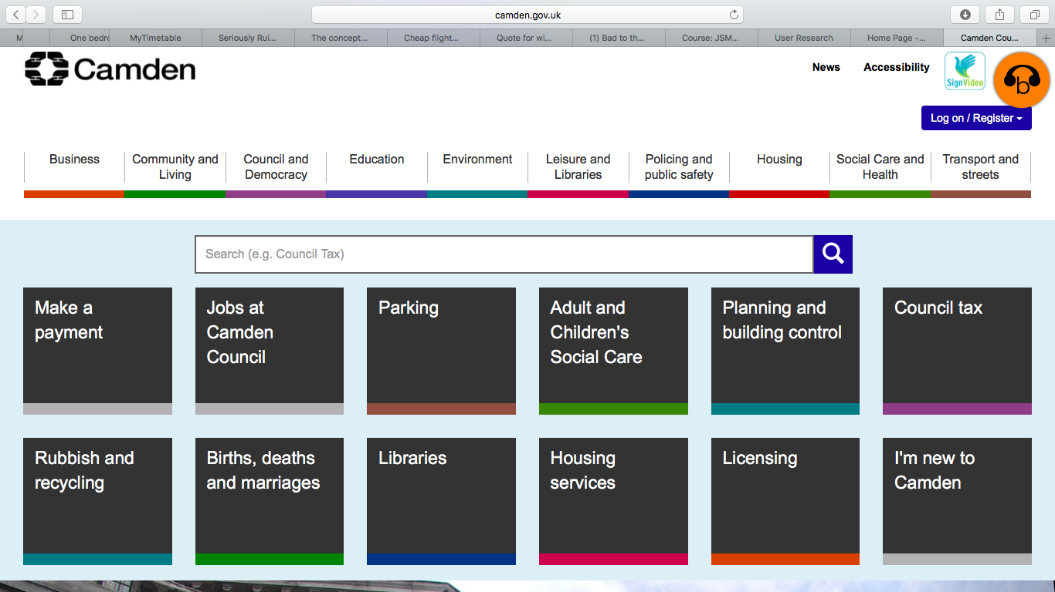

Figure 6: Camden Council Website Homepage, February, 2018. (http://camden.gov.uk/ccm/navigation/?find=GP)

User involvement in the re-design raised a number of specific frustrations and desires among local citizens, which design leader Liz Alyan compiled into a ‘wish/frustration list’. Alyan observed that “Based on the user research that we did on Camden residents, we found that people’s expectations on a council website are not that difficult or unreasonable. They just want things to work” (Alyan, 2010). The wish-list replicates a number of themes already raised in this section, but is more comprehensive and detailed in its observations of the frustrations encountered and what users would like to see done about them, giving it real potential to inform our own methodology at the questionnaire and focus group stages (see Appendix 2 for the full list).

METHODOLOGY

The project aims are to work out a) why some people don’t attempt to access the council website at all prior to calling for information or to complete a transaction, and b) why some callers who are accessing the site first still find themselves needing or wanting to phone anyway.

It was decided that the call centre was the most effective means of accessing a large volume of callers who could provide basic information on their journey to calling the Council at the point of contact. This would allow for a potentially large cohort of callers to feed their experiences into a phase 2 data collection, from which emergent patterns and themes could be extrapolated to a third phase of more focused qualitative data collection through focus group and/or interview methods. Quantitative and qualitative methods will be triangulated in this phase.

The third, qualitative phase is intended to address any clear barriers to engagement reported through Phase 1 data collection and analysis. Phase 3 involves working with selected respondents sampled from Phase 2 through focus group and/or interviews to see if any design suggestions and approaches might help smooth out problems for those visiting the site first and having an unsatisfactory experience, and to ascertain what kind of interventions might encourage those not engaging at all as yet to do so in future.

Methodological design for each phase is set out in detail below:

Phase 1

Initial scoping of Channel-Shift Data from CC

This phase will work with existing web use analytics and team narrative surrounding the recent histories of channel shift at CC to lay the local foundations for the next phases.

Phase 2

The Telephone Questionnaire

The phase 2 questionnaire (see appendix 1) was developed in order to capture a broad range of information from all callers to the CC switchboard.

Callers were first asked to state their age range and which service they were calling in relation to, allowing for analysis of variables in those categories.

They were then asked to state if they had attempted to access the website prior to phoning, with NO and YES categories each with tick box responses to elicit their reasons for either not doing so, or having the telephone anyway if they had done so. Both of these groupings are considered fundamental to this work, as barriers to engagement can be explored at the level of total non-engagement with web services, and unsuccessful or unsatisfactory attempts to engage.

Working with Respondents Not Going Online First

Those NOT accessing the website first were asked a number of tick box questions (see figure 8 below):

Did you try & access the website before phoning? | NO: Could you state briefly why?  - Don’t have internet access/device  - Didn’t realize service was available online  - Have tried website before without success  - Don’t like paying for things or sharing  personal details online  - Prefer to talk to someone  - Other (brief description)

Figure 7: Phase 2 questionnaire questions for callers not accessing online services first.

The questions were comprised of a number of potential rationale based on a range of practical and attitudinal approaches to using online services and making online transactions. These were based on the understanding of the diverse nature of the networks involved in uptake of web provision. In their 2017 report on adult digital behaviours in the UK, Ofcom canvassed internet users who have never completed any Government processes online, prompting them with eight similarly diverse reasons for not doing this and asking them to indicate which applies to them.

In our questionnaire, the ‘other’ category prompted callers to say something briefly about why they didn’t access online services if the prior categories hadn’t adequately described their reasoning. In effect, this creates an ‘open’ question in the initial questionnaire, and a potential rich seam for some qualitative narrative for thematic analysis underpinning phase 3.

Mapping Digital Skills

Relevant work also exists in relation to engagement with online local governance through the Gov.uk GDS ‘Service Manual’, particularly in relation to understanding those users who don’t use digital services. The manual suggests that service providers need first to understand what level of digital skill users need to transact with their service, suggesting the Digital Inclusion Scale (see Figure 8 below) as an appropriate tool for mapping users’ digital skills (Gov.uk, 2016).

.

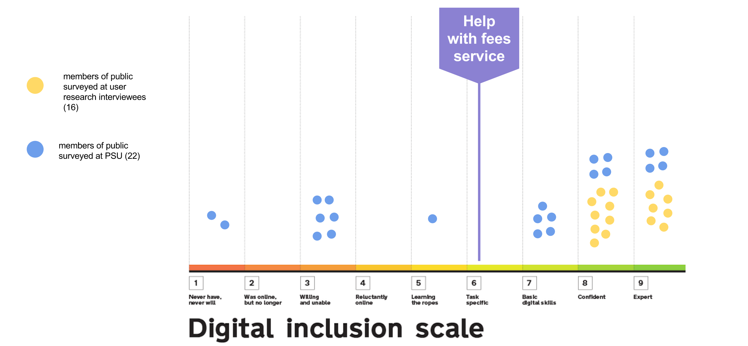

Figure 8: The GDS Digital Inclusion Scale

The scale works with digital skills and attitudes, describing 9 typical users by their digital skills ‘from those who can’t or won’t use the internet to experts with advanced digital skills’ (GDS, Gov.uk, 2016). The minimum ‘basic digital skills’ required in order to be able to use the internet effectively comes in at Point 7 on the scale, and people mapping onto this point or above can, according to the site, ‘manage their information, communicate online, carry out transactions, create things and problem solve’ (ibid). A more recent iteration of the scale can be accessed in the form of ‘The Essential Digital Skills Framework’ (drawn up by Lloyds Banking Group and the Tech Partnership and overseen by a steering group of business and institutional representatives including HMRC, the Greater London Authority, and the Greater Manchester Combined Authority). The framework builds on the concept of ‘basic digital skills’ to introduce a range of distinct skills statements demonstrating progression across life and work contexts in 5 categories (communicating; handling information and content; transacting; problem solving and being safe and legal online). In addition, it also identifies ‘foundation’ skills (see figure?, page?), the presence of which may motivate and encourage engagement in those currently not engaging with digital services (https://www.thetechpartnership.com/wp-content/uploads/2018/05/EssentialDigitalSkillsFramework-29May18.pdf) .

Use of the scale to assess the Cornish cohort as we move into the Phase 2 design is considered a potentially important tool for assessing some of the complex reasons why people aren’t engaging, and what might be done to start progressing them up the scale.

The GDS suggests working with what it refers to as ‘assisted digital personas’. These user personas are typical user descriptions created from local data and research to inform an understanding of digital inclusion at local levels. The GDS has itself created 8 of these ‘personas’ representing those likely to need assisted digital support, but these personas are useful too for looking at those who do use services and encounter problems, and will be used to underpin user narratives and identify needs for respondents selected for Phase 2 & 3 research and focus groups, potentially creating Cornwall-specific personas for future local user-engagement work.

Working with those who go online first

Those who had accessed the website first needed a different subset of rationale so that we could see what barriers bought them back to the telephone. Why, having engaged digitally initially, were they not able to complete their tasks or transactions online. The questions they were asked by the operators are outlined in Figure 9 below:

YES: Why did you end up phoning?

- Couldn’t find information I wanted online

- Found website confusing to navigate

- Couldn’t complete transaction online

- Other (brief description)

Figure 9: Phase 2 questions to ascertain why callers visiting website first resorted to phoning anyway

As with the non-digital users, 3 potential reasons for resorting to a phone call following the initial digital interaction were identified and offered as tick-box responses. These were in part informed by the Camden Council Web Re-design Project Citizens’ ‘Wish-list’ (2011) (see Appendices). Again, the ‘other’ category solicited a brief description for those wanting to say something more than those three categories allowed, and provided potential for basic narrative response for thematic analysis in this early phase. This information also allows the possibility of creating ‘digital personas’ to tell useful stories about unsuccessful attempts at digital engagement, and create meaningful solutions to barriers to completion of transactions online.

Quantitative Analysis in Phase 2

An element of quantitative analysis will be undertaken in the first phase to show % indices of reasons for non, or unsuccessful engagement across variables such as service type and age range. Do particular services produce specific issues that could be addressed to dissolve barriers to digital uptake for example? Might specific age groups experience different challenges, and by identifying them can we imagine creative responses to address them?

THEMATIC ANALYSIS

Phases 1 & 2 will triangulate quantitative data with some thematic analysis to map patterns and reported phenomena across the data sets. Thematic analysis lends itself well to a project such as this one, which does not set out to prove or disprove a particular theoretical argument, but rather to work with respondent narratives to identify reasons behind particular behaviours in order that relevant changes might be imagined and implemented.

Braun and Clarke (2006) describe thematic analysis as an ongoing process of constant analysis and refinement of ‘the specifics of each theme, and the overall story the analysis tells’ Braun and Clarke, 2006:77), and produce the following 6 point framework for its implementation:

- Familiarizing yourself with your data:
- Generating initial codes:
- Searching for themes:

- Reviewing themes:
- Defining and naming themes:
- Producing the report: (ibid)

Sampling for Phase 3

As Barbour (2007) points out, sampling is key to the success of focus/interview group selection as it frames the comparisons that can be made from the initial data set.

In line with the aim of finding out something about why some Cornish residents make no attempt to use online services, and why some of those that do end up calling anyway, we already have two distinct groupings emerging from the questionnaires. Whilst there may indeed be some shared similarities in the two groups, it is assumed that those attempting an online intervention may be at least at points 3 (willing and unable) or 4 (reluctantly online) on the Digital Inclusion Scale (2016), and demonstrating at least some of the basic skills across the five categories set out in the more recent ‘Essential Digital Skills Framework’ drawn up by the tech partnership (2018). The act of having gone online first and then resorting to the telephone anyway, characterizes a group of diverse individuals for whom something has acted as a barrier to completing the transaction online, and that information is particularly valuable in a group of residents already willing and able to go online to access services. This data will allow for identification and implementation of any changes necessary to smooth the road to successful online transactions for as many Cornish residents as possible.

The concept of this being a diverse group of residents is important however, and again this diversity affords a rich seam for further comparisons within the ‘online first’ group itself. Qualitative sampling seeks to reflect diversity in selected cohorts in ways that quantitative sampling motivated towards selecting representative groups cannot (Kuzel, 1992; Mays and Pope, 1995). Granular analysis of the phase 1 data will allow for ‘sorting’ into relevant sub-groups. Those assumed to be particularly relevant in this project would be age range and service type, based on previous work with digital engagement with government services (Ofcom, 2017). Gender does not appear to have made a significant difference to the likelihood of online engagement in previous work of this type, but it will be closely scrutinised should any distinct patterns emerge, and considered at the sampling phase. Should distinct themes and behaviour patterns emerge in particular service groups or age ranges, then sampling for the ‘Online First’ group will seek to include a diverse range of those for the next phase.

Those who went straight to the telephone are also a group of considerable value to the findings. It might be assumed here that at least some of those residents will be at points 1, 2 or maybe 3 on the Digital Inclusion Scale, and lacking in some of the basic skills as defined by the Essential Digital Skills Framework (2018) (EDSF). This assumption will need to be tested in the ‘straight to telephone’ group of course, but this group also provides some opportunity to work with assessing the level of the EDSF category of ‘foundation’ skills, the presence of which may motivate and encourage engagement in those currently not engaging with digital services (see Figure 10 below):

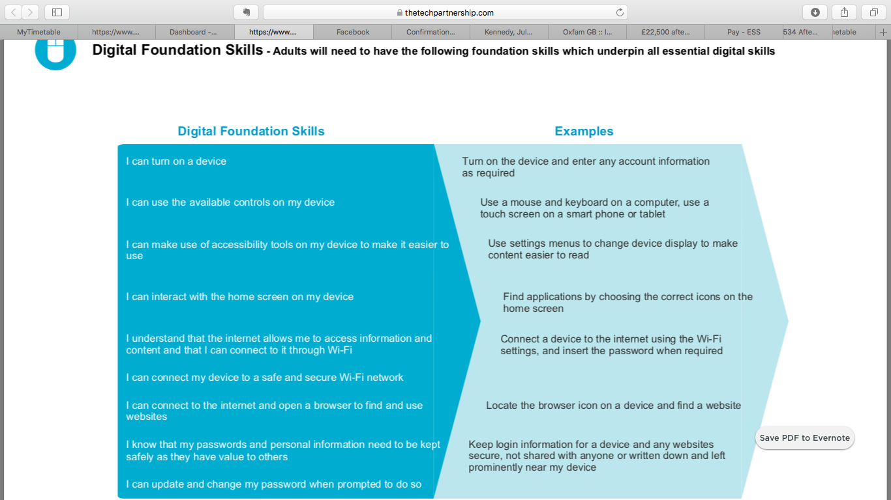

Figure 10: Screenshot of the Tech Partnership Digital Foundation Skills from their EDSF (2018)

Again, age and service type may be considered highly relevant in this group and will be selectively sampled according the phase 1 findings.

Phase 3

Focus Group/Interviews

Dependent on take-up and preference among sampled respondents from Phase 2, the detailed data collection of phase 3 will be carried out through focus groups, online or telephone interviews, or a combination thereof.

Callers sampled using the above criteria will be invited to take up further questioning about their barriers to online engagement in one of the above formats. If there is sufficient respondent take-up, preference will be given to some focus group work when potential changes to website design are being discussed. GDS have recommended that researchers working with digital inclusion in these contexts attempt to ‘show the on-screen service to all users, including those with low levels of digital skills and confidence, so they can give [you] accurate feedback on the support they would need’ (GDS, Gov.UK User Manual, 2015). Certainly in the case of those users already having gone online and failed to complete their desired task or transaction, collaboration with the personnel responsible for the design phase is also intrinsic to the success of any re-design. It is assumed that issues for discussion here might include ease of access to the site (for all users), the appeal of its user interface, navigability, levels of information, efficiency in transactional processes, branding and semiotics. All of these can of course be discussed in non face to face contexts, but any new suggestions or demonstrations of usage will be better served in face to face contexts with the current website and any visualizations for potential changes available to stimulate discussion.

Collaboration with Users for Designing Change

This methodological approach draws on the Camden Council Website Redesign project in 2011, where users were first invited to contribute to a ‘wish-list’ for the new site, and to engage in the ongoing research through the Council’s project blog (see figure 11, below):

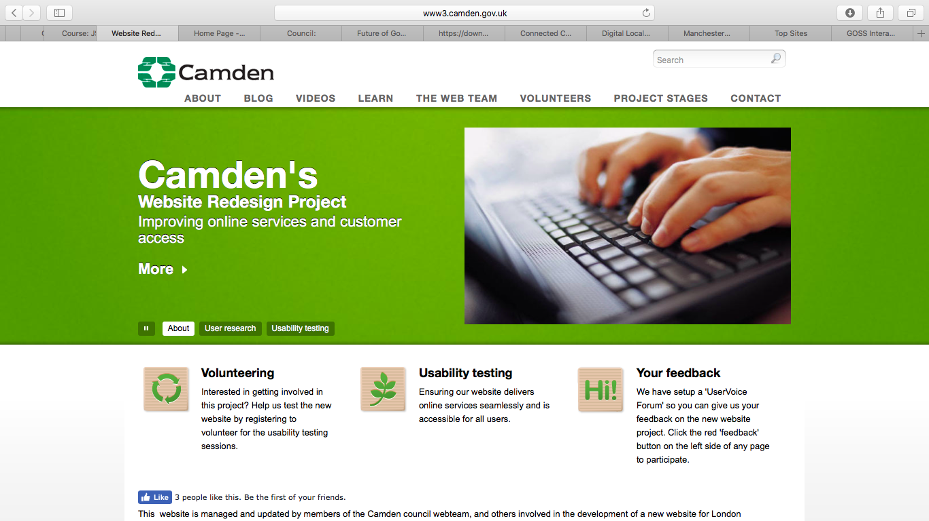

Figure 11: Camden Council Website Redesign Project Blog encouraging user engagement throughout the research and implementation phases.

This vibrant, dialogic approach to the project appears to have bought users on board in a way that granted them a sense of investment and ownership in the project, with the results reflecting a genuine acknowledgement of their self-articulated needs. Such an approach is likely to be more successful and enhance engagement than one conducted on the basis of what councils might think or assume their users want, and is important for our own methodological approach in building on CCs existing successes with user engagement in ongoing website evolution. Although this phase of the research doesn’t currently include a blog, findings from phases 1& 2, and any changes made as a result of phase 3 could potentially be written up and published in blog form on the council site as a means of including as broad a user-audience and wide access to the processes of change as possible.

ANALYSIS AND DISCUSSION

PHASE 1: WORKING WITH EXISTING CC DIGITIAL UPTAKE DATA

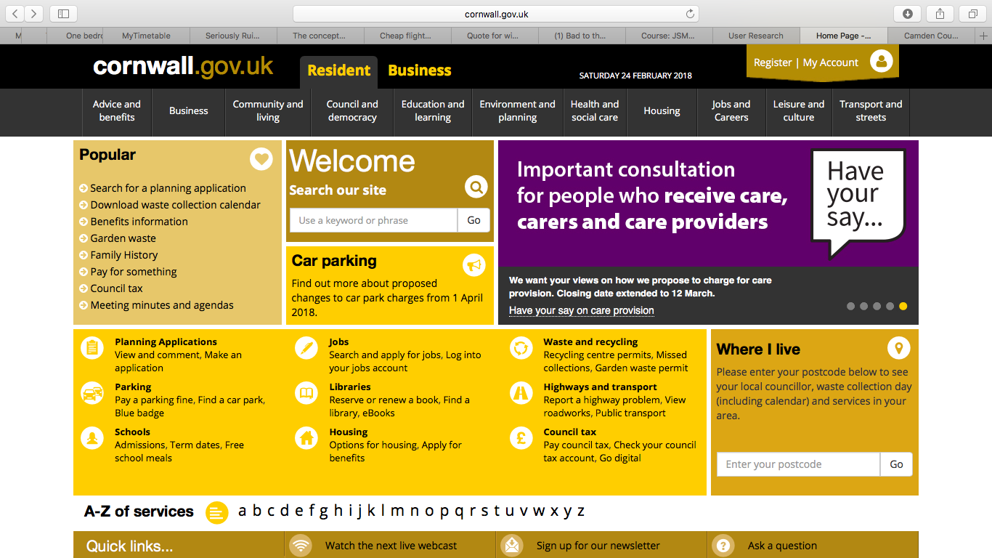

Figure 12: Cornwall Council website Homepage, February, 2018 (http://www.cornwall.gov.uk)

CC Digital Uptake and Design Histories 2013-14 and 2017-2018: the Foundations

Following a successful legal battle with BT in 2015 to extricate CC from a dysfunctional IT partnership signed in 2013, Cornwall Council’s service director for customer access and digital services acknowledged that CC was “behind the curve” with IT services (Read, cited in Hitchcock, 2017). In March, 2014, the current website was launched and the team began work on a strategy to significantly increase investment in IT services, addressing the troubled BT contract and long term perceived under-investment in IT (ibid). The research partnership with Falmouth University forms part of that increased investment.

The View from the Team

Anecdotal narrative data from members of the digital services team was collated into an e-mail to Falmouth University dated 12th March, 2018 (see appendices). The data is hugely valuable as it adds depth to the story from institutional actors directly involved in implementing channel shift from an expert perspective and shows the ethos behind the design decisions taken in 2013/2014:

We [carried out] an exercise to split up our screen estate and work out which parts were successful and which weren’t using statistics … we used analytics to work out what our top tasks were that people were performing online and then used those to write a design brief. At this time we also considered a mobile template and what we would need to present from that too. Once we had a design we used Chalkmark to test this by asking customers where they would click report a selection of tasks. First of all we tested this internally using our feedback group of staff, then we tested externally using our user group of 700 volunteers (CC Digital Services Team e-mail, 2018).

A strategy of evidence-based and collaborative work with the local community is articulated in the approach, and the importance of collaboration and feedback in implementing web design for public services will be addressed in further detail later in this literature review.

Useful narrative was also provided by the team on some of the service specific concerns at CC during these historical re-design phases. Data was gathered using Acorn customer profiling on Council Tax Revenues; Garden Waste; Blue Badge Holders; Highways ‘Report Potholes’ service, and School Transport. Some of these are worth mentioning further here as they provide valuable context for the project.

Analysis of Council Tax data over 500,000 householders showed that take up of online processes was lower than CC’s nearest neighbour. A review of these figures concluded that the likely cause for this was that a “complex verification process put people off” (CC email 2018). According to the team narrative, responses to this disappointing take up included:

New software in train. Texting launch, website redesign, web chat with verification piloted, statutory notification letter, redesign QR code, introduced promotion of online reduction of prominence of phone number. Growth steady - anticipated step change with new software-launch 2018.

Garden-waste customers make 30,000 contacts per year, and Acorn profiling indicated a shift from 40-76% in online transactions over two years following interventions including “reduce profile of phone number [through] letter redesign, phone scripts changed, incentive and speed of answering calls reduced” (CC email 2018)

The interactive ‘report potholes’ services for Highways was launched in February 2018 using a ‘soft-launch’ approach with no marketing’. The team reports that resident satisfaction results were low and the Highways Customer Excellence team ‘inundated’ leading to “Website redesign; call scripts changed; email footers changed; social media promotion” (ibid)

School Transport is reported as having the “highest customer predisposition for online services” leading to a “website design to focus more for online self-service [and] call scripts changed”, and
the team also reports website redesign in relation to Adult Services in which we see “call handling calls changed to reflect customer journey [and] call scripts amended” (ibid).

This data provides a rich unfolding narrative of ongoing evaluation and amendment in implementing channel-shift across the varying profiles of key services at CC.

Also interesting in the team narrative is the perception of CC’s position in relation to the digital skills and behaviours of users. As seen at the start of this section, the digital services team articulate an a sense of being “behind the curve” of the majority of their own users who are already going online to perform a number of other daily transactions:

Our customer profiling shows that our customers are already booking their holiday, ordering their books, doing their tax returns, applying for benefits, using social media to keep in touch with family across the world. The Council is significantly behind where our customer base is (E-mail, 2018)

Of course, not everybody is comfortable carrying out transactions online, and this is acknowledged too through responses in the team to the user profiling work at CC.

For the 20% that have not been online in the last 12 months 17% of those have a friend or family member that helps them or does it for them. For those with no online ability we have a robust vulnerable protocol so services can still be accessed in a face-to-face environment or on the phone (E-mail, 2018)

There is a well-considered acknowledgement in the team narrative report of the current weaknesses that need to be addressed according to team members, which is invaluable in framing design and analysis of this project. For example, the team report perceived barriers to user engagement such as “Our ability to deliver front line fully integrated no touch online technology at a pace our customer is expecting…” (ibid), again foregrounding the expectations of customers based on the speed and sophistication of digital change across daily activities undertaken elsewhere online.

Also raised was the perceived failure of marketing to exploit those processes already online using to increase uptake across further services using “nudge techniques and sticky content” (ibid). There is however a reduced ‘bounce rate’ % (the percentage of users accessing a page on the website then leaving before viewing any other page/s) across the board of service provision from the 2013/14 figures produced just prior to the launch of the new site, and the 2017/18 figures (ibid).

The need for all departments to be fully on board with and cognisant of best practice in relation to channel-shift is revealed in this insight. Barriers to engagement might just as easily come from resistance occurring between departmental nodes within institutional networks as from external factors, and that resistance or ‘blocking’ might simply be a case of entrenched legacy approaches not shifting rapidly enough to keep up with effective channel shift. This is further elucidated by the team’s awareness of the importance of boldness in leadership when implementing digital change when they write that:

The most successful areas are Revenues and Assessment and Waste both due to the leadership within those services driving through change and being brave enough try something new (ibid).

Whilst institutions can work towards whole system approaches in making channel-shift more seamless, a lack of agency and control over externally provided service areas is articulated as frustrating by the CC team. They cite such third party systems, including “our online planning register, democratic services management system and library catalogue”, adding that “with these systems we often have little or no control over the design and function” (ibid).

The team were also keen to address the issue of strategies for making content accessible for mobile devices, “during our redesign in 2014 we developed a mobile template. During any customer journey testing or UAT we always test on as many devices as we can” (ibid). Considering the staggering shift in mobile phone sessions (from 2013/2014 user statistics to the 2017/18 report) of 246.61% across all online services, and 6596.65% on the Cornwall.gov.uk site alone (CC, 2018) this is clearly a significant factor in any ongoing digital design process, and something we can look at where relevant in our own data set.

PHASE 2: THE TELEPHONE QUESTIONNAIRE

184 callers to the control centre in Truro were canvassed by telephone operators using the phase 1 questionnaire on 8th and 9th July, 2018 (see appendices for a copy of the questions). Of those, 63 reported having tried to access online services prior to phoning, the remaining 121 having gone straight to the telephone

This phase collected responses to generic questions about the callers’ internet use across a broad cohort of council service users. The data gathered is useful in its own right as a broad snapshot of use across 2 days in July, 2018, but more importantly provides means of identifying and sampling potential respondents for a third phase of deeper analysis in response to the initial findings.

All respondents canvassed were asked if they would be willing to get involved in further research following the initial phase.

84 agreed to consider taking part in further research, and gave details for further contact. Of the 99 who did not wish to be contacted further, 56 cited ‘lack of time’ as their a reason, 43 simply said they ‘were not interested in web services’, and 15 of the respondents cited both reasons together.

One of the key aims of the project is to get to know more about why some people, who could engage, choose not to (relate to stats and other work across councils). The next section will look at those callers who went straight to telephone, eschewing any online interaction at all.

Going straight to the telephone: callers not accessing website prior to calling

This user group is clearly of great interest to us in line with the aims of the project. Herein lies a wealth of potential for understanding why callers hadn’t attempted first to access services online before picking up the phone. A number of questions might arise in considering the question. Is this about lack of knowledge of online service availability, attitudes, poor perceptions of the quality of online information, lack of digital skills, trust, connectivity problems, administrative barriers, disabilities or other reasons? What might we learn from this group that we might harness and dig into for the next stage of analysis?

Respondents were asked whether or not they had attempted to access the council website prior to using the telephone. At 78% (140 out of 184), the overwhelming majority of callers reported not having attempted to use web services first on this occasion.

Overall, the figures and rationales for those not accessing online services look like this (Figure 13):

Reasons For Not Using Website Prior to Phoning | Number of Callers
Prefer to talk to someone | 70
No internet access/device | 27
Didn’t know service was available online Have tried website before without success | 7
No internet access/device | 6
Don’t like sharing data/payment details online | 2
Other | 28
Total | 140

Figure 13: Rationale for not using website prior to calling by caller number

As noted in previous research into digital engagement with government process, three in ten (30%) internet users who don’t complete Government processes online say it is because “they prefer some kind of verbal contact, either by phone or by talking to someone in person, or because they think the process cannot be done online” (Ofcom, 2017: 72).

This figure was much higher in the Cornish cohort, with 38% of all callers canvassed (and 50% of those who went straight to the telephone) reporting a preference for ‘talking to someone’.

More detail is required in order to work with the potential of this group of callers in phase 3. Questions we need to answer might include the motivation behind callers’ desire for human interaction. For example, to what extent was this expressed as a generic desire to deal with another human indicating a sense in some that digital communications are somehow too technical or soul-less, and might this be nuanced across variables such as age (see ‘Age Is Just A Number?’ section later in report). Alternatively, might some of this desire in fact be prompted by a lack of non-verbal information online currently, requiring callers to seek a more complex human interaction to effectively deal with their enquiries? Given the size of this group, this could certainly form a rich area for more intense scrutiny in the next phase. Are, or might there be design responses that might begin to address this very clear desire in the user group canvassed?

Internet Access Problems

Having no internet access or device forms 15% of the overall response for not accessing CC digital services. Issues of access to wi-fi need to be assessed across the entire cohort in the bigger picture of how internet provision across the region might impact on digital engagement. Again, existing information from CC may already be addressing this issue and further discussion with CC will inform the extent to which we sample respondents for this particular issue in Phase 3.

Previous Unsuccessful Experiences with Online Services

The 7 respondents who have accessed web services before and not had a successful or positive experience raise important questions about why their previous attempts failed, and what might be done to tempt these users back online in the future. This is a user group who have demonstrated willingness to engage digitally, albeit one that has been undermined by an unsatisfactory experience. This may be a result of a digital skills deficit, but it may also highlight problematic areas of digital service that can be addressed to improve future engagement.

Unaware of Online Services

The 6 callers unaware of the presence of online services are also a group worth exploring further in Phase 3 where possible to elicit further information on where they currently access council information, what might persuade them to go online, and their current levels of digital skill.

Anxieties with Sharing Information Online

The 2 who reported anxieties with sharing information online appear to be in a minority as service use and access generally shifts online, but it may be the case that more reassurance on data protection could be provided on site? The current environment of generalized anxieties around data protection breaches may also mean that these numbers may increase in future and that is something to be aware of, although the council’s robust GDPR policies may mitigate against that, and this is something worth exploring in Phase 3 as part of a digital skills assessment. This will be discussed in further detail in relation to the ‘lack of digital skills/trust’

The ‘other’ section produced some interesting short narrative responses – 28 in all, tabulated with shaded coding into broad thematic categories for ease of assimilation (figure 14 below):

LACK OF INFORMATION | LACK OF DIGITAL SKILLS/TRUST
“Information not online” | “Can’t use it very well”
“Right info wanted” | “Not too good on the internet”
“Wanted update quickly” | “Too confusing”
“She thought there may not have been the facilities online” | “Happy to make phone payments”
 | “Not confident online”
“Needed further info” | “Try to stay offline as much as possible”
“personal, no information online” | “Has tablet but not sure how to use it”
ALREADY HAD TELEPHONE NUMBER
“Had direct number” | SERVICES NOT AVAILABLE
“Easier to phone and didn’t need to use website as I already had number” | “Needed to call to make a booking”
“Didn’t think about it – had letter with number on” | “Booking system not available online” (planning)
“Didn’t think about it as Cornwall Housing gave me the number” | “Had to change a notice of marriage appointment”
“number was given by maternity team so didn’t bother going to website” | “Registration”
ADMINISTRATIVE | EQUALITY ACCESS ISSUES
“Thought I would have to register” | “Caller is blind/partially sighted and cannot see screen”
“Moved” | “Only have mobile access and medical condition makes online input/forms difficult due to shakes”
“Didn’t have Ref number”
INTERNET ACCESS PROBLEMS
“Internet not working”

Figure 14: Brief descriptors of ‘other’ reasons for not going to website prior to calling the council by telephone.

The various thematic categories provide a number of issues for further consideration in Phase 3, set out and analysed below:

Already having been given or accessed a telephone number so ‘not bothering’ to go online

5 callers stated already having a telephone number as their reason for not going online. The implication here is that calling first is seen as the preferable, intuitive or easier approach. Two callers for example said they ‘had a direct number’. This is evident in the language used by those 2 callers who preface their response with “Didn’t think about it…” as they already had a telephone number (SR54 given number by Cornwall Housing. SR96). The caller wanting to register a birth had been given a number by the maternity team and so “didn’t bother” going to the website (SR 177). One caller stated clearly that they felt it was ‘easier’ to phone, and having a number obviated any ‘need’ to go online. This ties in with findings in the group of users who did go online first, but purely to access a telephone number for the main switchboard. This theme should be explored in Phase 3, as here we have a group for which increased digital skills and awareness of what exactly the Council is offering by way of online services might shift the naturalised impression that phoning is the obvious first choice. It is clear also that external, third party agencies (such as the maternity team) in this instance may perpetuate that belief by handing out telephone numbers rather than website addresses, and this may form part of a broader awareness drive for CC extending beyond just residents to the range of third party agencies they may come into contact with en route to accessing Council services.

Not comfortable or ‘confused’ with using online services, devices or prefer to use phone.

Lack of digital skills or confidence was expressed overtly by three of these callers:

“Can’t use it very well” (SR97)

“Not too good on the internet” (SR16)

“Too confusing” (SR58)

“not confident online” (SR60)

One caller told the operators they had a tablet but didn’t “know how to use it”. One simply stated that she tries “to stay offline as much as possible” (SR25 calling in relation to planning) indicating discomfort or lack of trust in digital environments in general. Callers in this category are perfect candidates for further analysis in terms of their location on the digital inclusion scale, basic and foundation skills as defined by the Essential Digital Skills Framework, (2018) (EDSF). There is real potential for progressing such callers along these skill scales towards full engagement in the future.

Perceptions or experiences of lack of required information online

These callers expressed a belief, either intuitive or related to previous experience, that the information they required would not be available online. This was articulated variously. Several callers implied a certainty that what they wanted wasn’t or wouldn’t be there or would take too long to find:

“Information not online” (SR4)

“Right info wanted” (SR57)

“Wanted update quickly” (SR105)

“Needed further info”

Another ‘thought’ that the information wouldn’t be there, so called anyway without checking.

One caller was seeking information relating to her Mother’s eligibility for a particular service specifically, so called because her request was in her opinion:

“personal, no information online” (SR134)

So, again this constitutes a category of callers for whom greater awareness of what is available online may potentially change behaviours currently based on incorrect assumptions.

Specific services not yet available – for example booking systems

The four callers in this category told operators they had called first because they couldn’t do what they needed to do online. For 2 callers this was about a perception that there were no facilities to ‘book’ services online (SR 169 - Registration, and SR 56) and for another a need to amend an already booked ‘notice of marriage appointment’ (SR147). The last of the 4 simply stated ‘registration’ (SR162) indicating a common knowledge that registration cannot be managed online.

This category highlights either perceptions or realities of challenges with completing some specific service-related tasks online and so is useful for further exploration.

Administrative – such as caller having moved address or not having reference number

Not having a “reference number” (SR124, SR 73) was cited by residents who hadn’t gone online first as well as those who had. Wanting to report a change of address after having “moved” was another. One caller “thought they would have to register”(SR 44- Council Tax). These rationale are ripe for further exploration in terms of whether these administrative challenges actually do exist in relation to particular tasks or services online, addressing them if they do and addressing misconceptions among the user group if not.

Equality of Access

One of the two callers who went straight to the switchboard because of physical barriers to online access reported having “impaired vision” (SR107). The other was quite detailed in their description of only being able to access the internet via their mobile, and physical “shaking” (SR68) from a medical condition acting as a barrier to mobile phone internet access.

Clearly, access to services for callers with disabilities is an important issue in any aspiration to digital inclusivity. Further information is required from CC on their existing policies and work on inclusivity of access, to inform to what extent we might address this in phase 2.

GOING ONLINE FIRST: CALLERS LOGGING ON BEFORE CALLING
Another key interest group were those callers who tried to access services online first, but then ended up phoning the call centre anyway. Although a significantly smaller group in the data set, this cohort is equally interesting. As online service users who have had to resort to calling by telephone after consulting the website, it might be assumed they can tell us something about where the site is not meeting their needs, assisting us in identifying any gaps or omissions, and thinking about design solutions with their input. The next section looks closely at this group
Of the overall cohort, 17% (32) had visited the website first before calling.

We asked callers to say something about why, after accessing the site in the first instance, they ended up phoning anyway.

Reasons for resorting to telephone after visiting site | Caller numbers
Couldn’t find information I needed online | 17
Found website confusing to navigate | 17
Couldn’t complete transaction online | 17
‘Other’ | 17

Figure 15: Rationale for resorting to telephone following website visit by caller numbers

It is important to note that some callers cited more than one reason in this category, and several also used the ‘other’ category for a short narrative expansion on their responses. For this reason, I have avoided close scrutiny of the quantitative and percentage results (of limited value in this smaller category anyway), favouring instead the more relevant qualitative responses that will inform the next phase.

As with those callers not going online first, data is organised into thematic blocks, tabulated below in figure 16, and expanded on with further analysis of each theme following the table:

Wanted to Talk to Someone  “Needed to speak as not standard enquiry”  “Had some complex questions”  “Wanted to talk about a letter”  “Like to talk to someone”  “Preferred to talk to someone”  “Would rather talk to someone anyway”  “Prefer hard copy or basic phone”  “Really dislikes online services and prefers to speak to someone”  “Just call and ask”  “Wished to speak to someone”  “Would prefer to speak to someone when work-related”  “In this instance preferred to talk to someone and did not have account ref” | Specific Service-Related Issues  “First time registering for council tax” (x 2)  “Registration of birth” (x 2)  “wanted to speak about recovery”  “Down to a recovery notice and needed to talk to a person”  “Recovery notices needed to be resolved by phone call”  “Wanted clarification on recovery as was very confused”  “In regards to enforcement”  “Get Update”  “Needed to know if her Mom was registered for clinical collection”  “Thought they need to come in and pick up birth registration certificate in person so phoned to check”  “In regards to major works”
Phoned after online transaction for ‘confirmation’  “Needed more clarification and confirmation on case”  “Likes to speak to someone regarding Council Tax for confirmation”  “Needed to call for confirmation”  “Wanted to confirm info”  “Confirm collection info”  “Thought transaction went wrong” | Caller found website ‘confusing’ or uninformative  “Very confusing website”  “Not substantial facility online to do this more”  “Hard to find info – confusing”  “Couldn’t find links to the web forms easily enough”  “Quick/easier to call in the end”  “Couldn’t workout how to upload V5 Document”  “Opted to phone as website was confusing”  “Hoping there would be more information”
Went online only to get telephone number  “Only accessed website for contact number and info – did not attempt web forms”  “Went online primarily for phone number – didn’t look to see if he could do it online himself” (refuse and recycling)  “Prefer to phone – used site to get number” | Caller Lacked Digital Skills/Confidence to Complete Transaction Online  “Not very good on a computer”  “too modern”  “It’s her generation to speak to someone”  “Bad with the internet and technology”  “needed to call”  “She’s not very good with computers”  “old-fashioned”
Advised to call by ‘Webchat’  “Advised to phone by webchat”  “Advised to on webchat” | Access Issues  “Website not loading as mobile internet slow”  “Awaiting online access as just moved”  “Didn’t have 4G internet access”  “Customer’s computer in for repair but would normally use us online”
Previous negative experience online

“Used payment line before and payment didn’t go through”
Needed reference to complete transaction

“Couldn’t use webforms as didn’t have ref”

Figure 16: Narrative rationale by callers who accessed website prior to calling

Again, these were coded through shading into broad thematic groupings to allow for sampling and deeper analysis in Phase 3, and each category will be discussed in further detail in terms of its relevance to the next phase below:

Specific Service-Related Issues

13 callers going online first found reported having to call anyway due to specific service-related issues. Most notable among these were those trying to deal with “recovery” in relation to council tax. 4 of the 13 callers were in this group, and reported a ‘need’ to talk to someone, citing a lack of information and confusion surrounding the processes. 2 callers cited “registration” as a service that required them to phone after visiting the site, and two phoned to register for “first time council tax” payments. More information about processes for these particular services is needed from CC to inform sampling for the next phase. Are these processes that actively require residents to call first? Could they be made accessible online, or more clearly accessible if they already are? If not, could further information be given online that makes a need to speak to someone clear?

Logging on first but needing to ‘talk to someone’ anyway

These 7 callers who tried digital access but then still called because they wanted to talk to someone are a potentially rich source of information. This group will be further nuanced by age and service type where that information is available, and sampled accordingly for the next phase. Given that this is a group who are demonstrating willingness and ability to attempt digital transactions, it might be assumed that very little may need to be done in order to progress them towards effective digital interaction with the Council, and that the challenges they faced might yield valuable information on some of the barriers people are facing once they do get online.

Callers finding the website ‘confusing’ or unable to complete transactions

As above, this is a valuable group in terms of identifying challenges people are experiencing in relation to the website and online services. 3 of the 8 callers described the website as ‘confusing’, and it might reasonably assumed that the caller who found it ‘quicker and easier to phone in the end’ did not have the most successful experience online. The 2 callers who “couldn’t find links” or work out “how to upload a V5 document” for disabled parking (SR 154) indicate that some users are having their attempts to transact online thwarted by confusion in accessing the required webforms. Again, where possible, such respondents will be sampled for further research in phase 3, and the issue addressed in further questioning. If aspects of the site are confusing to some users, we need to know whether this is a matter of site design and navigability, more aligned with the digital skill levels of users, or a combination of factors. Residents of a North London borough included ‘confusing site’ on their ‘wish list’ for service amendments (see appendices) during the Camden website redesign phase (2011), many reporting that they “would resort to calling after having an unpleasant experience with the website” (Camden ‘wish list’, 2011), mainly occurring as a result of being unable to find the information they needed after logging on.

Not comfortable with technology: Digital skill issues

Although these 7 users had a go at using online services, they called anyway and cited a discomfort with digital services, or lack digital skills as the reason for doing so. Responses here were particularly interesting as they show a range of ways of articulating a lack of digital skills that might fit into broader cultural attitudes to digital communications and identity.

The following three callers describe themselves as ‘bad’ or ‘not very good’ in relation to ‘computers’, ‘the internet’ and ‘technology’:

“Not very good on a computer” (RS141 - CT)

“She’s not very good with computers” (RS128 - CT)

“Bad with the internet and technology” (RS129)

There is a distinct homogenizing, or ‘black-boxing’ of digital communications into the material form of the devices that enable them: ‘computers’; the conceptual space they operate in: ‘the internet’; and the broad concept of ‘technology’ itself as something difficult, alien and un-human.

Another 3 callers went on to describe their challenges with online communications entirely in generational terms:

“too modern” (RS58)

“It’s her generation to speak to someone” (RS130)

“old-fashioned” (RS61 CT)

This phase of the report will look more closely at how responses mapped across the various age groups in due course. However, it is clear that perceptions and desires surrounding digital inclusivity are to some extent impacted on by age groups and the cultural attitudes and experiences that define certain age bands. This is by no means an essentialist approach, as variable attitudes are demonstrated across all groups, but distinct patterns do emerge and this again is a useful parameter for further work and sampling in the next phase and beyond.

Calling for ‘confirmation’ following online transaction

6 callers reported completing their transaction or information search online, then calling anyway to confirm the transaction was complete or that they had correctly interpreted the information found. Of those 6, 5 actively used the words ‘confirm’ or ‘confirmation’ (SR 103, SR104, SR99, SR140), indicating a lack of clarity about whether the transaction had completed effectively. Samples from this grouping where possible can indicate to what extent this is around a generic lack of trust in online transactions, or design interventions that might make it clearer to a user that their transaction has completed successfully – sending a confirmation e-mail or text message for example, or provision of records in a ‘my account’ service for users if or where that is not yet available. It is also important to take into consideration the experience of the caller who declared having “used [the] payment line before and payment didn’t go through”. To what extent might previous unsuccessful online payments with CC or other services influence a lack of trust or engagement with online payments in future? How much is this tied into an already fragile sense of trust in digital transactions by some groups in society, and can we identify those in the Cornish cohort?

Only went to website to get number – did not attempt to access services

The assumptions and habits that lie behind seeking out or using available phone numbers as a first line approach to communicating with the council are set out in the previous section. Where users are actively going online just to retrieve a telephone number, then logging off to call (SR7, SR59, SR103) these attitudes are obviously fairly entrenched. Exploring this in further detail, and underpinning strategies for working with clients to persuade them to stay online to complete their transactions where possible once they are there is an important factor of the next phase.

Couldn’t use forms without a reference number

2 callers had been unable to complete webforms without knowing or having access to reference numbers required on the form (SR 69 change of address, SR 132). Are there ways in which this administrative access problem might be worked around? Does this kind of frustrating experience perhaps dissuade people from trying to use online services again?

Internet access problems

A number of access problems were reported. These included two temporary inabilities to get online due to a broken computer in one case, and being offline due to a recent house move in another. The remaining two had problems with “no 4G”, and slow-loading of the site due to patchy mobile data (SR127, SR121 CT).

Advised to call by Webchat

Two callers phoned after being advised to by webchat services (SR75 CT, SR43 CT). This raises questions surrounding the degree of assistance webchat operatives are trained or able to give in helping customers to complete transactions online. Is there a lack of parity in access to information with between webchat and telephone operatives, or are online ‘chatters’ only advised to use the telephone as a means of being re-directed to specific services for more detailed discussion of their cases or queries?

These initial thematic findings across those calling first and those logging on first are nuanced in the following sections across age, gender, service and device type in order to broaden the perspective on particular questions to ask in the next phase, and to inform sampling at a more granular level.

The Bigger Picture

This section of the report nuances findings across selected variables (such as Service accessed, device-type and caller age and gender). This allows for any patterns emerging across these distinct groupings to be identified and addressed in sampling for Phase 3.

The table below plots callers across the variables selected and gives an at a glance snapshot of the overall picture of callers over the two day Phase 2 data collection period:

Service | Callers | Visited website first | Device Used |  |  |  | Age |  |  |  |  |  |  | Gender
 |  |  | Desktop | Mobile | Tablet | Unknown | 16-24 | 25-34 | 35-44 | 45-54 | 55-64 | 65-74 | 75+ | Female | Male | Unknown
Council Tax | 35 | 11 | 8 | 2 | 0 | 1 | 2 | 3 | 2 | 3 | 1 | 0 | 0 | 2 | 1 | 8
Planning | 9 | 5 | 3 | 2 | 0 | 0 | 0 | 1 | 0 | 2 | 2 | 0 | 0 | 4 | 1 | 0
Refuse/ Recycling | 6 | 2 | 0 | 2 | 0 | 0 |  |  | 1 | 1 |  |  |  |  | 1 | 1
Registration | 7 | 1 |  |  | 1 |  |  |  |  |  | 1 |  |  |  |  | 1
Disabled Pkng | 3 | 2 | 2 |  |  |  |  |  |  |  | 1 | 1 |  |  |  | 2
Adress change | 2 | 0 |  |  |  |  |  |  |  |  |  | 2 |  |  | 1 | 1
Environmental Health | 4 | 3 | 1 | 1 | 1 |  |  | 1 |  | 2 |  |  |  |  | 1 | 2
Parking permits | 2 | 0 |  |  |  |  |  |  |  |  |  |  |  |  | 1 | 1
Garden waste | 2 | 1 |  |  | 1 |  |  |  |  |  |  |  | 1
Highways | 2 | 0
Bus passes | 2 | 2 |  | 1 | 1 |  |  | 1 |  |  |  | 1 |  | 1 | 1
Bulky waste | 1 | 0 |  |  |  |  |  |  |  |  |  |  | 1 |  |  | 1
Concessionary Fares | 1 | 0 |  |  |  |  |  |  |  |  |  | 1 |  |  |  | 1
Land ownership | 1 | 1 | 1 |  |  |  |  |  |  |  |  |  | 1 |  |  | 1
Roads and verges | 1 | 1 | 1 |  |  |  |  |  | 1 |  |  |  |  | 1
School transport | 1 | 0 |  |  |  |  |  |  | 1 |  |  |  |  | 1
Found dog | 1 | 0 |  |  |  |  |  | 1 |  |  |  |  |  | 1
Parking | 1 | 0 |  |  |  |  | 1
Noise nuisance | 1 | 0 |  |  |  |  |  |  |  |  |  | 1 |  | 1
Park times | 1 | 1 |  | 1 |  |  |  |  | 1 |  |  |  |  |  | 1
Post 16 transport | 1 | 1 | 1 |  |  |  |  | 1 |  |  |  |  |  |  |  | 1
Countryside access | 1 | 0 |  |  |  |  |  |  |  |  | 1 |  |  | 1
TOTALS | 75 | 32 | 17 | 9 | 4 | 2 | 3 | 8 | 6 | 8 | 6 | 6 | 3 | 12 | 8 | 20

Figure 17: Callers who visited website first by service, device, age and gender

The remainder of this report will look in detail at themes emerging across device type, gender, age and service use and how we might work with those effectively to inform and get the most out of the next phase of the research.

ONLINE ACCESS BY DEVICE TYPE IN THE CORNISH COHORT

For those who had gone online prior to phoning, we asked what devices they used to see if any device-specific patterns emerged.

Device Type | Number of callers using device type
Desktop Computer/laptop | 30
Mobile phone | 27
Tablet | 17

Figure 18: Device type use among callers accessing CC services online

Desktops were the most common device used to access online services among those canvassed, closely followed by mobile telephones and a not insignificant number reporting using a tablet.

AGE IS JUST A NUMBER?
RESULTS OF PHASE 2 BY AGE RANGE IN THE CORNISH COHORT

Callers were asked to put themselves into one of 7 age ranges from 16 years to 75 years+. The results are tabulated below (Figure 19), with 179 callers answering the question:

As age is often seen as a predictor of particular behaviours and attitudes in relation to digital engagement, a coding process was conducted to triangulate a number of thematic variables across the data set in relation to age. Are particular age ranges displaying particular behaviour patterns and thus in need of closer attention in extending digital democracy equally across the community in Cornwall?

Age Range (years) | Number of Callers | Visited website first | Phoned first | Prefer to talk |  | Digital Discomfort | Unaware of online services | website confusing | Not enough information | No access | Tried before | Couldn’t complete
16-24 | 14 | 4  29% | 10  71% | 5  38% |  | 1  7% | 0 | 0 | 2  14% | 2  14% | 0 | 1  7%
25-34 | 36 | 14  39% | 22  61% | 12  33% |  | 0 | 2  6% | 1  3% | 4  11% | 2  6% | 4  11% | 7  19%
35-44 | 22 | 15  68% | 7  32% | 1  5% |  | 2  9% | 2  9% | 1 | 8  36% | 2  9% | 1  5% | 4  18%
45-54 | 33 | 11  34% | 22  66% | 15  45% |  | 4  12% | 2  6% | 2  6% | 6  18% | 4  12% | 1  3% | 0
55-64 | 25 | 7  27% | 18  73% | 7  28% |  | 2  8% | 2  8% | 3  12% | 1 | 3  12% | 0 | 2  8%
65-74 | 34 | 8  26% | 26  74% | 11  32% |  | 1  3% | 0 | 2  6% | 1  3% | 9  26% | 2  6% | 4  12%
75+ | 18 | 4  22% | 14  78% | 9  50% |  | 1  6% | 0 | 0 | 4  22% | 7  39% | 0 | 0

Figure 19: Responses by age range

The remainder of this section explores the responses in relation to the 7 age bands within which users were asked to locate themselves. Which groups are most likely to demonstrate behaviour patterns indicating high levels of digital engagement, and what barriers are they encountering once online? Conversely, which groups are currently least likely to engage with digital services, and what can we find out about their reasons for non-engagement?

35-44: Key Digital Engagers

On the two days in July, 2018 when callers were canvassed an overall 30% of the 184 callers had attempted to get information or complete a transaction online immediately prior to calling. Of those, a significant 68% were in the 35-44 age range. This places Cornwall in line with the national figures for digital engagement with local councils, which show this age group demonstrating the highest likelihood to engage online (see Figure 20 below), although the differential was 9% higher in our cohort (Ofcom, 2017).

All internet users |  | 16-24 | 25-34 | 35-44 |  | 45-54 | 55-64 | 65-74 | 75+
Pay online for your council tax or for another local council service (parking ticket, congestion charge etc.) | 46% | 28% | 57% | 59% |  | 47% | 48% | 31% | 19%

Figure 20: Extract from Ofcom table Figure 42: Use of public or civic services online, by age, in the Adults’ Media Uses and Attitudes Report, 2017, p69.

Prompted to explain why they had ended up calling anyway, 36% (8) of these 15 respondents said there ‘wasn’t enough information’ to assist them online; 18% (4) couldn’t complete the transaction online (the 2 who recorded their chosen service called registration and ‘couldn’t complete the booking online’ (169, Female) and environmental health; and 2 (9%) had problems with loading due to connection problems on their devices.

The remaining 7 (7%) of respondents in this age range who called first, reported a number of reasons for not going online from feeling uncomfortable online, through a simple preference to talk, not being aware of online services and access issues.

25-34: Getting On Board

Again, as with the national Ofcom figures (2017), 25-34 yr olds were the next age group most likely to have logged on first, with 14 callers (35%) going to the site before calling.

Age Range (years) | Number of Callers | Visited website first | Phoned first | Prefer to talk |  |  | Digital Discomfort |  | Unaware of online services |  | website confusing |  | Not enough information |  | No access |  | Tried before |  | Couldn’t complete
25-34 | 36 | 14  (35%) | 22  (65%) | 12  (33%) |  |  |  | 0 |  | 2  (6%) |  | 1  (3%) |  | 4  (11%) |  | 2  (6%) |  | 4  (11%) |  | 7  (19%)

Figure 21: 25-34 yr old results

Of this group, 7 of the 14 (50%) ended up calling anyway as they were ‘unable to complete the transaction online’. Interested in this high failure rate, further detail was analysed where given. Two were council tax enquiries relating specifically to ‘recovery’ (R123 and R138), which could not be completed online (this cropped up too in other age groups and will be discussed in further detail in the service-specific section later). Two callers did not have their service recorded, but both stated that they used the website first but then rang to ‘confirm’ (R103 and R104). Again, this cropped up in other age groups too and raises interesting issues surrounding trust in digital services, which will also be addressed later in this section of the report. 4 callers reported a lack of the information they needed online, the 3 who stated their service had enquires related to Planning (R26), Council Tax (R73) and Refuse (R174). One caller (R102) found the website confusing.

None of the callers in this age group reported a lack of digital competence or aptitude, although 12 of them who went straight to telephone simply said they preferred to talk, 2 were unaware of online services and 4 had tried online services before without success so decided to call on this occasion. Of those trying before without success, one failed on both occasions due to not having a ‘reference number’ (R124). Again, this was not uncommon across the entire cohort and raises areas for further research into administrative processes as a barrier to digital engagement to be explored in greater detail later in the report.

16-24: Digital Natives and the Council

The Ofcom study shows this demographic coming in behind the 65-74 yr olds in their likelihood of engaging with online council services. In this Cornwall-based study, the 16-24 yr olds canvassed over the two days represented the smallest group making up just 14 of the callers overall. However, they showed a slightly higher likelihood to engage digitally with the council than the national average (see figure 22 below):

Age Range (years) | Number of Callers | Visited website first | Phoned first | Prefer to talk |  | Digital Discomfort | Unaware of online services | website confusing | Not enough information | No access | Tried before | Couldn’t complete
16-24 | 14 | 4 (29%) | 10  (71%) | 5  (38%) |  | 1  (7%) | 0 | 0 | 2  (14%) | 2  (14%) | 0 | 1  (7%)

Figure 22: 16-24 results

That said, only 4 of the 14 had a go at completing their query online first, 2 of them finding not enough information (R86 - CT, and R85) one not able to complete the transaction (R11 – registering a birth) and one experiencing connection problems.

45-54: Middle Ground

Age Range (years) | Number of Callers | Visited website first | Phoned first | Prefer to talk |  | Digital Discomfort | Unaware of online services | website confusing | Not enough information | No access | Tried before | Couldn’t complete
45-54 | 33 | 11  (34%) | 22  (66%) | 15  (45%) |  | 4  (12%) | 2  (6%) | 2  (6%) | 6  (18%) | 4  (12%) | 1  (3%) | 0

Figure 23: 45-54 results

11 of the 33 callers in the two ‘middle-aged’ bands went online first, representing 34% in the Cornish user group as opposed to the 47% national average (Ofcom, 2017). Of those, 6 couldn’t find enough information to complete their enquiry (R27, Planning; R30; R99 ‘needed more clarification and confirmation’; R114; R159), 2 found the website confusing (R125 who ‘couldn’t find the links to the [Council Tax] webforms easily enough’, and R159) and 3 callers had phoned after experiencing internet access problems.

Of the 22 who telephoned first, we see a steep rise in the %figures for those reporting a preference for ‘talking to someone’. At 45%, this age group alongside the 75+age group (50%) were much more likely to state this as a reason for calling. This group also demonstrated the highest ‘digital discomfort’ rate at 12% (R25 Planning, who ‘prefers to stay offline as much as possible’; R60 ‘not confident online’; R61 CT who declared herself ‘old fashioned’, and R139 who declared that he ‘really dislikes online services’).

55-64: More Middle Ground

Age Range (years) | Number of Callers | Visited website first | Phoned first | Prefer to talk |  | Digital Discomfort | Unaware of online services | website confusing | Not enough information | No access | Tried before | Couldn’t complete
55-64 | 25 | 7  (27%) | 18  (73%) | 7  28% |  | 2  (8%) | 2  (8%) | 3  (12%) | 1 | 3  (12%) | 0 | 2  (8%)

Figure 24: 55-64 results

In the national Ofcom survey, this group was marginally more likely than the previous subset to engage online (48% in comparison to 47%). In the Cornish cohort, only 7 of the 25 callers (27%) had a go at online engagement before calling as opposed to 11 (34%) of the 45-54 yr olds.
Two callers visiting the website first (R148 and R172 Planning) found it confusing, one (R2) couldn’t get enough info and had to call; 2 callers had been unable to complete their process online, both relating to Disabled Parking (R153 and R154 who ‘couldn’t work out how to upload V5 document’).

A preference to talk was again reasonably high in this group with 7 0f the 25 callers (28%) expressing this as a rationale for going straight to phone (R2, R63’ R78, R79, R136 and R137). Digital discomfort’ expressed in terms of a ‘dislike for online payments’ was cited by one caller (R110 Disabled Parking).

65-74: Decreasing Access

^{Age Range (years)} | ^{Number of Callers} | ^{Visited website first} | ^{Phoned first} | ^{Prefer to talk} |  | ^{Digital Discomfort} | ^{Unaware of online services} | ^{website confusing} | ^{Not enough information} | ^{No access} | ^{Tried before} | ^{Couldn’t complete}
⁶⁵⁻⁷⁴ | ³⁴ | ⁸  ^{(26%)} | ²⁶  ^{(74%)} | ¹¹  ^{(32%)} |  | ¹  ^{(3%)} | ⁰ | ²  ^{(6%)} | ¹  ^{(3%)} | ⁹  ^{(26%)} | ²  ^{(6%)} | ⁴  ^{(12%)}

Figure 25: 65-74 results

Again, the final two age groupings align with the national averages in the Ofcom report in terms of likelihood to engage digitally across the age spectrum.

The major shift we see happening in this group in the Cornish cohort is a declining rate in access to online services, with over 25% of the callers reporting having no internet access or device.

Of the 8 who did attempt to go online first, 2 found the website confusing (R47 who reported ‘only accessing the site for phone number and not attempting any webforms’, and R58 who described the site as ‘too confusing’ and ‘too modern’. 1 had tried before without success (R7 who just ‘phoned to get the number’ on this occasion), 4 were unable to complete the transaction online (R50 who ‘called to confirm’; R59 who went online ‘to get phone number and general info but needed to call’; R69 Change of address who ‘in this instance preferred to speak to someone and did not have acc. R ref.), and R151 Disabled Parking.

Just one caller actually articulated feeling uncomfortable online (R97).

75+: Increasingly Offline and Preferring to Talk

Age Range (years) | Number of Callers | Visited website first | Phoned first | Prefer to talk |  |  | Digital Discomfort |  | Unaware of online services |  | website confusing |  | Not enough information |  | No access |  | Tried before |  | Couldn’t complete
75+ | 18 | 4  (22%) | 14  (78%) | 9  (50%) |  |  |  | 1  (6%) |  | 0 |  | 0 |  | 4  (22%) |  | 7  (39%) |  | 0 |  | 0

Figure 26: 75+ results

Perhaps unsurprisingly, given the generational differences in exposure to digital cultures, this oldest group demonstrated the least likelihood to have attempted any online access prior to calling, with just 4 of the 18 older callers visiting the website first. All four of them reported not finding enough information (R95; R161; R170 Land Ownership; R180 who also reported ‘not really wanting to look online’).

50% of this group told callers they preferred to talk, and 7 of the 18 callers (39%) reported having no internet access.

This section has organised data in a manner that will enable careful consideration of respondent age in sampling for phase 3, especially in relation to digital skills assessment, user profiling for CC and inclusive design considerations for encourage particular age groups online.

The following section will briefly consider gender as a variable in the Cornish cohort.

GENDER

Of the 93 respondents leaving contact details, 63 were female, 29 male and 1 did not state gender.

As gender was only recorded in the case of those leaving contact details, we can only look at gender variables within that group, but will attempt to sample across the gender groups in the next phase where appropriate.
It is worth noting that the Ofcom report of 2017 showed very little difference in digital engagement between male and female respondents, with women showing a 1% higher likelihood to pay online for a council service at 47%.

Figure 43: Use of public or civic services online, by socio-economic group and gender
All internet users |  | AB | C1 | C2 | DE | Male | Female
Base | 1553 | 394 | 521 | 300 | 338 | 745 | 808
Pay online for your council tax or for another local council service (parking ticket, congestion charge etc.) | 46% | 59% | 48% | 42% | 32% | 46% | 47%

Figure 27: Ofcom (2017) % figures for use of civic services online by socio-economic group and gender

Looking at gender variables could still be important in order to see if particular behaviour trends might emerge in Cornish residents, and sampling for Phase 3 will consider the gender mix.

However, given the national picture, perhaps more important is the extent to which particular services produce particular successes or challenges in channel shift. The following section will explore responses by service.

SERVICES ACCESSED

Did any specific themes and patterns emerge across particular service groups over the two days that information was collected? In total, Only 86 callers had the service they were calling in connection with recorded (see figure 28 below):

Service | Number of callers in total | Service | Number of callers in total
Council Tax | 30 | Bus passes | 2
Planning | 9 | Bulky waste | 1
Refuse and Recycling | 7 | Concessionary Fares | 1
Registration | 5 | Land ownership | 1
Disabled parking and parking permits | 8 | Roads and verges | 1
Change of address | 5 | School times | 1
Environmental Health | 4 | Found dog | 1
Garden waste | 2 | Noise nuisance | 1
Highways | 2 | Park times | 1
Birth certificates | 2 | Post 16 transport | 1
 |  | Countryside access | 1

Figure 28: Service required by the CC callers recorded

Although the cohort is relatively small, these telephone results remain in line with the historical web use data for CC showing that in both periods 2103/14 and 2017/18, council tax and planning accounted the highest two internal search terms on the website (CC 2018).

Data Analysis by Services Accessed

Closer analysis was carried out with specific service groups, triangulating them with age, gender (where given), whether callers had accessed the website prior to calling, and themes from the narrative responses. The aim here was to see if any patterns emerged that might inform knowledge of digital use by service, and also inform sampling for the next phase of the work. We are able to zoom in here in the micro patterns within each service. Do those services attracting the most callers reveal any patterns of unsuccessful attempts to use the website first for example, and if so, can we draw conclusions about why from data at this stage? Where people are not even attempting to use the website, is their behaviour age related, gender related or specific to services in some way? What else might emerge that we could work with in the next phase to inform communication and design processes?

Each service accessed by callers over the two days in July, 2018 is discussed below:

COUNCIL TAX

Clocking up 47% of the overall calls across the two days, Council Tax was far and away the most popular service request by those who recorded a service. Of the 35 council tax callers, 11 (31%) tried accessing the website first.

Rationale for resorting to the telephone following online attempts to deal with Council tax queries were varied and summed up as follows.

7 of the 11 callers (64%) reported that they ‘couldn’t find the information they required online’. Two of those also added that they found the website ‘very confusing’ (SR77) or ‘difficult to navigate…couldn’t find links’ (SR125). One of this respondent group specifically stated not being to find the required ‘recovery solutions’ (SR138).

2 of the 11 callers (18%) reported being directed to the call centre by webchat advisors.

One caller gave up on the website as it wouldn’t load due to their mobile being ‘too slow’ (SR121).

The last of this group who had tried accessing the site first in respect of council tax, simply stated that she was “too old fashioned” (SR61). This final respondent was in the 45-54 yr age group.

Rationale for those Going Straight to Telephone for Council Tax Queries

As stated, all respondents not going online first were asked to say something about why that was the case. In the case of the 24 Council tax respondents going straight to phone, the following reasons were given.

Recovery

In addition to the respondent going online first but not being able to get the required information about recovery processes, four further respondents (17%) went straight to the call centre to talk to someone about recovery. One of these added a further narrative dimension stating they were:

“very confused” (SR143, SR45-54)

Prefer to Talk

10 of the 24 (42%) stated simply that they ‘prefer to talk to a person’.

Digital Discomfort

Although to some extent aligned with those stating a preference to talk to a person, there were a number of respondents (3) who articulated an active dislike of or discomfort with computers and digital processes. These 12.5% of straight-to-phone customers articulated the following responses:

“Really dislikes online services” (SR139 – Male, 45-54)

“Not very good on computer” (SR141, 65-74)

“Not very good with computers” (SR128, Female, 65-74)

Access Problems

4 of the 24 (17%) had to call as they couldn’t get online for a variety of reasons, including 2 who had no internet access in general:

“Don’t have internet” (SR66, Male, 55-64)

“No internet” (SR62, Female, 55-64)

One who was temporarily without access due to a move:

“Would have gone online but no internet as just moved” (SR45, Female, 16-24)

And one who couldn’t get mobile data:

“No 4G” (SR127, 25-34)

First Time Registration

Two of those electing to call initially did so as they were registering to pay council tax for the first time:

“Needed to talk to someone as applying for first time council tax” (SR126, 25-34).

“Prefer to talk as first time registering” (SR38, Female, 16-24).

Unsuccessful Previous Attempts

One respondent described using the online payment facility before, and it “not working” (SR88, 25-34)

Unaware of Online Facilities

One female in the 65-74 age range told the telephone operators that she “thought there may not have been online facilities to pay” (SR142)

PLANNING REQUESTS

Planning enquiries made up 12% of the service-specific callers recorded, with 5 of the 9 callers (56%) trying an online intervention first. Of those 5, 4 were female and one male.

Rationale for resorting to the telephone following online attempts to deal with planning requests are summed up thematically as follows:

Not enough information or site confusing

Broadly speaking, all five of the callers going online first ultimately ended up calling for this reason, albeit variously articulated:

“Couldn’t find information” (SR26, female, 25-34)

“Hoping there would be more information” (SR173, Female, 45-54)

“Found website confusing” (SR172, Female, 55-64)

“Not a standard enquiry” (SR111, 55-64)

One caller went online first but:

“Preferred to talk to someone anyway” (121, Female, 45-54)

Rationale for those Going Straight to Telephone

Preferred to talk

Of the 4 who opted to call first, 2 (50%) simply ‘preferred to talk’. One of these (166) was female and in the 35-44 age bracket, the other did not register their gender and was in the 55-64 age range.

Unsuccessful Previous Attempts

One female (25%) in the 45-54 age group (SR27) has “tried using the website before without success”.

Digital Discomfort

Finally, the last of the planning callers stated unequivocally that she tries:

“to stay offline as much as possible” (SR25, Female, 45-54)

REGISTRATION

Attracted 9% of the service specific calls registered, and was recorded as a generic category (although some callers did specify that they were concerned with registering births specifically). Of the 7 recorded ‘Registration’ callers, only one (14%) attempted to use the site first on their tablet, but found the site:

“Too confusing to navigate” (SR90, 55-64)

Rationale for those Going Straight to Telephone for Registration Queries

The remaining 6 customers calling about registration reported rationale falling into four of the emergent themes:

Preferred to Talk

One woman (SR6) in the 35-44 age bracket registering a birth expressed a preference to talk.

Not aware of Online Service Provision

3 (50%) of the straight to call centre customers rang because they were not sure, or had made assumptions about the extent of provision for registration services online:

“Thought registration couldn’t be done online” (SR162)

“Thought they would have to come in to pick up certificate in person [birth]” (SR15, Female, 25-34)

“Booking system not available online” (SR162)

Access Issues

One caller reported having “no internet access” (SR89, 65-74)

Advised to Call

One caller wanting to register a birth had been given the number by “the maternity team so didn’t need to go online” (SR177, 25-34). This raises a useful are for exploration of what external and internal advisors know about online services, and how that information might be more effectively disseminated where appropriate.

REFUSE AND RECYCLING

Attracted 8% of the overall calls in this category, with 2 of the 6 callers (33%) logging on initially.

Rationale for Resorting to Telephone Following Initial Online Visit for Refuse and Recycling Issues

Not enough Information or Site Confusing

One caller simply “couldn’t find the information” (SR174, 35-44)

Using Site Solely to Access Telephone Number

One male caller in the 55-64 age bracket went online only to access the telephone number and “didn’t look to see if he could do it himself” (SR155).

Rationale for those Going Straight to Telephone

Preferred to talk

Of the remaining remaining 4 who went straight to the call centre with their refuse and recycling queries, 3 of them expressed a preference to talk (SR152, 55-64; SR171, 75+; SR182, Female, 45-54).

Access Issues

One woman in the 75+ age range (SR183) had no internet access.

ENVIRONMENTAL HEALTH

5.3% of the callers (4) recording a service were concerned with environmental health issues. Of these, (3) 75% accessed online services first.

Rationale for Resorting to Telephone Following Initial Online Visit forEnvironmental Health Queries

Not enough Information or Site Confusing

This accounted for one caller using their mobile in the 25-34 age range (SR149).

Using Site Solely to Access Telephone Number

A caller in the 45-54 yr age range claimed that they prefer “to phone but used the site to get the telephone number” (SR176)

Digital Discomfort

One caller did try to access online information, but telephoned anyway as he “prefers to talk” (SR31, Male,45-54).

A number of services only attracted 2 recorded callers over the 2 days of the survey, but are summarized here as they may prove of interest in highlighting areas with a need for further research.

Parking permits accounted for 2 callers, neither of who accessed online services first. One – a male in the 65-74 age bracket, “didn’t have the internet” (SR20, Male, 65-74). The other “would normally use the internet, but computer in for repair” (SR165, 65-74).

Of the 2 Garden Waste callers, one attempted to access the website first, ultimately deciding it would be “Quicker/easier to phone” (SR184, 75+). The caller who went straight to switchboard was in the 16-24 age group and “didn’t have internet access” (SR175).

Neither of the 2 respondents calling in relation to Highways issues attempted to log on initially, one having no internet access (SR28, Female, 75+), and one “preferring to talk” (SR32, Female, 45-54).

Both of the Bus Pass callers did log on first. One used a tablet and reported also having tried before with no success, describing herself as “not too good on the internet” (SR17, Female, 25-34). The other accessed the site by mobile, but “couldn’t find the information they wanted” (SR22, Male, 65-74).

The remaining services required clocked up just one recorded caller each.

The caller for each of the following services did attempt to log on first: Land Ownership “couldn’t find info” (SR70, 75+); Roads and Verges “couldn’t find info” (SR14, Female) ; Park Times “other – not stated” (Male, 35-44), and Post-16 Transport “couldn’t find info” (SR178, 25-34).

For the remaining services recorded, the following responses were given: Bulky Waste “prefers to talk” (SR112, 75+); Concessionary Fares “no internet access” (SR150, 65-74); Found Dog “had direct number and wanted to talk” (23, Female, 35-44); Noise Nuisance “Prefer to talk” (SR24, Female, 65-74), and Countryside Access “Didn’t realise services available online and not too good on internet” (SR16, Male, 55-64). These callers had not attempted to use online services prior to calling.

SUMMARY AND SAMPLING SUGGESTIONS FOR PHASE 3

This initial or interim report provides analysis of the 180 completed questionnaires, identifying key themes in barriers to online engagement across age, gender, device type and service variables. Close analysis of these themes and categories has informed highly selective and fine-grained sampling for the next phase. This in turn has enabled us to draw on detailed data analysis to identify areas most likely to yield valuable results for CC in its ongoing process of channel-shift.

It is testament to the work of the telephone operators delivering the telephone questionnaires across 2 days in July, and the generosity of callers that this phase has been a far more valuable and diverse precursor to Phase 2 than any of us might have initially imagined.

A cohort of 84 callers has agreed to be contacted for further research. These callers have now been mapped across the themes and categories identified for further research and can be effectively sampled and selected accordingly to expand our understanding of barriers to digital take-up in Cornwall in the next phase.

The following key themes and areas emerging from analysis of Phases 1 & 2 have been selected for further exploration and respondent sampling where possible as we move into Phase 3:

ANALYTICAL GROUP 1: CALLERS GOING STRAIGHT TO PHONE

At 76% (140 out of 184), the overwhelming majority of callers reported not having attempted to use web services first on this occasion. This is an important group for further analysis, and the broad themes for lack of engagement are summarized below with rationale for Phase 3 sampling:

Preference For Human Interaction: ‘I just want to talk to someone’

Over the two days in question, 38% of all callers and 50% of those going straight to telephone reported an unequivocal preference for ‘talking to someone’.

National figures for barriers to e-governance engagement report a 29% response of this nature, including those who thought the process couldn’t be completed online (Ofcom, 2017: 72).

More detail is required in Phase 3 to explore the motivation behind callers’ desire for human interaction, addressing issues such as:

- To what extent was this expressed as a generic desire to deal with another human indicating a sense in some that digital communications are somehow too ‘technical’ or soul-less?
- Given the nuances noted across age bands, can specific work be done to address them?
- Alternatively, might some of this desire in fact be prompted by a lack of non-verbal information online currently, requiring callers to seek a more complex human interaction to effectively deal with their enquiries?
- If so, are particular services showing more likelihood to require a verbal interaction? Already, it is clear that all enquiries in relation to Council Tax ‘recovery’, some aspects of planning and some registration tasks sent those trying to go online first to the telephone to complete their tasks
- Do or might callers feel that webchat (where available) effectively meets the need for ‘talking to someone’?
- Are, or might there be, design responses that could address this very clear desire for human interaction in the user group canvassed?

Further work is already underway in relevant theoretical and practical applications of human communications with computerized institutional systems to underpin the Phase 3 data collection.

Respondents for the next phase are being sampled from those callers most likely to contribute to and gain from further engagement with the above questions.

Internet Access Problems

Having no internet access or device forms 15% of the overall response for not accessing CC digital services.

- Issues of access to wi-fi need to be assessed across the entire cohort in the bigger picture of how internet provision across the region might impact on digital engagement. It is not seen as a major point of consideration for this particular research, which is more concerned with those who can but don’t access services.

Previous Unsuccessful Experiences with Online Services

The 7 respondents who have accessed web services before and not had a successful or positive experience are important for sampling into Phase 3 where possible:

- What went wrong with their earlier attempts to engage with CC online?
- What might be done to reassure this group that it is worth coming back online?
- Might particular design features help?

Unaware of Online Services

The 6 callers unaware of the presence of online services are a group worth exploring in Phase 3 where possible:

- What current methods of engaging with the council might be exploited to nudge this user group towards a heightened awareness of online services?
- Are respondents in this group clustered around a lower level of digital skill and awareness in general, and in what ways to they think they might be successfully engaged with CC services online?

Anxieties with Sharing Information Online

The 2 who reported anxieties with sharing information online appear to be in a minority as service use and access generally shifts online, but it may be the case that more reassurance on data protection could be provided on site? The current environment of generalized anxieties around data protection breaches may also mean that these numbers may increase in future and that is something to be aware of, although the council’s robust GDPR policies may mitigate against that, and this is something worth exploring in Phase 3 as part of a digital skills assessment. This will be discussed in further detail in relation to the ‘lack of digital skills/trust’

Already having been given or accessed a telephone number so ‘not bothering’ to go online

5 callers stated already having a telephone number as their reason for not going online.

This theme will be explored through selective sampling (where possible) for Phase 3:

- Could awareness of CC online services alongside consideration of progressing digital inclusion levels in this group help to reverse an innate sense in some residents that phoning is the obvious first choice?
- Do third party agencies perpetuate that belief by handing out telephone numbers rather than website addresses, and might a broader awareness of CC’s digital aims across external agencies address this?
- What further measure might be taken to make accessing telephone numbers less frictionless for users, potentially nudging them towards online services in the first instance?

Callers who feel they lack digital skills

Callers in this category are perfect candidates for further analysis in terms of their location on the digital inclusion scale, basic and foundation skills as defined by the Essential Digital Skills Framework, (2018) (EDSF). Selective sampling of this group in phase 3 will enable us to:

- Assess potential for progressing such callers along these skill scales towards full engagement in the future.
- Increase awareness in this user group of what is available online in relation to CC services.
- Ascertain what this group needs to encourage them to improve digital skills and venture online for their local government transactions and information seeking.
- Discuss design architecture and interface visuals with a group for whom digital interaction currently feels ‘scary’, intimidating or exclusive

Perceptions or experiences of lack of required information online

These callers expressed a belief, either intuitive or related to previous experience, that the information they required would not be available online. This was articulated variously. Several callers implied a certainty that what they wanted wasn’t or wouldn’t be there or would take too long to find:

- Sampling from this group allows us to test out the extent to which increased awareness of what is available online may potentially change beliefs/behaviours.

Specific services not yet available – for example booking systems

The four callers in this category told operators they had called first because they couldn’t do what they needed to do online. For 2 callers this was about a perception that there were no facilities to ‘book’ services online (SR 169 - Registration, and SR 56) and for another a need to amend an already booked ‘notice of marriage appointment’ (SR147). The last of the 4 simply stated ‘registration’ (SR162) indicating a commonly held understanding that registration cannot be managed online:

- This category highlights either perceptions or realities of challenges with completing some specific service-related tasks online and so is useful for further exploration through sampling for Phase 3 where possible.

Administrative: caller having moved address or no reference number

Not having a “reference number” was a reported barrier for residents who hadn’t gone online first as well as those who had. Wanting to report a change of address after having “moved” was another. One caller “thought they would have to register”(SR 44- Council Tax):

    - These rationale are ripe for further exploration in terms of whether these administrative challenges actually do exist in relation to particular tasks or services online, addressing them if they do and addressing misconceptions among the user group if not.

Equality of Access

One of the two callers who went straight to the switchboard because of physical barriers to online access reported having “impaired vision” (SR107). The other was quite detailed in their description of only being able to access the internet via their mobile, and physical “shaking” (SR68) from a medical condition acting as a barrier to mobile phone internet access.

    - Clearly, access to services for callers with disabilities is an important issue in any aspiration to digital inclusivity. Further information is required from CC on their existing policies and work on inclusivity of access, to inform to what extent we might address this in phase 3 work.

As demonstrated, this group of ‘straight to telephone’ callers gives us a broad range of themes to work with in the next phase. We will sample for one focus group of around 6-8 respondents who went straight to phone using the above criteria. The intention is to work with digital inclusion scales and elements of essential skills frameworks in the group, alongside design suggestions and discussions using a projection of the website. This of course depends on take-up for the group but, should it not be significant enough, similar results can be achieved through interviewing.

The next summary section will look in brief at sampling for phase 3 in relation to phase 1 & 2 findings for those callers logging on before phoning.

ANALYTICALGROUP 2: CALLERS LOGGING ON INITIALLY BUT RESORTING TO PHONE TO COMPLETE TASK

As online service users who have had to resort to calling by telephone after consulting the website initially, it might be assumed that this group can tell us something about where the site is not meeting their needs, assisting us in identifying any gaps or omissions, and thinking about design (or other) solutions with their input. The following themes were identified:

Website Confusing

Callers finding the website ‘confusing’ or unable to complete transactions

Those callers proclaiming the website to be ‘confusing’ represent a valuable group in terms of identifying challenges people are experiencing in relation to the CC website and online services. 3 of the 8 callers described the website as ‘confusing’, and it might reasonably assumed that the caller who found it ‘quicker and easier to phone in the end’ did not have the most successful experience online. The 2 callers who “couldn’t find links” or work out “how to upload a V5 document” for disabled parking (SR 154) indicate that some users are having their attempts to transact online thwarted by confusion in accessing the required webforms.

The following areas will be explored in further detail in Phase 3:

- If aspects of the site are confusing to some users, we need to know whether this is a matter of site design and navigability.
- Or is it more aligned with the digital skill levels or previous online experiences of users?

This is a complex area, likely to be the result of a combination of factors that can be teased out through careful sampling of respondents for the next phase.

It is anticipated that work with digital inclusion and skills frameworks alongside design suggestions and examples will inform Phase 3 data collection in relation to working with user confusion. How might users be made to feel less ‘confused’ using a combination of design and behavioural approaches in site architecture and textual communications?

Specific Service-Related Issues

13 callers logging on first reported having to call anyway due to specific service-related issues. Most notable among these were those trying to deal with “recovery” in relation to council tax. 4 of the 13 callers were in this group, and reported a ‘need’ to talk to someone, citing a lack of information and confusion surrounding the processes. 2 callers cited “registration” as a service that required them to phone after visiting the site, and two phoned to register for “first time council tax” payments. More information about processes for these particular services is needed from CC to inform sampling for the next phase:

- Are these processes that actively require residents to call first?
- Could they be made accessible online (or more clearly accessible if they already are)?
- If not, could further information be given online that makes a need to speak to someone clear?

Logging on first but expressing a preference to ‘talk to someone’ anyway

These 7 callers who tried digital access but then still called because they wanted to talk to someone are a potentially rich source of information and will be sampled for phase 3 where possible:

- As they are already demonstrating willingness and ability to attempt digital transactions, it might be assumed that very little may need to be done in order to progress them towards effective digital interaction with the Council, and that the challenges they faced might yield valuable information on some of the barriers people are facing once they do get online.

Not comfortable with technology: Digital skill issues

Although these 7 users had a go at using online services, they called anyway and cited a discomfort with digital services, or lack digital skills as the reason for doing so. Responses here were particularly interesting as they show a range of ways of articulating a lack of digital skills that might fit into broader cultural attitudes to digital communications and identity.

Some of the analytical work done with age in these first two phases has confirmed that and desires surrounding digital inclusivity are to some extent shaped by the cultural attitudes and experiences that define certain age bands. This is by no means an essentialist approach, as variable attitudes are demonstrated across all groups, but distinct patterns do emerge and this again is a useful parameter for further work and sampling in the next phase and beyond.

Calling for ‘confirmation’ following online transaction

6 callers reported completing their transaction or information search online, then calling anyway to confirm the transaction was complete or that they had correctly interpreted the information found:

- Samples from this grouping where possible can indicate to what extent this is around a generic lack of trust in online transactions, or design interventions that might make it clearer to a user that their transaction has completed successfully.
- To what extent might previous unsuccessful online payments with CC or other services influence a lack of trust or engagement with online payments in future?
- How much is this tied into an already fragile sense of trust in digital transactions by some groups in society, and can we identify and work further with members of those groups in the Cornish cohort?

Only went to website to get number – did not attempt to access services

The assumptions and habits that lie behind seeking out or using available phone numbers as a first line approach to communicating with the council are set out in the previous section. Where users are actively going online just to retrieve a telephone number, then logging off to call (SR7, SR59, SR103) these attitudes are obviously fairly entrenched:

- Exploring this in further detail, and underpinning strategies for working with clients to persuade them to stay online to complete their transactions where possible once they are there is an important factor of the next phase.

Couldn’t use forms without a reference number

2 callers had been unable to complete webforms without knowing or having access to reference numbers required on the form (SR 69 change of address, SR 132):

- Are there ways in which this administrative access problem might be worked around?
- Does this kind of frustrating experience perhaps dissuade people from trying to use online services again?

Advised to call by Webchat

Two callers phoned after being advised to by webchat services (SR75 CT, SR43 CT). This raises questions surrounding the degree of assistance webchat operatives are trained or able to give in helping customers to complete transactions online:

- Is there a lack of parity in access to information with between webchat and telephone operatives, or are these customers advised to call because they need to be re-directed to specific services for more detailed discussion of their cases or queries?

Internet access problems

A number of access problems were reported. These included two temporary inabilities to get online due to a broken computer in one case, and being offline due to a recent house move in another. The remaining two had problems with “no 4G”, and slow-loading of the site due to patchy mobile data. Again, it is not our intention to work further with this group in Phase 3, but they provide a useful insight into the bigger picture of non-engagement in Cornwall.

CONCLUSION TO PHASES 1 & 2 AND MOVING FORWARD: CC INPUT

These initial thematic findings across those calling first and those logging on first are nuanced in previous sections of the report across age, gender, service, and device type. This broadens the perspective on particular questions to ask in the next phase, and informs sampling at a more granular level. Detail can be seen in the relevant sections of the report at this stage.

The intention here is to sample for a focus group of 6-8 focusing on particular barriers experienced by those already having chosen to go online. A degree of assessment of their digital skills will also be made alongside design discussions and suggestions as with the previous group.

This project is underpinned by a desire to facilitate a collaborative approach to meeting the needs of CC as we move into Phase 3, and the following questions are worthy of your consideration at this point before we make the final sample selections and fine-tune design decisions for Phase 3:

- Does anything in the data sets to date pique your interests as providers in particular?
- Are there any emergent themes and findings that you would like to expand on especially?
- Do any of these findings intersect with any other current work you might be doing on digital uptake?
- If feasible, would you like to consider some form of invitation for ‘suggestions for improving digital engagement’ to the 84 callers who have agreed to further contact?
- And/or a version of a digital inclusion scale adapted for ease of response and analysis?
- These suggestions are really about exploiting your data set to the maximum as you have 84 people willing to engage further, and focus groups would only include a small percentage of them. If you have alternative suggestions for using this larger set more effectively at this stage to fit in with your needs, we can discuss in relation to feasibility.
- Have you considered sharing some of this information with residents online through a blog, social media or news updates?

The next phase at Falmouth will be a collaborative one, drawing also on the skills of members of the Design School for creating ideas for design change, and members of the research community in AIR for any further data analysis and technical support as we further this important work with CC and the local community through focus groups and/or interviews.

***ENDS***

References

Azyan, L (2011), Citizens ‘wish list’ and frustrations with local government websites, on Camden.gov.uk Blog, April 23, 2010 (online) http://www3.camden.gov.uk/camdenwebsite/index.php/2010/04/citizens-wish-list-and-frustrations-with-local-government-websites/ [accessed 24th February, 2018].

Barbour, R. (2007). Doing Focus Groups. London: Sage

Benton, M and Simon, J (2016) CONNECTED COUNCILS
A DIGITAL VISION OF LOCAL GOVERNMENT IN 2025, Nesta Public Service Transformation Network (online) https://www.nesta.org.uk/publications/connected-councils-digital-vision-local-government-2025 [accessed 24th February, 2018].

Braun, V. and Clarke, V. (2006) ‘Using thematic analysis in psychology’ in Qualitative Research in Psychology 2006; 3: 77􏰀/-101.
BetterConnected (2018) (online) https://betterconnected.socitm.net [accessed 25th February, 2018].

Camden.gov.uk (2018). Homepage (online) http://camden.gov.uk/ccm/navigation/?find=GP [accessed 24th February, 2018].

Cornwall.gov.uk (2018). Homepage (online) http://www.cornwall.gov.uk [accessed 24th February, 2018].

Cornwall Council (2015). Indices of Multiple Deprivation Report (2015) -nHeadline data for Cornwall, 30th September (online) https://www.cornwall.gov.uk/media/15560743/imd-2015-analysis.pdf [accessed 25th February, 2018].

Curran, J (2016). ‘Digital Local Government: Delivering better local online Transactional Services’, 40C for Organisational Change, 29th March (online) http://the4oc.com/digital-local-government-delivering-better-local-online-transactional-services/ [accessed 25th February, 2018)

Gillham, B. (2007) Developing A Questionnaire: 2nd Edition. London: Continum.

GOSSInteractive.com (2018) ‘About Us’ (online) https://www.gossinteractive.com/about-us [accessed 25th February, 2018].

Gov.uk (2016). ‘Encouraging People to Use your Digital Service’ in www.gov.uk Service Manual [online] https://www.gov.uk/service-manual/helping-people-to-use-your-service/encouraging-people-to-use-your-digital-service [accessed 25th July, 2018].

Hitchcock, G. (2017) ‘A digital front door: Cornwall council’s plan to make up for underinvestment and a failed supplier partnership’ in Public Technology.net [online]
https://www.publictechnology.net/articles/features/digital-front-door-cornwall-council’s-plan-make-underinvestment-and-failed [accessed 2nd August,2018].

National Digital Report (2015) (online) https://www.ndl.co.uk/NEWS-EVENTS/Reports/Reports/The-National-Digital-Report [accessed 25th February, 2018]

novoville (2018) Homepage (online) http://novoville.com/about/ [accessed 24th February, 2018].

Ofcom (2017) Adult Behaviour (online) https://www.ofcom.org.uk/__data/assets/pdf_file/0020/102755/adults-media-use-attitudes-2017.pdf [accessed 25th February, 2018].

Olsen-Bedford, K (2015) (online) Local Digital Today - How are councils finding digital savings?, UKA Local Digital, Wednesday, 15th February (online)
http://www.ukauthority.com/UKA-Local-Digital/entry/5191/local-digital-today-how-are-councils-finding-digital-savings# [accessed 25th February, 2015).

Peake, A. (2014) ‘Five sources of channel shift failure from councils’, in PublicTechnology.net, 24th June (online) https://www.publictechnology.net/articles/features/five-sources-channel-shift-failure-councils [accessed 25th February, 2018].

Poluck, M (2014) ‘Manchester City Council saves £500,000 with website redesign’, UKA Local Digital, Wednesday 4th June (online)
http://www.ukauthority.com/UKA-Local-Digital/Entry/4772/manchester-city-council-saves-£500000-with-website-redesign [accessed 25/02/2018].

Public (2017) ‘The Future of GovTech: Novoville’, in Medium (online) Sep 16, 2017
https://medium.com/@Public.io/the-future-of-govtech-novoville-93cda4798290 [accessed 25th February, 2018].

Socitm (2014) ‘Business case for digital investment’ (online) https://www.socitm.net/files/download/26 [accessed 25th February, 2018].

Thetechpartnership.com (2017) ‘Essential Digital Skills’ [online] https://www.thetechpartnership.com/wp-content/uploads/2018/05/EssentialDigitalSkillsFramework-29May18.pdf [accessed 23rd July, 2018].

The Evaluation Trust and South West Foundation (2008) Engagement and Empowerment in Rural Areas: A Case Study (online) https://www.the-foundation.org.uk/south-west-research-project/ [accessed 25th February, 2018].

Thurston, J (2018), Cornwall Council website usage. Prepared for Falmouth University
by CC Customer and digital services.

Williams, J (Customer Standards and Digital Manager for CC) (2018) ‘Information on website re-design’ (e-mail) sent 18th March, 2018.

APPENDIX 1: THE PHASE 2 QUESTIONNAIRE DELIVERED BY CC TELEPHONE OPERATIVES JULY, 2018.

Cornwall Council Web Use Questionnaire
Date of call:
Age (please circle): 16-24 25-34 35-44 45-54 55-64 65-74 75+
Which service/s are you calling in connection with today?
Did you try & access the website before phoning? | NO: Could you state briefly why?  - Don’t have internet access/device  - Didn’t realize service was available online  - Have tried website before without success  - Don’t like paying for things or sharing  personal details online  - Prefer to talk to someone  - Other (brief description)  YES: Why did you end up phoning?  - Couldn’t find information I wanted online  - Found website confusing to navigate  - Couldn’t complete transaction online  - Other (brief description)
Thank you for your help.  Would you be willing to take part in further research with Falmouth University to help the council improve access to online services?  This may include telephone/online surveys and some focus/user groups for those available. | NO: Okay, thank you for taking the time to answer these  questions, your responses will be very useful in  helping us to improve online services.  Would you mind just saying briefly why you don’t want  to be involved further:  - Not interested in web services  - Don’t have time  YES: Thank you very much. Someone from Falmouth  University will be in touch with you to arrange the  next stage. Could you leave your e-mail address and  phone number please so you can be contacted?
- Email address:

- Telephone:

- No: Why: Yes: why revert to phoning (tick box response)
- Why did you end up phoning
- Would you be willing to take part in further research to help the council improve access to online services?
No: Why – not relevant/interested yes: Focus group
Online questionnaire
Don’t have time

Contact details? E-mail and telephone ?

Instruction for Operator to note which service

APPENDIX 2: CAMDEN COUNCIL WEB RE-DESIGN PROJECT CITIZEN’S ‘WISH-LIST’

Citizens ‘wish list’ and frustrations with local government websites
Based on the user research that we did on Camden residents, we found that people’s expectations on a council website are not that difficult or unreasonable. They just want things to work… Among the most obvious challenges for citizens when using local council websites and specifically for Camden residents are as follows:

- Better e-forms – E-forms are not clear, confusing and sometimes just doesn’t work.
- Need bigger headers and better filters – Some users complained that the headers were too small and the need for better filters of the information.
- Need acknowledgement of service, not referring to automated reply – Need notification or acknowledgement of current processing stage of query or transaction.
- The site is confusing, there is too much information – The site is very heavy text and a bit too overwhelming for users who don’t come to use the site regularly or are novice internet users.
- Wanting to pay online for recycling – Users don’t mind paying for council services online, even the novice users. They feel secure enough to make even the smallest transactions online like for their recycling.
- Better and clearer way to sign up for leisure centre and library online – The sign up process can be unclear and confusing.
- Website should have distinguishing categories like the BT website – Users agreed that there should be a clear distinction between corporate and resident users versions of the website like the BT website where business and home users are clearly defined.
- Prefer information such as news, events and general information on updates or emergencies to come to them through social networking channels – A regular social network user who subscribes to Love Camden, Camdentalking and our uservoice Facebook page described our social network channels to be useful to her because she likes information to come to her instead of coming to the website.
- Ability to give feedback – Users also expressed the want and need to give feedback on service, not necessarily on the website but through online channels.
- Have a “What is your diagnose” type facility – A lot of users seem to like using the NHS website because it has the “What is your diagnose” facility and wondered whether that could be incorporated into the council website
- Wanted to order lid for bin online but there wasn’t any for lids – User’s bin lid was stolen during the snow, possibly due to people stealing the lids to slide through the snow. Wanted to order the lid online but it was not possible. Therefore had to call to explain that she didn’t want to order the whole bin, but only the lid.
- Felt the website was information heavy for families but for childless couples or single individuals, it was limited – Interesting insight to how single or childless couples or individuals felt that the website wasn’t particularly relevant to their needs on the website because they did not need the schools, children and etc information. Maybe we should consider a section where this particular group of residents services to be highlighted.
- Desire to be digitally engaged with council – It seemed that particular segments of users want to be digitally engage with their council but not been clearly guided on how to do that on the website. This might mean that the council and democracy section does appeal to them or give the necessary tools to get involved.
- Desire to volunteer within their local area – There is also a limited or unclear online resource to look for volunteering opportunities, which also shows they are interested to be involved but yet again, the website does not engage with the activities that they may be interested in.
- Online licence application – For license application (letter to oppose & licensing list), you must make application by paper and can’t do it online.
- Unable to find information online – Customers mostly found they would resort to calling after having an unpleasant experience with the website. This mostly happens when they can’t find the information they are looking for.
- Unrelated headings – Headings and subheadings for categories on website is confusing and somewhat unrelated to the information being searched for.
- Services with most problems online – Most when asked about their general experience with the website, they refer to services such as
- Planning permissions – Some of the residents mentioned they couldn’t find the planning application on the website.
- Housing repairs and
- Recycling – Some of the residents mentioned that they would use the website for finding out when to put out the recycling and not for news.
- Preference of using the search box – Users found that they couldn’t find a particular service such as building control and rather have a search box to go directly to the information needed. This is mostly down to the unrelated categories in their minds. They also sometimes find the A-Z not useful either.
- Emergency services (24/7 contact details) – There was also a complaint regarding certain services which needed 24/7 attention such as complains about noise. We tried to search for the number and the number supplied was only for office times only. No 24-hour number was supplied via the website. The user had to refer to Camden magazine to get the 24-hour contact number. This causes a lot of frustration for users when using the website when they need it. It lessens their level of confidence to use the website again in case of emergencies.
- Limited use of council services – Some users indicated that if you don’t use the housing or education services, their usage of the council website and services is limited. For somebody who doesn’t use many of the council services, some users found the whole process of calling, polite and preferable but still didn’t get an answer. Therefore they feel that if a person can’t help them, how could a website help them.
- Wanting more interaction with officers online – They want the ability to make objections online and questions to officer about general interest.
- Events request – They also wanted to know more about events happening on the website (Alyan, 2010)

APPENDIX 3: TEAM NARRATIVE E-MAIL FROM JASON WILLIAMS
CUSTOMER STANDARDS AND DIGITAL MANAGER at CC dated 12th March,2018

Hi Julia

Sorry it took a bit of time to put together but hopefully this is the sort of thing you were anticipating? Narrative from the team below:

1. The website was redesigned in 2014, research began in late 2013
2. We an exercise to split up our screen estate and work out which parts were successful and which weren’t using statistics (evidence attached), we used analytics to work out what our top tasks were that people were performing online and then used those to write a design brief. At this time we also considered a mobile template and what we would need to present from that too. Once we had a design we used Chalkmark to test this by asking customers where they would click report a selection of tasks. First of all we tested this internally using our feedback group of staff, then we tested externally using our user group of 700 volunteers. Evidence attached.
3. Covered within statistics (attached)
4. Roughly based around volume of calls in order of volume:

Each Service has a different profile- the following areas we have done Acorn customer profiling on:

•Revenues and Assessment Council Tax 500,000 householders- take up of online processes lower than our nearest neighbour analysis. Review shows likely due to complex verification process put people off. New software in train. Texting launch, website redesign, web chat with verification piloted, statutory notification letter redesign QR code introduced promotion of online reduction of prominence of phone number. Growth steady anticipated step change with new software-launch 2018.
•Garden Waste 30,000 applications and renewals a year. Based on Acorn customer profiling lower predisposition than Blue Badge, due to age profile and single person status. In two years moved form 40% to 76%. Website redesign reduce profile of phone number-letter redesign, phone scripts changed, incentive and speed of answering calls reduced.
•Blue Badge-customer predisposition high- partial process online high uptake. No promotion as partial process due to PCI compliance
•Concessionary Fares-soft launch no marketing within 3 months 40% use renewal process. Profile 60% predisposing to go online so 40% no promotion high. Vulnerable processes in place- web-face to face-contact centre redesign.
•Highways report potholes, launch February 2018. Low resident satisfaction results, no marketing soft launch- Customer Excellence Team Highways inundated. Website redesign- call scripts changed email footers changed- social media promotion
•School Transport- Highest customer predisposition for online services-website design to focus more for online self-service-call scripts changed
•Adult Services website redesign, call handling calls changed to reflect customer journey, call scripts amended

Digital Engagement with customers is easy, our customer profiling shows that our customers are already booking their holiday, ordering their books, doing their tax returns, applying for benefits, using social media to keep in touch with family across the world. The Council is significantly behind where our customer base is. So from a digital engagement point of view, end users no difficulties. For the 20% that have not been online in the last 12 months 17% of those have a friend or family member that helps them or does it for them. For those with no online ability we have a robust vulnerable protocol so services can still be accessed in a face to face environment or on the phone.

Engagement difficulties:
•Our ability to deliver front line fully integrated no touch online technology at a pace our customer is expecting is the difficult area.
•Marketing of processes already online not focused on nudge techniques and sticky content to increase numbers of services already available.

The most successful areas are Revenues and Assessment and Waste both due to the leadership within those services driving through change and being brave enough try something new.

5. During our redesign in 2014 we developed a mobile template. During any customer journey testing or UAT we always test on as many devices as we can. Mobile stats included within stats pdfs
6. Stats attached

Obviously a bit to consume but hopefully its useful. The website usage elements are probably the most important elements. Let me know

With thanks
Jason

Jason Williams
Customer Standards and Digital Manager
Customer Access and Digital Services
Customer and Support Services
Cornwall Council
Cornwall Council – Konsel Kernow
Telephone: 01872 324824
Mobile: 07528983342
Email: jaswilliams@cornwall.gov.uk
Web: www.cornwall.gov.uk
Room 4s, New County Hall, Treyew Road, TR1 3AY
Twitter: http://twitter.com/cornwallcouncil
Vimeo: http://www.vimeo.com/cornwallcouncil
‘Onen hag oll’
Please let us know if you need any particular assistance from us, such as facilities to help with mobility, vision or hearing, or information in a different format.

Better Connected describes itself as Better connected has been assessing local authorities’ online performance since 1999. Today it evaluates a wide range of digital performance by local public service providers, covering websites, social media and customer portals, as well as takeup, satisfaction and management
77% of rural communities do not have access to a daily bus service 83% do not have access to a local doctor 38% do not have access to a local Post Office 26% do not have access to a pub 46% do not have access to a local school 36% do not have access to a local shop 22% do not have access to a village hall. (Sources MAFF 2000)iv
Understanding and applying the role of technology in local governance has spawned its own ‘Govtech’ start-up industry, with companies such as novoville - a Greek startup operating across 40 cities in Europe and describing themselves as a “Citizen Engagement Platform, that bridges the gap between local governments and their citizens in an innovative, efficient and citizen-focused way” (novoville, 2017).
The novoville ‘citizen smartphone app’ uses an approach of ‘progressive authentication’ whereby citizens provide only the exact data needed at a point in time, adding more personal data only as needed for more complex transactions.

