Dark Town: Reimagining dangerous tradition, group ritual and brutal betrayal
Linda Scott Falmouth University
ABSTRACT
Glen Jellenik writing in The Oxford Handbook of Adaptation Studies defines ‘adaptation ‘as being ’An altered or amended version of a text, musical composition, etc., one adapted for filming, broadcasting, or production on the stage from a novel or similar literary source’. ‘The Lottery ‘(1948), a short story written by novelist Shirley Jackson was reimagined in the form of a Graphic Novel (2016) using the original text as the catalyst for an unsettling and beautifully rendered interpretation by Jackson’s grandson, Miles Hyman. Jackson was a writer renowned for her ability to create unsettling narratives which at first appeared to reflect the mundane nature of everyday American life, but gradually unfolded to reveal much darker themes. Jackson’s writing is sparse and thus, creates opportunities for Hyman to create new layers of communication. Through the use of strong, directional lighting, the characters are often depicted from below, creating a dramatic and sometimes threatening atmosphere, which is suggestive of a foreboding that is not necessarily defined in the original text until the climax.
Echoing his Grandmother’s technique, Hyman minimizes prose, allowing his striking images to create a veneer that is initially difficult to penetrate. Although it was Hyman’s original intention to faithfully reproduce the narrative, it could be argued that the death of his grandmother when he was only three years old prevented opportunities for conversation and collaboration with her to discuss whether or not his visual interpretation matched her own vision of what the characters and town should be, although the clothing and environments are reflective of the period in which the story is set and evocative of that time. He resisted attempting any adaptation of the narrative until recently and realised that it would be a challenging undertaking, particularly as there were few descriptive examples of either characters or environments. Hyman rendered both through the use of a ‘realistic ‘aesthetic.

ABSTRAIT
Glen Jellenik écrit dans The Oxford Handbook of Adaptation Studies définit «adaptation» comme étant «Une version modifiée ou modifiée d’un texte, composition musicale, etc, un adapté pour le tournage, radiodiffusion, ou production sur scène à partir d’un roman ou d’une source littéraire similaire ». 'The Lottery'(1948), une nouvelle écrite par la romancière Shirley Jackson a été réinventée sous la forme d’un roman graphique (2016) en utilisant le texte original comme catalyseur d’un troublant et magnifiquement interprétation par le petit-fils de Jackson, Miles Hyman. Jackson était un écrivain réputé pour sa capacité à créer des récits troublants qui, au début, semblait refléter le nature banale de la vie quotidienne américaine, mais progressivement se déroula pour révéler des thèmes beaucoup plus sombres. L’écriture de Jackson est clairsemée et crée donc des occasions pour Hyman de créer de nouvelles couches de communication. Grâce à l’utilisation d’un éclairage fort et directionnel, les personnages sont souvent représentés d’en bas, créant une atmosphère dramatique et parfois menaçante, qui est évocatrice d’un pressentiment qui n’est pas nécessairement défini dans le texte original jusqu’à l’apogée. Faisant écho à la technique de sa grand-mère, Hyman minimise la prose, permettant à ses images saisissantes de créer un placage qui est d’abord difficile à pénétrer. Bien que ait eu l’intention initiale de reproduire fidèlement le récit, on pourrait soutenir que la mort de sa grand-mère alors qu’il n’avait que trois ans a empêché la conversation et la collaboration avec elle pour discuter de la question de savoir si son l’interprétation visuelle correspondait à sa propre vision de ce que les personnages et la ville devraient être, bien que les vêtements et les environnements reflètent la période dans laquelle l’histoire est fixée et évocatrice de cette époque. Il a résiste a tenter toute adaptation du récit jusqu’à récemment et s’est rendu compte que ce serait une entreprise difficile, d’autant plus qu’il y avait peu d’exemples descriptifs de personnages ou d’environnements. Hyman rendu à la fois par l’utilisation d’un «réaliste»esthétique.

Adaptation and illustration are closely intertwined in that much of the narrative illustration produced is done so in response to already existing textual narratives, and less commonly, we see illustrative adaptations of poetry, play, paintings, film and ballet. There are also many instances of illustrated narratives being adapted into other art forms, for example, Marjane Strapas whose graphic autobiography ‘Persepolis ‘was adapted as an animation. The focus of this exploration of adaptation in its varied forms, is on the Graphic Novel adaptation of Shirley Jackson’s short story ‘The Lottery ‘by Jackson’s own grandson , Miles Hyman.
Andre Bazin suggests that claims that the adaptation, far from being illegitimate, a perennial practice in all the arts’. 1(Stam 255) The French theorist claims that engraving and subsequently, photography – both means of reproducing images, are adaptations of original works of art and therefore, are representations of a root source– and further , can be found reproduced in a range of scales and contexts .
In a chapter of The Oxford Handbook of Adaptation Studies, Philip Cox, exploring the roots of adaptation states, ‘The adaptation of a narrative text from one medium into another has a long history in western culture’. 2(Cox 36) Similarly, Glenn Jellenik investigating adaptation and themes relating to originality, claims that a surge of adapted narrative texts that emerged in the late 18th century hailed the beginnings of this trend, when the novel became the dominant literary form, reflecting cultural and social changes of the time and growing in popularity with the expansion of Capitalism throughout the western world. Linda Hutcheon, writing in A Theory of Adaptation cites Axelrod as proposing that adaptations can be traced back as far as Aesop and even Moses. Robert Stam also argues that fictional prose originates long ago in history, citing the Bible and Homer’s Oddysey as examples and he also contradicts Jellenik’s claim that the growth and popularity of the novel was seeded within the 18th century western world. He states that, ‘According to Margaret Doody, the novel was the product of combinatory “contact between Southern Europe, Western Asia and Northern Africa’. 3 (Stam 8/9) ‘He goes on to say, “ The novel is thus rooted in the history of the multiracial ,multilingual Mediterranean basin…..Papyrus fragments of novels have suggested that novel reading was popular among Egyptians in the second century AD ‘. 4 ‘(Stam 8/9)
Jellenik describes any adaptation as originally being seeded from a literary source and further transmuted as film, broadcast, or production on the stage. He cites a description from the Oxford Book of Adaptation as being,’ An altered or amended version of a text, musical composition, etc’. 5 (Jellenik 36).
1 R.Stam ‘Literature through Film ‘2005
2 P.Cox ‘Oxford Book of Adaptation Studies’ 2017
3 R.Stam ‘Literature through Film’ 2005
4 R. Stam ‘Literature through Film ‘2005
5 G.Jellenik ‘Oxford Book of Adaptation Studies ‘2017

He goes on to highlight the end of the 18th century and the simultaneous period of Romanticism as a time when concepts such as genius, originality, adaptation, purity and invention were hotly debated as themes. During this period London became both melting pot and magnet for the literary scene and at this time, as demonstrated through the legal ruling’ Donaldson v. Beckett ‘(1774) perpetual copyright law and the monopoly on intellectual property were overruled, resulting in the potential for those working in the arts to rethink literature and reconstruct existing narratives into a myriad of other forms and genres.
According to Jellenik , the first adaptation of a narrative suitable for the stage was The Iron Chest, itself an adaptation of a novel written by the political Philosopher William Goodwin, whose intention was to write for a broader audience and offer philosophical perspectives that would be disseminated amongst a wider public, rather than an elite minority, as in the past. Jellenik cites Philip Cox, who in exploring the roots of adaptation states, ‘The adaptation of a narrative text from one medium into another has a long history in western culture.’6 (Jellenik 36). Cox’s perspective further refutes Jellenik’s claims that the adaptation of the novel was a by - product of the 18th century.
Theorists, including Linda Hutcheon, have sought to explain the term ‘adaptation ‘,elucidating how it differs from plagiarism in that the adaptor is not seeking to deceive the audience about the source material and its origins but is, instead, paying homage to the original through the new creation. She uses the term ‘palimpsest ’frequently throughout her analysis , to describe the traces of the former narratives that reverberate through time to reappear in altered states - similar to, but different from the original.
Contemporary adaptations of classic literature are currently undergoing a resurgence in the form of the Graphic Novel. Almost a century after the first 22 week comic strip interpretation of the novel Swiss Family Robinson by George Storm was published in 1926-27, a plethora of classic novels are being published. Both established and younger publishing houses are riding the waves of the trend and those publishers including Self Made Hero, Hill and Wang, Picador and Abrams are just a few of those commissioning illustrators of the genre.
In 1941, the American publication Classics Illustrated produced a series of comic book adaptations of classic novels, including The Three Musketeers by Alexander Dumas and advertised the range using grand descriptions affiliating the comic books with ‘The World’s greatest authors ‘in an attempt to raise the profile of the form, although being reviewed simultaneously by critics who wrote scathing reviews of the genre.
Theorist Robert Stam has speculated on forms of adaptation and intertextualties that were formerly marginalised due to the perception of low status by literary reviewers, educationalists, authors, publishers and those involved in associated industries. Although he asserts that class and hierarchy were historically connected with the demonising of certain genres he also claims that with time the previously low status of such forms can be raised through new interpretations: ’Art revitalizes by drawing on the strategies of previously marginalized forms and genres , canonizing what had been earlier reviled 7(Stam 6) .
Reviewers critical of the form used derogatory language suggestive of violation and barbarism to describe the quality of the artwork and production and in response to the editing of the original narrative. Adaptations of classic novels into comic book or graphic novel formats have been subject to much criticism as can be seen in poet and literary critic Delmore Shwarz’s scathing review of Classics Illustrated.
6 G Jellenik ’Oxford Book of Adaptation Studies ‘2017
7 R Stam ‘Literature through Film ‘2005

He refers to the illustrated depictions of classic narratives with language suggestive of violation, describing the ‘cuts and mutilation’s’8 suffered through the editing of the text. Fredric Wertham also condemned Classics Illustrated, using strong language suggestive of castration: he states ‘Comic books adapted from classical literature are reportedly used in 25,000 schools in the United States. If this is true, then I have never heard a more serious indictment of American education, for they emasculate the classics 9 (McFarlane 220). However, the schools supplying the books and pupils who read them clearly disagreed with the superior stance taken by a number of literary critics as this series of classics adaptations was the most successful venture of the genre to date and in later decades, the original black and white linear covers were replaced with full colour painted images and artworks that reflected contemporary art movements of the time and therefore raised the aesthetic value of the books.
An advertisement of the time made its case for the series on the basis of the appeal of the comic book and the textual fidelity of the adaptations: “The comic-strip technique, so popular among youngsters, is utilized to bring to life the heroes of great literature. Authentically illustrated in full colour and maintaining the original text, each title is a complete adaptation of the original ‘10(Mc Farlane 214).
Robert Stam, commenting on the question of elitism and the value of the written form over the visual goes on to say, ‘literature will always have axiomatic superiority over any adaptation of it because of its seniority as an art form.’ But this hierarchy also involves what he calls iconophobia (a suspicion of the visual) and logophilia (love of the word as sacred)’ 11 (Hutcheon 4).
In recent years, graphic novels have been harnessed as a vehicle through which to adapt classic texts, bringing awareness of these to new and younger audiences in more easily digestible forms. The quality of artwork is often more highly sophisticated than that seen in the past and, for example, in the case of Catherine Anyango’s charcoal rendering of Joseph Conrad’s Heart of Darkness, the dense and expressive atmosphere of the drawings is used to reflect the grave themes embedded within the narrative. The Strange Case of Jekyll and Hyde, adapted by Andrez Klimowski and Danusha Schejbal and another interpretation by Lorenzo Mattotti and Jerry Kramsky are both reinterpreted by accomplished and established illustrators who are respected within their fields.
Mattoti and Kramsky’s adaptation transferred the setting of Robert Louis Stevenson’s dark classic about the duality of human nature from Victorian London to Weimar Germany to enable illustrator Mattoti to increase the drama and tension within his visuals through the creation of an aesthetic influenced by the work of German Expressionist artists George Grosz and Max Beckmann.

8 B Mc Farlane ‘Novel to Film ‘1996
9 B Mc Farlane ‘Novel to Film ‘1996
10 ‘Oxford Book of Adaptation Studies’ 2017
11 L Hutcheon ‘A Theory of Adaptation ‘2013

In describing illustrated prose, adaptation theorist Kamilla Elliott writes,’ Absence and presence, negation and affirmation coexist in the jointures of linguistic and pictorial representation ’12 (Elliott). One could argue that the graphic novel attempts to create a bridge between both and also has something in common with subtitled film. It is worthy of note that successful contemporary Illustrators of the form, including Lorenzo Mattotti and Andrez Klimowski both claim to be highly influenced by film and that certain graphic novels bear a strong resemblance to film storyboards. However, creator of the graphic autobiography ‘Persepolis ‘Marjane Satrapi suggests,’ The language of cinema and comics is different. In comics you write with images: they’re like pictograms.’ 13 (Satrapi).She goes on to point out that reading comics requires an active engagement with the content, whereas watching films is a passive behaviour.
Shirley Jackson The Lottery
There has recently been a resurgence of interest in the novels and short stories of American author Shirley Jackson, whose classic short novel The Lottery has been adapted as Graphic Novel, radio show, film, theatre productions, television series and even a ballet. It was first published in The New Yorker Magazine in 1948 and caused a public outpouring of fury, communicated through a torrent of angry letters to the editor triggered by the shocking nature of the narrative. It has become one of America’s most famous novels, although considered very controversial at the time when first published as an anonymous story - notably as it was a challenging narrative written by a woman. The underlying message Jackson had wanted to convey through her story was, at the time of publication, misunderstood by many of the readers, who perhaps thought that the author condoned the violent practices annually undertaken by the community of villagers. The narrative can, instead, be understood as a morality tale warning of the dangers of blindly following tradition, ritual and superstition without question and of the cruelty associated with the practise of scapegoating in groups.
Jackson was a writer renowned for her ability to create unsettling narratives which at first appeared to reflect the mundane nature of ordinary people and everyday American life, but which gradually unfolded to reveal dark and uncanny underlying themes. The Lottery was reimagined in the form of a Graphic Novel (2016) using the original text as the catalyst for an unsettling and beautifully rendered interpretation by Jackson’s grandson Miles Hyman, who had earlier studied both English literature and printmaking. This singularly authorised adaptation won the 2017 Sollies Comics Festival’s best adult graphic novel.
Jackson’s writing style is sparse and subsequently provided rich opportunities for Hyman to create further layers of communication in which he brought to life, through his striking visual imagery, the small village community originally imagined by his grandmother. The original narrative unfolds similarly to the format of a play, with few descriptions of characters or environments and has a conversational tone. Such a story is a gift for an Illustrator, as it is not overly descriptive and therefore, enabled Hyman to create a visual narrative that was complementary to the original text but also deviated from the original chronology from time to time.
12 K Elliott ‘Rethinking the Novel/Film Debate ‘2003
13 M Satrapi https://corehi.files.wordpress.com/2015/12/aotc.pdf

Theorist Linda Hutcheon claimed, ‘It is obvious that adapters must have their own personal reasons for deciding first to do an adaptation and then choosing which adapted work and what medium to do it in ‘14(Hutcheon 92). For Hyman, the decision to affiliate himself with an author of such high regard as his grandmother and the kudos of being associated with her would, no doubt, have been a defining factor, but there may well have been other reasons in addition to reputation, the theme of the narrative and quality of writing.
As discussed earlier , the graphic novel or comic book genre has historically been perceived as a ‘low brow ‘form of art, but it could be argued that illustrators such as Miles Hyman raise the bar, certainly in terms of the quality of his aesthetic and choice of narrative. His drawing ability, knowledge of art, film and understanding of literature have enabled him to create a visually sophisticated interpretation of his grandmother’s dark novel which has earned him respect within certain literary circles - in September 2019 Hyman made an appearance at the Graham Greene Literary Festival in the UK. In addition to the perception of low status related to the genre, questions of fidelity and originality are also called into question.
Mirroring his Grandmother’s technique, Hyman minimizes prose, allowing his striking images to create an opaque veneer that is initially difficult to penetrate. Conversations between characters, depicted through the use of speech bubbles, is also kept to a minimum. It is often through the juxtaposition of content provided within separate frames that associations and conclusions are drawn and a sense of disturbing undercurrents begins to permeate the unconscious. Through the strategic use of cropping, he provides fragments of information that obfuscate the underlying tension building through the strangely lit images and hard to decipher characterizations. There is a brooding sense throughout of what Freud termed ‘The Uncanny ‘. Reflecting upon the narrative Hyman says, ‘The story is such a perfect apparatus that it leaves little room for meddling. Some books sprawl and dream and carry on in ways that seem to invite imagery in spades. “The lottery does none of that –it is a no –nonsense, largely hermetic structure, words joined with a jeweller’s precision.’ 15(Hyman Huffington Post).
Through the use of strong directional lighting, the characters are often depicted from a worms eye view, creating dramatic and sometimes intimidating atmospheres, which are suggestive of a foreboding that is not necessarily defined in the original text. In an interview with the Huffington Post, Hyman goes on to describe his strategy of adaptation saying ‘with graphic fiction you generally want to avoid over-using blocks of narrative text if at all possible. Action and dialogue tend to be much more effective storytelling tools when adapting a text in graphic form. So I made the decision to “tease out” the opening scenes of the graphic novel with a series of nearly text-less sequences, based on small snippets of the original story. It’s in these scenes that we get the bulk of our key information ― the essential visual landmarks that are going to help us navigate the action going forward 16 (Hyman, Huffington Post).
14 L Hutcheon ‘A Theory of Adaptation ‘2013
15 M Hyman ‘Huffington Post online’ Accessed October 2019
16 M Hyman ‘Huffington Post online’ Accessed October 2019
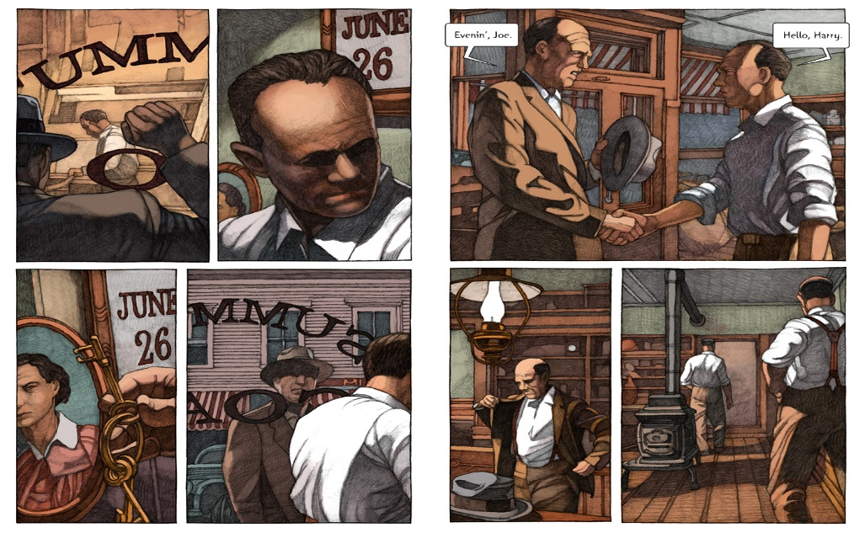
Figure 1: Miles Hyman; The Lottery (Hill And Wang 2016)
Although it was Hyman’s original intention to faithfully reproduce the narrative, it could be argued that the death of his grandmother when he was only three years old, impacted upon opportunities for discussion with her about how closely his visual interpretations reflected her personal vision of how the characters and village might be represented, although the clothing and environments are consistent with the period in which the story was written and evocative of that time. In the preface to his graphic novel, Hyman says ‘For me, as an artist who has spent much of his professional life adapting novels and stories into graphic form, it would stand to reason that my grandmother’s harrowing tale should entice over the years …because of how precise and nuanced the adaptation of this powerful piece of fiction would have to be to succeed’ 17(Hyman X).
Hyman prefaces his illustrated version of Jackson’s story with a series of portraits of the characters, each with their names and a few details with which to identify them and this format bears a similarity to a theatre programme introducing the cast of a play. In Jackson’s story, the narrative begins with the description ‘The morning of June 27th was clear and sunny, with the fresh warmth of a summer’s day; the flowers were blossoming profusely and the grass was richly green. The people of the village begin to gather in the square; ‘18(Jackson 25) Hyman alters the chronology of the unfolding of the narrative from the very start of his adaptation, although his original intention was to work with precision in terms of reflecting the content of the story.
Linda Hutcheon cites Keith Cohen; ‘Some critics go so far as to insist that a “truly artistic ‘adaptation absolutely must “subvert its original, perform a double and paradoxical job of masking and unveiling its source ’19 (Hutcheon 92). The commencement of the unveiling of Jackson’s prose within the context of this adaptation does not occur until page 9 and even then, it appears as a short, sparse introduction between the characters Harry and Joe. Up until that point, we are lead into the narrative through the identification with an unknown passenger in a car that is driving towards the town at night – the visual approach is somewhat suggestive of ‘film noir’ and sets the tone for the story, although in contrast, the tone of Jackson’s opening paragraph creates an idyllic tableau of a beautiful summer’s day.

17 M Hyman ‘The Lottery‘2016
18 S Jackson ‘The Lottery’1948
19 L Hutcheon ‘A Theory of Adaptation’2013

It was Hyman’s intention to minimise the use of prose at the beginning of the narrative and then gradually introduce limited conversation , to reflect the stylistic approach Jackson had used through her writing, although his adaptation deviates from Jackson’s timeline and his Grandmother’s opening paragraph of the story is not introduced until page 19 of his Graphic Novel and after we have been introduced to Harry and Joe who , apart from greeting one another , spend the rest of the time preparing the lottery tickets in silence.
Hyman resisted attempting any visual interpretation of the narrative until 2016 and realised that it would be a challenging undertaking, particularly as there were few detailed descriptive examples of either characters or environments. He tackled both by creating a ‘realistic ‘, representational aesthetic, in all likelihood choosing this method as a strategy to maintain fidelity to the original concept , to create characters a reader might easily identify with. However, adaptation theorist Robert Stam asserts; ‘The question of fidelity ignores the wider question: Fidelity to what? ‘20(‘Stam 44) Thomas Leitch further claims,’ Fidelity to its source text….is a hopelessly fallacious measure of a given adaptation’s value because it is unattainable, undesirable, and theoretically possible only in a trivial sense’ 21(Stam 44).
The characters depicted by Hyman are unsmiling and mostly represented as unemotional throughout his narrative, except for when the lottery tickets are drawn and one of the couples in the village realise that they have not drawn the winning ticket, and therefore could be interpreted as a pivotal point in the story when the reader may be aware that this particular lottery is not all that it appears to be. Brian Mc Farlane in his analysis Novel To Film highlights the ways in which adaptations of characters can be both reflective of their original source but can also differ through the process of translation into another form ‘Propp notes that functions of characters readily survive successive tellings of a tale ‘and ‘also draws attention to one of the ways in which a retelling may differ from an earlier version. ‘22 (Mc Farlane 147)

In a recent presentation of his Graphic Novel adaptation that Hyman delivered at Aix Marseille University in France, he included images of several strategies used to underpin his adaptation of the original narrative which had the effect of making his process more visible. He translates blocks of text from the novel and creates written descriptions of specific scenes he plans to illustrate. He appears to use strategies similar to those used for film storyboarding and the visual outcome certainly exudes a film – like quality.

20 R Stam ‘The Oxford Book of Adaptation Studies ‘2017
21 R Stam ‘The Oxford Book of Adaptation Studies ‘2017
22 B Mc Farlane ‘Novel to Film‘1996

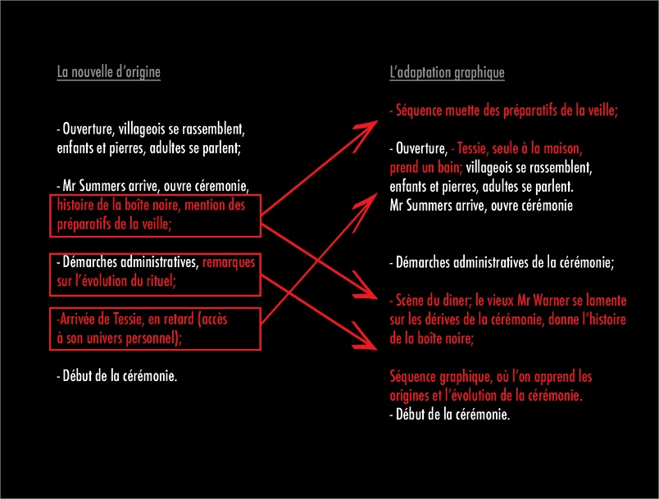
Figure 2: Miles Hyman, Power point Presentation 2019
In the diagram above, one can more fully understand how he structures components of the original text with his visual representations and attempts to match both, although through further investigation it is apparent that he alters the chronology of Jackson’s narrative from time to time. The graphic novel adaptation is lengthy compared to Jackson’s original short story and Hyman uses a range of techniques to draw out the pace and flow of the narrative.
As alluded to earlier, the artist describes his adaptation of the graphic novel as beginning with a ‘silent ‘and virtually text free setting of a scene in which the two men who oversee the lottery, Joe Summers and Harry Graves, prepare the lottery tickets at the coal office which Summers owns and this scene setting deviates from the original chronology of Jackson’s short story which begins with a written description of young children gathering stones. This calls into question Hyman’s intention to faithfully reproduce the story and further challenges the notion of the ‘fidelity ‘of any adaptation. He also adds a scene with Tessie Hutchinson taking a bath on the morning of June 27th with some visual details of the domestic setting of the Hutchinson’s home which helps the reader to humanise Tessie and identify with her vulnerability as a naked woman.
Figure 3:Miles Hyman, The Lottery ( Hill And Wang ) 2016
He also adds a touch of symbolism in two of the frames, firstly in the form of an axe embedded in a tree stump outside of the Hutchinson’s house in the frame following a previous image of the Hutchinson’s mailbox – which, in retrospect, appears as a kind of omen which is alluded to once again when Tessie notices the axe in the stump when looking out of the kitchen window further along in the narrative. The juxtaposition of these frames and the association with the Hutchinson family firstly and then specifically to Tessie perhaps alludes to the violent scene which unfolds towards the end of the novel.
The café scene is also added by Hyman and helps to provide a sense of the character of the town itself and the ordinariness of people going about their day to day business .The visual style pays homage to Edward Hopper’s depictions of interior spaces and elsewhere Hyman has talked about the influence that the artist had on his visual style.
A recurrent theme that runs through the narrative is that of the importance of tradition and an unquestioning response to change. There is talk of the box in which the lottery tickets are drawn from of being replaced, but there is resistance from the older residents of the town. There are suggestions that some of the young townsfolk are pressing for change, but the older folk are adamant that the tradition be passed on and adhered to as closely as possible. Conversations describe some original aspects of the tradition being lost or transformed, but the main purpose of the lottery, which is to select a person from the community to sacrifice in order to guarantee the success of the crops, remains as it has for as far back as the oldest member of the community can remember .Unlike the earlier film adaptation (1969), there is nothing light hearted about the atmosphere conveyed through Hyman’s visual interpretation. The film is colourful, mundane and in places – perhaps unintentionally, even humorous. The chilling outcome of the lottery draw is revealed during the final scene and quickly concludes, leaving the audience to imagine the full horror of the fate of the lottery winner.

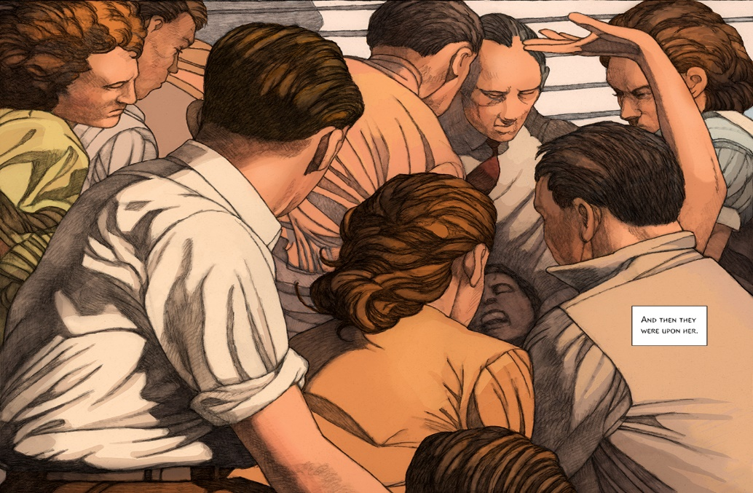
Figure 4: Miles Hyman, The Lottery (Hill And Wang) 2016

One of the challenges Hyman faced in his adaptation, was to keep the secret of the true purpose of the lottery hidden until the concluding frames of the story, in keeping with the original narrative by Shirley Jackson. The final, chilling climax of the original story is so unexpected and therefore, shocking, partly through Jackson’s understanding of the power of cognitive dissonance and its ability to manipulate our perceptions through the usual association of lotteries as positive rather than negative events. There are few clues as to the final unfolding of the violence undertaken by the townspeople, who blindly follow tradition in an unquestioning manner. The method of Tessie’s execution is stoning, which from a historical perspective, is imbued with religious overtones and the theme of scapegoating is one that has historically been associated with certain religious communities also. As the first stone is thrown and strikes Tessie on the forehead, the reality of the fate of the lottery winner becomes clear. In both the original story and Hyman’s adaptation, we learn that the mob closes in on Tessie, and we are left to imagine her fate. Through his use of ‘point of view’ and dramatic perspective Hyman draws the reader into the image to the point of identification with the mob. It becomes clear that Tessie has lost her footing and her fate is now sealed. This is the final scene of Jackson’s narrative, however, Hyman creates several more frames in which we see an overturned wooden stool and some discarded stones. Following the conclusion of the lottery, Hyman draws the reader away from the horrific scene that is unfolding and back to the houses of the village, and the surrounding environment, which appears as an idyllic small town on a pleasant summer’s day and is reflective of the tone suggested in the opening lines of Jackson’s original novel.
Conclusion
Kate Newell, writing in Expanding Adaptation Networks states: ‘Linda Hutcheon’s often cited definition defines adaptation – the – product as an “extended, deliberate, announced revisitation of a particular work of Art” 23 (Newell 5). Hutcheon’s phrasing suggests that for a work to be an adaptation it should check each of the boxes simultaneously (i.e. extended, deliberate, announced, revisitation). Hyman’s adaptation of his grandmother’s short novel meets the criteria outlined as above –indeed, it is marketed as the ‘official’ adaptation of the novel in which the artist meticulously planned the retelling of the story in graphic novel format, having waited thirty years to tackle the arduous task and intentionally wishing to remain as true as possible to the original narrative.
Dawn Keetley writing in Pop Matters describes Hyman’s The Lottery as ‘A beautiful book . . . in the way that [it] stays faithful to Jackson’s story, and also in the subtle interweaving of new meanings, Hyman’s graphic adaptation is an exceptional work of art."24(Keetley)
As it has been pointed out earlier, his adaptation brings new meaning to the original narrative through the imposition of visual information into the reader’s imagination which is conveyed through the use of media, perspective, cropping, lighting, colour palettes, atmosphere and style in a way that writing cannot. Jackson’s original prose creates space for the reader to imagine the town and its inhabitants for themselves, notably as the writing is so sparse in its provision of both information and description. Thereby, the reader is invited to imagine, to create associations through their personal experiences and interpretations of the text and in so doing, co – create a unique and personalised construction of the narrative. Adding visual images that provide the reader with more clarification of place and character takes us closer to Hyman’s interpretation of the reality of both and further away from Jackson’s original vision. Robert Stam points out that, ‘All artistic representations can pass themselves off as “reality” or straightforwardly admit their status as representations. Illusionistic realism presents its characters as real people, its sequence of words as substantiated fact. ‘25(Stam 2)
23 K Newell; ‘Expanding Adaptation Networks ‘From Illustration to Novelization.’ 2017
24 D Keetley https://www.theartblog.org/2017/01/miles-hymans-graphic-adaptation-of-the-lottery-a-paris-postcard/
25 R Stam ‘Literature through Film’ 2005

Throughout his visual interpretation of The Lottery, Miles Hyman uses a’ realistic ‘figurative style to set the tone of the story, to render it convincing to the reader so that they may identify with the subjects of the town. However, as Stam points out, representations – whether written or visual, are just that – illusionary worlds that the artist or author draws us into. The sense of place and the characters that Hyman depicts through his careful rendering, draw us into the story and into the community itself, in a way similar to film. His representations of the town folk takes the characterization further than Jackson’s original narrative, with its minimalistic language, essentially through his visual depictions of the people. Perhaps because of the realistic treatment of characters, who in their appearance are so ordinary and familiar to us, the final conclusion of the story is made all the more horrific than if he had used a more expressionistic or more stylised interpretation.

Dawn Keetley’s mention of the ‘ interweaving ‘ of new meaning within Hyman’s adaptation becomes apparent on closer analysis . Shirley Jackson’s introduction to the annual undertaking of the Lottery is listed among a range of other ‘ civic ‘ activities that are organised , including square dancing and as such , the reader is lulled into a false sense of security which continues until the latter part of the narrative. Alternatively, Hyman’s illustrations create a mysterious, unsettling atmosphere from the outset, conveyed through the detached, cool qualities of the unsmiling characters and dimly lit early scenes of Joe Summers and Harry Graves as they prepare the lottery tickets in silence, faces stern and set in shadow.

Hyman, in his recent interpretation of his Grandmothers narrative, would also have been aware of and possibly, influenced by earlier adaptations. As Kamilla Elliott has pointed out, ‘Adaptation theorists, most prominently Linda Hutcheon and Thomas Leitch, have pondered the boundaries between adaptation and intertextuality and found them problematically and promisingly permeable. Adaptation scholars now face the exciting possibility that every cultural production is an adaptation and the terrifying thought that we have somehow to account for it all. What is more, in the wake of postmodern theories of pastiche, adaptation scholars are keenly aware that each cultural production draws on—and adapts—a host of prior cultural productions ‘26(Elliott).
There are certain scholars who claim that adaptations have less value than their original source and who hold the view that an adaptation is to be seen as a less pure and therefore more diluted version of the original. Opposing this perspective, Linda Hutcheon proposes that many audiences gain pleasure from adaptations of stories they know and love - ‘the appeal of adaptations for audiences lies in their mixture of repetition and difference, of familiarity and novelty’27 (Hutcheon 114). She goes on to say,’ Like ritual, this kind of repetition brings comfort, a fuller understanding and the confidence that comes with the sense of knowing what is about to happen next ‘28 (Hutcheon 114). Hutcheon’s statements are predicated on the assumption that a particular adaptation stays true to the core themes embedded within the original version and do not subvert either these or the underlying narrative structure.

26 K Elliott ‘Rethinking the Novel/Film Debate ‘2003
27 L Hutcheon ‘A Theory of Adaptation ‘2013
28 L Hutcheon ‘A Theory of Adaptation ‘2013

In her analysis of the many faces of adaptation, Hutcheon cites Robert Stam’s inclusion of an epigraph by Louis Begley’s novelist-adapter in which he describes ‘strong and decidedly moralistic words used to attack film adaptations of literature, these words include the following: “tampering “ “interference” “ violation” and “ desecration “as though the original piece of literature had been brutalised in some way.29 (Hutcheon 2) Such descriptions imply that the original work is somehow sacrosanct and venerated to the point of being a deity and that any deviation, such as in the form of an adaptation, is an inferior and brutal interference. Certainly, there are those who having read a piece of literature, may be disappointed by a film interpretation that visually represents character and place in ways that interfere with the original subjective imaginings of the reader. Brian Mc Farlane says , “ Words like ‘tampering and ‘interference ‘ , and even ‘violation ‘ , give the whole process an air of deeply sinister molestation , perhaps springing from the viewer’s thwarted expectations relating to both’30 (McFarlane 12).
Although Hyman has deviated from absolute fidelity to Jackson’s original narrative, presumably to enable his adaptation to flow with greater ease , Roland Barthes 31 (McFarlane 13) has pointed out that the seed that is planted in a narrative will come to fruition at some point and that is its function and we can see that although Hyman sometimes deviates from chronological structures and the stylistic approach of the original story , the outcome of the ‘ seed ‘ that is the tradition of this very unique lottery , follows the same trajectory in both the original story and in Hymans adaptation and the final outcome of both is the same. According to Christopher Booker in his lengthy book The Seven Basic Plots, throughout the history of storytelling and culture, we can find one of seven narrative themes or Jungian archetypes embedded in any story, these being Rags to Riches, The Quest, Voyage and Return, Comedy, Tragedy, Rebirth and Overcoming The Monster and that humans carry these archetypes within us. He goes on to claim that subsequently, although a story may be contextualised within a certain environment and timeframe with a cast of different characters, the underlying plot will be one of the seven –therefore, to reiterate the theories of scholars of the field, including Kamilla Elliott, it could be claimed that all stories, throughout time and history are adaptations.

29 L Hutcheon ‘A Theory of Adaptation ‘2013
30 B Mc Farlane ‘Novel to Film ‘1996
31 B Mc Farlane ‘Novel to Film ‘1996

BIBLIOGRAPHY

ANYANGO, Catherine Heart of Darkness . Self Made Hero 2010
BAZIN, Andrez Literature through Film. Blackwell Publishing 2005
BOOKER, Christopher The Seven Basic Plots. Bloomsbury Publishing 2004
CONRAD, Joseph Heart of Darkness. Edinburgh Magazine Blackwood Publishing 1899
COX, Phillip The Oxford Handbook of Adaptation Studies. Edited by Thomas Leitch. Oxford University Press 2017
DUMAS, Alexander The Three Musketeesr. Classics Illustrated 1941
ELLIOTT, Kamilla Rethinking the Novel/Film Debate .Cambridge University Press 2003
HUTCHEON, Linda A Theory of Adaptation. Routledge 2006
HYMAN,Mileshttps://www.huffingtonpost.co.uk/entry/shirley-jackson-the-lottery-graphic-novel_us_Accessed 2019
HYMAN, Miles The Lottery. Hill and Wang 2016
JACKSON, Shirley The New Yorker Magazine 1948
JELLENIK, Glenn The Oxford Handbook of Adaptation Studies. Edited by Thomas Leitch .Oxford University Press 2017
KEETLEY,Dawn Pop Matters https://www.theartblog.org/2017/01/miles-hymans-graphic-adaptation-of-the-lottery-a-paris-postcard/ Accessed 2020
KLIMOWSKI, Klimowski Dr Jekyll and Mr Hyde. Self Made Hero 2009
KRAMSKY, Jerry Dr Jekyll and Mr Hyde. NBM 2002
MATTOTTI, Lorenzo Dr Jekyll and Mr Hyde .NBM 2002
McFARLANE, Brian Novel to Film. Oxford University Press 1996
McFARLANE, Brian The Oxford Handbook of Adaptation Studies. Edited by Thomas Leitch .Oxford University Press 2017
NEWELL, Kate Expanding Adaptation Networks: From Illustration to Novelization. Palgrave Mc Millan 2017
SATRAPI, Marjane https://corehi.files.wordpress.com/2015/12/aotc.pdf accessed 2019
SCHEJBAL,Danusia Dr Jekyll and Mr Hyde. Self Made Hero 2009
STAM, Robert Literature through Film. Blackwell Publishing 2005
STORM, George A Swiss Family Robinson. Classics Illustrated 1926-27
YUST, Larry The Lottery 1969
ZANE MAIROWICZ, David Heart of Darkness. Self Made Hero 2010

