Dark Town: Reimagining dangerous tradition, group ritual and brutal betrayal

Adaptation and illustration are closely intertwined in that much of the narrative illustration produced is done so in response to already existing textual narratives, and less commonly, we see illustrative adaptations of poetry, play, paintings, film and ballet. There are also many instances of illustrated narratives being adapted through other forms, for example, Marjane Strapas whose graphic autobiography ‘Persepolis ‘was adapted as an animation. The focus of this exploration of adaptation in its varied forms, is on the Graphic Novel adaptation of Shirley Jackson’s short story ‘ The Lottery ‘by Jackson’s own grandson , Miles Hyman.
Andre Bazin claims that adaptation is ..‘an established feature of the history of Art ‘[1] The French theorist claims that engraving and subsequently, photography – both means of reproducing images, are adaptations of original works of art and therefore, are representations of a root source– and further , can be found reproduced in a range of scales and contexts .
In a chapter of The Handbook of Adaptation Studies, Philip Cox, exploring the roots of adaptation states, ‘The adaptation of a narrative text from one medium into another has a long history in western culture.’ [2] Oxford book .Similarly ,Glenn Jellenik ( ox book of A S ) investigating adaptation and themes relating to originality , claims that a surge of adapted narrative texts that emerged in the late 18th century hailed the beginnings of this trend, when the novel became the dominant literary form , reflecting cultural and social changes of the time and growing in popularity with the expansion of Capitalism throughout the western world. Linda Hutcheon, writing in A Theory of Adaptation cites Axelrod as proposing that adaptations can be traced back as far as Aesop and even Moses. Robert Stam also argues that fictional prose originates long ago in history, citing the Bible and Homer’s Oddysey as examples and he also contradicts Jellenik’s claim that the growth and popularity of the novel was seeded within the 18th century western world. He states that, ‘According to Margaret Doody, the novel was the product of combinatory “contact between Southern Europe, Western Asia and Northern Africa. He says, “ The novel is thus rooted in the history of the multiracial ,multilingual Mediterranean basin…..Papyrus fragments of novels have suggested that novel reading was popular among Egyptians in the second century AD. ‘[3]
Jellenik describes any adaptation as being seeded from a literary source and further transmuted as film, broadcast ,or production on the stage. He cites a description from the Oxford Book of Adaptation as being,’ An altered or amended version of a text, musical composition, etc” .[4] pg 36 oxford book

He goes on to highlight the end of the 18th century and the simultaneous period of Romanticism as a time when concepts such as genius, originality, adaptation, purity and invention were hotly debated as themes. During this period London became both melting pot and magnet for the literary scene and at this time, as demonstrated through the legal ruling’ Donaldson v. Beckett ‘(1774) perpetual copyright law and the monopoly on intellectual property were overruled, resulting in the potential for those working in the arts to rethink literature and reconstruct existing narratives into a myriad of other forms and genres.
According to Jellenik , the first adaptation of a narrative suitable for the stage was The Iron Chest, itself an adaptation of a novel written by the political Philosopher William Goodwin, whose intention was to write for a broader audience and offer philosophical perspectives that would be disseminated amongst a wider public, rather than an elite minority, as in the past. Jellenik cites Philip Cox, who in exploring the roots of adaptation states, ‘The adaptation of a narrative text from one medium into another has a long history in western culture.’ [5] Oxford BOOK .Cox’s perspective further refutes Jellenik’s claims that the adaptation of the novel was a by - product of the 18th century.
Theorists, including Linda Hutcheon, have sought to explain the term ‘adaptation ‘,elucidating how it differs from plagiarism in that the adaptor is not seeking to deceive the audience about the source material and its origins but is, instead, paying homage to the original through the new creation. She uses the term ‘palimpsest ’frequently throughout her analysis , to describe the traces of the former narratives that reverberate through time to reappear in altered states - similar to, but different from the original.
Contemporary adaptations of classic literature are currently undergoing a resurgence in the form of the Graphic Novel. Almost a century after the first 22 week comic strip interpretation of the novel Swiss Family Robinson by George Storm was published in 1926-27, a plethora of classic novels are being published. Both established and younger publishing houses are riding the waves of the trend and those publishers including Self Made Hero, Hill and Wang, Picador and Abrams are just a few of those commissioning illustrators of the genre.
In 1941, the American publication Classics Illustrated produced a series of comic book adaptations of classic novels, including The Three Musketeers by Alexander Dumas and advertised the range using grand descriptions affiliating the comic books with ‘The World’s greatest authors ‘in an attempt to raise the profile of the form, although being reviewed simultaneously by critics who wrote scathing reviews of the genre.
Theorist Robert Stam has speculated on forms of adaptation and intertextualties that were formerly marginalised due to the perception of low status by literary reviewers, educationalists, authors, publishers and those involved in associated industries. Although he asserts that class and hierarchy were historically connected with the demonising of certain genres he also claims that with time the previously low status of such forms can be raised through new interpretations: ’Art revitalizes by drawing on the strategies of previously marginalized forms and genres , canonizing what had been earlier reviled . [6] pg 6 Literature

Reviewers critical of the form used derogatory language suggestive of violation and barbarism to describe the quality of the artwork and production and in response to the editing of the original narrative. Adaptations of classic novels into comic book or graphic novel formats have been subject to much criticism as can be seen in poet and literary critic Delmore Shwarz’s scathing review of Classics Illustrated. He refers to the illustrated depictions of classic narratives with language suggestive of violation, describing the ‘cuts and mutilation’s’ suffered through the editing of the text. Fredric Wertham also condemned Classics Illustrated, using strong language suggestive of castration: he states ‘Comic books adapted from classical literature are reportedly used in 25,000 schools in the United States. If this is true, then I have never heard a more serious indictment of American education, for they emasculate the classics. ‘[7] pg Brian Mc Farlane 220 Oxford B - what date was he writing ?
However, the schools supplying the books and pupils who read them clearly disagreed with the superior stance taken by a number of literary critics as this series of classics adaptations was the most successful venture of the genre to date and in later decades, the original black and white linear covers were replaced with full colour painted images and artworks that reflected contemporary art movements of the time and therefore raised the aesthetic value of the books.
An advertisement of the time made its case for the series on the basis of the appeal of the comic book and the textual fidelity of the adaptations: “The comic-strip technique, so popular among youngsters, is utilized to bring to life the heroes of great literature. Authentically illustrated in full colour and maintaining the original text, each title is a complete adaptation of the original. ‘[8] ox book of adapt. Pg 214
Robert Stam, commenting on the question of elitism and the value of the written form over the visual goes on to say, ‘literature will always have axiomatic superiority over any adaptation of it because of its seniority as an art form.’ But this hierarchy also involves what he calls iconophobia ( a suspicion of the visual ) and logophilia ( love of the word as sacred).’ [9] LH pg 4
In recent years, graphic novels have been harnessed as a vehicle through which to adapt classic texts, bringing awareness of these to new and younger audiences in more easily digestible forms.
The quality of artwork is often more highly sophisticated than that seen in the past and, for example, in the case of Catherine Anyango’s charcoal rendering of Joseph Conrad’s Heart of Darkness, the dense and expressive atmosphere of the drawings is used to reflect the grave themes embedded within the narrative. The Strange Case of Jekyll and Hyde, adapted by Andrez Klimowski and Danusha Schejbal and another interpretation by Lorenzo Mattotti and Jerry Kramsky are both reinterpreted by accomplished and established illustrators who are respected within their fields.
Mattoti and Kramsky’s adaptation transferred the setting of Robert Louis Stevenson’s dark classic about the duality of human nature from Victorian London to Weimar Germany to enable illustrator Mattoti to increase the drama and tension within his visuals through the creation of an aesthetic influenced by the work of German Expressionist artists George Grosz and Max Beckmann.
In describing illustrated prose, adaptation theorist Kamilla Elliott writes,’ Absence and presence, negation and affirmation coexist in the jointures of linguistic and pictorial representation ‘.[10] either paraphrase this or choose another quote ) One could argue that the graphic novel attempts to create a bridge between both and also has something in common with subtitled film. It is worthy of note that successful contemporary Illustrators of the form, including Lorenzo Mattotti and Andrez Klimowski both claim to be highly influenced by film and that certain graphic novels bear a strong resemblance to film storyboards. However, creator of the graphic autobiography ‘Persepolis ‘Marjane Satrapi suggests,’ The Language of cinema and comics is different. In comics you write with images: they’re like pictograms.’ [11] She goes on to point out that reading comics requires an active engagement with the content, whereas watching films is a passive behaviour.
Shirley Jackson The Lottery
There has recently been a resurgence of interest in the novels and short stories of American author Shirley Jackson, whose classic short novel The Lottery has been adapted as Graphic Novel, radio show, film, theatre productions, television series and even a ballet. It was first published in The New Yorker Magazine in 1948 and caused a public outpouring of fury, due to the shocking nature of the narrative. It has become one of America’s most famous novels, although considered very controversial at the time when first published as an anonymous story, particularly as it was a challenging narrative written by a woman.
Jackson was a writer renowned for her ability to create unsettling narratives which at first appeared to reflect the mundane nature of everyday American life, but which gradually unfolded to reveal dark and uncanny underlying themes. The Lottery was reimagined in the form of a Graphic Novel (2016) using the original text as the catalyst for an unsettling and beautifully rendered interpretation by Jackson’s grandson, Miles Hyman, who had earlier studied both literature and printmaking. This singularly authorised adaptation won the 2017 Sollies Comics Festival’s best adult graphic novel.
Jackson’s writing style is sparse and subsequently, provided opportunities for Hyman to create further layers of communication in which he brought to life through his striking visual imagery, the small town community originally imagined by his grandmother.
Such a story is a gift for an Illustrator, as it is not overly descriptive and therefore, enabled Hyman to create a visual narrative that was complementary to the original text but also deviated from the original chronology from time to time. Theorist Linda Hutcheon claimed,‘It is obvious that adapters must have their own personal reasons for deciding first to do an adaptation and then choosing which adapted work and what medium to do it in. ‘[121 LH pg 92] For Hyman, the decision to affiliate himself with an author of such high regard as his grandmother and the kudos of being associated with her would , no doubt have been a defining factor, but there may well have been other reasons in addition to reputation, the theme of the narrative and quality of writing.
As discussed earlier , the graphic novel or comic book genre has historically been perceived as a ‘low brow ‘form of art, but it could be argued that illustrators such as Miles Hyman raise the bar, certainly in terms of the quality of his aesthetic and choice of narrative. His drawing ability, knowledge of art, film and understanding of literature have enabled him to create a visually sophisticated interpretation of his grandmother’s dark novel which has earned him respect within certain literary circles - in September 2019 Hyman made an appearance at the Graham Greene Literary Festival in the UK. In addition to the perception of low status related to the genre, questions of fidelity and originality are also called into question.
Mirroring his Grandmother’s technique, Hyman minimizes prose, allowing his striking images to create an opaque veneer that is initially difficult to penetrate. Through the strategic use of cropping, he provides fragments of information that obfuscate the underlying tension building through the strangely lit images and hard to decipher characterizations. There is a brooding sense throughout of what Freud termed ‘The Uncanny ‘. Reflecting upon the narrative Hyman says, ‘The story is such a perfect apparatus that it leaves little room for meddling. Some books sprawl and dream and carry on in ways that seem to invite imagery in spades. “The lottery does none of that –it is a no –nonsense, largely hermetic structure, words joined with a jeweller’s precision. ‘ [13] https://www.huffingtonpost.co.uk/entry/shirley-jackson-the-lottery-graphic-novel_us_
Through the use of strong directional lighting, the characters are often depicted from a worms eye view, creating dramatic and sometimes intimidating atmospheres, which are suggestive of a foreboding that is not necessarily defined in the original text.
In an interview with the Huffington Post ,Hyman goes on to describe his strategy of adaptation saying ‘..with graphic fiction you generally want to avoid over-using blocks of narrative text if at all possible. Action and dialogue tend to be much more effective storytelling tools when adapting a text in graphic form. So I made the decision to “tease out” the opening scenes of the graphic novel with a series of nearly text-less sequences, based on small snippets of the original story. It’s in these scenes that we get the bulk of our key information ― the essential visual landmarks that are going to help us navigate the action going forward. ‘[14] Huff post
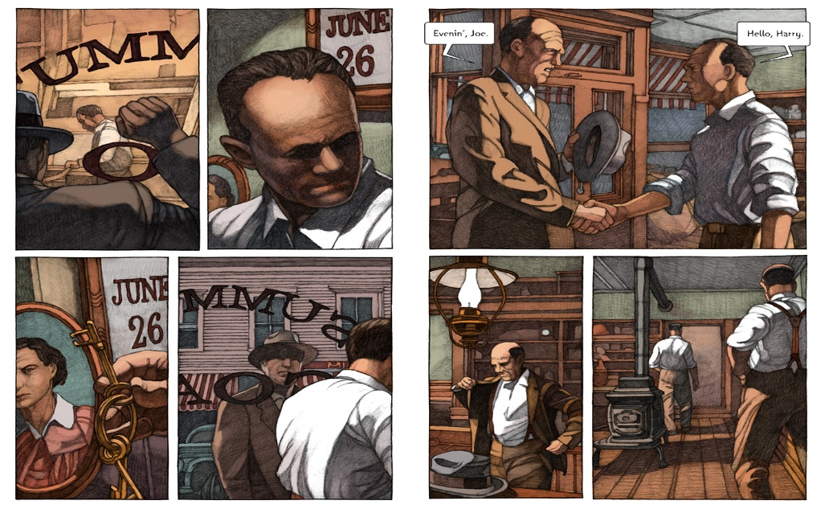

Although it was Hyman’s original intention to faithfully reproduce the narrative, it could be argued that the death of his grandmother when he was only three years old, impacted upon opportunities for discussion with her about how closely his visual interpretations reflected her personal vision of how the characters and town might be represented, although the clothing and environments are consistent with the period in which the story was written and evocative of that time.
Linda Hutcheon cites Keith Cohen in his statement ‘Some critics go so far as to insist that a “truly artistic ‘adaptation absolutely must “subvert its original, perform a double and paradoxical job of masking and unveiling its source ‘[15]LH pg 92. The commencement of the unveiling of Jackson’s prose within the context of this adaptation does not occur until page 9 and even then, it appears as a short, sparse introduction between the characters Harry and Joe. Up until that point, we are lead into the narrative through the identification with an unknown passenger in a car that is driving towards the town. It was Hyman’s intention to use a strategy known as a ‘silent novel ‘ at the beginning of the narrative and then gradually introduce limited conversation , to reflect the stylistic approach Jackson had used through her writing.
Hyman resisted attempting any visual interpretation of the narrative until 2016 and realised that it would be a challenging undertaking, particularly as there were few detailed descriptive examples of either characters or environments. He tackled both by creating a ‘realistic ‘, representational aesthetic, in all likelihood choosing this method as a strategy to maintain fidelity to the original concept. However, adaptation theorist Robert Stam asserts, ‘The question of fidelity ignores the wider question: Fidelity to what? ‘[16] pg 44 Thomas Leith further claims,’ Fidelity to its source text….is a hopelessly fallacious measure of a given adaptation’s value because it is unattainable, undesirable, and theoretically possible only in a trivial sense.’ [17]Oxford handbook. Pg 44
In a recent presentation that Hyman delivered at Aix Marseille University in France, he included visual schemata for his adaptation of the original text which had the effect of making his process more visible. He appears to use strategies similar to those used for film storyboarding and the visual outcome certainly exudes a film – like quality.

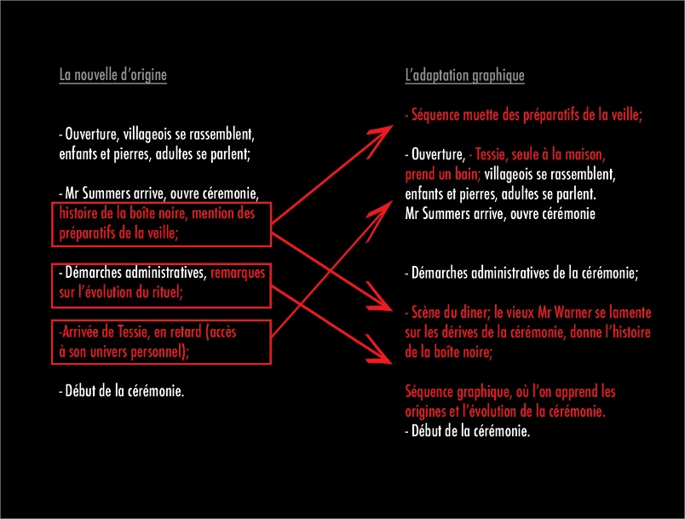

In the diagram above, one can more fully understand how he structures components of the original text with his visual representations and attempts to match both, although through further comparison it is apparent that he alters the chronology of Jackson’s narrative from time to time.
The graphic novel adaptation is lengthy compared to Jackson’s original short story and Hyman uses a range of techniques to draw out the pace and flow of the narrative.
As alluded to earlier, the artist describes his adaptation of the graphic novel as beginning with a ‘silent ‘and virtually text free setting of a scene in which the two men who oversee the lottery, Joe Summers and Harry Graves, prepare the lottery tickets at the coal office which Summers owns and this scene setting deviates from the original chronology of Jackson’s short story which begins with a written description of young children gathering stones. This calls into question Hyman’s intention to faithfully reproduce the story and further challenges the notion of the ‘fidelity ‘of any adaptation. He also adds a scene with Tessie Hutchinson taking a bath on the morning of June 27th with some details of the domestic setting of the Hutchinson’s home which helps the reader to humanise Tessie and identify with her vulnerability as a naked woman. He also adds a touch of symbolism to in two of the frames in the form of an axe embedded into a tree stump outside of the Hutchinson’s house which is

visually referred to twice within the context of
the story and which is also juxtaposed with the images of Tessie and perhaps, alludes to the violent scene which unfolds towards the end of the novel.
The café scene is also added by Hyman and helps to provide a sense of the character of the town itself and the ordinariness of people going about their day to day business .The visual style pays homage to Edward Hopper’s depictions of interior spaces and elsewhere Hyman has talked about the influence that the artist had on his visual style.
A recurrent theme that runs through the narrative is that of the importance of tradition and an unquestioning response to change. There is talk of the box in which the lottery tickets are drawn from of being replaced, but there is resistance from the older residents of the town. There are suggestions that some of the young townsfolk are pressing for change, but the older folk are adamant that the tradition be passed on and adhered to as closely as possible. Conversations describe some original aspects of the tradition being lost or transformed, but the main purpose of the lottery, which is to select a person from the community to sacrifice in order to guarantee the success of the crops, remains as it has for as far back as the oldest member of the community can remember .Unlike the earlier film adaptation (1969), there is nothing light hearted about the atmosphere conveyed through Hyman’s visual interpretation. The film is colourful, mundane and in places – perhaps unintentionally, even humorous. The chilling outcome of the lottery draw is revealed during the final scene and quickly concludes, leaving the audience to imagine the full horror of the fate of the lottery winner.

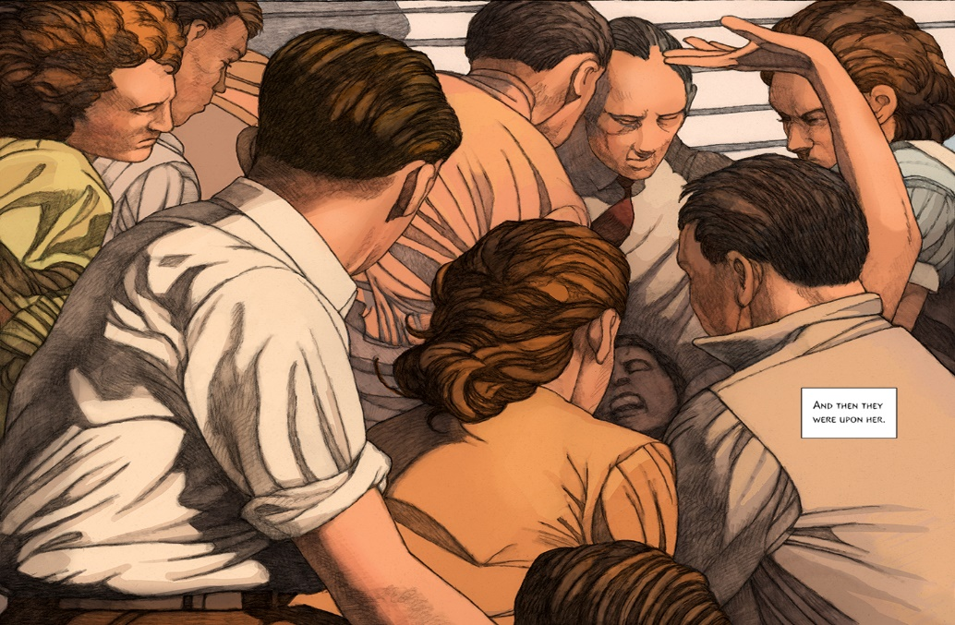

One of the challenges Hyman faced in his adaptation, was to keep the secret of the true purpose of the lottery hidden until the concluding frames of the story, in keeping with the original narrative by Shirley Jackson. The final, chilling climax of the story is so unexpected and therefore, shocking, partly through Jackson’s understanding of the power of cognitive dissonance and its ability to manipulate our perceptions through the usual association of lotteries as positive rather than negative events. There are few clues as to the final unfolding of the violence undertaken by the townspeople, who blindly follow tradition in an unquestioning manner. The method of Tessie’s execution is stoning, which from a historical perspective, is imbued with religious overtones and the theme of scapegoating is one that has historically been associated with certain religious communities also.
Conclusion
Kate Newell, writing in Adaptation Networks states:
‘Linda Hutcheon’s often cited definition defines adaptation – the – product as an “extended, deliberate, announced revisitation of a particular work of Art..” Hutcheon’s phrasing suggests that for a work to be an adaptation it should check each of the boxes simultaneously (i.e. extended, deliberate, announced, revisitation). ‘[18]
Hyman’s adaptation of his grandmother’s short novel meets the criteria outlined as above –indeed, it is marketed as the ‘official’ adaptation of the novel in which the artist meticulously planned the retelling of the story in graphic novel format, having waited thirty years to tackle the arduous task and intentionally wishing to remain as true as possible to the original narrative.
Dawn Keetley describes Hyman’s The Lottery as ‘A beautiful book . . . in the way that [it] stays faithful to Jackson’s story, and also in the subtle interweaving of new meanings, Hyman’s graphic adaptation is an exceptional work of art." —19 Dawn Keetley, PopMatters
https://www.theartblog.org/2017/01/miles-hymans-graphic-adaptation-of-the-lottery-a-paris-postcard/
As it has been pointed out earlier, his adaptation brings new meaning through the imposing of visual information into the reader’s imagination though the use of the medium, in a way that writing cannot. Jackson’s original prose creates space for the reader to imagine the town and its inhabitants for themselves, notably as the writing is so sparse in its provision of both information and description. Thereby, the reader is invited to imagine, to create associations through their personal experiences and interpretations of the text and in so doing, co – create a unique and personalised construction of the narrative. Adding visual images that provide the reader with more clarification of place and character takes us closer to Hyman’s interpretation of the reality of both and further away from Jackson’s original vision. Robert Stam points out that, ‘All artistic representations can pass themselves off as “reality” or straightforwardly admit their status as representations. Illusionistic realism presents its characters as real people, its sequence of words as substantiated fact. ‘[20] Robert Stam – Literature through Film.

Throughout his visual interpretation of The Lottery, Miles Hyman uses a’ realistic ‘figurative style to set the tone of the story, to render it convincing to the reader so that they may identify with the subjects of the town. However, as Stam points out, representations – whether written or visual, are just that – illusionary worlds that the artist or author draws us into. The sense of place and the characters that Hyman depicts through his careful rendering, draw us into the story and into the community itself, in a way similar to film. His representations of the town folk takes the characterization further than Jackson’s original narrative, with its minimalistic language, essentially through his visual depictions of the people. Perhaps because of the realistic treatment of characters, who in their appearance are so ordinary and familiar to us, the final conclusion of the story is made all the more horrific than if he had used a more expressionistic or more stylised interpretation.

Hyman, in his recent interpretation of his Grandmothers narrative, would also have been aware of and possibly, influenced by earlier adaptations. As Kamilla Elliott has pointed out, ‘Adaptation theorists, most prominently Linda Hutcheon and Thomas Leitch, have pondered the boundaries between adaptation and intertextuality and found them problematically and promisingly permeable. Adaptation scholars now face the exciting possibility that every cultural production is an adaptation and the terrifying thought that we have somehow to account for it all. What is more, in the wake of postmodern theories of pastiche, adaptation scholars are keenly aware that each cultural production draws on—and adapts—a host of prior cultural productions. ‘[21]
There are certain scholars who claim that adaptations have less value than their original counter point and who hold the view that an adaptation is to be seen as a less pure and more diluted version of the original. Opposing this perspective, Linda Hutcheon proposes that many audiences gain pleasure from adaptations of stories they know and love - ‘the appeal of adaptations for audiences lies in their mixture of repetition and difference, of familiarity and novelty.’[22] theory of adapt 114 She goes on to say,’ Like ritual, this kind of repetition brings comfort, a fuller understanding and the confidence that comes with the sense of knowing what is about to happen next. ‘[23] 114 Hutcheon’s statements are predicated on the assumption that a particular adaptation stays true to the core themes embedded within the original version and don’t subvert either these or the underlying narrative structure.

In her analysis of the many faces of adaptation, Hutcheon cites Robert Stam’s inclusion of an epigraph by Louis Begley’s novelist-adapter in which he describes ‘strong and decidedly moralistic words used to attack film adaptations of literature, these words include the following: “tampering “ “interference” “ violation” and “ desecration “as though the original piece of literature had been brutalised in some way. [24]Linda H Pg 2 Theory of A. Such descriptions imply that the original work is somehow sacrosanct and venerated to the point of being a deity and that any deviation, such as in the form of an adaptation, is an inferior and brutal interference. Certainly, there are those who having read a piece of literature, may be disappointed by a film interpretation that visually represents character and place in ways that interfere with the original subjective imaginings of the reader. According to Christopher Booker in his lengthy book The Seven Basic Plots, throughout the history of storytelling and culture, we can find one of seven narrative themes or Jungian archetypes embedded in any story, these being Rags to Riches, The Quest, Voyage and Return, Comedy, Tragedy, Rebirth and Overcoming The Monster and that humans carry these archetypes within us. He goes on to claim that subsequently, although a story may be contextualised within a certain environment and timeframe with a cast of different characters, the underlying plot will be one of the seven –therefore, to reiterate the theories of scholars of the field, including Kamilla Elliott, it could be claimed that all stories, throughout time and history are adaptations.

END

Dawn Keetley describes Hyman’s The Lottery as ‘A beautiful book . . . in the way that [it] stays faithful to Jackson’s story, and also in the subtle interweaving of new meanings, Hyman’s graphic adaptation is an exceptional work of art." —Dawn Keetley, PopMatters
https://www.theartblog.org/2017/01/miles-hymans-graphic-adaptation-of-the-lottery-a-paris-postcard/

.‘Novelist and …semiotician Umberto Eco contends that adaptation does not and cannot occur: that it is merely a collective cultural hallucination.’ [3] He goes on to suggest that the only relationship between his novel ‘The Name of The Rose ‘and the film is that they share the same title.

Distorted Dreams: Peter Ibbetson from Illustration to Adaptation
Rêves et variations : Peter Ibbetson, des dessins au film
Maxime Leroy

In this paper Leroy explores the adaptation of illustrations to create visual settings for films and analyses the shortcomings of such a translation.

"A beautiful book . . . in the way that [it] stays faithful to Jackson’s story, and also in the subtle interweaving of new meanings, Hyman’s graphic adaptation is an exceptional work of art." —Dawn Keetley, PopMatters
https://www.theartblog.org/2017/01/miles-hymans-graphic-adaptation-of-the-lottery-a-paris-postcard/

‘Novelist and …semiotician Umberto Eco contends that adaptation does not and cannot occur: that it is merely a collective cultural hallucination.’ [3] He goes on to suggest that the only relationship between his novel ‘The Name of The Rose ‘and the film is that they share the same title.
Kamilla Elliott Rethinking the novel/film debate Pg 134

Bibliography

- Bazin , ANDRE Tener , Sara SEPT 2012 Film adaptation.Qwriting.QC.Cuny.ED
- Cox , Phillip Oxford Book Of Pg 36 oxford b
- Stam, Robert Literature Through Film
- Jellenik , Glenn Pg 36 Oxford B

Linda Scott SEPT 201[1] Sara TENER SEPT 2012 FILMADAPTATION.QWRITING.QC.CUNY.ED
[2] Guardian online 16 jun 2011.
[3] Kamilla Elliott. Pg 134

[4] Expanding Adaptation Networks : From Illustration to Novelization
Kate Newell
5 Robert Stam literature Through Film
6 Novel To Film Brian Mc Farlane
7 The Oxford Book Of Adaptation Studies

8 The Lottery Shirley Jackson
9 The Lottery Miles Hyman
10 https://www.theartblog.org/2017/01/miles-hymans-graphic-adaptation-of-the-lottery-a-paris-postcard/
11 John Berger Ways Of Seeing

https://corehi.files.wordpress.com/2015/12/aotc.pdf
However, creator of the graphic autobiography ‘Persepolis ‘Marjane Satrapi suggests,’ The Language of cinema and comics is different. In comics you write with images: they’re like pictograms.’ [2] She goes on to point out that reading comics requires an active engagement with the content, whereas watching films is a passive behaviour.

