Angels, aliens, and annunciations
Sarah Cave and Rupert Loydell in conversation

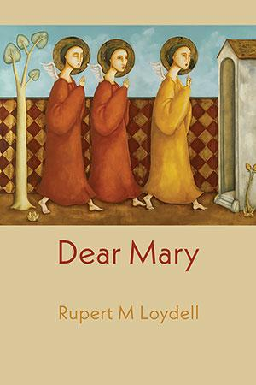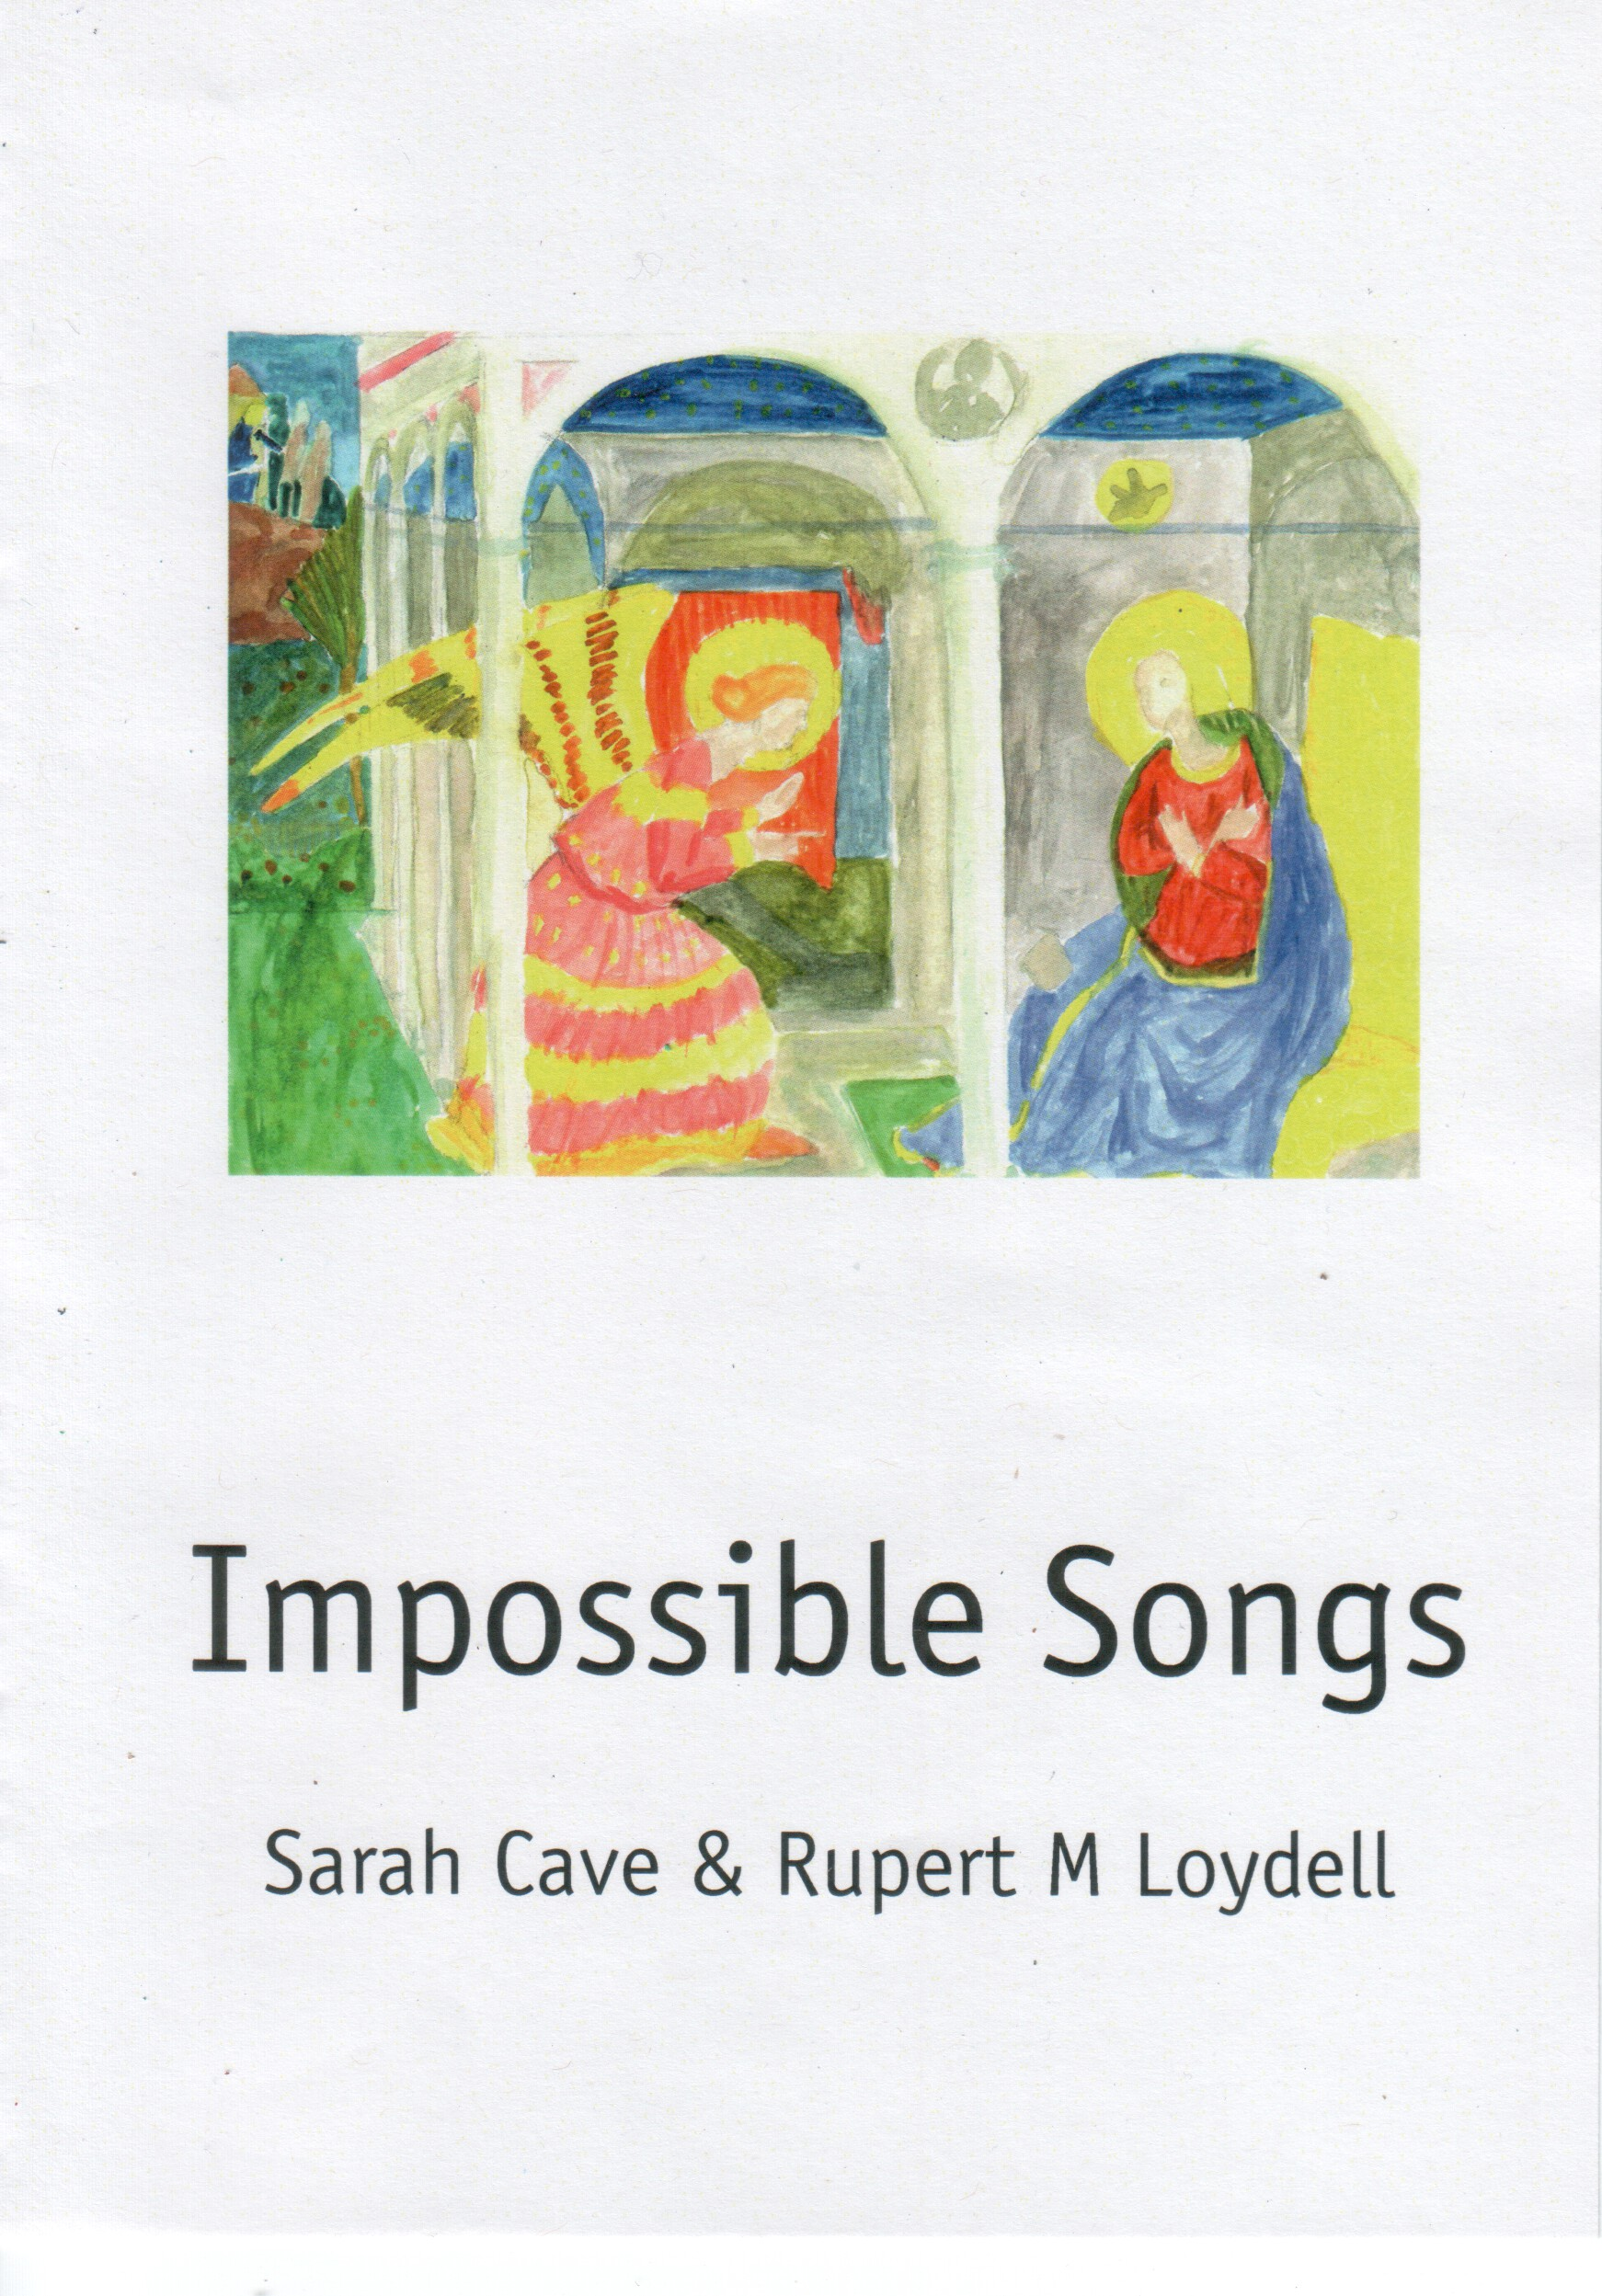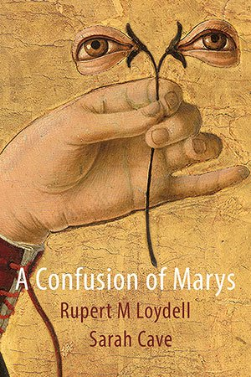

Rupert Loydell: So, A Confusion of Marys is finally out. A couple of people have asked about the process, the research, and motive for writing it. I can talk about trips to Italy and being mesmerised by a couple of Fra Angelica paintings, and then following through by looking at lots more annunciations and art and photography about angels, about deliberately [mis]reading works of art and events as annunciations, and a vague idea of something from elsewhere intruding into the human realm, but what's your perception of coming on board as it were? I honestly can't recall how we ended up doing those Joyful Mysteries pamphlets and then the Impossible Songs pamphlet.

Sarah Cave: I grew up a Christian and have been mentally dealing with what that means for the best part of three decades. My long poem in A Confusion of Marys was really my way of trying to understand Mary – a figure of grace – and to draw her for myself; beyond the annunciation, beyond liturgy. I think our conversations about the annunciation and John F Deane’s beautiful sequence of poems about Lydia in Give Dust a Tongue – the woman Jesus meets at Jacob’s well – helped frame how I wanted Mary to emerge in her own right. Also, when Pussy Riot’s ‘Punk Prayer’ was released in a softer form by the Norwegian singer Moddi, I was struck by their pleas, ‘Mary, our hands are tied in prayer / Help us if you’re there!’ and ‘O Holy Mary, be a feminist!’. I was also struck by the way that Maria Alyokhina talked about faith in interviews; faith wasn’t something that belonged to the church but to the individual. ‘Punk Prayer’ is irreligious, it’s rather an intercession begging Mary to dissolve the kyriarchy and free women from society’s oppressive expectations.

I think the two pamphlets we did were a combination of this and some very silly poems about ducks. I’m certain there was an element of irreverent one-upmanship going on there too.

RL: So, what's an autophagy then? And what's it got to do with Mary or the annunciation? Explain yourself!

SC: Autophagy literally means self-eating.

It’s a biological process of cell regeneration – clearing out old cells to encourage regrowth – and I’m interested in the idea of regenerative theology. I was a cradle Anglican and within that tradition Mary is more of a backseat figure – usually appearing in knitted form at crib services – no intercessions etc. I wanted to bring her to the forefront and to understand how, in her all pervasive way, she has shaped my life and the expectations people place on my life – gender, sexuality, politics, mysticism – and the lives of the women around me, and of course, how those expectations must have affected Mary’s own life.
I like that the title, A Confusion of Marys, evokes a sense of the process of writing and re-writing, the Marian annunciation scene as palimpsest. Was this deliberate?

RL: Very much so. I thought of it as a series of variations, accumulations and versions of the same event – including, as you say, some very silly and jokey ideas. I wanted to get away from any idea of theological certainty, I'm much more interested in doubt and myth, symbolism and tangential ideas than anything fixed or final. I like stories that get retold throughout culture, and the annunciation certainly seems to be one that has. I guess the long prose poem that opens the book is an attempt to pile up versions of the story: it could be this, or this, or like that, or what about this?

I confess I'm quite interested in being slightly irreverent, too. I'm not very good at po-faced religion in any shape or form, although I quite like some traditional liturgy. But I abhor those who use their certainty as an excuse for censorship, racism, hatred and abuse.

I enjoyed finding some of the images of angels and annunciations I did. There's a surprising amount of angel imagery, for instance, in contemporary photography, and many abstract paintings use 'Annunciation' as a title. I don't think these tie in to any version of the traditional Mary and angel story, but I was happy to make the link for myself, just as I did with other ideas such as a magician and his assistant, or boys at a fancy dress party.

From what you've said, I'm guessing that your work is actually much more personal to you, and less ideas-driven, than mine is? I'm not suggesting it's autobiography, but more concerned with ideas that are really important to you, whereas mine could be seen as a bit of an intellectual joke?

SC: Yes, they’re ideas that are important to me because I feel part of those stories. I see their patterns in my own life and the books that I read; a kind of cultural pareidolia, the culture I am simultaneously absorbing and rejecting, honouring and dishonouring. But, of course, the sequence isn’t autobiographical, no more than any other post-confessional poetry.

I think humour, play and irreverence are important when talking about theology. Human spirituality is such a beautifully absurd thing and, as you say, there’s nothing worse than po-faced believers, who sit in judgement. It’s the first step to exclusion and ‘theological certainty’ is what makes heretics and heresy is merely an historical excuse for killing people who don’t agree with you. There’s no way either of us would have survived the inquisition!
You don’t have to look much further than the bible for the sense of versioning, which you’re talking about. I love that this weird and supposedly holy text is the best sense the Council of Nicaea could make of the disparate strands of accounts, prophesy and scripture, and gloriously, it still doesn’t make much sense.

Did you have a personal sense of Mary? Where did your interest in her start?

RL: I've always been very resistant to any sense of Marian theology. Saints weren't a thing in the church I was brought up in, and Mary was simply a human being chosen by God. I think I'm mostly interested in the painting and the way people do turn Mary into something else, almost non-human: it's very strange to me. I keep coming back to that moment as the idea of worlds colliding; it's not just me being silly when I wrote about the annunciation as an alien encounter.

Having said that, a lot of the contemporary art I looked at, such as Eija-Liisa Ahtila's video installation and the book of it, is very concerned with female human experience, with exploring the story through Mary's eyes. And of course I've reversioned the story from both the male and female gaze, from lustful angels and desirous Mary, with the idea of the angel turning up via an online dating agency, to Joseph's point-of-view, feeling resentful and sidelined in both the original event and the ensuing art.

It's strange how once an idea starts – and originally my sense of the annunciation was very much to do with Renaissance art and Italy, as well as colour and ekphrasis – one can interpret almost anything through the lens of a particular story or event. At times it feels like an endless and somewhat ridiculous shaggy dog story, but it's become a real way to think about all sorts of stories and encounters in the world, a way of understanding human beings. So, I guess my 'sense of Mary' is not very specific, it's about bewildered, frightened, confused and perhaps empowered humans caught up in strange encounters and activities, sometimes aware they are within a painting, sculpture, film or story.

I can't help thinking about a text I use to teach the first years with, where Gabriel Josipovici talks about how stories die unless they are changed, reinvented, argued over and made new. He also questions the idea of ownership of stories, or even being able to 'ring-fence' them. Perhaps we are just part of a religious and artistic dialogue?

SC: Gosh, yes. The book is undoubtedly part of a wider dialogue. Even in Christianity there are so many different interpretations, the same story manifesting through art, literature and performance; from fish and crosses scratched in caves, renaissance frescoes, Sunday school cartoons, those strange graphics in religious pamphlets and school plays. I love the version of the nativity in the Quran, which has Mary give birth to the prophet, while clinging to a palm tree.

I don’t know about you, but one of the first things I was asked to do at Sunday school was to draw Jesus, which started off abstract and developed over the years into crayon stick people with palm leaves, poster paint crucifixions and pasta shaped ascensions. We’ve come an awful long way in two thousand years with this particular story, considering only half a century ago re-versions by writers such as Robert Graves, Nikos Kazantzakis et al and were met with horror and derision; it’s only forty years since The Life of Brian upset Malcolm Muggeridge and the Archbishop of York. I find Michael Palin’s visible pain at being told the film is irreligious during that debate very identifiable. For me, a sense of irreverence is its own reverie.

In ‘Autophagy’, I’ve tried to create my own Marian theology, based on tracing a matriarchal line of caregiving. By looking at the other women in the bible, such as Sarah and Hagar, allowed me to draw lines of comparison between different aspects of female experience. Sarah had her own miraculous conception, and, like Elizabeth’s, it went beyond biological expectation. God blesses Sarah but he also causes a rupture between her and her handmaiden Hagar. Women’s relationships are footnotes in the bible and the more we think about them the less clear cut the stories are and the less suitable for the simplistic moral guidance deployed by believers.

© Sarah Cave & Rupert Loydell 2020

