ePatients

The Medical, Ethical and Legal Repercussions of Blogging and
Micro-Blogging Experiences of Illness and Disease

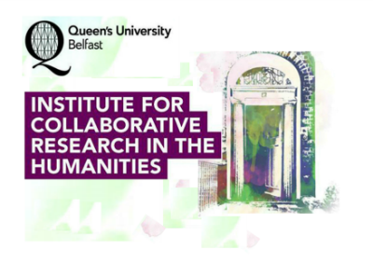

Queen’s University Belfast, 11-12 September 2015

Conference Schedule

All sessions, including registration, will take place in the Auditorium, McClay Library

Friday 11th September

11.00 – 11.30 Registration

11.30 – 11.45 Welcome

11.45 – 12.45 Keynote 1

Anne-Marie Cunningham (Cardiff University)

Learning with and from epatients

12.45 – 1.30 Lunch
1.30 – 3.30 Panel 1
Chair: Nathan Emmerich (QUB)

Amy Brown (SUNY Upstate Medical University, Syracuse, New York): Grounding the Relationship between Families and Physicians in a Digital Community: A Case Study

Columba Quigley (Reading Room Editor, Medical Humanities): The ePatient and Stories of Illness

Fiona McLaughlin (Northern Ireland Rare Disease Partnership): Social Media Participation by Patients: Power, Empowerment or Partnership?

Yewande Okuleye (University of Leicester): You call it Marijuana and I call it Medical Cannabis: Online Identity Construction and Illness Narratives from the epatient/activist Perspective.

3.30 – 3.50 Tea/Coffee

3.50 – 5.20 Panel 2
Chair: Pascal McKeown (QUB)

Maggie Bennett and Deborah Coleman (QUB): Cultivating Compassion through Analysis of Online Patient Narratives

Sylvia Hübel (Interfaculty Centre for Biomedical Ethics and Law, University of Leuven, Belgium): IVF Blogs and Online Forums as Sites of Patient Empowerment and Moral Agency

Angela Kennedy (independent researcher): Power and Conflict between Doctors and Patients: the Case of the ME Community

5.45 Drinks Reception, The Naughton Gallery at Queen’s

7.00 Conference Dinner, Deanes at Queen’s

Saturday 12th September

10.15 – 11.45 Panel 3
Chair: Paul Murphy (QUB)

Rebecca J. Hogue (ePatient Blogger & Educator): Cancer Blogging – A Survivor’s Story

Marie Ennis-O’Connor (Digital Media Strategist and Health Blogger): Connecting and Protecting: The Benefits and Pitfalls of Online Disclosure

Anne Lawlor (22q11 Ireland Support Group): Social Media as a Virtual Lifeline: A Support-Group Perspective of the Issues

11.45 – 12.00 Tea/Coffee

12.00 – 1.00 Keynote 2: Julia Kennedy (Falmouth University)

In Our Blood: Mapping Multiple Narrative Accounts of Leukaemia Online

1.00 – 1.45 Lunch

1.45 – 3.15 Panel 4
Chair: Jenny Johnston (QUB)

Victoria Betton (University of Leeds and mHealthHabitat programme director (NHS)): Mental Health Discourses in Social Networking Sites

Ida Milne (QUB): A Rash of Reaction: the e-parent and the 2015 Measles Epidemics

Sally Burch (Patient Blogger at “Just ME”/Hope 4 ME & Fibro Northern Ireland): The Use of Patient Blogs as a Care Resource

Closing remarks

