The All Seeing Eye: Surveillance Technologies as Tools of Control

Linda Scott

Falmouth University 25, Woodlane, Falmouth, Cornwall, United Kingdom, TR11 4RH
Linda Scott@falmouth.ac.uk

Abstract. Themes of surveillance, privacy, loss of freedom and Totalitarianism are explored in response to George Orwell’s prescient novel 1984 and those related to the control of women’s fertility and sexuality are tackled through analysis of Margaret Attwood’s chilling novel The Handmaid’s Tale. Prestigious publisher The Folio Society commissioned the sisters Elena and Ana Balbusso to respond visually to Attwood’s dystopian tale and illustrator Jonathan Burton was commissioned to visualise Orwell’s 1984 in 2012 and 2014, respectively. A striking adaptation of Attwood’s novel was created in Graphic Novel format by ‘Visual Storyteller ‘Renee Nault and in 1999 , to celebrate 50 years of the inception of 1984 ‘, illustrator Alex Williamson created a series of powerful images in a book commissioned by Secker and Warburg. Each illustrator tackles the subject with a unique voice that conveys their personal interpretation of the narrative.
Key Words: Margaret Attwood, George Orwell, The Handmaid’s Tale, 1984, Ana and Elena Balbusso, Alex Williamson, Jonathan Burton, Renee Nault , Dystopias, Panopticon, Jeremy Bentham , Shoshana Zuboff, Feminism, Totalitarianism, Big Brother, Thought Police , Fertility, Power .

Introduction

The focus of this paper is an analysis of two powerful dystopian narratives – ‘1984’, by George Orwell and ‘The Handmaid’s Tale’ by Margaret Attwood and explores strategies through which illustrators have utilised their visual language to convey and reflect themes, atmospheres and messages embedded within the text. Orwell’s controversial novel has been subjected to global censorship multiple times, due to both political and sexually explicit themes interwoven throughout the narrative.
Adaptations of ‘1984’ include a graphic novel, a film released in 1984 starring John Hurt as the main protagonist Winston Smith, directed by Michael Radford and in the form of a strikingly designed book commissioned in celebration of the 50th anniversary of the original publication of the novel and with compelling illustrations by Alex Williamson. ‘The Handmaid’s Tale’ has, in recent years, been broadcast as a television series, graphic novel adaptation by Canadian artist Renee Nault and a stunning Folio Society book illustrated by Italian sisters Elena and Ana Balbusso.’ In an online interview I recently undertook with the Balbusso sisters , they described the beginning of their creative process ‘ Before starting a project it is very important the iconographic and historical research, create an archive of sources that can inspire us. The history of art plays a fundamental role in all our work. Our goal is to create strong and essential images to create questions in the readers, capture their curiosity, attracting their attention without describing in detail but only suggest. We love to leave freedom to add different keys of interpretation depending on the different sensitivities.’ [1] In 2019 Nault was personally selected by Margaret Attwood to illustrate her dystopian novel and in an interview by online science fiction magazine ‘Outerplaces’ she praises Attwood for being so supportive of her adaptation. Nault describes herself as a ‘visual storyteller ‘and responded to Attwood’s chilling tale by aiming to honour the original text as closely as possible.
Both novels explore themes including surveillance, totalitarianism, dictatorship, the dissolution of freedom and notably, the loss of privacy - including privacy of thought and personal agency in the world. Throughout her narrative Margaret Attwood explores, through a feminist lens , the extreme control that the state exercises over women’s bodies and their fertility , notably the ‘Handmaids ‘, who are specifically selected as carriers of children for the ‘Commanders’. Women’s fertility is prized and commodified in Gilead, in response to the decline of fertile men in the state. Control and ownership of women’s fertility is also explored thematically and those women seeking to claim control of their own bodies and fertility are subjected to punitive measures for seeking to squander such a rare ‘resource’. Pervasive and chilling reminders of the consequences for such rebellion against the state control of fertility, are witnessed within the environment as seen through the punishment by proxy of doctors delivering abortions, who are subsequently executed and hung from the walls surrounding Gilead.
Orwell’s prescient novel ‘1984’, published in 1949, was powerfully influenced and impacted by his experiences during World War Two and many of the themes he explores in his famous novel, including that of Totalitarianism, are reflective of these. Michel Foucault, writing in ‘Discipline and Punish’ provides a metaphorical example of an actual historic event below, describing the extreme lockdown of free movement of citizens in a town and the consequent monitoring of their behaviour to highlight the aims of a totalitarian regime. ’The plague as a form, at once real and imaginary, of disorder had at its medical and political correlative discipline...the plague – stricken town , traversed throughout with hierarchy, surveillance, observation ,writing: the town immobilized by the functioning of an extensive power that bears in a distinct way over all individual bodies- this is the utopia of the perfectly governed city.’ [2]
In both novels, embedded themes include the misuse of surveillance technologies and the loss of human freedom. In 1984, Language is harnessed to indoctrinate and manipulate the masses through the use of slogans which are commonly chanted in a repetitive fashion within the context of party gatherings and through the dissemination of messages printed on posters displayed in public spaces. George Orwell created a special language,’ Newspeak’ that was spoken by the citizens of Oceania. He understood very well the power of language and of political rhetoric. Control and dominance are also repetitive themes embedded within both novels.
Privacy and Surveillance
The subject of surveillance cannot be successfully explored without also considering the subject of privacy. According to Capurro, Eldred and Nagel ’Personal privacy is therefore never the privacy of the individual, encapsulated, autonomous subject,” being let alone “in splendid isolation or brooding introspection, but the hiddenness of a private-life world shared with others to whom one is close and from which most are excluded…The key to understanding personal privacy is the display of disclosure and concealment of a personal world.’ [3]
Altman, 1975 goes on to describe privacy in terms of a human’s interdependence with their environment. He uses language including ‘territory ‘and the ‘invisible bubble of space ‘we have around our bodies that separates us from others and describes the levels of discomfort we have if this space is intruded upon.

Roger Fowler, in his book ’ Language of George Orwell’, an analysis of the linguistic strategies used within the context of the novel ‘1984’, described the methods used to control the citizens of Oceania ‘ The object of the Inner Party is thought control, the prevention of unorthodox thoughts both by coercion and by the curtailed form of English ‘ Newspeak ‘. A major concern is the elimination of history through the destruction and falsification of records. The totalitarian state recalls the Stalinist USSR in its broad outline and in details (Big Brother recalls Stalin, Goldstein Trotsky, the torture, confession and executions the Soviet purges) ...this novel is not simply a satire on the Soviets , for it also refers to Nazi Germany’. [4] Similar themes such as the denial of history resonate in current times, both reflected with the growth of ‘fake news’ disseminated through contemporary media platforms and again through the perspectives of holocaust deniers. The concept of thought control is explored further within the context of ‘1984’ and we see protagonist Winston Smith’s spirit finally broken by his persecutor , the ominous O’Brien, who after a period of extended torture persuades Smith to concede to his insistence that’ 2 + 2 = 5’. Orwell, profoundly affected by his war experiences and the losses of freedoms imposed by the invading powers, returns to this theme throughout the novel. In her recently published book ‘Surveillance Capitalism‘ Shosana Zuboff explores contemporary manifestations of breeches of privacy related to digital technologies and highlights the ongoing importance of freedom of thought and the ethics underpinning the subject, explaining that this vital human right was declared following the second world war . She goes on to discuss the relevance of radical seventeenth century Philosopher Spinoza’s perspectives on this theme.
Hidden in plain sight
A strikingly designed version of ‘1984’, commissioned by Random House to commemorate the 50th anniversary of the original publication of Orwell’s visionary novel, was illustrated by Alex Williamson in 1999, whose images were created using photo - screen printing techniques. The striking conceptual montages often include fragmented photocopied images juxtaposed with one another to create unsettling atmospheres and the use of these technologies creates a mechanical ,impersonal aesthetic which is reflective of themes tackled throughout the novel .The encoded use of the words ‘BIG BROTHER ‘ printed onto the edge of each page within the book ,using a technique known as ‘ fore edge printing ‘ , is only visible when the book is turned on its side and is not immediately visible – this clever technique is also reflective of the insidious imposition of the slogan upon the citizens of Oceania throughout the novel, whether it be experienced through enforced repetitive chanting or disseminated throughout the environment via the medium of public posters . The technique of fore edge printing appears to be invisible but it is, in fact, omnipresent throughout the narrative as the reader turns the pages – the slogan ‘BIG BROTHER ‘hidden in plain sight’, its presence embedded into the physical book , visually mirroring the omnipresence of the slogan chanted throughout Orwell’s narrative. The printing of the words also extends onto each interior page, creating the visual appearance of a bar code.
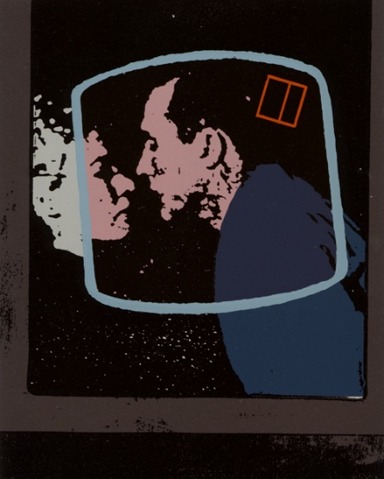
Fig I: 1984 Alex Williamson 1999
Williamson’s images evoke and reinforce the experience of surveillance through the content and aesthetic of his stylistic approach – a grainy image of Julia and Winston kissing, framed within what appears to be a television screen – an image of the back of a man which appears to be captured by CCTV, evoking a sense of voyeurism pervasive throughout the series of illustrations. The visual ambiguity, mechanised aesthetic and point of view of Williamson’s images enable the reader to identify with the mode of surveillance, thus enabling an identification which heightens the effect of voyeurism. Although Orwell’s prescient narrative pre-empted the widespread use of surveillance technologies in towns, cities and interior environments as a form of social control, even he could not have predicted the insidious growth of the use of such technologies and the breadth of their reach at the time of writing.

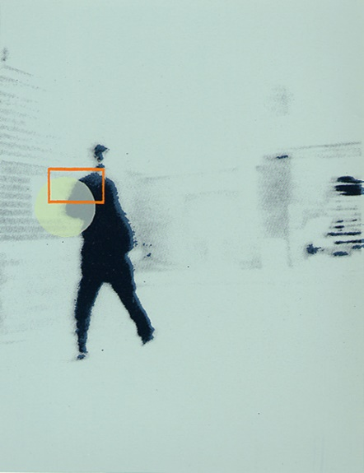
Fig II: 1984 Alex Williamson 1999

Like other Totalitarian states in the world, the intention of the ruling power described in ‘1984’ that is, the Inner Party of Oceania, was to subjugate its subjects and assert complete domination over them. Eventually, through sustained propaganda techniques disseminated through technologies, human spies and other techniques of control including violence, intimidation and psychological manipulation , the inhabitants of Oceania eventually begin to self -censor their behaviour , speech and thoughts, having internalised the dictates of the Oceanic oligarchs. ‘Besides the more direct method of police control, the party has devised other more subtle means to enforce a condition of complete servitude on the people. Building on the delirious notion that human nature is ultimately plastic and, by a due application of human engineering, can be transformed according to the wishes of the Party, the oligarchs of Oceania have long sought to fashion a new kind of man, completely subservient to the interests of the state, and yet entirely unaware of any feeling of servitude.’ [5]

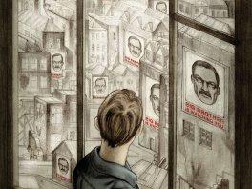

Fig III: 1984 Jonathan Burton 2014
In addition to the physical control of its inhabitants, Oceania employed more covert strategies for the purposes of control; Orwell understood only too well the power of language and its potential for controlling the masses. ‘If we agree with Orwell that language is an instrument, it can be misused deliberately; hence the provisional plausibility of Newspeak: a regime so confident of itself could, insanely, believe that it could manipulate language, and its users, by such a grand design’ [6] Continuing with his analysis of Orwell’s understanding of and deliberate use of political rhetoric in ‘1984’ Roger Fowler continues‘, he claims that ‘words of this kind [democracy, socialism, freedom, etc.] are often used in a consciously dishonest way.’ [7] However, although Orwell appeared to use ‘1984’ as a vehicle with which to critique the uses and misuses of political language Ed Smith, commenting on an essay that Orwell wrote, appears to suggest that Orwell himself used language in a way similar to those he was critical of. ‘There is a further irony about "Politics and the English Language". Orwell argues that the sins of obfuscation and euphemism followed inevitably from the brutalities of his political era. In the age of the atom bomb and the Gulag, politicians reached for words that hid unpalatable truths. By contrast, our era of vague political muddle and unclear dividing lines has inspired a snappy, gritty style of political language: the no-nonsense, evidence backed, bullet-pointed road to nowhere. Orwell's essay is rhetorically persuasive. And yet it makes little attempt to prove its central thesis. The reader, having nodded at a series of attractive and catchy stylistic observations, is tempted to accept the central thesis. In fact, Orwell's combination of masterly style and under-examined logic is the perfect refutation of his own argument.’ [8]
Panopticon
Highly esteemed publisher The Folio Society, produced a hardback version of ‘1984’ skill fully illustrated by Jonathan Burton in 2014. In the image above we see Winston gazing through a window into an urban landscape that reflects back to him a multiplicity of posters illustrated with the iconic and menacing image of Big Brother and bearing the slogan ‘ Big Brother Is Watching You’ emblazoned in bold, red upper case text . The image evokes a nightmarish Escher – like landscape in which Winston is incarcerated, perhaps a type of echo chamber, with no hope of escape. The image brings to mind Jeremy Bentham’s Panopticon, an architectural design for a prison building in which a centralised tower enabled guards to oversee the behaviour of inmates and whereby cells were designed to surround the tower to a complete 360 degrees with prisoners incarcerated in glass rooms enabling the guards to monitor them at all times. ‘The Panoptican must not be understood as a dream building: it is a diagram of a mechanism of power reduced to its ideal form.’ [9] This architectural embodiment of an ’external locus of control ‘devised to manipulate human behaviour, eventually operates without one’s personal conscious awareness of the process. One begins to imagine being watched in environments even where one is not. The embodied process and experience of ‘Big Brother ‘watching us, becomes internalised and our behaviour eventually becomes unconsciously modified.
As Foucault points out, that although we may appear to live in civilized democracies, surveillance technologies operate as a type of Panopticon and as can be seen in the visionary novel ‘1984,’ predicted a state of living in which the external technologies of surveillance had in effect, created an internalised state of self -monitoring and behavioural policing that resulted in the masses being effectively controlled by a powerful few. ‘Foucault’s term has been appropriated by a variety of disciplines to refer to a system where the powerful minority dominates the enervation majority through coercion rather than direct force. Foucault examines how surveillance has become an instrument for governments or other organizations to maintain power. He uses panopticon as a model for total surveillance, and as a metaphor for how contemporary power operates. He argues that in civilized societies, methods of surveillance have moved from the exterior to the interior, a notable shift from the force of the monarchical states to the internalized coercion of modern “democracies”. The modern state efforts to rely on internalized rules and make a ubiquitous –all seeing – appearance on society. This system of appearance and control is created through a number of new equipments: Propagation of media [10]
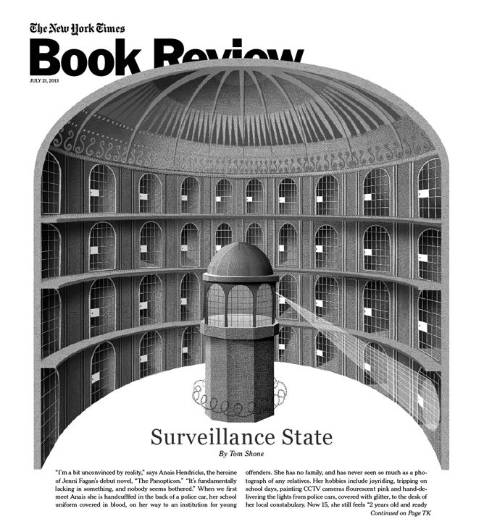
Fig IV: The New York Times Book Review The New York Times 2013
The increasing uses of technologies to maintain power and control are more insidious and covert than physical punishment and control, however, such surveillance technologies enable dominance through the enforcement of psychological and behavioural submission. The iconic design of the Panopticon created originally by Jeremy Bentham as a means to empower the penal system and which enabled visibility of the inmates at all times has been adopted by powerful institutions, including large corporations and institutions wishing to enforce coercive control over their subjects. Consider the modern office building, with its glass walls, offering visibility to all and therefore imposing a self- consciousness on the workers, who may or may not be under constant surveillance by a hypothetical ‘ all seeing boss ‘. As with Bentham’s original design, the ultimate function is control and for those who may or may not be under surveillance, the’ all seeing eye’ ultimately becomes internalised, ultimately resulting in subjects self- censoring and modifying their behaviour.

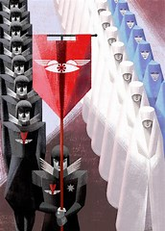
Fig V: The Handmaid’s Tale Elena and Ana Balbusso 2012
Visual identities
A collaboration between the Folio Society and Italian twins, Elena and Ana Balbusso resulted in the creation of a series of striking illustrations illuminating Margaret Atwood’s dystopian novel ‘The Handmaid’s Tale’ .The sisters also created a series of limited edition silkscreen prints and motion graphic versions of key themes in the story.
‘Margaret Atwood through her agent saw our first illustrations of the book and she totally appreciated our interpretation. We have been completely free, no external conditioning, no specific request.’ … We immediately understood the importance of The Handmaid's Tale project, quality and literary wealth of this exceptional text have greatly facilitated our work. ‘[11]
The Balbusso sisters’ representations of the visual identity of Gilead’s ruling powers and armies, including uniforms, banners and other insignia bring to mind the powerfully striking branding of the Nazi party. The re-appropriation of the swastika, the ancient symbol associated for thousands of years with themes of peace and good fortune became one of the most iconic political symbols in history. ‘The policing of all things Swastika was the responsibility of Dr Robert Ley, the head of the German Labour Front (Deutsche Arbeitsfront, DAF) and the Strength through Joy (Kraft durch Freude, KdF). …this former editor of the anti-Semitic newspaper, Westdeaucher Beobachter, was not a designer or art director, but garnered considerable power owing to his intense loyalty to Hitler. One of his most ambitious design initiatives was taking over the development of the Volkswagen (people’s car) from Porsche. It is not exactly clear how much Dr. Ley (who hanged himself after the war) was personally involved, although his introduction is in the volume. Perhaps he did not know the difference between typefaces, or even what graphic design was. But it was his office that determined the standards of stationery, enamel signs, flags and pennants, awards and badges, party uniforms and all things involving the swastika and ancillary symbols.’[12]
In response to a question I posed to the Balbusso’s they confirmed that they had, indeed, been influenced by such iconic symbolism ‘ We are also designers and we have created the logo of the eyes inspired by the Nazi-fascist graphic design. As regard our futuristic costumes, we wanted to create a contrast between the straight lines and angles of the women's dresses (like armour that imprisons their body) and the sinuous curves of the female body. The military uniforms of eyes are clear reference to The Schutzstaffel (SS) paramilitary organization. ‘[13]
Designer Hugo Boss, a member of the Nazi party at the time, created the uniforms for the party. The use of banners, flags, badges and symbols and the predominant use of the colours red and black created a visual uniformity and easily recognisable identity that projected a formidable presence and separation between groups of those with power and those without.
Responding to themes within Attwood’s powerful narrative the Balbusso sisters developed a visual style influenced by an Italian Futurist aesthetic. The ‘Eyes’ , who are the secret police of Gilead, are adorned in uniforms bearing the iconic logo of an eye which is also integrated throughout the visual identity of their clothing and also on banners and other insignia , reinforcing the concept of surveillance through an all seeing eye and suggestive of surveillance and control over the Handmaids. The stylistic approach of the illustrations connotes a sense of the mechanical and the characters appear as clones whereby both Handmaids and the ‘ Eyes ‘ have been visually reduced to a homogenized group, devoid of individuality. As we learn in the narrative, the Handmaids in Attwood’s chilling tale have had their autonomy removed and their role in life has been reduced to child bearing, in response to being identified as the exclusive group of remaining fertile women in Gilead. Handmaids are expected to be completely subservient to men and are expected to have no intellectual life. The forced act of sex (rape) with the commanders they are paired with, for the sole purpose of reproduction, is devoid of emotion or empathy and the Handmaids are expected to be fully compliant with their role.
‘In The Handmaid' Tale, we wanted to represent dehumanized people, women's uniforms are only containers of bodies. Women have been divided into rigid categories with precise roles without the possibility of individual choice. The Handmaids seem clones, their faces are anonymous, they have lost their individuality. When the handmaid takes off her red uniform, the body re-emerges with his carnality and identity (as the illustration titled: Red screen). Our references were also Mario Sironi and Felice Casorati Italian painters. They have suggested us the plasticity of the female body with clear volumes and synthesis of light and shadow. ‘ [14]

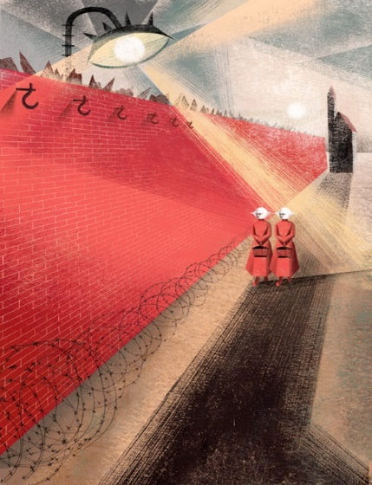
Fig VI: The Handmaid’s Tale Elena and Ana Balbusso 2012
In this image the iconic symbolism of the ‘Eye ‘(all seeing eye) the logo associated with the uniforms of the guards is reinforced visually within the environment as a search light monitoring the behaviour of the Handmaids. There is an emotional coldness communicated through the construction, muted colour palettes and tone of the image and the point of view creates a voyeuristic perspective meaning that the viewer is distanced from the characters, who are dehumanised and stripped of individuality through the identity imposed on them by their uniforms. The Balbusso’s repetitive use of identical and somewhat abstracted facial features for the Handmaids creates both an ambiguity and conformity of identity. The compositional use of the repetitious diagonal heightens the drama and this technical strategy is also used to visually impose a sense of entrapment on the Handmaids. The compositional diagonal appears in multiple forms – as the ‘red wall’ enclosing the camp, as the shadows cast and as the searchlight projected from the main ‘eye ‘search light beyond the boundary of the wall. The suggestion of multiple searchlights scanning the environment beyond the walls of the encampment, is conveyed through the network of diagonal light beams projected against the imposing grey sky. Describing the atmosphere they wished to convey, the Balbusso sisters stated, ‘We wanted an aseptic, meagre scenography with accentuated perspectives and strong light. Metropolis, the 1927 film directed by Fritz Lang, has suggested to us the scenography with influence from Bauhaus, Cubist and Futurist. In all images we chose an essential colour palette to communicate the psychological state of suffering, slavery, emptiness, obssession: red, black and white with a touch of striking, complementary colour, as acid green of the image titled “pregnant”. The colour reduction is like the reduction of the freedom of thought, characteristic of all totalitarian regimes ‘. [15]

Canadian artist Renee Nault created a graphic novel adaptation of Attwood’s novel in 2019. The artist worked predominately in coloured inks and watercolours and the visual representations of characters are very distinctive and individualistic, in contrast to the generic characters created by the Balbusso sisters in their interpretation of the narrative. Nault organises the graphic narrative into chapters and the predominant colour palette is of a rich, scarlet red. Colour is used strategically throughout the narrative to convey shifts in atmosphere: for example, chapter VII is predominantly painted with washes of limited colour palettes, mostly tonal washes of cool greys, which intentionally connotes a very specific and tone and atmosphere.

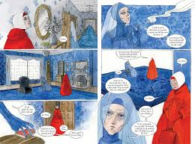

Fig VII: The Handmaid’s Tale Renee Nault 2019
The fluidity and sensitivity of the drawn outline combined with washes of colour, conveys Nault’s empathy for the characters, which is also reinforced through visual representations that honour the individuality of each person. This is effectively achieved through variations of facial features, body shape and racial differentiation. Perhaps it was Nault’s intention to enable the reader to emphasize and identify more fully with the Handmaids as a vehicle to gaining insights into the more shocking events of the narrative and therefore , to enable the experiencing of them on a more visceral level. Text is integrated mostly with the use of speech bubbles and is minimal, as is the inclusion of prose. Compositional technique and the use of strategic cropping create visual interest and variety throughout.
The visual representations of the Handmaids clothing is similar to that created by the Balbusso sisters and in costumes worn by characters in the television series. The colour red is the dominant palette used throughout the Graphic Novel and its symbolic association with themes including blood, anger and violence is note-worthy.

In addition to the over - arching subject of surveillance, other themes explored within both dystopian novels include the control of sex, fertility and the freedom to love whom one chooses.
Attwood’s focus on the control of women through sex and fertility covers similar ground to that which Orwell explores in ‘1984’; the Junior Anti Sex League promotes celibacy and children can only be created through the intervention of artificial insemination. In both novels, intimacy and sex are undertaken as an act of rebellion and in secret. Characters Winston and Julia in ‘1984’ and Offred and Nick in ‘The Handmaid’s Tale’ both engage in illicit sexual relationships, unendorsed and away from the control of the party. Rebellion as a theme is also communicated through the main protagonist of Attwood’s classic novel, Offred, who also demonstrates her intellectual prowess through her engagement in games of chess with the Commander. Both Alex Williamson and the Balbusso sisters create a sense of ambiguity through their visual depictions of characters –it could be argued that the decision to leave the identities of the characters somewhat less defined creates space for the reader to imagine their own personal visual interpretation and subsequently, to project themselves into the characters, enabling them to more fully identify with their experiences.

Conclusion
As discussed earlier, both ‘1984’ and ‘The Handmaid’s Tale’ tackle themes of surveillance, power and control. Both dystopian novels address the dangers of totalitarianism and of the denial of freedom by powerful dictatorial regimes. From a historical perspective, surveillance, whether through the use of physical spying or force has been easier to resist whilst it exists as a tangible force in the external world, but in our contemporary landscape and in the face of shifts in the uses and abuses of developing technologies, a more sinister narrative is emerging.
‘Surveillance Capitalism ‘by Shosana Zuboff , is a very timely analysis of contemporary methods of surveillance in which she explains how powerful forces continue to control societies and individuals using ominous techniques and strategies which are operated covertly and which are ,therefore ,potentially far more challenging to resist. She suggests that consumer choices are currently being shaped and monitored under the radar and compares past models of capitalism in which the land and sea were environments to be harvested, with a new inception that harvests humans - our knowledge, information and resources – she claims that we are the product.
In 2007 Facebook introduced ‘Beacon ‘a device which enabled advertisers to track their users’ consumer choices which were subsequently shared with their personal networks through their Face book pages. ‘Facebook founder Mark Zuckerberg shut the program down under duress but by 2010 he declared that privacy was no longer a social norm ‘[16]. Zuboff goes on to say that companies justify so called ‘free ‘ internet services in the following way ‘ Privacy , they said ,was the price one must pay for the abundant rewards of information , connection and other digital goods when , where and how you want them . ‘ [17 ] She continues ‘Under this new regime, the precise moment at which our needs are met is also the precise moment at which are lives are plundered for behavioural data , and all for the sake of others’ gain. ‘[18]
The methods of social control currently employed through surveillance technologies are more covert perhaps, than the strategies imposed in ‘1984‘and ‘The Handmaid’s Tale’ and therefore, it could be argued, even more insidious. The power dynamic is, as Zuboff claims, unequal as vastly powerful companies mine our digital data and harvest our information in an attempt to control our behaviour, whilst concurrently claiming that they are helping, rather than harming. Although in our contemporary society we believe that we are free to make our own choices , the data we often inadvertently provide enables companies to harvest our data and then use this to shape our behaviour and is described by Zuboff as ‘ Behavioural Surplus ‘.‘ Right now , however ,the extreme asymmetries of knowledge and power that have accrued to surveillance capitalism abrogate these elemental rights as our lives are unilaterally rendered as data, expropriated , and repurposed in new forms of social control , all of it in the service of others interests and in the absence of our awareness or means of combat.’ [19]
Returning to an earlier theme, Computer Scientist Joan Figenbaum compares the internet to Bantham’s Panoptican and explores the contemporary paradoxes of surveillance and privacy, highlighting ways in which our information and online communications are being monitored by advertisers, vendors, state surveillance organisations, criminal gangs and stalkers. Many internet users propose their right to anonymity and to protect their identities from being linked to their real –world identities. Those wishing to expose the identity of someone posting material on the internet can do so using anti- anonymity tactics. Visionary documentary maker Adam Curtis summarises the abuses of contemporary surveillance: ‘And the paranoia about surveillance carried on growing. But at the very time as this happened - a new system of watching and monitoring people rose up. It would do pretty much what the spies and the private detectives had been trying to do - but much, much more. It would record not just all our actions - but also be able to understand what was going on inside our heads - our wishes, our desires and our dislikes. It was called the internet. ‘. [20]
Orwell’s very prescient novel ‘1984’ was strongly influenced by a conversation he had with an artist during WW2 who was convinced that at least the Nazi’s wouldn’t be able to control peoples thoughts. The visionary author predicted the prospect of ‘thought control ‘as being the potent intrusion into that most private bastion of human freedom ,the mind -and explored this disturbing theme in his novel .Notably , with knowledge acquired through contemporary neuroscience and psychology the mind is now permeable and open to insidious manipulation and surveillance. In a recent thought provoking BBC Radio 4 broadcast, the presenter discussed our engagement with powerful modern technologies, including the internet, Google, Facebook, Apple and Amazon, tools which are all used to mine the public’s information. She suggests that each search undertaken via a platform such as Google, we are allowing the company access to our thoughts, whether or not we are aware of this. She compares the behaviour of such companies to the thought police of Orwell’s ‘1984’, and suggests they have the ability to harvest our online behaviour and data as it remains on their servers and that without our conscious awareness, our behaviour can then be shaped and modified and our future actions predicted. This perspective is reflective of themes discussed by Shoshana Zuboff. Likewise, computer scientist and Philosopher Jaron Lanier suggests that through gaining deeper understanding of human psychology and the mind , technologies have been harnessed to control and dominate society. “Going back to the 80s and 90s… there were these vivid arguments about the nature of truth made by people I like and respect, like Richard Dawkins and Daniel Dennett. Their argument was that we already have the basic outline of understanding how thought works, and so we can create algorithmic systems that capture knowledge, that exercise wisdom. I thought that was a huge trap – that it would turn into this house of mirrors that could be manipulated by whoever was the biggest asshole.” [21]
Returning to the illustrated narratives discussed earlier, it is of interest to note how both Alex Williamson and the Balbusso sisters adopted a more mechanical visual approach in their interpretation of these, reinforcing the depersonalised treatment of humans and the impact of technologies upon them. Both approaches create a distance between the reader and the subjects depicted in the illustrations. As both illustrated books are targeted at adult audiences, this may have been an intentional strategy to invite the reader to imagine for themselves and co – create the appearance of the characters, resulting in a less intrusive impact on the imagination. In contrast, the interpretations of the illustrated characters by Jonathan Burton and Renee Nault are far more nuanced and personalised, the reader being provided with more clarity with respect to characterization .In particular, Nault’s representations of diversity provides readers with a broader mode lwith which they might identify – there is certainly a sense of the unique humanity of the individual being conveyed.
Although many of the themes tackled in ‘The Handmaids Tale’ are of a dark and harrowing nature, Margaret Attwood also offers what Raefaela Baccolini describes as ‘a horizon of hope …one in which readers can learn from cultural commentary in fictional futures in order to make changes in the present.’ [22]. Baccolini has also noted that dystopian novels written by female authors ‘ have levelled important challenges to cultural and literary conventions: Women’s science fiction novels have contributed to the exploration and subsequent breakdown of certainities and universalist assumptions – those damaging stereotypes –about gendered identities by addressing , in dialectical engagement with tradition , themes such as the representation of women and their bodies , reproduction and sexuality , and language and its relation to identity.[23] The ability of humans to outwit their oppressors are themes that run through both novels and which have been explored within the context of this paper. Both Offred and perhaps, to a lesser extent, Winston Smith use rebellion and cunning behaviours as tools with which to resist their oppressors.
Attwood’s central protagonist Offred, represents a symbol of dissent and hope in an otherwise hopeless situation, she uses her intelligence, ingenuity and sexual power to outwit those who seek to control and exploit her and the other Handmaids. The current resurgence of interest in Margaret Attwood’s novel, amplified by the recent television series is very timely, as is Orwell’s 1984. Both narratives offer illustrators exciting opportunities to explore rich subject matter and bring such imposing themes to new and perhaps younger audiences, particularly in the case of Renee Nault’s adaptation ,so that the importance of powerful themes including freedom of thought can be passed on to younger generations – words and images combined are uniquely powerful .

References.
1 Scott, L Balbusso Sisters Interview , online ( 2020 )
2 Foucault, M: Discipline and Punish. Penguin Books (1975)
3 Capurro, R, Eldred, M and Nagel, D: Digital Whoness: Identity, Privacy and Freedom in the Cyber World Electronic book, 34 (2013)
4 Fowler, R: The Language of George Orwell, 182-183 (1995)
5. E and O, Diversitie: http://www.diversite.eu/pdf/12_1/DICE_12.1_Full_Text_p25-p36-Ervin-XHINAKU-Olsa-PEMA.pdf Accessed 09/02/20
6. Fowler, R: The Language of George Orwell. Macmillan Press (1995)
7 Fowler, R: The Language of George Orwell. Macmillan Press (1995)
8. Smith, E: New Statesman https://search-proquest-com.ezproxy.falmouth.ac.uk/docview/1289053694?OpenUrlRefId=info:xri/sid:primo&accountid=15894
New Statesman: Ed Smith VOL 142 fab 8-14th 2013 accessed (9/2/20)
9. Foucault, M: Discipline and Punish. Penguin Books, 205 (1975)
10. Surveillance www.ipedr.com/vol42/034-ICKCS2012-K10044.pdf
11. Scott, L Balbusso Sisters Interview, online (2020)
12. Heller, S: Design Observer https://designobserver.com/article.php?id=24358 Interview with Steve Heller Accessed (13/03/20)
13. Scott, L Balbusso Sisters Interview, online 2020
14. Scott, L Balbusso Sisters Interview, online 2020
15. Scott, L Balbusso Sisters Interview, online 2020
16 Zuboff, S: Surveillance Capitalism, Profile Books, 48 (2019)
17. Zuboff, S: Surveillance Capitalism, Profile Books, 52 (2019)
18. Zuboff, S: Surveillance Capitalism, Profile Books, 53 (2019)
19. Zuboff, S: Surveillance Capitalism, Profile Books, 54-55,(2019)
20. Curtis, A: https://www.bbc.co.uk/blogs/adamcurtis/entries/78691781-c9b7-30a0-9a0a-3ff76e8bfe58 accessed (9/02/20)
21. Lanier, J: Who Owns the Future? Penguin Books (2013)
22. Day, SK, Green-Barteet, MA, Montz,AL: Female Rebellion in Young Adult Dystopian Fiction. Ashgate Publishing, 10 (2014)
23. Day, SK, Green-Barteet, MA, Montz, AL: Female Rebellion in Young Adult Dystopian Fiction. Ashgate Publishing, 9 (2014)
Bibliography:

Female Rebellion in Young Adult Dystopian Fiction (2014) Sara K. Day, Miranda A. Green-Barteet , Amy L. Montz
The Handmaid’s Tale Margaret Attwood (1985)
The Handmaid’s Tale Folio Society (2012) Illustrated by Elena and Ana Balbusso
The Handmaid’s Tale Jonathan Cape (2019) Illustrated by Renee Nault
1984 George Orwell (1949)
1984 Secker and Warburg (1999) Illustrated by Alex Williamson
1984 Folio Society (2014) Illustrated by Jonathan Burton
The Age of Surveillance Capitalism Profile Books (2019) Shosana Zuboff
Picture This Molly Bang (2000) Turtleback Books
Discipline and Punish Michel Foucault (1975) Penguin Books
The Language of George Orwell Macmillan Press (1995) Roger Fowler
Who Owns The Future? Penguin (2013) Jaron Lanier
Digital Whoness: Identity, Privacy and Freedom in the Cyber World. De Gruyter Inc. (2013) Rafael Capurro, Michael Eldred ‘Seeking Anonymity in an Internet Panoptican ‘Big Data’ – internet article sourced (9/02/20) ‘Seeking Anonymity in an Internet Panoptican ‘Big Data’ – internet article sourced (9/02/20)
Joan Figenbaum Communities of the ACM Vol 58 2015 pg 61
https://dl.acm.org/doi/pdf/10.1145/2714561?download=true
https://www.outerplaces.com/science-fiction/item/19312-handmaids-tale-graphic-novel-renee-nault accessed
(11/03/20)
https://www.bbc.co.uk/blogs/adamcurtis/entries/78691781-c9b7-30a0-9a0a-3ff76e8bfe58 accessed 9/02/20
http://www.diversite.eu/pdf/12_1/DICE_12.1_Full_Text_p25-p36-Ervin-XHINAKU-Olsa-PEMA.pdf Accessed (09/02/20)
https://search-proquest-com.ezproxy.falmouth.ac.uk/docview/1289053694?OpenUrlRefId=info:xri/sid:primo&accountid=15894 New Statesman Ed Smith VOL 142 fab 8-14th (2013) accessed (9/2/20)
https://designobserver.com/article.php?id=24358 Interview with Steve Heller Forum Internum, 11:00 (13/03/20) BBC Radio 4, 30 mins. https://learningonscreen.ac.uk/ondemand/index.php/prog/15968196?bcast=131461039 Accessed (26/05/20)

