Community Radio in the UK: Lessons from a Demographic Survey in Cornwall

Introduction
Over the course of its history there has been little research into the audience for Community Radio (CR) in the UK. Commercial radio and the BBC generally use the Radio Joint Audience Research (RAJAR) service to measure audience figures, which charges an annual subscription of £7968 for stations with a Total Service Area (TSA) of less than 300,000 people (RAJAR, 2020a). Subscription to RAJAR is something which the CR sector cannot afford, run, as CR stations are, on a shoestring budget for the most part (Gordon, 2007). £7968 often represents the value of the contents of an entire CR studio. Hallett’s study of 2011 (Hallett, 2011) has previously suggested an estimated reach of 10% for the CR sector based on the studies which had been carried out at that time. Accurate audience figures are useful as a way of measuring the level of engagement of CR with its broadcast area, and at a time when the structure of local radio and CR’s role in this is very much up for discussion (Ofcom, 2018; Clarkson, 2019), proving the impact that CR has made in the communities it serves could help to ensure its sustainability and provide some important pointers for CR in the UK.
This survey seeks to gain an indication of the levels of listenership to CR in three small towns in close geographical proximity in the rural region of Cornwall, UK, each with varying approaches to volunteer involvement and broadcast content. These results are analysed for the implications for CR in the UK and the potential of the rhizomatic model for CR stations in the UK to improve social gain and increase audience in a way which offers a robust basis for the long-term survival of CR.
The Current Situation of CR in the UK
Commercial Radio is somewhat nervous of CR, fearing it may steal its audience and sponsorship money. A report published in 2018 by David Lloyd via Radiocentre (Lloyd, 2018) – the organisation founded to represent commercial radio’s interests – highlighted many of the concerns which commercial radio has in the face of the rise of CR in the UK: lost advertising revenue, lack of definition of CR’s remit, and lack of evaluation of CR’s success or otherwise. Commercial radio is going through a period of change and redefinition in the UK, with local stations being bought by global media organisations and the local aspect of these stations being lost. Localised radio in the commercial sector and the BBC is disappearing, and CR is being left to fill the gap without increased government support. Whether this is by design or circumstance remains to be seen but CR is often ignored when local radio and its apparent demise are discussed (Ryan, 2020).
CR was established in the UK in 2004 with the Community Radio Order (2004) serving communities which are not well represented by traditional media, with the stipulation that they must meet a ‘social gain’ requirement for the local community. ‘Social gain’, much like ‘community’, is a nebulous term, which is open to interpretation. In fact, one of the recommendations of Lloyd’s 2018 report was to provide a more rigorous definition of social gain, against which the success of CR stations could be measured. The social gain or benefit to the community which CR stations claim to provide ranges from providing individuals with broadcasting training to fully-fledged community development projects in care homes, schools, and hospitals.
De facto access to participation in CR varies according to the whim of the station manager and boards at the varying stations. This can range from a more closed-access model, where potential presenters submit a showreel, conform to a station’s existing format and play music from the station’s playlist, through to a more open-access model which allows anyone who expresses an interest to have a show. The station and studio managers are the gatekeepers. The aesthetics of CR in the UK split along a similar divide, with the majority imitating the format of Independent Local Radio or the BBC, and a minority of stations which explore more avant garde or experimental content or administrative structure (Soundart Radio, Reprezent). The Community Radio Awards were founded in 2015 by Martin Steer (Steer, 2020) and give an indication of the content which the sector values. As well as more prosaic categories such as ‘Best Male Presenter’, ‘Best Female Presenter’, others include ‘Best Outside Broadcast’, ‘Best Community Development Project’, and the ‘Innovation Award’.
CR stations in the UK can also be divided along other lines: urban stations serving ethnic minorities, art stations, youth/social work stations, and hyperlocal stations serving communities too small to sustain a commercial station. All the stations in Cornwall, and this survey, fall into the last category.
The Rhizomatic Model
The rhizome as a model for society was developed in Deleuze and Guattari’s text ‘A Thousand Plateaus: Capitalism and Schizophrenia’ (2004), based on the botanical rhizome. Nico Carpentier (2016) developed this idea as an analysis of community media in his work. Carpentier defines four theoretical approaches to community media: serving the community, an alternative to the mainstream, part of civil society, and rhizomatic. The community model is the largest basis for consideration in the UK – the notion of social gain being very much a part of that model. A rhizomatic model, however, implies a non-hierarchical structure, with many roots interconnecting. It is in opposition to a traditional hierarchical structure, which many CR stations adopt after the commercial radio model. Santana & Carpentier (2010) use the rhizome to map the connections to other communities that CR stations have, politically, musically, socially, and otherwise.
Methodology
The audience and impact of three CR stations in close geographical proximity but adopting different administrative and inclusive principles were measured to gain an understanding of the potential of the rhizomatic approach for CR. The methodology followed to gather data is that which is laid out in the ‘street survey’ aspect of the Prove-It methodology devised by Shember-Critchley (2012; 2014). It was chosen to follow as a robust method which has been rigorously developed and tested previously in the field. This method is a more developed version of the approach first mapped out by Janey Gordon (2006) in the CMA’s now defunct ‘Airflash’ magazine, and subsequently by Lawrie Hallett (2011).
Due to the Coronavirus outbreak and subsequent lockdown and social distancing, data for Saint Austell was collected online. The Prove-It survey was adapted to a Google Forms survey and distributed via Facebook groups, ‘St Austell Friends’ (8405 members) ‘Saint Austell Live’ (1400 members). These are the two largest Facebook groups for the town of Saint Austell. For that reason, data from this part of the survey may be less reliable due to the possible biases an anonymous online survey may contain, as is illustrated by the gender bias in the sample.
Context: Radio in Cornwall
Cornwall has a local BBC station (Radio Cornwall), a commercial station based in Redruth (Pirate FM), and seven hyperlocal CR stations, each serving a small Cornish town. This is a large number of CR stations per head of population: the entire population of Cornwall is circa 566,000 people (Cornwall Council, 2015), equivalent to the population of a city the size of Sheffield, which currently has 2 CR stations serving it.
Three stations in Cornwall were considered in the survey which serve similarly sized populations but represent diverse approaches to CR in the UK.
Station One: Source FM, Falmouth – The Rhizomatic Approach
Source FM serves the community of Falmouth and Penryn and surrounding areas, with a broadcast population of about 55000. Falmouth has, since 2005, experienced the establishment and growth of a university which gives the town a more cosmopolitan demographic than the rest of Cornwall. Most of Cornwall has an ageing population (Cornwall, 2015), Falmouth however has a large population of 18 to 25-year-old students.
Source FM is a station which belongs on the more artistic side of the content spectrum of CR, and it embraces a completely open-access ideology. It features shows such as the ‘Cosmic Art Show’, which invites the audience to create art directed by its presenter, and ‘Drewzy and the Robot’ which is presented by a man talking to a robot. There is, of course, also more traditional content such as music genre shows (‘Jazz Train’), news content and magazine style shows (‘Jimmy Miller’s Musical Allsorts’). Because of Source FM’s open-door policy and esoteric approach to scheduling it is the station with the most volunteers (88) broadcasting each week. Source FM also runs a highly successful live music event ‘Parklive’ every year which helps it to gain awareness amongst its potential audience. These factors mean Source FM is the station in the study which has adopted the most far-reaching rhizomatic model, the other two broadly following a traditional hierarchical model along the lines of a commercial radio station.
Station Two: CHBN, Truro
Community Health Broadcast Network (CHBN) broadcasts to Truro in Cornwall. Truro and the surrounding towns have a similar population to the Falmouth area of about 55000 people. Truro is Cornwall’s only city and its administrative centre. It also has a substantial commuting population of office workers. Truro is also the shopping and travel hub for West Cornwall and most people in the South and West of Cornwall will travel here at some point.
CHBN is a more conservative station than Source FM in terms of output and is closely associated with Royal Cornwall Hospital Treliske (RCHT), growing out of the old hospital radio station, and having its studios based there. It is still based in RCHT and has a health remit attached to its license application. There are none of the experimental programmes to be found on Source FM, output mainly consists of Adult, MOR content, although there is a focus on the community (‘The Community Help Show’), literature (‘Bookmark’), and a children’s bedtime story show.
Station Three: Radio Saint Austell Bay, Saint Austell
Radio Saint Austell Bay (RSAB) is the oldest station of the three surveyed, winning its Ofcom licence in 2007. Saint Austell is a more working-class town than the other two in our study and RSAB has recently been through a period of great change, with three of the management team, including founding station manager Sheila Vanloo, resigning shortly after the study was conducted. This change is partly because of a run of Ofcom breaches within the space of a year which has given RSAB some notoriety within the CR sector.
RSAB favours the most conservative approach to the scheduling – with presenters appearing in the same slot every day during the week in the vein of commercial or BBC radio stations, meaning fewer volunteers are involved.
Results
Where possible, terms and definitions echo RAJAR’s to make the data as comparable as possible. The RAJAR data from the first quarter of 2020 (RAJAR, 2020b) was used as a reference (the same timeframe in which the study was carried out).
Source FM, Falmouth
The Falmouth survey interviewed 177 people, 134 of which listened regularly to the radio. 21.76% of the sample listen to Source FM at some point representing 30.08% of the radio listeners. 37% of population are aware of Source FM’s existence. Extrapolating this over the whole population of the broadcast area this represents 11,968 people listening into Source FM at some point. Interestingly Source FM was the only CR station to have listeners reported outside its broadcast area with two people in the Truro survey saying they listened to Source FM.
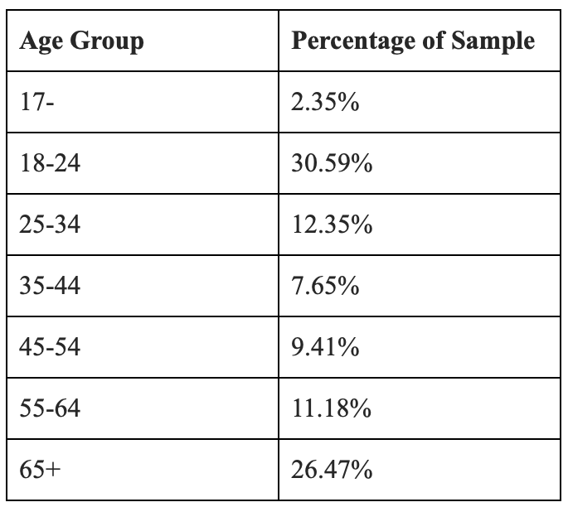
Figure 1 Listeners by Age for Source FM
Source FM has a broad range of ages listening, with an obvious spike in the 18-24 age range due to the large student presence in the town. There is a slight majority of women listeners. Reasons given for not listening included it being too ‘old sounding’, and the reception being poor. Things that people appreciated about the Source FM included the Parklive series of events (mentioned by 10% of participants), and people felt Source FM was ‘good for the community’.
CHBN
The sample size was 130 people, giving a margin of error of 8.51% at 95% certainty. There was a smaller listening reach for CHBN in the community with only 8.51% having ever listened to CHBN and 20.45% aware of its existence. Reasons for not listening by people who were aware of the station included: it being ‘too amateurish’. Significantly, several people mentioned they did not think it could be received outside of the hospital and CHBN remains perceived as a hospital radio station by the inhabitants of Truro. Positive impressions amongst listeners included the fact that it provides local community news. Criticisms from those aware of the station included the choice of music played being ‘not for them’. The listenership is also quite well spread across the age ranges.
Listener Demographics
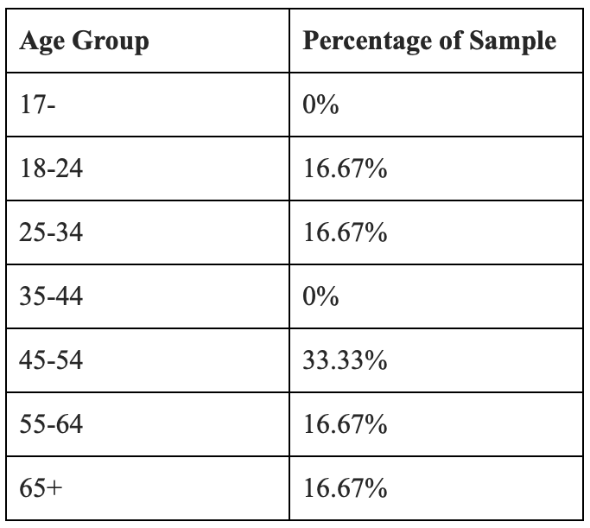
Figure 2 Listeners by Age for CHBN
Radio Saint Austell Bay
12.16% of those who responded to the online survey listened to RSAB or 13% of the radio listeners. RSAB has a great awareness in the town with 66% of population aware of its existence. Reasons for not listening amongst the people aware of the station again included: ‘Too amateurish’, and ‘poor reception’. Positive impressions of the station included that it was ‘good for the town’. Criticisms of RSAB amongst those who have listened included the choice of music and the presenting style.
Listener Demographics
The listeners to RSAB were majority male (61.5%), despite the sample being majority women. The age range of listeners is skewed greatly towards the over 65s, which aligns with some of the feedback from younger interviewees that the station was for ‘old people’.
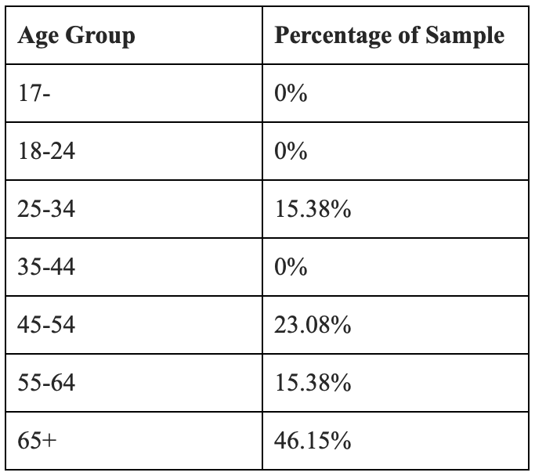
Figure 3 Listeners by Age for RSAB
Comparison of Listenership and Awareness Levels amongst Three Community Radio stations
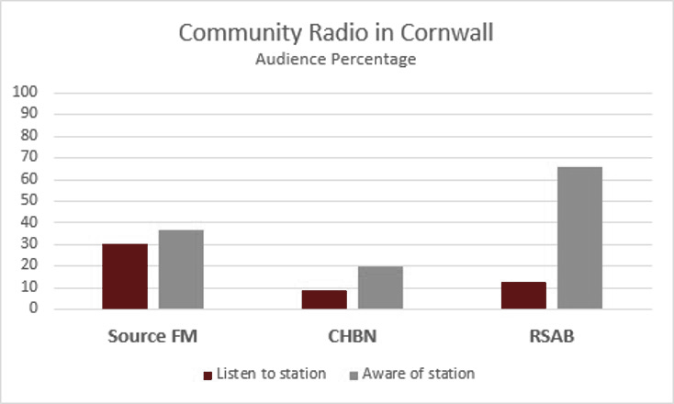
Figure 4 Audience and Awareness at the Three Stations
The results show that all three stations are listened to by a small but significant percentage of the populations of each town. There is a small cohort of regular listeners who listen weekly, daily or monthly. The random listening habits of the listener somewhat reflect the unpredictable output of stations, and several interviewees remarked that they didn’t know what to expect when they tuned in.
Reach is defined by RAJAR as the number of people who tune in at least once per week. If we use our sample of those who listen at least daily or weekly to each station as an indication of reach that gives us: Source FM with a reach of 8.46% (4653 listeners), CHBN a reach of 3.29% (1829 listeners), RSAB a reach of 6.3% (3465 listeners). To put these figures into context with a comparison to the reach of national stations, that would put Source FM on an equal reach with Radio 5, CHBN, Radio 3 and RSAB, KISS FM, albeit within their limited geographical area.
Implications and Recommendations
I now present some preliminary thoughts on the data, which may appear in a more developed fashion in future publications. The results show that CR does have an audience and is being listened to in small but significant numbers. Even in the case of the least listened to station, around 10% of the potential audience were listening at some point. All three stations share some common positive perceptions and criticisms: that the output is not for them in some way, that they serve the community well and give opportunities to local people. Source FM has the best listenership and a good level of awareness. RSAB’s notoriety has not translated to increased audience, and the large number of people aware of its existence is possibly due to the local news reports of its various Ofcom breaches.
Source FM’s success in gaining an audience points to its adoption of a rhizomatic model in terms of its schedule and management style as potentially being a strong model for other CR stations to adopt. Source FM’s large number of presenters and its many root-like connections to affinity groups within the community it is based in, extend its outreach: ‘Rainbow Source’ serves the LGBTQ community, ‘One and All’ the Cornish independence movement and ‘Damped Waves’ the sound art community. In some cases, this rhizomatic approach has been actively pursued, with community groups representing the BAME community, women, the LGBT community, and other local organisations being approached to create a show. Source FM’s Parklive free music events also help it to be seen in the community in a positive light.
Applying an artistic approach such as the Source FM’s may not go down so well, of course, in a more working-class town such as Saint Austell, but Source FM’s open-access approach means it reflects the spirit of the town it serves more accurately. A rhizomatic approach to the schedule, and perhaps more importantly, the governance of the CR station can lead to increased listenership, engagement, and sustainability. It should be noted that all the stations in our survey did provide a voice for the under-represented and provide social gain to their communities, but perhaps not to the same extent as Source FM.
CR in the UK stands at a transitional point. Its future could be to become a hyperlocal replacement for the local aspect of ILR and the BBC, which is now disappearing. This could potentially harm the social gains which CR has offered. The rhizomatic model is already being embraced on non-Ofcom licensed Internet Radio stations such as NTS in London. Internet Radio, along with podcasting, does not need to adhere to the license requirements necessary to have a CR license. The rhizomatic model is a powerful model for the future of successful community media in the UK. If CR is to survive as a useful, creative, and community-serving movement it should consider embracing the rhizome.

Acknowledgements
Thanks to field interviewers: Georgina Colman, Aleksandar Milchev, Bethany Pritchard, Henry Tuite, Ruth Wakefield, Rhys White.

References
Carpentier, Nico (2016), ‘Community Media as Rhizome’. Journal of Alternative and Community Media.
Clarkson, Stuart (2019), ‘UK commercial radio presenter numbers could drop by more than 250’. https://radiotoday.co.uk/2019/02/opinion-uk-commercial-radio-presenter-numbers-could-drop-by-more-than-250/. Accessed 13 May 2019.
Cornwall Council. (2015), ‘Cornwall. A Brief Description…’ https://www.cornwall.gov.uk/media/20392018/cornwall-statistics-infographic-a3_proof3.pdf.
Deleuze, Gilles, & Guattari, Felix (2004), A thousand plateaus: capitalism and schizophrenia, London, Continuum.
Gordon, Janey (2006), ‘Is Anybody Out There? Audience Research for Community Stations’. Airflash. Summer 2006, p20-21. Sheffield, CMA
Gordon, Janey (2007), ‘Community Radio, Funding and Ethics’. The International Journal of Regional and Local Studies. Vol.3 (2), pp.23–40.
Hallett, Lawrie (2011), ‘Measuring Community Radio Audiences’, Radio Evolution: Conference Proceedings, September, 14-16, 2011, Braga, University of Minho: Communication and Society Research Centre
Lloyd, David (2018), ‘Small-scale Radio in the UK. How local, commercial and community radio can co-exist’. https://www.radiocentre.org/wp-content/uploads/2018/11/SMALL-SCALE-RADIO-IN-THE-UK-ONLINE.pdf. Accessed 8 May 2020.
Ofcom (2018), ‘The Communications Market Report 2015’. Ofcom. https://www.ofcom.org.uk/__data/assets/pdf_file/0022/20668/cmr_uk_2015.pdf. Accessed 17 Oct 2020.
RAJAR (2020a). ‘RAJAR ratecard’. https://www.rajar.co.uk/docs/how_to_subscribe/2020_Full_Station_Ratecard.pdf. Accessed on: 01-06-20.
RAJAR (2020b). Quarterly Report generated at: https://www.rajar.co.uk/listening/quarterly_listening.php
Ryan, Frances. (2020). ‘Local broadcasting is dying out with a whimper. We'll miss it when it's gone’. Guardian. https://theguardian.com/commentisfree/2020/jun/10/local-broadcasting-regional-radio-tv-shows-local-communities?CMP=share_btn_tw
Santana, Maaika, & Carpentier, Nico (2010), ‘Mapping the rhizome. Organizational and informational networks of two Brussels alternative radio stations’, Telematics and Informatics, 27(2), 162–176. https://doi.org/10.1016/j.tele.2009.07.003
Shember‐Critchley, Eleanor (2012). ‘Prove It: An Audience Research Tool for Community Radio Stations’. Manchester: Radio Regen
Shember-Critchley, Eleanor (2014). ‘Prove It’: A community radio research methodology’. ECREA European Communication Conference: Lisbon
Steer, Martin (2020), ‘Community Radio Awards’. https://communityradioawards.org.uk/. Accessed on 4 Jun 2020.

