Taylor & Francis Word Template for journal articles

Wild Home: Photography, Domesticity and More-than-human Boundaries in Fieldwork and Expeditionary Science

Drawing on archival research conducted at the Royal Society, London by _______an artist and accidental historian of Science, this paper will explore the borders and boundaries in the fluid domains of fieldwork photography and expeditionary science research stations. Through the story of Angela Bishop, the wife of an expedition leader to Central Brazil in the 1960’s, this paper examines the borders between wild and domestic, public and private, institutional and autobiographical in the Royal Society Iain Bishop expedition photographic collection.
Keywords: photography, film, super 8, science, expedition, fieldwork, visual culture, exploration, wild, domestic, non-human, animals, boundaries, gender, Brazil,

Introduction
‘With Iain, went Angela, a nurse who had become his wife shortly beforehand. Both Royal Societies, mindful of all the famous expeditions their societies had dispatched in the past, when the idea of a leader taking his wife along had been entirely unthinkable on all sides, were not daunted by Iain’s marriage after his appointment as a leader. In any case, he was insistent: his new wife would not be left behind in England”.

To write of photographs of domesticity in wild places, I will call upon the story of a 20-year-old barmaid from London, Angela, who found herself in the middle of the forest in central Brazil for near nearly two and a half years in the late 1960’s, during a British scientific expedition. This story is a sidestep, marginal narrative line that emerges from an expeditionary science archival collection at the Royal Society in London and a productive refusal to re-enforce dominant western, post-colonial and male traditional narratives.
Angela’s story emerges from the photographic archive, and it is centred here to reflect upon the borders and boundaries between wild and domestic, as fluid social and ecological constructs, tracked through images and their contextual narrative.

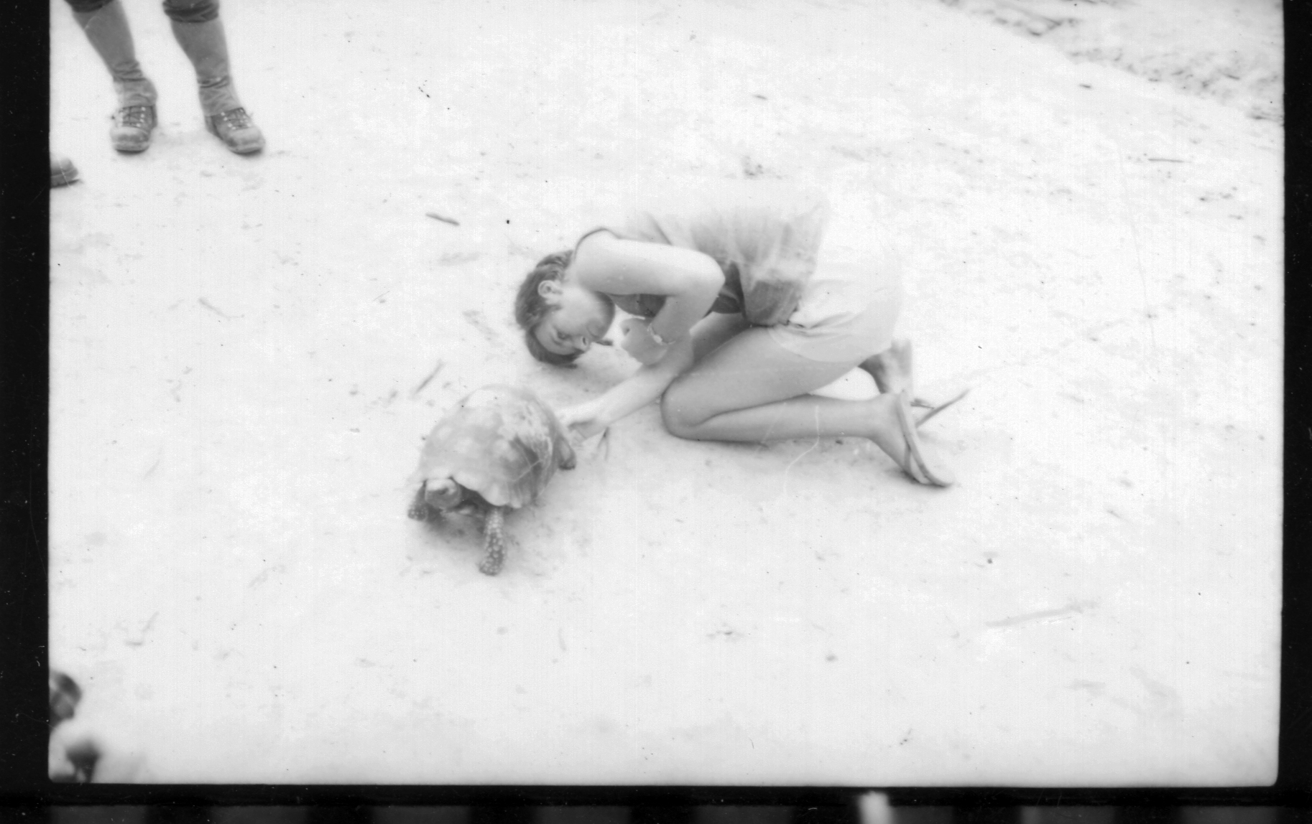

Figure 1 Angela with tortoise, Iain Bishop Collection,
Royal Society Archive.
© Copyright of the Royal Society London

In 1967, in the context of a scientific expedition, Angela embarked on a journey which allowed her to conform to and simultaneously rebel against established gender norms in both domestic and public spheres. In many ways, this journey allowed Angela to renew and interrogate the domestic socialisation of women in mid 20th century, as described by Nancy Chodorow, and circumvented settling into a traditional domestic role in England, following her wedding to the expedition leader, Iain Bishop, which had taken place only a few months before the launch of the expedition.

The story of Angela settles itself within my doctoral case study, the Royal Society and Royal Geographical Society Xavantina-Cachimbo expedition to Mato Grosso, in Central Brazil (1967-69), and it considers the expedition fieldwork Base Camp, Angela’s wild home, as a transitional and liminal space where borders and boundaries are key to the general understanding of image making practises in the field.

Through the photographic archive, Base Camp emerges as a blended and fluid domain of the public and the private; of the domestic and the wild. This wild home challenges the positioning of the familial album, the autobiographical image, and the institutional collection, within one another. Angela’s story and atypical home recentred here, is only visible and accessible through the photographs her husband made with her during the expedition.

The Xavantina-Cachimbo expedition stemmed from the invitation of the military government of Brazil to global scientific institutions to study the area around the construction site of an interstate road crossing the state of Mato Grosso, a mostly unexplored undeveloped territory four times larger than Britain. The invitation and the expedition emerge from the links between science and development, scientific inquiry, extraction and destruction of green spaces, in a trans-national historical event. The Royal Society and the Royal Geographical Society were prompt to accept the invitation.

The expedition Base Camp, set up in 1967, was situated in a region composed of a shifting mosaic of habitats, with the savanna-like cerrado itself present on a well-drained areas, between strips of gallery forest and streams, along which expedition members washed themselves, their clothes, and dishes, in this way signalling the wild configurations of this atypical domestic space, which spilled into the forest. It is the relationship between image making and these fuzzy domestic and wild borders that are explored in this paper. Expeditionary science is itself a ‘process of physical and material contact and exchange’ build upon a postcolonial environment and histories of extraction and violence towards indigenous peoples in the region. So, it becomes necessary to flag this fluidity of spaces, as anything but neutral.

The fact that British scientists led this expedition transforms this event into a trans-post-colonial moment whereby land, peoples and forms of knowledge are reconfigured still through post-colonial histories, despite the lack of a common national history of invasion and colonialism. The ancestral land of indigenous nations in Brazil becomes ‘the field’ as a ‘particular kind of space for the production of scientific knowledge’.

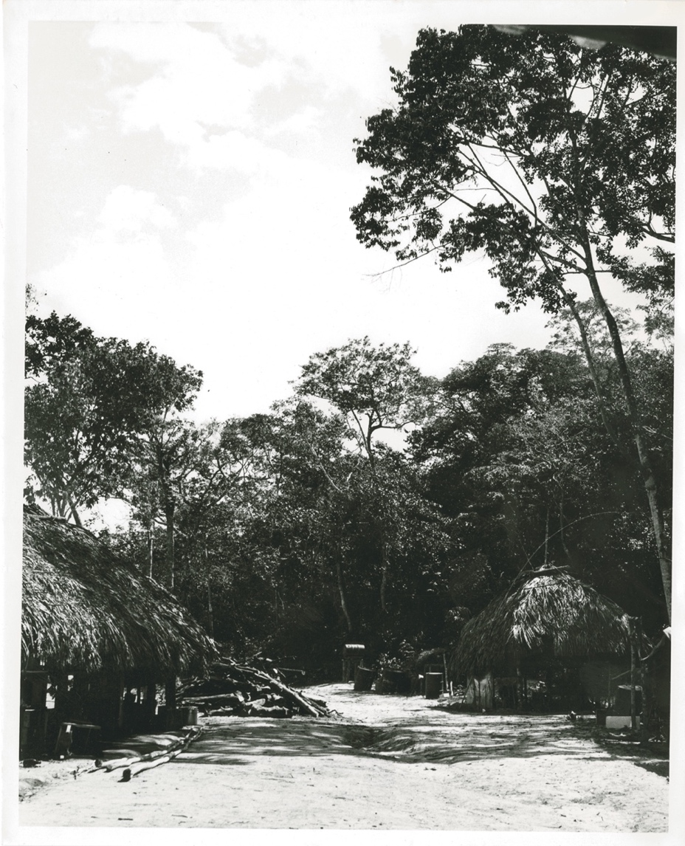
Figure 2 View of base camp huts, Iain Bishop Collection, Royal Society Archive.
© Copyright of the Royal Society London

The expedition leader, the zoologist Iain Bishop produced extensive accounts formal documentation, fieldwork notebooks, photographic and filmic records of the expedition. These were posted to London to be processed and a selection posted back to Base Camp. It is through this material that we can think through this event, the role of its members and the analysis of spaces, in particular its central space of Base Camp (Figure 2), and the presence within it, of his wife.
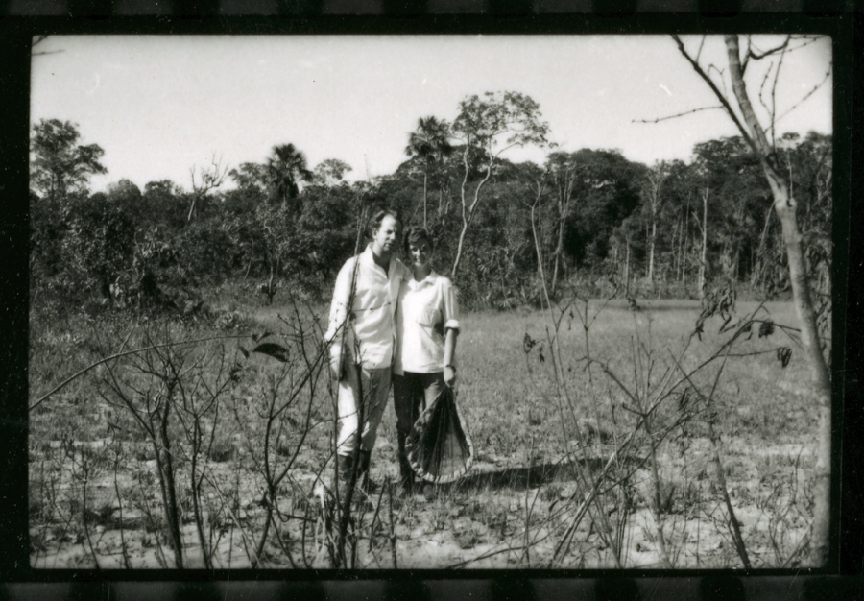

Figure 3 Angela and Iain Bishop, Iain Bishop Collection,
Royal Society Archive.
© Copyright of the Royal Society London

Angela emerges as a central figure in the expedition visual records, but as a marginal figure within the personal and official written expedition records, published articles and scientific outcomes of the expedition, making her a partially visible collaborator of science.

Through depictions of Angela, photography effectively evidences Angela’s labour and involvement in expedition research projects, representing Base Camp as a place of work in the field. Through this collection, the field, as a site for scientific knowledge making and a wild home for Angela intersects with the visual ‘field’ with its multiple and interlocking qualities, suggesting that these photographs of the field would come to do more than to document expeditionary science.

In the next two figures (Figures 4 and 5), Angela is seen at work in the field/ in the first image Angela is attempting to capture a fish or amphibian in one of the many streams and rivers, which surrounded the Base Camp, presumably for one of the freshwater biologists, and in the other image she is seen holding a parrot-like bird. The images of Angela at work in the field are as plentiful as they are diverse, showing her involvement in field research and close relationship with local fauna. This influences the qualities of Angela’s wild home and suggests its porous borders to non-human life.

The photographs of Angela scientific labour and the affective engagement during this expedition, also alert us to the question of training, education and membership within the scientific communities, and scientific institutional bodies. As Kohler states ‘the relationship between the expert and the vernacular in Natural History remains a contentious issue in democratic societies in which access to privileged categories is a political issue’.

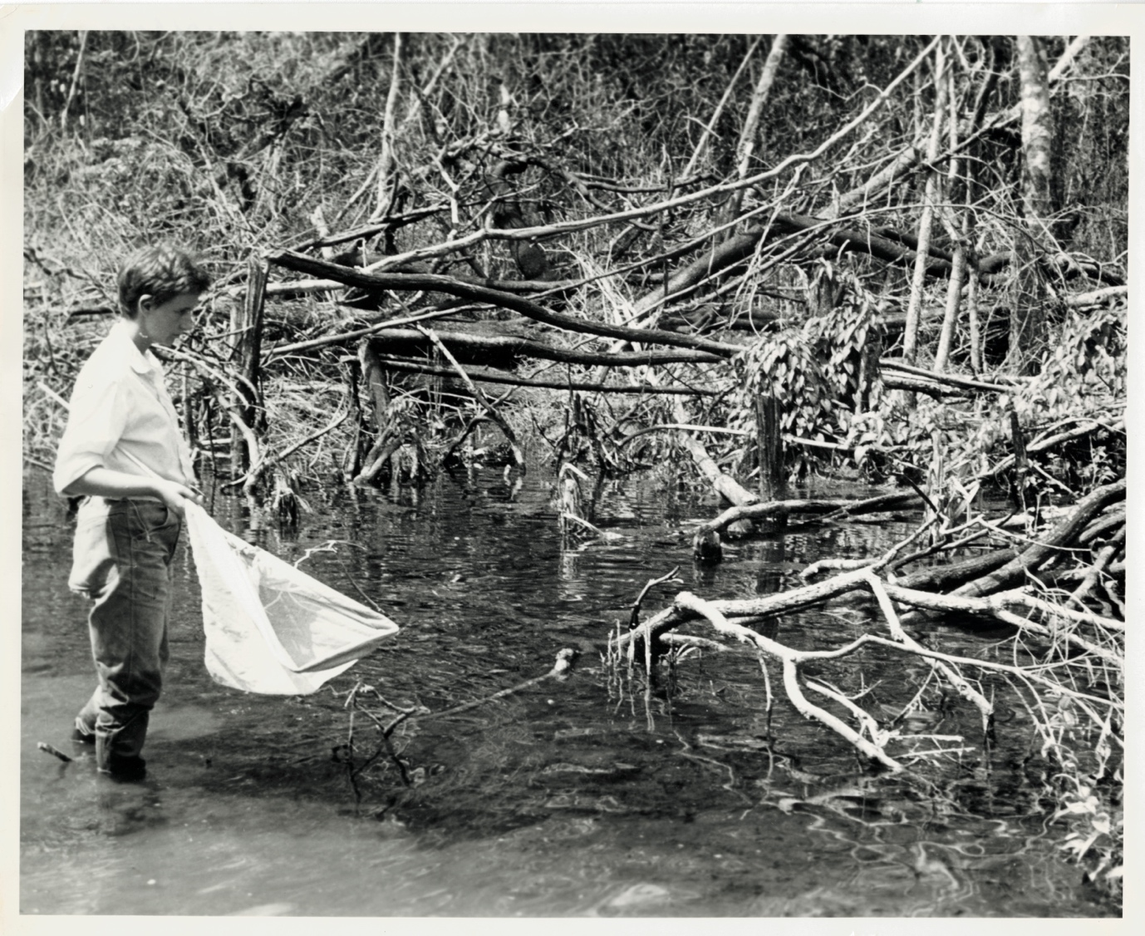

Figure 4 Angela Bishop with net, Iain Bishop Collection,
Royal Society Archive.
© Copyright of the Royal Society London

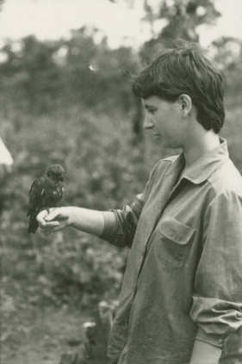

Figure 5 Angela with bird, Iain Bishop Collection,
Royal Society Archive. © Copyright of the Royal Society London

Being the only non-scientist woman in the field, and one of the only few women to inhabit Base Camp over the course of the expedition situates Angela in a unique position of relationship with the wild environment and the nonhuman animals around Base Camp. This relationship becomes a key element in the transformations of Base Camp into a fluid territory where the boundaries between wild and domestic, private, and public, emerge and get dissolved through the photographic archive. Additionally, fieldwork photography testifies and amplifies this relationship through the arguably enamoured and familial gaze of Angela’s husband, the expedition leader and photographer.

Wild Home: The Field in the Photographic Archive
Primarily through the photographs and films of Angela, I argue that this expedition Base Camp and ‘the field’ can be seen through a sociocultural lens as a domestic space, as well as being a recognised public site for the production of scientific knowledge. This idea can be introduced by introducing a ‘contamination’ of the spheres of scientific work and the domestic, private realm of ‘everyday life’. Ann Schteir, who studied scientific contributions by ‘silent partners’ found that the documentation generated by scientific knowledge production allow historians to situate scientific activities within the scope of ‘everyday life’, or inversely for ‘everyday life’ to penetrate the sites of scientific work, such as the field.

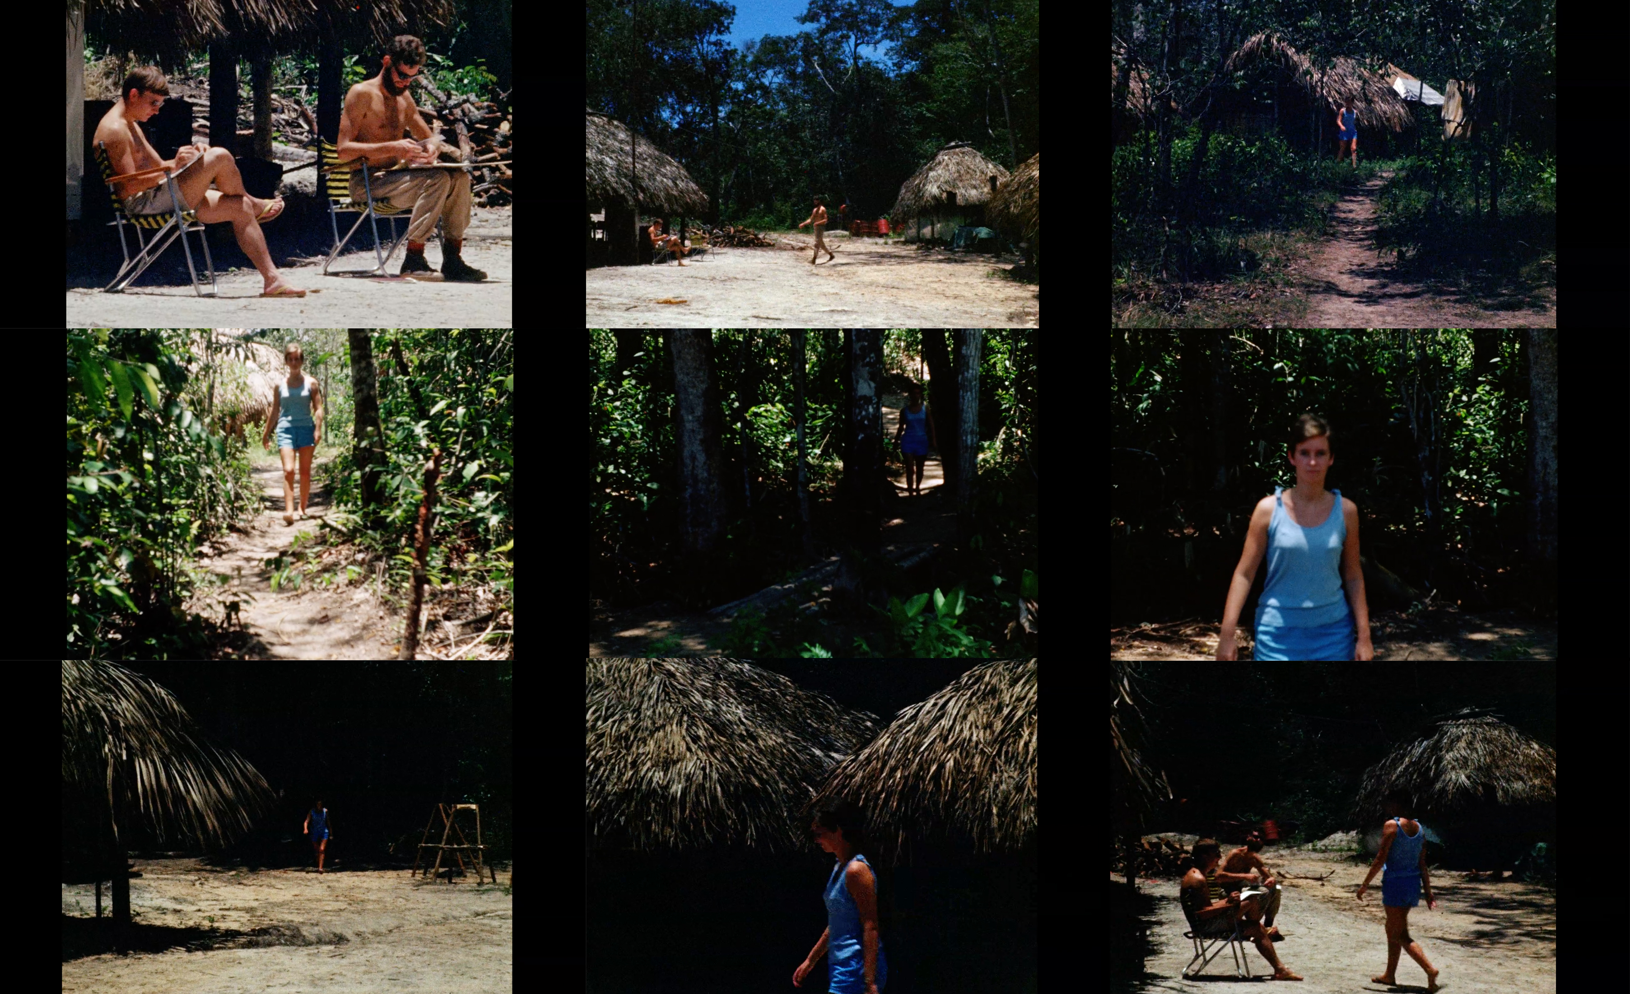

Figure 6 Collection of film stills, Super 8 Film Piece, Iain Bishop Collection,
Royal Society Archive.
© Copyright of the Royal Society London

The super-8 film stills above show a long sequence of four distinct paths, in which Angela is seen walking in a confident and tranquil manner. There is a clear sense that these routes are as familiar to Angela as the ones we make from living room to kitchen, bedroom, bathroom, in our own homes. These are open domestic spaces with large transitional spaces and corridors in between.

We are invited to walk with Angela, to follow attentively each of her steps, but when at her destination, nothing of particular importance happens, just the continuation of a regular day at base camp. The topic and narrative, although set in a rather unusual space, is mundane and quotidian. This is how this short film piece becomes an illustration of the domestic space. I, perhaps like most viewers, could have a hard time identifying this place with home, but we recognise the walk, we recognise the confident and direct ways in which we walk through our own domestic spaces, doing tasks. Angela knows her route intimately.

This super 8 sequence does not share any of the traits of expeditionary film described by Alison Griffiths as evidence of an immersive encounter into a distinct time and space with ‘safe return to the point of origin’. Kathryn Yusoff described representation of the field, in exploration setting as performative, photography rendering spaces in the field as ‘profoundly other’. These images don’t play by the rules of expeditionary imagery and could be easily understood as domestic/familial pieces. In the above film footage of Angela walking through forest corridors there are no insiders and outsiders, there is no othering of the space or the people; there is only home, if only a temporary one.

The notion that a woman can attribute or bring with her a domestic singularity to a social space is of course problematic, as claimed by Alison Blunt and Gillian Rose many of the struggles of Western feminism can be seen as diverse array of challenges to the distinction between public and private and to the comparative value accorded to them. The ways in which the domestic features of Base Camp are made visible by Angela’s presence are not a product of her gender.

They are, however, made visible firstly by Angela and Iain Bishop’s personal, familial relationship, with Base Camp being the couple's first home, secondly, by Angela status as a non-scientist in the field and thirdly, by the absence of an institutional or cultural agenda with which Angela was able to make her work at Base Camp centred around an ethics of care for both human and nonhumans, which, I argue, speak to the intimate and domestic. Finally, there is also the unlikely, but recognisable, relationship between Angela, and her pet capybara, which evoke and establish the domestic within the wild space of Mato Grosso’s cerrado.

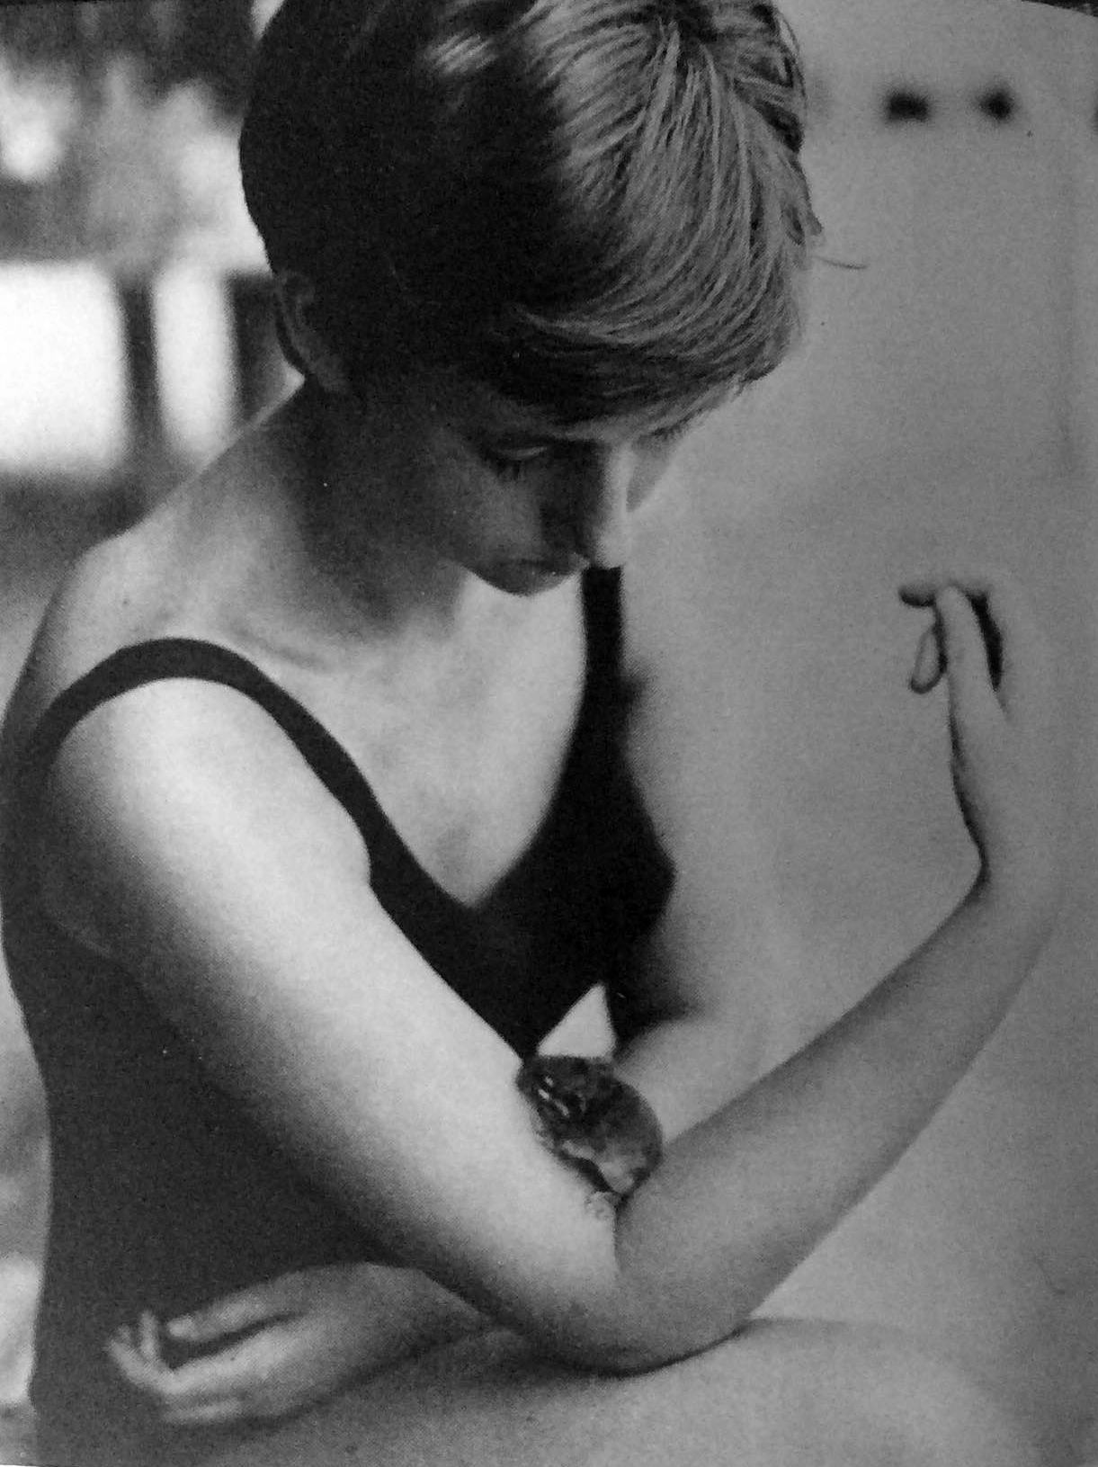

Figure 7 Angela with a small rodent, Iain Bishop Collection, Royal Society Archive.

© Copyright of the Royal Society London

In this portrait, Angela, as if in choreography with a mouse, holding an elegant and tender pose with an equally attentive framing and composition, evokes a kind of romance. This lover’s visual discourse, which allowed for and created this unique way of seeing Angela, is also interwoven with the boundaries between private and public at Base Camp. Often, Iain's enamoured gaze represents Angela evoking her as a maternal person, performing acts of care and nurturing, alongside visual documents of her scientific labour and work, positioning the field as a collective space, as well as a ‘physical site of marriage, challenging the ways in which domestic life was traditionally envisioned’. The field, transformed by the expedition into the context of an intimate, new romantic relationship, is more easily understood then as domestic space.

Throughout the two years of the expedition, Angela created space for herself, in roles of collaboration with many scientists at Base Camp, caring for the animals which had been captured for research, and being responsible for the healthcare of members whenever Base Camp found itself without a medical officer. Angela’s ethics of care, as seen in the photographic collection, directly influenced the way in which the wild is made home in the expedition narrative.

In this photograph (Figure 8) Angela feeds a baby marsupial some milk through a spoon. There is an intensely domestic quality to this image: the ceramic teacup and the teaspoon, Angela’s metallic and thin wristwatch, her body language in the offering of milk, make this an exceptional image of the relevance of non-human animal care in fieldwork and science making. It could be argued, however, that as the expedition was, in part, focused on science for development – which in Mato Grosso relies on deforestation – this kind of ethics and aesthetics of care and domesticity can be seen as tender versions of extractivist-capitalism practices with a post-imperialist quality, which have given way to ‘future trajectories of extinction’

Despite the tenderness, and even affection Angela shows to the non-human captives, at Base Camp, we are called by Wexler to investigate the sentimentalism, what she called of ‘averted gaze’, which functions to normalize and inscribe asymmetrical power dynamics, used in her book Tender Violence to address raced and classed relations of dominance.

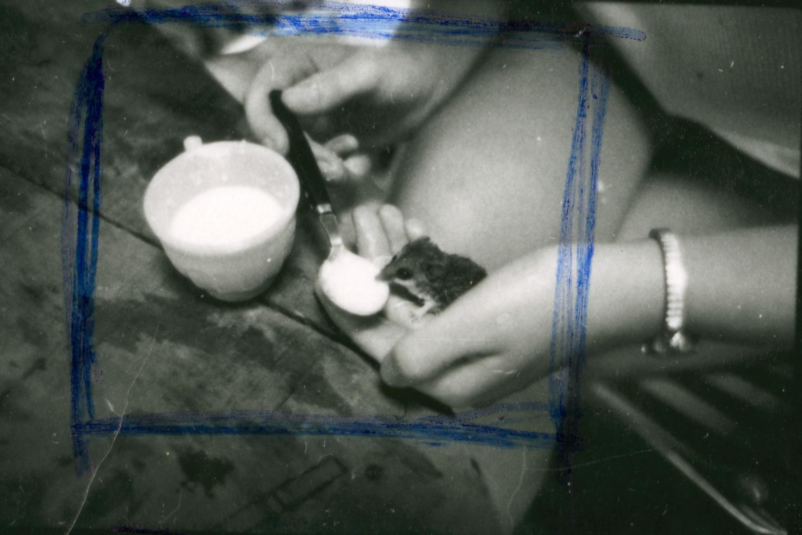
Figure 8 Angela Bishop feeding a marsupial cub,
Royal Society Archive.
© Copyright of the Royal Society London

This practice of animal care Angela engaged in the field sometimes transformed into emotional attachment, as shown in the attempted domestication of a capybara cub named ‘cappy’ whom Angela cared for and reared as a pet. The nurturing and dedication required from Angela to domesticate and raise this animal was considerable. The way in which ‘cappy’ acted around Angela was very much the way our own pets, in our own homes, act around us: looking for and obtaining affection and attention requesting food learning from us and providing companionship in our domestic spaces.

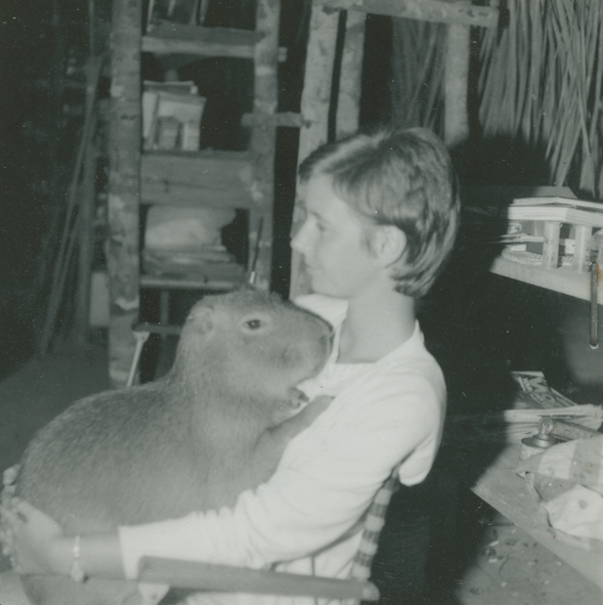

Figure 9 Angela with ‘Cappy’, Iain Bishop Collection,
Royal Society Archive.
© Copyright of the Royal Society London

‘Cappy’, Angela’s pet, and companion at the time of extreme isolation and separation from Angela’s support networks, contributes to the way in which domesticity in the wild, is seen through the collection, primarily through a photographic focus on Angela's relationship with this animal. The very term ‘to domesticate’ indicates the intentional inclusion of a wild being or trait, into the domestic realm, turning it provisionally ‘tamed’. ‘Cappy’ and Angela’s proximity and intimacy are felt, as well as enquired, through the lens in this collection. A distinct sense of normalcy is accessible through the empathic, albeit anthropocentric, lens of their human-pet relationship. These images make us forget where they are, and the kind of animal ‘Cappy’ is. In these photographs we sense affection, playfulness domestic comfort and safety, in their relationship.
But there is more happening here, the American thinker Cary Wolfe has stated that “the animal has always been especially, frightfully nearby, always lying in wait at the very heart of the constitutive disavowals and self-constructing narratives enacted by that fantasy figure called ‘the human’.

In order to create a pet, Angela, removed – albeit temporarily - from ‘cappy’ the animal qualities of wildness and self-suﬃciency and replaced them with tameness and dependency.’ As cappy grew, he pushed back against his own domestication, being acting against his human family and was left to return to the forest.

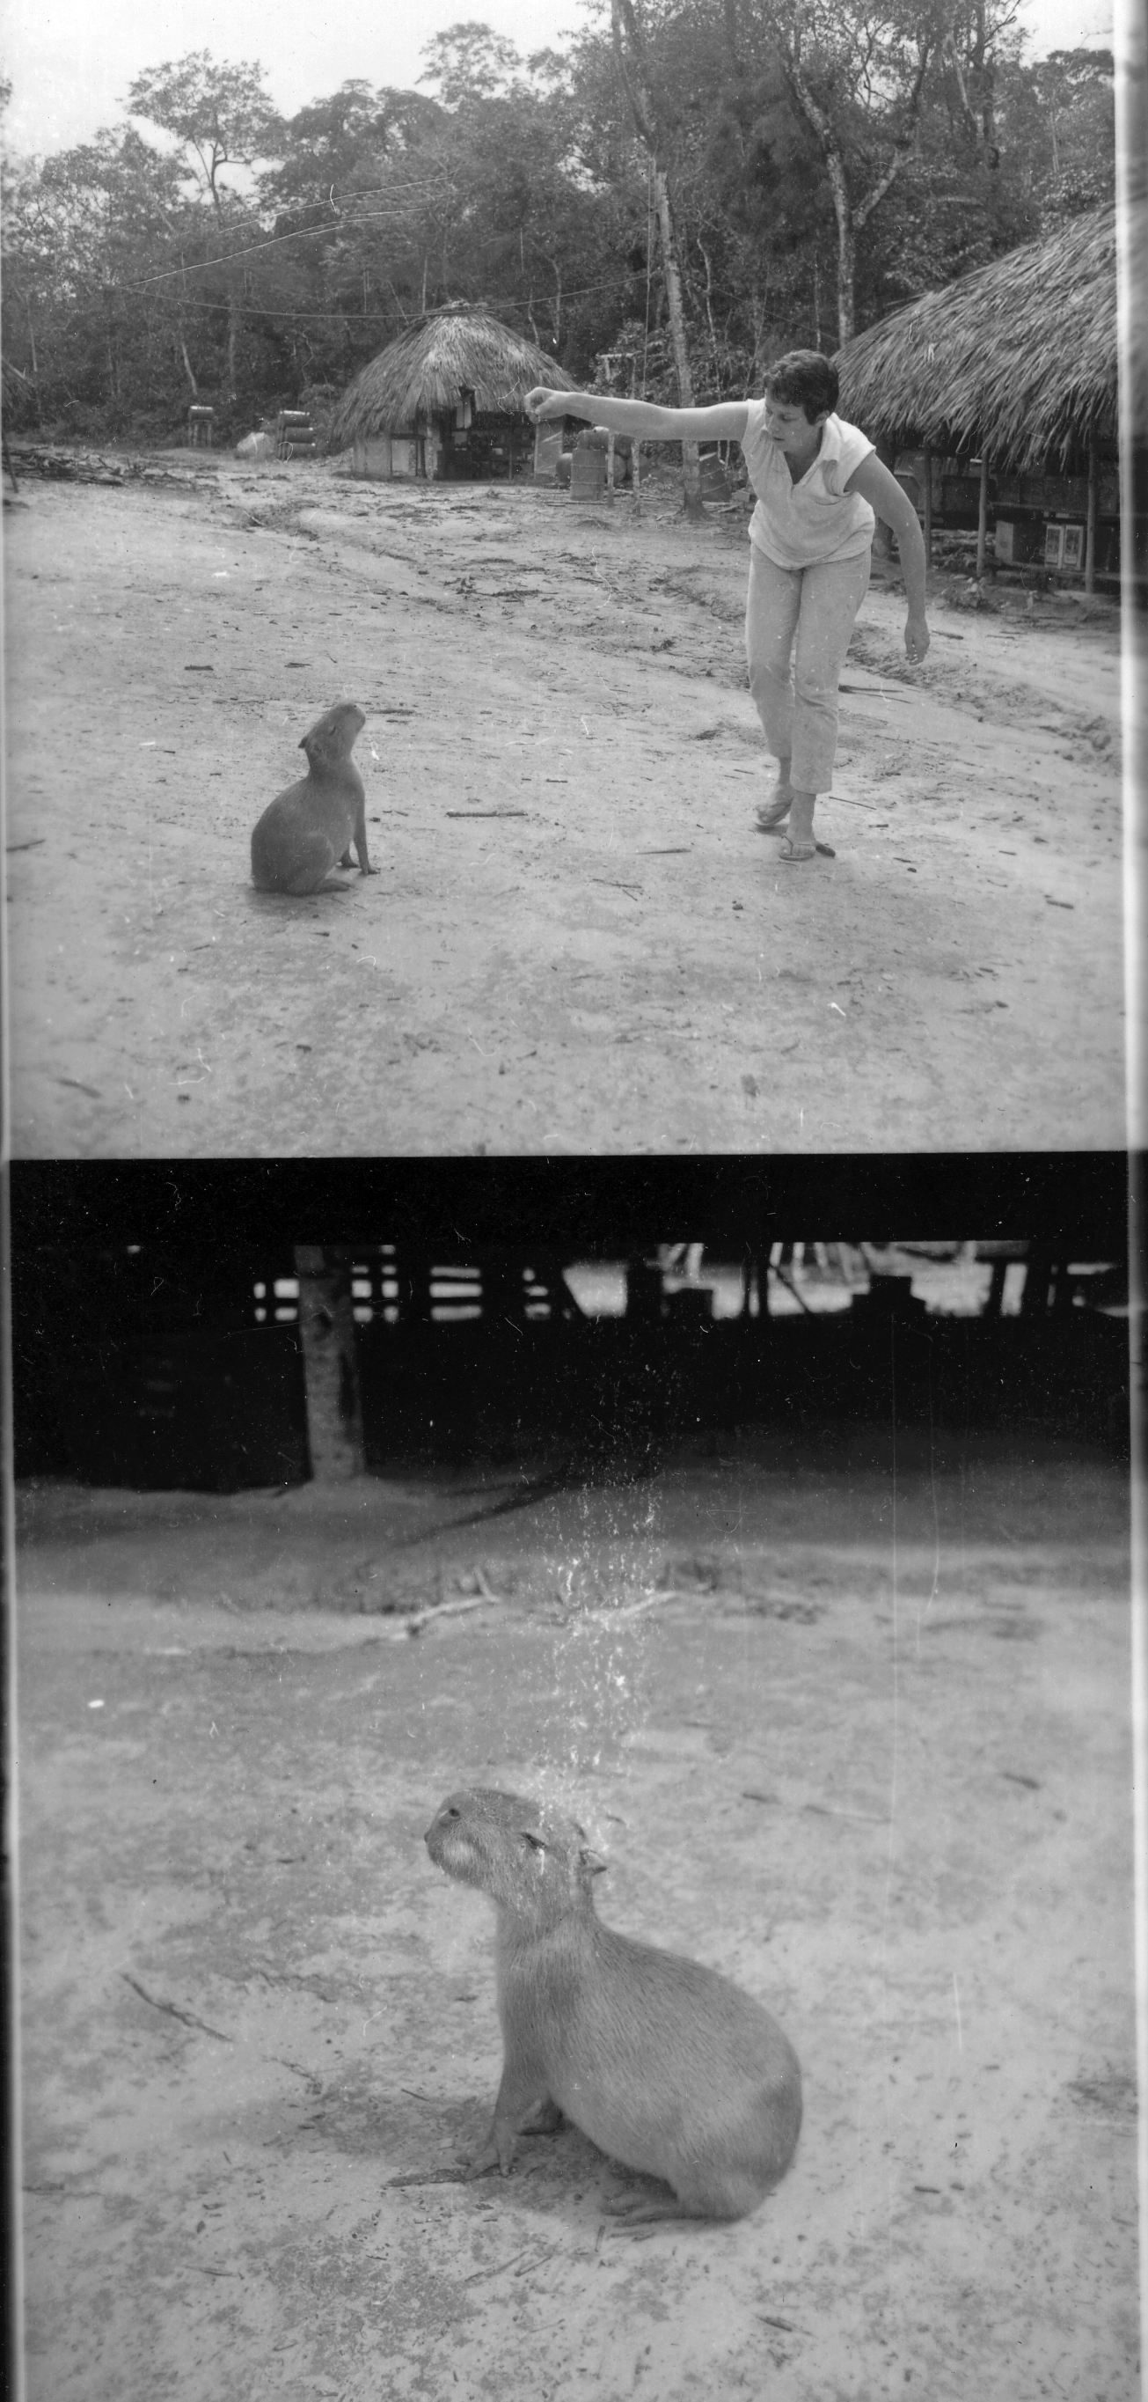

Figure 10 Angela training ‘Cappy’, Iain Bishop Collection, Royal Society Archive.
© Copyright of the Royal Society London

Non-Human Territories and Boundaries in Expeditionary Visual Culture
In the same way as the scientific space of Base Camp blends with an atypical domestic sphere so does the institutional expedition archive merges with personal autobiographical and familial photography and film. Simultaneously, the domestic sphere in the field emerges from the wild spaces, and the wild seeps into the domestic in both predictable and unexpected ways.

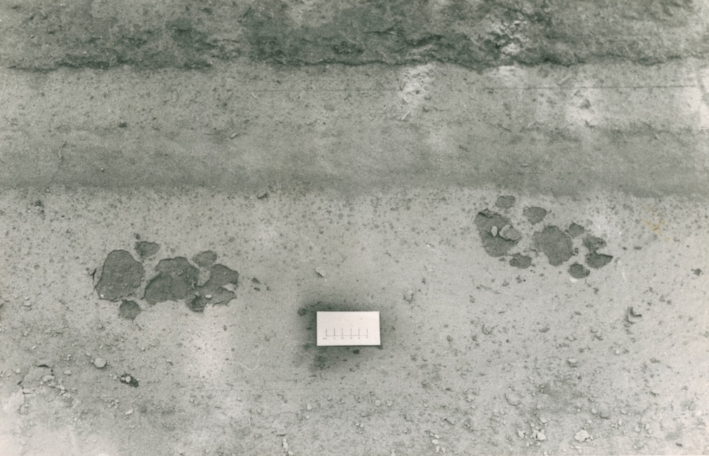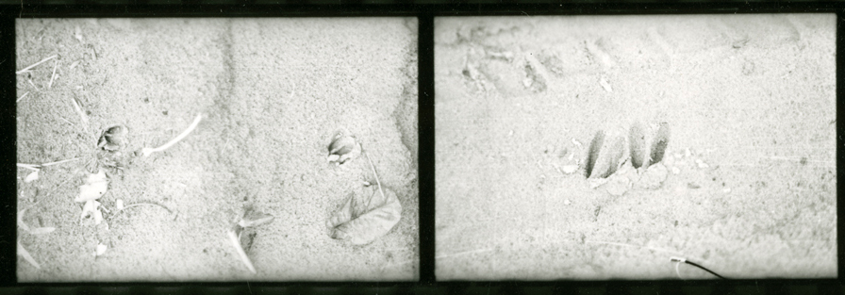
Figure 11 Animal tracks, Iain Bishop Collection, Royal Society Archive.
© Copyright of the Royal Society London

Figure 4 shows four paw prints of a mammal of considerable size in a muddy track, in the area surrounding Base Camp. Non-human living beings of all kinds intersect the domestic sphere of the research station, creating an entangled space home to human and non-humans alike. The placement of semi-permanent human dwellings in this space, crosses and interrupts the boundaries and borders of imperceptible non-human territories and spaces. This image is typical of zoological research visual culture, where animal traces are documented to monitor specimens’ movements and behaviour. It is as if the non-human animal has been made abstract by its own mark-making, leaving a confirming trace of the crossing of territories and boundaries.

In ‘Why Look at Animals’, Berger writes of the process of physical marginalisation of animals in increasingly build environments. Here, in the field, animals’ cross temporary human paths regularly occasionally at the cost of capture and death and the hands of scientists. Post-colonial developments in the region on Mato Grosso, translating from the Portuguese as ‘thick bushland’, have since segregated further human and animal at scale, deepening species asymmetries in wild spaces. The figures above are evidence of the transgression of boundaries by the human temporary settlers, intersection existing vibrant borders, despite the fact that it is non-human tracks which are depicted. As Lucy Davies writes, the task when writing about animals in cultural theory is to ‘transcend the tendency for things to become, once more, all about us’.

These can be thought as images ‘at the edge of sight’, as Shawn smith describes them, photographs which ‘enable one to perceive elements in the visual field, that generally pass before the eye unnoticed, making one aware of invisible worlds and ordinary blindness (…) full of gaps and contradictions’ These photographs strength lies of how they highlight vulnerability in anthropocentric science discourse and understanding, from a perspective at the margins, or as Shawn describes this, from the ‘edge of sight’.

These photographs centre something vulnerable from the edge of sight (and anthropocentric science), which could be a more original direction to pursue.

These photographs allude to (unseen) free animals, otherwise not often featured in the photographic collection, full of captive specimens, to be studied, killed, and sent to natural history collections in Brazil and in the UK. Yusoff and Gabrys write that the captive lived within ‘tight delineations of life and animality’, in this case study subjects of imperialistic extraction remnants of ‘nature behind glass’.

Ultimately, this photograph of animal tracks points to the evidentiary qualities of the collection and of expeditionary images themselves. Figure 4 could be said to illustrate a ‘truth-to-presence’, to use Geoffrey Batchen’s term — it certifies something, or someone was once there before the camera, in some past moment in time and space.

The aesthetic of mechanical objectivity can be felt through this photographic, with its levelled angles, calculated framing, and literal measuring sticks. Pierce introduces a psychological dimension to this idea of index; it blurs boundaries in relation to the referent, the sign, and what the viewers brings to the visual encounter. According to Pierce, an index is, amongst other things, ‘a dynamical (including spatial) connection both with the individual object on the one hand, and with the senses of memory of the person for whom it serves as a sign, on the other’ Pierce refers to indices in a state of bordering between material and memory worlds, arguing that ‘psychologically, the action of indices depends upon association by contiguity.’ Paradoxically, neither of these interpretations of the indexicality its associations with mechanical objectivity, convey the longing and paradox in an indexical mark of an absent, free wild animal, expression of wilderness itself.

Conclusion

This paper looks to show multiple borders, borders, and binaries – gender, human/more-than-human, scientist vs non-scientists – dissolve in the field, leading a productive expansion of notions of the domestic and wild, autobiographic, and institutional features of the scientific archive itself, and of narrative making within it. The photographic archive, and photographs as materials, with their multiple, accumulative, and evolving meaning-making qualities, lend themselves to the exercise of non-binary ways of thinking. Thinking by means of ‘unencompassable’ photography as Elkin’s puts it, Angela was not a scientist neither she was a non-scientist, strictly speaking, because she performed the work of science. She appears as something in between, her presence conjuring an atmosphere which is rarely evoked by images of science. The field was at once, domestic, and wild; public and private; professional and familial; inhabited by humans in an invisible territorial network of more-than-human action and agency.

Finally, perhaps a unique feature of the autobiographical familial photographs in the field, and those of Angela in particular, it is its function. The function of providing us with boundaries, showing us glimpses of the volatile and fluid nature of the domestic space in the wild and more-than-human field. One moment, we are in Iain and Angela’s wild home, and the next we are deep in the forest as non-human territory. The photographic collection provides a nuanced experience of Base Camp and the surrounding forest, which moves from domestic to wild, and from wild to domestic, on multiple occasions.

The expedition photographic collection then becomes an enmeshed record of both: home and wilderness, inextricable from one another.

Acknowledgements:

List of Figures:

Figure 1. Angela with tortoise, Iain Bishop Collection, Royal Society Archive. © Copyright of the Royal Society London
Figure 2. View of Base Camp huts, Iain Bishop Collection, Royal Society Archive. © Copyright of the Royal Society London
Figure 3. Angela and Iain Bishop, Iain Bishop Collection, Royal Society Archive. © Copyright of the Royal Society London
Figure 4. Angela Bishop with net, Iain Bishop Collection, Royal Society Archive. © Copyright of the Royal Society London
Figure 5. Angela Bishop with bird, Iain Bishop Collection, Royal Society Archive. © Copyright of the Royal Society London
Figure 6. Collection of Film Stills, Super 8 Film Piece, Iain Bishop Collection, Royal Society Archive. © Copyright of the Royal Society London
Figure 7. Angela Bishop with a small rodent, Iain Bishop Collection, Royal Society Archive. © Copyright of the Royal Society London
Figure 8. Angela Bishop feeding a marsupial cub, Iain Bishop Collection, Royal Society Archive. © Copyright of the Royal Society London
Figure 9. Angela Bishop with ‘Cappy’, Iain Bishop Collection, Royal Society Archive. © Copyright of the Royal Society London
Figure 10. Angela training ‘Cappy’, Iain Bishop Collection, Royal Society Archive. © Copyright of the Royal Society London
Figure 1. Animal tracks, Iain Bishop Collection, Royal Society Archive. © Copyright of the Royal Society London

Dr. Catarina Fontoura
ª Institute of Photography, Falmouth University, United Kingdom.
Catarina Fontoura
8 Wheal Vyvyan,
Constantine, Falmouth,
Cornwall
TR11 5AF
Catarina.fontoura@falmouth.ac.uk

Catarina Fontoura is an artist, educator, and writer. She was awarded her PhD from Birkbeck, University of London, specialising in History of Photography and visual histories of science. Catarina was the recipient of a Collaborative Doctoral Award between Birkbeck and the Royal Society in London, where she studied expeditionary photographic archives.
Catarina’s artistic practice explores the relation between art, science, spirituality, storytelling, and ecology. She is particularly interested in reconfiguring the land into entangled systems and stories, embedding human beings into non-human narratives and entities. Her work has been exhibited in Germany, USA, Mexico, U.K, and Portugal.
Catarina was a nominee for the Magnum Graduate award in 2015. Her work has been published in several independent art publications and online platforms, such as AP, Der Grief, Paper Journal, The Lost Prairie and Phases Magazine. Recent exhibitions include the collective show ‘The colour of there, seen from here, the colour of where you are not’, in Vital Spaces, New Mexico, US and 'In Progress' at the Centre for Contemporary Art and Gallery in Augsburg, Germany.
Her latest research focuses on the relationship between autobiography, creative practice and ecology and her book chapter ‘Urgent Autobiographies: Lived Experiences of Ecology in Photographic Practice’ was published in 2023 by IGI Publishers, USA.
Originally from Portugal, she lives and works in West Cornwall, UK

Smith, Anthony. Mato Grosso: Last Virgin Land: An Account of the Mato Grosso, Based on the Royal Society and Royal Geographical Society Expedition to Central Brazil, 1967-9. London: George Rainbird, 1971, p. 49. Print.
Chodorow, Nancy. The Reproduction of Mothering: Psychoanalysis and Sociology of Gender. Berkeley: University of California Press, 1978. Print
Kohler, Robert E. “History of Field Sciences: Trends and Prospects in Knowing Global Environments.” New Historical Perspectives on the Field Sciences. Ed. Jeremy Vetter. London: Rutgers University Press, 2011, p. 216. Print.
Yusoff, Kathryn. “Configuring the Field: Photography in Early Twentieth Century Antarctic Exploration.” New Spaces of Exploration Geographies of Discovery in the Twentieth Century, edited by James R. Ryan and Simon Naylor, IB Tauris, London, 2010, pp. 52–77.
Kohler, Robert E. “History of Field Sciences: Trends and Prospects in Knowing Global Environments.” New Historical Perspectives on the Field Sciences. Ed. Jeremy Vetter. London: Rutgers University Press, 2011, p. 216. Print.
Schteir, Ann B. “Botany in the Breakfast Room: Women and Early Nineteenth-Century British Plant Study.” Uneasy Careers and Intimate Lives: Women in Science, 1789-1979. Ed. Pnina G. Abir-Am and Ouram, Dorinda. New Jersey: Rutgers University Press, 2009, pp. 31–43. Web. 2 June 2021.
Griffiths, Alison. “The Untrammeled Camera: A Topos of the Expedition Film.” Film History, vol. 25, no. 1-2, 2013, pp. 95–109. Print.
Yusoff, Kathryn. “Configuring the Field: Photography in Early Twentieth Century Antarctic Exploration.” New Spaces of Exploration Geographies of Discovery in the Twentieth Century, edited by James R. Ryan and Simon Naylor, IB Tauris, London, 2010, p. 65.
Rose, Gillian, and Alison Blunt. Writing Women and Space: Colonial and Postcolonial Geographies. New York: Guilford Press, 1994, p. 4. Print.
Yusoff, Kathryn. “The inhumanities.” Annals of the American Association of Geographers, vol. 111, no. 3, 2020, pp. 663–676, https://doi.org/10.1080/24694452.2020.1814688.
Wexler, Laura. Tender Violence: Domestic Visions in an Age of U.S. Imperialism. University of North Carolina Press, 2000.
Wolfe, Cary. Animal Rites: American Culture, the Discourse of Species, and Posthumanist Theory. University of Chicago Press, 2003, p.6.
Fudge, Erica. Pets. Routledge, 2014, p.8.
Berger, John. ‘Why Look at Animals’, John Berger, Selected Essays, Geoff Dyer (ed.), New York: Vintage, 2001, p.26.
Davies, Lucy ‘Introduction to Regional Animalities’ in Forum on Contemporary Art and Society: Regional Animalities. 2007, p.8.
Smith, Shawn Michelle. At the Edge of Sight: Photography and the Unseen. 1 ed. Duke University Press, 2013. Project MUSE, p.76.
Batchen, Geoffrey. "Origins without End." Photography and Its Origins. Ed. Tanya Sheehan and Andres Mario Zevigon. London: Routledge, 2015, p. 72. Print.
Sanders Pierce, Charles. "Logic as Semiotic: The Theory of Signs." Philosophic Writings of Pierce. Ed. Justus Burchler. New York: Dover, 1950, pp. 107-08. Web. 16 August 2021.
Elkin, James. “Foreword: Unencompassable Photography.” Routledge Companion to Photography and Visual Culture, ROUTLEDGE, S.l., 2022, pp.20-23.
Ibid.
Royal Society Archive, item EXP 6/5/1/7.

