Decolonising Decarbonisation Zine Submission

Catarina Fontoura

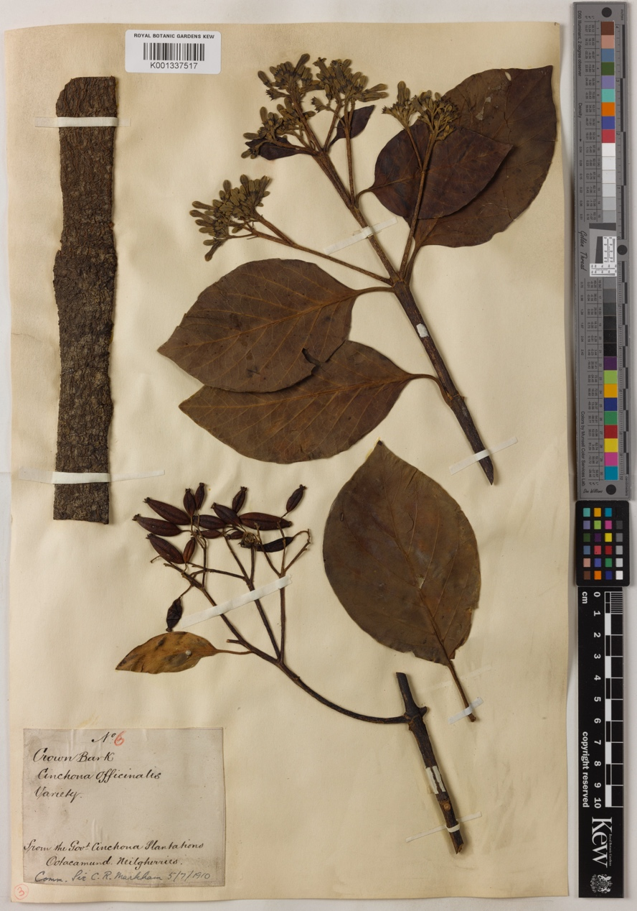
‘Chinchona Officinalis’, collected by C.R Markham, India 1910
Kew Gardens Herbarium
© copyright of the Board of Trustees of the Royal Botanic Gardens, Kew.

Ecological Reparations: The story of the Quinquai Tree

Decarbonising with integrity means owning up to our violent histories, to ‘sit with the scream’ as Akomolafe shares echoing Ben Okri’s call to listen to the speech, the cries, the howls, and the screams. It means uncovering and telling these histories as entangled with toxic aspect of modernity as we currently experience it, to give it the palliative care it needs.
Let me tell you the story – or legend - of Ana de Osorio, the wife of 4th Count of Chinchón, a Spanish nobleman, viceroy of Peru in the 1600’s. Ana fell ill to malaria in Peru and was cured by the bark of the Chinchona tree. Known by Queshua people as Quinquai or Yaracucchu Carachucchu containing high levels of quinine, this tree became one of the most valuable sustaining resources of imperial ambitions of several European nations. The appropriation - by Western science - of Traditional Ecological Knowledge (TEK) literally made centuries of violent colonial events possible. Ecosystems containing this tree were then decimated in South America, as trees were completely uprooted for the removal of bark until three centuries later when the tree was transferred to India, and other colonised territories. Stories like that of the Quinquai tree, we have in the thousands.

As an accidental historian of science and postcolonialism I want to pass on a very important message for the decolonizing of decarbonization: Euro-centric imperialism, land appropriation, ecological enslavement of African people and dominion, abuse and genocide of indigenous people are historically entangled and directly linked to current levels of forestation in the Global South and to levels of carbon in the atmosphere today. The problem of (de) forestation and (de) carbonisation is not one of individual countries, as borders are laid out today. It is the response-ability of oppressor societies to offer respectful reparations for these ecological histories, as part of decarbonisation.

'The Herbarium Catalogue, Royal Botanic Gardens, Kew. Published on the Internet http://www.kew.org/herbcat [accessed on 26/06/2022]'.
See https://www.bayoakomolafe.net/post/we-will-tell-our-stories
Okri, B., 1998. A Way of Being Free. 1st ed. London: Phoenix.
Machado de Oliveira, V., 2021. Hospicing Modernity: Facing Humanity's Wrongs and the Implications for Social Activism. North Atlantic Books.
Schiebinger, Londa L. Plants and empire: colonial bioprospecting in the Atlantic world. Cambridge, MA : Harvard University Press, c2004.
Brockway, Lucile H, Science and Colonial Expansion: The Role of the British Royal Botanic Gardens, New Haven and London, Yale University Press, 2002
Nelson, Melissa K., and Daniel Shilling, editors. Traditional Ecological Knowledge: Learning from Indigenous Practices for Environmental Sustainability. Cambridge University Press, 2018.
Watt, George, Dictionary of the Economic Products of India, v.2 Cabbage to Cyperus (Calcutta: Printed by the Superintendent of Govt. Printing, India, 1889).
With a background in Fine Arts, I was awarded a AHRC scholarship in 2014 to undertake a collaborative doctoral award with Birkbeck, University of London and the Royal Society to study visual cultures and histories of expeditionary science to the tropics in the twentieth century, coming a marginal and oftentimes unwilling historian of -Western- science.

