The Royal Cornwall Polytechnic Society, Falmouth, Cornwall.

Lucy Willow: Unfurling Fern – Introducing the new RCPS Medal Exhibition
https://thepoly.org/whats-on/event/2203/lucy-willow-unfurling-fern-introducing-the-new-rcps-medal-exhibition
Lucy Willow has been commissioned by the Poly to design a new medal to be awarded for outstanding achievements in arts, science, and industry each year in Cornwall.
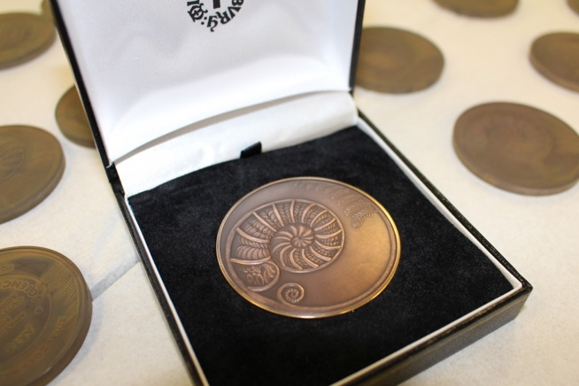
Image: The Unfurling Fern, courtesy of RPS.
The new medal has been designed by Cornwall-based artist and award-winning medallist Lucy Willow. In 2018 she received the British Art Medal Society’s (BAMS) prestigious Marsh Award for the Encouragement of Medallic Art in recognition of her success supporting Falmouth University students in the BAMS annual medal competition. Lucy’s design centres on an unfurling fern, its suggestion of new beginnings, vitality and growth making it relevant to all three categories celebrated by the RCPS Medal Awards. The fern is emblematic of morphogenesis, the patterns of growth in nature as explained by bio-mathematician, D’Arcy Wentworth Thompson (1860-1948) in his influential book On Growth and Form (1917) and echoes the golden spiral or Fibonacci Spiral, exemplified by the Nautilus shell, on which the RCPS’s current logo is based. It also links to the horticultural interests of The Poly’s founders - gardens created by the Fox family include those at Trebah, Penjerrick, and Fox Rosehill, Cornwall’s first Mediterranean-style garden.
Lucy’s art work will be shown alongside information about the history of the RCPS medals, first awarded in the 1830s.
This exhibition provides a unique opportunity to preview the new Royal Cornwall Polytechnic Society (RCPS) medal, designed by Cornwall-based artist and award-winning medallist, Lucy Willow, for the relaunch of the RCPS Medal Awards taking place in April 2023.
The awarding of medals played a pivotal role in The Poly’s early history: The Polytechnic Hall was built solely to exhibit and promote new inventions. The medals encouraged submissions from the fields of Science, Industry and the Arts. The relaunch of the medal awards, almost two hundred years since the Poly’s founding, will celebrate the range of exciting, innovative work taking place in Cornwall today across these categories.
‘The unfurling fern spreads outwards to meet the wind, the elements, and the insects in the garden. Much of my work as an artist comes from observing small details in my garden and using these as a metaphor to make drawings or sculptural works. There is something so joyful and celebratory about the fiddlehead, the new growth on a fern. It became the perfect metaphor to use for the design on one side of the medal.’ (December 2021) Lucy Willow.

