Dr Carolyn Shapiro, Associate Professor of Visual Culture, Falmouth University

Title: Andrew Humphreys’ and Olivier Kugler’s The Great Fish & Chips: Indexical Pathways in Illustration Research
Abstract: The graphic reportage of Andrew Humphreys and Olivier Kugler, specifically, their project The Great British Fish & Chips, is analysed here on three levels: first, in terms of their practices of graphic journalism; second, as a mechanism for navigating, through illustration and storytelling, difficult social and political currents about British national territory and sovereignty emergent in Brexit; and third, building upon critical theory already established in modern art history, as a matrix of the theoretical propositions offered by 19th century philosopher Charles S. Peirce’s semiotic category of the index. Using what I am proposing to be ‘indexical strategies’ within illustrative practice, Humphreys and Kugler bring forth the ironic tensions within certain constructions of ‘British’ identity. Ultimately, I want to consider The Great Fish & Chips as an exploratory site for the larger proposition that indexical relation might be the primary mode of illustration itself.
Key words: graphic reportage; Brexit; referentiality; Index; Charles S. Peirce; trace; deixis; Shifter
In their ongoing graphic reportage project The Great Fish & Chips, journalist Andrew Humphreys and illustrator Olivier Kugler navigate a journey beginning with the ‘national dish’ Fish and Chips, back through its line of production, meeting the diverse individuals who contribute to its British identity. Humphreys’ and Kugler’s presentation of the people and places behind a plate of fish and chips presents a ‘Britishness’ that tugs against populist notions claimed by the forces of Brexit. Launching their project from the instability felt by British people on both sides of the Brexit debate, Humphreys’ and Kugler’s graphic reportage runs parallel to historian Timothy Brennan’s deconstruction of ‘the national longing for form’. I propose that the indexical strategies of Humphreys’ and Kugler’s illustrative practice allow them to bring forth ironic tensions within the construction of Fish and Chips as national dish. Exploring what theorist Mary Ann Doane has characterized as ‘the vexed issue of referentiality in representation,’ my essay builds upon the art historical engagement with Charles S. Peirce’s semiotic category of the Index, outlining the components of indexicality to situate illustration within a larger art historical and philosophical enquiry while investigating the affordances of indexicality particular to illustration. More than any other mode of communication, illustration is fundamentally indexical, in all its semiotic forces.
Andrew Humphreys’ and Olivier Kugler’s The Great Fish & Chips
In the contemporary contexts of Brexit, signs of ‘nation’ circulate, accumulate, and break down in the dissemination of the myths of Britishness. Through their graphic reportage practices, Humphreys and Kugler are negotiating anxieties about referentiality. The questions motivating Humphreys’ and Kugler’s proposed book, The Great Fish & Chips, are, who and what is ‘British’? And, even more specifically, how does the construction of ‘the British nation’ both mask and reveal the heterogeneity of British nationality? Their project began with a deconstruction: the national dish of Britain is not native, but in fact brought to Britain in the mid-19th century by immigrant communities of Jews, French and Belgians. Furthermore, approximately 80% of the fish served in UK chippies today is imported, with approximately 80% of the fish caught by British boats exported. Fish and Chips is approached as an investigative platform that negotiates these inconsistencies. Reliant upon the availability of funding, Humphreys and Kugler travel from the ports of Scotland, down to the most southern points of England, and to fishing communities in between such as Grimsby, visiting chippies across Britain, looking for interesting subjects to interview. As they’ve proposed for their book, their research could, in theory, take them to the Faroe Islands, Iceland, Norway, France, Italy and possibly even China and the United States to investigate the full network that is British fish and chips.
Much of their research time is spent on location, interviewing owners of Fish and Chips shops; customers; auctioneers; truck drivers; fishermen, and any others behind a plate of fish and chips. While Andrew interviews, Olivier (Oli) takes photographs. Afterwards, Andrew transcribes the interviews and maps out story arcs, while Oli makes rough sketches from his photographs. They then match the words to the images. The images are laid out on the page with narrative texts positioned above the internal story world. Speech bubbles are included within the depicted scene, citing the words spoken by the interviewed individuals. The process is highly organic. Andrew and Oli approach their work as a kind of portraiture, through drawn images and recorded words that maintain a link to what is being represented. Eventually, the finished book will include an illustrated map marked with all the places they visited in addition to the drawings and accompanying stories, looking like a graphic novel.
Audiences of Humphreys’ and Kugler’s Keynote Address for the 12th Annual International Illustration Research Symposium delivered online by Falmouth University, UK, July 15-16, 2022, were treated to an introduction to the illustrations and stories developed thus far for The Great Fish & Chips, some of the imagery of which are included in the current analysis. Figure 1 depicts Benny’s Fish & Chips in Clapham, South London. We see the owner, whose name we will learn is Benny, opening up the chippie, on a typical London corner, one morning. The narration is displayed in highlighted yellow boxes, placed above the illustrated scene. This narration gives us a specific time and date: ‘It is 11 o’clock on the morning of 09.06.2018 and the owner is getting the shop ready for the day’s business.’ We also see Benny’s words in quotation marks, situated to his right, floating within the composition: ‘Every time before I open the shop, I say a private a prayer to help me survive the night…’ In the foreground of the page is a close-up anatomization of British Fish & Chips, labelled with attendant text. The zoomed-in image displays all that makes up a plate of fish and chips: vinegar, salt, cod, chips, sugar, mushy peas, lemon, and cup of tea. Each ingredient is identified through an arrow coming out of a word, e.g. ‘vinegar’. Narrative text introduces the point of investigation of the entire project: ‘Fish and chips, the great British meal. A fillet of fish deep-fried in batter, served with chips and mushy peas, and seasoned with salt and vinegar, and ideally accompanied by a cup of tea. It’s a national institution!’ Having seen the cover of the book, the reader already reads the image through the illustrator and writer’s ironic lens. (see figure 2)
The book cover presents the identical plate of fish and chips described above, however, it also includes, in parentheses after the words that indicate that image, the country of origin of that particular commodity. Hence, ‘Cod (Faroe Islands)’; ‘vinegar (United States)’; ‘salt (Britain)’; ‘tea (China, India, or Kenya)’; ‘sugar (Belize)’; ‘lemon (Spain or Turkey)’; ‘Mushy peas (Britain)’; ‘chips (Britain or Cypress).’ Here, the ingredients’ origin, pointing to their corresponding ingredient, breaks down the magical aura of this commodity being British in a homogenous way. Similarly, the book’s depiction of individuals, from chippie, back through suppliers and fishermen, shows that ‘British’ workers in the fish and chips industry hail from Cypress, the Philippines, Eastern Europe, Turkey, and Iceland, among other non-British places. The people whom Kugler and Humphreys encountered in their research, hand-drawn by Kugler from his photographs, whose words are recorded and quoted by Humphreys, introduce vibrant stories into what would otherwise be an objective general term, ‘national dish.’ Real life stories such as that of Benny (see Figure 3) complicate mythic the constructions of nationality embraced on behalf of the British fishing industry engendered by the values and ideologies of Brexit.
British fisherman became the focal point and sign of the Brexit debate. An example of a double spread of The Great Fish & Chips (Figure 4) presents the contentions within this social and political context. Writer and illustrator make the most of the compositional allowances of the medium. In the upper left corner we see the mast of a ship with a flag that appears to be moving in the wind. In uppercase letters, the message is emblazoned: ‘FISHING FOR LEAVE; SAVE BRITAIN’S FISH.’ Also on this flag, reiterating the message, is a fish, with a shield and flag, both proudly decorated with the Union Jack. A yellow narrative box describes the UK’s love of Fish & Chips and this dish’s role in the Brexit debate. In the middle of the page, between the horizontally oriented narrative inscriptions, is an image of a trawler boat in motion, with five flags drawn to show that they are moving in the wind, steering the momentum of Brexit. The flags display recognizable signs of the British nation: a Union Jack flag; a St George’s Cross flag; another flag on which we see the word ‘Fishing’ and ‘—ave’. We fill in what this word would be, if we could see the entire flag: ‘Save.’ Another slogan on the trawler, which looks like a hand-painted sign, reads: ‘Let’s put the Great Back into Britain, Vote Out and Be GREAT AGAIN.’ Also included in this group of signifiers of British nationhood is a floating logo of The Sun newspaper in the left margin.
Specific to the formal means of graphic illustration is the maximalization of both pages of a spread, including the white negative space down the middle separating the pages. This white negative space, as utilized in Figure 4, is a dynamic space across which one image relates to other images on the opposite page. We see a drawing of Nigel Farage, set apart from the scene, in the upper right corner. Kugler has drawn Farage holding a dead haddock in each hand, and we see a hand coming towards Farage that is holding a microphone from beyond the edge of the page. Farage’s body is turned at a three-quarter degree angle, on a diagonal which points our eye downwards to the patriotic trawler depicted on the opposite page, in the bottom left corner. His mouth is open, with a large floating speech bubble placed to his right. The page’s horizontal registers depict the speaking Farage with the microphones on the uppermost register; the Houses of Parliament on the next register; another image of the trawler, with a highlighted blue section encircling what is identified as Farage (from a distance) on the trawler accompanied by his props, the dead haddocks, on the next register; and finally, on the lowest register, in the foreground, a zoomed-in image of Michel Barnier, identified as the EU’s Chief Negotiator. Barnier is also given his own speech bubble, which says that the EU wants the status quo.
The organization into horizontal registers allows for a juxtaposition of narration, images, symbols, and speech bubbles within and across a controlled visual field, which act as a composite of related signifiers across time and space. The viewer’s first encounter is the image of Farage, speaking to the Press and to the public: Kugler and Humphrey insert Farage’s famous phrase, added in as part of the composite nature of the spread: ‘The acid-test of Brexit is, have we got back our territorial waters?’ A relay between Farage, the flags, and the fishermen has been established. There are also two inset images, both of which depict the EU blue background with its circle of yellow stars. One blue inset shows Barnier, the other blue inset a hand, surrounded by the circle of yellow stars, with a middle finger expressing the fishermens’ sentiments. The connotations set into motion between images of Barnier against the European Union flag, and Farage, associated with the emblazoned British/Brexit fishing trawler and the Houses of Parliament, create an active signifying field that enhances the opposition of each side’s stance. The negative space out of which the composite of signifiers emerge, so prominently enunciated across the white space between each page of the spread, pulls the reader into the scenario and its debates. The composition utilizes syntagmatic, directional relations between the signifiers of social and political referents, maximizing an indicative ‘pointing’ function within the field of the illustrated page. Although Humphreys and Kugler were not present on the trawler or on the Thames that day, the hand-rendered drawing and text signify the moment of the event through interpretive marks of artist and journalist.
The British fisherman as index to national identity
The British fisherman is an index to his nation. He is the figure of the territorialization of the seas, and of the continuity through successive generations of a standing on that territory. The landing of fish into British ports such as Grimsby and Peterhead taps deep into the national psyche and its relation to its shore: while fish are claimed as belonging to the land, immigrants are actively kept off the land. The fish belong to Britain, and to no other land. The hard-working British fisherman became romanticized in the public discourse of the Brexit referendum, standing as the ‘true’ referent of the British nation. Timothy Brennan underlines the rise of the modern working class as a primary component of national formation. ‘[Nationalism] necessarily invokes the “people”, although this people becomes, increasingly after the late nineteenth century, inseparable from the modern working class…’ (Brennan, 1990, 53) Brennan’s long citation of Bruce King resonates with the Brexit scenario explored in Kugler and Humphrey’s research:
“Nationalism is an urban movement which identifies with the rural areas as a source of authenticity, finding in the ‘folk’ the attitudes, beliefs, customs and language to create a sense of national unity among people who have other loyalties. Nationalism aims at… rejection of cosmopolitan upper classes, intellectuals, and others likely to be influenced by foreign ideas.” (Brennan, 53, citing King, 1980, 42)
The correspondence between King’s ‘cosmopolitan upper classes, intellectuals, and others likely to be influenced by foreign ideas’ and those who voted for and supported the choice to Remain in the EU, is fairly straightforward, the Remain stance easily mapped onto the cosmopolitan, Europe-loving British middle class, while the romanticized working-class fisherman stands for the true British native. But Humphreys and Kugler challenge the simplicity of binary assumptions, presenting examples of fishermen who do not blame ‘foreign ideas’ for national problems. We encounter, for example, Grimsby fisherman Darren Kenyon, Skipper of the Sweetwater. (see figure 5) Darren does not blame the EU for the fishermens’ loss of territorial water rights. He sets the blame squarely, as shown in the illustrations and speech boxes, on the UK government’s selling off the fishing quota licences to Spain and other European countries. In another example, Humphreys and Kugler depict and give voice to Andrew Duhie, the lone trawlerman to vote to Remain in his Scottish fishing community of Peterhead. Duhie’s local nickname, ‘The Black Sheep of Peterhead’ attests to what Humphreys and Kugler expose as the non-uniformity of the referent of even the term ‘British fisherman’
The life stories depicted in The Great Fish & Chips act as a counterpoint to the imagined ideal of ‘Britishness’ as homogenous, native culture. Humphreys’ and Kugler’s portrayal of the production phases from sea to plate of fish and chips reveals what is repressed from the final product - the actual diversity of opinions and nationalities that amalgamate to form the dish. Kugler and Humphreys’ journey in deconstructing the British national dish reflects a Marxian insistence: their grounding of the commodity in its material determinants re-joins the commodity to the moorings from which it has been alienated, breaking down the fantasy aura around the commodity.
Media specificity: the art historical context
The reportage practices which ‘materialize’ the commodity in The Great Fish & Chips recall an insistence upon historicity that Mary Ann Doane noted in her important essay, ‘The Indexical and the Concept of Medium Specificity’ (2007), in which she looks at Structuralist filmmakers of the 1970s whose work contemplates the accelerating waning of celluloid in the advent of digital media. The art historical concern of ‘media specificity’ corrolates with graphic reportage practices such as The Great Fish & Chips. Doane weaves art historian Rosalind Krauss’s theory of medium into her own observations on medium specificity:
Medium specificity names the crucial recursiveness of that structure that is a medium: ‘For, in order to sustain artistic practice, a medium must be a supporting structure, generative of a set of conventions, some of which, in assuming the medium itself as their subject, will be wholly “specific” to it, thus producing an experience of their own necessity’ (Voyage 26). This is a restricted specificity that takes the individual work and its activation of particular conventions as its point of departure, and not the medium itself. Those works that can be labelled “medium specific” are those reiterating and reconfirming the constraints of their material support. (Doane, 2007, 131)
Doane then explains that this focus on media specificity ‘excluded notions of representation, of iconicity, of the illusion of the real’ (Doane, 2007, 132), comprising a ‘Structuralist-Materialist’ approach to film that had a direct connection to the methods of Marxist materialism. (Doane, 2007, 132) Doane also focuses on the historicity of medium specificity, which I want to suggest is another iteration of the presence in specific time and place that is so central to site-based graphic reportage. Like the Marxist determinations of historicity which are deployed as tools for breaking up the abstraction of bourgeois myth, the approaches taken by Humphreys and Kugler arguably embrace historicity to forge a wedge into otherwise mythic formations of British identity.
The Semiotic Register; introduction to the Index: inscribing real life through material marks of a historical moment
Humphreys’ and Kugler’s work communicates to its audiences through a transcriptive process of moments in time and place as writer and illustrator capture the actual words and appearances of individuals and their locations. Notions of immigration, cultural identity, trade economics, and debates about the growth and decline of industrial Britain, are grounded in individual stories in order to counteract the abstraction of these issues. The discursivity of semiotic forces in the Brexit debate brought forth in The Great Fish & Chips speaks to a politics of representation as well as to a representation of politics. In this section, I consider the acts of transcription in the graphic reportage of Humphreys and Kugler on the semiotic register, in particular, in light of indexical signification, as elaborated by Peirce, and, more recently, by Krauss (1977) and Doane (2007). The critical insights delivered by Krauss, followed by Doane, unpack how the framework of the Index contributes to aesthetic and semiotic comportments. Together, Krauss and Doane’s groundbreaking explications of Peirce’s figure of the Index serve here as a pathway for understanding the centrality of indexical forces to reportage illustration and to illustration more broadly as a mode of communication.
The grounding in ‘real’ people and places in Humphreys’ and Kugler’s practices not only breaks the alienation from the invisible production behind the commodity Fish & Chips; it also retains traces of reality, rather than operating purely within the realm of representation. The quoted words inscribed by hand in the speech bubbles of the spreads, and the hand-drawn portraiture copied from the photographs taken at an exact time and place, rely existentially upon the live interaction between Humphreys and Kugler and their subjects. Hence the power of all reportage journalism, which taps into the immediacy of images that have been created as a result of the illustrator’s presence on location and the journalist’s proactive construction of a narrative arc that comes from engaging in interviews, ‘translating what they witness into handmade imagery.’ The ‘handmade’ imagery, including the words written in the speech bubbles, that emerge from being ‘there’ - witnessing – operate as indexical signifiers: marks which conjoin their referent. Examples of indexical signifiers include, among many things, footprints, cigarette ashes, scents that linger, autographs, echoes, sweat stains, and traditional (non-digital) photography. In this sense of connectedness or contiguity, an index never ‘is’ on its own; it always, by definition, connects to something which anchors and touches it, that is, which it ‘is of’. This category of semiotics was proposed by Charles S. Peirce, the American philosopher writing in the middle through late 19th century.
Peirce’s system of semiotics is distinctive from other semioticians in its introduction of the Index, which he differentiated from his other forms of signification, namely, the Icon and the Symbol. The Icon relies on resemblance (e.g. an image, a linguistic description of a scene), imparting reassuring, stable meaning. We understand this assurance through the long history of mimesis or imitation of something True and Good (Plato). Peirce’s next category is the Symbol, which imparts meaning through shared social codes. In both the Icon and the Symbol, relations of referentiality have no literal connection to their referents. As such, the Icon and the Symbol can ‘exist’ on their own, even in their referential function. Indexical signs, however, exist solely in the act of connecting to something else; they can never stand alone as a sign. Art historian Rosalind Krauss clarifies what makes the Index distinctive within Peirce’s classification: ‘As distinct from symbols, indexes establish their meaning along the axis of a physical relation to their referents. They are marks or traces of a particular cause, and that cause is the thing to which they refer, the object they signify.’
Peirce’s notion of the Index encompasses two categories: that of trace and that of deictic. The trace is, as defined as above, a physical remnant, and, as such, does not ‘represent’ something because it ‘is of’ something, as residue, or, imprint. Deictic refers to the Index’s other aspect, which, in some ways, seems opposite to the trace: a pointing function that works because it indicates beyond and outside of itself, emptying itself by pointing to another signifier. This action of pointing often leads to a chain of pointing signifiers, carrying the eye around the visual field from one signifier to the next, away from the initial object of focus. Together, these double, seemingly contradictive actions offer rich critical tools for considering illustration philosophically, allowing for deeper understanding of its operations of referentiality.
The Prototype of indexical reading: Krauss on Duchamp’s Tu M’ and Vito Acconci’s Airtime
In 1977, Rosalind Krauss published ‘Notes on the Index: Seventies Art in America,’ which inaugurated the art historical theorization of the Index. Krauss extrapolated the forces of Peirce’s Index: indication (deixis); and connectivity, to which she added, inspired by Lacanian theory, the Shifter. Across her enumerated Notes, Krauss implies that theory itself, as intrinsic to a particular artist’s work and not extrinsic to it, is active within the work performatively, working indexically within and beyond the work of art. Note 6 in the ‘Notes’ reads Marcel Duchamp’s painting of 1918, Tu M’, which she characterizes as a ‘panorama’ of indexical traits: its composition consists of images that are cast shadows of ready-made items not visible to the viewer, emphasizing the trace aspect of the indexical sign. In case the message is not already clear, Krauss adds, Duchamp paints an image of a hand with a pointing finger in the middle of the canvas. Both the trace function and the indicative (pointing) function of the Index are presented in Duchamp’s painting. As Krauss reads the painting, the title of two pronouns, Tu M’, enfolds the theory of the Shifter, which she elaborates as yet another expression of the Index. (Krauss, 1977, 198-199) The Shifter is the site where the seemingly opposing functions of trace and deixis come together with generative possibility.
Presenting… The Shifter
In this section I am presenting ‘The Shifter.’ But the Shifter also always presents itself, in its present moment.
The linguistic category of the Shifter has been adopted as a rich theoretical rubric within linguistics, psychonanalysis, and art history. Krauss’s implementation of indexical reading serves here as a template for understanding the important role of indexicality in illustration, and for recognizing the exemplarity of this critical framework in the graphic reportage of Humphreys and Kugler. I propose that The Great Fish & Chips presents the national dish Fish and Chips as a Shifter figure. But what exactly is a Shifter?
Krauss’s ‘Notes on the Index’ remarks upon the early Postmodern embrace of multiple voices in contemporary art that, though diverse by virtue of its postmodern awakenings, also exhibited a forthright insertion of the individual artist’s presence. Looking at Vito Acconci’s work Airtime (1973), she considers the presentation of narcissistic subjectivity that Acconci complicates by his inclusion of confused pronouns: he refers to himself both as ‘I’ and as ‘you’ in the work. This teetering between the speaker ‘I’ and the speaker ‘You’ in the artwork allows Krauss to open up the linguistic category elaborated by structuralist linguist Roman Jakobson later to be adopted by the psychoanalyst Jacques Lacan: the Shifter. For Krauss, Seventies art should be understood through a play of pronouns which tap into ‘the gymnastics of the “empty” pronominal sign.’ (Krauss, 1977, 69) This ‘gymnastics’ designates an ability to traverse signification. What is at stake for Krauss in embracing Peirce’s Index, and, following Krauss, film theorist Doane, is the social disquiet posed by postmodernism and emergent digital media about the looming break with an anchoring referent. But this untethering from a referent also offers myriad possibilities for ‘filling in’ an empty sign that are flexibly specific to changing times, individuals, and locations. In her important Note 3 of ‘Notes,’ Krauss highlights the paradox of the pronominal Subject, both in grammar and otherwise, worth citing at length for her clarity:
3. The shifter is Jakobson’s term for that category “filled with signification” only because it is “empty.” The word “this” is such a sign, waiting each time it is invoked for its reference to be supplied. “This chair,” “this table,” or “this...” and we point to something lying on the desk. “Not that, this,” we say. The personal pronouns “I” and “you” are also shifters. As we speak to one another, both of us using “I” and “you”, the referents of those words keep changing places across the space of our conversation. I am the referent of “I” only when I am the one who is speaking. When it is your turn, it belongs to you. (Krauss, 1977, 69)
The shifter’s ‘emptiness’ works to its plenitude, always on offer to be filled up with a different material referent: that of the here and the now. Roman Jakobson’s Shifter sits within Peirce’s broader ‘deictic’ or pointing function of the index in that it can only be contiguous. For example, the words ‘this,’ and first and second person pronouns ‘I’ and ‘you’ are primary cases of shifters, because their meaning is always contingent on the time and place at which they are used.
In The Great British Fish & Chips, Humphreys and Kugler present us with ‘here and now’ examples in the production chain, captured through indexical practices such as interviewing, hand-drawing, and photographing. In these practices of graphic storytelling, each depicted named individual stands in for the ‘this’; the speaking ‘I’ and the addressed ‘you’, making more and more apparent to the reader the shifting referents behind ‘national dish.’ ‘National dish’ is a constructed figure of general Britishness, which at the same time gets ‘filled in’ with culturally diverse and specific examples of Britishness (that are not always necessarily even British).
With every deictic element of their illustration practice, Kugler and Humphreys query fixed characterisation, particularly the one promised by Brexit, of Britishness. This tension between a composite national identity and the individual stake or entry into a given nationality is considered by Timothy Brennan. Although he does not frame his enquiry into “The National Longing for Form” as one of semiotics, his analysis of the modern rise of the novel as national form can be read as a parallel figure to Fish and Chips, which is also a modern British national formation. The novel came into being, writes Brennan, as a kind of ‘mass ceremony’ where ‘one could read alone with the conviction that millions of others were doing the same, at the same time,’ gathering a ‘composite quality.’ (Brennan, 1990, 52) This ‘composite quality’ which allowed for individual inclusion in the shared national readership, fashioned the novel as an expression of ‘nation.’ ‘Nation’ as a term is both an objectively generic and personal, simultaneously.
The Great Fish & Chips as panorama of indexicality
Krauss’s modelling of Duchamp’s Tu M’ as a panorama of indexicality conveys the hive effect of indexical forces that is characteristic of the index’s efficacies. Similarly, I am reading Humphreys’ and Kugler’s Fish & Chips project as a matrix of indexical practices. In addition to their transcriptive approach to content, their book employs the indexical practices that appear in illustration more generally: the use of speech bubbles, which both ‘point to’ the depicted speaking subject within the composition (figure 6), and, which preserve and signify the trace of the spoken words as transcribed by Humphreys. In conjunction with the transcribed words, the hand-rendering of the photographs bears the trace of the photographed subject (even if the photographs are digital), because it carries, through his interpretive transcription, the ‘presence’ of Kugler’s having been there. Here, I use the word ‘transcription’ to refer to both Humphreys’ process of recording conversations and then transcribing them through story arcs, as well as to Kugler’s illustrative practice which interprets the photographs of his subjects through handmade imagery. As witnesses, so to speak, of a moment and place in history, Humphreys and Kugler themselves act indexically, as bodily connections to what they are depicting. The transcription of live presence grants the graphic storytelling authenticity, a claim that has been attributed to the index ‘by virtue of its privileging of contact, of touch, of a physical connection’ that ‘touches the real.’ (Doane, 2007, 142; 140)
‘The fantasy of referentiality’: Touching Ground in Britain
Mary Ann Doane’s edited issue of the journal Differences, ‘Indexicality: Trace and Sign,’ (2007) elaborates extensively on the Index, and in her own essay about medium specificity, she compellingly unpacks the ambivalences of the authenticity imbued in the indexical sign. For our purposes, I want to focus on her pairing of Roland Barthes’ meditation on the power of the indexical authenticity of the photograph with her citation of Georges Didi-Huberman’s important contribution to reading the indexicality of the Shroud of Turin (1984). Doane writes, ‘The lure of the indexical is linked to its intimate collusion with what Didi-Huberman calls the “fantasy of referentiality,” with the inert stability of the real…’ (Doane, 2007, 129) Doane’s recognition, following Barthes and Didi-Huberman, of the ‘intimacy’ (Barthes) of the ‘fantasy’ of a stabilizing real (Didi-Huberman) speaks to the emotional and political intensity of the Brexit fantasy of British native identity and sovereignty as an authentic anchor to its nationality. As proposed in an earlier part of this essay, the Brexit debate presented the British fisherman as index to the nation’s identity, with his claim to territorial ownership and sovereignty over the quotas and policies of the fishing industry. Going back to Timothy Brennan, who contextualizes his ideas within historical philosophical accounts of nationalism, we can see just how important the territory itself is to ideological constructions – fantasies – of ‘nation’. These fantasies, in their foundation in rootedness, grounding, and birth, are iterations of the ideal of authenticity as characterized by contact and touch. Brennan draws our attention to the German quality of Volksgeist, introduced by Herder’s ‘woo[ly] Romantic insistence on the primordial and ineluctable roots of nationhood as a distinguishing feature from other communities.’ (Brennan, 1990, 53) Brennan’s citation of Raymond Williams frames this invocation of ‘primordial roots’:
“’Nation’ as a term is radically connected with ‘native’. We are born into relationships which are typically settled in a place. This form of primary and ‘placeable’ bonding is of quite fundamental human and natural importance.” (Brennan, 1990, 45, citing Williams, 1983, 180)
Williams’ remarks upon the coincidence between etymological roots and national roots effectively inform the imagined physical connection between nation and land. The foundational connection between ‘native’ and ‘nation’ instigates a gravitational pull, an ‘ineluctable’ force, to use Brennan’s characterization. The Great Fish & Chips dissolves the gravitational and ineluctable pull of the native-nation relation by revealing it as a fantasy, a fantasy of referentiality.
Conclusion
Andrew Humphreys’ and Olivier Kugler’s illustrated reportage project, The Great British Fish & Chips, employs a transcriptive ‘indexical’ approach in their research, storytelling, and image-making. By bringing forth the diverse individuals and production sites that go into a plate of Fish and Chips, the signifier ‘British’ is shown to refer to people and places that are not necessarily British, breaking the aura generated by the ‘national dish’ and challenging prevailing myths about British national identity and sovereignty that came to the fore in the Brexit debate. Humphreys and Kugler present the ironies of the Brexiteer’s insistence upon a native, non-immigrant based national identity. What they find to be the international character of Fish & Chips, down to its origin in immigrant roots, is communicated through a complex querying of the politics of referentiality itself. The Peircean semiotic category of the Index, as explicated by Rosalind Krauss and Mary Anne Doane, carries, because of its shifting transferability, an anxiety about losing a stable referent, an anxiety manifested in the Brexit fishermens’ investment in the territorialized connectedness that grounds their claim to authentic Britishness. At the same time, Humphreys’ and Kugler’s panorama approach of the various propensities of indexical relations also puts forth an affirmation of British nationality, a joyfulness in the play between people and places and the pride in the composite national form that is the plate of Fish and Chips. Kugler and Humphrey’s indexical practices are a model for critically engaged illustration research. Their work has also opened up a larger philosophical proposition about illustration itself: that, unlike other forms of visual discourse, it operates through a gymnastic, indicative relationality rather than through iconic or mimetic representation.

Figure 1: Introductory image to The Great Fish & Chips book, Andrew Humphreys and Olivier Kugler [publication date TBC]

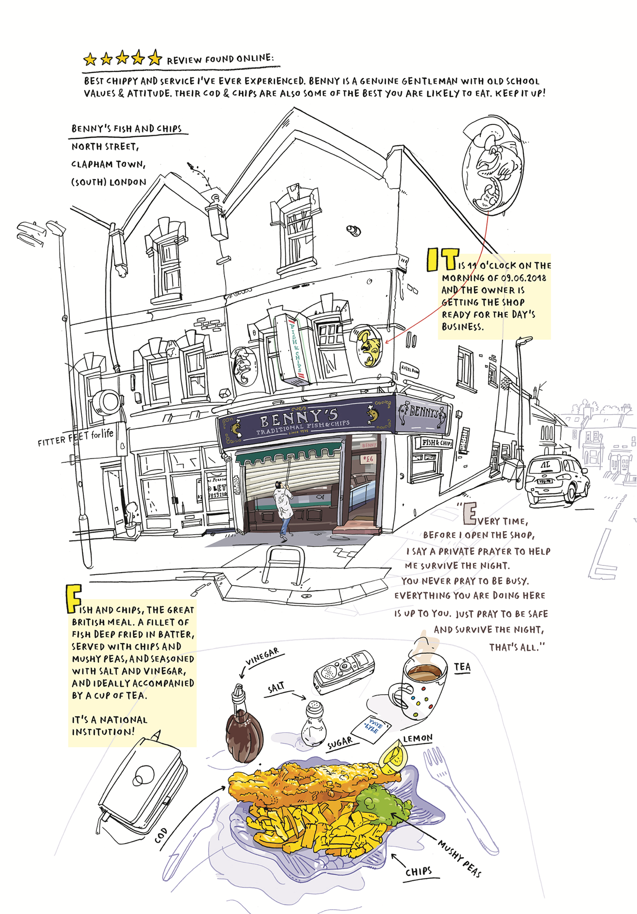

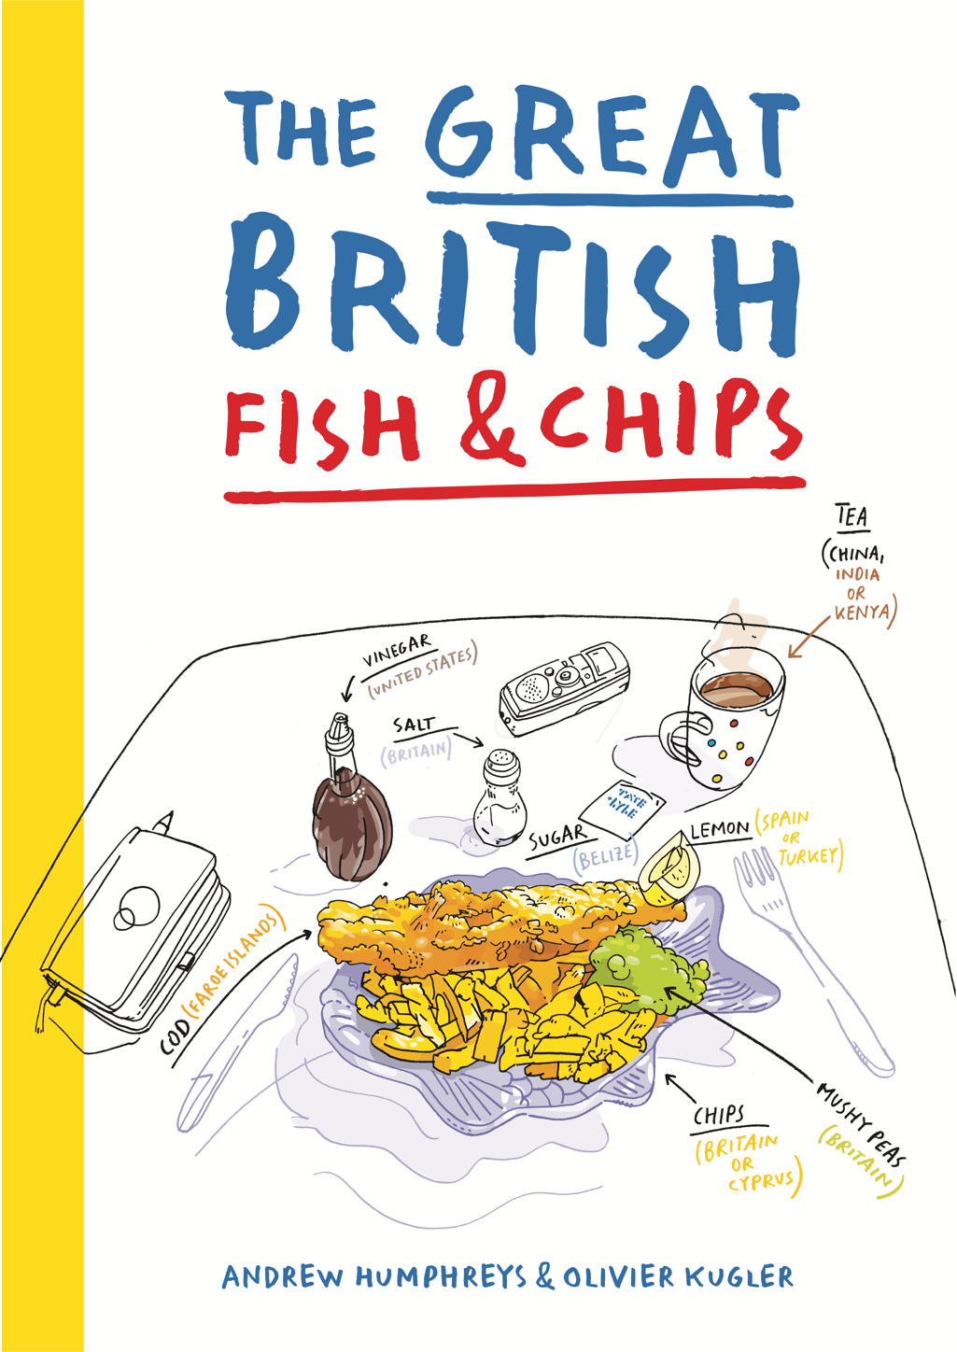
Figure 2: proposed book cover, The Great British Fish & Chips
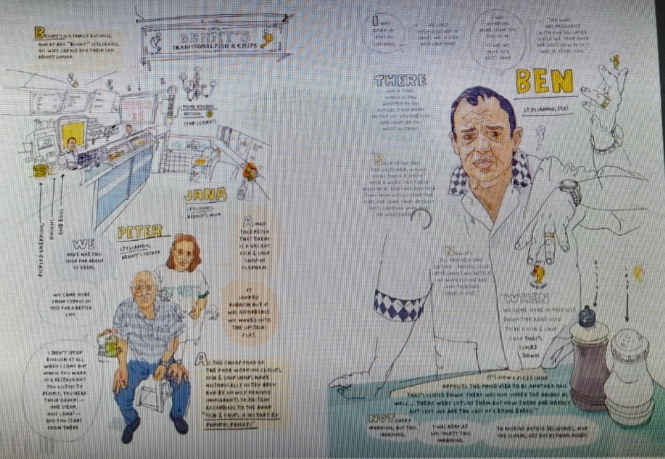Figure 3, Benny’s Fish & Chips
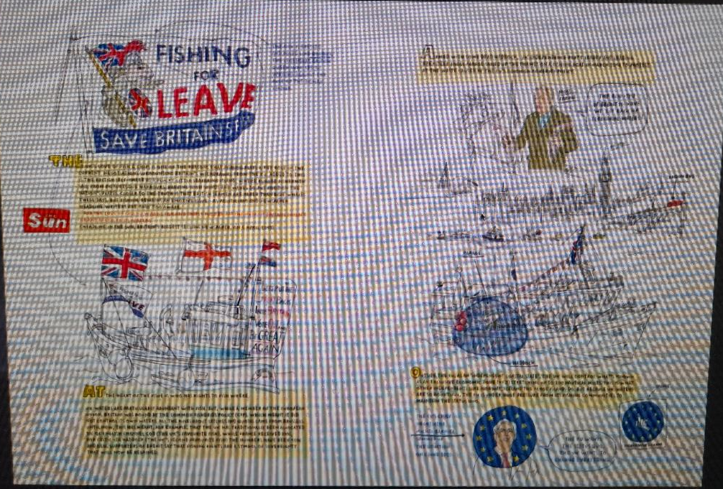Figure 4, Fishermens’ protest on the River Thames outside of Parliament
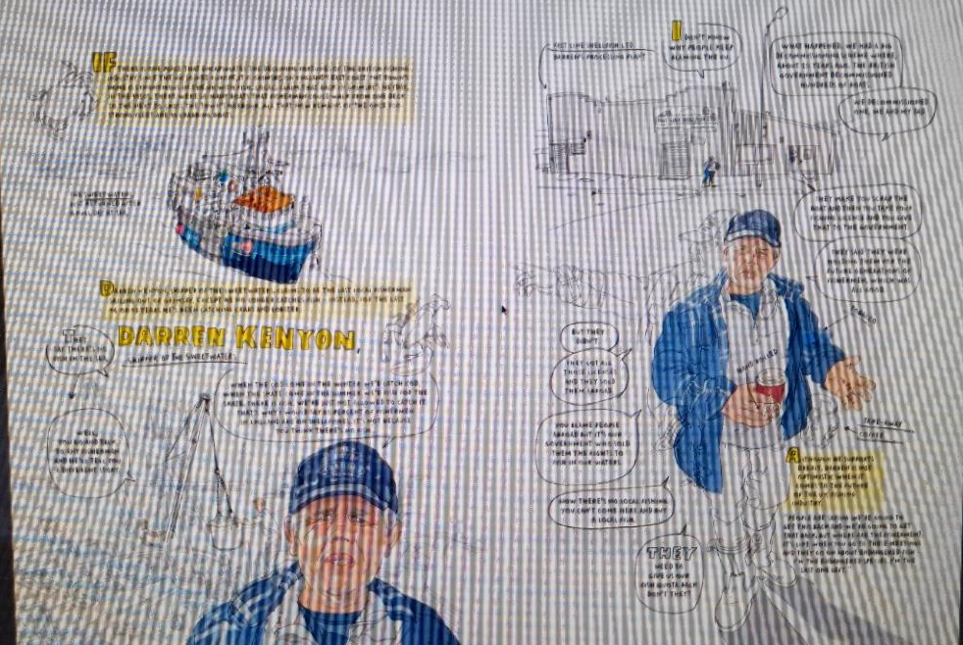Figure 5, Darren Kenyon, Skipper of The Sweetwater, Grimsby
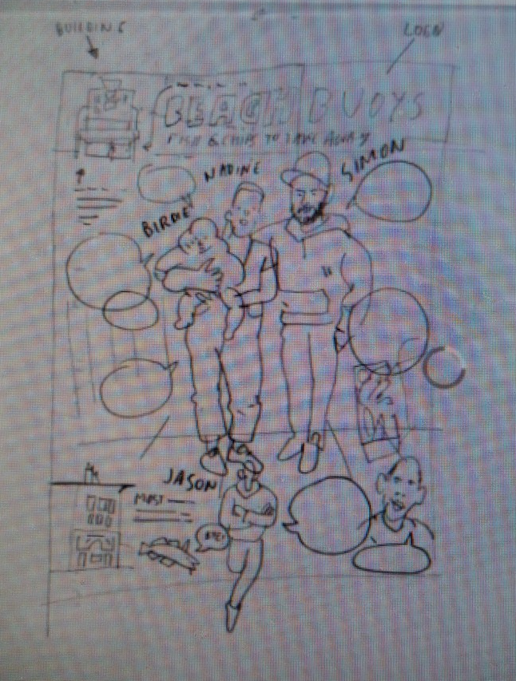
Figure 6, Olivier Kugler, working sketch of Beach Buoys Fish & Chips family, showing prominence of the speech bubbles within the composition

Timothy Brennan, “The National Longing for Form,” in Nation and Narration, ed. Homi K. Bhaba, Routledge, 1990.
Mary Ann Doane, “Indexicality: Trace and Sign, Introduction,” in Differences: A Journal of Feminist Cultural Studies: Indexicality: Trace and Sign, vol 18, number 1, Spring 2007, 6.
Andrew Humphreys and Olivier Kugler, ‘The Great Fish & Chips’, unpublished PDF, 2022.
In their proposal, Humphreys and Kugler plan a large format, full-colour book of 240 pages, building upon previously the published stories ‘Last Night at Benny’s’ for French magazine XXI (Summer 2020); and on another story explaining why fishing was at the heart of Brexit, for Swiss magazine Reportagen (Autumn 2020).
Keynote Address, Humphreys and Kugler, 12th Annual International Illustration Research Symposium, Falmouth University, July 15, 2022.
Definition of ‘territorial waters’: ‘the waters under the sovereign jurisdiction of a nation or state including both marginal sea and inland waters,’ Merriam-Webster dictionary, https://www.merriam-webster.com/dictionary/territorial%20waters.
Keynote address, Kugler and Humphreys, July 15, 2022.
https://www.bloomsbury.com/uk/reportage-illustration-9781350031883/. Blurb from website for Reportage Illustration: Visual Journalism, Gary Embury and Mario Minichiello, London: Bloomsbury, 2018.
Rosalind Krauss, “Notes on the Index: Seventies Art in America,” October Vol. 3 (Spring, 1977), pp. 68-81, The MIT Press, 70.
See Roman Jakobson, “Shifters, Verbal Categories, and the Russian Verb.” Volume II Word and Language, Berlin, New York: De Gruyter Mouton, 1971, pp. 130-147. Although Jakobson is often cited as Lacan’s inspiration for the term ‘Shifter’ in language, Thomas A. Sebeok notes that it was Otto Jespersen who first used the term ‘shifter’, in 1923, to refer to grammatical terms which depend upon the sentence for their meaning. See Thomas Sebeok, “Indexicality,” Peirce and Contemporary Thought, ed. Kenneth Laine Ketner, New York: Fordham University Press, 1995, 240. For another linguistical approach to the primary indexicality of the pronoun in language, see the key texts by Emile Benveniste, Problems in general linguistics, 2 vols, Coral Gables, FL: University of Miami Press, 1971; and Emile Benveniste, La nature des pronoms. In M. Halle, ed., For Roman Jakobson. Essays on the Occasion of His Sixtieth Birthday, 11 October 1956, The Hague: Mouton. For a comparison between Benveniste’s indexical pronoun and Jakobson’s Shifter, see Julia Kursell, ‘First person plural: Roman Jakobson’s grammatical fictions,’ Studies in Eastern European Thought (2010) 62: 217-236.
See Roland Barthes’ meditation on the indexical ‘authenticity’ of the photograph in Roland Barthes, Camera Lucida: Reflections on Photography, trans. Richard Howard, Hill and Want: The Noonday Press, 1981, where he writes, ‘From a phenomenological viewpoint, in the Photograph, the power of authentication exceeds the power of representation.’ (89)
Georges Didi-Huberman, “The Index of the Absent Wound (Monograph on a Stain),” October 29 (Summer 1984): 63-82.

