Falmouth University, Core Academic Training, 15 June 2018

Author: Dr Cui Su

Title of paper: Teaching Entrepreneurship: Building on the Creative Advertising experiment. [see also www.falmouthlab.com]

Relevant CAT themes: Doing it for Real

On the night when the ‘Beast from the East’ struck Cornwall, the first minimum viable prototype (MVP) of Hidden Jam, a secret living room gig and music events network based in Falmouth, was held.

Introduction
Hidden Jam is a Falmouth-based micro business that curates and hosts secret living room gigs of musicians and undiscovered talent from the local area. Inspired by the global music events startup Sofar Sounds, awareness of Hidden Jam is similarly based off word-of-mouth and through social media channels, with the specific aim of bringing some diversity and providing an exciting alternative to the gig scene in Cornwall. Dates of each jam are announced with teaser posts on Facebook and Instagram but the venue and line-up (normally four to five acts) is kept secret until the last minute. People turn up with their own booze and buy a £5 ticket for entry. Some of the proceeds go to paying the performers and covering any running costs.

Hidden Jam is also one of 14 micro businesses created from a Creative Advertising module. ADV340 Advertising Business Management is a 3rd year, 20 credit module that lasts 12 weeks in Study Block 2. The cohort size is 56, split into teams of 4. Each team is given a ‘seed fund’ of £300 and tasked to propose original business ideas that would have a social benefit, and develop them into a business as far as they can manage. At the end of the module, each team will deliver a presentation of their project, any prototype products or associated multimedia artefacts, and a written report. To track their progress, they must also maintain team blogs.

The teaching team is composed mainly of myself and design researcher James Branch, with guest input from freelance copywriter Rebecca Wass, Rachel Warren, IP litigation specialist from Foote Antsey, Jon Christie from our Employability and Careers services, Jamie Smith from local business support programme Unlocking Potential, and Kate Wild, Founder and CEO of PR agency Wild Card, based in Truro and London.

Like many studio-based modules, the structure of the module is such that key lectures and workshops are front loaded, followed by contextual lectures and supervised sessions to review and reflect on each team’s status and progress. Below is an outline:

 | Lecture | Seminar workshop
Week 1 | Intro to Lean Startup | Where do ideas come from?
Week 2 | What is a business model? | Ideas -> Business: problem mapping
Week 3 | Talking to humans | Customer development + Value proposition
Week 4 | MVP and Prototyping | Testing your hypotheses
Week 5 | Pivots | Crits of findings
Week 6 | Entrepreneurship 2.0 | Team Progress Review
Week 7 | Basics of startup funding | Team Progress Review
Week 8 | Pre-Easter review and planning | Pre-Easter review and planning
Week 9 | IP | Team Progress Review
Week 10 | Business of Self: Freelancing | Team Progress Review
Week 11 | Practice presentations | Practice presentations
Week 12 | Final Assessment & Demo Event | Final Assessment & Demo Event

Teaching with the Lean Startup
As evident from above, the module design is based on the Lean Startup (Ries, 2009). It is a methodology for entrepreneurship that has become increasingly popular in the last decade, entering entrepreneurship university courses around the world as a key topic. ‘Lean’ refers to the principle of focusing on the efforts that create value for customers and avoid waste/cost in business creation process.

It is essentially a hypothesis-driven approach where entrepreneurial decisions are based on evidence and validated learning (Ries, 2011; Blank & Dorf, 2012; Osterwalder & Pigneur, 2010). Crucially, it sees every market as real and totally unique. Regardless of previous successes and however well established the product or service sector is, everything is treated as an untested assumption. Therefore, entrepreneurs should build and test minimum viable prototypes (MVP) of their new product and service, ‘get out of the building’ (GOOTB), and talk to customers as soon as possible.

In contrast to its ubiquity in American universities, adoption in UK and European institutions is comparatively measured but have grown steadily within business school offerings. There were many activities organised by local councils and training centres for those who already EU-funded, multi-million Open Innovation Project 2010-2014, which teaches Lean Startup . More recently, it is taking shape as course modules, mostly postgraduate, in business, computer science, social science and development studies. For example LSE’s Co-Creation Lab, University of Edinburgh’s Launch.ed, and initiatives at University of Kent and Copenhagen Business School, all use the Lean Startup.

Doing Theory
Previous scholarship on entrepreneurship education distinguishes between education about enterprise- teaching the theoretical aspects of setting up and running a business -, and education for enterprise, i.e. to provide the practical skills and knowledge required for setting up a business (Jamieson, 1984; Levie, 1999). On the one hand, theory-focused courses typically task students with researching and writing up, for example, a high-level, top-down business plan document describing objectives, strategies, sales, marketing and financial forecasts. On the other hand, activity-based teaching or practically-oriented classes begin from the premise that in the real world, business plans go wrong or become irrelevant quickly. Therefore, their focus is on helping students learn through practice and action, provide inspiration and mentoring for coping with and managing uncertain entrepreneurial environments (Gibb, 2002).

Lean Startup does both. It provides a theory of entrepreneurship typically associated with high-growth corporate ventures but it is also a theory of practice-based learning which actually also mirrors the way that small businesses owners research and learn, whereby experience is paramount: “learning from peers; learning by doing, learning from feedback from customers and suppliers; learning by copying; learning by experiment; learning by problem solving and opportunity taking; and learning from making mistakes (Gibb, 1997:19). Furthermore, researchers of entrepreneurship education have argued that practically oriented pedagogy, by virtue of being more optimistic and motivational than theory-led courses, is linked to enhancing students’ sense of entrepreneurial self-efficacy and entrepreneurial intentions to initiate and pursue their own business after the course (Piperopoulos & Dimov, 2015).

Ultimately, however, like any other research method that claims to engage with real contexts, in practice, the Lean Startup inevitably falls short and this was certainly the experience on this creative advertising module. There were many things that did not fit. As sociologist John Law argues, “Realities are not flat. They are not consistent, coherent and definite” (2003: 11). In the next section, I will discuss three lessons from the creative advertising teaching experiment based on a critical reflection of the module using scholarship on entrepreneurship education.

1. Battling the myth that entrepreneurship equals business
In the beginning, some students in class showed resistance because they considered the module irrelevant to their aspirations to become creatives. This was not totally unexpected since Falmouth is, like Bucks or Watford, a specialist creative advertising course, strongly vocational and geared towards top London agencies. While this career specialisation has worked well for the degree in terms of employability, the narrow niche could militate against anything outside of how the creative function is organised and managed within advertising agency cultures.

Professor Allan Gibb OBE, who pioneered education and training for entrepreneurs since the 1970s, argues, “entrepreneurial behaviour is not the prerogative of business” (2002:233). Yet entrepreneurial learning outside of business schools, such as in an arts and design, is still limited and even more so in creative sub-sectors such as advertising (DCMS, 2006). Education scholars and policymakers alike have, for some time, been suggesting that the better place for entrepreneurship courses in universities may in fact lie outside the business school (Gibb, 2002; Hampden-Turner, 2009; HE Innovate, 2016). As Hampden-Turner (2009) argued, “While entrepreneurship depends heavily on developments in hard sciences, the ability to generate hope, mobilize enthusiasm, persuade investors and read customers all depends crucially on soft skills of personal and social judgement, which are usually associated with the liberal arts” (2009).

Arguably, the modern equation of entrepreneurship with business manager obscures a more expansive and ontological definition of entrepreneurship: “Behaviours, skills and attributes applied individually and/or collectively to help individuals and organisations of all kinds to create, cope with and enjoy change and innovation involving higher levels of uncertainty and complexity as a means of achieving personal fulfilment” (Gibb, 2007:3). This view could well be describing lots of creatives, including advertising creatives, who may not label themselves as entrepreneurs but who exhibit those attributes. Entrenched myths do not come undone easily in 12 weeks but the point is that it is worth noting that some students need time to ease out of their preconceived views or may not do so at all.

2. Entrepreneurial learning is ethnographic

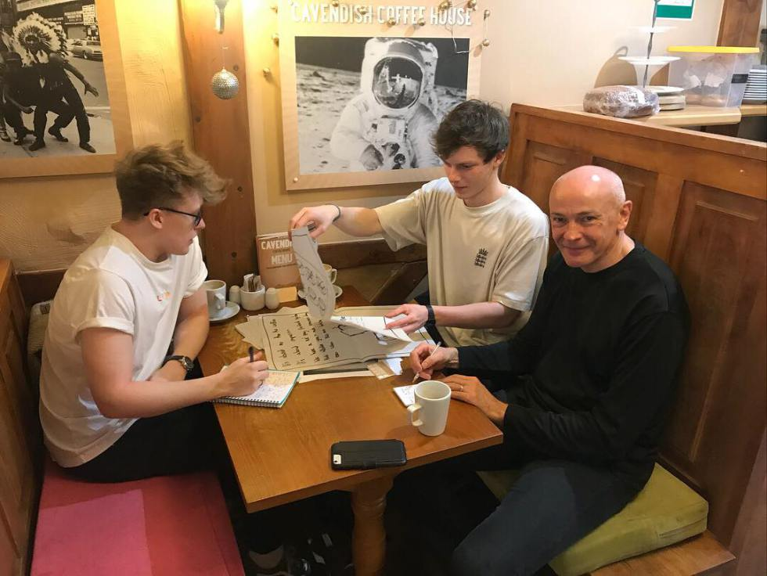
Interviewing high street shoppers Meeting with local Falmouth business owner

The Get Out of the Building approach worked well in that students spent at least half their entrepreneurial learning outside of our advertising studios. This included using campus facilities they have never used for coursework before such as woodworking, screenprinting and 3D printing studios. They collaborated with students on other Falmouth courses, such as illustration, popular music and graphics. In this respect, students have been able to contrive and immerse in their own “entrepreneurial eco-system” (Hampden-Turner, 2009). This involved going out into the surrounding local area to speak to shoppers, business owners and their customers. Some of them even spoke to the local council, police and even environmental health service to find out how to get a food license.

Like ethnography, this mode of learning and knowing is immersive not only in the sense that students have to live in the MVP eco-systems they created and engage with different entities within them, they must also perform their assumptions and hypotheses and test them in real contexts. The Hidden Jam team embraced this right from the beginning, organising and hosting these music events but also building a world and social network with their performers, punters, online fans, and local venue hosts.

3. The challenge of assessment
Assessing the module was logically and emotionally challenging. Although we mapped out the learning outcomes against course-specific outcomes for creative advertising, for the purposes of reflection here, I will talk about three proxy learning metrics we used: competencies, resilience, and transformation.

Competencies and Resilience
For competencies, we looked for demonstrations of how Lean Startup methodology was applied, which included the build-measure-learn process, team management, getting-out-the-building and customer development (Ries, 2011; Blank & Dorf, 2012; Osterwalder & Pigneur, 2010). According to the National Council for Graduate Entrepreneurship’s (NCGE) entrepreneurial learning framework, this was described as generic entrepreneurship competencies or ‘key minimum business how tos’ associated with the startup process and understanding the entrepreneurial values around creative problem solving, embracing failure, working opportunities with limited resources (Pittaway, Hannon, Gibb & Thompson, 2009:77).

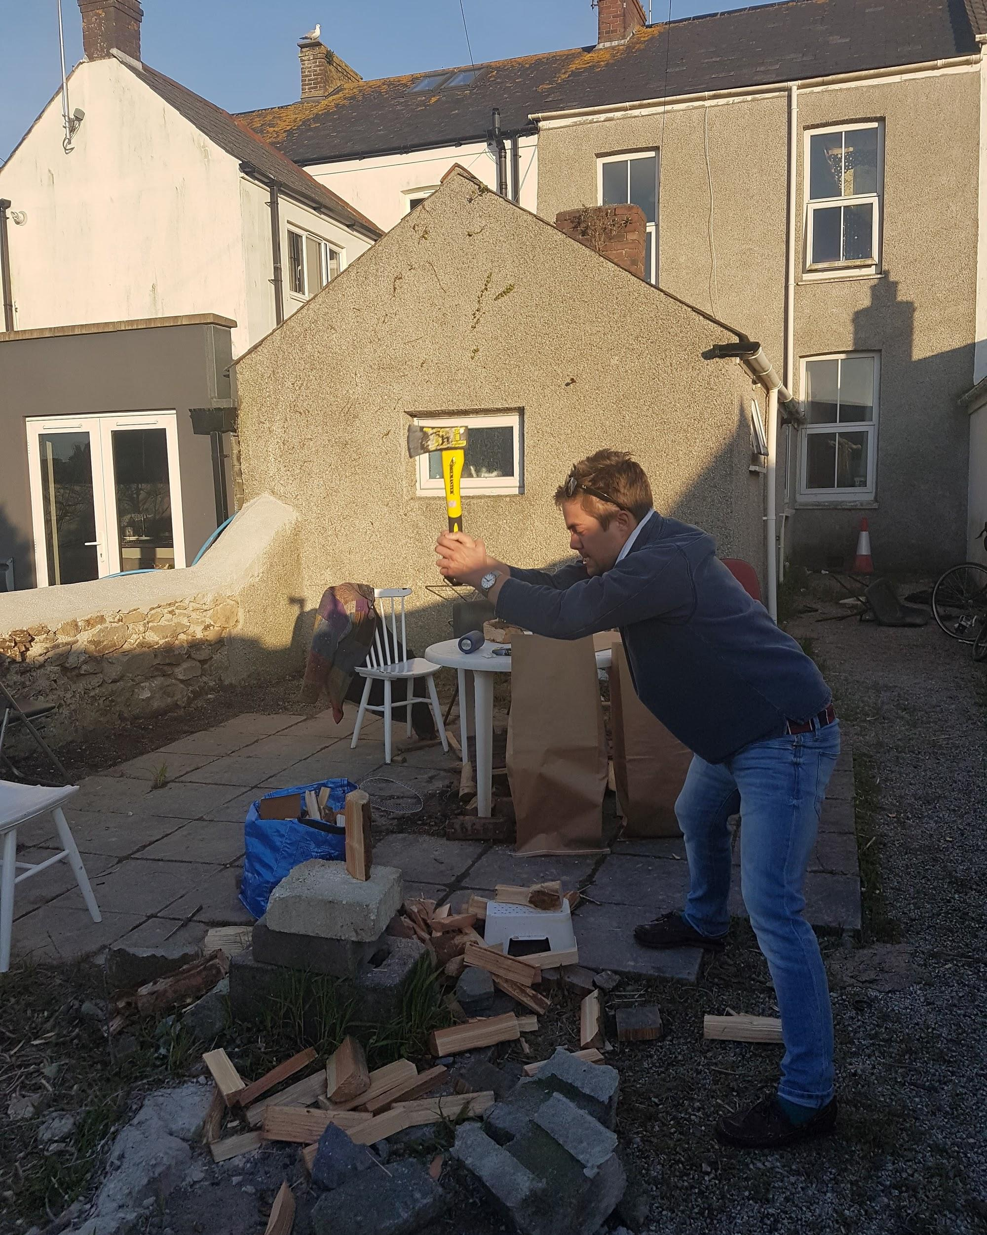

Confirming previous research into assessment practice in enterprise education, regardless of whether teams struggled or thrived in the 12 weeks, the summative written report seemed irrelevant and unreliable as a method of assessment (Pittaway, Hanon, Gibb & Thompson, 2009). Only the blogs, although messy and harder to decipher, were able to capture the team experiences more truthfully. This provoked a number of questions around assessment: must entrepreneurial learning productivity always take written form? And if not, what form should it take and would work best for assessment?

How do you assess the business artefact, especially when they come in a variety of finished stages? We also considered what the role of the Ian Bogost’s description of practicing theory as carpentry is instructive here. If we think of entrepreneurship as a type of craft, like carpentry, and Lean Startup a kind of entrepreneurship philosophy, then students learning about entrepreneurship using Lean Startup, can be thought of as engaging in philosophical practice, i.e. they are carpenter-philosophers. And the (real) businesses that they have created can be assessed as a philosophical object, alongside a series of reflective blog posts?

Transformation

“Actually, this is more me”

“I now understand where the clients are coming from in an advertising agency”

“I’m considering a career in events and project management through the experience I’ve had developing an events business”

For some of the student teams, the process was so emotionally-laden, intense, often during critical moments when they faced challenging issues; for example, when stakes were high in MVP testing, or when things went wrong and drastic pivots under time pressure, or when the team dynamic broke down and had to be managed. These crisis moments involved a high degree of what Cope (2003) refers to as personal exposure, that the process forced students ‘to question their taken-for-granted beliefs and assumptions and reframe their understanding of the situation at hand’ (2003:431).

Two groups, Cardbites and Bonfire Kits, clearly stated their intentions to carry on with their business after the module. The Cardbites team went so far as to spend some of their own money to buy a professional-grade 3D printer so that they can carry on developing their new product. After a successful MVP review session, one of the Bonfire Kit students told us “actually, I think this [project] is more me”, in contrast to creating ad campaigns. Two students from the Hidden Jam team told us they are now considering getting into events management instead of advertising after graduation.

It is important not to overstate these changes from taking a 12-week module but they were there nonetheless and proved to be the most difficult to measure especially since none of the summative formats had individual components and thus had limited scope for individual self reflection. These types of outcome, argues Cope (2003), might be described as transformative learning which “has a distinctly personal dimension and has the capacity to stimulate considerable changes in the entrepreneur’s self understanding” (2003:437). Comparing pre with post-module entrepreneurial intentions and shifts in students’ sense of self efficacy did give us a clue (Piperopoulos & Dimov, 2015). This was demonstrated in the reflective components of the presentation, report and blog only in a limited sense because they were all joint submissions. A post-module survey was conducted to try to capture some of the individual reflection through the question ‘what would you do differently in your profession after this module?’ (link to survey here). On hindsight, to properly capture transformative learning outcomes, some space for individual critical self-reflection needs to be built into assessment design.

Creative Entreprecariats
Although this module tried to motivate students’ self-belief in their entrepreneurial capabilities, it is important to recognise that many of them will enter precarious conditions upon graduation even for those who had performed well. In spite of the well-established view that enterprising individuals succeed on ingenuity and hard work alone, getting into advertising often involves “enduring considerable periods of financial hardship between placements and unemployment” (McLeod, O’Donohoe & Townley, 2009:1026).

Precarity characterises much of the work in UK creative industries (McRobbie, 2015) and advertising is no different. Even after painstakingly creating a creative portfolio, in all likelihood many graduate creative teams have to attend lots of ‘book crits’, do a few low-paid or unpaid placements, proactively network at industry events and enter competitions, and survive in this way for a couple of years before landing stable employment.

Therefore, while entrepreneurship can be a term of genuine enthusiasm, optimism and motivation which is useful for pedagogic strategies, it is worth acknowledging the “entreprecariats”, to borrow a portmanteau from Silvio Lorusso, that will graduate from our classrooms into situations of pervasive precarity (Lorusso, 2016) in the freelance world. They must, he argues, cope with the cognitive dissonance brought about by the fact that “precarious conditions demand an entrepreneurial attitude, while affirmative entrepreneurialism dwells into constructive instability and change” (Lorusso, 2016:1). This contradiction characterises the kind of lives carved out by many young advertising creatives today. The role and impact of entrepreneurship education on their ability to manage and even thrive, is still difficult to say.

Conclusion
To sum up, this module was the first step in helping us gain a new understanding of the pedagogy of entrepreneurship within the context of a creative advertising department and with the help of wider entrepreneurship scholarship, this paper offers a reflective discussion of it. Whilst the Lean Startup provided a useful framework for designing an active, action-based pedagogy, using it outside of the business school context, in localised, and micro-scale modes compared than high-growth tech ventures requires some degree of adaption. This paper offers three ways: 1. In the set up, it is necessary to first overcome some myths and misconception around the concept of entrepreneurship, particularly in shifting away from its associations with corporate organisations to a more holistic and ontological idea of entrepreneurial ways of being; 2. The ethnographic aspect of practically-oriented learning is especially powerful when students are allowed to embed and explore their university and involve locality in ways that go beyond departmental and disciplinary boundaries; 3. Assessment of entrepreneurial learning, particularly the personal and critically reflective aspects of it is challenging and may require innovative or non-traditional ways of thinking about assessment.

References
Arnold, H. 2009. “Grasping the entrepreneurial mindset” 21 April, Financial Times

Blank, S. & Dorf, B. (2012). The Startup Owners Manual. California: K&S Ranch.

Bogost, I. 2012. Alien Phenomenology, or What It’s Like to be a Thing. University of Minnesota Press.

Cope, J. 2003. “Entrepreneurial learning and critical reflection: discontinuous events as triggers for ‘higher-level’ learning, Management learning, 34(4), pp.429-450.

DCMS. 2006. Developing Entrepreneurship for the Creative Industries. Available online: http://dera.ioe.ac.uk/7624/2/dcms_enterprise_and_he.pdf

Duckworth, A. 2016. Grit: The Power of Passion and Perseverance. London: Random House.

Gibb, A. A. 2002. “In pursuit of a new ‘enterprise’ and ‘entrepreneurship’ paradigm for learning: creative destruction, new values, new ways of doing things and new combinations of knowledge” In International Journal of Management Reviews, 4(3), pp233-269. [Accessed 4 June 2018] https://www.researchgate.net/publication/228118643_In_Pursuit_of_a_New_%27Enterprise%27_and_%27Entrepreneurship%27_Paradigm_for_Learning_Creative_Destruction_New_Values_New_Ways_of_Doing_Things_and_New_Combinations_of_Knowledge.

Gibb, A. A. 2007. “Enterprise in education: educating tomorrow’s entrepreneurs” In Pentti Menkinen. [Accessed 4 June 2018] http://www.enorssi.fi/opetus-ja-materiaalit/yrittajyyskasvatus/pdf/Gibb.pdf

Hampden-Turner, Charles. 2009. Teaching Innovation and Entrepreneurship: Building on the Singapore Experiment. UK: Cambridge University Press.

Jamieson, I. 1984. “Education for enterprise” In eds. Watts, A. G. and Moran, P., CRAC, Bellinger, Cambridge, pp.19-27.

Lorusso S. 2016. “What is an entreprecariat?” Institute of Network Cultures, Amsterdam University of Applied Sciences. [Accessed 1 June 2018]

McLeod C., O’Donohoe, S., & Townley, B. 2009. “The elephant in the room? Class and creative careers in British advertising agencies”. In Human Relations, 62(7), pp.1011-1039.

McRobbie, A. 2015. Be Creative: Making a Living in the New Culture Industries. London: Polity.

OPEN INNOVATION. 2011. “Open Innovation Project: Events and Activities 2014-15”. Available online: http://www.openinnovationproject.co.uk [Accessed 1 June 2018]

Osterwalder, A. & Pigneur, Y. (2010). Business Model Generation. New Jersey: John Wiley.

Piperopoulos, P. and Dimov, D. 2015. “Burst bubbles or build steam? Entrepreneurship education, entrepreneurial self-efficacy, and entrepreneurial intentions”. In Journal of Small Business Management, 53(4), pp.970-985.

Pittaway, L., Hannon, P., Gibb, A. A. & Thompson J. 2009. “Assessment practice in enterprise education” In International Journal of Entrepreneurial Behaviour and Research, vol.15, no. 1, pp71-93. [Accessed 4 June 2018] http://ieeponline.com/wp-content/uploads/2013/11/Assessment-practice-in-enterprise-education-Pittaway-Hannon-Gibb-Thompson.pdf

Ries, E. (2011). The Lean Startup. New York: Crown Business.

Schön, Donald. A. 1983. “Design as a Reflective Conversation with the Situation”. In The Reflective Practitioner, USA: Basic Books.

Wang, Xiaofeng & Khanna, Dron & Abrahamsson, Pekka. 2016. “Teaching Lean Startup at University: an Experience Report”. In International Technology Management Conference, proceedings, Trondheim, Norway, June 13th, 2016. [Accessed 1 June 2018]: https://www.researchgate.net/publication/323808770_Teaching_Lean_Startup_at_University_an_Experience_Report

Wong, A. L. 2017. “Work in the Creative Economy: Living Contradictions between the market and creative collaboration”. In eds. Graham, J. and Gandini, A. Collaborative Production in the Creative Industries. London: University of Westminster Press, pp.197-215.

More generally, enterprise education as a concept and as a national priority can be traced alongside the emergence of a ‘talent economy’ under Gordon Brown’s Labour government (cf. UK Government, “Enterprise: Unlocking the UK’s Talent”. [Accessed online 1 June 2018])

