As Well As/Instead Of Orpheus:
Making, teaching and living in grief

Laura Canning

In the early hours of Friday September 13th 2019, a few short months before our wedding, my fiancé Eric, the father of our three-year-old son and his twelve-year-old daughter, an apparently healthy man in his mid-forties, died in his sleep without any warning. This set of fragments examines my attempts to make, teach, and live without him.

For Ben, with all my gratitude.

It is September 2019

It is September the 12th 2019, sometime after ten. We are watching First Dates Hotel on television: he is an inveterate romantic now, he cannot believe that love will not happen, for the brave and the kind.
Would you do it all again, he asks me?
I would.

As I yawn, and stretch, ready to go to bed, he covers my hair with kisses, and goes back up to his office. It has been a good, ordinary, day. We are happy.

By morning he is dead.

-------------

There is something about the extremity of a loss like this that makes others thrill with horror, with vicarious sensation. It is this extremity of loss that makes grief so cinematic, or cinema so like grief. I can’t begin to imagine, they say. But you can, I think. Cinema has taught you how.

There are films that offer ways to think about grief, but they are not necessarily the films that describe or depict the experience directly: I could as easily open a vein and watch my own blood gush out as watch Kieslowski’s Three Colours: Blue, for example. It is more that fragments, moments unfurl or explode into the screen in metaphorical connection or emotional resonance. I watch one scene in Fellini’s I Vitelloni again and again. It is night, and as an ecstatic party in a theatre becomes increasingly frenzied, Fellini’s camera moves away from it, briefly framing two old ladies asleep in a balcony box, through an empty corridor, then back into the main space of the theatre to the sound of a discordant trumpet, as the final partygoers, still clutching theatrical props and paper streamers, droop in the early hours of the morning. What had been hedonistic and vital looks now ugly and vain, a parody of joy and human connection. The trumpet sound becomes shrill, flat. A garish clown face fills the screen in place of the glamour of the previous night. Characters reel, sickly under the chandelier. The world is the same but different. Impossibly, unbearably worse.

We are late lovers, having known a dumb animal longing for each other since our very first meeting. I am eighteen, he is twenty-one. He is already with the woman he will later marry, his teenage sweetheart. I am 14 months away from my twentieth birthday, from meeting the man I will spend the next decade and a half with.

You talked about Greece, he tells me, many years later.
What did I say? I ask, embarrassed by the memory of my teenage self, growing out a buzzcut, full of angst and permanent restless energy.
I don’t know. I just know it was like standing in the sun.

In a deeply future-obliterating loss, such as this one, the challenge is not so much in accepting the death – I know this to my core, his absence reaches inside my bones with every breath – but in accepting that I live without him. I am, in a sense, condemned to life.

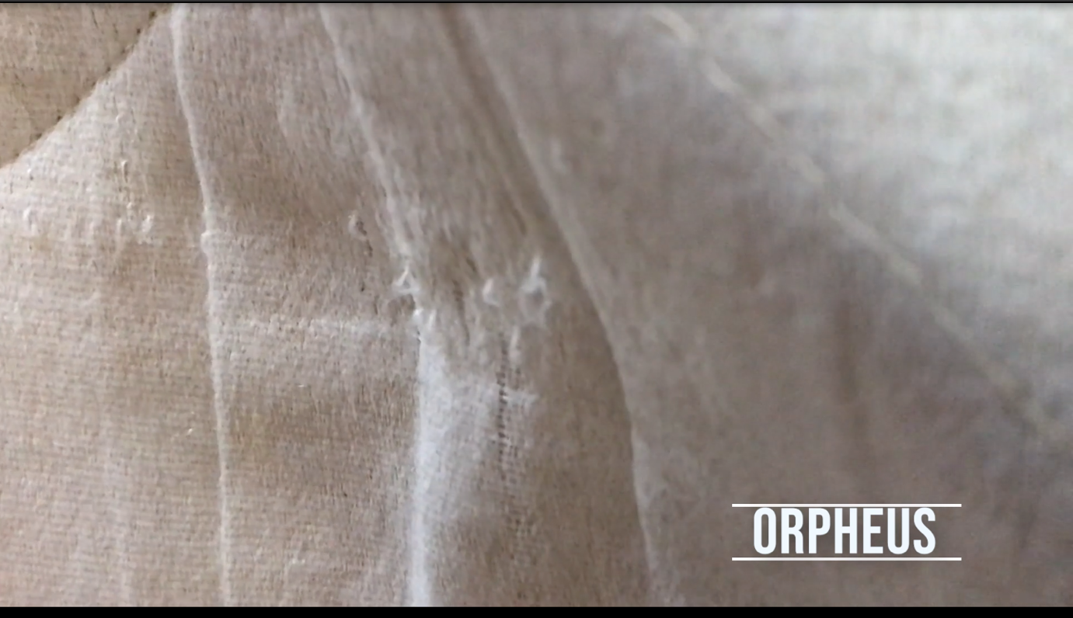
Fig. 1. Last night I dreamed of you again, my Orpheus. You opened those long-closed eyes, said “I would do anything to get back to you”…There is no sound louder than this: your dead hand, falling.

It is October 2019

I remember almost nothing of the funeral, except this: an elderly woman I have never seen before takes my hand, and says I know, it’s bad. It only gets worse. I know I have not imagined it. I know too that it is a cinematic moment. Life is cinematic in all its best and worst moments. The portent of a single sentence. My eyes framing an old, gnarled hand, holding mine. The sense of time unfurling into nothing. Lost.

My experience of grieving is inextricably bound up with my feelings of shame for grieving. To grieve is to feel almost constantly ashamed: I have lost, your heart says. One who loses. I am a loser. We are often shamed, inadvertently, by those who have not experienced this level of colossal derangement. We are shamed for not ‘getting over it’ (we never will). For not being grateful enough for the things we have (I am grateful for my house but it is not the home we had; I am grateful for my son but once I was part of a family, and now I must be a family, all by myself).

Funerals mark an ending, or the passage from one world to the next: and so it is, for those who get to walk away and think fondly of the dead person from time to time. Similarly with funerals in cinema: they are a moment of narrative transition, a spatial-temporal device whereby the exculpatory processes of the mourners can be mobilised, such that they can move towards crisis and a resolution. But with Eric’s death – with any sudden death of a young person, or perhaps any death for those whose lives are inexorably changed by it – the funeral means nothing. It is only a portal into the continuous-present. He is always dead. He is constantly, eternally, unbearably dead.

My body and mind react to the constant physical pain of grief as if I were in a war zone, which in many ways I am. In an effort to manage – to outrun – the cortisol and adrenaline spooling through my body, I run. While I run, I am conscious that my body is metabolising my grief, attempting to break its colossal unmanageability down into something more like feelings. I am running in linear time, know it is unfolding around me, and yet my mind shifts abruptly across time, as if a pitiless editor clips coil after coil of celluloid in place around my shattered heart.

My life – what used to be my life – intrudes, erupts around me unpredictably. It is 2012. It is 1994. It is 2007. It is 2019. It is 2021 and we are exchanging vows at the wedding we will never have. We are bringing our son to his first day of primary school, a day from which Eric will forever be absent. It is like being on one of those fairground rides that drops you abruptly from a height, your mind registering a past trajectory through space even as your body traces an entirely different flight path. Time seems to slip around me, as my past coalesces horribly with futures-which-might-have-been. I have not just lost him: I have lost the one person I could rely on to navigate a loss this great. I am unfurling. I am being edited.

People say to me: Let me know if I can help.
How are you at necromancy? I reply. They laugh nervously.

The only thing I need is him. I need nothing. There is nothing anyone can give me.

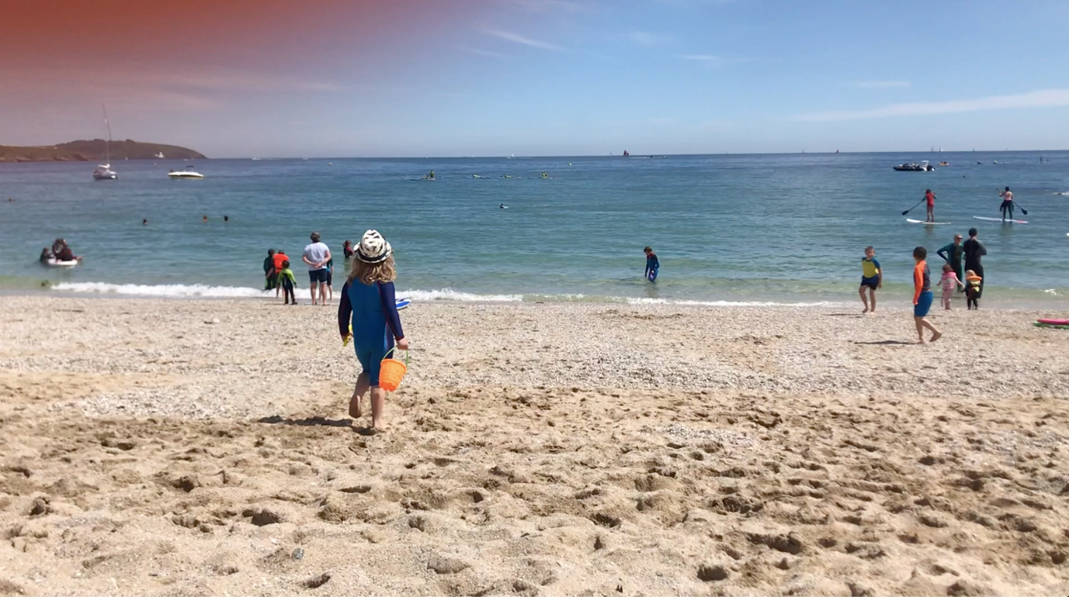
Fig. 2. Oh my love, you have missed so much.

It is November 2019

I go back to work, where I can immerse myself in the details of other people’s lives, can feel slightly less useless.

Friends send videos of Eric to me. Joyful, intense clips of him at his happiest, performing, or his voice soundtracking film clips made by others. I simply cannot watch them. This is not the rich necromancy of narrative, but a pitiless documenting of everything that has been taken from us by death. But there are fragments of our old life on my phone, that once was his. Videos I have never seen before, made by him. Glimpses of Singapore, Manila, San Francisco, Amman, Rome. Clips of our life. This is what I want, only this. His joyful and compassionate eye, back in the world. He videos our tiny son in grubby Paw Patrol pyjamas, that last Christmas together, singing Rudolph the Red Nosed Reindeer. Eric’s warm, deep voice encouraging him. The glow of his love around us, making us a family.

It is Winter

I write only one sentence, this: Writing has failed me.

It is March 2020

My boss and I shut down the studio sets. We lock up our office and say goodbye to each other, as reassuringly as we can manage. I meet a colleague in the library, where I stack up as many books and DVDs as I can carry. They feel like insurance, a safety net, like an attic filled with tinned food. He is doing the same. We smile guiltily at each other. This lockdown feels like we are all lovers, parting for war.

It is 1997. We have recently spent an awkward, painful week – also a joyful, funny one – rampaging with friends around a Scottish stately home on the moors. He writes to me from a grey, cold beach on the North Sea, somewhere in the Netherlands, or Belgium, or Denmark. He cannot feel like this any longer. He is going away.

If I had not been grieving in a pandemic, things might have been different. I do not know, and it is impossible to say. I am honest, but not comfortably a discloser of feelings by nature. I am the child who lied in the confession box to the priest, not because I was ashamed but because it was none of his damn business. I am the child who read all the first aid books and taught themselves to sleep in the recovery position. Perhaps this is why the only place in the world that has ever truly felt safe to me (other than his arms) is the cinema. Other people’s feelings take the place of my own. I thrill, I rage, I cry for them in the dark warmth, then fold my ragged edges together as I come blinking out into the light. Now I feel, somehow, fictional myself.

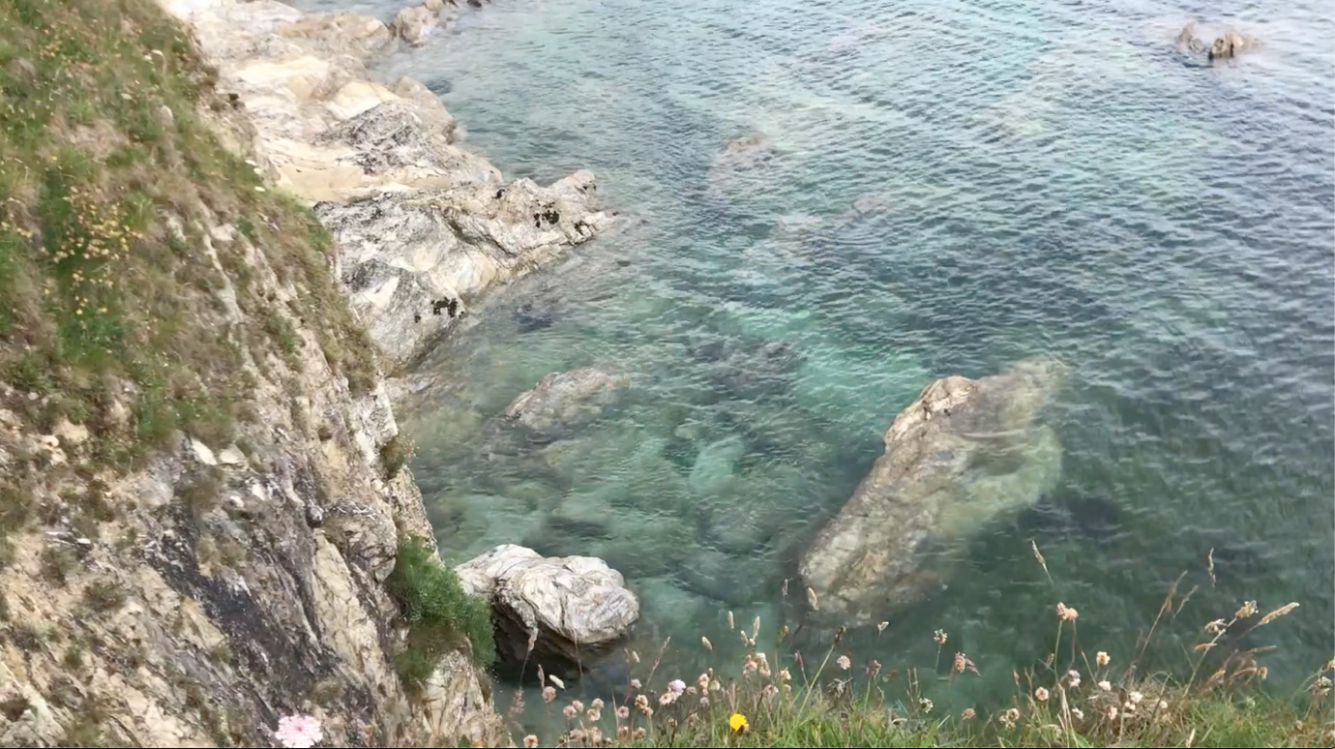
Fig. 3 Orpheus, I will say, leave your battles and your worries far behind. Sing me into the cool deep, beyond our own volcano. Ease my burning flesh. Eurydice is waiting.

It is April 2020

I work. I have made myself into a great net, webbed tendrils of myself stretching via webcam across the country to where my students, mostly, have fled to their homes. Some sleep in their cars, terrified of infecting vulnerable family members. I watch cats twine themselves around their owners, warm their paws on overworked laptops. I hear angry fights from adjacent rooms. I hold them as best I can, when webcams go black, when uncertainty and loneliness overwhelm them.

I oscillate between life and death.

I try to tell people how I feel. I wish I was dead.

No you don’t.
We all feel like that sometimes, you just have to move on.
That kind of talk doesn’t help anyone.

I understand that my pain is just too much for other people to look directly at. It is as huge, as harsh as the sun. So little by little, my voice slips away. I am silent.

I research methods of death, their history, their symbolism. I discover that historically, hanging has been regarded as the most shameful way to die. The purple bulging tongue. The voided bowels. The death of the criminal. This makes sense to me, as I am ashamed: ashamed of my pain, my perfectly normal human feelings, my inability to live, my deep and unalloyed artesian well of despair. I discover despair has been seen as a sin too. I make all the necessary calculations.

I think, Eric would have done this better. He would have understood the maths, the mass-to-drop ratios. He would have drawn me an elegant and unfathomable equation to describe the problem, the way he once drew me an elegant and unfathomable equation to describe the flight of a cricket ball. Look, he would have said. Isn’t it beautiful? He would not have been a failure at surviving this, like me.

I buy a rope. I weigh and measure myself carefully. I calculate various heights, sundry domestic vantage points. I sit at night with a cocktail in my hand and the rope coiled around my neck. I sit with it on the stairs and calculate the drop. I plan how to time my very last message so that it reaches them too late. I write, in purple crayon, a sign to put on the door: my child is sleeping upstairs, please don’t disturb him. He will go to his aunt and uncle in Ireland, raised with a happy extended family and cousins who adore him, instead of the solitary, withered wreck left over from the woman who gave birth to him a million years ago. He is better off with them. I write a list of emergency contacts and secure it on the fridge with a magnet Eric picked up in Oman, or Vancouver, or Berlin, or Helsinki. I outline my last wishes. I write our passport numbers, my national insurance number. No known allergies, I write beside my son’s name.

Every night, I make the necessary preparations. Every night I tell myself, if you still feel like this tomorrow, you can do it then. This is the only way I know how to keep myself safe.

It is 2007. I walk down the platform of a Paris train station and he is there, waiting. He looks up at me and smiles, and although I have not seen him for nearly ten years, I know as clearly as if I were walking to execution, I am doomed. At this moment, I realise that everything I thought I knew about myself and my own life is wrong, and that I must burn it all to the ground. I pause a moment. I accept my doom.

Time passes. People are hurt. Things are left out.
Things are always left out. People are always hurt.

One Saturday in spring, I realise that while I do not care about being alive, there is a pang of spring somewhere in the sky. The outside of my house is green with the same algae that has scummed it over all winter, as happens in Cornwall with this damp, brackish air, but today for some reason I get a basin and a scrubbing brush.

Then for some other – still mysterious – reason, I get out my phone and balance it precariously on the side of the wall. I film myself as I scuff the weight of winter off my walls. Back and forth: warm water, hard brush. I watch myself on the screen, a concrete manifestation in vest and cut-off shorts, and feel a brief crackle of electricity through the ice around me.

I have given myself life again, somehow, in the act of picking up the phone and turning the lens on myself. I realise, suddenly, that it is not the me on screen that is alive. The aliveness resides in the me who chose to press ‘record’. This feels like a recalibration of some kind for me: normally, to navigate the world and myself, I write. But at this point, my life has fallen apart so catastrophically that even words are treacherous. So I begin to film.

It is May 2020

I – and I understand objectively that this is strange, but in lockdown there is nobody left to see my increasing strangeness – begin to take my rope for walks. I walk the cliffs and fields, the woods, the beaches. It sits coiled in my backpack like a child, pressed hard up against my ribs while my flesh and blood child wanders behind me. There is something in me that it begins to express which I cannot. One of the hardest things about grief is the sense that I am far from the reach of others, that my experience of being alive feels fundamentally non-human now, for all that loss is one of the few human experiences we all share. All grief is experienced alone.

I see an image of the Sacred Heart paintings of my childhood, each sorrowful Christ with a flaming heart in the middle of his chest twined around with thorns. I understand it now: I feel invisibly and constantly on fire, my heart burning neon through my chest, screaming body somehow encased in ice. The rope has become my totem, the physical emblem of my agony. I reach into my bag and touch it. I would, if I dared, walk the paths like a penitent, with it tied around my neck. Maybe then the fire around my heart could be seen. Maybe they could hear the screams. Not being heard creates its own prison.

The threads that bound Eric and I together came from our voices. We met, as students, singing; the two of us, louder than the rest, assigned a microphone to share, thrilling silently as our shoulders brushed. It always seemed to me that our voices, which meshed in the purest, most honest way, knew our hearts long before the rest of us did. In that last beautiful year we communicated mostly by song, sang to each other the way most other people speak. We wove the love that ran unbreakably between us through song. It stretched, it expanded, it wound its way through our lives and cradled us, our dreams for the future, our son.

Orpheus is the Greek hero whose musical skills are so prodigious, his grief at the death of his wife Eurydice so profound, that he makes the journey to the Underworld, where Hades himself is moved to release her. There is just one condition: during their journey from the Underworld, they must not look back. But Orpheus does – in some versions, so that he can point out the rising sun to her, a tiny intimate gesture of ordinary love – and she is taken forever. Plato’s version is more brutal: Orpheus is granted only an apparition of Eurydice, having mocked the gods in coming alive to the Underworld. He has been a coward, instead of dying to join her.

I do not know which Orpheus I am. But just as my love was epic, mythical – a mystery of the most deep-rooted kind – so is my grief. I am finding, in the fragments of footage that I find on my phone, which used to be his phone, the shadowed remnants of our life together. The beginning of a song to him.
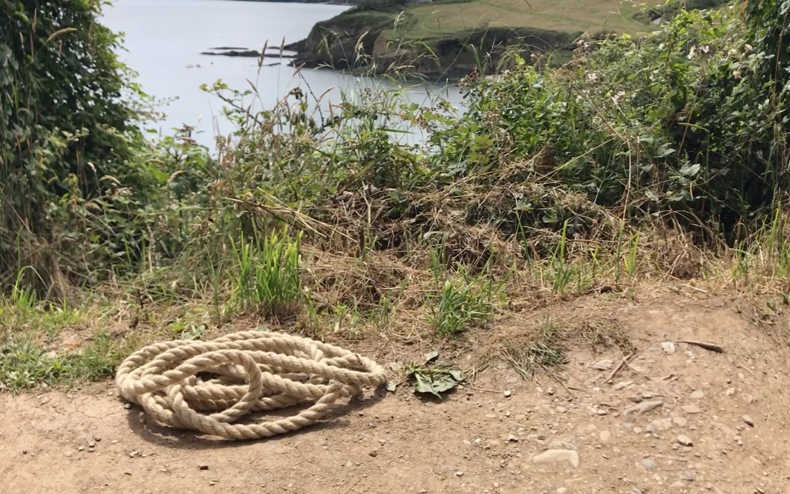
Fig. 4. But now I see my own death, everywhere.

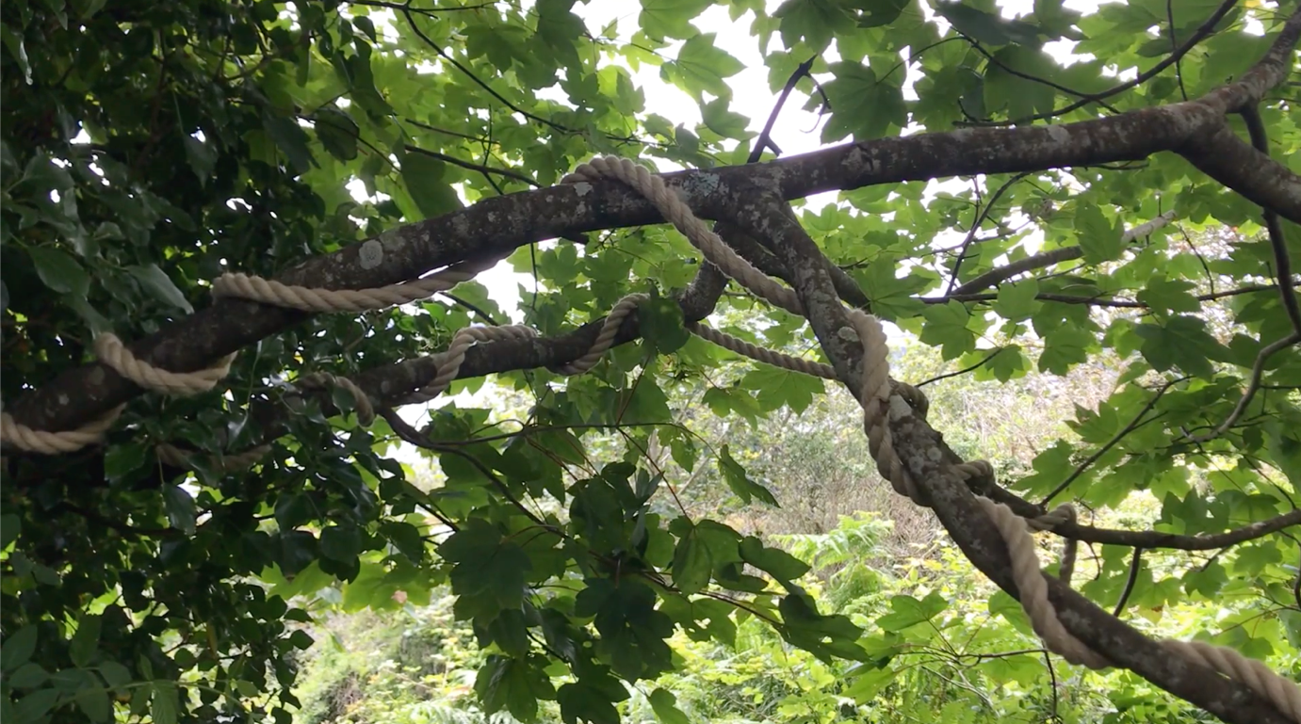
Fig. 5. It follows, like a serpent.

It is June 2020

My son has gone back to preschool, is learning how to play again, so I have moments of solitude. These are both necessary and horrific. I run and swim. I film. I begin to film my rope. It has become a kind of witness to this strange process. I write with it coiled around an arm. I watch Premiere Pro tutorials on YouTube, immerse myself in the processes. I stitch small pieces of time and space together to make something other, something made of fragments rescued from the flood, the fire. It is absorbing in a way that soothes the burning hole inside for seconds at a time. Then for whole minutes. Collecting, kaleidescoping these fragments unhooks me from the inexorable flow of time, the awful truth that with every moment I move further away from my life, away from love. Here, I feel pleasure, satisfaction. It is deeply unsettling.

The Kintsugi vase is a metaphor popular in what is known, fatuously, as ‘grief recovery’. It shows us the proud gold tracery intersecting the broken pieces: the vessel made whole again, different but itself – still useful, beautiful. It is a popular metaphor because it is formally entirely seductive: who would not want to think of themselves this way, emerging triumphantly better, more beautiful? But this image, the serene object on its pedestal in a silent room, smashed and reconstituted long before those we love were born and died, tells us nothing about process.

The aftermath of sudden death is more like this: someone hands you a bag of smashed pottery that used to be you, and leaves. Here, they say, as they walk off. I’m sorry. This is all that’s left. You blink at it. But there must be more, you think. It was all here a second ago. None of these things go together any more. And indeed, most of those things just don’t go together now. Mostly, you think, I have no idea what to do with these. And you don’t. For a very long time. For what feels like forever.

Editing bears, for me, a much closer relation to the experiential processing of grief because it requires me to learn to live in sympathy, over a long time, with the material reality that None of these things go together. I have no idea what to do with these. I sit with them for long enough, combine them in different ways, pick and unpick them, look at them in unanticipated juxtapositions, and eventually they do. I do the work, and slowly the film emerges, becomes itself.

For now, I am not a kintsugi vase. I am a bag of smashed pottery. There may or may not follow a painstaking assembly. Some fragments may be worth keeping. Many will not fit anywhere.

It is worth pointing out that I am not a filmmaker. I am an academic, an industrial historian, essentially. In my experience, which is of course partial, many academics have extrapolated a highly singular approach to knowledge and evidence as if it were the only way to examine the world, or to live in it. Many of us who end up in academia are good boys and girls from birth, needily dependent on external approval, on ‘getting it right’ for our self-worth, to the point of self-harm and self-hate. We pride ourselves on being problem-solvers, and we (often unconsciously) value our abilities to organise, observe, analyse, critique, examine and expound over our abilities to experience, feel, make, integrate, believe, and intuit.

Many of us congeal these things under a fragile shell of ego and pretend that they are a personality. We mythologise individualism and endurance, embracing the exploitation and frantic overwork that neoliberal university administrations impose upon us from above, because they align perfectly with our own masochistic desires to be good boys, good girls. Many of us extend these abusive and exploitative desires so thoroughly outwards from ourselves that they become prisons for our colleagues, our students, our loved ones.

We are successful. We are respected. We are shells of ourselves, open shells full to the brim with some kind of delicate liquid that will spill over at the slightest jolt.

The characteristics seen to define successful academics are often antithetical to a truly humanist approach to teaching, and to creativity. I have found that again and again, this year. As I yield with more compassion to my own pain and vulnerability, and become gentler with the vulnerabilities of others, I believe we all become stronger and more brave, creatively and intellectually. I tell my Dissertation students I am trying to write a piece (this piece) that takes me out of my industrial historian comfort zone. I do not show them completed work, or any writing.

Instead, I let them see my process of thinking. I let them see that I do not yet understand the language needed for this piece, or the structure. I don’t yet know my research questions. I don’t want to pretend that there is a single correct way to approach an intellectual enquiry, or to find your way through the woods. Every week they see me falter and stumble, and still persist. They begin to understand that where are you in this? is a real question, one of ethical, intellectual, and creative significance.

In this combination of making and teaching work is a paradox I have not been prepared for. I had, at an abstract level, understood that I am learning how to negotiate Eric’s death through film’s manipulation of space and time. But engaging in this process itself illuminates the way in which my life, my own story, is mediated by the conscious and unconscious manipulation of what I can only describe as my own narrative personhood. Maybe I am not a filmmaker is just another story I tell myself. Maybe film is making me. Maybe my teaching is teaching me.

It is a billion years since I was loved passionately, recklessly. It is a millisecond ago.

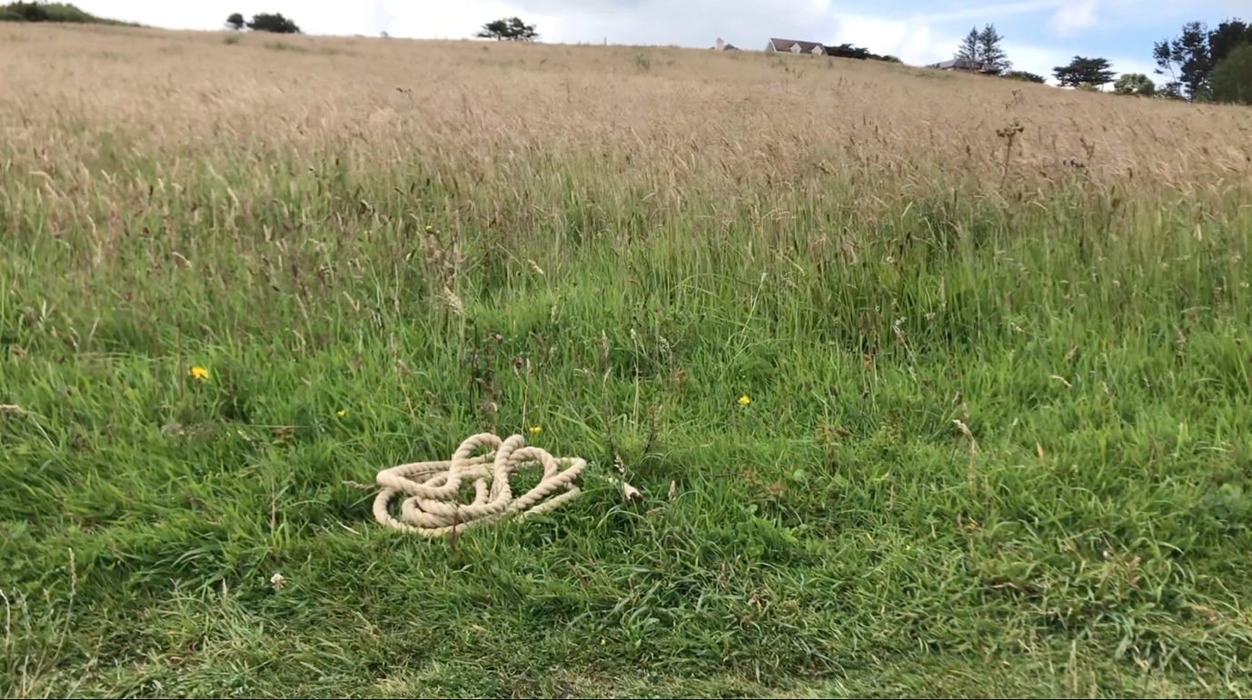
Fig. 6. For I have tried to live, and I have tried to die, and it seems neither will quite do.

It is July 2020

My colleague and friend Neil tells me that one of our graduates, Raf, has set up a small virtual event, The Future Solstice Film Festival, centred around a manifesto that strikes something in the ice around my heart.

Raf’s poster for the festival runs as follows: ‘The year is 2024. June twenty. The summer solstice beings at eight-fifty-one in the evening. No-one can explain what happens for the next few hours. Everyone experiences at least one thing they cannot explain. No-one forgets where they were that night. The night of the northern solstice, two thousand and twenty-four’.

I know for certain that I could not enter a ‘regular’ film festival – the idea that my fragments could have something deliberate and purposeful to say is still beyond me at this point – but I keep coming back to the idea of a film in response to this something I am living. A film is not a statement I am required to defend, but a tentative answer to a gently-posed question. It feels less terrifying.

As an atheist I lack the ability to resurrect Eric in any way other than this. I understand that he is dead and gone forever, for me, in a way that he is not for those who love him and are religious. I understand that he is dead and I will never see him again, and to write those words causes me profound and terrible pain. In film, it is immediately obvious to me, in a more than slightly crazed way, that I can bring him back. This is the only thing that matters to me: the only thing I want. I can descend into Hades. I can be Orpheus and Eurydice, both.

And so, I make a short, amateurish film, cobbled together of despairing or banal bits of mobile phone footage, with a few small interventions from myth. I make the song of my loss, the song of the deathbed mattress I cannot make myself give up, which becomes the song of the rope I carry with me in my bag and will not be parted from, which becomes the song of my small son playing on the beach. Becomes the song of the sun on the water, the bees in their flowers, the grass in the fields. Becomes a clip from my own viewpoint, with candles, flowers and seaglass ready to perform my solstice necromancy. Becomes the final clip of my own little family, restored for one single fleeing moment before it is obliterated again. My two beautiful boys, singing together, at Christmas.

The constant hum of pain that has become the defining sensation of my body becomes a reedy voiceover, filled with loss. This small film becomes my intervention in Eric’s death – in all the things I cannot show or adequately tell. In my failed chest compressions, in the engagement ring I have broken while ineffectually cracking his ribs, in my screams to my small, terrified child to stay in your room, don’t come out, in the hacking rhythm of the air ambulance overhead, in my terrible, inescapable, screaming guilt. Somehow, I must make all of this part of myself.

The film is done.

We watch the films together on Zoom. I make a chocolate cake. People seem to like what I have done and they give me a prize, Best Film. Perhaps it is kind of a sympathy vote, for the crazy woman with her thumb mostly over the phone’s lens. But there is honesty in it.
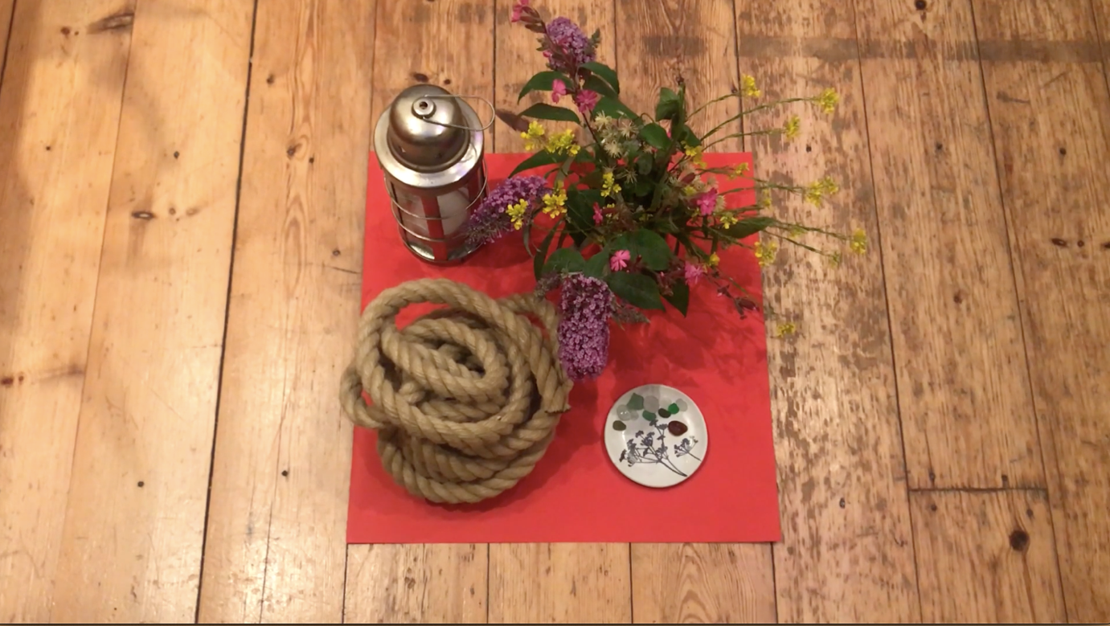
Fig. 7. You must return. My heart, like seaglass. My death, coiled. The pitiless bees. The empty flowers.
August 2021

I must write the truth as I know it right now: I cannot imagine ever being happy again.

This is a deeply shameful thing to write in a culture – and in a film culture – so focused on the happy ending, or at least the ‘meaningful’ one, and I am ashamed to write it. I could give you a fake happy or at least hopeful ending, in which I have embraced my liberation from the pressures of heteronormativity, found inspiration in independence (I have not: I am lonely, dry, unfucked and unfuckable, separate). I could give you a fake meaningful ending: I have found solace and comfort in creativity, redeemed my loss by taking a filmmaking path I would never have dreamed of without this tragic event (it is simply not true, I had been directing myself towards this path anyway). I keep trying to imagine happiness, or love, and when I do, the answer that comes from my body is this: these are things which belong to your past. You must look elsewhere.

I do not know why loss seems so impossible to us, so unlikely. I could blame capitalism, like I do for almost everything else: that we have internalised its logic, and have come to believe life is a process of continual increase, that if we obey the rules, we will be rewarded (and hang the others, look away from their pain: let us distract ourselves with cinema and imagine that the neatly-framed arc of death and redemption gives us a pattern for our own lives). I could blame our idealism, our innocence. But I do not think we should blame ourselves. Life is a story of continual loss, and the only way we have to counter this is to hold onto it lightly, and welcome new possibilities – for distraction, for meaning, for love – even as we shudder in terror and pain.

We live in a culture of narrativized toxic positivity, one that demands an ending now, a triumphant resolution now. Always now, the horror of the first act forgotten as we barrel towards the happy ever after, so many of our films betraying themselves as products of our fear of pain and death, our desire to look away, our fantasy of a life which can be resolved.

I can only give the advice I have given to dozens of students on reading their draft scripts. You cannot race towards the ending like this. The story has to unfold the way it has to unfold. I understand that mostly we want to look away from pain and death, on screen, in our own hearts. We want to hope that others’ bad fortune will not crawl towards us, a nameless, faceless stalking thing. It is the root of all cinematic horror. What if this were me? It is. At the same time, it is the root of cinematic pleasure. A man kisses the woman he has loved from afar, over nearly two decades, for the very first time on a rooftop in Paris. What if this were me? It is.

It is not enough, for me, that this happened, and that it is over. I cannot make meaning from his loss. I can make things: small, amateurish things that I cannot in good conscience call films, but which help to move the tightly packed ice around my heart. It does not melt, but the process of making, like the process of teaching – at its best the process of cultivating a great flow of ice-melt, warming people enough to bring forth their own creativity and courage into the world – can aggravate the occasional crack into being, through which sometimes some light can shine.

I watch Ratcatcher, Lynne Ramsay’s tale of grief and silence, and what stays with me is not Ryan’s death or his mother’s grief, but a moment just before James’s escape into the expansive freedom of a wheat field. He wanders through a half-built house on the new estate, a visible/invisible space filled with sheets of crackling, opaque plastic: almost functional, almost identifiable as a home. In one exhilarating camera pan across a featureless new-plastered wall, blank except for a light-switch, James appears first on the extreme right of our screen and then, suddenly, on our left. In this liminal place, unmoored from James’s normal life, time and space themselves have come unanchored.

In trauma-based grief, space and time shift in perplexing, unpredictable ways. Last night, as I went to pull back the covers on my bed – our bed, the bed he died in – they were piled in a manner that suggested for a moment a human leg. I felt a sick, thrilling shift in time: to all the moments when that shape was his shape. Those sudden jerks in time – to and from memories not experienced as shadows of the past, but as brutal or tender re-livings – feel cinematic to me. Or rather: cinema is at its most cinematic when, as tenderly or as brutally as it will, it pulls us into those ecstasies of feeling that come with the direct experience of a spacetime not our own.

Unlike in my own film-dream, I cannot sing my Orpheus home. I cannot give you the ending you want, and life cannot reverse death, or redeem it. The task, then, becomes to examine what a life without happiness can be. I have no answers, but the best way to find them may be to pay close attention to the small details of the world, and to see where this brings me. The Cornish light, the laughter of my son, the embrace of the sea. Maybe some kind of happiness lurks in wait.

Things change. Things only ever change.

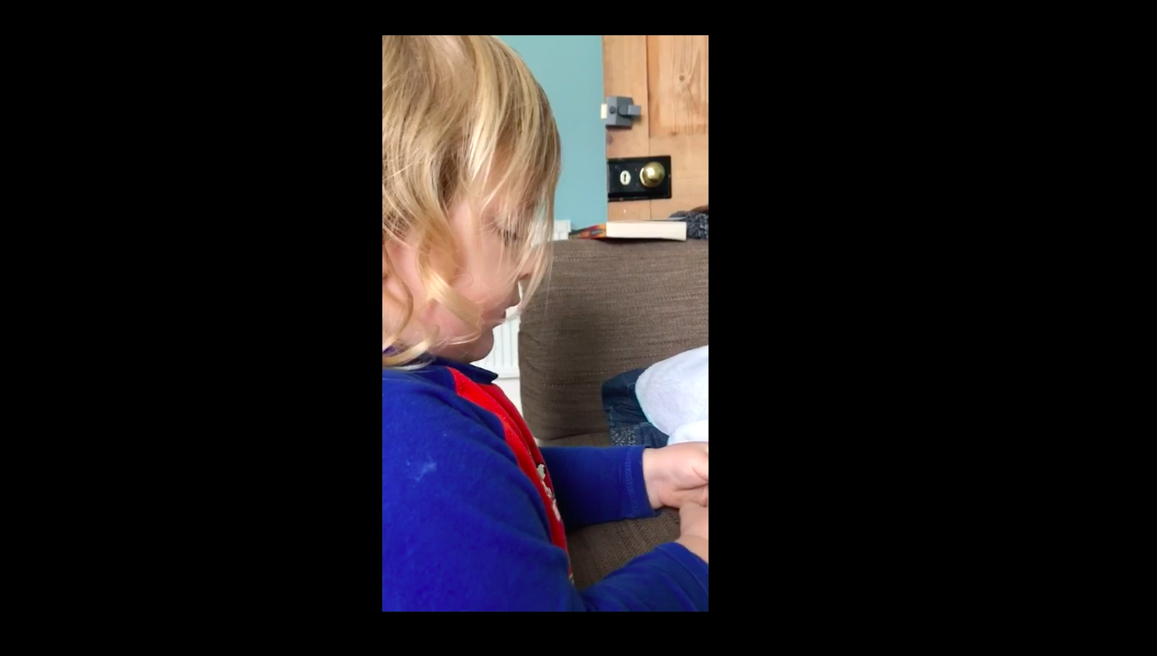
Fig. 8. They sing, together again.

It is now

My mother-in-law sent me a package which included a lily bulb. I kept meaning to take it out of its box, to dig some soil and carefully pot it. To nurture something living, which existed only for itself and had seen none of my pain. But I kept forgetting, occupied with keeping myself alive and my son happy. Eventually, months later, I opened the cardboard to find the lily bulb had sprouted small pure-white leaves like swords, which were leaning desperately towards the one small crack in the box. It had grown in the dark, despite me.

Each movement I make out of myself, into a world of images and creation, is a gesture at widening the boundaries of a life that I understand will never be like my life was – and which is filled with pain that cannot be removed – but which is still a life. I make things because it is part of the work I do to imagine myself as someone who might be able to survive this. I understand that the life I create for myself will always be as well as this grief, not instead of. It has its own gravity which will expand and contract, in proportion to the time of day or year, or a certain angle of light in the sky, and it is as much part of me as my love was. It is not going anywhere.

Some days I wake up and realise I am already crying. Some, I make it through the school run before the part of me that is performing normality falters, and I crack, and cry. Some days I get all the way to bedtime before the exhaustion of surviving another day without him overwhelms me. I have a lot to be grateful for – a beautiful son, a home, work I love – but these too are all as well as my grief, not instead of.

And yet.

I am helping people make films, students, and friends. I am making more things myself: fragments slowly emerging from shadow. These directions are, in many ways, terrifying to me. This piece, terrifying. When I proposed it, I saw myself writing something self-consciously clever, glacial, an intellectual mask to hide behind. But I don’t want ‘clever’ anymore. I want true.

Here is a truth: I had lived my whole life, till we were together, in an ever-hardening set of concentric fictions about myself. Competent, capable, powerful. Trapped. Terrified. He saw me, whole, and he loved me, wildly and utterly unreasonably, and that love is what broke me apart, made me embrace the hot and reckless spirit of vulnerability in which I am writing here, and am determined to carry with me. The terrible void he has left in me is a touchstone that is forever body-hot, forever open to failure and loss, and maybe, if I reach honestly and curiously for the places, people and experiences in which it may lie, joy. If I can let it in.

It is always

We were so happy. This was not supposed to be our ending. This piece was supposed to have much more in it about films, and a lot less about me. But just as the trauma has reshaped my brain – it took me almost a year to read a full paragraph without having to start again, or to write anything more taxing than an Instagram post – it has reshaped my relationship with film. I start watching a dozen films a week, but I make it through almost none. I had thought that it was (just) the effects of trauma on my attention span, but I think now that it is something different. I have simply had enough of endings. I do not trust them anymore. Let there be only beginnings now. As well as. Not instead of.

It is always Thursday. I have always been coming home from work, singing and kicking up the dust in the alleyway outside. It is always that hot Thursday evening, the sun running slantways on my frayed trenchcoat sleeves, my burning skin. I have always, that Thursday, been clicking send on the email to order my wedding dress, been meeting the florist to talk about naming our reception tables after the great gardens of Cornwall. I have always made us dinner. He has always asked me, that night, would you do it all again? And I have always said yes, yes, I would do it all again, because though each of us lost so much, we found each other and it was bliss, in a million ordinary and extraordinary ways. He has always been, and is always, and always will be kissing my hair and my eyes and saying goodnight. Let it never be Friday, never. Stay. It is always now.

He reaches for me through time. I reach back. He is gone.

Filmography

First Dates Hotel (TV series), Twenty Twenty for Channel 4 2017-.

I Vitelloni, Federico Fellini (Director), Cité Films/Peg-Films, 1953

Ratcatcher, Lynne Ramsay (Director), Pathé Pictures/BBC Films/Arts Council of England/Lazennec/Le Studio Canal+/Holy Cow Films, 1999.

Three Colours: Blue, Krzysztof Kieslowski (Director), MK2 Productions/CE Productions/France 3 Cinéma/CAB Productions/Torr Production, 1993.

The Future Solstice Film Festival manifesto is: i) ten minutes maximum ii) you must show the date 20/06/24 iii) you must show the time of 20:51 iv) you must recreate a shot from a film or show that you love v) you must use the story from the poster as a jumping-off point vi) you must include a red square in a shot vii) you must include these sounds: paper ripping, water running & someone humming. The sounds do not have to match the imagery.

