A Re-imagining of Measure for Measure by West Cornwall Women’s Aid.
Researcher Jane Pugh
Women writers from West Cornwall Women’s Aid engaged in writing workshops to respond to William Shakespeare’s Measure for Measure. The play has a male to female abusive relationship at its core. The women writers shared stories of their lived experiences of domestic abuse to generate text, props and costumes for the producing company, Moving Stories, and the producing theatre, The Minack Theatre. The intention was to combine real life experiences of today with this 400 year old play so that the participants and audience could examine the impact and consequences of abusive behaviour, then and now.

Contents
Project Details – Page Two
Supporting Statement – Page Three
Research Output – Page Four
Dissemination – Page Five
Contextual Evidence – Page Six
Acknowledgements – Page Seven

Project Details
TITLE:
A Reimagining of Measure for Measure by
West Cornwall Women’s Aid
Throughout 2023, the project was situated in several locations –
Research and development involving West Cornwall Women’s Aid, Moving Stories Theatre Company, The Minack Theatre and Researcher, Writer and Facilitator, Jane Pugh, began on Monday 9 January at The Minack Theatre, Porthcurno, Cornwall.
Six four-hour text analysis and writing workshops took place at West Cornwall Women’s Aid Centre, (11 Market Place, Penzance, TR18 2JB) between Sunday 26 February and Sunday 30 April. Contribution to the workshops were made by the Director and two key cast members via Zoom (London to Penzance).
The rehearsals ran for six weeks at Kentish Town Community Centre (17 Busby Place, London, NW5 2SP) from Monday 9 May to Friday 23 June. Contributions to the rehearsals were made by the writers via Zoom (Penzance to London) on Monday 19 June.
Measure for Measure was performed by Moving Hands Theatre Company at The Minack Theatre, Porthcurno (TR19 6JU) from Monday 3 July to Saturday 8 July.
Project Evaluation took place via Zoom with partners and women writers on Thursday 12 October, via Zoom.
The women writers, who originally formed a writing group when they first became clients of Women’s Aid, produced poems, prose and choruses which was incorporated into the original text of Measure for Measure. To achieve this, we utilized resources and materials. They were West Cornwall Women’s Aid meeting space to gather as a writing team and engage in the writing workshops. As the workshops unfolded, we used giant pieces of paper for sketching, idea gathering, scribbling and freely expressing. We used a white board for agendas and notes. We used notebooks for individual writing. We recorded minutes using a laptop. We used Zoom for communicating with London-based creatives. Jane Pugh used script writing software (Final Draft) to write up the additional material generated by the women. We had use of the Women’s Aid meeting space kitchen to make hot drinks and lunches to share.
Present at the writing workshops were Alison Tandy West Cornwall Women’s Aid Facilitator and Counsellor, Jane Pugh, Writer, Researcher, Facilitator and the six women writers, who must remain anonymous to meet their safeguarding needs. Via Zoom, the play’s director, Emma Gersch, and creative director, Kitty Randall attended. Via Zoom and email, we reported regularly to Zoe Kernow, show producer and director of The Minack Theatre.

300 Word Supporting Statement
The research context was a theatrical production of Shakespeare’s Measure for Measure with six emerging writers from West Cornwall Women’s Aid. The aim was to explore how new text can impact on an existing text to make a theatre production meaningful and accessible to diverse audience at a commercial theatre.
Within a post trauma recovery context, I conducted a series of exploratory writing workshops in response to the original text of Measure for Measure to generate poetry, prose and chorus for inclusion in the show. I recorded the women writers’ observations of the process and its impact on them within an appropriate forum which was discussive, sharing, safe and ethical.
Process and Development
Ideation – Women writers and survivors of domestic abuse contribute to a production of Measure for Measure within an ethical framework to enhance the production and benefit the women, creatively and morally.
Writing workshops to explore the original text and examine lived experiences to generate written material.
Editing additional material within the original text.
Rehearsals and rewrites with the participation of the women writers.
Performance of Measure for Measure at the Minack.
Evaluation of the objectives and experience.
It was critical to maintain a disciplined approach to the production’s objectives whilst managing difficult material that relates to traumatic lived experiences.
Outputs
Measure for Measure by Moving Stories Theatre Company at The Minack, 3rd to 8th July 2023.
Completed script including additional material.
Writing workshop structure and content.
Material written by the women from West Cornwall Women’s Aid.
Contribution to my field is a model of practice for working with vulnerable adults on a professional theatrical production.
Impact and Significance
My role was to research-by-doing through each stage of writing, editing and rehearsing. In addition we evaluated during the project and at its end.

Research Output
- Extracts from the script.
- Two examples of the writing workshops, content and delivery.
- Writing samples by the women writers from West Cornwall Women’s Aid.
- Images from the performances.
- Evaluation data.

Dissemination
The production of Measure for Measure at The Minack Theatre, Cornwall by Moving Stories Theatre Company from 3rd July to 8th July, 2023.
Short documentary produced by Moving Stories Theatre Company for online distribution as a record of the project.
Part of Moving Stories Theatre Company website under, Past Productions.
https://www.movingstories.org.uk/

Contextual Evidence
This is a progression from some traditional research methods within theatre productions of consulting those with lived experiences to collaborating with them.
It is an interaction between a commercial theatre venue and collaborative, participatory practitioners.
It is an examination of the juxtaposition between the value of talented writing without direct lived experience and the value of inexperienced writing with direct lived experience.
It is a modern contextualization of, in this case, women survivors of domestic abuse of being disbelieved in comparison with that of a fictional woman victim of an abusive relationship from four hundred years ago. She is asked rhetorically asked asked during the play, Who will believe you?

Acknowledgements
Zoe Kernow – Director, The Minack Theatre
Emma Gersch – Creative Director, Moving Stories and Director of Measure for Measure
Kitty Randall – Creative Director, Moving Stories
Faye Billing – Workshop Associate
Alison Tangye – Workshop Coordinator
Rene Crouch – West Cornwall Women’s Aid Writing Facilitator
West Cornwall Women’s Aid, Penzance Cornwall
The six women writers from West Cornwall Women’s Aid. For safeguarding reasons, remain anonymous.

A Reimagining of William Shakespeare’s Measure for Measure by Writers from West Cornwall Women’s Aid.

SAMPLE EVIDENCE OF THE PROJECT CONTENT AND DELIVERY

Contents

Play summary and Project Proposal; Pages 1 - 1

The Outcome; Pages 1 – 5.

The Process; Pages 6 – 7.

The Evaluation; Pages 8 -8

Jane Pugh 4 July 2024

Measure for Measure Summary
The Duke leaves Angelo in charge of Vienna, where he quickly condemns Claudio to death for immoral behaviour. Angelo offers to pardon Claudio if his sister, Isabella, sleeps with him. Isabella agrees but has Angelo's fiancé switch places with her. The Duke returns to spare Claudio, punish Angelo, and propose to Isabella. She doesn’t reply.
(Shakespeare’s Birthplace Trust, 2024)
Project Proposal Summary
We propose to run a community project for local women who have experienced being silenced or have fought to have their voices heard. At the end of Shakespeare’s ‘Measure for Measure’, Isabella is silenced, whilst others plan for her future. We want to imagine what she would say if she could. Through a series of supported creative writing workshops, we aim to work in partnership with local women’s charities and writers to develop a new piece of writing that will feature as the epilogue of our play. We are committed to making our play relevant, personal and to be able to represent voices that might otherwise go unheard.
As a preamble to the play, the Punks gather. Shakespeare used the word in Measure for Measure (written around 1603-04) where Lucio tries to explain Mariana’s cryptic denial that she is ‘... neither maid, widow, nor wife’ by declaring ‘She may be a Puncke’ (5.1.178). It’s not surprising that the word crops up in this play given its preoccupation with sexual morality and its setting in a debauched Vienna where whoring is big business. (Shakespeare in Ten Acts, Wilcox Zoe, the British Library, UK, 2016).
In our production, the Punks offer a politicized if unregulated counterculture to the stifling dogma of theocratic rule. It is the Punks as chorus who deliver the words written by the writers from West Cornwall Women’s Aid as the following three extracts show.
Extract One.
Prelude
The Punks enter, a dancing, noisy, riotous rabble.
PUNKS What do we want?! Freedom and autonomy. When do we want it? Now!
What do we want? Money and food and humour! When do we want it? Now!
What do we want? Colour and music and wine! Hey! We've got it, and how!! (Laughter)
They chant to throbbing rave music.
PUNKS (cont.) Right here in the present, the total chance to breathe in and out,
be myself and breathe.
Right here in the present, the total chance to breathe in and out, be myself, and breathe.
Extract Two.

Act Two, Scene Two
In this extract, the PUNKS are sad and angry at Claudio's fate and that of his fiancée and his unborn child. The new Duke, Angelo, has sentenced Claudio to death for having sex with his fiancée outside of marriage. Meanwhile, Angelo is closing the brothels and bars, threatening the Punks’ homes and livelihood.

PUNK Children and love against the law?
Claudio's fiancée deemed a whore.
The unborn child, what of its fate?
God is love, but man is hate.
Extract Three.
Act Two, Scene Two
In this scene, Angelo abuses Isabelle telling her that he will save her brother, Claudio, but only if she will have sexual intercourse with him. In response, Pompey (a Tapster) derides Angelo and in doing so comments that Angelo’s misuse of his status, power and wealth to sexually abuse a woman has happened before and will happen again, as emphasised with the use of present day vernacular.
POMPEY The suited,
Booted
Person on a Pedestal.
The Big,
Powerful
Great I Am.
The eloquent
Malevolent
Superman.
He rules Vienna
Leaves himself unchecked,
Sounds familiar?
I'll bet.
Extract Four
Epilogue
At the end of the play, Duke Vincentio, impressed at how Isabella has conducted herself (by his measures), offers to marry her. Significantly, William Shakespeare does not include her response and the play ends on a suspenseful note. During the writing workshops, the writers were asked, instead of accepting or not a marriage proposal, what they would choose, their responses were shared out between the characters at the end of the play.
ALL
I choose Strength
I choose Peace
I choose Joy
I choose Life
ISABELLA – I choose to speak
THE MEN
I choose Kindness
I choose Beauty
I choose Fairness
I choose Justice
I choose Light
ISABELLA I choose to be heard
THE WOMEN
I choose Agency
I choose Equality
I choose Adventure
WOMEN AS ONE VOICE
And we choose to be right.

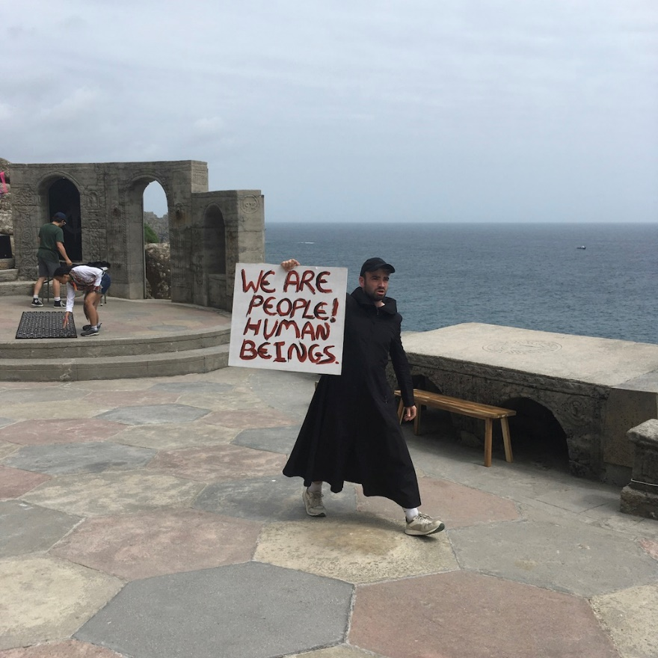
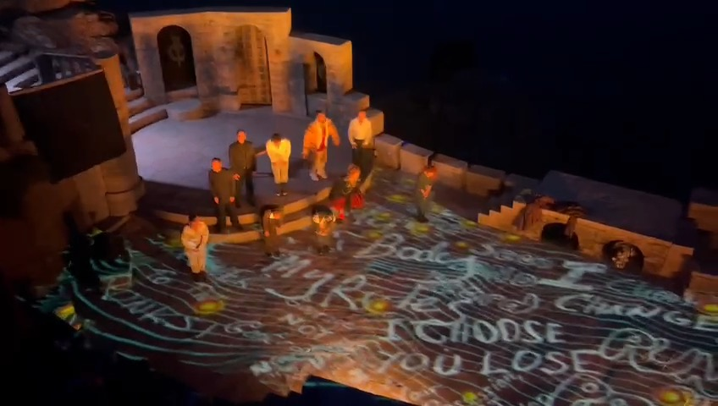
© Emma Gersch, June, 2023.
In the first picture, taken from the rehearsals, a Punk uses a placard to express his feelings towards Angelo’s closure of the brothels and bars.
In the second photograph, taken from one of the performances, the assembled characters recite the statements for the future, taken from the Prologue and statements written by the women writers are projected onto the stage floor.

The Writing Workshops
In pursuit of the theatre production outcomes, women writers from West Cornwall Women’s Aid participated in writing workshops. Below is a sample of the structure and content from one of the workshops. It includes two of the four writing exercises and our strategies for creating a safe space at the start of the workshop and preparing for departure at the end.
Measure for Measure Workshop Three Sunday 2 April 2023, 11.00-13.00
Jane Pugh

Resources – pens and paper, refreshments, rules of engagement.
Warm up exercises led by Faye
Information to share and discuss – Jane to lead, Faye to chip in!
- Retaining confidentiality.
- How about attending rehearsals on the Wednesday in July?
- Are there safe guarding issues around watching the show in the evening?
- What actions do we take to enable visits to The Minack Theatre?
10 mins
- Workshop recap – Jane to lead, Faye to contribute
- What do you remember from the last workshop? Our Fantasy Government Cabinet?
- Have you completed more writing in the intervening weeks?
- Any thoughts and ideas following from the last workshop?
10 mins

First Exercise
'I'
Jane shares the quote from the film 'I Am Daniel Blake.' (Loach, Ken, 2016, UK)
I am not a client, a customer, nor a service user. I am not a shirker, a scrounger, a beggar nor a thief. I am not a national insurance number, nor a blip on a screen. I paid my dues, never a penny short, and was proud to do so. I don’t tug the forelock but look my neighbour in the eye. I don’t accept or seek charity. My name is Daniel Blake, I am a man, not a dog. As such I demand my rights. I demand you treat me with respect. I, Daniel Blake, am a citizen, nothing more, nothing less. Thank you.”
Let’s read the quote, share responses, share memories that the quote evokes and in your own words, write your version of the letter.
Here are some writing prompts which might be useful -
I Am
I Will
I Can
I Do
I Dare
I Dream
Write in first person, present tense. Approach it as a monologue.
20 mins to write.
15 mins to share.

Second Writing Exercise –
Examine Isabella's quote,
But proud man Drest in a little brief authority,
Most ignorant of what he’s most assur’d;
His glassy essence, like an angry ape,
Plays such fantastic tricks before high heaven,
As make the angels weep....'
We’ll read and interpret then, have a go at the speech in your voice.
Share one or two.
30 mins
Grounding and regrouping
- Thoughts on today's workshop.
- What are we doing for the rest of the day? Share our plans.
- Ideas for our next workshop.

Evaluation
Below, two examples of participant feedback which were part of the evaluation of the entire project.

FEEDBACK COMMENTS ON WORKSHOP TWO –
‘I have learnt so much in today's session. Always inspiring and motivating. A privilege to be included. Thank you. ANON
'Felt really energized and inspired today by everyone's amazing and informed contributions. Thank you all.' ANON
'Thanks to everyone for the positive energy, I really enjoyed the session.' ANON
'Thank you for the magic, my mind feels so enlightened, every session is full of magic.' ANON.
FEEDBACK COMMENTS ON WORKSHOP THREE
'I'm sustaining a severe amount of stress currently. I'm not sleeping and finding refuge lie incredibly challenging. Physically and psychologically, it was difficult for me to even get to today's session but it was so worth it. This session has allowed me to tap into an otherwise dormant creativity and the benefits cannot be overstated. ANON.
So amazing. Sessions with different positivity feelings. Thank you all. ANON.
Really wonderful to feel so inspired by the group's writing and willingness to share. Really felt warm and moved by today's truths. Alison Tangi Co-ordinator from West Penwith Women’s Aid.

(End).

