The CACHE Lectures

Changing Behaviour for Good
My name is Lucy Cokes and I teach on the Creative Advertising courses at Falmouth University. I lead the Behaviour Change for Good modules where the students learn to use behavioural economics and their creative ideas to change people’s behaviour for the good of their health, wealth or happiness.
I love the idea of being able to use advertising, marketing and psychology in a way that will change people’s behaviour to improve their lives and the environment. This piece will give you a taster for some of things to consider when making behaviour change campaigns.
To kick things off we’re getting pretty personal straight away and considering men's toilet habits!
Some of you may have noticed that men are not always that good at aiming and it can get a little bit smelly in men's toilets.
Not aiming properly at home is bad enough, but in public toilets it can be pretty catastrophic!
Some-one has tried to solve this issue using a simple solution.
All the urinals in this picture have a fly sticker, and the fly is always in the same position, just above the urinal drain and off to the left. Men can’t resist peeing on things, especially if they look as though they might wash away.
So, the addition of a fly sticker to urinals is a simple inexpensive way of reducing cleaning costs and improving the smell. The urinal fly was introduced into Schiphol Airport in the Netherlands in the early 1990s. This is an example of a Nudge…a Nudge is something simple and inexpensive to Nudge or change people’s behaviour.
In this piece I will be:
- firstly, outlining what a behaviour is, and what a behaviour is not and the concept around behaviour change.
- secondly outlining what a nudge is and provide a brief history of nudging.
- finally, I will introduce you to the Behavioural Insights Team and their EAST framework, which is used to help come up with ideas to change behaviour.

What is a behaviour?
A behaviour is a physical interaction or an action that you can observe happening. It is not a thought, a feeling, an attitude or a belief.
Behaviors can be in part caused by people’s attitudes or beliefs, but most often it is simply do to with the situation or the environment in which we find ourselves. Most of our decisions are made automatically so people adopt the behaviour that is the easiest, or the habit they have formed already.
For example, the behaviour of keeping a mobile phone in your hand or pocket while walking down the street is one of the many reasons mobile phones are stolen. This behaviour has several causes, one of which being a lack of awareness of mobile phone crime. If you tried to change this habit by just increasing awareness of crime, it would probably not be that effective.
Education and understanding can help change people’s behaviour, but they are not that effective on their own.

What is a Nudge?
We can help make it easier for people to make changes to their behaviour that will be better for their health, wealth, happiness or better for the environment by changing things around them. We are often subtly Nudged without us being aware of it.
To count as a Nudge, the intervention must be easy and cheap. Nudges are not mandates, such as making a certain behaviour illegal. Putting fruit at eye level in a shop, counts as a Nudge. Banning all junk food does not, as you no longer have a choice.
In the 1910’s and 1920’s the number of cars on the road in the UK increased ten-fold. In 1921 there was a spate of accidents on this corner on a road in Sutton Coldfield outside Birmingham.
Many accidents were caused here by fast cars cutting the corner, so someone had the idea to paint a white line in the center of the road. It worked. Within a few years white lines were being painted on roads all over the country.
Believe it or not this is an example of a Nudge. It is simple, cheap, and it works to change people’s behaviour, without taking away their choices.
The Behavioural Insights Team – also known as the ‘Nudge Unit’ – is a social purpose company set up in 2010. They have been pivotal in establishing the credibility and importance of behavioural science within the government, as well as in the private and voluntary sectors to help change people’s behaviour.
They have been responsible for improving organ donation rates, reducing tax fraud and raising money for charitable causes. They were also responsible for leading all the government campaigns to change people’s behaviour during the Coronavirus pandemic.

The EAST framework
The Behavioural Insights Team came up with their own framework to provides four simple ways to apply behavioural insights to change people’s behaviour.
They believe that if you want to encourage a behaviour you should make it Easy, Attractive, Social and Timely (EAST). These four simple principles for applying behavioural insights are based on the Behavioural Insights Team’s own work and the wider academic behavioural science literature.
I will be explaining each of the four elements of the EAST framework and providing one example of each part being used.
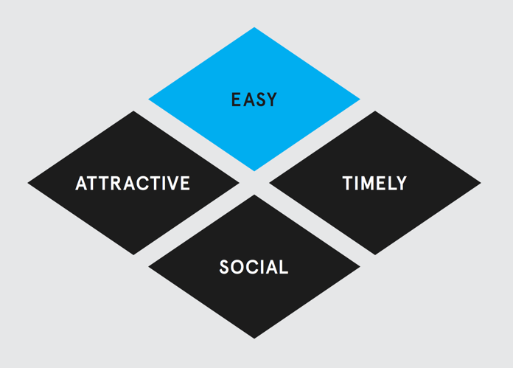
When coming up with behavioural change ideas, the idea is most likely to work if all four elements of the EAST frame can be used.

EASY
The first principle from the EAST framework is about making it Easy.
There are three main ways we can try and make it Easy for people to adopt the behaviour we want them to. These are:
1. Using defaults. We have a strong tendency to go with the default or pre-set option, since it is easy to do so. Making an option the default makes it more likely to be adopted.
2. Reduce the ‘hassle factor’ of doing something. The effort required to perform an action often puts people off. Reducing the effort required can increase uptake or response rates.
3. Simplify messages. Making the message clear often results in a significant increase in response rates to communications. In particular, it’s useful to identify how a complex goal can be broken down into simpler, easier actions.

EASY example
In order to increase organ donation rates in the UK, the nudge unit recommended that the default be changed. It used to be that people had to opt-in to donating their organs, but in 2020 the default was changed, so organs will automatically be donated when someone dies, unless of course they choose to opt out. As a result of this change, the number of people donating their organs has increased from just 40% to over 95%. So far less than 5% of the population has chosen to opt out.

ATTRACTIVE
The second principle of the EAST framework are to do with making the new behaviour Attractive.
There are two main ways we can try and make it Attractive for people to adopt the behaviour we want them to. These are:
- Firstly: Attracting attention. We are more likely to do something that our attention is drawn towards. Ways of doing this include the use of images, use of colour or personalisation of a message.
- And secondly: Designing rewards and sanctions for maximum effect. Financial incentives or fines are often highly effective. Other incentive designs such as being entered into a lottery often works really well and costs less.
A well-known successful behaviour change for good is when a charge for plastic bags was introduced by the UK government. As a result of this ‘sanction’ people hardly use plastic bags anymore, as they do not want to loose their hard earnt 10 pence.

ATTRACTIVE example
A way of encouraging people to do something, is by making your desired behaviour seem more attractive by making it appear scarce…
One experiment tested the power of limiting the number of soup cans that could be bought per person.
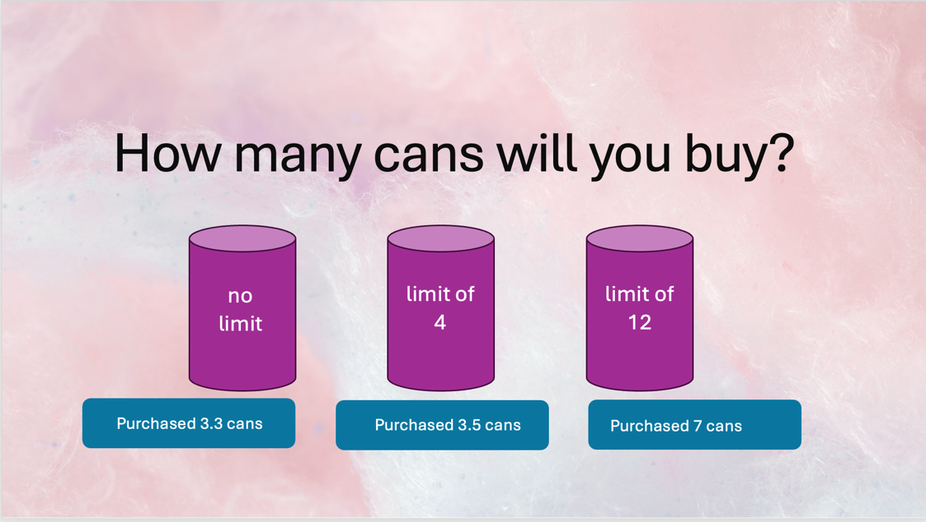
When a limit was set on the number of cans people could buy, the number of cans customers purchased went up significantly. This is because if something is in scarce supply it makes us want it more.
This could be seen happening during lockdown with toilet paper and most annoying for me with Barista Oatley where the supermarkets were limiting how many you could buy – this could have actually been making the problem worse as everyone bought the maximum amount they were allowed.

SOCIAL
The third principle of the EAST framework are to do with making it Social.
There are three main ways we can try and make it Social for people to adopt the behaviour we want them to. These are:
- Firstly, show that most people perform the desired behaviour. Describing what most people do in a particular situation encourages others to do the same. Show people what you want them to do, don’t highlight where people are doing the opposite. We often adopt behaviours that we see other doing, without question.
- Secondly, use the power of social networks. We are embedded in a network of social relationships, and those we encounter shape our actions. Who the request comes from is very important…should it come from an authority figure or someone who is a friend?
- Finally encourage people to make a commitment to others. We often use commitment devices to voluntarily ‘lock ourselves’ into doing something in advance, for example joining weight watchers to help us lose weight. The social nature of these commitments is often crucial, so the more people we tell about our intention to do something the more likely it is to happen.

SOCIAL example
We like to think we care about the environment, but it turns out we are more easily influenced by what others are doing.
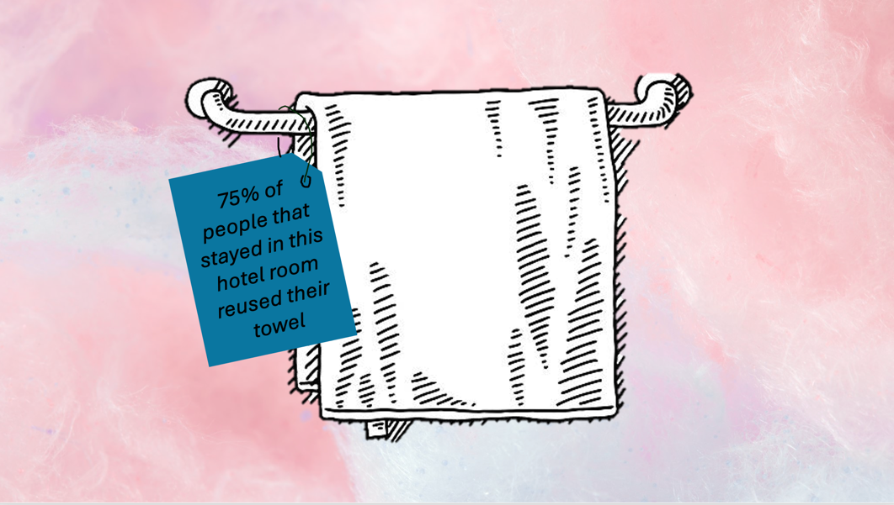
For example, a hotel wanted people to reuse their towels during a hotel stay and told them to do it to save their environment, but few people did this. The hotel then changed the messaging to say ‘75% of people who stayed at this hotel reused their towels at least once during their stay’.
The description of ‘normal behaviour’ outperformed the environmental message in effectiveness. However, when people were casually asked which message they believed would change their behaviour, they prioritised the environmental one over the normal behaviour one. This highlights that for a large part of our decision making we’re quite blind to what is actually influencing it.

TIMELY
The fourth principles of the EAST framework are to do with making it Timely.
There are three main ways we can try and make it Timely so people to adopt the behaviour we want them to. These are:
- Firstly to prompt when they are likely to be most receptive. Behaviour is generally easier to change when habits are already disrupted, such as around major life events.
- Secondly, consider the immediate costs and benefits. We are more influenced by costs and benefits that take effect immediately than those delivered later.
- Finally, help people plan their response to events. There is a substantial gap between people’s intentions and actual behaviour, so can help people make a specific plan to address them.
Unfortunately having a message about the health impacts of smoking on the packing for people to see when they are choosing to smoke a cigarette doesn’t make much difference to smoking rates. This is because of two bias’:
- present bias, which means that this negative impact is not being seen right now, it is a possibility in the future, so it won’t change behaviour.
- over-confidence bias, where people don’t believe, bad things will happen to them.
So when you are devising sanctions or benefits they need to be immediate.

TIMELY example
People are for more likely to complete a task if they already feel a sense of progress. The closer we get to reaching a goal, the more motivated we become to complete it.
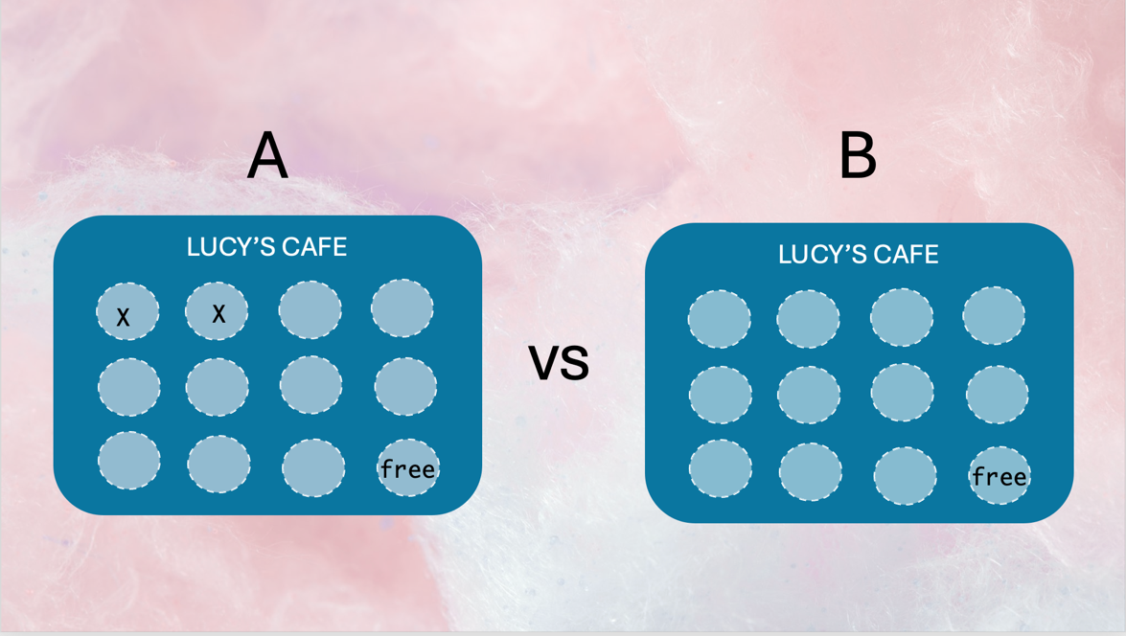
If two types of loyalty cards A & B were given out at Lucy’s café where customers received a stamp for every coffee they bought, you would see a big difference in how quickly people complete their cards.
Both cards reward customers with a free coffee once they had obtained nine stamps, but customers who received card A completed it on average five days earlier than those who received card B. This is because the first loyalty card gives people the illusion of a head start. So perhaps you could come up with an idea to encourage a behaviour by giving people the illusion of a head start?

SUMMARY
We have now looked at all four elements of the EAST Framework. Making it Easy, Attractive, Social and Timely means that people are more likely to be able to adopt a new behaviour. It is not straightforward to change people’s behaviours, as most of what we do is automatic, and we make decisions about what to do next quickly. Simply educating people about the fact that a particular behaviour is bad for them, or the environment is not enough to make people actually change their behaviour. Often you will need to change the environment or provide a Nudge where and when the behaviour is happening to make it simple for people to do something different.
So in this piece I have introduced the concept of nudges and given you some examples of ways that you can use the EAST framework to come up with ideas to try and change people’s behaviours.
Even something as simple as painting a line in the middle of the road will make most people adopt a safer driving style.

