THIS LAND
Contents

INTRODUCTION 3
ANN LYNHAM: Brandy Row, Illustrating a Family History 12
STEPHEN YATES: Brandy Row, Research as Practice 21
JACQUIE KELLY: “Portland laws give a married woman rights she doesn’t get in other places, I’ve heard”: Women landowners of the strip fields on Portland in the mid-nineteenth century 32
JESS CHAMBERS: Prison Farming and Portland Bill 35
CATHERINE BENNETT: Commoning the Commons 37
STUART MORRIS: Interview 22 August 2022 41
SARA CREW: The Community on the Bill 48
PENNY PIDDOCK: Portland’s Beach Hut Community 52
ANDREW HARVEY: Court Leet of the Island and Royal Manor of Portland 60
SCOTT IRVINE: Our (once) Enchanted Landscape 64
STEVE CHRISTMAS: Sago, “A Curious Industry” 71
MARK SAMSWORTH: The Last Landscape/Some Birds in the Landscape. 75
MARK SAMSWORTH: Some notes on Portland Sheep 76

THIS LAND

INTRODUCTION

This report has been compiled from research carried out by a small and dedicated group of people who really care about the people and places of Portland.
This report is not intended to be comprehensive - it is not a complete or chronological history of either place. Instead, it uncovers histories and ecologies of Brandy Row and the Bill that are not well known, and in some cases, entirely new. These hidden histories give a fascinating insight into Portland’s history, beyond the things for which it is well-known, like quarrying, the prison, and the military. These histories often take a different view of Portland’s history, focusing particularly on the details of places that would otherwise be overlooked.
The researchers use oral histories, archive documents, old photographs, drawing, and making to produce their stories. They have brought their existing skills and knowledge to the project, as well as learning new ones. Researchers have taken unique approaches to looking at the history of Portland’s landscape, that bring to light particular memories or experiences that are common to others in the community, things that are perhaps personal, that have a much greater significance in terms of loss of habitat, or the impact of gentrification on communities.

It is perhaps not very well known that women on Portland had more rights than their sisters on the mainland. Jacquie Kelly describes how women were allowed to own their own property, and how land ownership gave women on Portland more power than women in England, whose property, if they were able to own any, automatically belonged to their husband on marriage.
Jess Chambers discusses the history of the Prison Farm on Portland. An original piece of research that uses previously unstudied sources, Jess’s work gives an insight into the history of prison farming using the governor’s diary dating from the 1980s.
Stephen Yate’s research through practice started with a collaboration with Ann Lynham, one of the other researchers. Using some of the experimental sketches Ann created to research Brandy Row, Stephen produced a series of research-based and artworks that explore the history of the building, and through this work, the impact of climate change on Portland. Ann Lynham’s compelling research tells the story of her own family, who lived in Brandy Row in the early part of the twentieth century. It reveals what life was like in ‘Entry’, living in the dwellings behind the Brandy Row cottage that were eventually demolished in the slum clearances of the 1930s.
Catherine Bennett’s exploration of the commons are is essential reading to understand exactly what common land is and how that relates to Portland’s communities and its visitors. The interview with Stuart Morris reveals his complex work over thirty years to preserve the rights of Portlanders and visitors to access its common land and rights of way, and his passion for the landscape.
Penny Piddock’s extensive oral histories explore the history of the Bill’s beach huts, and with it, its landscape and ecologies. Interviews with other beach hut owners reveal their unique character, as well as the changes in the Bill’s natural environment and species loss over the last half-century.
More oral histories from the residents of the Bill, collected by Sara Crew, give insights into what it is like to live in such an unusual environment. Local residents describe life in a place with a “millionaires’s view for ordinary people”.
The story of sago is told by Steve Christmas, showing the importance of this plant to the economy of Portland, and its use as a starch in this ‘curious industry’.
Also by Steve, research on Portland’s Lepidoptera gives a comparison between data from 150 years ago. This demonstrates the loss of butterflies on Portland, and how the conservation and preservation of Portland’s calcareous grasslands can reverse those losses.
Scott Irvine recounts the history of Portland’s royal ownership, agriculture, quarrying and archaeology, and the history of the folklore that dwells within the landscape.
Mark Samsworth writes about the birds of Portland, like the chough and stonechat, and also explores the history of Portland’s sheep.

Brandy Row: Smuggler’s Cottage
The house at Brandy Row dates from the early part of the seventeenth century, around the time of the reign of Charles I. Its dilapidated appearance belies its rich history. The house is not listed, but is situated in the Portland (Underhill) Conservation Area has been designated as an ‘important local building’. The conservation report by Senior Conservation Officer Dr James Weir for Dorset Council states that ‘the arched passage doorway and lintel chamfers are certainly consistent with an early- to mid-17th-century date’. James Barker, an architect who is an expert on the history of local architecture, and also works for Portland Buildings Preservation Trust, has also identified elements of the building as being in a local Portland vernacular seen in other buildings on the island that can be dated to this period. The dwellings attached to the north side of the cottage were falling into disrepair by the late nineteenth century and had been demolished by 1900. This means that, despite the extensive alterations to the building, it remains of high local significance.
According to Weir, the elements of the building that are original are ‘the general footprint of the cottage; the position of the original front door and adjacent window; and the front and rear entrances (both with depressed four-centred arch heads) to the passageway through to the rear yard, from which the adjoining cottage (now demolished) was accessed (the doorway with chamfered-and-stopped lintel survives); and possibly parts of 19th century (at least) store buildings to the rear.’
Significantly, it was only through the process of this research that we discovered that there had been buildings to the rear, not for storage, but dwellings.

The occupants of Brandy Row over the period of the nineteenth century vary. In the 1841census, Master Mariner William Gibbs is listed as the head of the household, followed by his wife Elizabeth and young daughters. In the census of 1851, Elizabeth is listed as a dressmaker, and both his daughters as lacemakers. Lacemaking was a specialist skill that enabled women to earn relatively good money. Their work, completed at home, would have been collected by a merchant and sold on in the textile trade. Further research revealed
that in the census of 1851, there were four lacemakers living only a few doors apart.
Mary and Susan Gibbs were sisters aged 19 and 17, and were both listed as lacemakers, and lived in Smugglers Cottage. Just a few doors down, cousins Elizabeth Pearce and Sarah Way are also listed as lacemakers. Further investigation of the census data reveals that in 1851, no fewer than 50 women were lacemakers on Portland. It is not clear where they learned their trade.
Evidence for lacemaking in Portland dates back to the late seventeenth century, with archive documents detailing apprenticeships to lacemakers. Lacemaking is a highly skilled specialist craft, and would have brought in much needed income to working class families. With this many women producing lace in Portland, it was clearly also important to the local economy. Women would have worked at home, usually producing lace for a merchant or company who would sell their products on. However, the numbers of lacemakers in the 1861 census shows a decline in the number of women earning a living from the craft. By this time, machines for making lace had been around for over fifty years, and making lace by hand was no longer competitive.

One of the issues we initially encountered with the research on Brandy Row is that it was difficult to identify the building for certain on old maps and census documents. Houses were not numbered until much later, and although the census taker would visit each house in a particular order, the direction walked might vary considerably from census to census, so it is not easy to be sure that a census entry relates to a specific property. Ann Lynham’s work on the project, using the tithe map of 1840, combined with wills and church deeds of gift (a form of conveyance witnessed by a minister of the church), and ordinance survey maps, has allowed us to more specifically identify the cottage as it appears on documents over the years.
The wills and deeds of gift should have a special mention, as they locate the property to which they refer in relation to those around it. They rely on the reader knowing where other properties are located, with a property lying north of this person’s property, west of another person’s house, east of another’s, and so on, which may have been clear at the time it was written, but has required a great deal of detective work to locate in the present.
After the great storm of 1824, when 80 properties in Chiswell were damaged or destroyed, and 26 residents killed, many properties were abandoned and left to rot. Inheritance law meant that property was shared equally between sons or daughters. This often meant that no one person was responsible for the cost of repairs, and houses fell into disrepair.
Ann Lynham asks an important question: “If the cottages at Brandy Row were possibly built in the 17th Century what prompted the building of the cottages for workers to live in?”
She goes on to write:

We can establish from various documents that there were feudal landowners in relation to the Island and these freeholders/tenants paid duty to the Crown Agent through the Court Leet, and presumably one of these tenants wanted secure housing, as any wooden buildings would be demolished with any flooding. The tenant was allowed to carry away his own stone and any overburden would have been available and would only pay the Crown if the stone was being sent away and they had to apply for this to happen, to the H.M. Surveyor General. In addition, all free tenants had a right to quarry on common land provided they did not damage the public highways and the duty was paid per tonne. Accounts put the duty at 12d per ton of which 6d went to the tenants, 3d to the Crown and 3d to the Islanders (the Stone Fund).
One plausible reason for investing in sturdy homes in Chiswell is the first rebuilding of St Pauls in London, the original St Pauls had been built by the Normans and the later choir which was Gothic, had been added in the 13th century and had a tall central tower and tapering spire. During the reign of Elizabeth I (1558-1603) the timber spire was struck by lightening and crashed through the roof, the roof was repaired but no spire replaced. James I appointed a Royal Commission to look at the rebuilding of St Pauls but it took Inigo Jones during the reign of Charles I (1625-1649) before any work was started. Jones had used Portland stone when building the Banqueting Hall in 1619, together with Oxfordshire and Northampton stone and had selected Portland stone when rebuilding St Pauls. The first stones were laid in April 1633 and this rebuilding carried on until the Civil War brought any further building to an end – in fact, the church that stood there at the time was robbed and left in ruins.
In the spring of 1663, a new Royal Commission was drawn up to recover such of the Cathedral’s property as had been disposed of during the common wealth, however in 1665 the Bubonic Plague swept through the country, so it was 1666 before Wren, who had been involved in an effort to rebuild in 1661, was commissioned to rebuild St Pauls again, and had his proposal accepted 27 August 1666. Then came the great fire of London and all work stopped, so it was November 1673 before the work on what we recognise as being St Pauls Cathedral began. Like Jones before him, Wren selected Portland stone as not only was the stone the most suitable for various reasons of building, but as the Portland Quarries were also on Crown Land they were accessible by sea and as Wren had been appointed HM Surveyor General he only had to give himself permission. Stone used for Royal works was exempt from tonnage duty and the quarries on the East side of the Island had access to piers and onward journeys to London and the Thames. All piers, tracks and cranes had been kept in good order during quarrying for Inigo Jones but during the civil war, there was no overseer so when Wren began making arrangements for stone to be shipped for the new cathedral, he found all the roads and equipment in need of repair before he could depend upon a steady supply of stone. Accounts put the number of Islanders at about 700 at this time and most would have been employed as “stone cutters”.

Ann’s account gives a convincing account of the evidence for the increase in building of permanent dwellings on Brandy Row, in response to an increase in sustained demand for Portland stone for the building of new and significant buildings in London, including St Pauls.

Another Portlander, interviewed by Penny about the Bill’s community of ‘Hutters’, affectionately describes her family links to Brandy Row:

“The Brandy Row family connection? ‘Cause I was so pleased to hear somebody saying about Brandy Row. My father was born and in Brandy Row, and he used to tell us stories of when he was young of the sea coming over and somebody knocking the doors. They came downstairs and the cat and the dog would be sat floating around the kitchen. And uh, it amused me to think of that.
And then I said, that must have been awful ‘cause all your furniture and your carpets and everything. My father said, what carpets? It was stone floors. Then nobody had carpets, very little furniture because he would be, 99 now if he was still alive. He moved out when he was about ten and they moved to Wyke and they have the house next to the, what was the pub in Wyke and they were there until my grandmother died.”

This story is indicative of the importance of Brandy Row to local people, and to Portland’s stories. The house on Brandy Row is not just a derelict building, it is a container for histories that make up the identity of Portland and Portlanders. We have barely scratched the surface, and there are many more stories to be uncovered, but here we have some of the fragments of narratives that reveal much about what and who Portland was, is, and will be. Past, present and future Portland dwells in Smugglers’ Cottage, and our report begins to unravel the many threads of stories that connect people and place in Brandy Row.

The Last Landscape
The other site our researchers explored was the landscape from below Southwell to the Bill. The forms that the research took here differed from the research for Brandy Row. The stories of the landscape are from living memory, spanning the latter half of the twentieth century to the present day. The landscape of the Bill is a contested space. Conflicts exist between the needs and desires of different parts of the community around land use, from quarrying to conservation, and there are different ideas of what a sustainable future might be.
The history of the Bill’s landscape reveals Portland’s unique history in other ways. Women’s historic right to inherit land and property is demonstrated by Jacquie Kelly’s essay. This meant that women on Portland had rights far exceeding those of women on the mainland, and suggests that they were able to participate in, and influence life on the Island, as indicated in the number of women appointed as Reeve of the Court Leet.
The Commons Registration Act 1965 was introduced by the government for the registration of commons and town or village greens and ownership of and rights over them. The Act’s introduction led to much common land and rights of access to that land being lost. Despite having a full time job as a civil engineer and a busy young family, Stuart Morris recognised the risk of Portland’s common land being lost, and embarked on a ‘late night hobby’ that would go on to keep him busy for the next thirty years. Issues around public access to land, like the right to roam, as well as the protection of important ecological heritage for future generations, have been recently been brought into mainstream conversations. That these issues are still so relevant in the present highlight the importance of the work Stuart began in the mid-1960s.
‘I knew there was a lot of common land in Portland traditionally, and I then delved into it’. Stuart’s research skills, that would later make him well-known as a historian of Portland, were key to discovering the history of Portland’s common lands, that would provide important evidence for an inquiry in the mid-1970s that decided which land in Portland was common land. ‘The more I looked into it the more interested I got. The thing that surprised me was that nobody else seemed interested in doing the registration.’ Despite Portland’s active Court Leet and its links to the Crown, who owned most of the common land on Portland, no one was taking action to register these spaces and places under the Act, so Stuart decided to take on the challenge himself. Building on his interest in local history and the local environment, ‘it didn’t take much investigation to find out that a lot had been written about Portland’s commons, and a lot of maps and document that showed where Portland’s commons were’. Decades before the advent of the internet would make this kind of research easier, Stuart’s painstaking gathering of evidence was vital to the enquiry that ensured the registration of the common land that remains accessible to Portlanders today. It is only through Stuart’s historic research into Portland’s common lands, and his quiet activism, that we know where these spaces are, without which Portlander’s rights to their own land would have been quietly and gradually eroded. Even so, there are areas of Portland that were historically common land that were lost as Stuart was not able to provide evidence at the time, or because he faced strong objections from land owners. According to Stuart, the issue of access to common land is ‘as important now as it ever was’.
It is thanks to Stuart’s dedication and research that common land in Portland remains accessible and open to Portlanders and its visitors. However, these rights are hard won and easily lost through complacency and lack of action, there is much work still to be done.
The Commons Registration Act 1965 encouraged anyone with an interest in common land, town or village greens to register their rights in order to safeguard them. Owners or boundaries of common land were often not clear, and the act aimed to establish where land existed with rights of common. Failure to register common land under the act meant that these rights would be lost. Anyone who possessed rights of common could register them.
Common Land is privately owned land with ‘Rights of Common’ over that land, most commonly to graze animals. First enshrined in law in the Magna Carta in 1215, Common Land traditionally sustained the poorest people in rural communities who owned no land of their own, providing them with a source of wood, bracken for bedding and pasture for livestock. Over one-third of England’s moorland is common land. At one time nearly half of the land in Britain was Common Land, but from the C16th onwards the gentry excluded Commoners from land which could be ‘improved’ through agriculture. That is why most Common Land is now found in areas with low agricultural potential, but areas which we know hold value for high conservation significance and natural beauty.
Common Land now accounts for 3% of England, but this includes large tracts of our most well-loved and ecologically rich landscapes including Dartmoor, the Lake District, Yorkshire Dales and Shropshire Hills. The right of a commoner to take resources from a piece of common land is called a right of common. A right of common can be:

pasturage - the right to put livestock out to feed on the land, usually grass but can be heather or other vegetation
estover - the right to take specific timber products from the land, like whole trees or firewood
turbary - the right to take turf or peat from the land to burn as fuel
piscary - the right to take fish from ponds, lakes, rivers and streams
rights in the soil - the right to take soil or minerals from the common
animals ferae naturae - the right to take wild animals

Commoners can only take enough turf, peat, fish, soil or minerals for the property to which their right of common is attached.

Extensive oral histories from people who have lived at the Bill, or spent summers at their beach huts there, reveal the same rhythms as the changing seasons in the landscape. Conversations echo the same refrains, of long summers of children playing, of memories of the sights, sounds, tastes and smells of the landscape. Even human interventions in the landscape like the foghorn and the lighthouse, now made redundant by modern technology. Change in the landscape is also marked by changes in livestock; since the prison farm closed in the 1990s, there are no longer cows, although there are more horses, as well as a revival of Portland’s unique breed of sheep, its habits carefully attuned to its habitat. Each of these shifts in occupation and use has had an impact on the land. As Steve Christmas notes in his essay on Portland’s butterflies, the state of the Lepidoptera population is encouraging, with species previously in danger of extinction showing growth on Portland in recent years.
The ‘beach’ huts without a beach are containers for memories of the landscape, allowing their occupiers a much closer relationship with the Bill’s environment than they would otherwise have, and the interviews reveal stories going back almost to the beginning of the huts’ histories, just after the Second World War. The landscape itself is described by one hutter as both ‘desolate’ and beautiful. The treelessness of the Bill’s windswept cliffs can be traced back to prehistoric times, and its beauty is particular and unique. Discussions between the hutters on the weather and storms create a sense of awe at the landscape and the privilege of being present within it to witness the power of storms, or the silence of fog.
There is also a sense of inbetweeness from the hutters. An idea of the thinness between the realms of the living and the dead, between everyday life and the timelessness of the Bill and its eternal childhood summers. The Bill also represents the liminal space between land and sea, and is defined by its constant changes. Sands shift, and over time, beaches disappear. Hutters and Bill residents mention beaches that are now just memories. The expanse of time that these memories span come with a sense of loss that is tangible in people’s stories of the Bill. There are fewer crabs and lobster now than there used to be, and fewer fish. But there is also perhaps more care for the landscape, an awareness of its fragility and a greater attention to, and sense of responsibility for, its flora and fauna because of a sense of its scarcity. The collective memories of the hutters and Bill residents provide a record of what has been lost, absences haunt the stories of what is no longer heard, seen, tasted. But along with the stories of loss, there are hopeful moments, of changes in thinking about how the land is used, or how it should be used, of Portland sheep and bee orchids, of crickets and storm petrels. And most of all, a sense of the uniqueness of Portland’s last landscape, its fragility and preciousness.
The shift in land use is marked with the end of the prison farm on the Bill, described in Jessica’s essay. As she notes, the earliest evidence of agricultural use of land on Portland is documented by the late archaeologist Susann Palmer, whose important work on the Culverwell Mesolithic site uncovered evidence of early agricultural interventions in the landscape. Since the prison farm closed thirty years ago, not only are there no more cows, but with that there is also shift away from nutrient dense soil for growing vegetables, as well as more conservation focused management, allows the land to gradually return to the calcareous grassland as Steve Christmas describes in his essay on Portland’s calcareous grassland.

ANN LYNHAM: Brandy Row, Illustrating a Family History

Ann’s family’s story begins when the Brandy Row house has already seen better days. The houses on its north side had already been demolished by the turn of the twentieth century. Known locally as Smugglers’ Cottage, the passageway through the house was referred to as ‘Entry’. Ann’s research has been really important to understanding the history of the property at Brandy Row. She got involved in the project after seeing posts on Facebook, as she was already tracing her family history. Tracing became a more literal research process, as she worked extensively with photographs, drawings, maps and plans to illustrate both the Brandy Row cottage and the buildings behind it. In doing so, Ann has begun to uncover the hidden history of the little community that existed there, which no one knew existed at the beginning of the project as it is not shown clearly on any documents. This is really important research, as it not only makes clear what the area looked like before the slum clearances of the 1930s, but it also reveals the history of the poorest and most vulnerable people of Portland’s community, about whom few records exist. Understanding the history of place is essential to understanding how people lived. Ann’s research shows how visually creative research methods can uncover new and exciting information. Ann’s drawings enable us to see more clearly what the living conditions were like in Brandy Row, and her family history gives us an insight into the lives of people that lived there. By tracing photographs of the house at Brandy Row, Ann was able to ensure that the images that she was looking at, in different stages of repair, were all the same property.

The Brandy Row cottage was known locally as ‘Entry’ which described the passageway through the middle of the house that led out to the rear of the property, into a courtyard where there were four other properties, a washhouse and shared toilets. The properties consisted of three storeys, each with one room on top of each other. Two bedrooms on each of the upper floors, and a living room that was below ground, and would have posed enormous risk in the event of flooding. Number 171 was directly in front of the other houses, blocking out light.
The Western Gazette from 17 April 1936 reports that the Sanitary Committee has recommended that further properties in the Underhill area of Portland are recommended for demolition. These slum clearances were widespread in the period before the Second World War across the United Kingdom, as a result of the government’s efforts to improve housing, and therefore the health of its citizens following the First World War.
The report from 1928, on number 165, occupied by the Osbornes, reveals why the properties needed to be demolished. There is no running water or sink in the three-room house, and instead the family of six people, five of whom are over fourteen, share a wash house and w.c. with four other families. The living room of the property is underground, and the whole house is damp and poorly ventilated. There is no guttering, the wash house roof is dangerous, and none of the properties have proper bins or anywhere to store food, with the exception of number 175, which is, however, too damp to store food safely. The conditions are appalling. The houses to the rear of the Brandy Row house are rightfully condemned as slum housing, and eventually demolished in 1938, and the occupants of the properties offered the chance to move to newly built council houses in Tilleycombe.
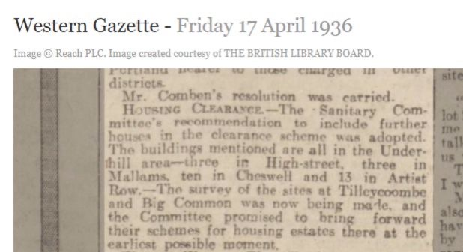
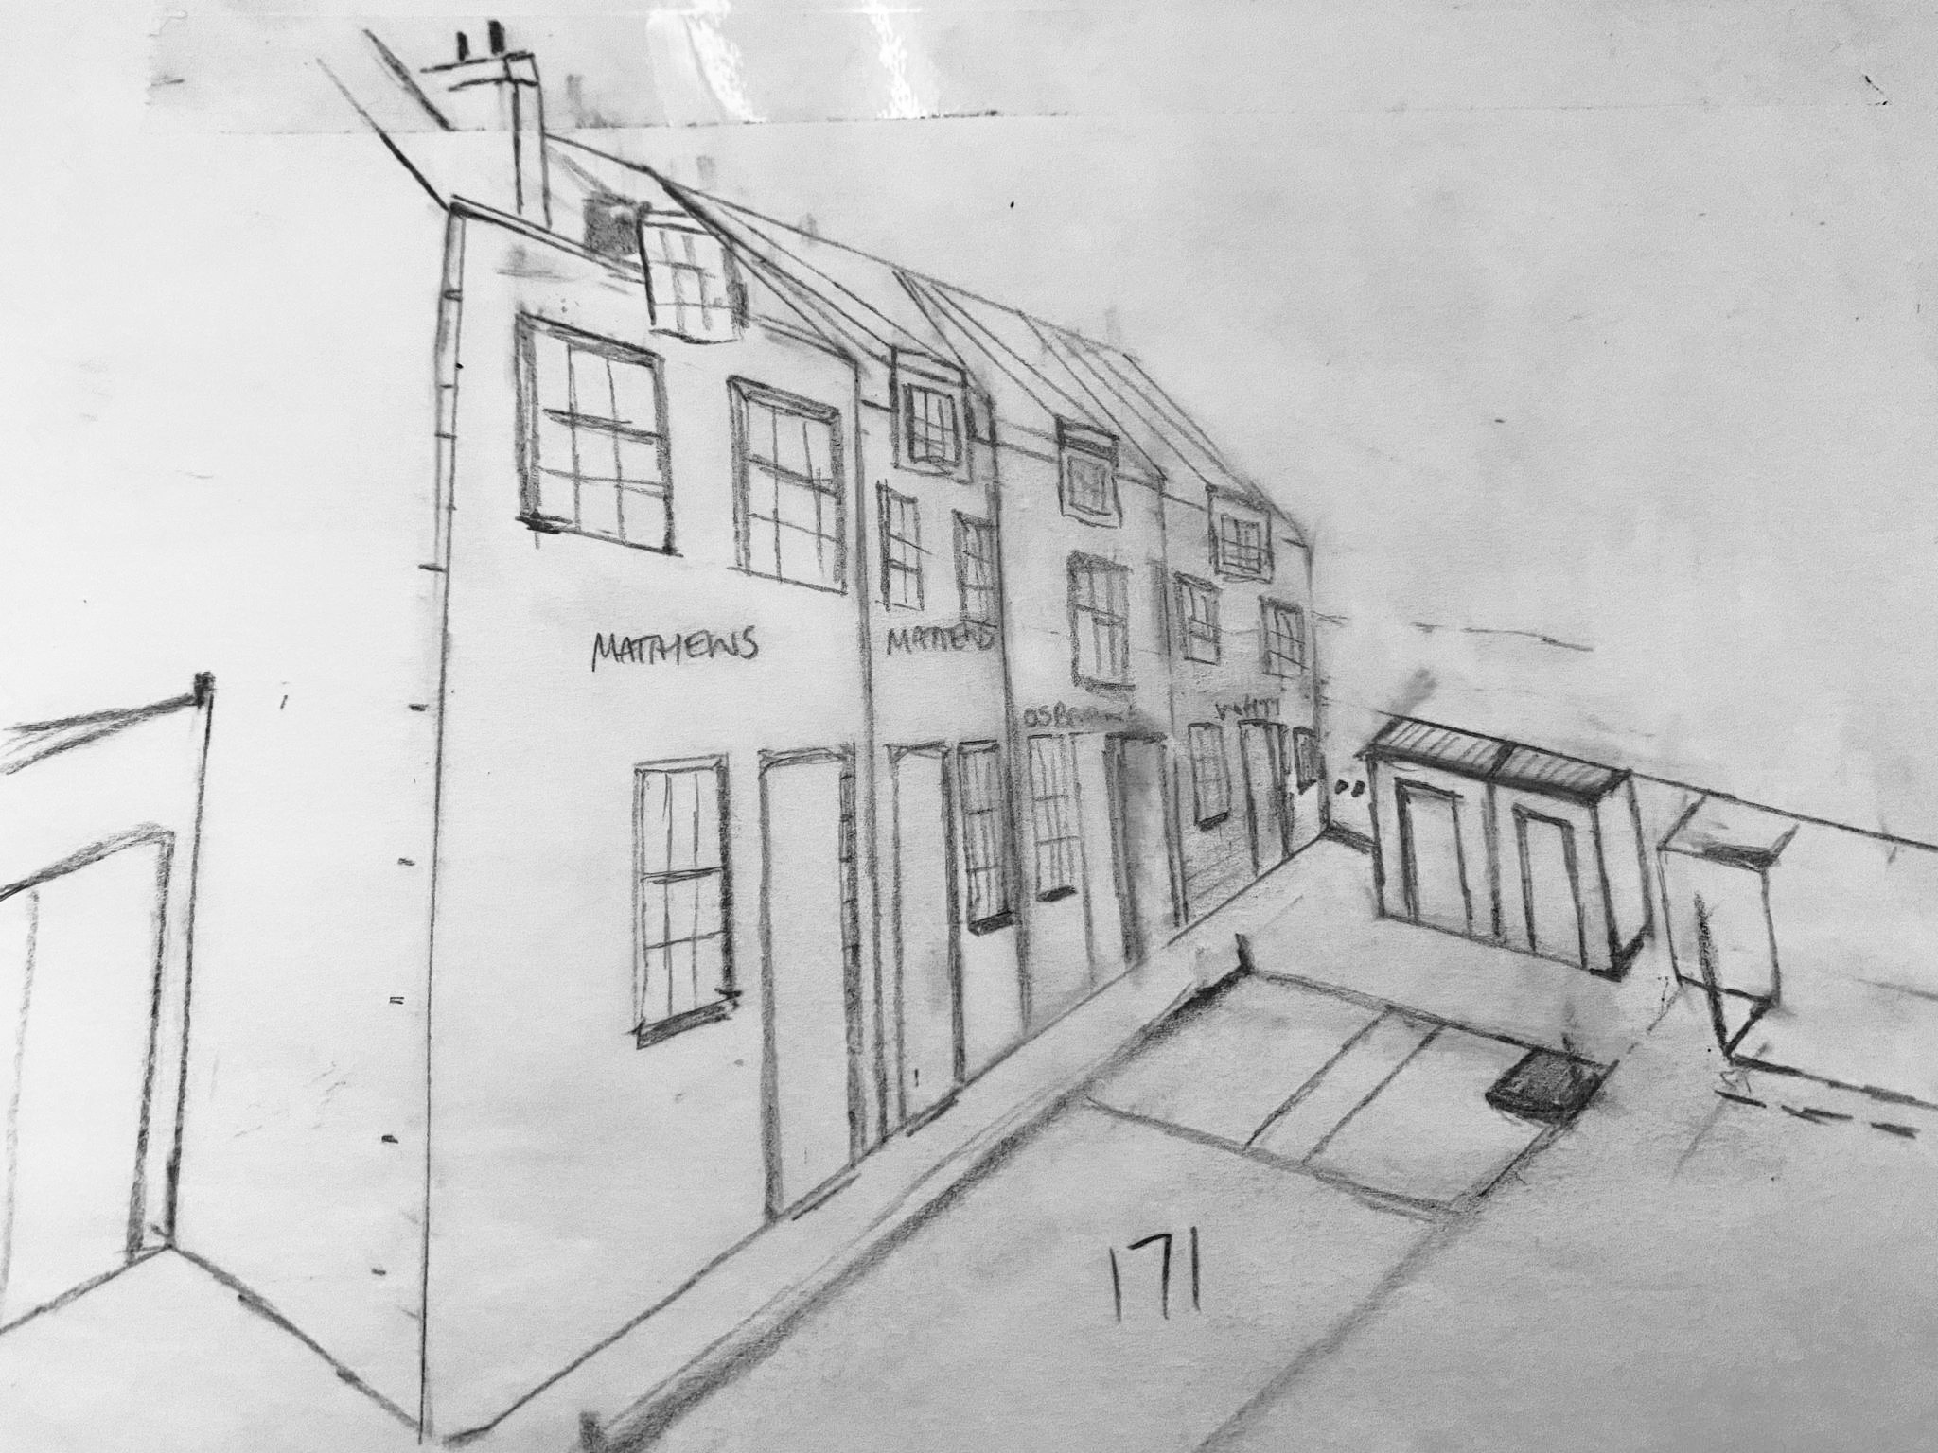
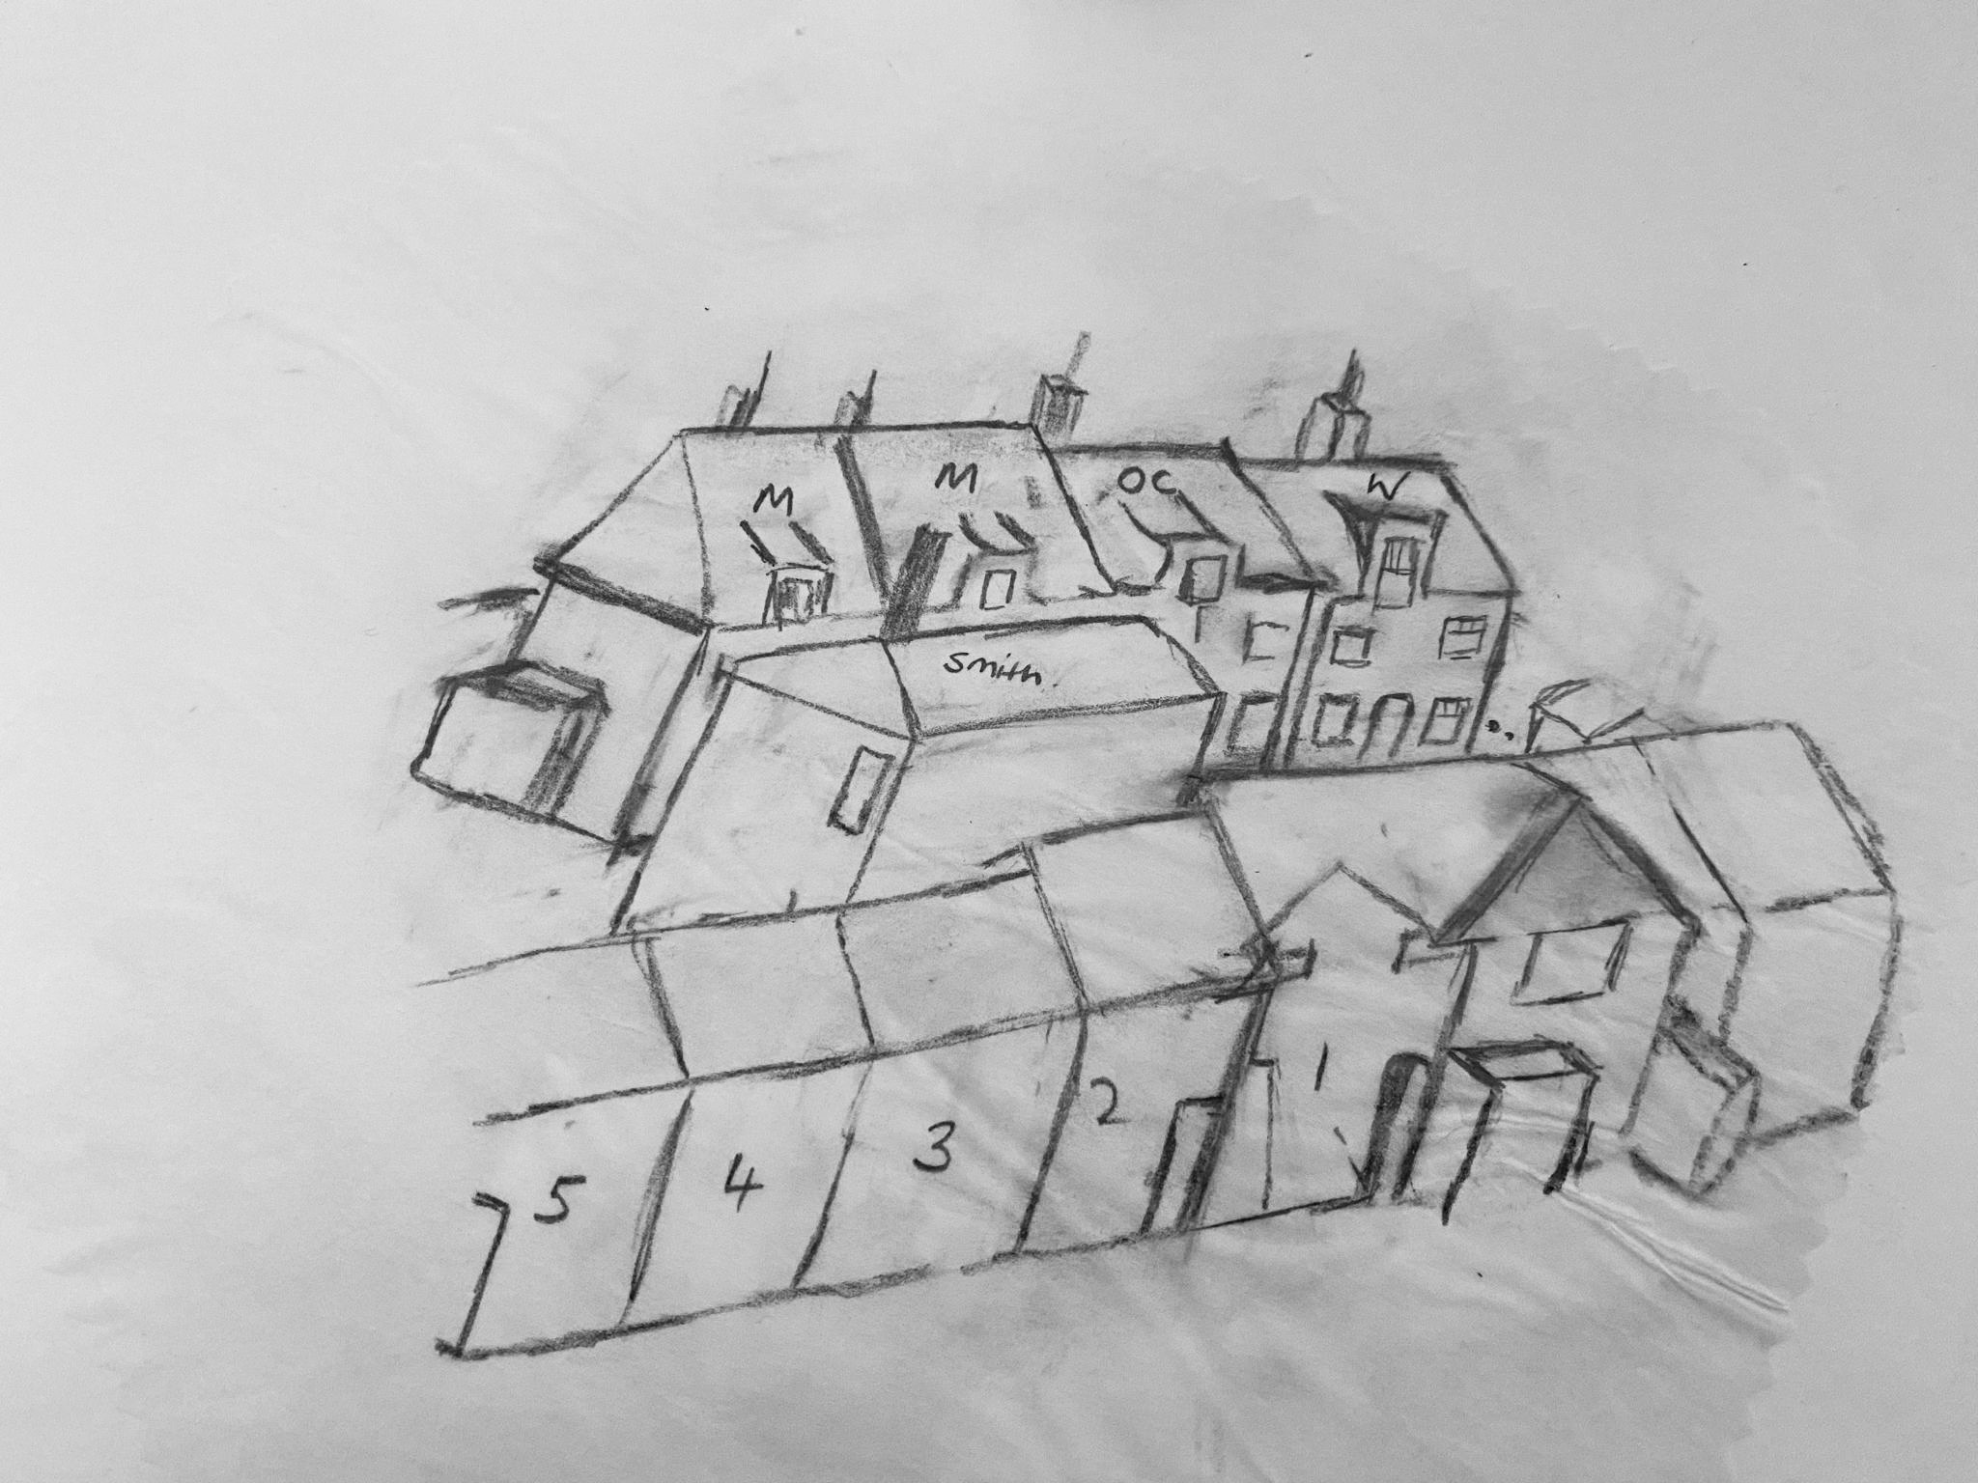
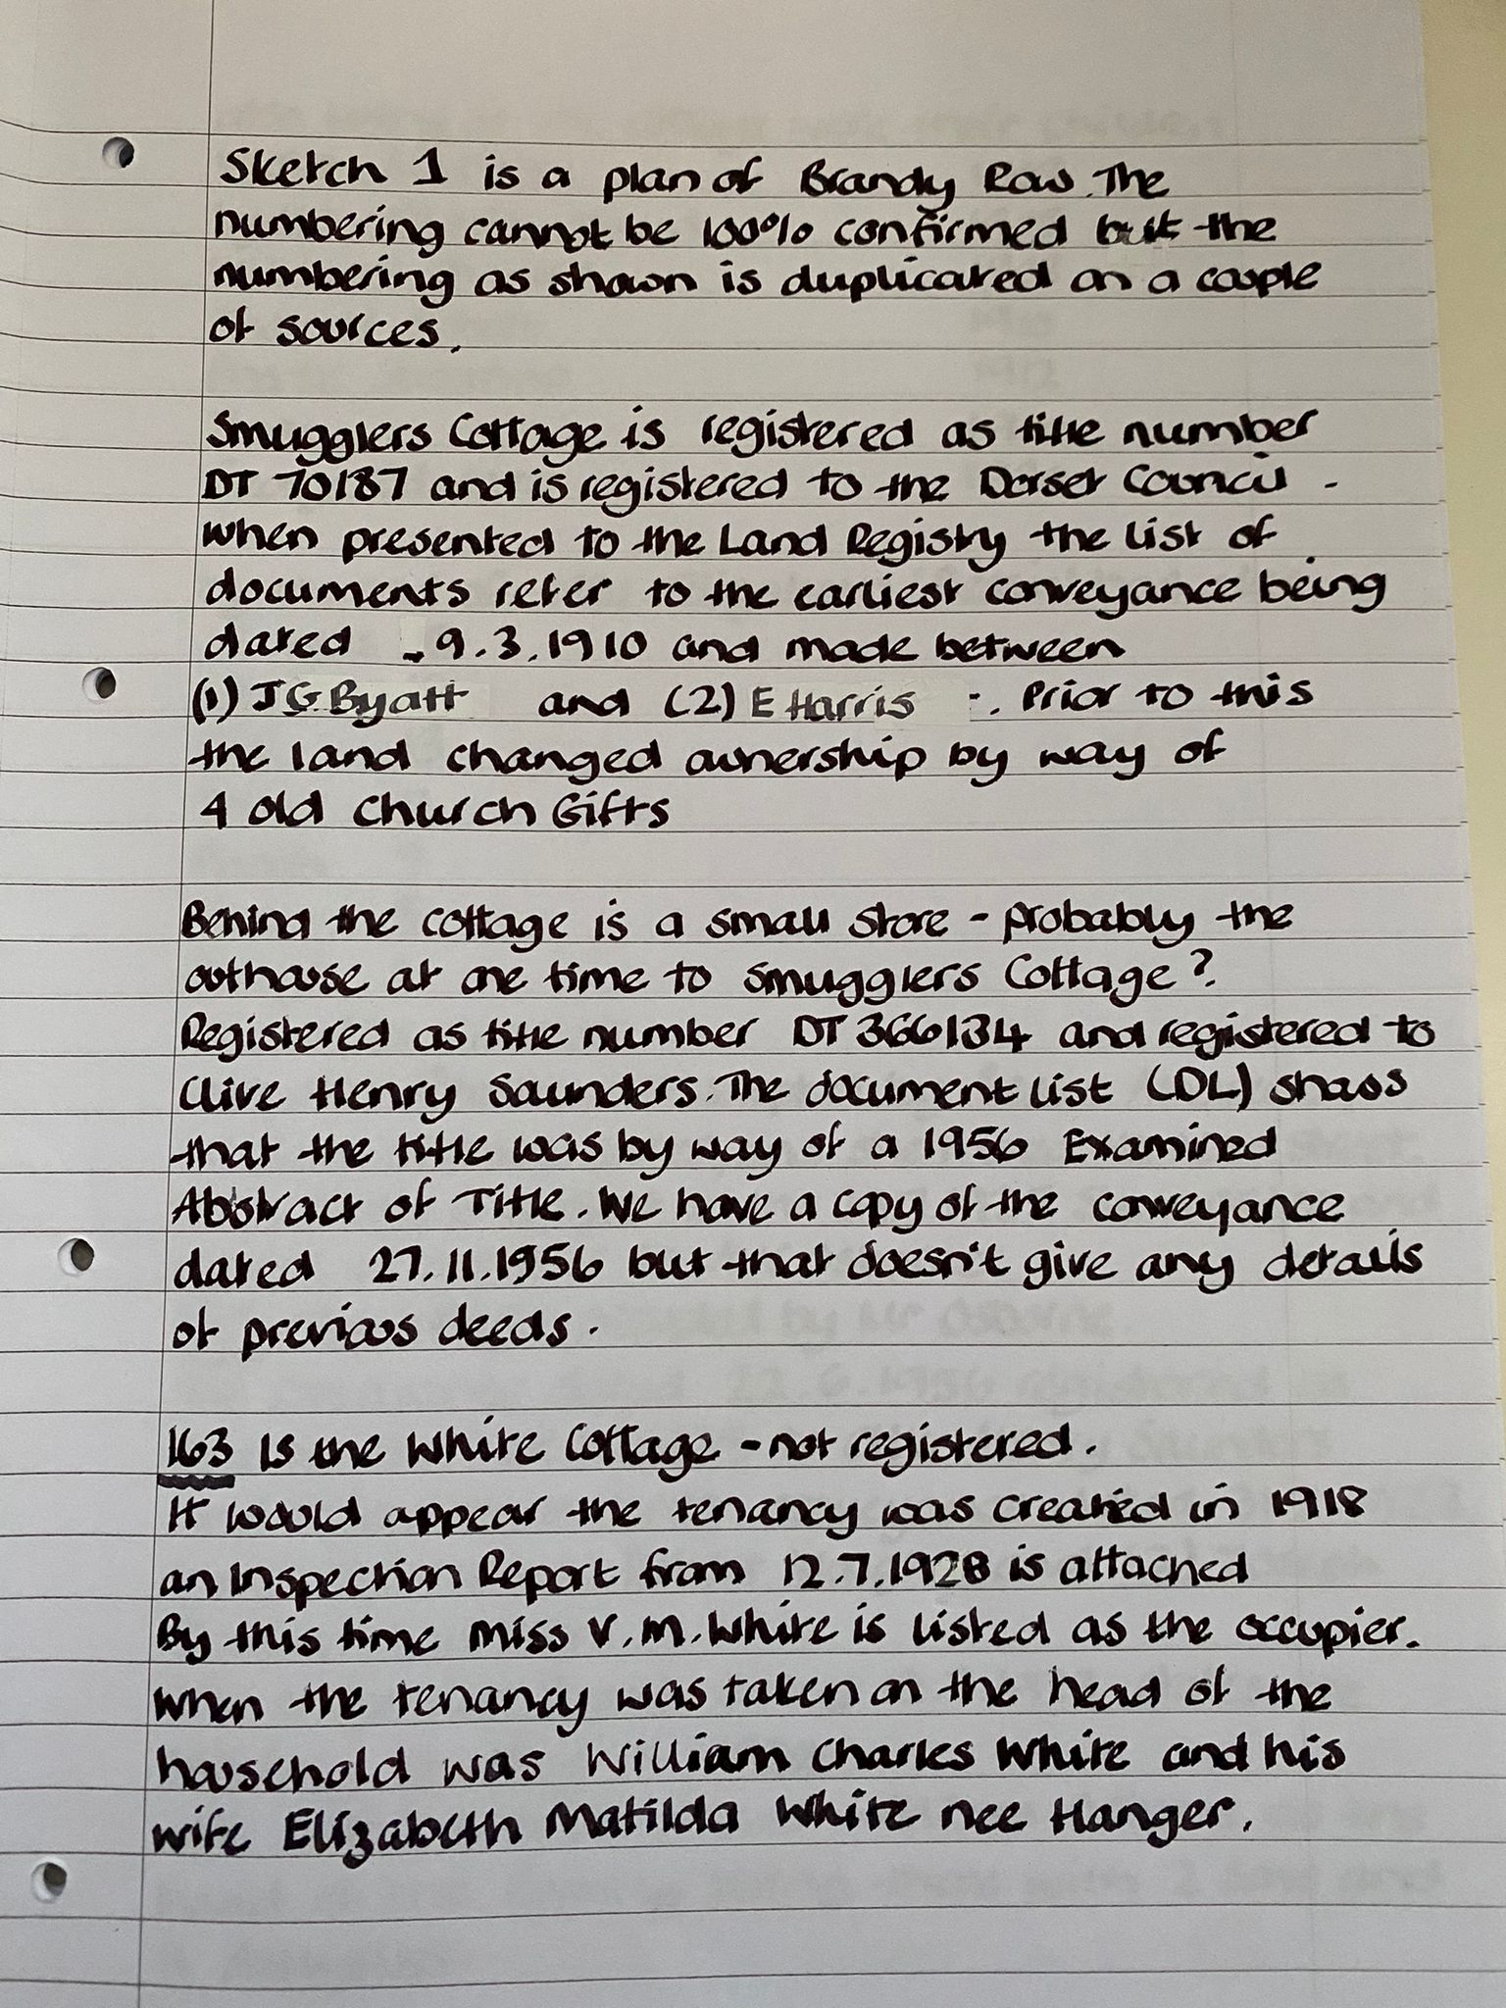
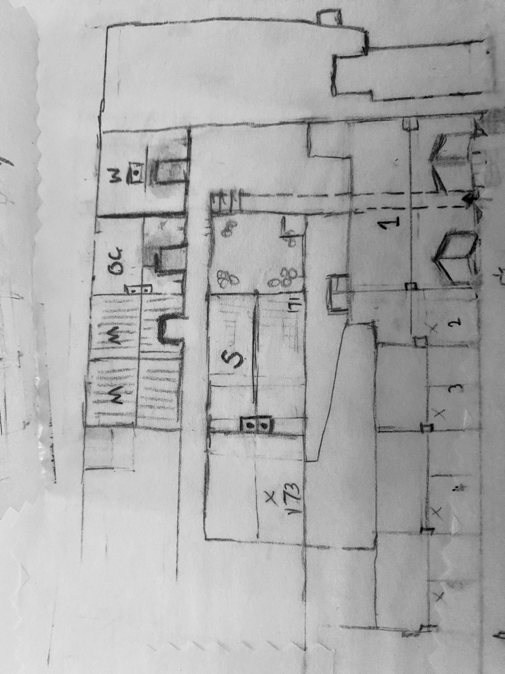
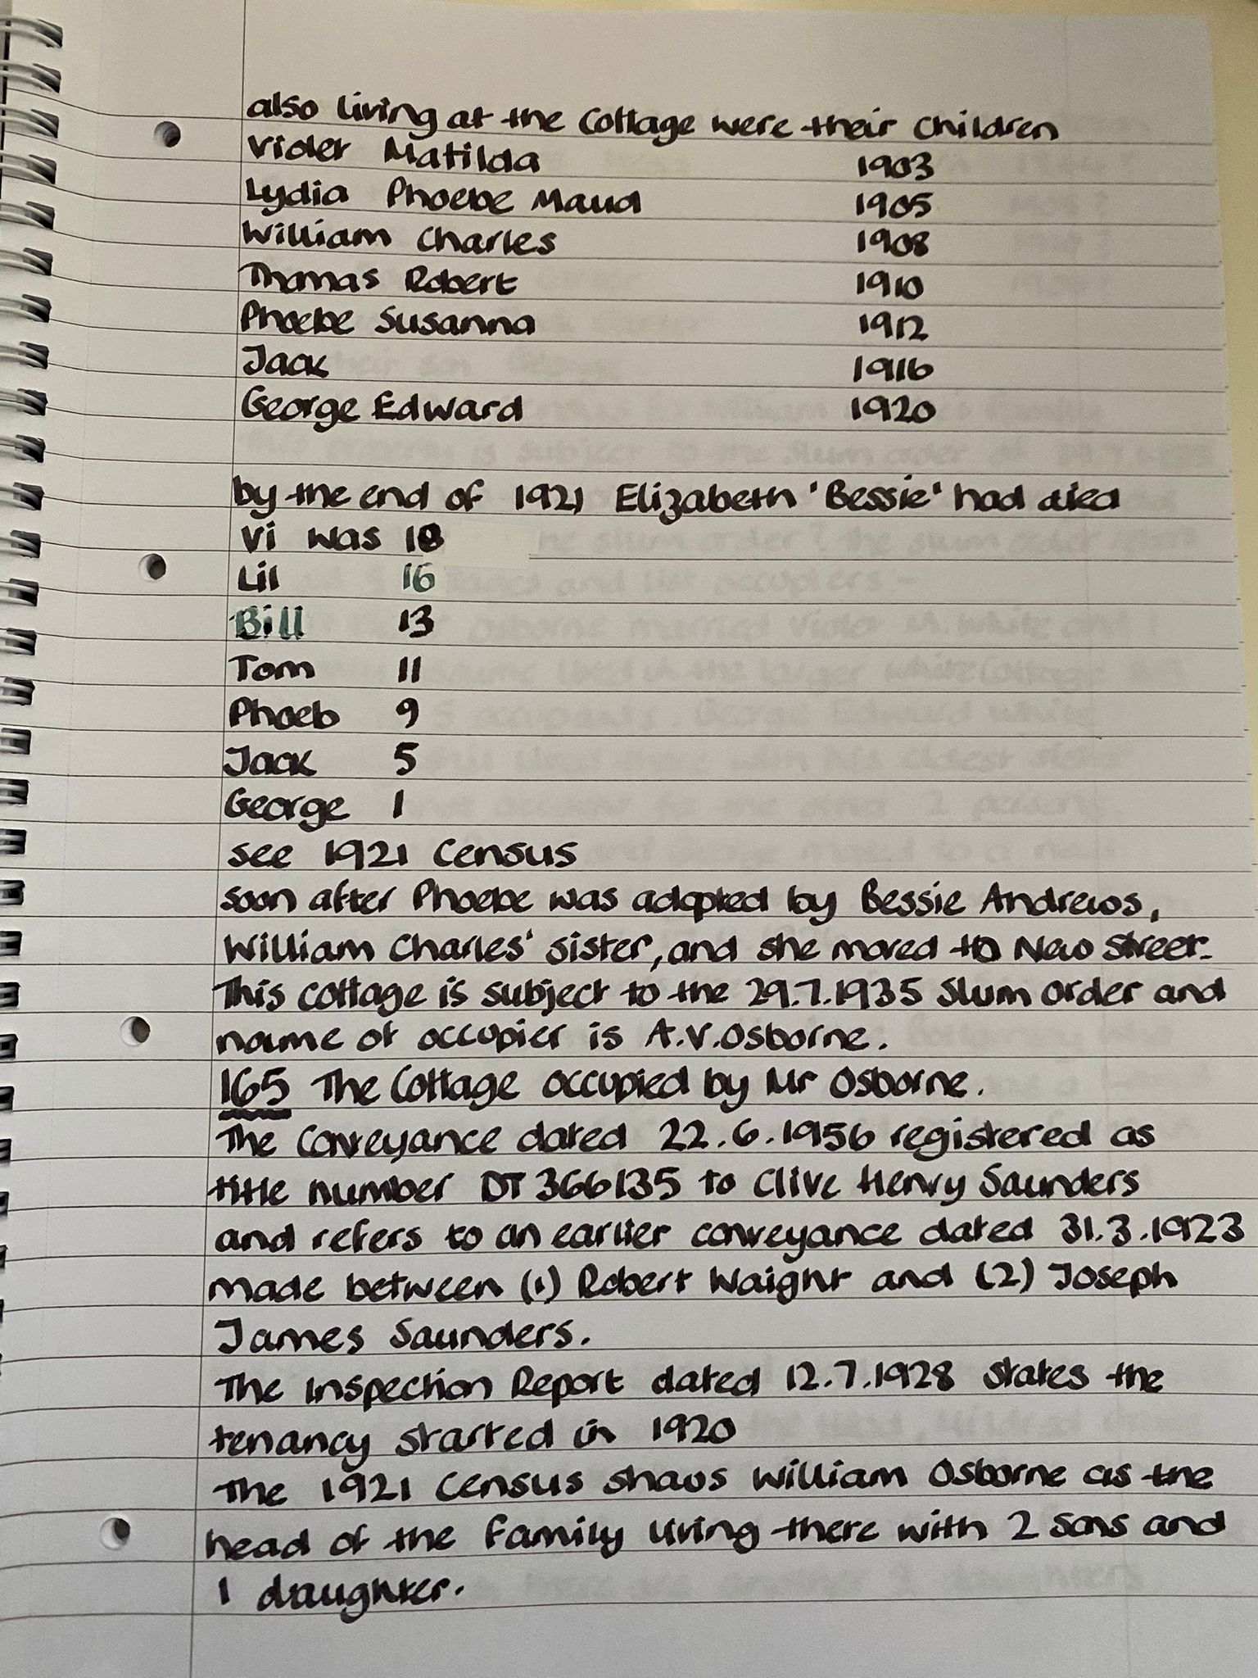
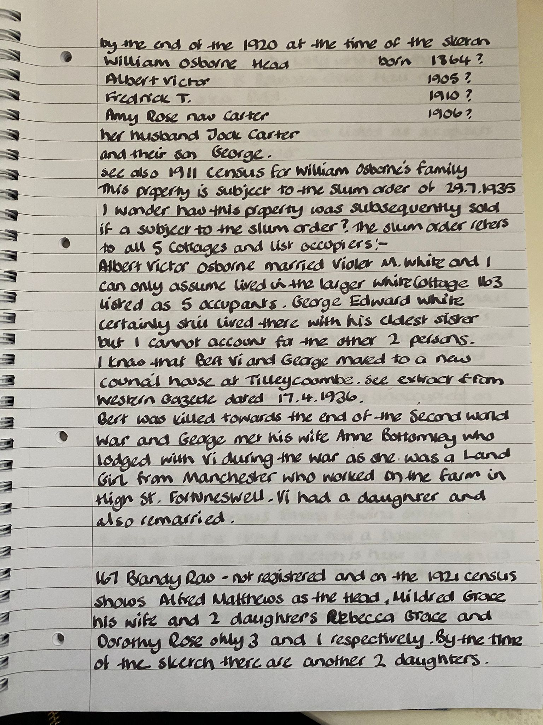
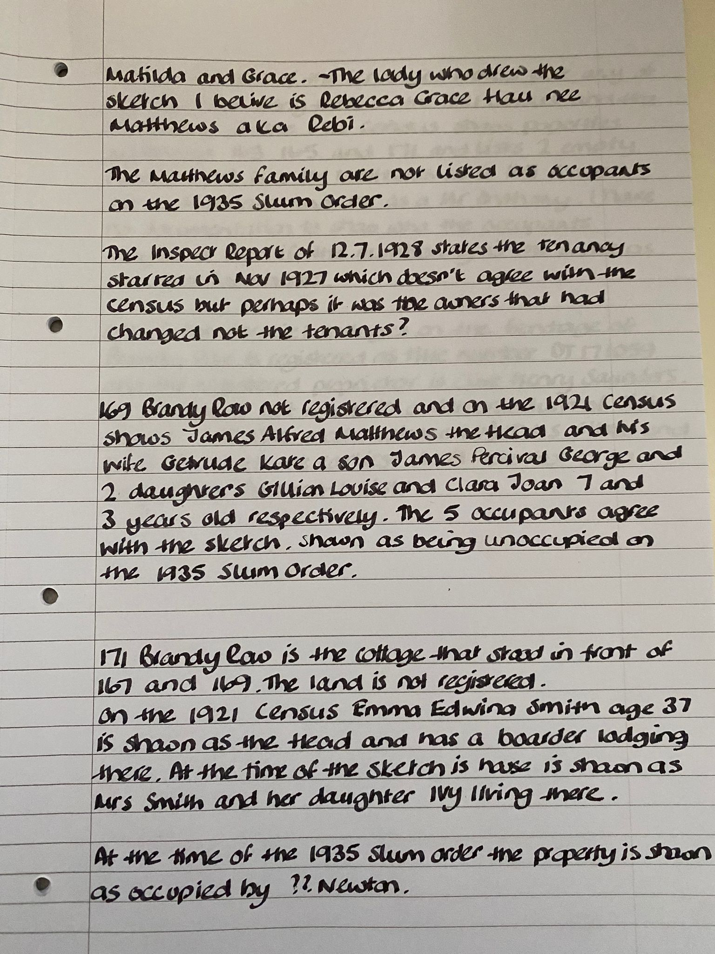
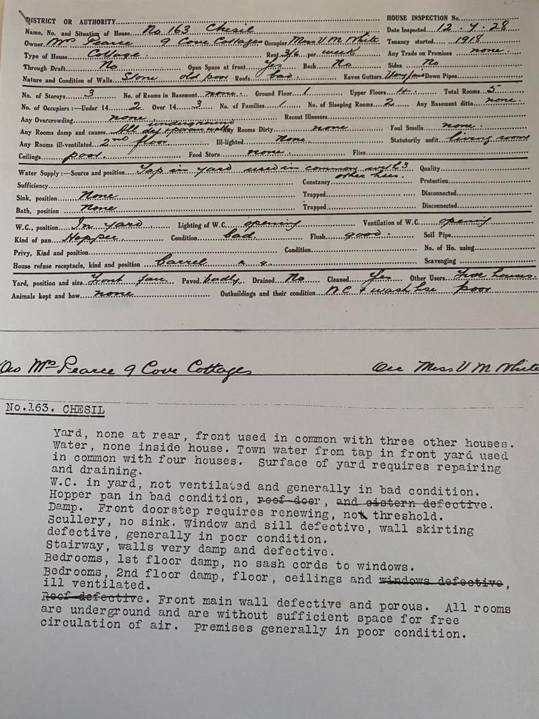

STEPHEN YATES: Brandy Row, Research as Practice

Ann and Stephen first got talking about the Brandy Row Cottage at on of the research events in August 2022. Ann was showing her tracings of photographs that she had used to compare images, and she and Stephen got chatting. Stephen initially used Ann’s images to create a series of beautiful watercolours of the cottage, and then used his 2D work as a starting point to develop work in clay.
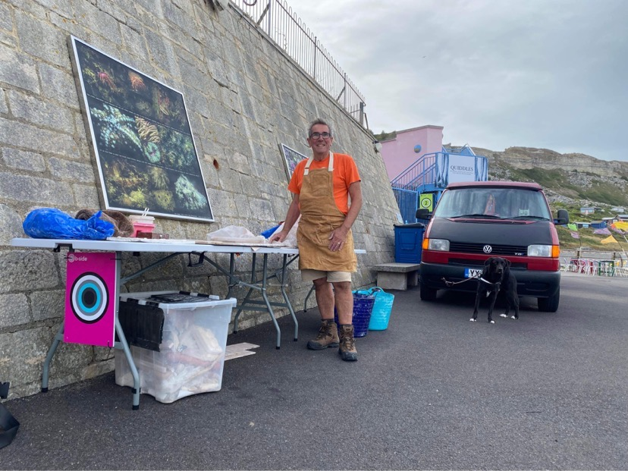
Not only did Stephen go on to make 3D images of the buildings, recreating in detail the Brandy Row cottage as it might of been, he also worked with the fabric of the building itself to produce other, more abstract works in clay that create a direct connection with the cottage. On a visit to the cottage, he rolled clay on its walls, imprinting the textures of the house’s interiors onto the clay, which he then turned into pots. The imprints of the past provide both a poetic and physical connection to the past through touch, touching the surface of the pots reminding us of the many fingers who have brushed those walls over many centuries.He made a model in clay of the cottage, and then at the b-side festival fringe in 2022, ran workshops for people to make sea tiles. Together, these became an installation addressing the cottages proximity to the coast, and the issue of rising sea levels. Stephen’s work demonstrates both the value of collaboration and artistic research to this project. Without his and Ann’s work together, we would have a much less detailed understanding of the Brandy Row site.

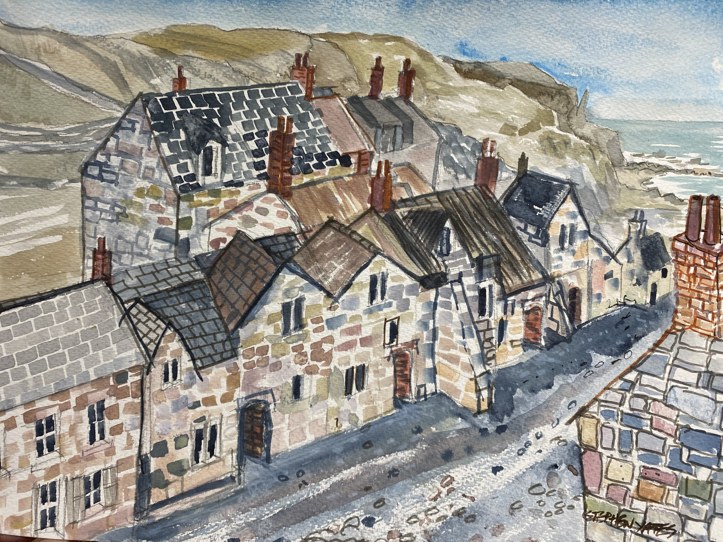
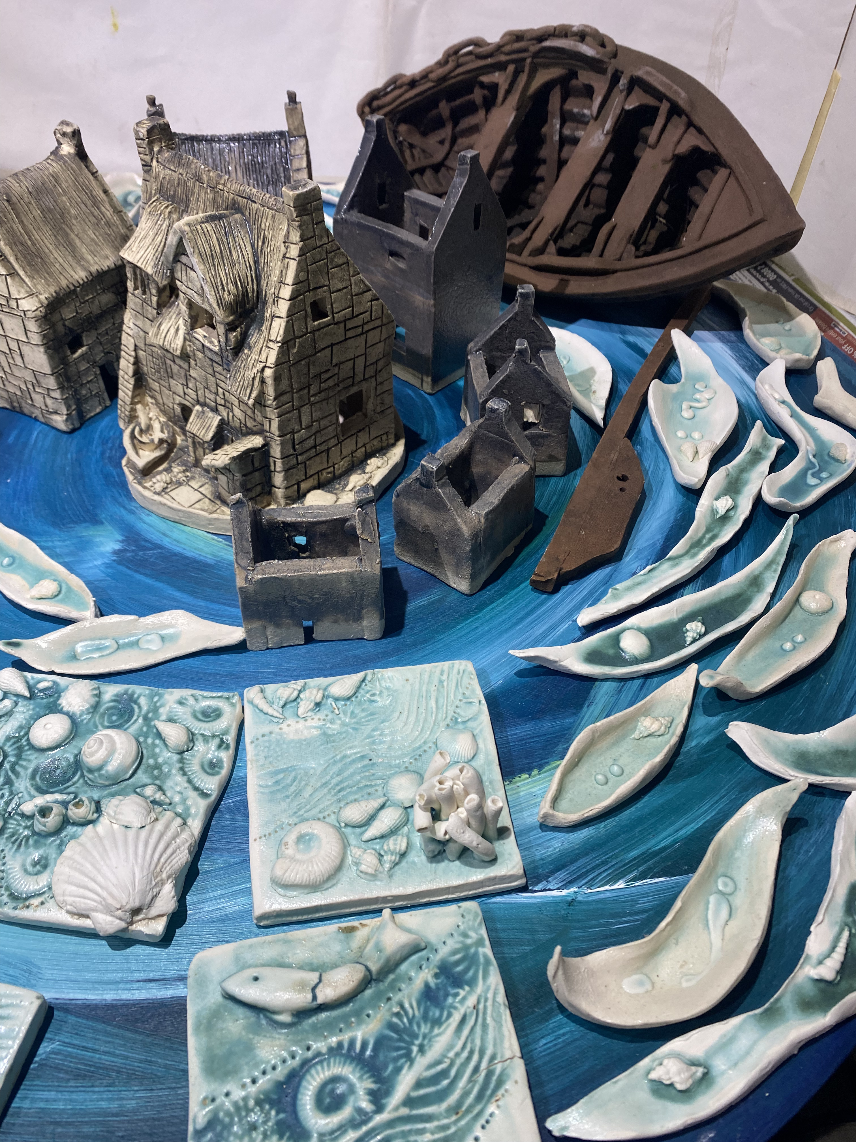
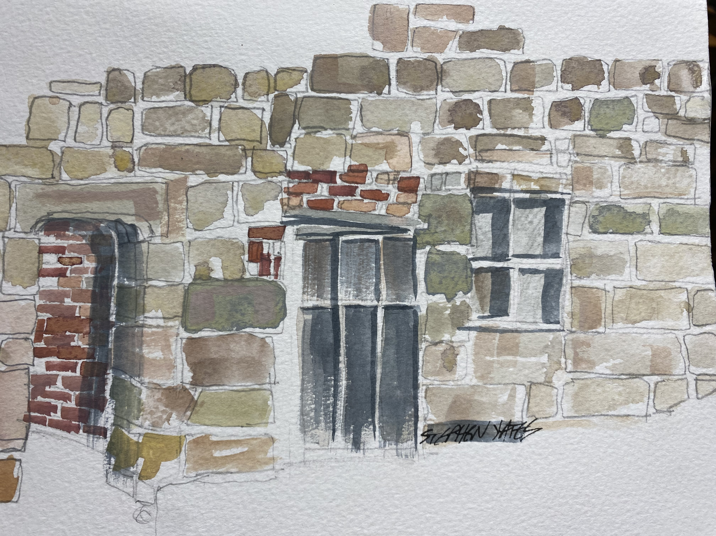
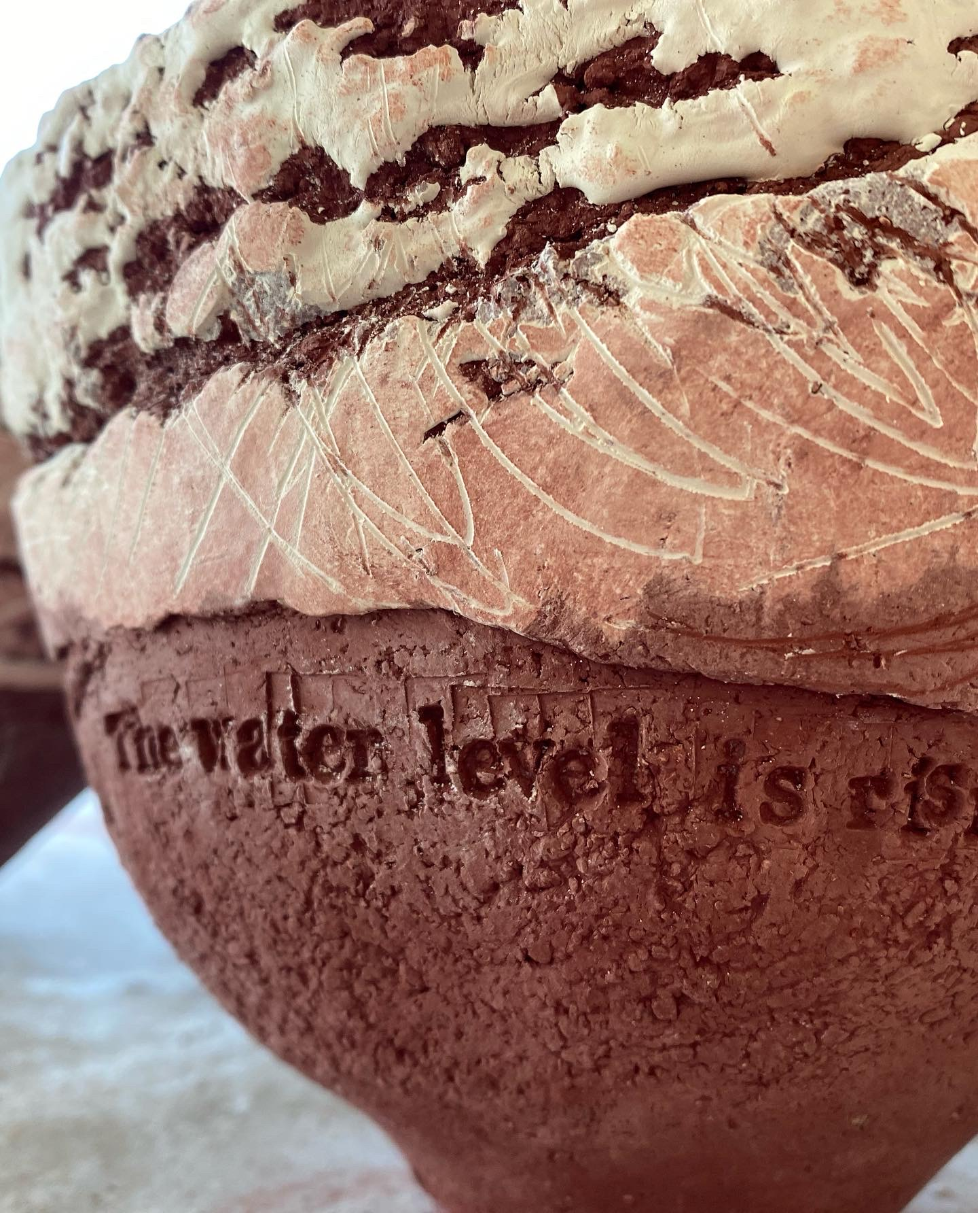
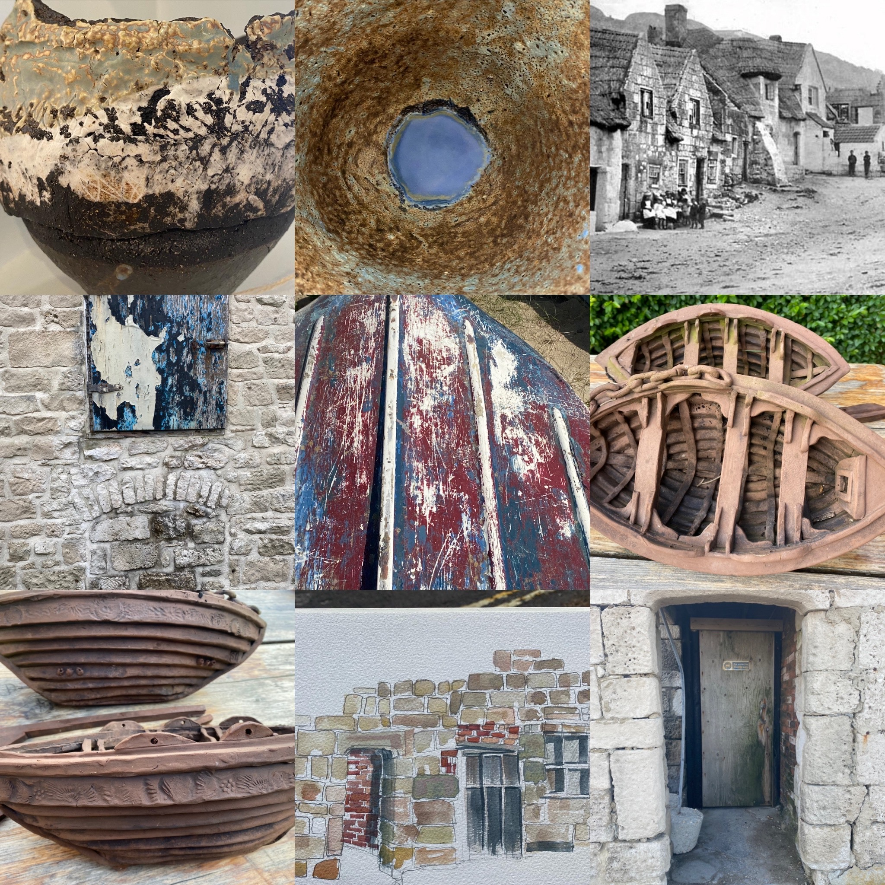
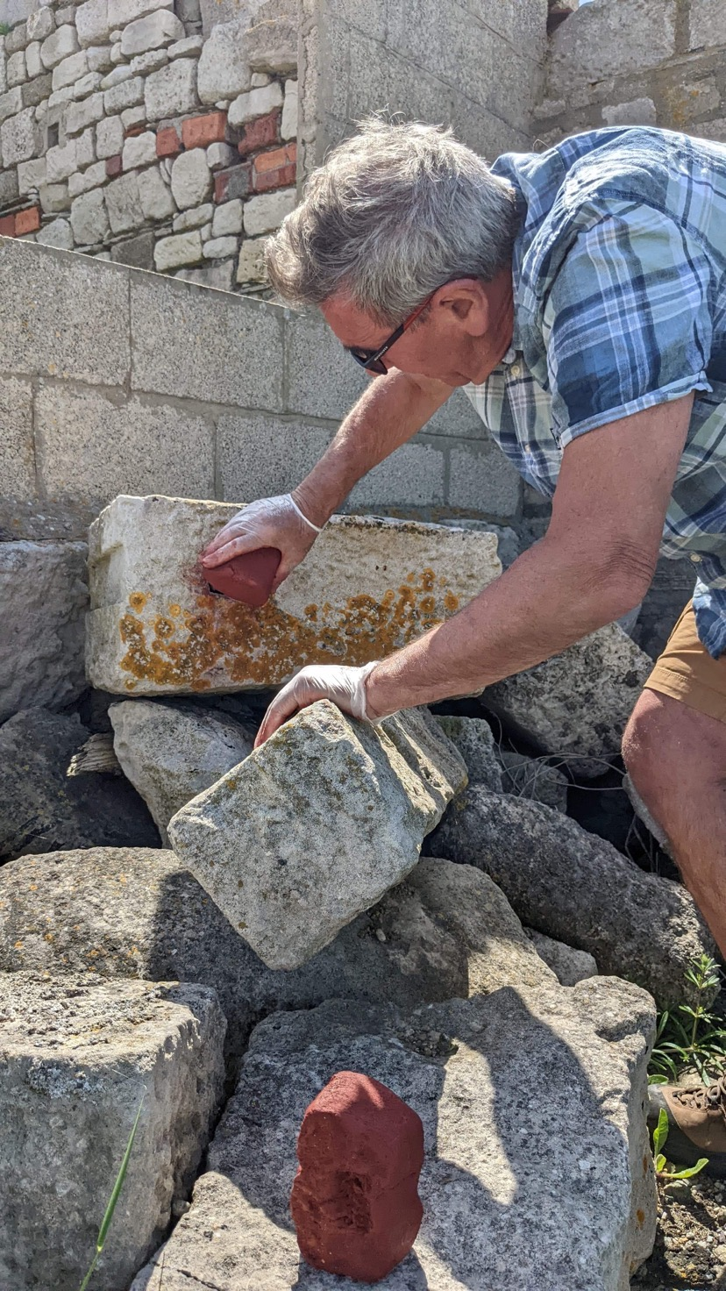
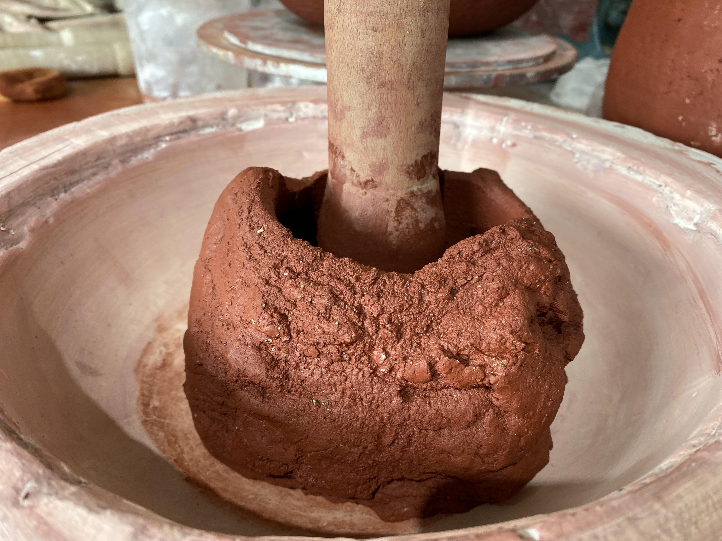

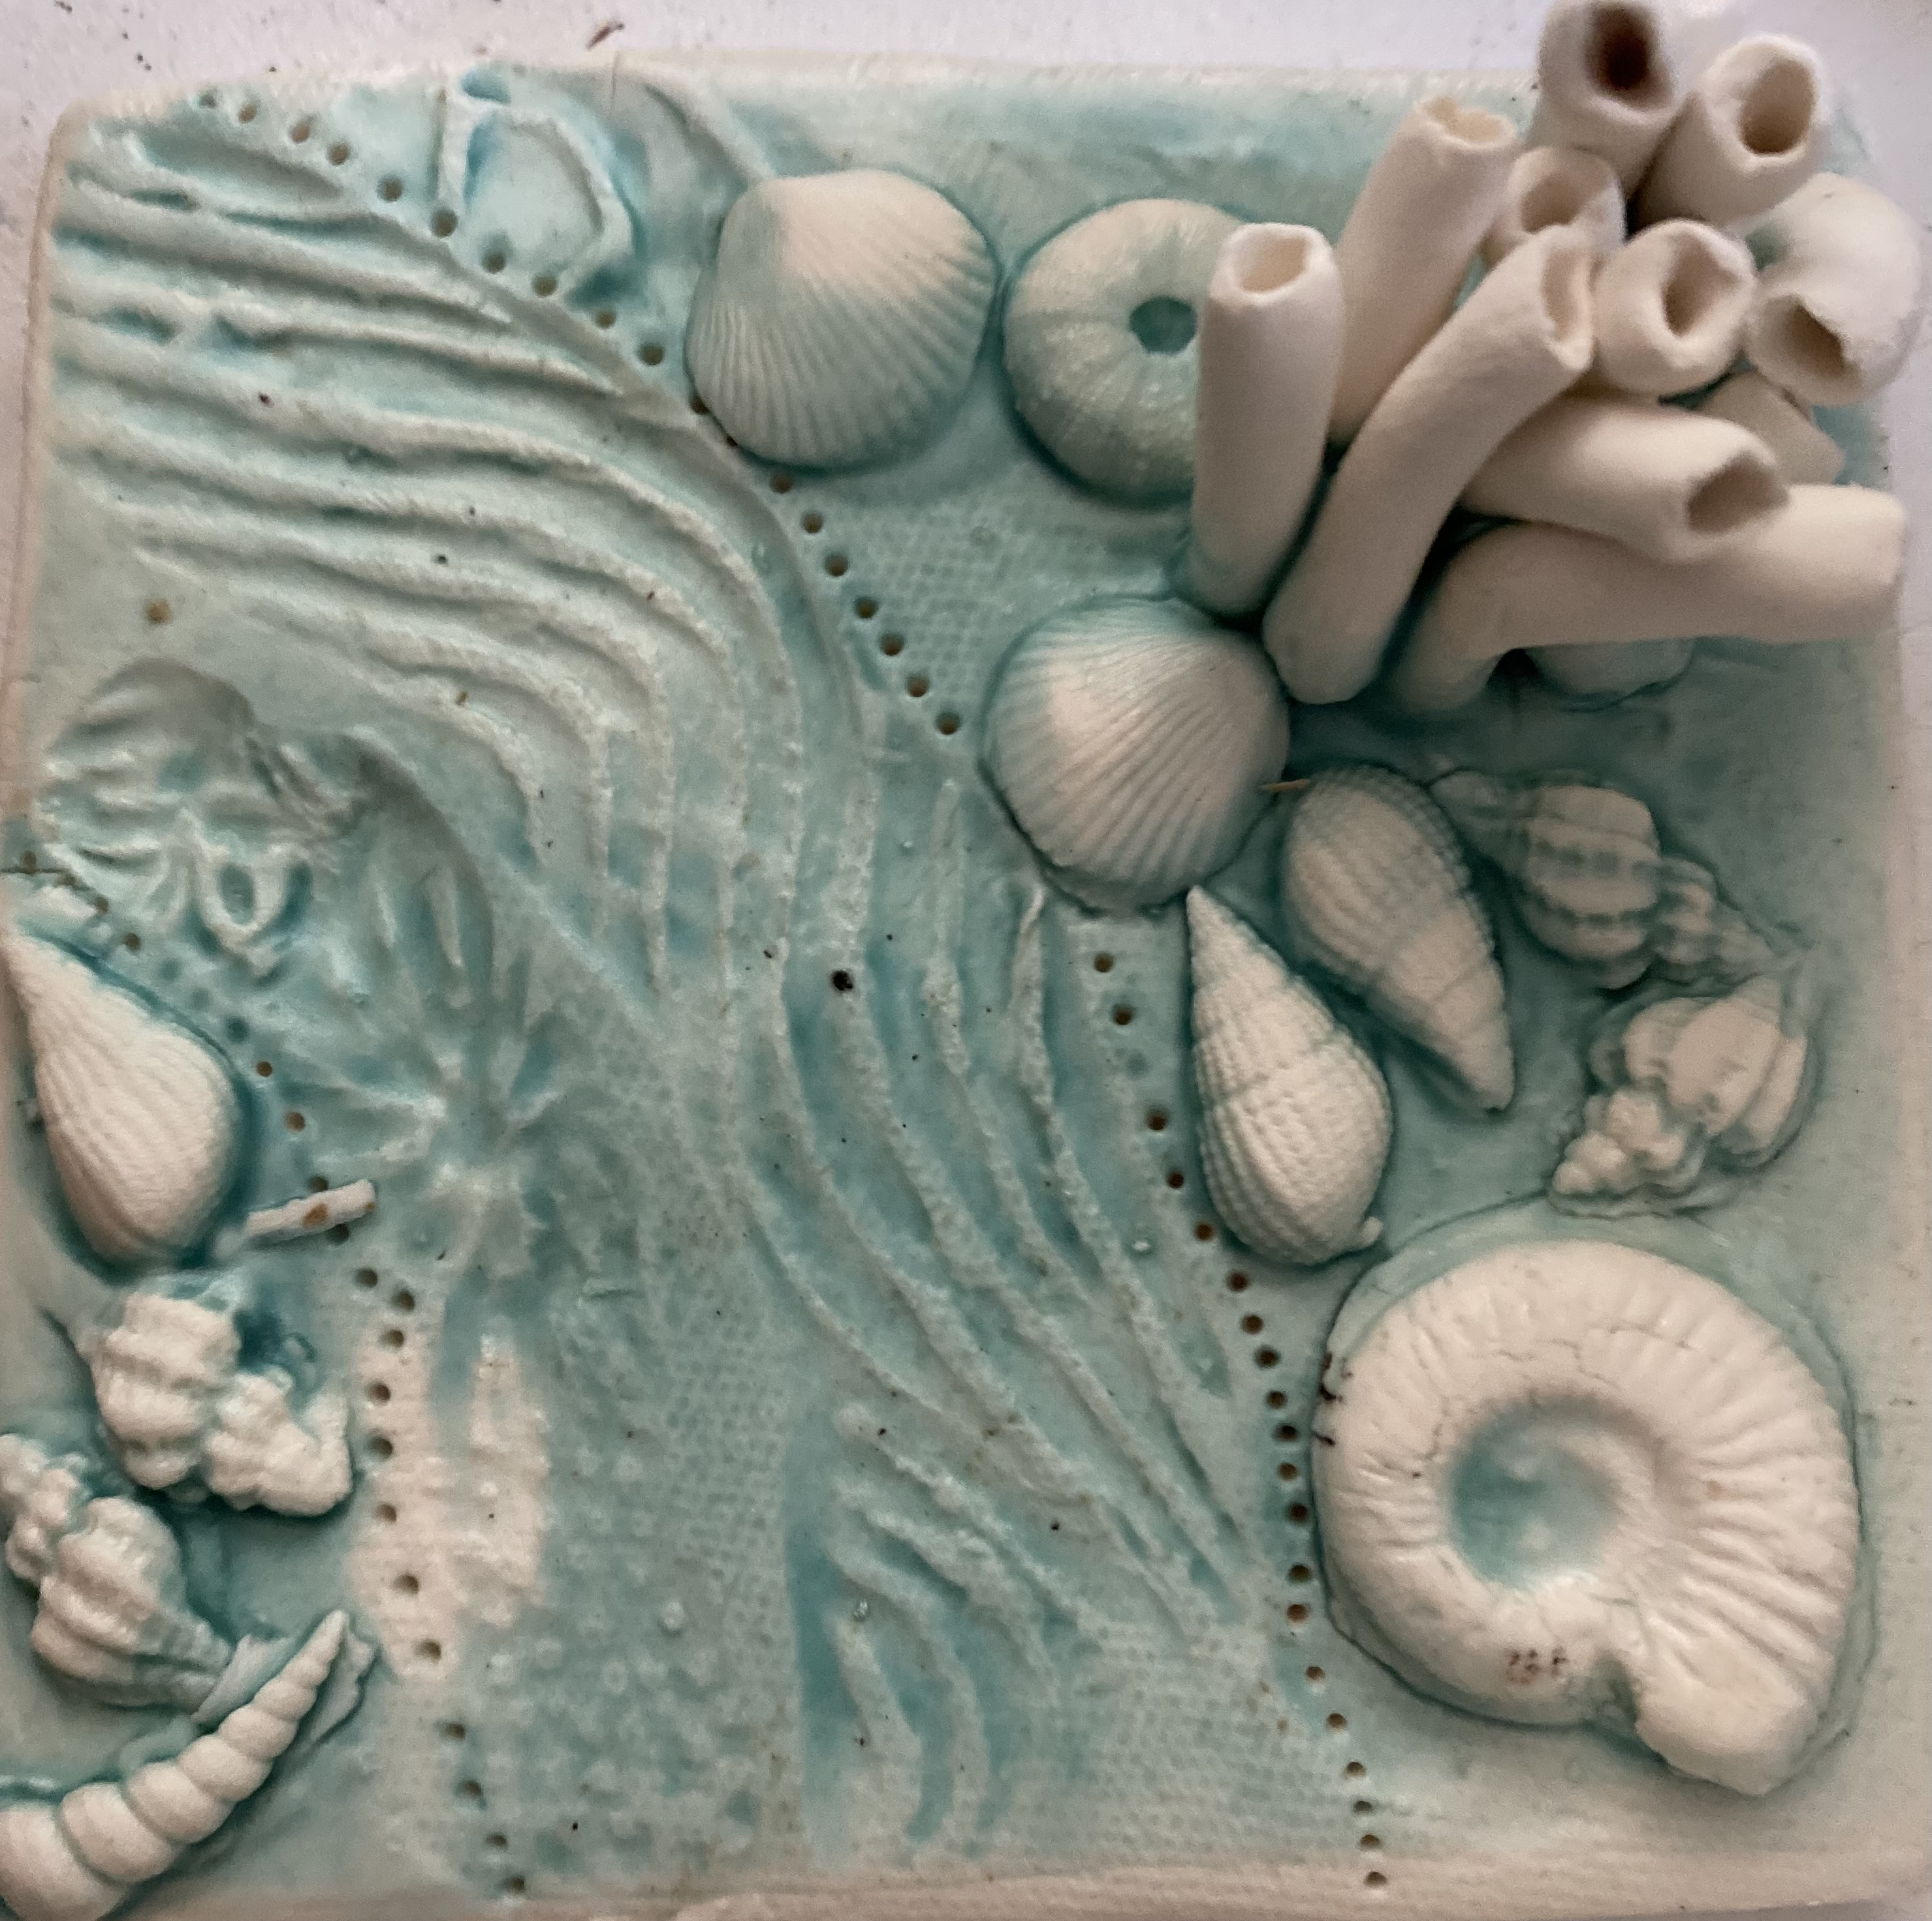
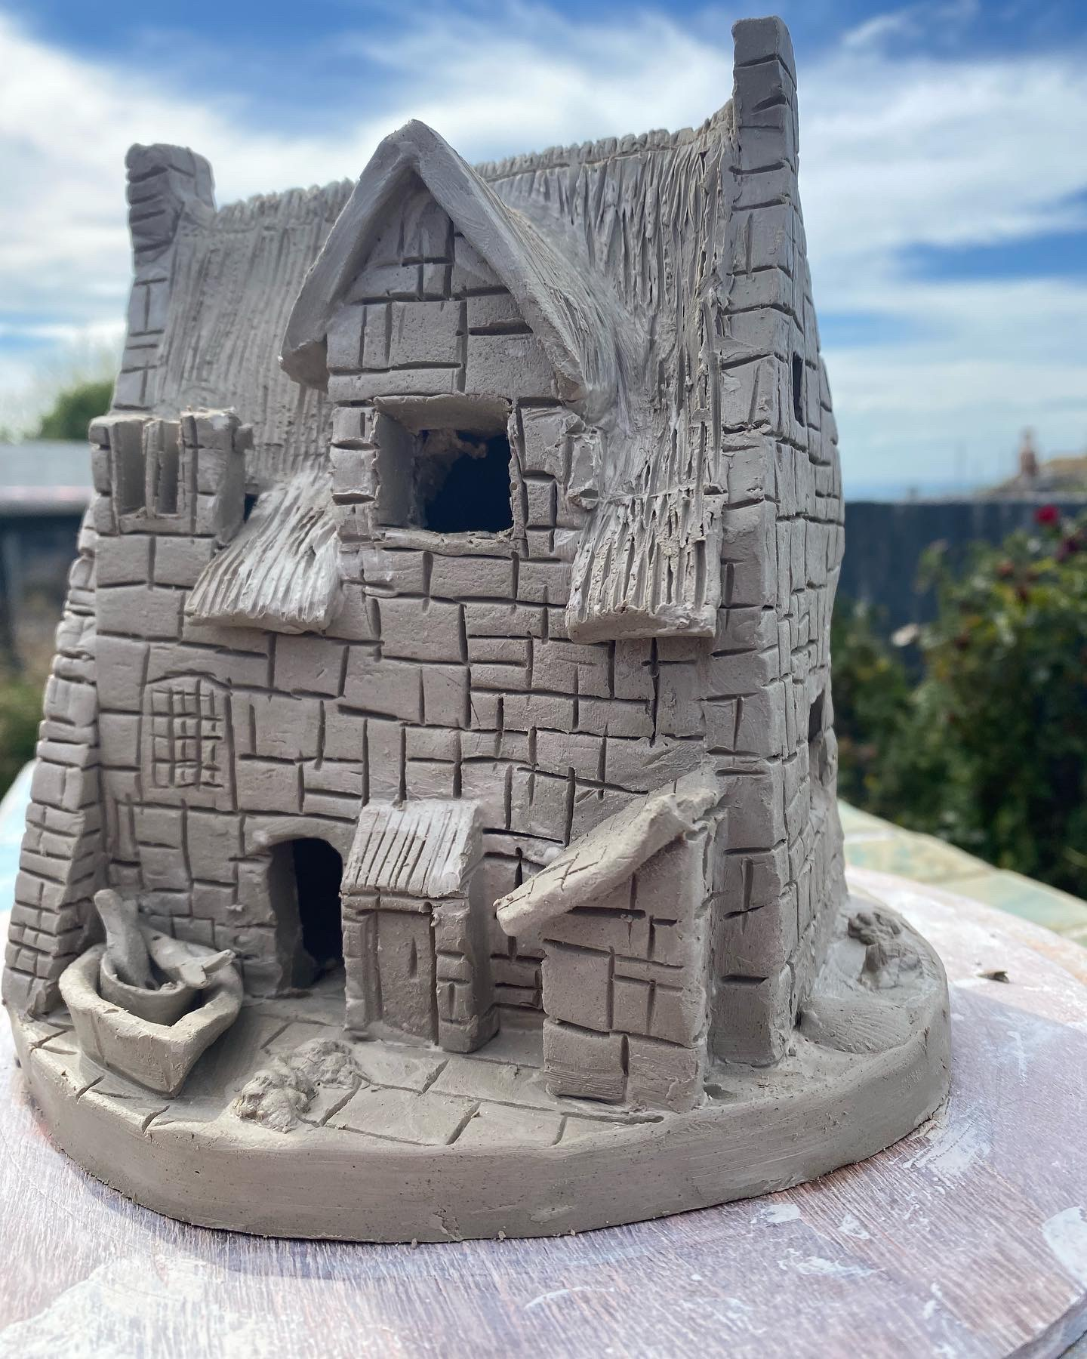
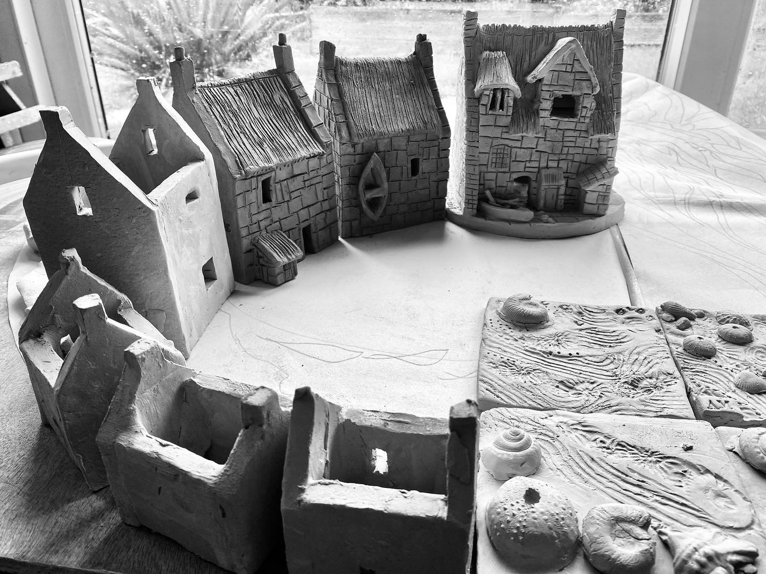

JACQUIE KELLY: “Portland laws give a married woman rights she doesn’t get in other places, I’ve heard”: Women landowners of the strip fields on Portland in the mid-nineteenth century

In her diary entry for July 1799, Elizabeth Pearce is concerned about the attention that John Hill of Weymouth is paying her sister, Grace:

I say all I can, about saving money, and not letting a husband get hold of it. We have little of that here; for Portland laws give a married woman rights she doesn’t get in other places, I’ve heard.

Elizabeth is worried that her sister will give up her rights as a woman of Portland, rights which enable her to maintain an independence unknown on the mainland. Elsewhere in England, inheritance was through male-line primogeniture, where the eldest male relative inherited property and anything a woman owned passed to her husband when she married. The situation for Portland women was very different:

The most noteworthy feature in the old Portland customs was the position of women in the local social fabric. Centuries before the Married Women's Property Act came into force, a woman of Portland was allowed to own property, and to demise it in her own right, quite independently of her husband.

Women played a crucial role in maintaining the standard of living on Portland. Although the soil was relatively poor, Portlanders made good use of the land, “by an industrious and prudent use of the scanty favours of the comparatively barren rock on which they spend their days.” The community relied on women for the extra labour to bring in the harvest, gather arrowroot from fallow fields which was sold on the mainland, and collect cow-dung for fuel.
What is more, because of the inheritance laws, women could own land in their own right. The strip fields, known as ‘lawns’, that form part of the Last Landscape, are the surviving fraction of hundreds of fields that were farmed across the Island until the mid-nineteenth century. In 1858, Charles Dickens wrote, “under the Crown, there are no fewer than three hundred and twelve landed proprietors, who lord it over three thousand acres of titheable land.”
The tithe apportionments of 1842 record over forty women who owned property on Portland. More than half of these owned farmland of some kind, and some owned more than ten fields, which were spread across the Island. By correlating information from the apportionments with the census of 1841, it is possible to start to build a picture of who women were:

Mary Moore was a widow in her early eighties who lived in Reforne, with her daughter and her sons; both women are described as ‘Independent’. Mary owned 37 arable fields, four meadows, and three pastures, as well as three stables, seven houses and six gardens.
Deborah Stone lived in Maiden Well, was in her early seventies, and also recorded in the census as ‘Independent’. She owned 19 arable fields, two pastures, two meadows and a barn.
Catherine Way was another ‘Independent’ in her seventies who lived in Chesil. She owned 16 arable fields, three pastures and two meadows.
Widowed since 1836, Sarah Read was in her forties and lived in Queens Row, Underhill. She owned 12 arable fields and six meadows.
Rebecca Lowman was a farmer’s widow, aged 70, whom the census of 1851 records as living in Easton Street, with 214 acres and 9 labourers. She owned 20 arable fields, two pastures, and one meadow, and also two part-owned plots. She occupied two arable fields herself, and the rest was occupied by her son, Edward Lowman.

As property owners, women were eligible to hold the office of Reeve, an officer who collected ‘quit-rent’, paid by landowners as tenants of the Royal Manor. Douch explains that “the Reeve was appointed at the Michaelmas Court to serve for one year and was always that tenant paying the highest quit-rent who had not held office before.” He gives the names of four women who held the office in the mid-nineteenth century.
Rebecca Lowman was Reeve in 1831. She died in 1856 and her will divides her property into nine shares between her surviving children, daughter-in-law and grandchildren. As well as her land on Portland, she left her pews in St Georges Church, and two houses and a stable in Weymouth.
The other three women who were Reeve between 1845-7 do not appear in the tithe apportionments, but the names of men who could be their husbands are listed (ie. there could be more than one person with the same name, or it could refer to a different person). All three were widowed between December 1843 and December 1844, after the tithe map was made, and, if they inherited their husbands’ land, this may explain how they came to be eligible to be Reeve.
Margaret Heath was Reeve in 1845 and, in the 1841 census, is listed as living in Mary Street, Melcombe Regis, with her husband, William, a merchant who died in December 1843. In the tithe apportionments, over seventy pieces of farmland are listed under the ownership of William Heath.
Margery Comben, Reeve in 1846, was married to Bartholomew, and in 1841 they were living in Maiden Well. There are over a hundred entries for Bartholomew Comben in the apportionments, but there were several men with that name on the Island at the time. Bartholomew died in December 1844.
Margery Spencer, Reeve in 1847, lived with her husband, William, in Weston Village. The apportionments list over forty pieces of farmland under the ownership of William Spencer. William died in July 1844, and, by 1851, Margery is described as “Landed proprietress”.
In most cases, the land owned by women is listed in the apportionments as occupied by men, but there are five women landowners who are occupiers of at least one of their fields.
Hannah Whittle owned four arable fields and two gardens. Two of her fields were occupied by Charles Whittle and two by Hannah herself. In the 1841 census, Hannah is aged 60 and living in Southwell with Charles. They were not married to each other, so they may have been brother and sister. They were active in the Methodist movement on Portland, and it was Hannah who seems to have owned the land that was converted into a chapel in Southwell in 1836:
“It was at this time steps were first taken to obtain a site for building a chapel at Southwell. There are letters from Mrs. Brackenbury [wife of Methodist preacher, Robert Carr Brackenbury] this year, in one of which she sent £40 for the purchase of some property belonging to the family of the Whittles… By church gift bearing date November 25th, 1836, certain premises were conveyed by Hannah Whittle, for the above purpose.”
The Last landscape is all that remains of the farmland these women owned and/or worked on. It would be interesting to learn more about their lives, which were so different to the experiences of women on the mainland at that time.

JESS CHAMBERS: Prison Farming and Portland Bill

Ten thousand years ago the first settlers decided to make the land at Portland Bill their permanent home. This was a first. The first time in all of Great Britain that people had established a permanent residence and given up their nomadic existence. In 1967 Susann Palmer, a Fellow of the Royal Anthropological Society, discovered the Culverwell Mesolithic Site. She made this determination based on certain tools that were discovered on site, and the layout of the living quarters. So we know that agricultural activities started on this land ten millennia ago. Ms Palmer also unearthed ancient sheep bones, and through DNA profiling had undertaken work to prove that Portland Sheep are Roman in origin and not from the stock on the ships of the Spanish Armada, as many historians had believed.
Ms Palmer was one of the original members of the Portland Field Research Group who were successful in having Portland Sheep reintroduced to the island in 1977. They were maintained by the Young Offenders, as part of a Prisoner Rehabilitation programme. By 1995 funding for this programme was not so readily available and most of the sheep were moved off the island.
The few sheep that remained eventually came into the care and ownership of Fancy’s Farm, and some of the Portland Sheep on the farm today are descended from that original flock introduced in 1977.
The Prison Farm was hugely influential regarding the agriculture and usage of the land at Portland Bill, from grazing of sheep and cows to the growing of feed crops and vegetables.
By 1992 there were 14,000 (5,600+ ha) of prison land being farmed under 17 large farms, an 80 person management team, 3,500 temporary workers and an annual turnover of £35 million: HMP Farms and Gardens were the 3rd largest farming operation in the UK, able to feed 47,000 inmates.
Portland Borstal was one of these 17 establishments. Together with its satellite dairy and pig farm at Tadnoll Mill. Portland grew potatoes and other vegetables, and had polytunnels and glass-houses at the actual prison.
After interviewing a former Portland Prison Farm Manager, it has been established that Portland Prison managed the grasslands at Portland Bill by cutting primarily for silage for animal feed. This was to feed the heifers from Tadnoll Mill Farm, who were also brought over to Portland for grazing. Hay was also cut from these fields, but not in such quantity, and the farm also grew some potatoes and cabbages at the Bill.
The Prison Service Farm Managers met annually for a Farm Conference, and records exist of the Prison Service Farm Conference History from 1956-1995. The conferences involved a Farm Walk, and the earlier documents (from 1956-1968) include a map with a key to the land use, planting, amount of seed use, fertiliser use, etc. From 1969 onwards these details aren’t included. Unfortunately Portland Borstal was not an establishment that was visited, and so there is no definitive plan of how the land at the Bill was used.
Chapter 11 of Outside Time refers to “Fresh Start”, which saw a new era in the Prison Service. New recruits started under different terms and conditions to those they were working alongside. Overtime became a thing of the past in some ways, and without overtime it became more difficult for staffing to be maintained to manage additional activities outside of the main prison setting. Therefore just ploughing a field became more difficult. Hannah Wright goes into full details in her book. This was perhaps the beginning of the end of large-scale farming within the prison sector.
The lawnsheds at Portland Bill have been settled and used in agricultural ways for ten thousand years. Portland Sheep have been grazed there, as can be seen from archaeological finds to more modern farming. Animal feeds and vegetables have been grown there, and now the common grounds are home to calcareous grass lands. Is it any wonder that so many of the Portland place names have sheep connotations?

Notes:
Please see Volume One page 15-17 for a good example of a field plan and cropping use.
Please see Volume One page 167 for an interesting detail relating to Annual Leave at that time, and also that Agricultural Work was considered a “man’s job”. This certainly adds some historical context to attitudes from 1972!
Please see Volume Two page 208 ref grass management at Dartmoor. This would probably be similar to grass management in other places. Portland was cut for hay and silage, so this would probably have been similarly managed.
Please see Volume Two page 230 ref Kirkham polytunnels. Kirkham was the largest producer of such horticultural produce. Portland had similar polytunnels, and so could have produced similar goods on a smaller scale. Again, Portland’s details are not included in the records.
Please see Volume Two page 248 – interesting quote regarding “Farmer George”. This is the only reference to “Portland Borstal” in the Conference Histories, but refers to the satellite dairy and piggery at Tadnoll Farm, rather than any farming on Portland.
Please see Volume Two page 295 ref Conservation Grassland Management on Dartmoor.
Please see Volume Two page 309 ref crops grown for animal feed. This was probably the case across all the Prison Farms.

CATHERINE BENNETT: Commoning the Commons

My interest in land is having access to it to be able to grow food to eat and in having the freedom to roam. I have a photo of my 8-year-old running full pelt down over Verne Hill towards the harbour and it is this sense of space and being able to really free yourself that I want children (and adults) to experience. I want to sit and take in the view and he wants to just stretch every sinew. First of all, I will explain what is common land and then I will relate the rather sad tale of loss of common land on Portland.
Common Land is privately owned land, but which we, as the commoners, have access to. The Foundation for Common Land provides some useful context: First enshrined in law in the Magna Carta in 1215, Common Land traditionally sustained the poorest people in rural communities who owned no land of their own, providing them with pasture for livestock and other rights to resources such as to gathering wood and fish from Chesil.
At one time nearly half of the land in Britain was Common Land, but from the C16th onwards the gentry excluded Commoners from land which could be ‘improved’ through agriculture or had other useful resources such as stone. That is why most Common Land is now found in areas with low agricultural potential, but areas which we know hold value for high conservation significance and natural beauty. Over one-third of England’s moorland is common land.
Common Land now accounts for 3% of England, but this includes large tracts of our most well-loved and ecologically rich landscapes including Dartmoor, the Lake District, Yorkshire Dales and our very own Chesil Beach.
Commoning is an ancient land management practice that involves a group of farmers – from one or two to over 100 – having “commoners rights” to graze their animals (mostly sheep but also cattle, pigs, horses…and even ducks) on a shared piece of land – the common – without fences or boundaries between them. The sheep don’t need fences, through flock memory passed down through the generations they stay on their patch of the common.
The sheep belong on their lear (patch). The commoners belong on their family farms, and the commoners’ rights belong with the farm. The common itself belongs to a private individual or council or organisation. On Portland this would be Crown Land managed by The Court Leet or land managed by Dorset Council.
In the past commons were the backbone and the rock (literally) of our civilisation, and the turn of these quiet sentinels has come again.
We must protect them, for their intrinsic value. This is our heritage; as commons provided for our ancestors so they can provide for our descendants, and once again we must work with our environment to shape and secure our future.
Commoners graze their livestock (sheep, cows, ponies) on Common Land. This use of land for pasture -without ploughing or planting -has protected landscapes for over 1,000 years. It has ensured the survival of thousands of ancient monuments and has enabled wildlife such as rare birds and butterflies to thrive, as grazing maintains the balance of the delicate ecosystems. Grazing, if on large enough areas of land, is intrinsic to our calcareous grasslands on Portland.
Commoning is also an ancient part of our history. Commoning families preserve traditions and practices upheld since the Magna Carta unchanged for centuries. But the heritage of commons isn’t just about commoners and livestock, it’s about some of the UK’s most spectacular landscapes, its most valuable biodiversity, its geology and pre-history, and its history of settlement and industry. Beyond that it’s also about natural systems such as the water and carbon cycles, which shape and support our everyday lives locally, nationally and internationally.
Centuries’ old farming practices on Commons are unexpectedly relevant to many of our 21st century challenges – physical and mental wellbeing, rural economic sustainability, food quality and security, flood management and climate change. However, these issues present challenges and risks for commons and commoning, but stakeholders in commons – owners, commoners and agencies – can work together to agree how to tackle them.
Working together as a ‘Coalition of the Willing’ is important, as commons have always been shared – and sometimes contested – spaces; relationships on some commons are comfortable and enabling whilst on others there is disagreement.
Commons encapsulate the many different aspects of decisions around land management – and agendas can be single issue – it can only be about nature, it must be about trees, save farming, abandon farming, right to ride my horse, my right to roam, the desire to fundraise for health and environmental causes can be detrimental to the very environment we seek to conserve.
Protection of common land
There are four key parts to the tale of Portland’s common land. The first part is to explain why enclosure never happened as it did on the mainland, the next is the loss of Verne Common to defences and the third is quarrying and the stone industry and the enormous impact this has had on Portland and how drastically it changed/es the landscape. Last is the registration of common land in 1965.

Portland with its fallow year and long period when commoners could graze their sheep was seen to have old-fashioned and inefficient farming methods. It was felt that crops could be grown every year on all the land and that enclosure would ensure that efficiency improved this however, that would of course mean that grazing rights would end. The wrangling went on over many years with petitions, meetings and letters by the larger landowners at the time, such as Thomas Heath, but still resulted in no resolution to the matter. The reason why all attempts to enclose the land failed is due to ‘the narrow strips not being worth the expense of enclosure, and from some being Quarry land, or expected shortly to be so, renders them more valuable, thereby making any exchange of lands impracticable’. On the 29th May, 1846 the Court Leet made an attempt to get some agreement about enclosure and asked the Court Steward to convene a meeting on the 7th July 1846. We find out what happened from John Way’s notebook in which he mentions, “There were a public meeting about sharing the common and parish land, but almost all the inhabitants were against it”.

The open fields survived here unlike elsewhere because of the large number of freehold tenants of the manor, and partly in the potential value of the land, which made the expense of enclosure intolerable. Although the larger landowners were in favour the great majority of tenants on small areas of land were not prepared to give up their grazing rights in favour of more efficient agriculture. Also, the value of quarrying in small areas of land meant that compensation could not be arranged like it was elsewhere. Therefore, the commons remained until the whole pattern of farming and eventually, the whole landscape changed by the naval defence establishment and quarrying.

The next part of the story is the land taken by the building of The Verne and prison that in large part took away Girt Common for grazing rights. A sum of £20,000 was paid by the government of the time. In 1797 a quarter of the Island (some 725 acres) was common land. The 1874 return gives 629 acres of common. That 1874 return would have taken account of the large area of the Verne Common taken for War Department purposes under the Defence Act 1860, in 1862, 1863 and 1867 when £20,000 was paid to the Commoners for the loss of their rights on that area. Much of this War Department land was enclosed and subsequently developed. But although common rights were extinguished on all of the Verne, some of the land was never used for government purposes, and remains open and unenclosed to this day. This was the main reason for attempted registrations so some could be officially common land again.

The Islander’s relationship with quarrying is a complicated one as to what it has given and what it has taken. The possible value of the land due to possible quarrying certainly played a part in keeping the commons for much longer, but it also ultimately, took away most of the land and has left us with the small amount of common land Portland has today. However, it did also give some people great wealth and it did provide the Stone Grant Fund that did spend a lot of money for the benefit of the inhabitants through the Court Leet. One such expense ironically, was legal costs fighting John Penn when he ‘enclosed’ land including Rufus Castle and access to St. Andrew’s in the building of his new castellated abode. Eventually, compensation was paid, but he kept the land. Also, it was mainly women that brought in the crops because the men could earn too much quarrying to stay on the land. Another difference between Portland and much of the mainland.

The last battle began with the Commons Registration Act in 1965. Stuart Morris took it upon himself to make sure that all the ancient commons left were registered. However, he probably didn’t realise that it was something that would take so much time and patience and would continue into the late 80s with various wrangles. The story is part of our research and some of the documentation from the 60s and beyond will be exhibited at the b-side festival at The Pulpit. Many areas that Portlanders would have traditionally seen as commons were eventually excluded from the register including most of the roadside verges and the coastal areas of West and East Weares. The area of Portland that were confirmed in that registration were Stert Common (The Bill), Weston Greens, Royal (above Fortuneswell and below Yeates), quarry land near Blacknor, the whole of Chesil Beach, including the grasslands by Beach Road, Church Ope Cove beach and cliffs. These areas are inviolate. Crown Common land is Chesil Beach between Chesil Cove and The Bound Stone, Hamm Common, Victoria Gardens, Weston’s two village greens and several access ways, Gooseberry field and recreation ground opposite the Royal Exchange. The existing common land is mainly owned by the Crown or Dorset Council, but they have no right to develop the land or deny access to the public on foot. Common land has always been protected. However, the Commons Act 2006 affords common land with better protection then previous legislation. The Act contains provisions relating to consent for works and fencing on common land. It also protects common land from being abused and protects against encroachment and unauthorised developments.
The last landscape is vital on Portland because it is the last of the agricultural landscape that was Portland, within it is one of the last bits of common land that made up the vast fields where the commoners of Portland could graze their animals.

STUART MORRIS: Interview 22 August 2022

My interest pricked up because I knew that there was a lot of common land on Portland traditionally. And I then delved into it, and quite separate from my day job, it was a hobby type thing. The more I looked into it, the more involved and interested I got because I could see the thing that surprised me at the time, nobody else seemed to be interested or involved in doing the registration, which was a requirement.

We've got a very very functional Court Leet here with legal powers whose duty main duty it is to look after the common land. And they worked very closely with the Crown because a lot of the commons on Portland, most of the commons on Portland are Crown owned. But nothing was happening, so I decided to take it on my own back to make the registrations. Anybody could make the registrations, and so it went on from there.

I'd been interested in local history for a long time and in the local environment. So I was aware that there was a lot of land which people called common land.

And it didn't take much investigation to find that a lot had been written about it, Portland’s commons, and a lot of maps and documents and things like that, which showed where historically the commons were. And so I said, I’ll try, try to prove and provide evidence for, to back up the registrations. So I drew up various maps of Portland showing what I thought should be registered as commons. And that was really the starting point.

There was the some of the rights of way footpaths organisations were very keen to support, not the local one necessarily, the Dorset-wide ones. Very keen to support what I was doing. I basically was doing it and bearing in mind I had a very busy career and a busy family as well.

Three young children, which are more than a full-time job. And so it was one of these late night things that took a lot of my time trying to investigate and it became more and more interesting for me. Then once you, once I started putting in the registrations of course that drew the objections.

And a lot of very, vociferous and strong objections to various from various landowners. Notably the stone firms at the time, various stone firms thought it might be impeding their operations. They were just saying that this is not common. We own the land. It's not common, which I annoyed me. I persisted for a while, but I never got a straight answer to it.

I contacted various authorities to see, if I persisted and it went to the inquiry, would I be subject to costs and charges? And because I didn't get a straight answer on some of that I found myself having to withdraw things, which I very bitterly regretted having to do.

And I've since found out an awful lot more, that if I'd known at the time, if I'd had the evidence… there is no doubt that literally all round the edges of Portland, all the weares under the cliffs and on the top of the cliffs all the way around Portland, that was all common.
It was all common land. But obviously all land has to be owned by somebody. Even common land is not under common ownership. It's owned by somebody.I could never find out and I still haven't found out how land, which was at one time owned by the Crown, including all these weares and things, In time, probably we're talking 18th century, maybe into the 19th century, how that became owned by various people. Because what happened the with the quarry, as quarrying progressed, quarrying all the rubble, they would tip over the cliff edges or the overburden tip over the cliff edges for which these purported landowners would make a charge.

So I think they, they jumped in and claimed the land somehow. The Crown as, as it was, they obviously didn't take any involvement. To enable these firms and private owners to claim compensation for the rubble being tipped on their weares. But anyway, it, I am still convinced that all those weares, and those sort of areas should have been registered as common.

They're all owned by various firms. Some are open and people can wander around them, and nobody would ever dare fence anything off there.

Although, on some of the clifftop areas, which was always open grassland, that has been fenced off now for horse grazing. That was one of the areas which I had initially registered with withdrew because the stone firms at the time objected.

And I, I just didn't feel myself in a position of the time, energy or money to resist that. The upshot of it all, it went to a public inquiry. Was it 1976? Was it 77? Yeah. It went to a hearing in Dorchester. It was a QC named Squibb.

And it was a very thorough investigation and I gave evidence and I was pleased in that most of what I had registered at that time. Bear in mind it was a pared down set of proposals most of that was accepted, but it just happened to coincide. It was very belatedly before the inquiry. The Crown did get involved and registered all their land, which they regarded as common land. And obviously that coincided with what I had put in most cases.

It supported [the registrations] and the way it came out by this Mr. Squibb was that everything that they had registered, he confirmed, which was effectively the same as what I had registered. But some of the other ones, which I had put in because there were objections, were not accepted.

There was one interesting exception to that that up at new Ground on Portland. On the top, near, near Portland Heights. All the hillside below that was no longer owned by the Crown. It was owned by the council, the borough council at the time.

And I negotiated with them. And although they had initially objected to it, they withdrew their objection. So that is registered common. It's the only part of the Portland Commons, which is not actually owned by the Crown Estate. It's owned by the council, which is now Dorset Council, of course.

A lot of the time they realise that it's common, it is actually registered common subject to all the all the rules and rights and things like that, which commons have. In parallel to the land registration, of course was the common rights registration.

And that's where Mr. Squibb got, I think, got in a little bit of a muddled because, although initially the both the Crown and me registered rights, all the normal rights, which are well documented on all the land. He insisted, I don’t know if that's the law, but he insisted that all those rights had to be tied to particular properties, couldn’t be a general thing for all the inhabitants of Portland, which I think it could and should have been. Because that's what that's what a lot of the old documents say. So there's actually a limited list of addresses of people that happened to respond and make their claim for common rights.

So people had to individually claim their common rights. Otherwise they were taken away automatically. I have property here, and that's registered, got rights attached to this. So we've got the rights to, various rights to graze.

One of the [rights of common] is the right to dig stone in the commons. Yeah. Extract stone. Never tried doing that. It's an interesting dilemma on Chesil Beach, which is a part of the registered commonwealth, the whole of Chesil Beach within the Portland boundary, which goes quite a way northward many more miles to the brownstone. Obviously there is a very tight restriction, banned effectively by the Crown who owns it, on any pebbles being taken out. I just wondered whether to take a few pebbles to challenge, to assert my rights. But no, I wouldn't, but it's just a bit of a thing to consider,

On a separate occasion with, I came with my private hat on. I was involved in another public inquiry was because I was a member of the Dorset Council at that time.

And the there was a commercial extraction going on of pebbles from the beach, including some they would take quite a few tonnes a week away for various, they would grind the pebbles down for paint and stuff like that. And I objected and persuaded the county council at the time to put a stop to it.
And there was a public inquiry which again, for which I gave evidence and various others, the nature conservation people, also gave evidence and that was all firmly banned, and that is banned now. So I had a part in that side of it. Quite separate to the common land side.

There's a whole range of rights attached to the various things. The rights are restricted to the named properties. The right of access to the commons is a general one for the general public. All the general public and all the inhabitants of Portland. [People are] entitled to walk freely all over the commons, registered commons. Yeah. And of course, the commons included include virtually the whole of the Portland bill area.

Some of the cliffs around there, And Church Ope Cove area. Chesil Beach and and little pockets elsewhere. One big thing, which there was no argument over because it was governed by an act of parliament, it was the in the 1840s, the government acquired a vast area of Portland.
For effectively, initially for the building of the breakwaters to form the harbour. And that became expanded to the defences and the building of the Citadel. Now all of that area, so you have the whole of the sort of a quarter of Portland, the north and northeast of Portland was acquired under an act of parliament under various acts of current parliament to which explicitly ended the commons status, common land rights for which Portland, Portlanders, were compensated after, again, some public inquiries in the 1840s and 1846 I think was I think they had I think the compensation was £20,000

Of course there was the search of John Way's notebook. There's a little bit in that about it. That's right. A about people being actually quite furious about that.n Yes. They were undersold. So we don't know if it, if they hadn't accepted that and or it held out for more, we don't know what would've happened.

But still that's a fact. And you can't argue with an act of parliament, that's the thing. When the Navy pulled out in the 1990s and disposed of all their land I did make some inquiries to see whether there was any prospect of the all the common status being resurrected, restored.

Didn't get anywhere with that. I didn't really have time to pursue it. But it was a thought, it could have been done. But of course, once most of the Navy land had been sold commercially to Portland Port, and others, that became the de facto situation.

I'm very supportive of Portland port generally. I think there's a lot of the land, old common land around the east where, which is within the port estate, which is not used. Going all around the northern part of Portland, the banks below and around there.

It's probably got access to it. It's just left. It's become one big bramble bush now on the whole Bill side. It'd be lovely to see that in, in effect as common land again. And that would be, because I can't see them ever developing that they've developed some parts of the east where is further around.

But there's also a lot of destruction and a lot of mess there, which I think needs to be tidied up. And there's a lot of Victorian defences there as well, be lovely to see those opened up and with access to them. That may happen one day.

On the commons side of it the Court Leet is still very active and the Crown Estate has changed. They obviously have agents. For years and years it was a big agency firm. And they were very supportive of the Portland commons more latterly. They've passed that over different firms now, and I get the impression that they are just interested in the money side of things, maximising the returns from their land and sometimes forgetting that it's actually common.

And there are various examples I could use at the on the Portland Beach road on the harbour side. There's a cafe been set up, which apparently is very popular. I've never been in there. But a lot of the common adjoining that has been laid out as a car park, for which I believe the cafe owner is charging, set up a meter and everything like that. But it's all common land. It's illegal to drive on commons. It's so important to keep the traditional rights and restrictions on commons going.

I think some of the newer people, they can just see the pound signs and they're just interested in maximising the money that they get from the various lands, which is fair enough up to a point as long as it doesn't detract from the rights which are important.

And in many ways, many of the rights are almost unique to Portland, and the the fact that Portland is a Royal Manor. It’s a struggle to keep track of it all, and keep it all under control.

It's one of those things that just kept cropping up. Every time something happened and I would take out my file and try and remind people about the situation.
I just felt strongly about everything. Portland has suffered so much in so many different ways. Environmentally and, physically. And it's an absolutely unique place. It's great. That's why I wrote the history of the place.
Once you delve into it and you realise some things are very important and once, once rights and privileges are gone, and once the development, unreasonable development takes over, then it's lost forever. It's not nothing, you can't recover it. That was part of the motivation.
And that the government will, or private companies or whatever, if you don't stand up for those rights, they will take them away.

I was involved in an organisation called the Portland Field Research Group, which just started off as an archaeological group, but became through the eighties and nineties, very much more involved in very widespread environmental concerns, and it was very successful actually. Started by a friend of ours, an archaeologist, Suzanne Palmer. That finished simply because the people involved didn't have the time to keep it going.
The members published news newsletters. They were all very supportive of the common land aspects and and rights. And yeah, a lot of people did a lot of things in their own way. A friend of mine, Reg Perry, who's passed on now, but he was also very much involved later on in, in drawing attention to common lands and footpaths and things like this. There’s a lot still to be done. But I'm getting on a bit. My time has taken up with so many different things now that I don't have the time to pursue everything that I wanna pursue, but still.
I just regret giving in on some of the things I knew were right.

I could now point to maps from the two or 300 year old maps, which quite clearly labelled some of those areas common. When did it stop being common? I think if I'd done a bit more research, [if] I had more time to do more research at the time.

Because that was in the seventies when this inquiry came on. I didn't have a computer and never did. So it was all manual and visits to libraries and things like that.
These days with with the internet so much easier to research stuff online, which must have been there. Not everything is online, there's more to be found out.

It's not just suddenly taken away, it's all just gradually encroaching on people's rights, it’s so slow. Nobody notices. A little bit goes and are lost and it's such a gradual erosion.
You have to register your rights of way or your footpaths, or those are gone forever as well. But there's growing campaigns now to have access to to a greater part of land and and have, public rights of access to private land. I hope things like that are successful because yeah, it is one of those things that people take for granted until it's suddenly taken away from them.

I and many others have always long said that Portland is lucky. There's a freedom about the place - you can wander about around even over quarry land and things like that, which are obviously privately owned. But other than for safety, it's never fenced off and people can wander around and that's something which is precious, really, the old quarries.

We're lucky with places like Tout, which is now the sculpture park. It and King Barrow. It's all now publicly accessible, and managed to a certain degree, but not restrictive. It's good. So areas like that. And we've also got to watch - there’s an awful lot of development taking place on Portland building development, which, all right, is good from the economy point of view, and a lot of people want to come here to live, but it's an island. They're not making land anymore, and it's everything that is built on is lost to lost to nature and lost to access. So there has to be a limit somewhere. It does annoy me that the government insisted on councils having to supply a constant five year supply of building land, as if after five years you can find another lot of land. You can't do it. It's got to end somewhere on a place like Portland. Nationally it may work, but not when you look at the local context.

Humans don't really like scrubland. It has to be, managed or made nice. Or tidied up. And actually that's because that's what the weares are. Essentially means scrubland.

There's a lot of rarer plants on Portland, which are very precious again.

It's one of those things you don't let go, cause it's it's as important now as it ever was, and I just wish I had more time to pursue other aspects of it.

But the registration was a fact and that was it. I don't think, you won't get any more common land. I don't think we'll get any unless legislation changes, I don't think we'll recover any of the registration what I regard as lost commons. But so we've got to look at other ways of securing or maintaining access.

Making sure it doesn't get destroyed in any way. And the weares are very important and It annoys me that the Dorset Council and the Dorset County Council before they obviously got rights of way. And you get a thing like some movement on the pathway, which led from, or leads from the sea wall at Chesil right out to Hallelujah Bay, as they call it, under, near towards Blacknor.

Very popular walk. But it's over loose ground, where all the rocks, many, most of which were tumbled over the side from quarry waste, some of was natural cliff falls. From time to time, every decade or so, that path needed to be restored, rebuilt because of the natural ground movement.

After the last one, one section was totally destroyed and, oh! too dangerous. We can't do that. It's mindless. You've got the towering cliffs above and somebody decided, oh, something might fall down from the cliff. We've had cliff falls, 2014 was the most recent big one, but the stuff which falls down from the cliff stops well short of that path route. It's not an excuse, it's just they just don't wanna bother. And on the top there's one section of the cliff has fallen away destroying the clifftop path, which is part of the round the island, part of the Southwest Coast Path. And with my engineering hat on this time in the seventies, the same thing happened. Further back towards Prairie Corner, the road, further east on the same cliff. A huge chunk of cliff fell away and we just got on with it. I got negotiated permission with the then landowners and we cut away the bank behind this fallen section of cliff, diverted the path around the back. And it's fine. I suggested that now, we can't do that. The bank is is protected. It's got flora on it. People won't like it. It's a rubble bank which has grown over and it recovers so quickly.
And weighing one against the other, it could have been done. But they were frightened.
I think it it's always, it's been a historical thing.
A lot of people, any authorities further north, they don't care a lot about Portland, enough about Portland. I think, it's just one of those, it's an appendage off the bottom of the map, and I just don't think they try hard enough to resolve these issues. It's so easy to bring in health and safety and all sorts of reasons why we can't do this.

Nothing which has been done in the past to create these paths would've been done if in the past, they'd had the same attitudes as they've got now. I’d like to see those paths restored. They're very important. And that opens up, even though it's not on registered commons it's a vital part of the access to the coast.

But they're all recorded and they're all official. There was a temporary closure put on both of those paths, just on those sections. I don’t know if it's still temporary or whether access spiralled or whether they made it permanent, but I've not heard anything. It really does annoy me. That's one of the things I'm not going to let go on. I'll be pursuing that somehow.

SARA CREW: The Community on the Bill

These are snippets from a conversation between residents of the Bill at the Pulpit. Like the interviews with the Bill hut owners, themes emerge around the changes in the sights and sounds of the landscape. The houses here, built to house the coastguard and radio operators, are relatively isolated, a couple of miles from anything else, so it is important for neighbours to support each other. The residents also talk about the sense of isolation created by the landscape itself. There’s a real sense of community here, whether people have lived on Portland for generations or are comparatively new.
Some of the residents have had family living at the Bill since the 1930s, and can describe some of the things that have changed, and some things that have remained the same.
There used to be beaches at the Bill. There was one by Red Crane on the left, and one on the right, because they have pictures of people on the beach there.

“And I did look at some photographs and it went one time. There was beaches down there and people used to go down there with the beaches now, obviously is that before they, there's any beaches now? Is there?
No.
Is that before the quarry? They quarried it or, um, I, well this is from the thirties, storms.
From the thirties. I think it's the weather that would've changed. Yeah. In that sense. But yeah.
So where, so where were the beaches, John?
Well, I think there was one by red crane there. I think so. Down in that.
Oh, okay. Yeah. And I think there was, um, one just to the left and one to the right, I believe. Really?
I have not seen photos, so I don't know. They're all, no, I'm not that old, so I don't know know. But so it just shows how the, the rock formation has changed and Yeah.
This is, this is how life is, isn't it? Everything changes. Mm-hmm. But we don't want it to change too much. No, no. Cause it's going to spoil. Yeah.”

“But it's interesting being then coming to an island with, as we all enjoy the sea view and the ruggedness and those, but we always say this is a millionaires view when we sit at the garden.
It's still like the millionaires views for ordinary people.”

But things are changing all the time.
Childhood birthdays on the Bill were a big event, and someone remembers that ‘everyone was auntie and uncle’ to the children when they were small, ‘but it was mister and misses for adults’.
The residents love the ruggedness and openness. They’ve ‘thought about moving but where would we go?’
It’s ‘always been a lovely community’, with ‘shouty conversations’ over garden fences.

Living with the wildlife on the Bill means listening to foxes screaming at night, and hedgehogs in the garden. ‘There are pheasants, watched a cock pheasant with a hareem…loads of pheasants.’
There were stories of people helping themselves to vegetables from the borstal farm, which was closed in the 1990s.
Generations of Bill residents and Hutters have grown up together, and many have children and grandchildren that are friends.
Changes have occurred not just in the natural ecology of the Bill, but also changes in the built environment that mark technological progress. Some of the residents are nostalgic for the loss of the foghorn, and the original lighthouse lamp, and describe it evocatively:

“The lighthouse keeper used to pay the girls to clean the steps down.
That's right.
Was that with a scrubbing brush and
Oh, yeah.
To clean it down.
Yeah.
And what I think they liked, they had to wear ear defenders, didn't they?
In case they foghorn went off. Now do you know this our J's just been to wedding in Tasmania. Yeah.
And guess what's over there? The Portland Bill Light.
Uh, whose horn is it?
Tasmania.
Wow.
I think I got that right.
Okay. Right. Yeah. So, um, just shows.
Yeah. I mean, we want it back.
Yeah, I know.
Yeah. We missed it.”

“One of the games that children, the girls used to play down the light house, it was when the foghorn was going and bearing in mind there was toilets between the lighthouse and the, and they used to, when they've stopped going, they've run out of the house over the wall into the toilet before that went off again.
And then when they stop there, then run back over the wall, back into their house. And that was a game because when the, when the old horn was going, the ground actually shook, in those toilets, ‘cause you could feel it in your chest.
And of course we had the big old horn going in those days and poor old D. he was frightened to death. He thought it was a dinosaur coming, but uh, but it was a lovely sound, wasn't it?
Yeah.
And then Larry used to test it every Sunday morning.
That's right. Yeah. Yeah. Um, I had to phone F at half past ten on the Sunday morning, stand by the window so she could hear the phone.
I used to hold my phone out the window so that C could hear it in Australia. It's going, C, there it is. It's closer to him now.
And to this day, he’s on the phone with me every Sunday. Every Sunday half past ten.
You still carry on. He still carry on. Yeah. Was that the time, was it how past then?
It was somewhere around then. That's when he used to test it, when they was testing it.
Yeah. I know it's progress, but I miss the beams.
Oh yeah. Yeah. And it's gorgeous. Just the, you know, LED bulb you can get from Asda flashing on it's not got the same romance, does it?
I've got actually one of the original bulbs, big bulbs from down there. I asked it, Larry gave it to me.
That's amazing, isn't it? Just how long that, you know, just that thing about it was so clever. The way that the lenses angled, the light that it was from when it was, was it first Victorian times something? It, 1907 I think it was.”

The foghorn was loud enough to connect people in Portland to the other side of the world, long after it had gone silent.
There used to be camping in the field behind the Bill’s residents houses:

“And they, people used to camp in the field, didn't they? Fact you don't remember that? Now funny enough, my boys remember that.
Yeah. And because, but I can't remember that. That's right. They used to go and collect the money from the campers parking in the field there. Yeah. We, we used to park up there when we came on holiday before we lived here. And we had this storm come up in the night and there was these, all the tents.
Lots of tents were demolished. Yeah. The pans an’ all were going all over. And our father, he had the idea, which was good. He drove his car onto the skirt of the tent.
So this is the sixties. Oh. So yeah, this would've been the sixties up until maybe early seventies. Oh. Then they, another time they didn't want any, uh, camper vans, anything.”

Fishing is another topic that gets mentioned frequently. Often, people remember fish being plentiful around the Bill:

“I know when R's got varied memories of the bath being full of fish. Yeah. Yes. I've got especially the when the mackerel come in. Yeah. Yeah. I got memories of that. And all alive, yeah. Oh, okay. Well it died eventually, but yeah, they used to shove it in the bath cause that's the only place they could find.
Yeah. I I, I've experienced that. That's what, in fact we used to have so much skate when Brian used to do the long line in Yeah. I, to this day, I cannot eat skate. I can’t stand the smell of it. It's awful, isn't it? Is that ammonia smell, ammonia? Yeah. If it's prepared, I'll eat it. But yeah, I've done it a few times, but I couldn't eat it. But we have to live on it. Oh, I love skate.”

The landscape has changed in lots of ways. One person said they ‘hated Portland as a kid. I thought it was the worst place in the world.’ Portland was the most ‘desolate, dead place I've ever come to. Now there was no animals in the Bill. There was no horses or anything.’

"I was saying back in the eighties, was that before you or not? There was cows in the fields. Yes, there was Beginning of eighties.
Yeah. Yeah. 86 there was, she had a couple of goats. No, I never saw any movement of animals. Yeah, they, no, you wouldn't hear. There used to be goats and there was cows.
Because when we first moved out here, the girl looked out the window feeling like the wind and the field behind the cottages. There, there were cows in there and said, oh, we've got cows. We've got cows.”

PENNY PIDDOCK: Portland’s Beach Hut Community

My two small huts have been in our family since huts were appeared in the fields. They were gifted to me by a relative who could no longer use them around 1972. A gift that has ‘gone on giving’ until this day and I hope beyond to future generations.
The ‘Hut Community‘ is close knit, often going back for generations . Over the years I have heard many stories: ‘wartime when they were requisitioned and The Bill was Out of bounds., fishermen’s tales, and family feuds’.
As 2000 approached I decided on a personal Millennium Project, I photographed our ‘hut neighbours’ in a very informal way and some of them wrote a few words about their huts. This resulted in a small Exhibition where I attached the photos to a windbreak along with their notes.
I continued taking pictures, putting the pictures into an album so I could show people and ask them to take part. This became much easier once digital photography became the norm and by natural progression I was able to put them into a photo book filling the spare pages with other Bill pictures. My intention was to leave it in our huts for future generations. Just a personal project that I was happy to share.
As people saw ‘the book’ they sometimes asked if I could get a copy for them and the ‘Bill Copy’ gets passed around.
‘Hutters’ now have a Facebook group that has generated more stories and pictures. I have been asked to extend the project to include other fields. Huts have changed hands or been replaced with modern equivalents. The children I watched grow up are now parents. An extension to the project is now ongoing.

Below are extracts from Penny’s interviews.

“ I think the huts have got so many people with stories to tell. Histories as well. Every hut tells a story, which I hope, I'll find out a few more stories. “

“We arrived in the dark and, you know, you don't know, coming to the hut, slept the night. And then I remember vividly opening the door the next day to a glorious, sunny day like this and thinking, wow, how fantastic is this? You know, just being blown away by it. Because when you arrive in the dark, you have no idea what to expect.”

“You know, you all you see is the, is the stars and the lighthouse going around and it was just, it was fantastic. Yeah. I'm fell in love with it that day.”

“I remember every year you'd come down and you'd see another bit of rock. Fallen off. Yeah, there's a bit over there. Chipped away, you know, by the, um, the chair over there. I've been watching over the years. Oh yeah. Because there's been a crack and now there's sort of quite a dip. Obviously something's happened during the storms.”

“The light isn't the same either. No, the light isn't the same. Definitely. Definitely hasn't got the same ambiance. We missed the swivelling beams, which you could see, but surprisingly I thought it would be better from the light pollution point of view. But it's actually worse because you know you can't avoid it.”

“I think it's such a unique place, isn't it? We were talking about the sea Pinks. To Anne. You know, when the sea pinks come out, it's, it, there's something about it that is just, Really so unique and so special.”

“I feel you wouldn't find it anywhere else. It's just, it's just lovely all through the year, whether it's winter or summer, there's something different, bird watching, you know, we like to bird watch. Um, it's just amazing. And even when it's really stormy, there's something exhilarating about being here. Have you been here in a really big storm?

“Yes. We've been, we've slept and woken up and there's been seaweed on the windows, you know, and the, and the, it would and it would rock in the wind. Yeah. In the wind. Yes. I know Sarah next door said they wonder, they decamped Yeah. And went off because in the middle of the night because it was just so frightening.”

“We were talking about bee orchids. You know? There's a point where we would go and have a look, see if we can find them. ‘Cause they're very elusive, aren't they? When you've seen one, you see that there's loads of them.
Yes, yes. But you've got to get your eye in tune to the one. And sometimes we are lucky to be here when they, you know, when they're in flower and the camera comes out again, even though you've done it hundreds of times.”

“But with the fog, it just, indeed in way it's a calming, calming effect on everybody and it's, it just has, makes it look so different, doesn't it?”

“And there he also had a nice little allotment there. I think there's still a few wild apples or something growing.”

“And it was Alison with her group of sea swimmers and because they had their lights in the water and instead swimming around and she had her, her mermaid costume on them. And I was with his family with two little children walking along the, the edge of the water. And they're amazed to see she, she couldn't come in very easily because she just thought it would spoil the illusion.
Yes, yes. Is it a real mermaid? Is it a real, really, really a mermaid? Oh, how wonderful. Oh gosh. That's lovely, isn't it?”

“Yes. It's quite, uh, you have to like the sea a lot, don't you?”

“It's my thin place. Do you know what a thin place is? It's, it's a Catholic thing. Not that I'm a Catholic. It's the, um, veil between this world and the next.
It's very thin. ‘Cause it's very spiritual. Unless I'm going mad, of course. I sit there sometimes and it's just, just think. Just watch the sea. Just watch the sea. Perhaps it is the sea.”

“But the sea was just so fascinating. Yeah. So you go swimming quite, quite frequently, don't you? So I do. Not as much as I used to. I mean, I used to be in the water all the time.”

“I went on, carried on walking and eventually I did see something, I think thought it was her and I could see swimming and I thought there's the seal there.
Yeah, she, anyway, carried on, went back and eventually I was going back the same way as, as she was obviously coming out of the water and just got changed and we bumped into one another again, and, and I said to, did you have a, oh yes, she said It was lovely. I was swimming along and suddenly this seal came up and it was this close to me, oh gosh.
It's good Josh didn't worry ‘cause I mean, if, if we'd been some people, they would've really panicked. Oh, they would've been very, Carol would've been very frightened. Well, I think rightly so, because that big Atlantic seal, well, it's quite big too. Too much. When the dolphin was out, the bill, and it came in for some obscure reason to Red Pond, one evening Sam did swim, but I said to him, did you enjoy it?
And he said, no. He said, I realised, although Simon is a very good swimmer, he said, I realised that the dolphin was infinitely more capable than me and that it could do whatever it liked. Yeah, no, we say that sometimes when they say, well, don't you know, I mean, I know if you're on a boat it's different, but when you are swimming with things like be a turtle or something like that, they're much better at it than you are.
And if they choose to let you sort of have a look at them and you, you know, but they'll often come up to you. And investigate you is what, what are you doing? It’s incredible. Yes. But I always feel quite privileged when, when things don't go, turn tail and go, they actually stay around. And some of our friends, they swim with seals a lot, but they tend to be the ones that, you know, everybody swims with all the time and they, they're not the big Atlantic ones like we get here.”

“The sea was utterly magnificent. Huge waves, and it was just like being in a different place altogether. Yes, they are quite spectacular. Now I'm always a bit wary though, and I have, I have warned people in the past from standing by the blow hole. Oh gosh. Well, it's not a blow hole, it's a, the vent bit.
I know they, the visitors are standing there and they don't realise what's going to happen the next big wave that comes in. And also I remember someone that was a keen photographer who messed up one of his cameras when he was trying to take some separate photos. Which is a shame.
But I only go out with the underwater one in that sort of, yeah. And that's what you need really, isn't it? Because the time the salt spray gets into your camera, there's no, no use anymore. No. That's what happened with him. Salt spray. It's only spray. He obviously didn't stand in the way of a way. No, but it's in the air, isn't it?”

“What about the plants? Do you I see you. Well of course bee orchids. It's lovely to see them, isn't it? Are they biannual? I don't, I'm not sure.
No, because they, they, they seem to come up in the same spots a couple of years running, so I think they were okay. But then they'll disappear, won't they? It's conditioned as much as anything. Yes. Probably because the port a bit hot. Yeah. Last summer wasn't it? But the Portland bee orchids are much shorter than the ones you get in other places.
‘Cause the wind I suppose. I suppose so, yes. Oh yes. I mean it's just wonderful, isn't it, to see so many wild flowers and the pyramid orchids just everywhere. Yeah. Yeah. And then you know, come the autumn, you get the breeze, the plums, the sloes, sloes. Lots of sloes. Yes. Rebecca made sloe gin last year.”

“Didn't make sloe gin in our house, but people did, I'm sure. Um, and that's how we got our blackberries. We walked up Sweet Hill, turned left onto the path that, that, that goes along the top field. And then we did our blackberries along that, along that field and along the, and along the other field.
And in front of that, the road goes along the path at the top here. Um, we used to go on there and pick all the blackberries, but I'm sure the bushes have even gone now. Some, lots of the blackberries are still there. It wasn't a very good sloe year last year. I didn't see any at all.”

“I said to this chap, what were you doing last night? Don't mind me asking, because I said it was a bit worrying because you know, you with three of 'em, you came along and, and, uh, then you disappeared over the cliff and he said, oh, we were calling storm petrels in over by the bird observatory.
And he said, we, we play a distress call that brings them in, ‘cause they're about, normally about half a mile, a mile or so out. And said ‘cause we wanted to ring them. And he said, we normally do it further, further around, but that's all gone now. You can't get down there anymore. So he said, we thought we would try this, this location, this time.
Oh, were they successful?
No, they weren't that night because the light, because the lighthouse is against them really. But anyway, but then we had somebody come to the club to talk about night photography and he told this funny story about how he'd been out the bill. These strange noise is, oh no, I know what the catch line is.
Yes. Oh, how amazing. Gosh, there it is. Storm petrels.”

“Do you get hedgehogs your house?
Oh, yes. I put out my hedgehog tray.
Mm. It's a shallow dish. You know? I think it was the bottom of a, a plant pot because we, we were all out sort of helping hedgehogs last year, weren't we?
We were. In fact, that reminds me, I don't know if I've seen it this year. I hope no one's stolen it.
Um, well, maybe it's just covered in grass.”

“We were seeing lots of hedgehogs after that. Yes. We didn't see many before, but, oh, I, I've, I mean, I've seen hedgehogs before, but last year when they were saying about please put some water out for [them], because it was so, it was a hot summer, wasn't it? Very hot. Well, these parts of it were hot, but they were all, all dehydrated then.”

“I don't remember anything else except that we were not very environmentally conscious. I don't think anybody was there putting stuff in the, in the, um, Quarry, although we were, because it was only grass we used to put in there and the rubbish went in the sea. Um, and now you are hearing about all these sewers draining into the sea, all around, all around Britain. Yes. I mean, uh, presumably that's been going on for a long time.”

“And you went down the ladder, you know, I wonder when that went away. That you went down the ladder and then onto the beach, which was, there was never a beach.
And then on the left hand side you swam and there were those Little Rock and Big Rock. So you used to swim out to Little Rock and then to Big Rock, and if you were really a swimmer, you could swim out to the, the far one that disappears. You know a lot. That beach has changed incredibly.”

“Then the, the night that it was actually on the radio saying they'd landed on the moon. Gosh. And we heard that out there. Went out and looked at the moon and thought, gosh, there are people up there. In fact, when we first had the hut or your father had the hut, it was still a, an area of bramble and rough grass in the middle.”

“I'm amazed what as has been there. That is the birds, the story about, birds out there. Bird watchers often used to come round and go up to C's hut up in the top corner by, towards the lighthouse, uh, the bird observatory. And, um, they, several times they would arrive and there were birdwatchers.”

“The skylarks, and since then several people said all about skylarks, which is quite Yes, yes. Well, I hadn't heard, I didn't hear any last year, and I think I only heard it once the previous year. But I think this is largely because there's not the long grass now for them so much, which is a pity.”

“J set one field aside. Hasn't she wore, she's trying to, trying to encourage them. I don’t know if she's got any Portland sheep on there. Has she? She brings them out at the time that it's the right time for, yeah.”

“My earliest memories, there was a shingle beach at the back of a stack of rocks, and I can remember going down there and playing in the shingle.”

“That's my oldest memory of, of the bill. But I reckon I come from, I would've come from Jack and Lou's, in John's hut. Yeah. Before we had that one. And then the next memory I think would've been… Would've been actually coming out here and going, uh, crabbing in low water, you know, getting back crabs and things like that.”

“Oh, the Bill is a special place though, isn't it really? Oh, yeah, yeah, yeah. It's got its own community.
Everybody knows everybody else.”

“Have you noticed any changes?
Yeah, I think I have. I think they're. Is there's less, just less life. Less, fish. Animals. It's not just fish. There's less crabs, there's less lobsters, there's less little crabs, there's less sand eels. There's less all sorts of things. I'd remember when we were really little, we'd go snorkelling and there'd be just, there'd be, like there'd be tons of spider crabs. Yeah. And we used to like play catch with the crab, which probably isn't great, but we, they were just, they were everywhere. And now when you put the pots up, they'd be full of spider crabs. And now we've decided that actually maybe we'd try to eat the spider crab, that’s when they stopped.”

“I know. Yeah. You don't get anything. Yeah. Well, some people get some stuff. Well, I think they realised that they could sell 'em to the Spanish and suddenly became popular, whereas before people just threw them back. Yeah, yeah. There were loads. There were. It was after watching a television program, wasn't it?
Where they were talking about exporting them to Spain and how the Spanish make a big, you know, family feast after them. They'll sit at the table a bit like we would with prawns, you know, it used to sort of make a feature of the fact that it was fiddling as opposed to just being put off by Yeah, I think you're right.
That's when it did so, but it, it is lovely to be able to just catch things and eat them, isn't it? It is. It's not just for the sake of catching them, but because you know, you a little bit self-sufficient and the fishing, yeah. You catch you as much now as you used to. No, I don't think there's as much mackerel around as there used to be.”

“You've got a grasshopper book on the shelf.
Yeah. Grasshoppers, Crickets, and Cockroaches of the British Isles.
Not the shrews though.
And we've still got the, we've still got the container for grasshoppers in the, in the drill store. I'm sure we can come along. We'll be doing exactly the same. Same. I hope so. I could still do it, you know. Yeah. But yes, there's still grasshoppers to find.
I was sat at the front just now reading the, the supplements that you both brought me and a tiny, tiny baby, little one just alighted on my newspaper as I was reading it. See, you talk about grasshoppers…
I'm just going to say, this is one of my amazing memories that has been important. And it wasn't all that long ago.
I was sat outside, um, the hut, um, and it was really quiet. And we had a rug out and there was a, um, a kestrel on a hut just a bit further along, and the kestrel from a, it must have been 50 yards away, it saw a big grasshopper. It's a cricket, a cricket in front of me, and it came and took it right in front of me and flew off with it.
And I thought, wow, that was amazing. So I hope there's always grasshoppers for that time.
Do you think it's changed much?
No. I think, I think the last few years seen in the peak season, so in the holiday months now we've got campsites and we've got, it's much busier. The beaches are much busier. I, I personally, I don't think I mind that, I think it is a lovely place.”

“I think you can't keep somewhere to yourself forever.”

“She said, you'll never guess what happened. She, and it was completely on her own. I was swimming and this seal came up, looked at me. It was this far away.”

“And the, the little owls. Yeah. Do you remember the little owls? A showed us little owls, I think, didn't she?
I remember there, there were ones, I think they'd gone from there to…. Yeah… There last year, a friend of mine who had been quite poorly actually, and she was coming out and about again. She said, I want to go and see the little owls. And I said, well, you can't guarantee that you’ll see.
Anyway, she did see it, and then we went down again and she said, you know, I'd like to walk down. So we walked down and there's no little owl, but then we came back. And there it was again. And a kestrel came down and flew right down by her. So it was just lovely. It's also nice, isn't it, that those are in those little exploratory quarries and you think, well, you know, again, you could look back and starting to read some of the supplements about not quarrying in this area.
“And it's a shame about the quarry, but also it has opened up habitats, hasn't it, for certain species to have those little areas. Yeah, and I suppose in some ways, perhaps those refuges make it easier to coexist. People coming out to the huts because that's sometimes been a bit of a contentious relationship, hasn't it?”

“If the tide was right and we would be very unlucky if we didn't get ten crabs between us, well over, well over two pain. And we used to sell them to the guy at the um, Manor Cafe and he used to give us two, she a crab in those days live. And one day I went up there, I don't know, for what reason, whether it was to buy an ice cream or something.
And I looked up on his board and he was selling crab sandwiches for two shills. And that really, although I was young and I thought, come on a bit, that's, you know, giving us two SHIs and we're getting about 20 gram sandwiches for two SHIs. It's a big profit. So my gram, I don't know, gas boiler that we could use outside like a brook home boiler.
And we used to cook our own outside the hut and the word got around and we'd have people queuing from all the huts to want to buy the crabs off us. So we made enough money in the first year to buy our own suits and spear guns and God knows what else out of the crabs that we got little but now completely different.
You've been lucky to get ten crabs a season. You could get lobsters, going back when we was younger. There's very few lobsters about, come complete turnaround there. Yeah. It's strange isn’t it.”

“So yeah, things are good, especially when it's weather like this. A bit windy, but nice and blue. But I can remember, I'm sure perhaps you can only remember the good days when you're young, but. It never seemed to be raining or very rarely. It never seemed to. Definitely, it wasn't so windy years gone by off the bill, but I think after the last summer we had, and a few summers prior, it's definitely got a bit warmer as well.”

“The sea seems a little bit warmer, not a great deal, but it does seem warmer and uh, I like the seals are in. And have been in for quite a few years now, but I can't remember them when I was six, seven, or eight years old. No, no. I can never remember. But they've, they've slowly come around and an actual fact, I've noticed the last three or four years, the Ravens, and I can't remember them when I was a boy.”

“Right. Remember stacks and stacks of bunnies, which have seemed to have disappeared and not so many bunnies now, but, um, the fishermen have gone on a search. They used to be, Semi-professional, I should imagine, because they used to work all the summer with their lobster pots and fishing nets and go off the, the red crane.”
But they're all gone. There's only the w boats that go off of their night. But um, yeah, they used to have their little clinker boats and 10 or 12 lobster pots and drop 'em off the, they've always got the story to tell 'em. Yeah. Yeah. But I can also remember walking up there, they used to keep their bait in brine in old, like milk churns or plastic.”

“It's like quite a community out here. Um, and like, it's always nice, like whenever I come out here, it's always seeing friends, like seeing Jack's family. Like it's always, always like happy memories whenever I come out.”

“Freedom to just enjoy the space, jump in the sea when you wanted to go out. We used to have dens in the caves and I can remember taking rugs up to one cave up at the quarry. Jars to put your flowers in that you probably picked and shouldn't have done.”

“But it was things like dad collecting. I can remember him with, um, a ch a crab changing shell and he brought it back up and we had it in a bucket in the call behind the hut and watching it gradually over hours and possibly even a day or two wriggling out of its shell. Sort of casting it, drifting and having a new one.”

“The seal and the dolphins. We get to see the dolphins. See the dolphins now. The last few years. We didn't know about those before, did we? No. We used to call 'em porpoises, so perhaps they were porpoises when we were young.”

“We used to talk about looking for the porpoises. Yeah. And now it's dolphins. And we know they're dolphins for the most part. Oh, well that's probably, I just wondering if the porpoises we saw when we were children were actually dolphins. Oh, could it be? Yeah. I know there were two of them sort of in unison coming up out of the water.
I mean, those sharks are around at the bill. Mm-hmm. ‘Cause the divers see them.”

ANDREW HARVEY: Court Leet of the Island and Royal Manor of Portland

We are not some secret society with unusual handshakes or secret signs which some seem to think we are, we leave that to the Masons. The Court Leet is of Saxon origin and is mentioned in the Domesday book, and has continued in much the same format ever since, being an important part of community life, and unlike other courts which fell into decay and were absorbed by local government.
Portland is a royal manor, and it is thought that the manor may have extended into Wyke and Weymouth at some time, and it has been able to manage itself due to its isolation and determination of its island residents. At various times during the Middle Ages the manor of Portland was granted to various individuals including the monks of St Swithin’s in Winchester, however they were exchanged and confiscated back to the crown in following years. For purely local affairs and minor offences each manor would have held its own court run by the lord of the manor and in Portland’s case this was the court leet. More serious issues would have been dealt with by the court royal or crown court. It is understood that the court was held twice yearly hence the word leet meaning twice, and the court has run unbroken since the Norman times in much the same format due to the determination and thanks of some resolute islanders, however without quite the power it used to hold.
The first and main concern of the court was to maintain and administer the commons on the island, it was accepted that the soil belongs to the crown and the herbage is for the tenants also known as the commoners, the rights of the tenants are protected and unaltered and it would take an act of parliament to alter this system. Although today with less farming on Portland this is not quite so apparent. There are two types of common land on Portland the first being Crown freehold land which is controlled by the Crown Estates this can be found in the Verne, Verne common, Victoria and Easton gardens leased to the council and various properties on Portland and many of the quarries, and this is where the crown generate income receiving a fee for every tonne of stone quarried.
The other is the crown common land and this is administered by the court leet and includes the commons at Portland bill, Hamm common along Portland Beach road, Church Ope and other areas of land including parts of Chesil beach and the common being reinstated along the east side of wide street as they refill the quarry.
The court leet exists due to its close connections with the crown estates the owners of the land and have a close working relationship, however there are no written documents formalising this agreement.
An extract from the 1905 yearbook states that the court dinner be held at the Lugger Inn and the dinner was broccoli and artichokes. This inn was the first house on Portland to have glass windows. It was then moved to meet at the George Inn, Pennsylvania Castle, and now meets at the Heights Hotel.
The current court is set up very similar to that of the last few hundred years and still has the same mission statement of managing the traditions, safeguarding and protecting the common land against encroachments and abuse, whilst embracing future change for the benefit of the islanders.
Instead of the lord of the manor we now have the local crown bailiff who is appointed and paid by the Crown Estates, and he also takes the role of steward of the court and it is his duty to call the court to attend meetings. When you receive the invite, you are warned to attend the court, which is still held twice yearly in May and November for all members. The November meeting is also attended by the Crown steward, deputy crown steward and other Crown representative including the mineral and marine agent, and guests who are chosen for the input into local life on Portland. At this meeting a list of presentments are read out confirming the activity of the court and the revenue raised by the court and Crown. Officials are sworn in by the Crown steward and until recently the minutes of all the meetings throughout the year were read. Further meetings are held every two months with court officials and village inspectors. The foreman is the first officer of the court and he controls and conducts the meetings and he is also responsible for other appointing some other officers of the court who we will mention shortly. He will work very closely with the bailiff, when it’s time to retire at the age of 75 he will be the person to select his successor. The chief constable is the second officer, and this is the position that I currently hold, and I similar to the foreman can stay in this post if I so wish until the age of 75 when all court members have to retire, or if I decide I can pass the position on to someone else in the court of my choosing. As chief constable the traditional post was to ensure law and order not only in the court but in the manor and to appoint the village inspectors at the various villages around the island. It is still my responsibility to appoint the village inspectors and obtain reports from them on any issues relating to crown land within the village. There are six village inspectors covering Portland Bill, Southwell, Weston, Wakeham, Fortuneswell and Chiswell.
The chief constable’s staff is, as far as we are aware, the only one in use in England and was first used in the reign of George V.
The reeve is next in line and is appointed for a term of one year and you can only hold this position once. The reeve was originally the person who collected the rent from the tenants, and they would have had a reeve stick similar to this, sometimes up to six feet long. They used a form of cuts and scratches to determine who had paid the rent on the land, and each reeve stick had the various markings of the villages and acted like a modern day rent book. The different markings represented the different villages on the island: Southwell a hollow circle; Weston a cross between parallel lines; Wakeham a cross in a circle; Easton a w; Chesil a v; and Fortuneswell a cross. The latter seems to be a more recent addition to the village signs. The rent was set at three pence per acre, when a sheep cost one penny, generating an annual income of some £14 per year. These rents stayed in place for some 800 years.
Portland was one of the first places in the monarchy to collect money as rent rather than the usual obligation of service to the king or queen, this became known as quit rent, the tenant being quit of the obligation. Current duties for the reeve involve laying of the wreath on Remembrance Day and beating the bounds held every seven years.
Other officers include the Afferors, there would have been five to seven of these in days past, however today there are two with no formal duty. The Afferor would set fines for unlawful encroachments and set rents if the land was to be continued to be used under authorised use.
The Hayward, again now with no official duties, would have been responsible to keep a check on any stray sheep or cattle and these would have been put into the pounds at Weston and Fortuneswell, and the animals would only have been released on payment of a fine.
The pound at Pound Piece can still be seen at Weston and the one in Fortuneswell was by the bus stop behind the electric substation. The court has 24 members, and the remaining members of the court are made up of the Rector of Portland and other members. The court leet used to be made up of all generally older gentlemen as you remained on the court until you died. They would have been tenants and land owners on Portland. It was about 20 years ago that women were permitted, and I think was pushed along by the first woman rector on Portland, Anita Thorne. At this point a number of members left in disgust. Women are now an integral part of the court.
Currently there are still quite a few issues that are dealt with by the court leet. It administers the beach huts at Portland Bill and Church Ope that are on crown land, they maintain the commons with grass restoration at the bill, they look after the toilets at Church Ope and also are stakeholders in the Chesil Beach Centre, including funding the little tern colony at the fleet and the Lobster Pot at Portland bill. At Hamm Common, they installed the walkways and ensure that any disturbance to land by utility companies or the local authority is returned to a natural habitat with the correct soils and plants native to the area. They have also funded the clearance of the invasive cotoneaster plant.
If people wish to gain access or cross Crown land they can apply for what is called an encroachment, and will be charged a fee for this use. Fees are currently charged for all pipes below ground and any road signs, markers etc. on the common land.
Other funds are generated from stone extraction from the quarries, beach hut rents and as land managers a grant from the Rural Payments Agency and Natural England are sometimes received.
Each year the court invite applications for funding to local organisations or charities on Portland and distribute about £10-12,000 known as disbursements. Sometimes additional payments are made if deemed appropriate, like reroofing Portland Museum, lead work at St Georges Centre and other community buildings or larger projects which will benefit local people especially those most deserving.
Court Leet officials attend a number of civic events including the mayor making, Remembrance Day, ceremony of the keys and beating the bounds when the boundary stone is checked every 7 years on Ascension Day.
Many ask how they can join the Court Leet. It is not something that you can ask to join, you are approached by the Crown local bailiff, and it is totally his choice who can join. It is generally people who have knowledge about and care for Portland's environment.
If members do not support and act accordingly they can be removed and generally although very rare will not be invited to attend the court.
As mentioned, you retire at 75 and then become a retired member and will be invited to court functions.
I feel quite privileged to be on the Court Leet, and have been for 14 years now, and hope that this has given you an insight into what the court leet is all about without boring you too much with a history lesson.

SCOTT IRVINE: Our (once) Enchanted Landscape

Portland’s landscape was once rich with earth spirits thriving in nature among the many stone circles and standing stones from the Neolithic (4,000-2,500BC) and the Bronze Age (2,500-700BC) and Iron Age burial mounds (700BC-AD43). When the Saxons settled here nearly 1,500 years ago, they created field strips which only survive today around Barrow Hill and Culverwell between Southwell and Portland Bill. The strips were designed to be worked by and feed a family for a year with a little left over for the church to store and manage for emergencies. These thin strips of arable land were called lawns and separated from each other by unploughed turf known as lawnsheds. The whole of the area around Culverwell is believed to be rich with Mesolithic artefacts. A Middle Stone Age site (12,000-4,000BC) was discovered just across the road from the bird observatory and excavated by the Portland Field Research Group formed by Susann Palmer and Bob Cooper in 1967, working part time over the next thirty years with the help of volunteers uncovering the earliest evidence of a continued occupation settlement in England. The first Portlanders if you like. Back then, the sea level was much lower than it is now with the shore about half a mile further out and Portland was still part of the mainland.
The antiquarian travel writer John Lelend visited the island in 1542 during the reign of Henry VIII who gave the Portland Royal Estate to his last three wives as a wedding gift, recorded ‘the isle is fruitful of corn and geese and also plenty of sheep’. Lelend also noted that the islanders lived mostly by tilling the land and fishing. Then, a person could walk all around Portland along the shore.
By 1811, Portland was a Royal Estate of George III and had a population of 2,079. A visitor to the island at that time, Mr W. Stevenson reported of an ancient custom where half the arable land was sowed with wheat, barley, oats and a few peas and ryegrass while the other half was left fallow each year. His reason for this was down to the lack of fertility of the soil, which was normally overcome by digging in manure. Because of the lack of trees on the island for fuel other than driftwood, dry cow dung was used to burn for heating and cooking. Stevenson noted a long-standing practice of saving urine in casks over the winter and spread over the crops in the spring. It worked well because the average produce was 18 bushels of wheat per acre compared with 17 ¾ bushels produced on the mainland.
During the Victorian Age, Portland had eight arable fields, each comprising of a large number of smaller field systems. There were also considerable areas of common grazing land, at the Bill, around the cliffs and the whole of the Verne Common. A Portland custom allowed sheep and cattle onto the arable fields to graze the stubble after the crops had been harvested.
With the increase of steam technology available at the beginning of the 19th Century, quarrying started to move inland from the cliffs and Portland’s sacred landscape changed forever. Because it was a Royal Manor, the land belonged to the Crown and contracts were offered to the quarry industry. To be able to offer land for quarrying it needed to be ‘parcelled’ up into sections. In 1846, it was put to the inhabitants to enclose the arable and common land but most were against the idea. Those opposed to enclosures were not prepared to sacrifice their ancient grazing rights in favour of ‘more efficient agriculture’ that would not only increase the worth of the land but also increase the cost of their rents. Unfortunately for the Portlanders and the earth spirits, the rich and powerful got their way and by the end of the 19th Century most of Tophill was either quarries or Admiralty defence establishments. Some farms survived in Easton, Weston, Southwell and the Grove and because of the substandard stone under Barrow Hill and Culverwell, the ancient strip fields between Southwell and Portland Bill were left intact.
With the fields on top of the island being destroyed by drills gouging out great chunks of Mother Earth making such a racket, disturbed the earth spirits that once flourished in the vegetation that some believe manifested into physical creatures taking up residency in the gaps of the stone boundary walls of Coombefield between Southwell and Wakeham. These Elfish type beings, known locally as Nanny Diments would cast an evil eye on anyone who dared to disturb them. Any unlucky soul who came across them, either purposely or accidentally would lose their sanity almost immediately. In an attempt to put off the quarrymen, they would cause the stone to collapse on them and blame it on the bunnies. Some believed smugglers made up the story of the Nanny Diments to keep away any unwanted attention when a shipment of contraband arrived in Church Ope. The old tales reveal the Nanny Diments arrived here with the Celts, conjured up by their powerful priest kings, the Druids to protect the sacred stone circles on the island while other ancient stories claim they are much older than that, coming into existence during the Neolithic period when stone was first used to build their stone temples. Either way, it was not until the late 19th Century when they turned against the islanders. These small folk are said to be anywhere between six inches and knee height to an adult in size, wore green tunics and kilts with a wide black belt and white cone shaped hats with a small feather tucked into the hat band. Many of them left the island when they heard the first toll of the bell of the newly built St. George’s Church at the top of Reforne in 1766. The noise irritated them so much it drove them to leave Portland for the mainland. So, just a word of warning when walking between Southwell and Wakeham, especially after a night out at the Eight Kings, do not look over the wall into Coombefield, you just never know who or what could be lurking in the darkness waiting to cast an evil eye.

STEVE CHRISTMAS: Portland and its Grasslands

Beginnings
Our island has long been isolated from the mainland, but those mesolithic pioneers that made it here were able to walk across from the mainland, sea levels being significantly lower than they are today. Whilst it is difficult to visualise what they found here, we know it was a largely open, windswept landscape. It was a place that was rich in flora and fauna, with abundant edible plants, deer and small mammals and with access to the beaches for shellfish, on which they were able to sustain themselves. We also know that trees were few as no pollen record has been found during excavations at Culverwell and elsewhere. Where they occurred they were restricted to the more sheltered parts of the island; the Elms (Ulmus) around Church Ope may be our only evidence of the wildwood.

Documentary evidence first comes from the Domesday Book of 1087. It has no record of woodland on Portland, but it does give us our first evidence of grasslands, recording eight acres of meadow, and pasture measuring eight furlongs by eight [a square mile]. There are further records of our first domestic grazing animals: ‘3 Cobs and 14 beasts and 27 pigs and 900 sheep’. Sheep, in particular, were to become very important to the economy of the island, and the numbers here grew throughout the middle ages and beyond. Arable farming was also to become a significant land-use throughout this period.

The Nature of our Grassland
It should not be surprising, that an enormous slab of limestone, covered by a smear of brown calcareous soils will have a significant bearing on the vegetation that results. The base rich nature of our soils restricts the range of plants able to establish and thrive. Two further factors also play a major part in the development and growth of plants; stress and disturbance. Stress takes the form of photosynthetic opportunity, water and mineral availability and uptake. Disturbance is the effects of destroying all or part of the growing plant from the activities of herbivores, man (trampling, mowing, ploughing), as well as from wind-damage, frost and other environmental pressures. Plants evolve strategies in response to disturbance and stress, and they often exhibit competitive, opportunistic (ruderal) or stress-tolerant tendencies. These tendencies are a major factor in the communities of plants that result.

So from our geology and soils we get the calcareous nature of our vegetation. From the stresses and disturbance our plants are subject to, we get distinct communities of plants within discrete habitats. We can identify three distinct classifications that form the calcareous grassland of the island (from the National Vegetation Classification). First the Maritime Cliff and Slope communities, influenced by exposure to the salt air; Neutral (Mesotrophic) communities, of moderate inherent fertility; and, the Calcicolous communities which thrive in lime rich soils.
Maritime Cliff (MC) communities: These are areas exposed to the stresses of the salt air where Red Fescue (Festuca rubra) dominates as the main grass species present, often joined by Cock’sfoot (Dactylis glomerata) where it grades into the other community types. The Red Fescue can often occur a bit like a bouncy mattress on shallower soils, but which can be poor in other species. This can be seen around the edge of the Bill along the coast to Cave Hole and the coastal strip beyond. It comes alive in late May to Early June with a display of Kidney Vetch (Anthyllis vulneraria), Bird’s-foot Trefoil (Lotus corniculatus), English Stonecrop (Sedum anglicum) and Thrift (Armeria maritima). Along much of the periphery of the island the Red Fescue and Cocksfoot is joined by Sea Carrot (Daucus carota ssp. gummifer) , which provides a distinctive outlook, especially when joined by Wild Cabbage (Brassica oleracea), Viper’s-bugloss (Echium vulgare) and Common Restharrow (Ononis repens).
Neutral (Mesotrophic) Communities: Two neutral communities thrive on the calcareous soils here. One is the neglected version of the other where traditional grazing or other management has lapsed and some nutrient enrichment of the soil occurs. It becomes dominated by False Oat-grass (Arrhenatherum elatius), with a limited range of other grasses but mainly, Cocksfoot and Yorkshire Fog (Holcus lanatus), and where the main floristic interest is limited to species such as Yarrow (Achillea millefolium) and Ribwort Plantain (Plantago lanceolata), along with some other weedy species.

The other occurs where management has been maintained, grazing or mowing removing the biomass preventing enrichment through decomposition, which limits the ability of the ranker taller grasses to outcompete. Here finer grasses Red Fescue, Crested Dog-tail (Cynosaurus cristatus), coexist with Cock’s-foot and Yorkshire Fog and the floristic community reflects a greater diversity including Common Knapweed (Centaurea nigra), Bird’s-foot trefoil, Red Clover (Trifolium pratense) and Ladies Bedstraw (Galium verum). The recent adoption of the cut and collect mowing regime around the island should see this community become more obvious.
Calcicolous (lime-loving) Grassland: These are the communities, of which there are around six, which give Portland its most spectacular flora and dependent fauna. Two of these communities are fairly distinct, and one more is indicative of the effects of disturbance or lack of it (the others are not considered further).

Two species are constant in all of these communities: Sheep’s Fescue (Festuca ovina) and Glaucous Sedge (Carex flacca). Characteristically a community of short and open tussocky grasses, including Crested Hair-grass (Koeleria macrantha) and Meadow Oat-grass (Helictotrichon pratense), the first is found where outcropping of stone and thin fragmented soils provide the right conditions, around many of our quarries and old workings. They have a rich diversity of herbs, including Mouse-eared Hawkweed (Pilosella officinarium), Wild Thyme (Thymus drucei), Carline Thistle (Carlina vulgare), Fairy Flax (Linum cathcartum), and Yellow-wort (Blackstonia perfoliata).

In the next community Upright Brome (Bromopsis erecta) is constant. Often a community with a taller structure occurring on deeper soils. Salad Burnet (Sanguisorbia minor), Ribwort Plantain and Bird’s-foot Trefoil also occur, but Mouse-eared Hawkweed, Wild Thyme and Carline Thistle are less apparent. These communities often host the most special of our flora, Early Gentian (Gentianella amarella ssp anglica), Autumn Lady’s-tresses (Spiranthes spiralis), Pyramidal Orchid (Anacamptis pyramidalis), Bee Orchid (Ophrys apifera), Squinancywort (Asperula cynanchica), Sainfoin (Onobrychis viciifolia) and Dwarf Mouse-ear (Cerastium pumilum).

The final community is that dominated by Tor Grass (Brachypodium pinnatum), which has an obvious presence. It becomes established where a previous grazing regime has lapsed and the absence of disturbance allows it to take hold. It becomes floristically poor as a result, with the interest resulting from those species able to cling on in the face of such competition. St George's Churchyard provides an obvious example. With appropriate intervention and management, the diversity and abundance of species of interest can be restored.

The other jewels of our Calcareous Grasslands are the presence of an important invertebrate fauna that is both declining and increasingly threatened. The extensive presence of larval food plants within these habitats is of particular importance for butterflies. Horseshoe Vetch (Hippocrepis comosa), for example, is the sole larval food plant of both Adonis Blue (Lysandra bellargus) and Chalkhill Blue (Lysandra coridon), which have important colonies here. Small Blue (Cupido minimus) is dependent on Kidney Vetch, as is Silver-studded Blue (Plebeius argus) on Sheep’s Fescue. These few examples in no way do justice to the range of species that occurs within our grassland habitats, and the complex interactions, dependencies and ecology that has evolved within our invertebrate fauna. Calcareous grassland can host 30 - 50 species of plant per square metre, and with its dependent fauna it becomes easy to appreciate why some consider these habitats as more diverse by area than tropical rainforest.

Before moving on it is worth reflecting that the descriptions above are based upon the species of plants that comprise the communities that make up each of the classifications. You will find no mention, for example, of amenity grassland: that usually intensively managed, closely mown grassland found in many parks, sports grounds and around buildings. Similarly, I have avoided the use of pastures (for grazing animals) or meadows (for hay production), which are forms of agricultural practice. These types of grassland reflect a land use, not the communities of species they contain. Each of these uses occur here on Portland, but all occur on calcareous soils, some have been extensively modified (seeded and fertilised) whilst some have not, still reflecting the richer communities above.

Our grasslands here are important. Nationally, around only two percent of the grassland across the whole UK represent our most natural unimproved types. In Dorset, of a total grassland cover of circa 1,250,000 hectares only around 89,000 hectares (0.7%) is semi-improved or unimproved. On Portland we have around 88 hectares of land identified as Lowland Calcareous Grassland Priority Habitat type, much of which falls into this semi-improved/unimproved category. Most of this land is included within the SSSIs which affords it some protection, mainly from development activity. However, much of this land is deteriorating through lack of appropriate management, the loss of grazing, in particular, being significant. In addition to the 88 hectares above, there remains much of the island that has high quality calcareous grassland which is unprotected and similar to similar deterioration. With the recent declaration of an ‘ecological emergency’, as a result of the catastrophic collapse of biodiversity here and world wide, and the Government intent to address that decline following the enactment of the Environment Act in 2021, a realistic opportunity to restore and expand our best quality calcareous grasslands may yet exist.

STEVE CHRISTMAS: Portland Lepidoptera

In 1876 CW Dale published a list of Lepidoptera (Butterflies and Moths). There have been a lot of changes since he published his observations. We thought it would be interesting to compare his observations with today. So, starting with Butterflies, below is a table of the Butterflies Mr Dale observed with some notes on the status of our Butterflies today.
The good news, we haven’t lost any of the species that he observed, but we have come close. The Large Tortoiseshell is officially extinct in Britain, the last being seen in the 1960’s. However, this species seems to have re-colonised a small area around Church Ope Cove in the last few years. We also have an additional nine species Mr Dale didn’t note, although it is possible they were simply overlooked.
Inevitably, there have been some that have not fared so well nationally, which is reflected in the Red Data Book status, although Portland remains a stronghold where they seem to be holding their own. These include: Grayling, Wall, Small Blue and Silver-studded Blue. There are a further two for which Portland remains a stronghold but which seem to be declining here as well. These are the Adonis Blue and the Chalkhill Blue.
Conversely some species are doing well. Orange Tip, Brimstone, Speckled Wood, Ringlet, and Marbled White. Certainly some of these are benefitting from the changes in traditional management that has allowed grassland to succeed through rough grassland, scrub to secondary woodland.
Other changes have occurred to the names of our butterflies. These mostly result from reviews that have taken place on the classification of species as science has progressed. This has meant changes to the Latin names of most of our species. Additionally, common names have changed in many cases: Black-eyed Marble has become Grayling; Clifden Blue is now the Adonis Blue; and the Heat Blue is Silver-studded Blue.
There are some rare migrant species that have arrived here in Portland, but these have not been covered in this article.

STEVE CHRISTMAS: Sago, “A Curious Industry”

Portland was once the ‘home of a curious industry’ and it wasn’t quarrying. This industry was the production of a substitute for arrowroot made from the roots of a plant common on the island. It was said that enough was made to send to London; it was sold under the name of Portland Sago. By 1857 there were believed to be only two people remaining who made it and the process by which it was made became lost in time. Or so we thought; the account below has recently been found. The extract from a manuscript dated 1824 was reproduced in THE ISLAND AND ROYAL MANOR OF PORTLAND: Notes on its History, Laws and Customs. J.W. Warren, 1939. Published on the order of the Court Leet and Court of the Manor. And reproduced here.

Many bushels of hemlock or hellebore are procured in Portland every year; and a plant from which Arrowroot is made and starch extracted; it is called Starchmoor by the natives. In the Island the roots are dug up in large quantities and when made into powder, many hundredweights of which are sold in Weymouth for starch and nourishment for invalids, and it is also used in pastry, soups, pudding etc. The following is a particular account of the various uses, properties, names and preparation of this herb: Arum Maculatum, otherwise Arrow Root, Wake-robin, Cuckow-pint, Lords and Ladies, Cows and Calves.

DIRECTIONS FOR MAKING THE ARUM INTO POWDER
In July or August dig up the roots and carefully separate them from the offsets (which should be
replanted in good earth). Wash the roots thoroughly clean, and rub off the fibres and skin, and
when perfectly white put them into a marble or stone mortar and pound them until they become a pulp. Put the pulp into a sieve and pour water over it till all that will pass through is gone through; what remains in the sieve to be pounded again. After it has stood for 24 hours in an earthen pan six inches under water, fresh water is put to it for the same number of hours. Then throw away the water (which like potato water, is poisonous) and dry it in dishes for use: when quite dry it should be kept in paper bags in a dry place. No kind of metal should be used in the preparation of the Arum Root.

From the Memoirs of Elizabeth Pearce (born 1782):

10th December 1799
Mother has a shocking bad cold, and is very feverish. She can't take beef tea, gruel nor treacle posset; and we were out of arrowroot. So it came about that I had to go on the hill to fetch some; for we always have it from M.H. as hers is the best even where all is good. They need to understand the making well; for it might be poisonous if not properly managed. One or two top hill families have made it for generations so it stands to reason theirs must be best.

There are two species of Arum on the island to which this process is relevant: In addition to Arum maculatum above, which is not threatened, but seems to occur in considerably less numbers than previously. It is listed in the Vascular Plants Red Data Book as of ‘Least Concern’. There is also Arum italicum, Italian Lords-and-Ladies. This latter species of which the sub-species neglectum occurs here is listed as Nationally Scarce and in the the UK Red Data Book as ‘Near Threatened’. Both plants are toxic when handled or ingested.

Until about 55 years ago, comparatively little was known of the flora of Portland. Some scanty
records had come down to us in Dr Pulteney's Catalogue of Dorset Plants, probably compiled for the most part, between 1765 and 1785. These were augmented, from time to time, by the observations of occasional visitors to the Island. The first edition of the late Mr Mansel-Pleydell's
Flora of Dorsetshire was in published 1874, and the 2nd Edition in1895. He made fairly frequent visits to the island:

My own observations of Portland plants have extended, at intervals snatched from a busy professional life, over a period of about 37 years. The Island has now been well worked. This is one of innumerable instances of the immense advance made during the last half-century, in investigating the geographical distribution of vegetation in the British Isles. I contributed to the Club in 1905 a Paper on the Flora of the Chesil Bank, including the shores of the Fleet, from Abbotsbury to the mouth of the Fleet called Smallmouth. This paper gives the result of the examination of the coast line in continuation from Smallmouth southwards to the Bill of Portland.
The geographical position and geological formation of Portland supply congenial conditions for a large proportion of our maritime plants, but we naturally miss most, but not quite all, of the species of the Heaths and Woodlands, and of aquatic and paludal plants ; the ferns, too, are but few.
The native flora has suffered much in recent years by interference with the old Common, the construction of the Government Works on the Verne and in the Mere, the making of the Easton and Church Hope Railway through the most romantic part of the Island, and by extensive quarrying operations, especially on its south-eastern side. The efforts of the quarrymen have destroyed the beautiful Maiden-hair Fern, dozens of specimens of which, bearing fronds 4 to 5 inches long, I found, in 1877, in the crevices of a sunny Portland cliff. Thirty years ago, some of the Islanders used to grow in pots native specimens. The desirability of recording native plants, the knowledge of the past existence of which might otherwise be lost to science, may be mentioned as one proof of the value of local floras.
Thirty years ago, some of the Islanders used to grow in pots native specimens. The desirability of recording native plants, the knowledge of the past existence of which might otherwise be lost to science, may be mentioned as one proof of the value of local floras.
Mansel-Pleydell, (1874)

The story continues in this account from the 1912 Proceedings of the Dorset Natural History and Antiquarian Field Club, Volume 33:

Until about 55 years ago, comparatively little was known of the flora of Portland” writes W. Bowles Barrett in his presentation to the Society on The Contributions to a Flora of Portland in 1911. His observations on the plants of Portland makes special mention of Arum Maculatum, (more commonly known as Lords and Ladies and the source of Portland Starch or Sago) and the landlady of The Portland Arms!. He continues …..
”The native flora has suffered much in recent years by interference with the old Common, the construction of the Government Works on the Verne and in the Mere, the making of the Easton and Church Hope Railway through the most romantic part of the Island, and by extensive quarrying operations, especially on its south-eastern side. The efforts of the quarrymen have destroyed the beautiful Maiden-hair Fern, dozens of specimens of which, bearing fronds 4 to 5 inches long, I found, in 1877, in the crevices of a sunny Portland cliff.

Arum maculatum abundant in open pastures …... The fresh root like the rest of the plant, is very acrid and poisonous; But it contains a large amount of nutritious starchy fecular. This starch, separated by crushing and washing, was formerly prepared for laundry work and other purposes, and at one time was much esteemed on in the island of Portland as a food for sick folk. In 1797 the gold medal of the Society of Arts was awarded to Mrs Jane Gibbs of Portland for producing starch suitable for economic purposes from material unfit for the food of man.”

The transactions of The Society for the Encouragement of Arts, Manufactures, and Commerce states in 1797 ….
“During the time that wheat, from which starch is usually manufactured, was at a high price in the year 1796, the Society, in order to save as much as possible of that grain for the purpose of bread, offered a premium of THE GOLD MEDAL or THIRTY GUINEAS, for discovering a method of manufacturing starch from materials not used as food for man; on this session a claim was made for that premium by Mrs Jane Gibbs, of Portland. “

“This is to certify, that Jane Gibbs, of the Isle of Portland, has in her possession 200 weight of starch made from roots dug in the common field, which roots are not the food of man; and the said Jane Gibbs will produce any quantity of the starch, whenever required: the said roots were dug, and the starch made, in the present year.
J. Payne, Rector. William Pearce and Edward Pearce, Churchwardens.
Portland December the 22nd 1796

In consequence of your letter, I have made inquiry concerning the quantity of roots of the plant from which my starch has been prepared, necessary for the making a given quantity of starch; but do not find any of the roots have been weighed, so that I cannot ascertain what proportion of starch is yielded by them. It is believed a Peck of the roots will make about four pounds of starch, though in the operation, a less quantity is obtained from some roots than from others; the starch is sold at about eleven pence a pound: the plant from which it is prepared is here called Lords and ladies; the roots are found in the common fields, and being cleaned, and pounded in a stone mortar with water, the whole is then strained, and after settling, the water being poured off, the starch remains at the bottom, which when dried becomes a fine powder. It may be advisable, during the preparing starch from the roots of this plant, to be careful in handling them, lest their acrid quality may injure the hands.

The two hundred weight of starch I have prepared, as mentioned in the Certificate, is equal to the sample now sent.
I am, your humble servant,
JANE GIBBS.
Portland Arms, Portland Dorsetshire, January 2, 1797

MARK SAMSWORTH: The Last Landscape/Some Birds in the Landscape.

Choughs are distinct black birds with a curved red bill and red legs that are markedly different from similar birds such as crows; their traditional habitats are on the west coast of Ireland and Wales, with some in Scotland. In 2001 a small number of choughs arrived on the south coast of England from Portland to the Isles of Scilly and began breeding in Cornwall the following year; a re-introduction has also taken place on Jersey. The Cornish birds are likely to range along the south coast, and one was recorded on Portland in May 2021. Choughs inhabit short grassland and low intensity livestock grazing areas, rocky coasts provide sites for nesting, suggesting that the land around the Bill is a perfect fit for choughs.
As specialists, they depend on invertebrates for food and require ground that is soft enough for them to probe with their beaks.
Other birds that in contrast are abundant in number on Portland are the stonechat and the goldfinch. Both will feed on open grassland or low shrub, the stonechat eating insects, moths, spiders, snails, worms and seeds, while the finch is a seed specialist relying upon plants such as thistles, teasels, dandelions, burdocks, groundsels and ragworts. Both birds have distinct sounds, hweet chac chac of the stonechat and whit-a whit of the goldfinch.
In folklore the stonechat is said to be in constant chatter with the devil. Culturally, the goldfinch comes out a little better. Much renowned for its song and colourful appearance, goldfinches became cage birds or pets. A small bird has been used to depict the soul from ancient Egyptian times onwards, and as such the goldfinch found its way into Christian imagery as a symbol of the Resurrection. A fine example is Luca di Tommè's altar painting Madonna and Child, Museo San Pietro (Colle di Val d'Elsa). A little closer to home is a portrait by Marco d'Oggiono in the collection at Bristol City Museum and Art Gallery. Perhaps the best known depiction of a goldfinch in historical art is a life size painting by the Dutch artist Carel Frabitrius (1654).

MARK SAMSWORTH: Some notes on Portland Sheep

Key Characteristics
Portlands are a hardy, thrifty breed used to surviving on sparse grazing. The Portland can be bucket trained and is well suited to life on a smallholding. The breed is small so easy to handle but does take some catching. They are known as a one lamb sheep and it unusual for the breed to have twins. Lambs are small and lively and there are few lambing problems. The breed is reputed to be able to lamb all year around.
A small breed, the body is of a primitive type within the Down Group of breeds with good width between the legs, although not a primitive breed. Ewes weigh around 35-40kg and rams, around 55kg. Lambs are born a russet red colour. This fades as the sheep age but the face and legs are a distinctive tan colour whilst the fleece is a cream colour. Ewes and rams are horned, rams with heavy spiralled horns.

History
The Portland is a typical representative of the old tan-faced sheep that was found throughout the south west before the Roman invasion. The sheep were originally bred on the Isle of Portland and whilst the rest of the UK was experimenting with breed development the sheep of Portland remained isolated. By the early 20th century the Portland was under pressure from other breeds and in 1920 the last Portland sheep left the island. The breed became very rare, although there were always Portlands at Calke Abbey in Derbyshire, where a flock had been established in 1770. The sheep’s small size and distinctive look have earned the breed many devoted admirers. Recently Portlands have been re-introduced on to the Isle of Portland.

Uses
The Portland will eat rough grasses and does browse on shrubs so is a good choice for certain conservation grazing situations. The Portland is usually taken to hogget and mutton age as the lambs lack size. The meat is known for its flavour - George III was a fan of the mutton, and direct marketing would be a good choice. The wool staple length is between 6-9cm, with a fleece weight of 2-3kg and a quality of 50s-60s. The Domesday Book records that in 1086 there were nine hundred sheep on Portland.
Once common all over Dorset, the breed was once one of the rarest in Britain and is still at risk. It nearly became extinct in the 1970s, but has now recovered through efforts of dedicated breeders and the help of the Rare Breeds Survival Trust. It is now listed as "at risk", being a minority breed. As one of the very old tan-faced breeds native to heathlands, the Portland was a primary contributor to the Dorset breed.
Fancy's Family Farm, a community farm on the Isle of Portland is home to the only flock of the Portland Sheep breed on the island.
Portland is world famous for its stone but less known for its indigenous sheep population.
Legend has it that the ancestors of this rare breed, noted for its red face and legs, swam ashore from the Armada, more likely that the Mediterranean type sheep were introduced to the area by the Romans. At its peak in 1840 there were four flocks of 1,000 sheep each which roamed Portland. The increase in quarrying on the island saw their decline with the final flock leaving Portland in 1920.
By 1974 the breed had almost become extinct The Rare Breeds Survival Trust set about finding the remaining 86 breeding ewes and three major bloodlines were traced.
1977 saw the reintroduction of the breed. Today there are currently 100 flocks and in 1996 a survey indicated that the breed was no longer threatened.

Image credit: Acabashi - Own work, CC BY-SA 4.0, https://commons.wikimedia.org/w/index.php?curid=41416204

Extract below from: Portland Pathways Research
Evidence of sheep farming on Portland goes back to Roman Times, with the Domesday book recording around 900 sheep being kept on the Island in 1299. When he visited Portland between 1535 and 1543, John Leyland remarked on the importance of sheep farming on the Island, noting that the sheep were: ‘horned, remarkably small and rather short in the carcass - produces fine flavoured mutton”. At the peak of sheep farming on the Island, around 1840, there were approximately 4000 sheep being reared. 19 This importance of sheep farming, and the roaming of sheep across Portland, is evident from local place names such as Sheepcroft, Shepherds Croft, Mutton Cove, Wool lane, and Wool Meadow. Before the 20th Century, small holdings for rearing sheep would have been found across the island. Flocks were shepherded to common grazing lands on a daily basis, with large common lands for grazing at The Verne and The Sturt (near Portland Bill). The area around Southwell was particularly important area for sheep rearing, with grazing around Reap Lane and Sweet Hill. Issues of wandering from grazing on the common lands was a constant problem, which led to fines for sheep farmers from the Portland Court Leet. Many of these common grazing meadows were fitted with ‘yeat’ stones (also known as ‘yate’ or ‘yite’ stones), fitted with a bar to prevent sheep from escaping. Bob Wollage described this gradual enclosure of the island: “When parts of the island became walled in slotted posts were erected with a wooden bar across the top to keep the cattle in or out. They were known by Portlanders as Yeat Stones”

The Dorset Horn originated in Dorset in south-west England. Like the extinct Pink-nosed Somerset to which it is related, it probably derived from cross-breeding of Merinos imported from Spain with local tan-faced sheep similar to the modern Portland. Unlike many British lowland breeds, Dorset sheep were not influenced by cross-breeding with the Leicester or Southdown breeds which were much used for this purpose in the latter eighteenth and early nineteenth centuries. A breeders' society, the Dorset Horn Sheep Breeders' Association, was set up in 1891 and the first flock book was published in the following year.

Field Trip & Conversation at Fancy's Farm 11/12/22
They have a flock of Portland sheep at the farm and also in a field at the Bill. The sheep are small and slow growing, but can exist on poor grazing. Alongside the Dorset Down, they are one of the oldest native breeds and are capable of breeding all year round and with two seasons a year, unlike most other breeds. Portlands are not commercially viable. The sheep were last kept on the island in the 1920s, but were returned by Susann Palmer and the Portland Field Research Group (a registered charity).
There are two records in Dorset History Centre archive relating to PFRG 1971-74 concerning planning permission for an animal feed supplement factory at Easton, Portland and Papers of evidence, photographs, maps, relating to objections to the Portland Deepwater Quays Bill, June 1974 (6 copies, 5 duplicates with no photographs, 1 copy with no photographs of maps). Book of Standing Orders of the House of Lords, 1971. Susann Palmer wrote this study of Portland: Ancient Portland: Archaeology of the Isle. PFRG also published a newsletter.
There are a couple of other species that are fairly unique to Portland: The Portland Ribbon Wave Moth and the Scaly Cricket - only found on Chesil Beach.

Sources/contacts/further research:
https://www.rspb.org.uk/birds-and-wildlife/wildlife-guides/bird-a-z/chough/habitat-and-food/
https://greenfutures.exeter.ac.uk/renew/
https://www.rbst.org.uk/portland
The Rare Breeds Survival Trust was established by Joe Henson, father of Countryfile presenter Adam Henson.
BBC - Dorset - Nature - The fortunes of Portland sheep take a ewe turn

Portland sheep breeders group: https://www.facebook.com/groups/436358157187182/members
Fancy's Farm, community interest company and a SSSI: http://www.fancysfarm.co.uk/index.html
portlandsheep.com
BBC - Dorset - Nature - The fortunes of Portland sheep take a ewe turn 11/09/2008

Brandy Row Conservation Report (2022), Dr James Weir
Ibid.
J W Warren, The Island and Royal Manor of Portland, 1939
From https://foundationforcommonland.org.uk/a-guide-to-common-land-and-commoning
ibid
Jean M. Edwards and Rodney Legg Old Portland: The Eighteenth and Nineteenth Century Memoirs of Elizabeth Pearce (Later White) and Clara Jane White (Later King Warry) of Portland Isle, Dorset 1983
ibid.
ibid
1841 Census and Tithe Apportionments 1842
Douch, R. (1949). Customs and Traditions of the Isle of Portland Dorset. Antiquity, 23(91), 140-152. doi:10.1017/S0003598X00020202
ibid
Wild Fibers magazine, Winter 2010/2011 edition, Vol. 7 issue 4
Outside Times by Hannah Wright
Ibid.
See: Valerie Porter, Lawrence Alderson, Stephen J.G. Hall, D. Phillip Sponenberg Mason's World Encyclopedia of Livestock Breeds and Breeding 2016

