Journal of Bentham Studies, Special Issue 2026
—‘Jeremy Bentham, the Panopticon penitentiary scheme, and A Picture of the Treasury’.

Language, Chance and Happiness: the psycholinguistic topography of the ‘Contractor manqué’
Carolyn Shapiro

Falmouth University

Abstract.
A close-reading A Picture of the Treasury offers rich insight into Jeremy Bentham’s larger philosophical project’s complex understanding of happiness as his material groundwork. In this chapter, I zoom in on Bentham’s compelling characterisation of himself as ‘Contractor manqué’, the state to which he feels reduced after a long series of failed actions towards the end goal of constructing his national Penitentiary. I look at the linguistic figure of the contractor as an exemplary ‘performative’ entity, with all its high potential for infelicity. Compounded with the word manqué, what I am isolating here as Bentham’s primary figure resonates as a psycholinguistic formation that can be plumbed and explicated through twentieth-century philosophers of language and happiness Jacques Lacan and J.L. Austin, who, I argue, join Bentham in his radical shake-up of Aristotelian metaphysics. My close reading of Bentham’s rich usages of language in A Picture of the Treasury will be enhanced by a consideration of the visual material which accompanied his initial proposal to the English government and all its apparatuses to acquire the land and build upon that land, imagery which after reading this plaintive address to Lord Pelham manifests a deep psychic investment that encompasses his personal and greater philosophical convictions. I also open up the relevance and propitiousness of what C.S. Peirce presented later as the tychic register to Bentham’s overall felicific calculus with an in-depth analysis of Jacques Lacan’s indebtedness to Bentham’s theories of fiction. However, as central as Bentham’s theories around language were to Lacan’s concept of the symbolic, I argue speculatively that Bentham could have been borrowing from Lacan just as substantially when he configured himself ‘Contractor manqué’.

Keywords: Infelicity; Lacanian symbolic; contractor; fiction; Tuché; Panopticon; performative
In A Picture of the Treasury, Bentham has narrated, in the form of a direct address to Lord Pelham, the long chronology of obstacles pitched against the construction of his panoptic Penitentiary. Recounting a complicated series of encounters and avoidances, Bentham’s voice evinces the effect of accumulated devastation from the end point of the project’s eventual failure. He is unequivocally distressed, conveying the full emotional impact of the Treasury system’s successive obstructions. Picture can also be approached as a work of crafted narrative in which Bentham’s enjoys plumbing the depths and possibilities of language. His compelling characterisation of himself as ‘Contractor manqué’, a psycho-linguistic formation, presents an opportunity to open up the complexity of Bentham’s philosophical approach to ‘happiness’. Bentham’s greatest happiness principle values the experiential feelings of pleasure and pain as sovereign, but at the same time functions through an externally calculable provision for probable success against the tendency towards mischief, a tendency which for Bentham is an inherent property of language. By ‘psycho-linguistic’ I mean the quality of the human psyche realised through language’s myriad operations and effects. A subject becomes a subject via the efficacy of language, particularly law. Such a theorisation might sound anachronistically twentieth-century-Structuralist. But it might also be understood as an aspect of Bentham’s utilitarian greatest happiness principle, by which good law, tied to the real entities of pleasure and pain, produces happier subjects. In his address to Lord Pelham, Bentham presents himself as contractor, that is, as person who comes into being via the language of the law. Any tendencies towards legal fiction here are counteracted by the backing by the real entities of land promised by real people. Speech act theory deems the contract a quintessentially performative linguistic utterance. I argue that Bentham approaches the ‘contractor’ as a person of language which has superseded the tendencies towards fiction and mischief because of that person’s attachment to real entities. I look to Bentham’s own prospective maps and illustrations of the proposed property for the Penitentiary as projection sites of his desired ideal and as visual expressions of what he emphasises, from hindsight, as the apparently incontrovertible impossibility of failure according to his probability calculus: it could not ‘miss’, he writes repeatedly. And yet, the aspect of the manqué was also seemingly inevitable.
Bentham’s presentation of the ‘Contractor manqué’ as figure or even literary trope in A Picture of the Treasury pitches him into twentieth century philosophical arenas, namely, the psychoanalytic structuralism of Jacques Lacan, the tychism of Charles Sanders Peirce, and the philosophy of language elaborated by J.L. Austin. In this chapter, I look to these philosophers as either direct or indirect inheritors of Bentham’s greatest happiness principle whose theories help us to understand the complexity of Bentham’s philosophical proposition for ‘happiness’. I explore the ways in which Bentham, Lacan and J.L. Austin share a fundamental concurrence that happiness is a function of language, and that language is prone to ‘missing’ its users. In this sense, Bentham’s psycholinguistic figure of the ‘Contractor manqué’ names all three philosophers’ conceptions of the human subject, each in their own distinctive, yet interlinking ways. Bentham’s ‘Contractor manqué’ evidences the nexus between language, chance, and happiness.
The Contractor.
In his plaintive address A Picture of the Treasury, written in the hindsight of dejected failure, Bentham replays the incidents leading up to, and already showing signs of, the disjunction between the promise of sure-fire success for the construction of the Penitentiary, and the calamity of the shut-down of that promise by a raft of disingenuous contractual arrangements. His opening paragraph to Lord Pelham emphasises the legal foundations which were seemingly secured: by contract, by land, and by trusted sincerity on the part of the signers. The words ‘promise’ and ‘pledge’ recur again and again throughout the Picture narrative, anchored for Bentham by the real entity of land which had been purchased from Lord Salisbury for its singular ‘best’ purpose, deeming that ‘the land—the inapplicable and unemployable land—though nothing as a compensation, would still be something, as an evidence and a pledge’. Here, real, provable land grounds the language of the promise, further grounded by the signatures of the contractors, physical connections to the contracting bodies who would experience the pleasure or pain bestowed by the agreed actions which would take place. In this sense, the ‘contractor’ easily circumvents what Bentham elsewhere understands as the mischief brought about by legal fiction. He is assured (despite his misgivings) that Lord Belgrave would not prove to be a stumbling block to the acquisition of Lord Salisbury’s estate, which bordered Belgrave’s property:
in the midst of all this felicity, it concerned me, in point of prudence, to obtain whatever security might, by any exertion of mine, be obtainable. … After testifying my acquiescence and my acknowledgments, by such expressions of language, voice, countenance and gesture, as the sensibility of the moment could not but inspire (for at this time, I felt neither suspicion nor apprehension, unless it were from indolence and unsteadiness)—‘But it joins me’ (says I, speaking of the proposed acquisition) ‘to Lord Belgrave’s residence—and may not this prove an obstacle, as in this and that, and t’other instance?’—The identical words of the answer I do not take upon me to remember: but the pantomime had that in it which, more free from mistake and less exposed to misconstruction, is engraven on my memory in characters much more durable.
In this passage, Bentham explains that all signs for success were positive; that he was ‘in the midst of all this felicity’, but that he still needed reassurance. It was the bodily-based communication that provided this reassurance, the voice, countenance and gesture which accompanied the language. Ever true to his consistent workings of what he named paraphrasis, Bentham trusts that greater happiness for the greater good is guaranteed by the ‘sensibility of the moment’, which was ‘more free from mistake and less exposed to misconstruction’, not to mention engraven and durable, due to the physical realness of its expression. Opening up the possibilities of infelicity inherent in language below, I will say more about the ways in which Bentham’s four-year journey in his acquisition of land for his national Penitentiary unwittingly produced an elaborate glossary of his fundamental concept of mischief, his name for the effects of law and other language which have strayed from the gravity supplied by physical entities.
Bentham’s prospective maps and other illustrations played an important role in enhancing his proposal for a National Penitentiary through visual avenues of persuasion. But these illustrations also realise a topography of psychic investment in a proposition which he believed could not fail. Reading A Picture of the Treasury, his plaintive address to Lord Pelham, we are struck by Bentham’s agony as his psychic and financial investments have been thwarted by misdeed, insincerity and broken faith on the part of government and other highly placed individuals, as well as by what he is now devastated to understand as his own misplaced confidence in promises and contracts. Bentham’s own penitentiary illustrations, along with those of architect Willey Reveley, whom Bentham commissioned for his purpose, possess the energy of an ardent investment in the operational quality of the apparatus and its carefully calculated promise for greater good.
The illustrations accompanying Bentham’s proposal for a national Inspection House comprise three categories: illustrations and diagrams of the building design which Bentham commissioned for purposes of publication; Bentham’s hand-drawn diagrams which convey his philosophical concepts and which, like the commissioned illustrations, were applied for purposes of persuasion; and hand-drawn maps (see Figure 1) such as this one by Bentham himself which denotes the land he was hoping would be made available to build the Inspection House at Tothill Fields.
Figure 1. ‘Sketch of the Waste called Tothill Fields’, UC cxxiii. 250.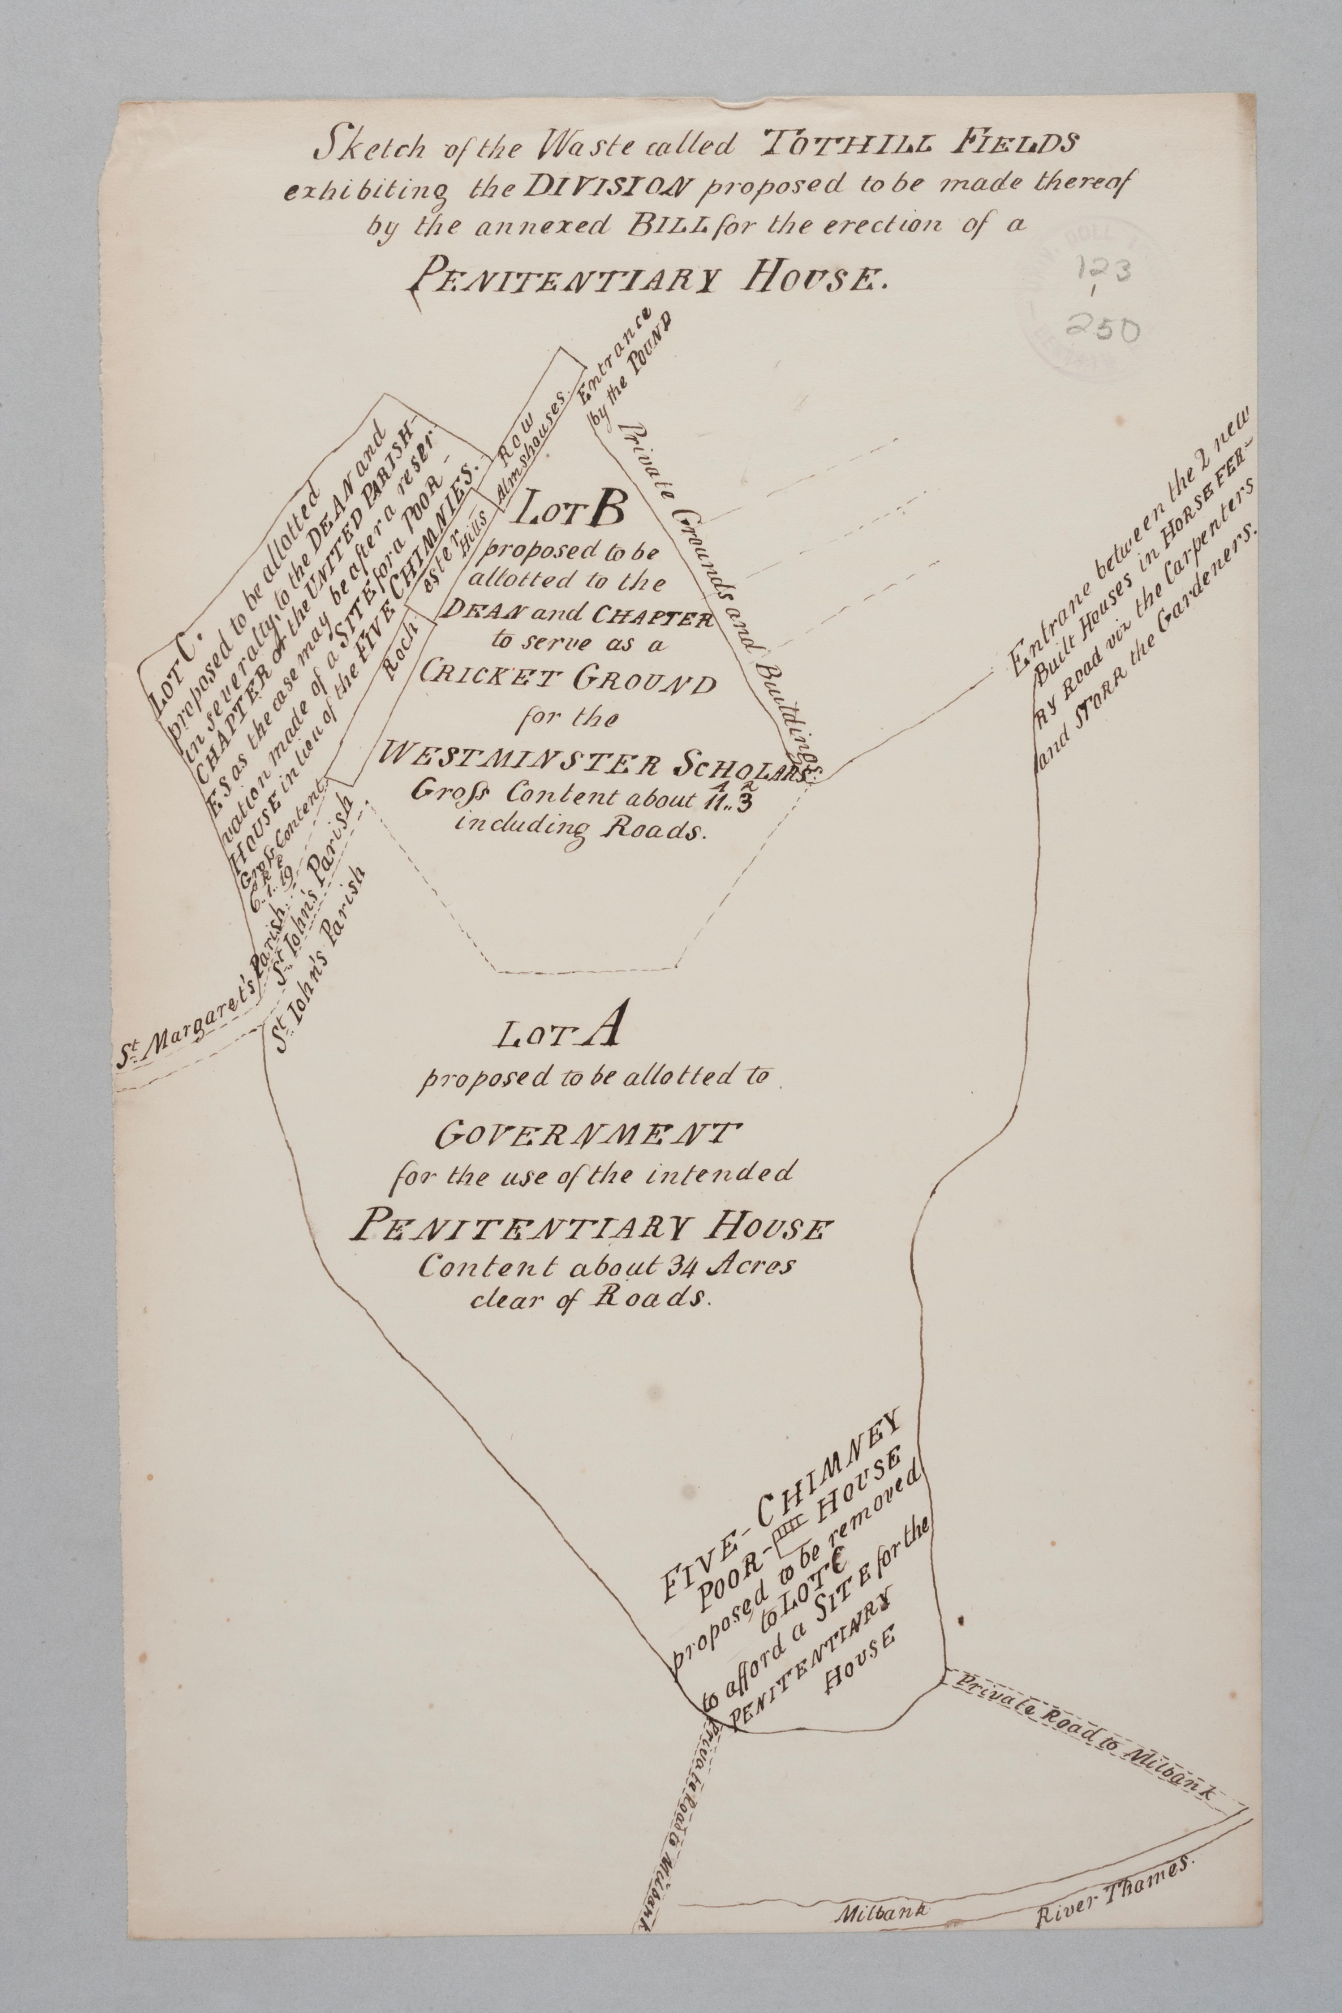

Bentham’s commissioning of prospective illustrations of the Penitentiary to Royal academician Willey Reveley, (see Figures 2, 3, and 4) illustrations which were based on Samuel Bentham’s original designs for the Penitentiary, suggest a Benthamite faith in design itself as a visual mode of efficacious felicity. (Jeremy) Bentham also drew his own diagrammatic illustrations for the purposes of persuading funders, and in the act of doing so, would have become more and more invested himself in the probability of a happy outcome for his proposal. Confident and enthusiastic in its hand and words, Bentham’s ‘sketch for the general form of the whole building’ (see Figure 5) promotes airy spaces for prisoners, secure and free to move about without chains, to work in any required trade, as he offers to his potential funders: ‘the above [sketch] is a meer idea for your fertile imagination to begin upon’. Another illustration in Bentham’s hand (see Figure 6) applies visual rhetoric of his time: a triangular figure with emanating lines, flanked with calls for Mercy, Justice and Vigilance, respectively, bears remarkable similarity to Masonic symbols which would have been circulating, even covertly. Bentham’s inclusion of Psalm 139 seems surprising considering his views on religion, but he was setting up an illustrative relationship between text and image that was probably intended to speak to those for whom a Psalm would have lent justification to an otherwise secular project. Bentham himself eschewed both the Church of England and Freemasonry, avoidances highly unusual for his class and his historical time and place. He deployed the Psalm perhaps as a tool of persuasion to the wealthy elite who would have been deeply embedded in the social and economic milieus of Church and government.
Characteristically, Bentham interpreted the Psalm applying his own philosophical proposition of surveillance, taking liberties with the translation of the Latin in his version of the psalm’s opening lines: ‘Thou art above my path, and above my bed: and spiest out all my ways’. (see also Reveley’s version of this diagram, Figure 7) Bentham never doubted an outcome of greatest happiness pledged by these visual attendants to his proposal.
Figure 2. ‘Section of an Inspection House’, UC cxix. 119.
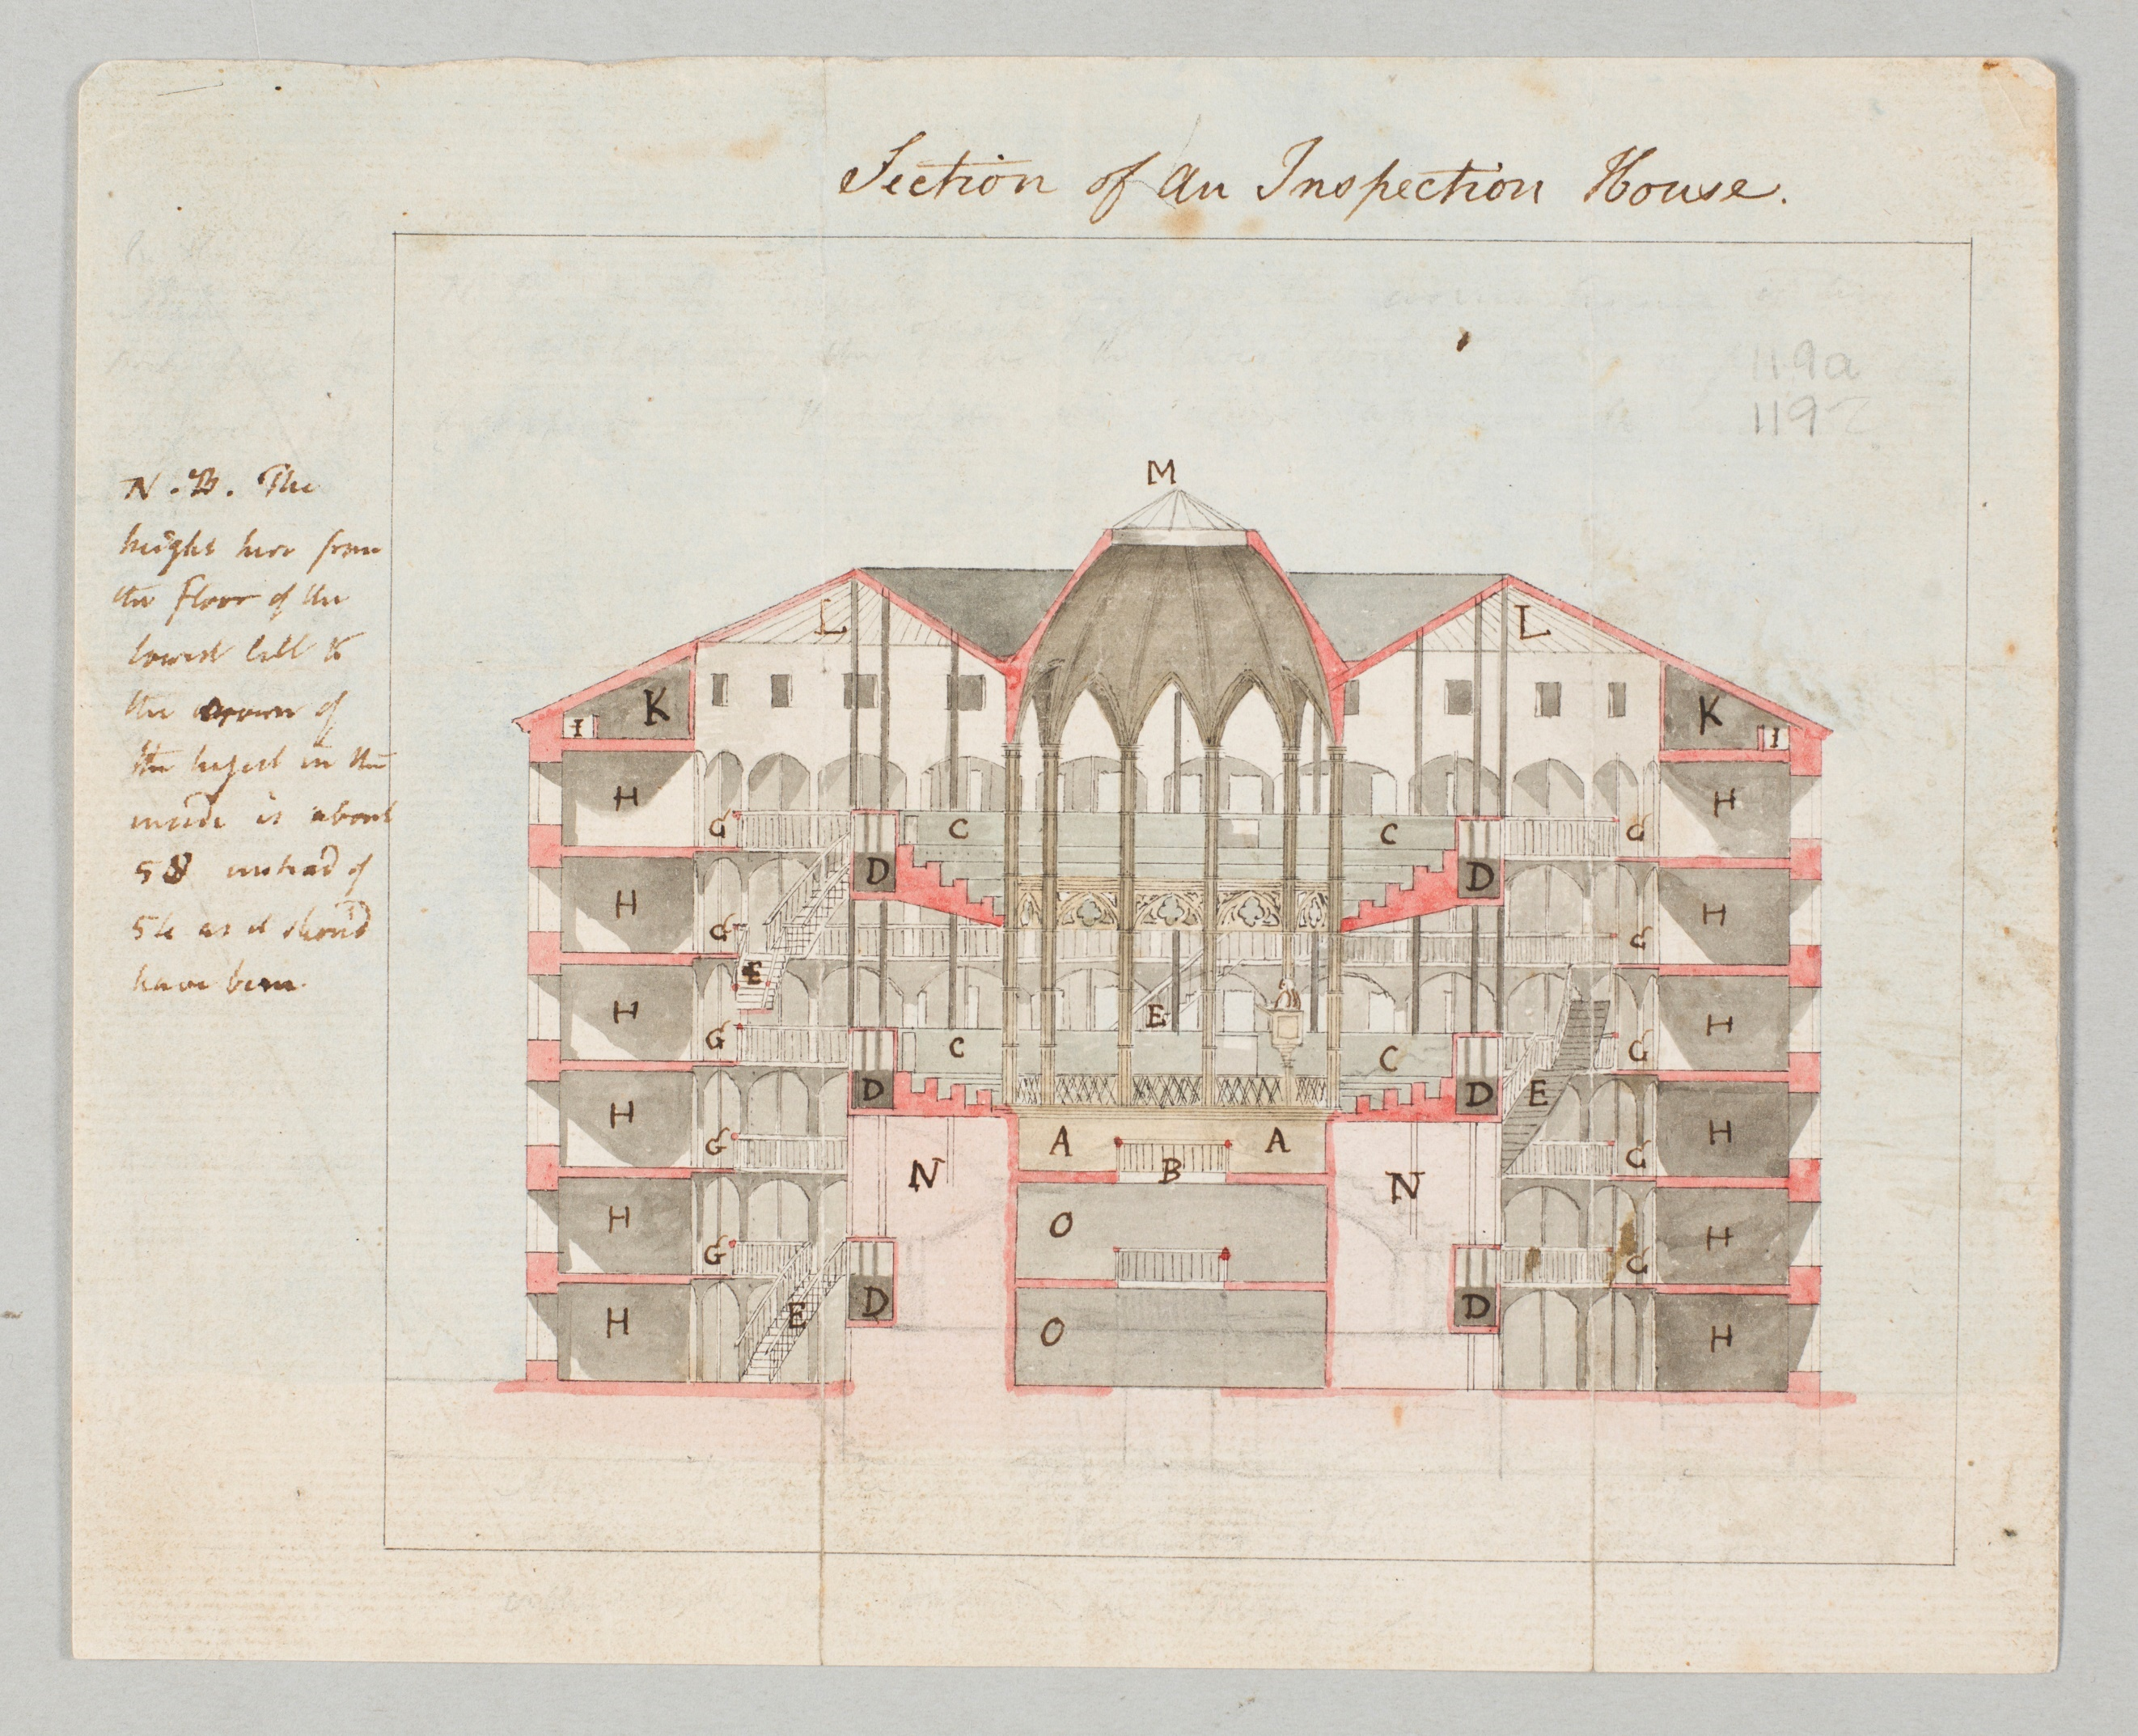

Figure 3. Willey Reveley, elevation, section and plan, 1791 (Bowring, iv. 172–3).
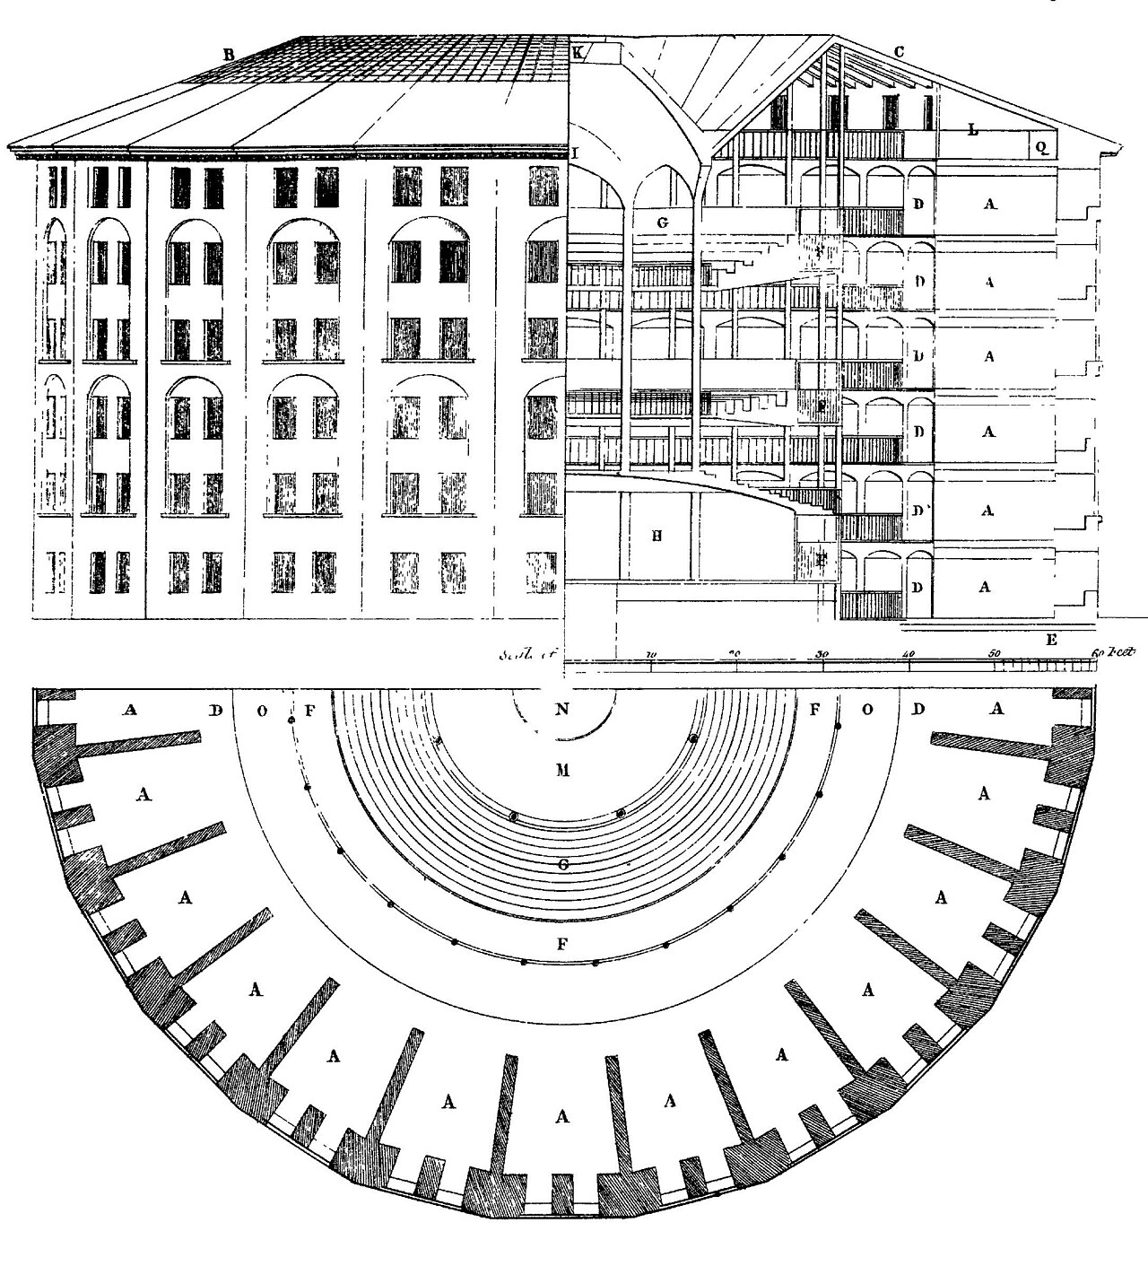

Figure 4. Pencil, pen and ink and watercolour sketch on paper, inscribed with manuscript notes, UC cxix. 121.
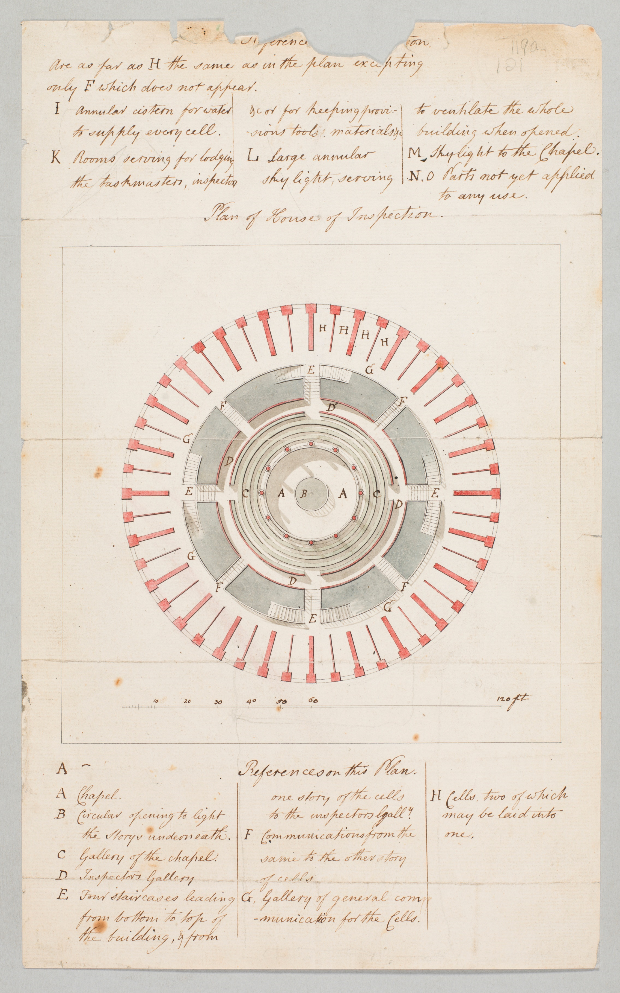

Figure 5. ‘[A] sketch of a general form for the whole building’, UC cxix. 129.
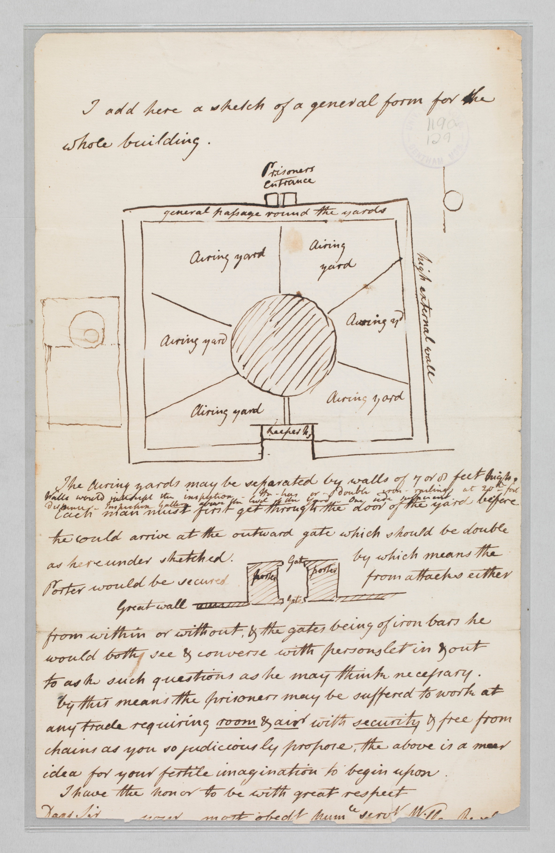

Figure 6. Bentham’s panopticon interpretation with Psalm 139, UC cxix. 124.
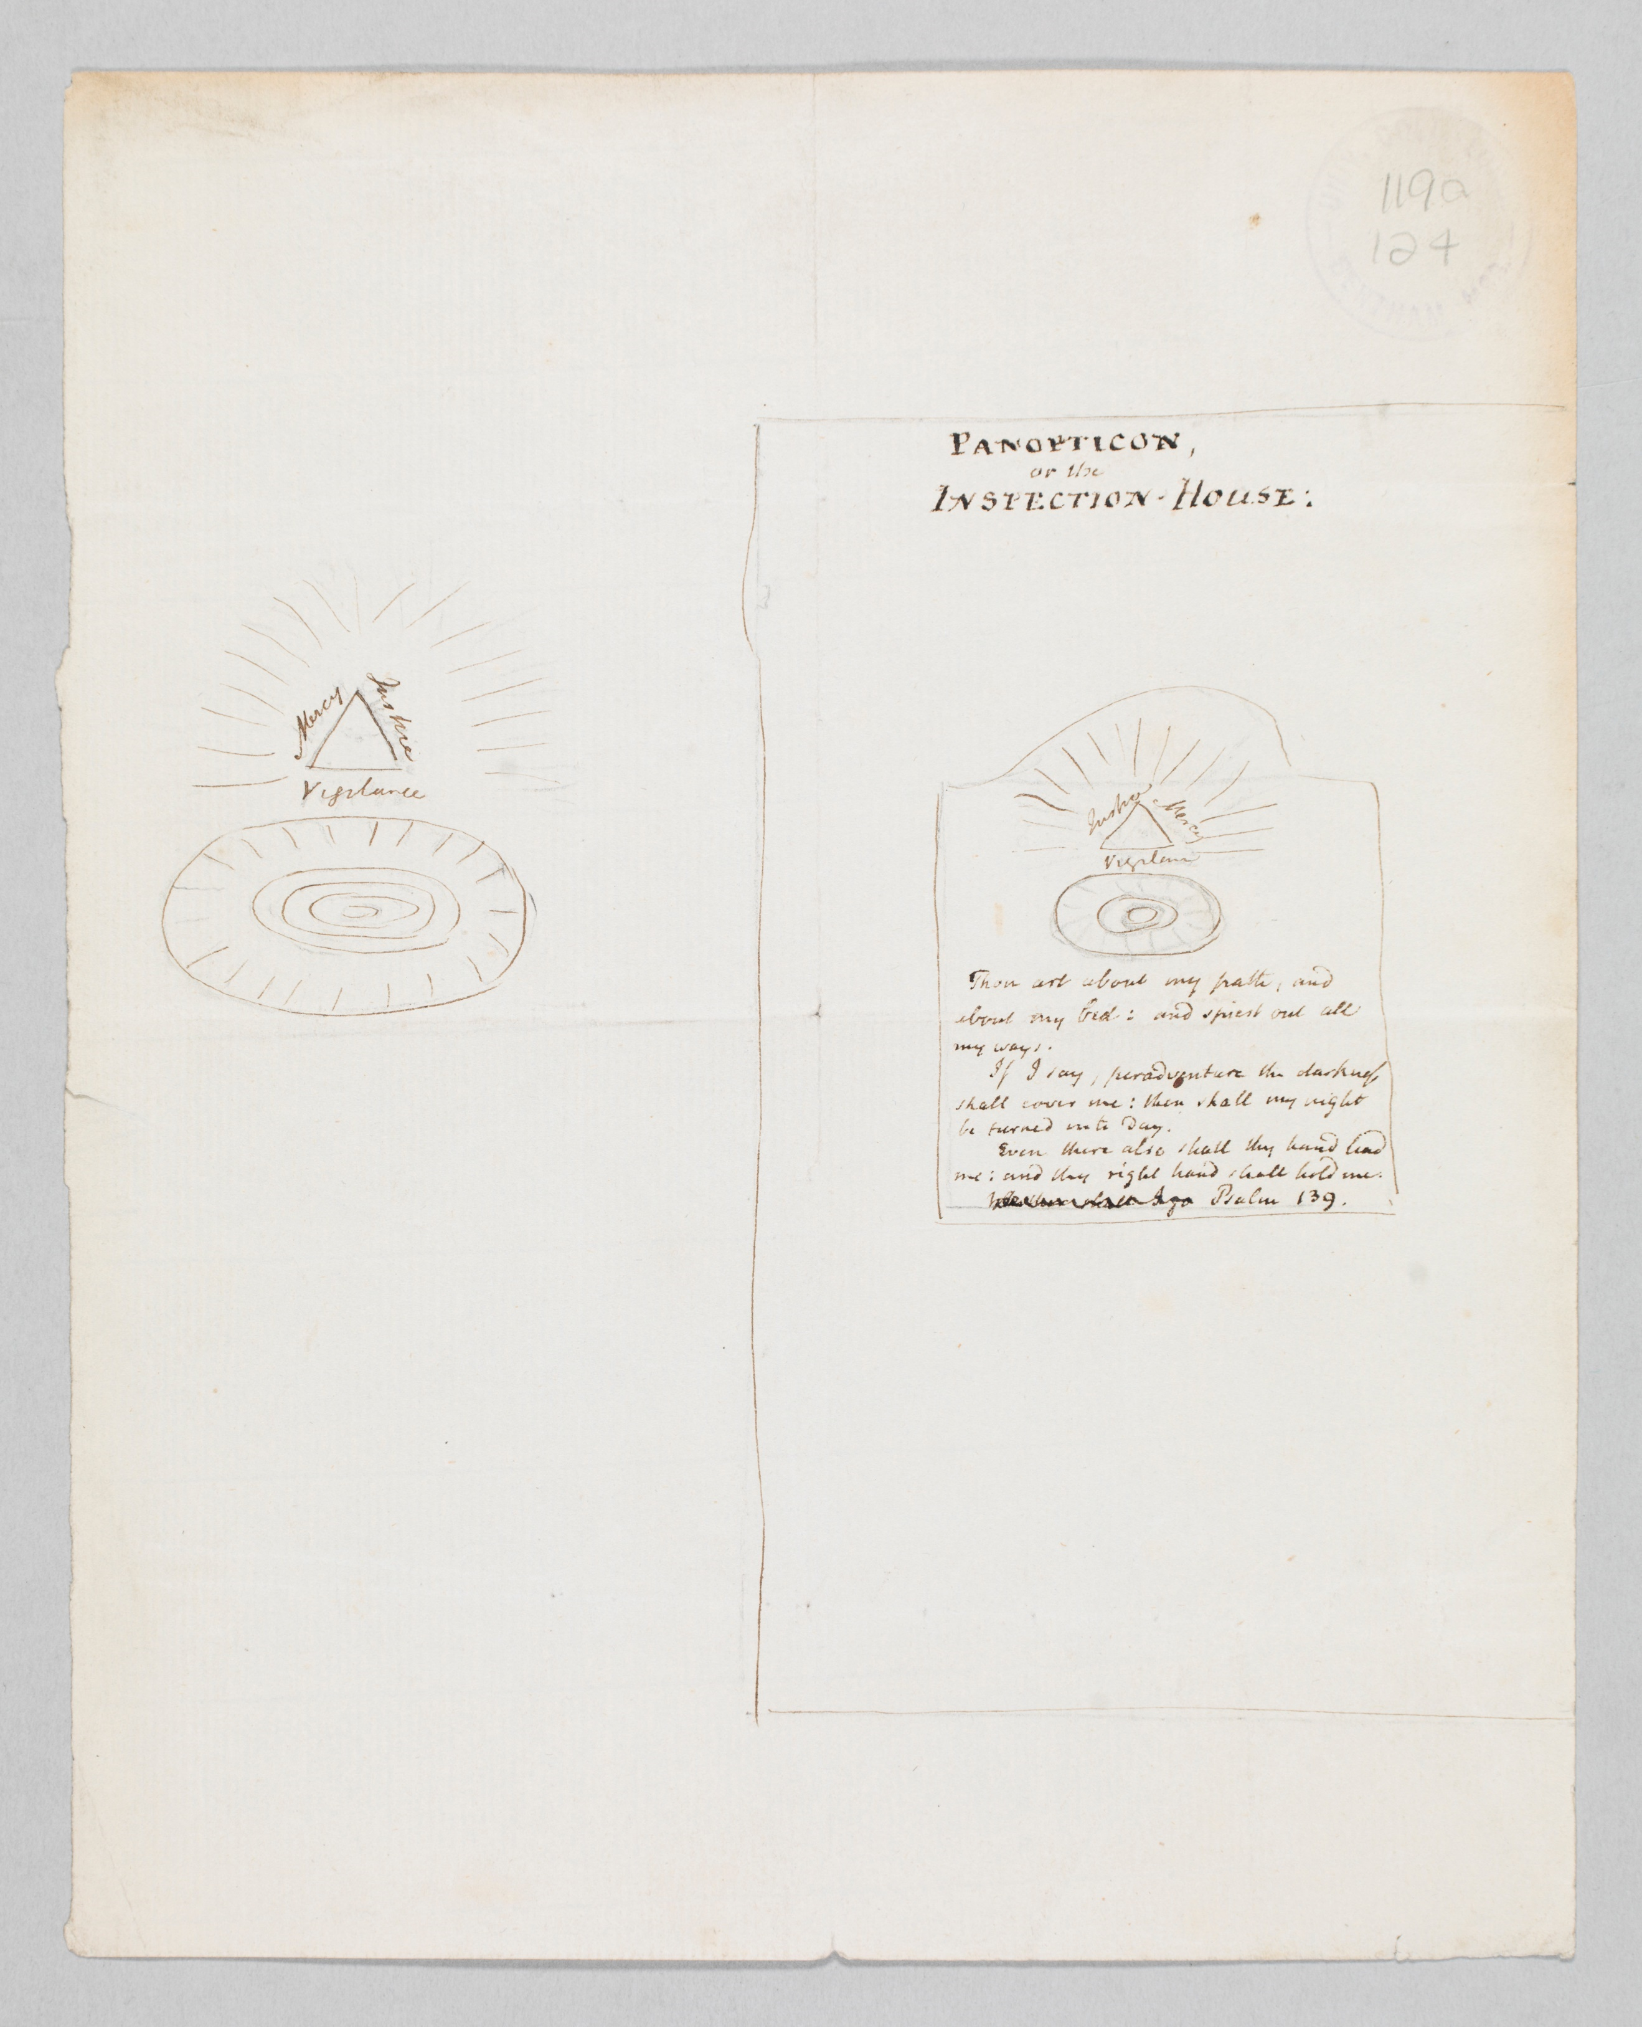

Figure 7. Reveley’s version of Bentham’s interpretive illustration, UC cxviii. (Reproduced in Correspondence (CW), iv. 219).

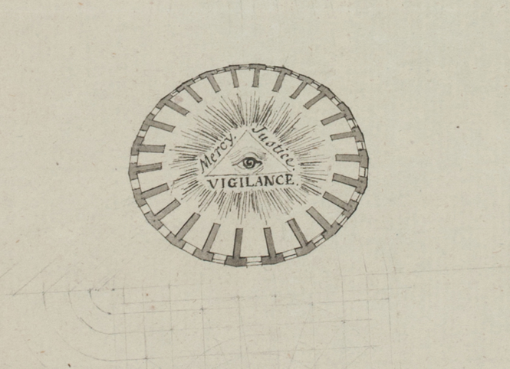
Bentham also drew very early-stage maps outlining the distinctive parameters of the initially proposed property, Tothill Fields, as determined by adjacent holdings of Lord Salisbury and Lord Belgrave. It is these adjacent holdings which supply the dramatic subject matter for Bentham’s ongoing negotiations with the actors of the Treasury, as he chronicled in his long address to Lord Pelham.
(See Figure 8). Almost like modern art, these very early-stage maps that Bentham drew bear a beauty in their abstraction, the beauty of immanence. Through his sketches, Bentham imagined the open, propitious space within the distinctive outline of Tothill Fields, which had been allocated for Bentham’s purposes by Parliament in the Penitentiary Act of 1794, but which never actually materialised as such. Not a private property but a public one, Tothill Fields, in the course of Bentham’s travails, and as presented in his many sketches and maps of the property, serves as a kind of visual central core around which the drama of property lines gathers. One can imagine these early hand-drawn sketches as direct expressions of psychic projection and as indicators of the land onto which Bentham imagined that he and many others would walk. (See Figure 9). He considered his maps to be tools of persuasion that would have enhanced his written proposal, as suggested by his inscription accompanying these maps: ‘23 Nov: 1797. Sketch of the Waste called TOTHILL FIELDS: exhibiting the Division proposed to be made thereof, by the annexed BILL for the erection of a PENITENTIARY HOUSE. To accompany the CASE, explanatory of the Said BILL’ (T 1/794).

Figure 8. Simple line drawing of Tothill Fields, UC clvii. 90.

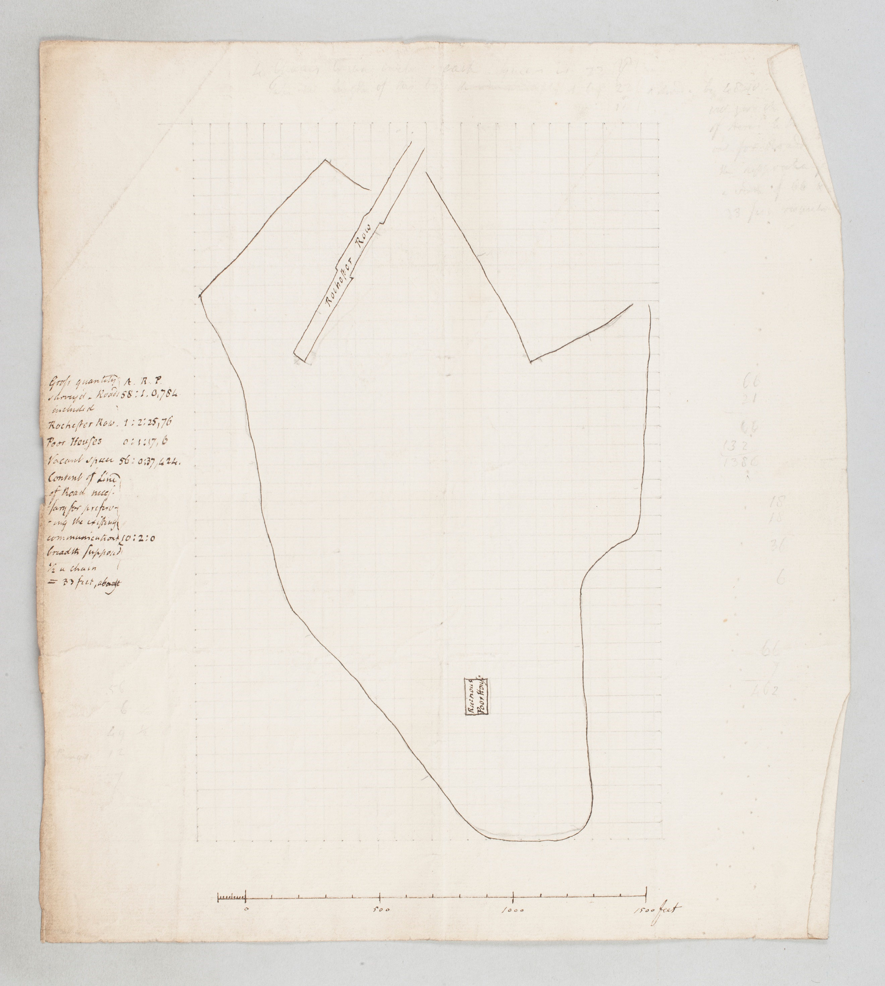

Figure 9. Hand-drawn prospective map, with labelled ponds, streets and rows of houses, and the Five Chimneys Poor House, UC clvii. 81.
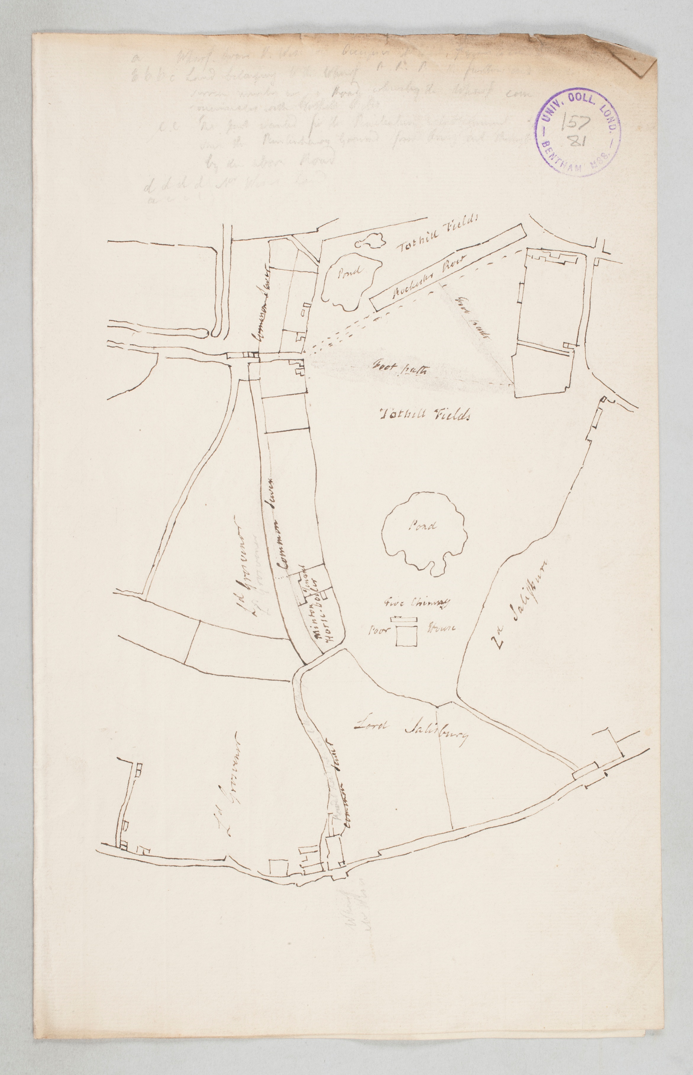
Despite its unequivocally better usage as grounds for the national penitentiary, Tothill Fields came to act, especially when seen as a repeated visual trope, almost an abstraction, a placeholder which is nothing but an empty, suspended field of waste around which the ensuing action would occur, a field which served the purposes of maintaining the system, the establishment. Lord Salisbury’s bordering property is ‘offered’ to Bentham ostensibly for the purposes of extending the Penitentiary, but the property, which seems to have been purchased by the government purely to benefit the purse of Lord Salisbury, in actuality served as a further deterrent to Bentham’s purposes, adding more obstacles and challenges from what Bentham had naively assumed would be a happy outcome. The benefits for Bentham of Lord Salisbury’s property being purchased for its contiguity to Tothill Fields would be obliterated by the Salisbury property’s contiguity to Lord Belgrave’s estate, the latter contiguous item proving to be an embroiled site of deterrence.
To return to our understanding of the ‘contractor’ as figure in Bentham’s philosophical outlook: the contractor is a figure of language; it comes into its being within this milieu. It is an ideal construction of the paraphrasis, ‘as an evidence and a pledge’, as it can be immediately worked into a movement towards physical referents (signing individuals and land). Bentham’s sketches for the proposed penitentiary property denote physical land, property, as encompassed by property lines. The property line is a highly compelling signifier, both of the law, and, as a figure which indicates the ‘thereness’ of a specific place in its marking of its perimeters—and its contiguities. Just as Bentham’s linguistic technique of phraseoplerosis ‘fills up’ a word, through the supply of syntax, to give it this-ness or there-ness, that is, a physical stance in time and place, the ‘this-ness’ and ‘there-ness’ that can be immediately added into the mark of the property line endows the contractor of those lines with the ultimate physical realness: that of property. Such an ultimate realness of entities comprising the contractor presented, in Bentham’s mind, the impossibility of failure, a bulwark against misfire. For Bentham, such a grounding in real entities performed actuarially, towards the prevention of mischief.
In what has come to be understood as Bentham’s felicific calculus, probability, presented as certainty and uncertainty, is one of the six values which contribute to the calculation of the greatest pleasure and the greatest pain. While I am interested in Bentham’s engagement with probability as the important single value of certainty/uncertainty, I am also curious about how Bentham’s prerequisite of the ‘greater good’ might be understood as a general paradigm of probability. If probability can be predicted and calculated, or, more exactly, if probability needs to be predicted and calculated as a kind of safeguarding within society, it does suggest that chance and even fate are always present with the calculus devised for the very purpose of minimising chance by meeting as many people as possible in its promised security. While Bentham tends to be approached through the positive aspect of his philosophical operation, I would like to bring forth here the flip side of the coin: that the aim of Bentham’s felicific calculus is to set up affordances against the likelihood of infelicity and mischief.
As an illustration of the general tendency towards infelicity, one of Bentham’s central notions, is that language as an entity is fundamentally prone to fiction in its usage, application, and in its very structure. Mischief is always waiting in the wings, and must be stopped in its probable tracks. Arguably, the prevention or insurance against the high possibility of mischief as carried out through language is at the core of Bentham’s greatest happiness principle, and I am struck, as was Jean-Pierre Cléro in his examination of the influence of English philosophy on Jacques Lacan, by Bentham’s understanding of affordance and chance as it plays out in linguistic scenarios. Comparing Bentham and Lacan’s similar inclusion of foreign language terms within their respective writing strategies, Cléro notes,
Bentham, of whom Lacan, as we shall see, had detailed knowledge, shared the practice of introducing foreign terms in his own language, and he theorized the procedure in these terms in Church-of-Englandism and Its Catechism Examined (London, 1817), 203: ‘Say pretium affectionis: not because for English use Latin is better than English; but because an expression—which, being borrowed from any foreign language, is stuck into the vernacular language—affords a better chance, than can be presented by any correspondent expression taken from the vernacular itself for laying hold of the attention and fixing itself on the memory.’
Bentham and Lacan are not the only philosophers to include foreign language terms in their writing, of course. But I want to underline here Bentham’s material approach to language and the ways in which, as such, language can be deployed to ‘afford a better chance … for laying hold’ (emphasis mine) within a general milieu of chance. The calculus of greatest happiness is devised to be applied as a prophylactic to what could or would otherwise go amiss.
In A Picture of the Treasury we sense Bentham’s anguish at having been excluded by the Treasury machine. He did not anticipate feeling ‘missed’. In his mind, each of his encounters within the apparatus of the Treasury accumulated the certainty of his proposal’s success. In fact, he remarks confoundedly, barely any calculation was even needed, as the whole business was practically all summed up:
What crowned the whole, and gave at once a complexion of unprecedented practicability to the whole business, was a sort of providential conspiracy of favourable incidents, in virtue of which an absolute mathematical minimum of trouble promised to suffice for the completion of it. Not only the Marquis was willing to sell, but (what was more) his Lordship’s Agent (Mr Estcourt, the Sollicitor to the Stamp Office) was a gentleman whom Mr Long (virtute officiarum) was under the frequently recurring necessity of seeing about other business. This circumstance was communicated to me by Mr Long; and the value of it was not lost upon me.
Writing from the point of failure and infelicity, Bentham conveys a sense of misery in his own naïve thinking that he could even have begun to calculate towards a happy outcome in an environment roiled with sinister interest, insincerity and of course power. The title of Bentham’s address to Lord Pelham piques our interest in that he is painting a figurative ‘picture’ of his experience, but the signifier ‘Treasury’ must also not be taken solely at face value, because it stands in for the larger force at work which ultimately controls the outcome, a force which, Bentham learns, he cannot calculate against because it consistently deflects anything from actually happening. We could say that Bentham’s angst expressed in Picture centres around not so much bad luck but around no luck, that is, hap-lessness, in the face of a machine, the Treasury, which ultimately offers him nothing, effectively, no consequences whatsoever.
Bentham’s recently published manuscripts on logic and language have been helpfully framed by Philip Schofield as a bold encounter with Aristotle, or rather, with the University of Oxford’s standard text book version of Aristotle which had been based upon Sanderson’s Logicae artis compendium of 1618. As Schofield carefully unpacks, Bentham, even as a (very) young student at Oxford, identified a foundational misconception of logic on Aristotle’s part which Bentham would ‘”treasure … up in his mind”’ as a platform for what would become his own radical philosophical departure: Utilitarianism. Bentham contends with the theretofore unquestioned centrality of knowledge purely for purposes of its acquisition in Aristotle’s comprehension of logic. Schofield notes that ancient Greek philosophy in general and as exemplified by Aristotle valued knowledge more than happiness, the latter of which would simply ‘”follow as of course.”’ This ‘as of course’ was not satisfactory to Bentham, who proposed that logic instead was part of a ‘field’ which comprehended thought and action, also understood as science and art. Bentham thus activates knowledge beyond static acquisition to include an effective operation of affordance. As summarized by Schofield, the remit of logic for Bentham always entails conduciveness: ‘Bentham aimed to give a coherent and consistent account of the whole field of thought and action and to organize it in the way that was most conducive to the promotion of well-being.’ When knowledge does not lead to well-being/happiness, its value is ‘”just nothing”’.
Throughout his Seminar of 1959-1960, entitled The Ethics of Psychoanalysis, Jacques Lacan elaborates what he marks as a tectonic shift that occurred between Aristotle and Freud. Lacan characterizes this shift as ‘the utilitarian conversion or reversion’ attributable to Jeremy Bentham’s introduction of a linguistic philosophy which was revolutionary in its constructed separation between the terms ‘real’ and ‘fictitious’. Lacan thanks the linguist Roman Jakobson for providing him with the ‘key, the little latch’ which was Jeremy Bentham’s Theory of Fictions. Bentham’s theories of fictions inspired Lacan’s register of the symbolic. ‘The fictitious [in Bentham] is not, in effect, in its essence that which deceives, but is precisely what I call the symbolic,’ announced Lacan. Jean-Pierre Cléro emphasises Lacan’s fervour in recognising a kindred structuralist in Bentham: ‘Lacan says forcefully: Bentham “approaches the question on the level of the signifier.”’ Further, as Lacan himself points out, in their respective theories of language both Bentham and Lacan (following Bentham’s ideas) place the real and the fictitious in dynamic dialectic.
Lacan traces the trajectory that leads from Aristotle to Bentham to Freud through the whereabouts of pleasure. Freud designates ‘the pleasure principle’, a guiding force, to be ‘on the side of the fictitious’, that is, within the symbolic. Lacan proposes that Freud’s transformation from ‘Aristotle’s … idea that pleasure has something irrefutable about it, and that it is situated at the guiding pole of human fulfilment, insofar as if there is something divine in man … his bond to nature’, to Freud’s ‘pleasurable element … which directs man in his behaviour without his knowledge …’ marks a revolutionary shift by which knowledge is no longer sovereign, replaced as it is by the ongoing complexities of the actions and chains of signification, complexities which Bentham understands as ‘logic’, a dynamic field of affordances for pleasure and hence well-being. Closely reading Bentham’s Essays on Logic, Ethics, and Universal Grammar, Philip Schofield has provided a painstakingly detailed explication of Bentham’s aggregative and bifurcative method by which Bentham aimed to improve upon Aristotelian logic by creating two ‘arms’ for each given entity where each ‘arm’ signified ‘properties’ of the given term rather than only one of the terms doing so, as was the case with Aristotle’s method. Bentham’s improved method fortified the language, working it closer to real entities and serving as a more performative version of logic in its purposeful achievement of greater well-being. Bentham’s method of aggregation and bifurcation for the purposes of extending and expanding the ‘properties’ of the terms aligns with what Lacan develops as the metonymic economy of the symbolic. With the site of pleasure now moved from the metaphysical realm of knowledge, thanks to Bentham, Lacan embraces the residence of pleasure within ‘fiction’, adopting, as credited to Bentham, a quality of fertile materiality proper to signification, a kind of plasticity that is performative.
Lacan also understands what I am calling the plasticity of signification (in Bentham’s terms, fiction and its logical operations) as a philosophical ‘crossroad’ regarding the Good, building upon cross-linguistic differences between English and French regarding the word ‘good’. In English, the plural word ‘goods’ carries a material definition of economic exchange, a definition which for Lacan is integrated into his ethical understanding of what is ‘good’. A lengthy citation from Lacan, keeping in mind Schofield’s analysis of Bentham on logic and language, consolidates Bentham’s paradigm shift away from Aristotle into a new realm of material potential for ‘good’:
With relation to institutions in their fictive or, in other words, fundamentally verbal dimension, [Bentham’s] search has involved not attempting to reduce to nothing all the multiple, incoherent, contradictory rights of which English jurisprudence furnishes an example, but, on the contrary, observing on the basis of the symbolic artifice of these terms, which are themselves also creators of texts, what there is there that may be used to some purpose, that is to say, become, in effect, the object of a division. The long historical development of the problem of the good is in the end centered on the notion of how goods are created, insofar as they are organized not on the basis of so-called natural and predetermined needs, but insofar as they furnish the material of a distribution; and it is in relation to this that the dialectic of the good is articulated to the degree that it takes on effective meaning for man. Man’s needs to find their home on the level of utility, which involves that portion of the symbolic text that may be of some use.

In this material sense of signification does Lacan fully embrace Bentham’s theories of fiction, which similarly understands the potential within the seemingly endless deferral of the real. For Bentham, language must be actively worked towards the physical, preventing in advance mischievous tendencies. The requisite consideration of the greater good in Bentham’s utilitarianism acts as a kind of probability calculator towards greatest happiness. Jean-Pierre Cléro clinches Lacan’s appreciation of Bentham’s utilitarianism: ‘Calculation, far from having to be rendered impossible to thought, is the essence of Lacanian desire’. Both Bentham and Lacan prioritise putting into practice the actions which work calculatively within a certain materiality (of circumstances, of aggregated signification) to reach or encounter ‘the real’.
Thus while Lacan is reiterating Bentham’s fiction as his all-encompassing register of the ‘symbolic’, he is also proposing a comparison of both philosophers’ working methods towards reaching the ‘real’. I propose that Aristotle’s principle of tuché (chance) permeates both Bentham and Lacan. Lacan’s insight and his thorough embrace of Bentham’s theory of fictions that alert us to the centrality of chance in philosophies of happiness.
Lacan’s interprets tuché’s function as ‘encounter’, or more specifically, as ‘the encounter in so far as it may be missed, in so far as it is essentially the missed encounter’. He points out that ‘[i]t is odd that in almost all languages happiness offers itself in terms of a meeting—Τύχη [tuché]. Except in English and even there it is very close. A kind of favorable divinity is involved … “[h]appiness” is after all “happen”’. Lacan’s fundamental notion of desire comprises the treadmill of almost always-missed encounters, accepting happenstance. As Cléro highlights, ‘while Lacan clearly states that “no roll of the dice in the signifier will ever abolish chance”, it is “for the reason that no chance exists outside of language, and under whatever aspect it is conceived, of automatism and encounter”’. Chance and the missed encounter seem here to be shot through the social order, inviting calculation towards the greater social good. For Lacan, ‘the real’ is an encounter that is a kind of rare ‘hit’ amongst incessant repetition (which is applies to everyday life but particularly in the psychotherapeutic setting) within endless chains and substitutions of signification. Bentham’s calculus of felicity works against what chance might present.
Cléro opens his chapter on Jeremy Bentham in his book Lacan and the English Language (2020) by highlighting Bentham’s philosophy of language which was so influential upon Lacan, a large proponent of Bentham’s philosophy that he argues has been neglected in the dominance of the Panopticon philosophy popularised by Michel Foucault from the 1970s onwards. Cléro notes that Lacan took no interest at all in Bentham’s Panopticon project. If he had read Bentham’s letter to Lord Pelham, Lacan’s ‘true connoisseurship of Bentham’ might have reached levels far beyond his considerable admiration of Bentham’s theory of fictions.
The Contractor manqué.
I am reading A Picture of the Treasury psycholinguistically as a case study of the subject’s missed encounter with language. Bentham is expressing symptomatic anxiety around feeling ‘manqué’ within a network of interrelating signifiers—a network which operates as a machine. The Treasury was a ‘hazardous’ machine as would have been understood by Lacan: ‘speakers are destined to little more than a hazardous and precarious identification with … language’. Bentham’s optimistic philosophy that laid down a calculus for reaching the greatest happiness for the greatest number worked within a certain propitiousness that he effectively attributed to fiction’s possibilities. The element of probability is what Bentham misjudged in the case of his Penitentiary proposal to the Treasury.
Bentham’s calculations, based on the promises, contracts and encounters detailed in his address to Lord Pelham pointed to an extremely high probability of success for his proposal to acquire land, as brokered by the Treasury. He had understood that the series of encounters was happy, creating a midst of general felicity which ‘could not miss’:
the plan—Your Lordship may have observed—the plan such as it is, Your Lordship sees it—is a plan [that] could not fail—that could not miss of answering its intended purpose. Accordingly, it has not missed of it. But why not fail? because of the situation, from which the operations (including the no-operations) were to be carried on. If in that situation a plan had been capable of failing, this would have failed over and over, as Your Lordship will see, by the execution of it.
Reading Bentham’s agonised narrative we understand that indeed, he was confident within his own probability calculus: the plan ‘could not’ miss/‘has not’ missed.
At the same time, however, Bentham includes within his narrative indicators that the construction of his Penitentiary was an impossible act to fulfil; there are inklings of warnings that he admits to from hindsight. It is as if his constant battle with mischief that is so important in his critical positioning overall is impossible for him to ignore, despite signs of certainty for his success:
No, my Lord—notwithstanding so many mysterious warnings, as at different times had been play’d off upon me, in such a variety of black and appalling shapes (of which hereafter) from the tongue, the pen, and the brow of the Master Secretary—notwithstanding all this and more, it had not yet occurred to me—that the death of my plan was to flow from the very spring and fountain of its life, and that the establishment was to date its overthrow from the purchase of the first spot on which it could find ground to stand upon.
Here, Bentham’s tone is almost supernatural in what he now recognises as ‘so many mysterious warnings’; his plan was from its very first spot of ground marked for failure, or, in Bentham’s more dramatic characterisation, it was a plan ‘overthrown’ from the beginning; from its very ‘fountain of life’ sprang an already dead plan. I am reading Bentham’s state of being overthrown as the effect of a psycholinguistic predicament: feeling missed by language. Already prescient in what we now know as the Lacanian understanding of the subject made discontinuous with his own knowledge by the otherness of language, Bentham names his predicament ‘Contractor manqué’, which refers to the seemingly probable success that the subject-within-language, the contractor, promises but never meets. In this sense, Bentham is hap-less, and, as such, ‘fit for nothing’:
As a would-be Contractor, I was an object of envy and ill-will: as a Contractor manqué, I was an object of contempt: as a man of no party, I was no object of support: as a man radically incapable of belonging to a party, I was without resource.
But were there not wider circles? ... O yes, my Lord, but too wide. To what quarter could a man like me be expected to look for help? As a would-be Contractor, I was an object of envy, jealousy and ill-will: as a contractor manqué, an object of contempt: as a man of no-party, no-object of support: as a man radically incapable of being made into a party man, I was a man fit for nothing, a man without resource.
Interestingly, Bentham sets up the tension between Contractor and Contractor manqué through their temporal values. The prominent plenteousness of the Contractor who ‘would be’ is counteracted by the brutal reality that Bentham’s Penitentiary was never really grounded in property at all.
Feeling defeated by infelicity of the promise, the Contractor manqué personifies the missed encounter. He is helpless in the face of larger powers—Bentham often uses the word ‘conspiracy’ to name the directive force, and he frequently invokes fate, ill-fate and its handlers: ‘in my unhappy case, to learn the will and pleasure of the invisible and inaccessible arbiter of my fate—there was the great, and continually recurring, and never surmounted, difficulty’. Bentham repeats his status of would-be contractor-only to be contractor manqué as emphatic refrain, and this repetition is a clue to readers today of his painful, albeit not entirely unexpected, recognition of the pitfalls of living within the hit-or-miss randomness of the language of law. Bentham’s rhetorical disjunction between the ‘would be’ person who is envied for his success and the person whose promise was never met, and, as such, was ‘manqué’ on all accounts (party, object of support, all resources), speaks to the not-necessarily reliable social identity with which the individual always contends. As argued above, the element of unreliability or chance is part of, following Lacan following Bentham, all signification, hence, the necessity to calculate against what could go wrong or what might never happen at all.
Bentham’s play across languages always contributes to the depth and richness of his writing. Translated into English as ‘missed’, the French word manqué is used to describe what a person could or should have been but never was, a state of being ‘missed out’. An etymological search reveals layers of linguistic usage and application which intertwines failure, (missing) the mark, going wrong, and lack. To cite etymolonline:
‘Miss’ originates from the Old English missan, meaning ‘to fail to hit, miss (a mark); fail in what was aimed at; escape (someone's notice)’, and is related to the proto-Germanic word missjan, meaning ‘to go wrong’. (source also of Old Frisian missa, Middle Dutch, Dutch missen, German missen ‘to miss, fail’, from *missa- ‘in a changed manner’, hence ‘abnormally, wrongly’, from PIE root *mei- (1) ‘to change, go, move’. Reinforced or influenced by cognate Old Norse missa ‘to miss, to lack’.

Supplementing the richness behind the English word ‘miss’, Bentham chooses the French manqué to characterise his state as ‘contractor’. As I mentioned above, Bentham himself noted that his use of foreign language within his own English writing is a mode of ‘affordance’ (as is all language in a more general sense) which supplies ‘a better chance’ against an implied general milieu of chance which needs to be better managed. Bentham would have been aware of the complexity of the meanings offered only in the French. ‘Manqué’ allows for subtle shifts in meaning and usage according to whether de or à follows the word, or, whether it is used in the uniquely French reciprocal syntax, e.g. ‘Tu me manques’ to mean, ‘I miss you’. In selecting the word manqué Bentham gathers the experience of things having gone wrong (from the position of being subject to luck or chance), as well as the notion of having missed a particular opportunity, as well as, perhaps, the specifically French feeling of missing someone through a detour of some one or thing other to the feeling person.
It could be argued that ‘mischief’, referring to law going wrong, is the underside of Bentham’s greatest happiness for the greatest number proposition. Mischievousness refers to bad law which diverges from the common end of happiness. Bentham’s project of utility is fundamentally engaged in working law—which is language—away from mischievousness. As I have developed previously, the word ‘mischief’ comes from the Middle English and Old French mes-chef, meaning having a bad end, missing its direction (i.e. its ‘head’), also to be understood as ‘misfortune’. We might understand the prefix ‘mis-’ in this sense to modify that something has gone wayward, or off course, and it is not surprising that Bentham infuses the text of A Picture of the Treasury with an entire lexicon of words prefixed by their going awry. Applying an indexical search within Picture for terms beginning with ‘mis’, we find multiple mentions of the following words:
‘mischief’/‘mischievousness’; ‘misbehavior’; ‘misconceptions’; ‘mistaken’; ‘misconstruction’; ‘mis-statement’; ‘miss/missed’; ‘miscalculation’; ‘misled’; ‘misdeeds’; ‘misfortune’; ‘misconduct’; ‘misdemeanors’; ‘misinformed’; ‘mislaid’; ‘mismatching’; ‘miscarry’/ ‘miscarriage’; ‘misapprehended’; ‘misrecollect’; ‘amiss’; ‘misapplied’
Bentham masterfully parses the repercussions of his critical figure, the Contractor manqué,
acutely aware of the etymological resonances and the persuasive effectiveness of rhetorical flourish.
As the Contractor manqué is a construct of language, it feels appropriate to consider speech act philosopher J.L. Austin’s notion of the ‘performative’ as elaborated in the lectures that he delivered at Harvard in 1955, entitled and published as How to do Things with Words. In these lectures Austin introduces the ‘performative utterance’, which he explained could also be called ‘operative’ language, crediting H.L.A. Hart. By the end of the lecture series, Austin comes to see all language, including constative utterances, as operational, that is, as ‘performatives’. But as he expands his thesis, we learn that with language’s operationality always comes the considerable possibility of failure, or, more relevantly, of infelicity. A failed utterance, he explains, is ‘not indeed false but in general unhappy’. Exemplary performative speech acts are the contract, the pledge and the promise. What we are reading in A Picture of the Treasury records a build-up of what seemed to be probable felicific signs of sure-fire success indicated by promises and contracts. Bentham inscribes an interesting inevitability of the proposition being ‘incompleatable’. Infelicity shoots through in various moments of his narrative. In a dramatic recounting of his encounter with Charles Long, who on horseback imposed upon Bentham an imperious effect of grandiose generosity, Bentham recounts the glorious effect of this accidental meeting, which occurred ‘somewhere along Constitution Hill, which connected The Mall, in front of The Queen’s Palace (now Buckingham Palace), with Hyde Park Corner’:
To my enraptured eyes, the brow of Constitution Hill was thus transformed, all at once, into a Mount Pisgah. With the eye of flesh and blood nearly, and with the mind’s eye compleatly, I thus grasped, and for the first time, the beatific vision of a happily situated and easily accessible and compleatable, though in the first instance uncompleated spot, with a phantasmagoric view of a compensation for the deficiency. In this eventful period—a period of which the maximum was three minutes, my ears had full employment, my tongue could scarce obtain, or so much as seek, an interval for utterance.
As annotated by our excellent manuscript editors, readers are reminded that: ‘Mount Pisgah was a mountain to the east of the River Jordan, from which God allowed Moses to see the Promised Land: see Deuteronomy 3: 27, 34: 1–4.’ Bentham’s analogy of himself on Constitution Hill with Moses on Mount Pisgah knowingly inscribed the foreclosure by God, who told Moses that he could look at the promised land but that he would not go into it. Here, Bentham’s rich intertextual systems are on display, giving the narration layers and tensions. In the case of Moses (and Bentham), the breaking of the promise of the promised land doubled the affective impact of infelicity.
Bentham’s long account of the different wrongdoings that befell him could be diagrammed as what J.L. Austin explicated as the Doctrine of the Infelicities, which charts everything that can go wrong in a performative utterance, an utterance which performs an action (‘I apologise’; ‘I christen this boat’) in its very utterance. As seen in Figure 10, on the right side of Austin’s chart is the category of Abuses: ‘Abuses: Act professed but hollow’, characterised by ‘Insincerities’. Throughout Picture Bentham focuses on the tug between sincerity and insincerity, the latter of which indeed led to infelicity. Looking at the left side of the chart, we see the complex category of Misfires—Austin’s general term for things that go wrong in a given performative utterance—or actually, as Austin builds up in his lectures, in all language. The Misfire, as Austin anatomises it, is the overall name for many possibilities: Misinvocations, Misexecutions, Misapplications, Flaws and Hitches. The vicissitudes of the Misfire all have in common the prefix mis-, which I have elaborated above, going back to the Old French mes- (based on Latin minus), and which is, I am arguing, at play in Bentham’s overall conception of mischief and of the Contractor manqué. As with Bentham’s understanding that mischief is always at play in language, Austin similarly recognised a certain constancy of infelicity:
How widespread is infelicity?
Well, it seems clear in the first place that, although it has excited us (or failed to excite us) in connexion with certain acts which are or are in part acts of uttering words, infelicity is an ill to which all acts are heir which have the general character of ritual or ceremonial, all conventional acts: not indeed that every ritual is liable to every form of infelicity (but then nor is every performative utterance).
What Austin is saying here is that language which is meant to be performing an action will always by virtue of it being language be susceptible to going wrong, to being an unhappy performative. It reiterates, through a line of modern philosophical enquiry, what Bentham already knew about the workings of fiction as would be appreciated by Lacan. As Cléro pointed out, ‘we build conceptual momentum and find that it breaks down after a short distance. Bentham shows, with multiple examples, how the metaphorical designations through which concepts are designated, as well as represented, trigger ideas and constitute at the same time the worst obstacles to the constitution and the articulation of concepts’.
Figure 10. J.L. Austin’s doctrine of infelicities.
See J.L. Austin, How to do Things with Words, ed. J.O. Urmson and Marina Sbisà, Cambridge, MA: Harvard University Press, 1975 [1962], 18.
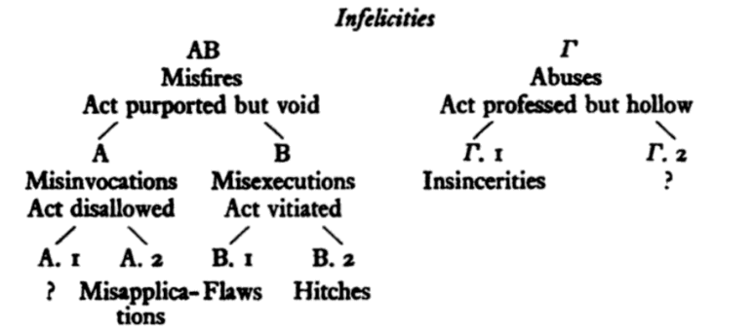
Warp and Weft: Bentham’s textuality.

(See Figure 11). To return to Bentham’s plaintive address to Lord Pelham: I devised my own diagram to illustrate what I found by happy accident upon putting ‘m-i-s’ into the search index of the A Picture of the Treasury. Finding all of Bentham’s words here that began with the prefix ‘mis’ that I have listed above, the index also picked up on all the words that contained ‘mis’ in the middle of the word. Bentham’s address is saturated with words which share the etymology of his very genre of the missive—that which is sent. It is a root word which is positivist; active; performative. Encountering Bentham’s profusion of these words related to ‘miss’ (from the Latin mittere, to send), such as ‘promise’; ‘Commissioner’/‘commission’; ‘transmission’; ‘submission’; ‘dismiss’; ‘omission’; ‘permission’ and ‘admission’, I am struck by Bentham’s virtuosity as a writer. The search index that accompanies A Picture of the Treasury allows the reader to appreciate Bentham’s material approach to his own language. His title word ‘picture’ lends the address a sense that his text is a woven canvas, with the structural, vertically orientated warp as the driving momentum of the ‘-miss’, the forward approach of the missive; and the horizontal filler material of the ‘Weft’ being those actions beginning with the prefix mis-: everything that can go wrong. While J.L. Austin reversed this warp and weft to make the ‘misfires’ the structural warp feature, I propose that Bentham, as understood and reiterated by Lacan, is more optimistic and affirmative, with probability and chance embraced within the conduits of fiction towards calculable, objective happiness.

Figure 11. Warp and Weft, adapted from Alfred Barlow, The History and Principles of Weaving by Hand and by Power, London, 1878.

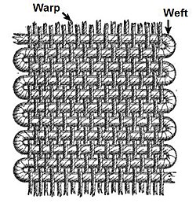
Bentham’s ongoing negotiation with probability is too large for this current paper to engage with, however, I would like to isolate one point that Gerald J. Postema makes in his analysis of how probability factors into Bentham’s theory of fictions. Postema points out that Bentham understands probability as a quality which operates as fiction. Probability is not a fact that exists in nature, but is rather relative to the assessor of evidence who would then be persuaded, as opposed to already possessing an a priori belief. ‘The key to understanding the central themes of Bentham’s ontology and epistemology, and thus his theory of probability’, writes Postema, ‘lies in understanding this thesis regarding the dependence of fictions on language and mind’. Postema’s analysis infers that probability for Bentham operates, out of necessity, outside of being true or false, real or natural.
Thus probability operates as part of the apparatus of fiction, what Lacan fully comprehends as the symbolic’s operation of ‘Tuché and Automaton’. Cléro’s explication of Lacan’s engagement with the semiotician Charles Sanders Peirce allows me to consider Tychism, Peirce’s name for his fundamental primacy of chance in the universe. Helpfully, Cléro identifies Peirce’s tri-partite logic which recognises that there is a third register—the tychic—that is neither true nor false. Peirce’s register of ‘probability that [is] not merely “subjective”’ is explained as such:
the probable is not a mode of being that can be sanctioned by the true and the false in the same way as other propositions, to the extent that the reasons to believe than an event, or a sequence of events, have a chance of happening may not be affected by truth or falsehood. … There is a way of measuring probability that eludes the truth or falsity of things, or events. … What is measured, then, is the probability of their changing as a consequence of this action.
In this sense of measuring probability, action that is neither true nor false, nor subjective, Peirce’s tychic register is a given for Bentham.
Returning to J.L. Austin’s speech act theory once again: Austin’s primary intervention is to present a new speech act, the ‘performative utterance’, as language which is radically outside of the metaphysical True-False regime; it is a type of locution which is actively non-referential to a something that ‘is’ or ‘was’. Thus, when an utterance ‘misfires’ it is not false but rather ‘unhappy’.
Lacanian theorist Joan Copjec brings together Aristotle, Lacan, Peirce, J.L. Austin, H.L.A. Hart and A. Honoré into her meticulous reading of cause in relation to tuché and automaton, and I am introducing Bentham’s felicific calculus and his Contractor manqué into her convocation. Lacan, concludes Copjec, ‘share[d] and improve[d] on the insights of Hart and Honoré. … By making the questions that require us to seek after cause arise not from the subject but from the materiality of language’. The philosophical shift away from physical force as cause over to failure and accident as possible cause shifts the discourse over from knowledge and truth into felicity, accompanied as it is by all the possibilities of infelicity.
Conclusion.
In A Picture of the Treasury Bentham narrates the series of misfires which prevented his chance for a happy outcome. The quality of being manqué speaks to his disappointment at never having had a chance from the beginning. His address to Lord Pelham paints a picture of the Treasury as a self-operating machine, paying into itself. Lacan might have identified ‘the Treasury’ as the configuration of the symbolic itself. Bentham was moving along with anticipation, waiting for something to happen. Bentham, Contractor manqué, found himself on a treadmill, without felicitous end. Again, Bentham brings in the richness of French language in his exposition of the nameless person On for which there is no exact English translation. Grammatically singular and at the same time entirely collective, the Frenchman M. On evades accountability (he is everyone and no one). On is the personage of a collective conspiracy:
in that picture of mine … there was not one individual, there was not a single name, to any one part of the picture. There is a Frenchman, my Lord, of the name of On, whose office it is—here—there—upon occasion every where—to bear the blame of every thing. His is the name, and the only name, Your Lordship will find to every part of my picture.
In Picture, Bentham has gathered the large cast of aristocrats and politicians who worked as an assemblage of interlocking parts within a single picture plane, a unified system which deflected blame. The generalised common pronoun ‘On’ of this picture-system effectively eliminated anything happening by forestalling any interruptions into its operation. Bentham’s figure of the ‘Picture of the Treasury’ discerns what Lacan would appreciate and elaborate as the operation of signification itself into which we, as subjects, join into, living hazardously, hit or miss. Incorporating the tychic register (chance, probability, fate, encounter, felicity), the material scenarios of signification recognised by Bentham, Lacan, Peirce and J.L. Austin embrace philosophies of happiness which coalesce in their respective inter-imbrication of language and chance, an interaction transpiring within the greater social fabric. Lacan’s conception of the symbolic as well as his theorisation around the real as chance encounter are indebted to Bentham’s radical shift away from the Aristotelian foundation in knowledge towards the materialist linguistic philosophy, carefully parsed by Bentham in his revision of logic that insisted upon the inclusion of active language. Implemented via the instrument of language, logic must be conducive to greatest well-being or happiness for the greatest number. Bentham’s Utilitarian philosophy embraces the subjective experience of pleasure as well as the understanding that ‘happiness’ is what may or may not ‘happen’ according to exterior factors of chance, probability and calculation. A bold and fundamental investment in the primacy of language under the rubric of logic is what launches Bentham’s stance, even from his young days at Oxford, against Aristotle’s metaphysical paradigm of knowledge (also the realm of ‘true’ and ‘false’) to replace it with one of ‘happiness’.
Despite Bentham’s great devastation at the failure of his Panopticon plan, his felicific calculus does recognise a general tychic milieu that endows fiction with potential to be worked towards the realness in entities, a working that guards against mischievous tendencies. His hand-drawn preliminary sketches for the Penitentiary and those he commissioned for purposes of persuading sponsors indicated material real entities and performative consequentiality, acting as visual parallels to language which has undergone the processes of paraphrasis and phraseoplerosis. In this particular case, that ‘real’ entity behind image and linguistic promise was land, and more specifically, property. With property as the primary real entity at stake came the entire edifice named ‘the Treasury’. The Treasury stands in for the entrenched class and political network which operated like a moving but closed-off system that excluded Bentham, a ‘missing out’ that he had not foreseen because he miscalculated signs of probability. Not coincidentally, Bentham’s figure of the ‘Contractor manqué’ anticipated what Lacan would encapsulate as the encounter that is essentially and forever the missed encounter. Lacan would have recognised the linguistically constituted person that is the ‘Contractor’ who, through this constitution via signification, would inevitably be ‘cut off’, to use Copjec’s vivid idiom. In his exposition of the psycholinguistic condition of the Contractor manqué who never stood a chance, Bentham’s philosophy of the greatest happiness for the greatest number can be appreciated in all its complexities and modern theoretical underpinnings.

References.

Jeremy Bentham, ‘A Picture of the Treasury’, pre-publication text, ed. P. Schofield, C. Riley, and T. Causer, Bentham Project: London, March 2026, p. 6 [https://tinyurl.com/pictureofthetreasury].
Bentham, ‘A Picture of the Treasury’, pre-publication text, pp. 76–7.
UC cxix. 129.
See Philip Schofield’s helpful elucidation of Bentham’s operations of ‘phraseoplerosis’ and ‘paraphrasis’ as the techniques for working language so that it is ‘real’, that is, so that it moves towards the physical, in P. Schofield, Bentham: A Guide for the Perplexed, London & New York: Continuum, 2009, 50–3.
Jean-Pierre Cléro, Lacan and the English Language, trans. Jacques Houis, New York: Agincourt Press, 2020, 29, n. 39. I am grateful to Peter Lythe here for his generative responses and helpful contextualisation to my point of Bentham’s inclusion of foreign language terms throughout his writing, which in this particular quotation, is part of a wider discussion in Church-of-Englandism of another Latin term, uti possidetis, which supports what I am suggesting realises a kind of material, functional approach to language that Bentham enjoyed. Similarly, as Cléro analyses, the structuralist psychoanalytic writings of Jacques Lacan also included untranslated terminology for purposes that were similar to Bentham’s.
Bentham, ‘A Picture of the Treasury’, pre-publication text, p. 76.
Jeremy Bentham, Essays on Logic, Ethics and Universal Grammar, London: UCL Press, 2025.
Philip Schofield, ‘Logic, Language, and Ethics: Bentham’s Encounter with Aristotle,’ ISUS paper delivered 19 June 2024.
Schofield, 2024, 16.
Schofield, 2024, 5.
Schofield, 2024, 7.
Schofield, 2024, 5.
Jacques Lacan, The Seminar of Jacques Lacan: Book VII: The Ethics of Psychoanalysis 1959-1960, trans. Dennis Porter, ed. Jacques-Alain Miller, New York and London: W.W. Norton & Company, 1992.
Lacan, 1992, 11-12.
As Cléro explains, Lacan discovered Bentham via C.K. Ogden’s Bentham’s Theory of Fictions, Patterson, NJ: Littlefield, Adams & Co., 1959. Ogden’s compilation of anything related throughout Bentham’s corpus mentioning fiction is sometimes viewed disparagingly as a kind of ‘greatest hits’ approach to Bentham’s thought, seemingly very reductive of Bentham’s philosophical breadth. However, the importance of Ogden’s book cannot be discounted: it was admired as a kind of secret hidden gem by the twentieth century structuralist linguist Roman Jakobson, who ‘first found the key, the little latch’. Lacan gives special mention of thanks to Jakobson for enlightening Lacan with Bentham’s ideas as they had been helpfully streamlined by Ogden. Considering how central Bentham’s ideas become for Lacan in his prodigious output, Ogden must be hailed almost as a motherlode for Bentham’s most profoundly modern ideas about the role of signification as the interface within social existence. See Jean-Pierre Cléro, Lacan and the English Language, trans. Jacques Houis, New York: Agincourt Press, 2020.
Lacan, The Seminar of Jacques Lacan: Book VII: The Ethics of Psychoanalysis, 12.
Cléro, Lacan and the English Language, 43–4, citing Lacan, Ethics of Psychoanalysis, seminar of 11 May 1960.
Lacan, 1992, 12.
Lacan, 1992, 13, 12.
Schofield, 2024, 9-10.
A helpful footnote by Lacan’s editor explains: ‘English usage, unlike French usage, generally limits the plural of “the good,” namely, “the good” to a specific and material meaning. Here and in what follows, however, “goods” in the plural is to be read as also retaining the ethical connotations implied by the singular.’ Lacan, 1992, 216, n.2.
Lacan, 1992, 228-229.
Cléro, Lacan and the English Language, 47.
Errity, ‘Tyche and Automation in Aristotle’s Physics’, 72.
Lacan, The Four Fundamental Concepts of Psycho-Analysis, trans. Alan Sheridan, ed. Jacques-Alain Miller, New York and London: W.W. Norton & Company, 1977, 55.
Lacan, The Seminar of Jacques Lacan: Book VII: The Ethics of Psychoanalysis, 13.
Cléro, Lacan and the English Language, 67, citing Lacan, ‘Le métaphore du suject’, Écrits, 892.
Cléro understands this dynamic of propitious repetition as the meeting place between Bentham and Lacan more generally, as exemplified by Chrestomathia: ‘As for the realm of theory, it is the whole of Chrestomathia that provides the best example, at the beginning of the nineteenth century, of the play of the symbolic through which there is an attempt to seize hold of the real, the methods, the concepts and the words to represent them.’ Cléro, Lacan and the English Language, 45.
Cléro, Lacan and the English Language, 41.
Cléro, Lacan and the English Language, 19.
Cléro, Lacan and the English Language, 22.
Lacanian theorist Jean-Michel Rabaté characterises the Lacanian automaton as ‘propitious repetition’, the very mode which Bentham assumed. Jean-Michel Rabaté, Jacques Lacan, Houndmills, UK: Palgrave, 2001, 204.
Bentham, ‘A Picture of the Treasury’, pre-publication text, p. 91.
Bentham, ‘A Picture of the Treasury’, pre-publication text, p. 79.
By ‘deconstructive grit’ I mean that Bentham fully accepts as given the impossibility of, say, an unadulterated spring of life, imbuing that sign of life and promise with tainted origin. The Lacanian theorist Joan Copjec understands deconstruction as ‘the undoing of every totality … betraying the illusory character of the whole’. See Copjec, Read My Desire: Lacan Against the Historicists, 59.
Bentham, ‘A Picture of the Treasury’, pre-publication text, p. 90.
Bentham, ‘A Picture of the Treasury’, pre-publication text, p. 81.
‘miss (v)’ in etymonline: https://www.etymonline.com/word/miss. [Last accessed: 24 January 2026].
For a subtle breakdown of the French meanings of ‘manque’, see ‘All the Meanings of MANQUER in French’, The Perfect French with Dylane: https://www.youtube.com/watch?v=c5wKlB-gPPQ. [Last accessed: 23 January 2026].
Carolyn Shapiro, ‘Bentham’s Image: the Corpo-reality check’, in Bentham and the Arts, ed. Anthony Julius, Malcolm Quinn and Philip Schofield, London: UCL Press, 2020, 276.
J.L. Austin, How to do Things with Words, ed. J.O. Urmson and Marina Sbisà, Cambridge, MA: Harvard University Press, 1975 [1962].
Austin footnotes Professor H.L.A. Hart for the observation which Austin fully embraces, writing, ‘One technical term that comes nearest to what we need is perhaps “operative”, as it is used strictly by lawyers in referring to that part, i.e. those clauses, of an instrument which serves to effect the transaction (conveyance or what not) which is its main object, whereas the rest of the document merely “recites” the circumstances in which the transaction is to be effected.’ See J.L. Austin, How to do Things with Words, 7. Hart’s extensive engagement with Bentham’s ideas makes sense in their mutual appreciation of ‘operational’ language. Bentham’s revision of logic to include ‘active’ terms for the purposes of consequence, that is, greater happiness, indicates that the genealogy of JL Austin’s speech-act theory reveals a relation to Bentham’s theories of language.
Austin, How to do Things with Words, 14.
Bentham, ‘A Picture of the Treasury’, pre-publication text, pp. 81–2 & n.
Deuteronomy 34: 4.
Austin, How to do Things with Words, 14.
Austin, How to do Things with Words, 18.
Austin, How to do Things with Words, 18.
Cléro, Lacan and the English Language, 45.
Gerald J. Postema, ‘Fact, Fictions, and Law: Bentham on the Foundations of Evidence’, in Facts in Law: Association for Legal and Social Philosophy, ninth annual conference at Hatfield College, University of Durham, 2–4 April 1982, ed. W.L. Twining, Wiesbaden: Franz Steiner Verlag GmbH, 1983, 37–65.
Postema, ‘Fact, Fictions, and Law: Bentham on the Foundations of Evidence’, 40ff.
Postema, ‘Fact, Fictions, and Law: Bentham on the Foundations of Evidence’, 48.
Jacques Lacan, ‘Tuché and Automaton’, in The Four Fundamentals of Psycho-Analysis, 1977, 53–67.
Cléro, Lacan and the English Language, 66.
Cléro, Lacan and the English Language, 68.
Copjec, ‘Cutting Up’, in Read My Desire, 39–63.
Copjec, Read My Desire, 61–3.
Copjec, Read My Desire, 63.
Bentham, ‘A Picture of the Treasury’, pre-publication text, p. 92.
Lacan, The Four Fundamental Concepts of Psycho-Analysis, trans. Alan Sheridan, ed. Jacques-Alain Miller, New York and London: W.W. Norton & Company, 1977, 55, 59.
Joan Copjec, Read My Desire: Lacan Against the Historicists, London & New York: Verso, 2015 [1994], 53. Bibliography. Austin, J.L. ‘άγαθόν [Agathon] and εὐδαιμονία [Eudaimonia] in the Ethics of Aristotle,’ in Philosophical Papers, ed. J.O. Urmson and G.J. Warnock, Oxford: Oxford University Press, 1979 [1961]. Austin, J.L. How to do Things with Words, ed. J.O. Urmson and Marina Sbisà, Cambridge, MA: Harvard University Press, 1975. Cléro, Jean-Pierre, Lacan and the English Language, trans. Jacques Houis, New York: Agincourt Press, 2020. Bentham, Jeremy. ‘A Picture of the Treasury’, pre-publication text, ed. P. Schofield, C. Riley, and T. Causer, Bentham Project: London, March 2026 [https://tinyurl.com/pictureofthetreasury]. Copjec, Joan. Read My Desire: Lacan Against the Historicists, London & New York: Verso, 2015 [1994]. Dylane, ‘All the Meanings of MANQUER in French’, The perfect French with Dylane, https://www.youtube.com/watch?v=c5wKlB-gPPQ. [Last accessed: 23 January 2026]. Errity, Monica, ‘Tyche and Automation in Aristotle’s Physics’, The Letter 51, Autumn 2012, 69–73. ‘Miss’, etymonline, https://www.etymonline.com/word/miss [Last accessed: 24 January 2026]. Lacan, Jacques, The Seminar of Jacques Lacan: Book VII: The Ethics of Psychoanalysis 1959–1960, ed. Jaques-Alain Miller, trans. Dennis Porter, New York & London: W.W. Norton & Company, 1992 [1986]. Lacan, Jacques, The Four Fundamental Concepts of Psycho-Analysis, trans. Alan Sheridan, ed. Jacques-Alain Miller, New York and London: W.W. Norton & Company, 1977. Postema, Gerald J. ‘Fact, Fictions, and Law: Bentham on the Foundations of Evidence’, in Facts in Law: Association for Legal and Social Philosophy, ninth annual conference at Hatfield College, University of Durham, 2–4 April 1982, ed. W.L. Twining, Wiesbaden: Franz Steiner Verlag GmbH, 1983, 37–65. Rabaté, Jean-Michel, Jacques Lacan, Houndmills, UK: Palgrave, 2001. Schofield, Philip, Bentham: A Guide for the Perplexed, London & New York: Continuum, 2009.

