Sigils into Spaces: Community Mapping in DOOM as an Expression of The Weird in Video Game Horror
Anthony Pellicone, Falmouth University (tony.pellicone@falmouth.ac.uk)
Phoebe Herring, Falmouth University (phoebe.herring@falmouth.ac.uk)

Keywords: Game Spaces, Game Mechanics, The Weird

Level design is a core aspect of crafting player experience in digital games. The creation of custom levels using existing editing software for games is often referred to as ‘mapping’. Mapping is a fan practice and frequently focuses on first person shooters (FPSes). Among the most mature mapping communities is the one that is associated with the classic FPS DOOM (1993 & 1994).

Modern versions of the engine allow for larger and more technically complex maps, allowing for greater expressivity and interactivity. DOOM mapping relies on drawing level geometry in 2 dimensions, which is then extruded into 3D when it is rendered. The relationship between the linework and the level can be playful: some mappers create precise architecture shaped from elaborate sigils or symbols, while others fill the automap with abstract forms and glyphs that do not directly correspond with the gameworld, or allow players to wander outside the map into liminal edge spaces.

Our proposed talk explores how these maps push boundaries in terms of mechanics, technology, and aesthetics to produce horrific and unsettling player experiences. Our initial work has found that the nature of DOOM mapping affords spaces that tie in well to existing theories of the uncanny, the weird, and the liminal in horror game scholarship.

We present a technological and historical overview of DOOM mapping, highlighting several illustrative techniques and approaches: uncanny non-representational architecture (Figures 1 & 2), sigil-drawing within the automap (Figure 3), and vast ‘slaughter’ arenas (Figure 1). We conclude by tying these approaches to existing theories of designing horrific spaces in games, and present plans for future analysis of DOOM mapping within this context.

Figures:
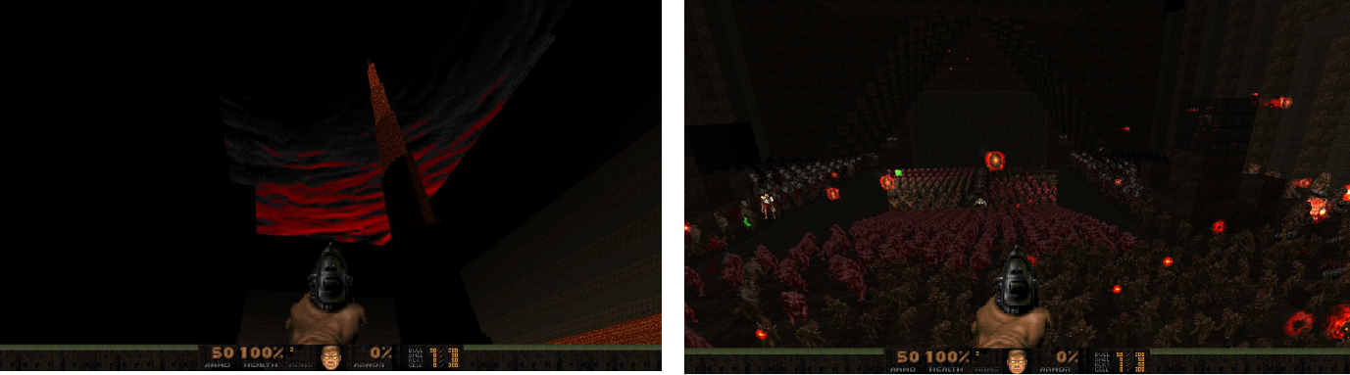
Figure 1: Abandon megawad [screenshot]. The level is designed around the ‘slaughter’ gameplay style, which often feature broad expanses and non-representative architecture.

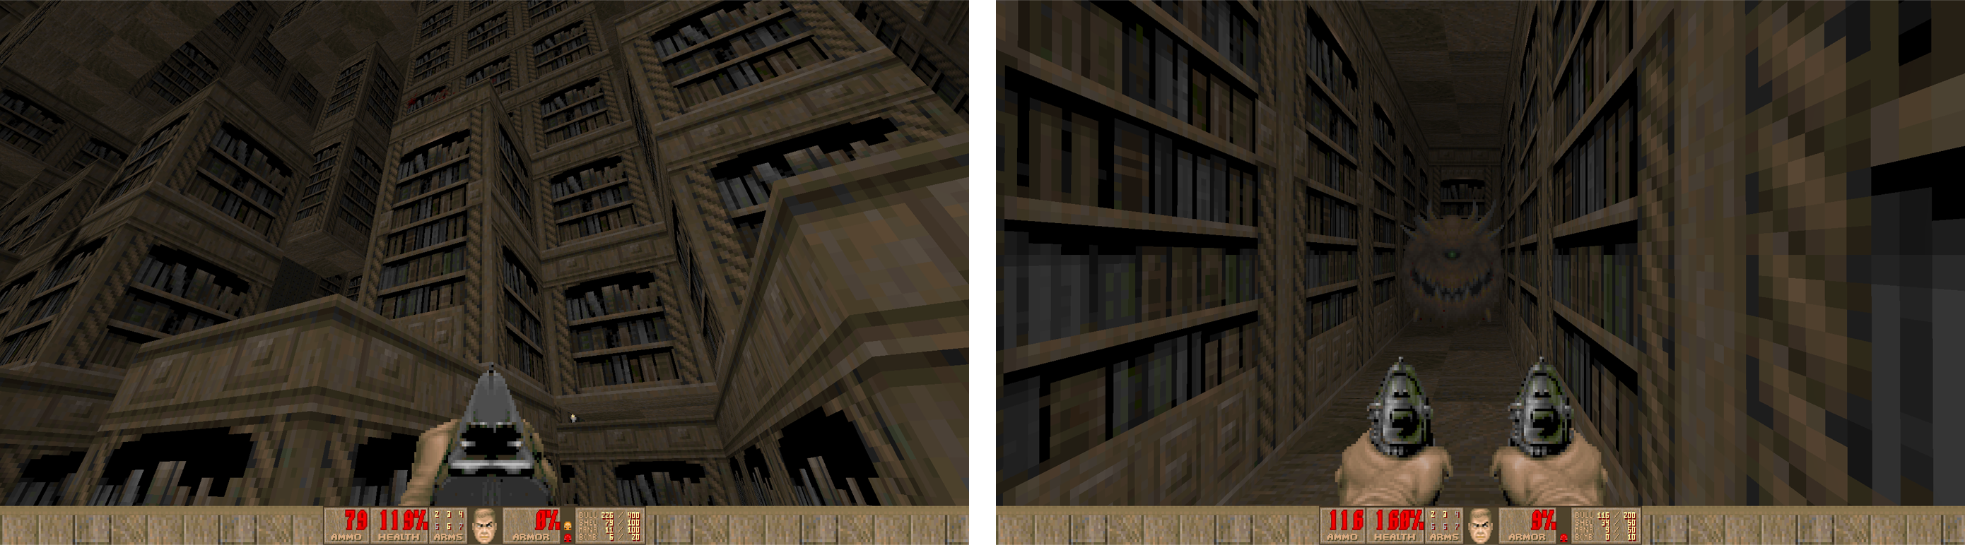
Figure 2: Maskim Xul [screenshot]. The level is designed to invoke uncanny spaces such as those found in traditional Lovecraftian fiction. Pictured is a massive library environment.

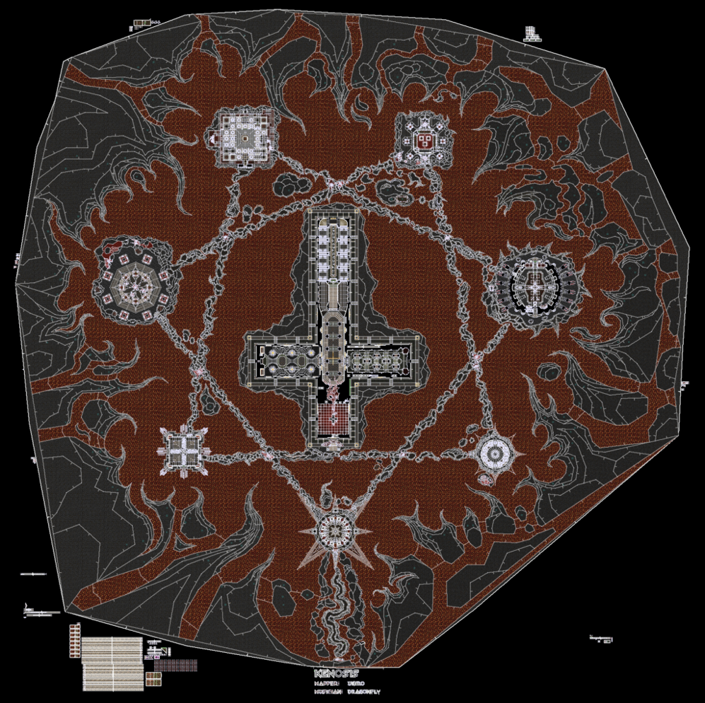
Figure 3: Kenosis from Eviternity II [screenshot]. The level is designed as a sigil that is interpretable from the automap file or as 2.5D gamespace.

References:
DOOM. 1993. id Software.

DOOM 2. 1994. id Software.

Figure 1: Bemused, Benjogami, Scotty, Insane_Gazebo, galileo31do01. Abandon. Screenshot by author.

Figure 2: Obsidian. Maskim Xul. Screenshot by author.

Figure 3: uriko. Kenosis. From: uirko’s Doom works, https://doom.ukiro.com/2024/01/29/the-making-of-eviternity-ii-map-36-kenosis/. 2024.

