Communication Arts and the Polymath Principle: Intellectual Multi- Tasking and the Creation of Knowledge Bearing Imagery
Professor ALAN MALE
This is a provocative thesis that advocates a need for illustrators and other creative visual communication practitioners to acquire a greater knowledge base through focussed scholarship and an increase in intellectual capacity.
‘We are beginning to see a return of the Polymath Principle, in other words, an illustration practice that exudes authority and a breadth of intellectual skills and learning. The consequence is that many illustrators will have wide ranging and in-depth knowledge of subject matter and acquire an esteem driven ownership for their work. Examples might be new or original knowledge embedded in their illustrations, literary authorship for fiction, documentation, journalism and commentary’
The implication for this will be insurmountable for some practitioners and students of visual communication; it clearly transcends the traditional concept of the commercial illustrator being chosen for their style in order to undertake a prescribed and heavily directed brief. What does this mean and what are the consequences for it?
The parameters of illustration practice have changed considerably in recent years and have had to respond accordingly to the ever changing vicissitudes in vogue and culture; the economy, technological advancements and an ever expanding media and communications industry. And, there is this insatiable need in many audiences for imagery that satisfies a thirst for new knowledge; a rollercoaster of research and documentation that manifests in ever increasing visual forms either on the internet, on television, in books and through e-learning.
The significance for this can be summed up thus: “Illustration practice is not judged purely by visual literacy and technical qualities but is one that engenders the best intellectual engagement with subject matter, problem solving and visual communication; the practitioner disclosing and interpreting content with authority and un-ambiguity with the pursuit of knowledge and information being a pre-requisite to eminent professional illustration practice”
Keywords: Interdisciplinary Practice, Research, Authorship, Illustration, Science in Culture

Introduction

Many will define illustration by its genre and style, often with an appreciative recognition for the quality of its production; in other words technique and media appropriation; the operative and technical skills inherent in securing the given and assigned aesthetic being of paramount importance. Indeed some commissioning art directors and illustration tutors will place significant importance on the superficiality of visual language and the commercial and cultural constraints placed upon it to conform to contemporary trends and fashion. In education, the student illustrator is often under pressure to ‘break new ground’ and push the boundaries of the subject. This usually means the production of so-called ‘innovative’ mark making that in reality does nothing to consider the real business of professional visual communication.

Power and Effect

But, it is the power of applied imagery and the strength and originality of its messages that defines its true reason for being. When given to its traditional five contexts of practice; knowledge exchange, commentary, fiction and creative expression, persuasion and identity, illustration has, over the years, had a significant and influential effect and incited a diversity of audience reactions and emotion. This can be exemplified by numerous impact bearing examples; Political cartoons and fascist propaganda that have stirred up mass hatred and affected bloody revolution; Character creations such as the Coca Cola ‘Santa’ giving rise to glutinous consumerism by re-inventing Christmas; ‘The Joy of Sex’, the original manual to set precedents regarding explicitly sexual themes or Pornography Made Decent; Dinosaurs and other prehistoric animals visualised for the first time, further affecting values and attitudes towards science and evolution as well as inspiring a roster of science fiction creations: the list is extensive.
How do visual communicators deliver meaningful and effective messages? An initial premise will suggest education; ‘the best art and design undergraduate education encourages the acquisition of appropriate specific and transferrable skills that are not only practical, but intellectual and knowledge based: the command of written and oral language, presentation and research’; in other words, the foundation of the Polymath Principle.

Historical Context
The definition of a Polymath is a person of great and varied learning, an erudite and learned individual with broad knowledge and skills. A more contemporary informal description might imply an all rounder, an oracle, a multi-disciplinarian, a mine of information. The history of visual communication could claim origin for these descriptors as far back as 300BC with the publication of Euclid’s first known diagrams contained within his ‘Elements of Geometry’. It can even be argued that Palaeolithic people produced information bearing art, the caves and other geologic features that were adorned akin to libraries or cultural centres.
The Renaissance
The Renaissance Period gave rise to an intense and prolific interaction between science and art with protagonists laying claim for association with both vocations. This view brought about a suggestion that science and art can be one and the same, a view held today and substantiated by the nature of working practice exemplified by the case studies in the sub-chapter ‘Knowledge Exchange and Research’. It also affirms the theme ‘Science in Culture’, a significant agenda for support and funding from the UK Arts and Humanities Research Council. This theme ‘aims to develop the reciprocal relationship between science and art on the one hand, and arts and humanities on the other’.
The drawings from the Renaissance, particularly those associated with Leonardo da Vinci (1452-1519), have become synonymous with early scientific and technological research with many of these images firmly established as an important genre of study related to art and science history. It would also appear that the subject matter was the driving force regarding the development of the work being produced by the artists of this movement. Knowledge and understanding of the natural world, anatomy, astronomy, mathematics, architecture and technology underpinned the imagery being produced and in many cases was the reason for its production. The key to understanding Renaissance research and their scientific propositions and discoveries were that they were not just described in textual form, they were illustrated, the ideas externalised through drawing.
The Nineteenth Century
‘From the early nineteenth century, a person wasn’t considered fully educated unless they had a broad, deep and detailed knowledge of all areas of culture, science and human endeavour. The physical and intellectual world of this period started to be captured and categorised by way of innumerable complex and painstakingly precise illustrations, evidenced at the time by black and white and tonal engravings. Practically every subject known to humankind was subjected to intense scrutiny and research by the Victorian age engravers.’

Content and Context in Contemporary Practice
It is important to represent and discern that part of the visual communication process which determines the true value of the work in question; context and content. Context defines the reason for the image in the first place and underpins the essence of the whole brief; it is the job of work assigned for the imagery; the message communicated to its intended audience. Content defines subject matter.
The following case studies (presented after each contextual definition) represent a practice based on the acquisition of heightened specific and transferrable skills that have enabled a broadening of scope and opportunity with a particular emphasis on context and content.
Knowledge Exchange and Research
Today, what type of visual communication exemplifies the aforementioned origins/history and background for a polymath driven practice? First reference must be made to the context of illustration that delivers meaningful knowledge by research, documentation, information, instruction and education. This covers an array of media outlets from exhibition; young audience retail, national curriculum and non-fiction material; television documentary; e-learning; encyclopaedia; museum and journal.
A principal methodology for this context will imply that drawings and images are created to have epistemological value, underpinned by research and authoritativeness for the subject matter; a gravitas afforded by the uniqueness of context, concept or theme and a desire to contribute to new knowledge.
Principal Criteria
- Impact: cultural, academic and educational value measured by insights with which the public/prescribed audience or user have engaged measured by evaluation, user feedback or testimony and national/international review
- Reach: extent of the information and influence to the form and content of education/knowledge transfer to any group in a global context
- Content: credibility and authoritativeness regarding topic/subject matter
- Standpoint: thematic/scientific uniqueness, thrust, context, argument
- Methodologies: quality of research; intellectual and practical processes
- Concept: creativity and/or originality; appropriate and considered use of ideas
- Aesthetics: design and visual language
- Technical Applications: drawing, media, image/product construction, presentation, exhibition, publication or broadcast
Interactive Book
This case study is an interactive or ‘movable’ book. Entitled Optical Illusions, it was conceived, researched, graphically designed and technically engineered by illustrator Jemma Westing. Westing will have creative ownership of the entire product and is an exemplification of how an illustrator, working as an in-house designer for the publisher, establishes a reputation for combining and utilising a broad range of relevant skills. The product is classed as a visual reference source for a chapter book audience (5-9 years). Its remit is, by innovative design, to invite its audience to explore, discover, and be entertained by having a ‘hands on’ approach to learning.
Westing states; ‘Interactive printed books can achieve polymathic status as educational tools if their capacity to facilitate active, deep learning and cognitive thinking is capitalised on. The reader will use high-order cognitive skills in order to achieve long term subject understanding’. This thesis, presented as a paper at an international conference, exemplifies complete discernment and comprehension for the rationale of the work; an example of an illustrator applying the polymath principle to her own practice as well as recognising the poymathic attachment to the product of her own practice.
In recent correspondence (March, 2013), Westing explained that her current role requires ‘those who don’t just answer a brief in a practical or technical sense, instead, go further and be responsible for designing the concept in its entirety, evidence ideas with research, development and a strong contextualised market positioning’. In praise of her education (BA Hons Illustration, University College Falmouth, 2007-2010); ‘you made sure that students left with not only a developing toolbox, but also and more importantly, the ability to think and adapt’.
Westing was promoted to Project Art Editor Knowledge, Dorling Kindersley Limited (Random House Group), London, July 2013.
Figure I: Interactive Book: ‘Optical Illusions’, conceived, researched, designed and technically engineered by Jemma Westing
Isomorphology
This is a PhD research project and is by Gemma Anderson (Falmouth University, 2012-2015). It is entitled ‘Isomorphology: An investigation through drawing and modelling into the mathematical forms underlying the resemblances between animal, vegetable and mineral’.
‘Isomorphology’ is a new term to both science and visual arts practice. Derived by Anderson, a visual arts practitioner, it is a drawing based method of inquiry into the shared forms of fauna, flora and geology. Iso means similar or equal (‘isometric’), morphology is the study of organic form and structure. The outcome will be a new type of taxonomic order for organic life. Instead of the traditional scientific classification system based on genetic and evolutionary relationships (Linnean et al), this method relies on drawing and visual arts practice to establish ‘families’ related by sharing common anatomical structures such as spiralling and geometric shape. Images are produced as copper etchings and drawn directly from primary research material; for example, specimens seen by electron microscope or by direct physical examination. The work has been published and exhibited widely and has formed the basis of several reviewed and published papers.
The methodologies for this project are broadly interdisciplinary; as well as utilising the aesthetics and techniques of traditional visual arts practice, Anderson engages in deep study for the subject matter including the historic practice of natural philosophy and contemporary mathematics and participates in a discourse for the philosophy of art and science.
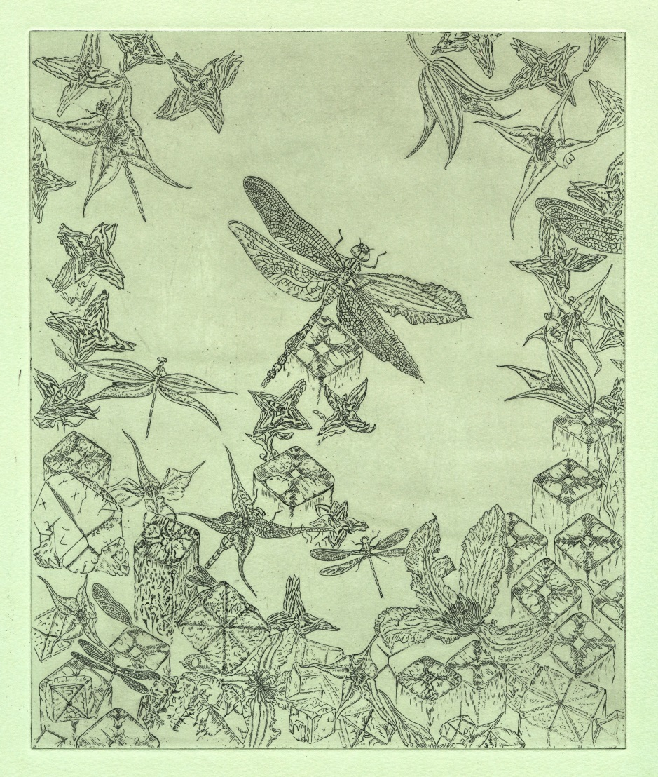
Figure II: ‘Isomorphology’: 4-fold symmetry by Gemma Anderson
Palaeo-Ecology
Illustrations of prehistoric life manifest in a variety of styles and for a range of audiences. Popular themes such as dinosaurs are often contrived to be entertaining and dramatic as well as informative. This case study is borne out of primary research with species recently discovered being shown for the first time. Entitled ‘A Carboniferous Faunascape’, it is part of an illustrated evolutionary procession with this image passing through the Carboniferous Period (359-259 mya); a conceptual and composite arrangement showing the complexity, confusion and texture of a teeming coal forest ecosystem. Researched and illustrated by the author, its essence is palaeo-ecology infused with new knowledge related to the morphology and diversification of emergent life.
The methodology for this project combines objective and analytical drawing, the study of the morphology, taxonomy and ecology of palaeo- fauna and scientific practical empiricism by the synthesis of data.
The principal organism revealed for the first time is the Tetrapod ‘Pederpes’. This was produced in collaboration with the Museum of Zoology, Cambridge University.
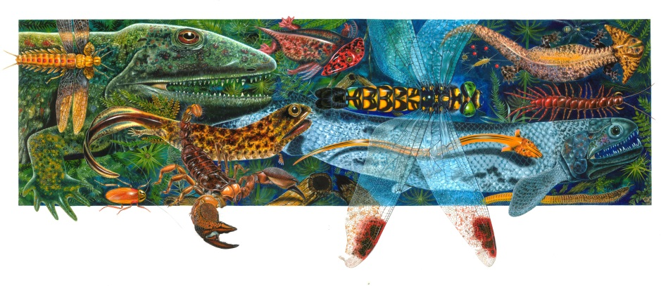Figure III: ‘Carboniferous Faunascape’: conceived, researched and illustrated by Professor Alan Male
Medical Illustration
The vocation of medical illustration can be traced back as far as the 16th century. The same practice today is demanding and diverse. It is an extremely specialised field. To engage professionally the practitioner must be fully conversant in human anatomy, medical terminology, the available reference materials and the correct procedures for working in a medical and surgical environment. It is often essential to undertake specialist undergraduate or post graduate study and it is this preparation for working closely with medical professionals and producing work for surgical training and education that distinguishes the medical illustrator from other scientific illustration disciplines.
This case study is by Arran Lewis (BA Hons Illustration, University College Falmouth 2005-2008) and is entitled ‘Neural Networks’. Lewis conducted extra curricula study at the Peninsular Medical School in Cornwall, United Kingdom in order to gain extensive insight and knowledge regarding biological processes, human anatomy and medical procedures. He is currently the Director of ‘Ecorche Medical Anatomical Scientific 3D Illustration’ with an extensive roster of clients including the Wellcome Trust and The British Broadcasting Corporation. The example shown is part of a biological research project.
Figure IV: Medical Illustration: ‘Neural Networks’ by Arran Lewis
Commentary
This domain of practice is mostly associated with reportage and journalism with a contextual thrust for editorial review, comment and opinion. Outlets include news media, magazine and journal traversed by print, broadcast and online.
Interdisciplinary practice is evidenced by the illustrator adopting a journalistic stance and transcending the role of sole recorder of observed material as in the practice of visual reportage. Instead, the thrust of an argument, standpoint or opinion comes directly from the illustrator, a practitioner who will be recognised as informed and knowledgeable; a status bearer of authority and credibility with subject matter and context.
Principal Criteria
- Impact: level of public engagement measured by review, critique and repercussion
- Reach: extent and/or diversity of individuals, organisations and communities who have/will benefit or be influenced by the impact
- Content: credibility and authoritativeness regarding subject/topic
- Standpoint: thrust, context, argument, consequence and effect
- Concept: creativity and/or originality; appropriate and considered use of ideas; discernment regarding audience receptivity
- Aesthetics: visual language
- Technical Applications: drawing, media, image construction, publication, presentation or broadcast

Satire
Journalist-illustrators will court controversy, be extreme in opinion, challenge and obfuscate. Often, imagery and words will be contrived to make an audience take note of a contentious argument. The best examples are exemplified by the ‘political cartoon’; a practice that has influenced public opinion for centuries. This case study was published in a UK newspaper in 2009; it is a clear exposition of opinion regarding the behaviour of the capitalist elite. Entitled ‘Capitalist Pig Latest’, it is by Martin Rowson. Unafraid of contestation, Rowson describes his work as ‘an oasis of anarchy in the topography of newspapers’ He is an illustrator/cartoonist, author, writer and commentator, correspondent, book reviewer and council member of the Zoological Society of London.
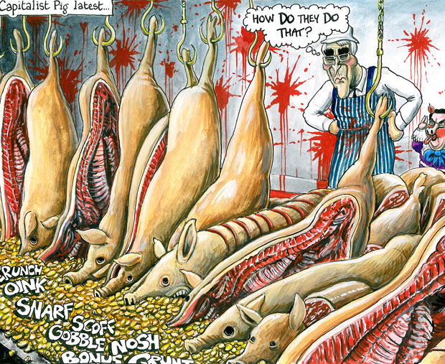
Figure V: Satire: ‘Capitalist Pig Latest’ by Martin Rowson
Critique, Law, Ethics and Social Awareness
Journalistic illustrators will engage with themes and subjects that are sober, sensitive and critical in nature. The brief may also require an element of personal conviction and sentiment to be expressed. This editorial image is by Rose Lloyd and is entitled ‘Scarred for Life’. It accompanies a published report about preventing young females from the United Kingdom being taken out of the country and subjected to Female Genital Mutilation. This particular practice was outlawed in the UK in 1985. In 2003 it was made illegal to take children abroad to have it performed.
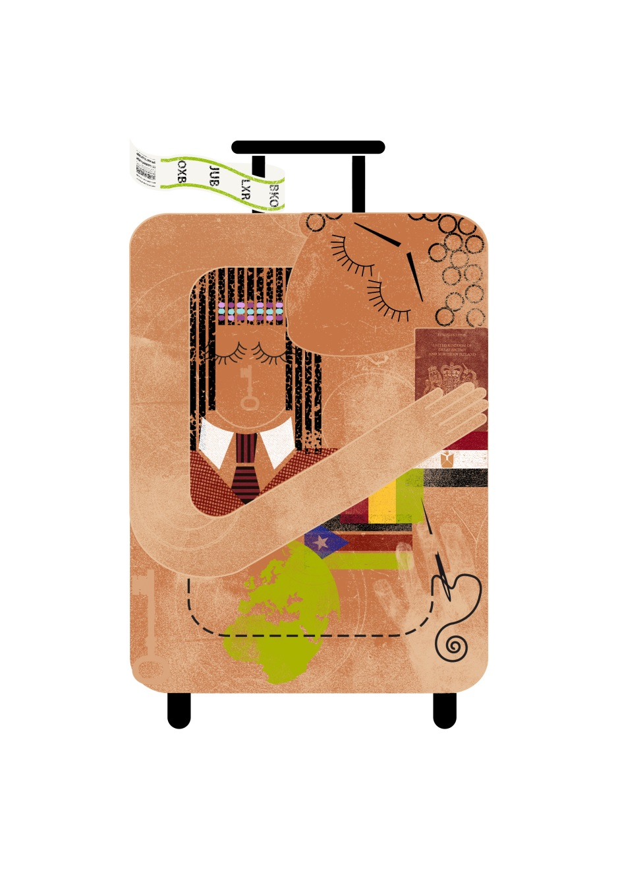Figure VI: Critique, Law, Ethics and Social Awareness: ‘Scarred for Life’ by Rose Lloyd
Narrative Fiction and Creative Expression
It is considered that some of the most creative and innovative illustration has been generated by way of this contextual domain and has had an influential bearing regarding many aspects of published and performance entertainment, including classic and contemporary literature, children’s picture and chapter books, comics and graphic novels, motion pictures and animated films. Contextually and in its published form the contents and subject matter regarding that of narrative fiction will conform as conventionally accepted falsehoods; everything is feigned, imagined or invented.
This context offers the illustrator a diversity of creative and expressive opportunity and facilitates an expanse of potential multi disciplinary engagements from authorship and the conception and ideas for literary works of all description and media outlet, scriptwriting, performance, music and exhibition.
Principal Criteria
- Impact: the creation and interpretation of cultural capital in all of its forms to enrich and expand the lives, imaginations and sensibilities of individuals and groups measured by national/international review and critique
- Reach: extent and/or diversity of individuals and communities who have/will engage with and/or benefit from the impact
- Content: the creation and inspiration for supporting/generating new/original forms of artistic, literary, linguistic and other expression
- Standpoint: strength and rationale regarding message, expression, narrative concept and/or argument to prescribed audience
- Concept: creativity and/or originality; purpose and appropriation of media and outreach into the public domain
- Aesthetics: highest attainment level for the application and choice of genre/language/design
- Technical Applications: media, product/artefact construction, performance, presentation, publication, exhibition or broadcast
Dyslexia
Children’s picture and chapter books, although principally couched in fiction and fantasy can often be identified with pre-school and early school learning, with some, becoming essential aspects of the curriculum. This can be no more so than when conceived principally to either aid the reading and literacy process, or be couched in a defined reference or ethical concern such as the conservation, care and protection for the environment.
Because of the demand to communicate greater awareness, accountability and information regarding education, health and welfare, the role for illustration and visual communication will undoubtedly increase. This example is a children’s book entitled ‘Hudson Hates School’, conceived, written, designed and illustrated by Ella Hudson (BA Hons Illustration, University College Falmouth, 2005-2008). Considered innovative and contemporaneous regarding characterisation, visual language, content and narrative, its principal rationale is to support children of primary school age with Dyslexia. The content assumes a semi autobiographical thrust, Hudson is herself dyslexic and the story she has developed as played out by fictionalised character Hudson, presents a quirky yet sensitive treatment of the subject. Published by Francis Lincoln Children’s Books, London and developed while Hudson was still a student, the book is narrative fiction couched in pedagogy. A form of bibliotherapy, it follows a theme and rationale for similar books that claim a form of cognitive healing or counselling.
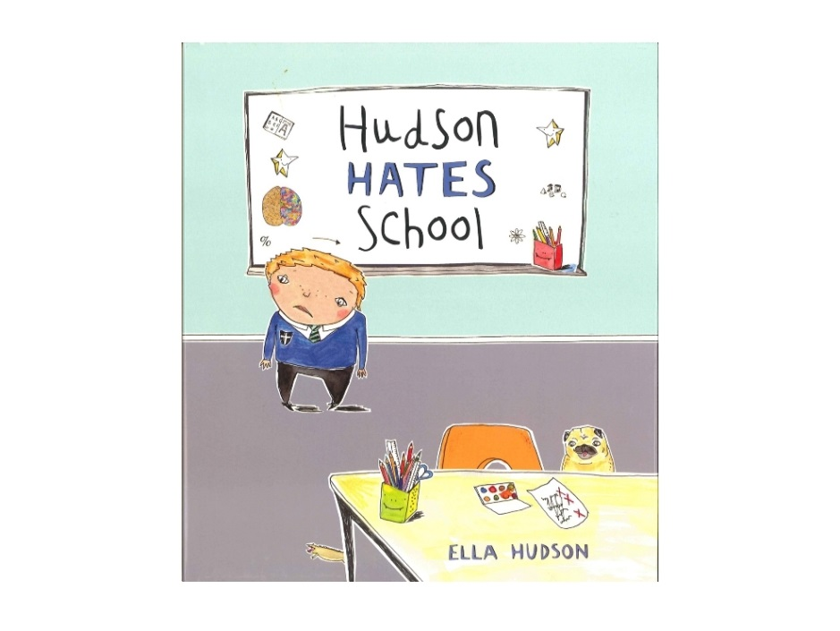Figure VII: Dyslexia: ‘Hudson Hates School’, conceived, written, designed and illustrated by Ella Hudson
Live Music, Illustration and Records
Interest, expertise and breadth of skill can facilitate a far reaching symbiosis with other disciplines as well as illustration and the graphic arts. This case study features the work of Nick Mott, a musician and composer of many years having recorded and performed internationally, both solo and with celebrated contemporary music ensemble ‘Volcano Bear’. Mott recently composed, recorded and produced the music on four vinyl long playing records and one seven inch single. He also designed and illustrated the entire record sleeves; substantial multi-tasking with the practitioner having creative ownership of the whole artefact and its contents. These music releases have been published and distributed by several international record labels and subsequently reviewed in the quality music press, including ‘Wire’ and ‘Collector’ magazines.
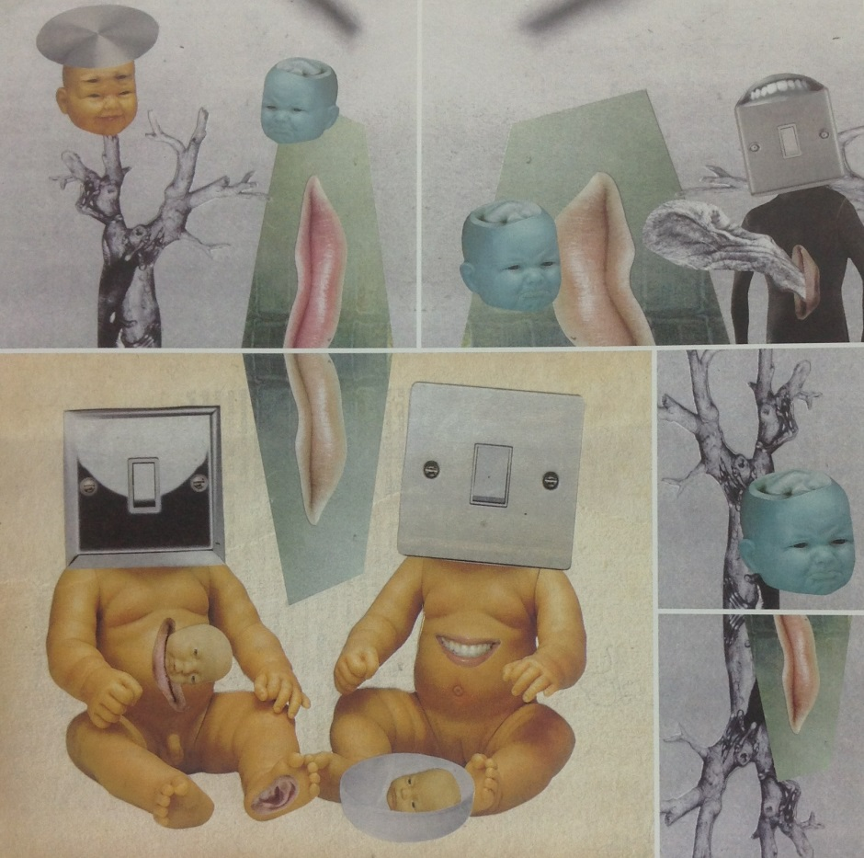
Figure VIII: Live Music, Illustration and Records, ‘The Visitors’, album cover conceived, illustrated and designed by Nick Mott
‘Drawing on Sand’
The image shown is by illustrator, fine artist, author and educator Matt Osmond. Osmond has been composing narrative poems in words and pictures under the working title ‘Stories for seeing in the Dark’. This project is not driven by an ambition that is overtly commercial; it is self authored and underscored by research; a symbiosis of creative and artistic endeavour, combining the craft of written language and image making. There are three principal works entitled ‘Drawing on Sand’, ‘Drawing on Water’ and ‘Deadman and Hare’. All themes are rooted in nocturnal walks along the coastline in Cornwall, United Kingdom.
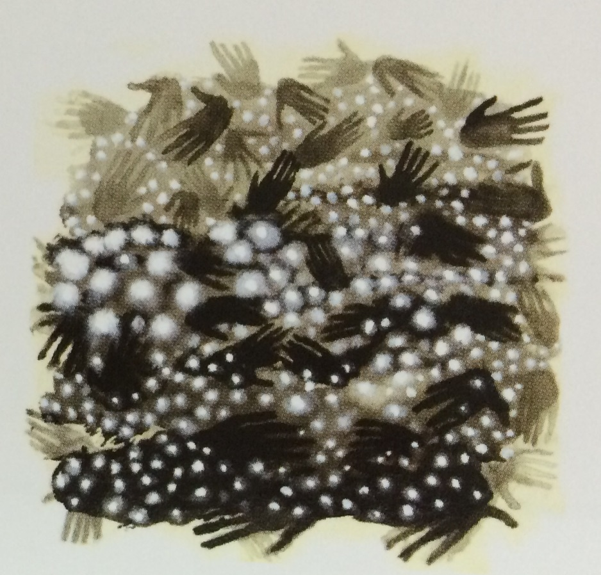
Figure IX: ‘Drawing on Sand’, an illustration by Matt Osmond from his self authored series of poetry books entitled ‘Stories for seeing in the Dark’
Authorship and Illustration for Children
This domain of narrative fiction offers the illustrator significant opportunities for authorship with children’s picture books being the most prominent context for these possibilities. Initially, ownership, personal expression and choices made as creator and author can be given precedence over being commissioned in a standard commercial manner; in other words, that is where a publisher oversees the production of prescribed and art directed imagery. Narrative fiction conceived by an author-illustrator, whatever mould envisaged for publication, will generally manifest comprising text and image. A practitioner who conceives ideas, writes and illustrates fiction can assume the recently (21st cent.) coined status of being an ‘authorstrator’.
The case study represented is a work for young audiences authored, designed and illustrated by Emma Yarlett (BA Hons Illustration, University College Falmouth, 2008-2011). Yarlett is now a successful and widely acclaimed creator of illustrated children’s literature; this book is entitled ‘Sidney, Stella and the Moon’ and was published by Templar, 2013.
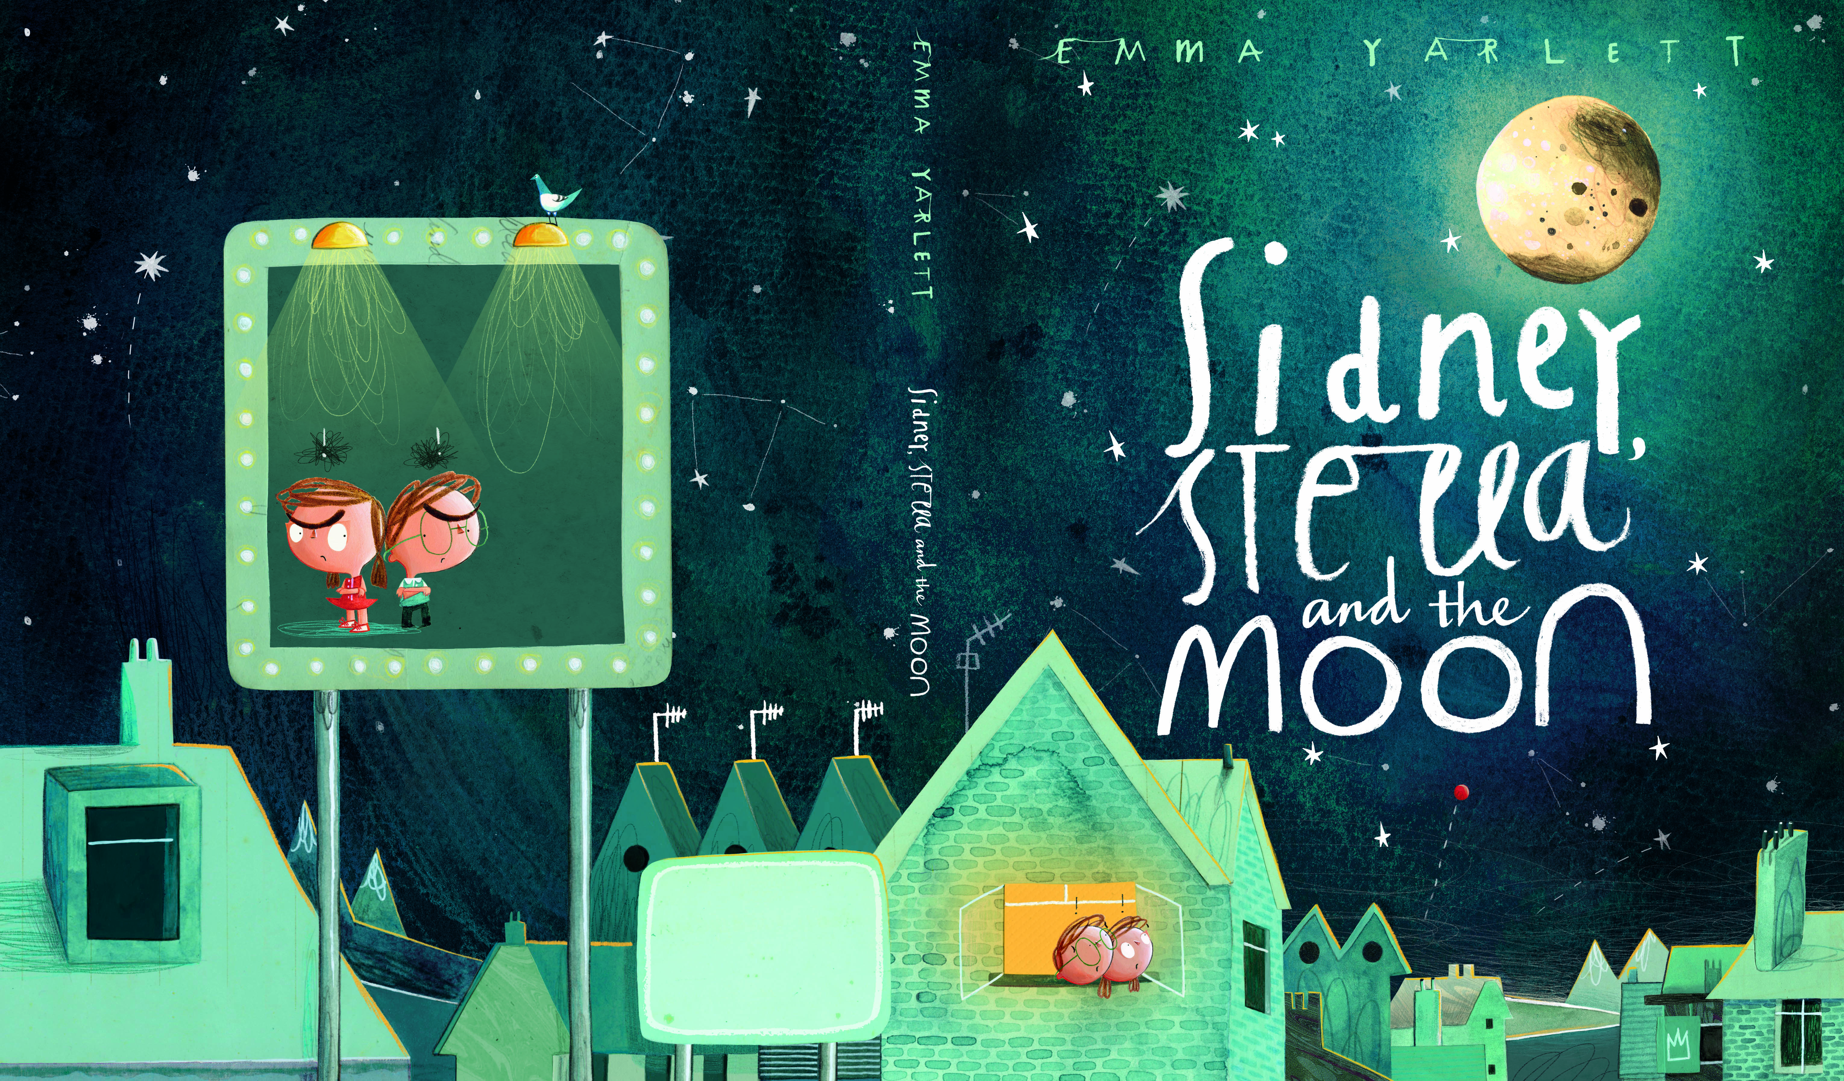
Figure X: Authorship and Illustration for Children, ‘Sidney, Stella and the Moon’, written and illustrated by Emma Yarlett

A Case for Interdisciplinary Practice
The case studies can be considered representative of integrated disciplinary practice. All have clearly defined connections with subject matter and message and compatible with criteria identified for the contextual domain in question. In accordance with the brief, there are clear correlations regarding connection, expertise and intellectual engagement across a range of subjects and skills; a broad and specific knowledge base, literacy and authorship, research methodologies, problem solving, contextual engagement, creativity and innovation, conceptualisation, ideas development and imaginative processing, production and technical skill.
Authorship
A principal aspect for interdisciplinary practice is that of authorship. ‘Authorship suggests having a voice. This can be through research and the dissemination of original knowledge and by one’s own creative invention’’; as exemplified by the majority of case studies.
How is it possible for the visual communicator to gain authorship status? Many professional and student graphic artists and illustrators will be commissioned or prescribed a brief that requires the inclusion of specialist content. This can lead to the practitioner assuming authority regarding themes and subjects and may qualify them as an expert. Researching and illustrating outputs like books that are subject-specific, published nationally/internationally and subject to review can facilitate an authorial status.
There are a number of scientific and cultural illustrators who trained specifically in subject matter; archaeology, botany, biology, zoology. These individuals have established their status of author-illustrator by undertaking undergraduate or post graduate science and cultural degrees before formal art training. The intrinsic link between words and image, the increase in illustrators engaging directly with subject matter suggests the firm establishment of a culture representative of and given for the non fiction author-illustrator.
Illustration enjoys significant correlations and synergies with the craft of the written word. Ninety nine percent of all applied imagery is accompanied by words. Writing and illustration are more than just adjacent; they are deeply connected and are often one and the same.
The following analogy reveals how professional writing disciplines relate and intertwine with the contexts of visual communication practice:
- journalism and commentary = editorial imagery
- literature and other forms of fiction = narrative imagery
- academic, documentary and technical authorship = knowledge bearing imagery
- copywriting and media literature = advertising and corporate imagery
A Multi-Disciplinary Vocation
As exemplified by the case studies, interests, expertise and breadth of skill can facilitate far reaching symbioses with other disciplines and that, in turn establishes possibilities for extensive collaboration and interdisciplinary practice. The creative, media and communications industries alone comprise an extensive sweep of vocations such as: visual arts; journalism and correspondence; broadcasting, entertainment and performance; scriptwriting, copywriting and authorship; motion picture and theatre direction; editing, production, marketing and promotion. However, it is those academic and documentary disciplines that will afford context and content for the practitioner’s work which determines any real notion of intellectual multi-tasking. The disciplines in question include science, technology, education and humanities.
It can be possible for practitioners to create job descriptions that proffer disparate combinations of application. For example: illustrator- author; illustrator- musician- composer; illustrator- scientist; illustrator- journalist- commentator; illustrator- academic- researcher.
The opportunities afforded to visual communicators can be considered multi-various and can manifest through commission, direct employment, research and/or self initiative (authorship and developing original projects, etc). It is the array of skills both specific and transferrable that can facilitate professional mobility; sideways and upwards. Some graduate visual communicators are given to pursue careers outside the basic parameters of their discipline. By utilising, promoting and building upon the skills acquired in education it is possible to move into areas that command specific directives for creativity, scholarship and management such as art direction, editorship, research, scholarship and pedagogy.
Research
Visual communication informed by research, suggests that a knowledge-based discourse might be held within it. It is also incumbent on practitioners who discharge their experience and knowledge through teaching to undertake research. As educators one needs to adopt a holistic and non-discriminatory overview of the whole discipline, developing a deep understanding and application of all its contexts and cultural applications. It is essential to transcend a surface engagement with just contemporary trends in visual language and makes ones practice say and do something mature and relevant. A meaningful approach is to be evaluative and enquiring, to have a voice and engage in debate both nationally and internationally. The idea of illustrators and practitioner-educators discarding the role of being just artwork renderers, operating to a prescribed and directed brief so as to assume authority and ownership over content and subject matter takes on an alternative meaning. Illustration practice becomes holistic and acquires gravitas because it develops broadly, with parameters that extend far beyond the remit of commercial instruction. It becomes a vocation for deep learning facilitating opinion and fresh insights regarding one’s own practice and that of others. The driving force behind the need to do this will be informed by your creative and intellectual potential and by your ambition and desire to extend and challenge your abilities.
A sea change in higher education art and design has facilitated a research based culture to manifest. In the last twenty years or so, those courses that were once overtly vocational and technique-led now have sharper emphases on contextual, critical, and historical study. The integration of theory with practice has enabled many graduates to multi task, to be professionally independent and to be more intellectually capable, acquiring skills that are knowledge based and embedded in the most appropriate methodologies for research.

Conclusion
The Polymath Principle: Framework for Implementation
- 1.Visual Arts and Communication: Illustration, Graphic Design, Fine Art, Animation and Photographic Media
Underpinned by:
- 2. An intellectual and holistic connection with subject matter; science, culture and humanities, education and technology by research, collaboration, knowledge acquisition and enquiry, further education, evaluation and critique
Resulting in:
- 3. The production of knowledge bearing imagery through the contextual domains of research and the presentation of new/original knowledge; documentation, commentary and review; instruction, education and reference; creative and personal expression. Borne from appropriate methodologies and by facilitating specific/defined contexts
Manifesting as:
- 4. Outputs for distribution and publication throughout the public domain and subject to review: books, academic papers and literature, journals, newsprint, posters, online documents, blogs and postings, interactive media; moving imagery; exhibitions, conferences and lectures; broadcast and performance
Measured and determined by:
- 5. Impact through context, reach and significance by creating new forms of creative expression; preserving, conserving and presenting cultural heritage; influencing the design, delivery of curricula and syllabi in education and knowledge exchange; contributing to the economic and cultural prosperity via the creative, media and communications sector including publishing, performance, museums, film and broadcast

Epilogue
In reiterative conclusion, the rationale for authorship and the polymath principle is ownership and having a voice; through research and the dissemination of original knowledge, through one’s own creative invention such as literature, artefact or performance and by expressing comment and opinion.
The methodologies for acquiring authorship status will need to be polymathic; to multi-task and in many instances work with the craft of written and oral language.
To have ambition and embark on a successful career in illustration and the graphic arts, practitioners ‘will need to be educated, socially and culturally aware communicators, utilising a breadth of intellectual and practical skills’.
‘The notion of illustrator as ‘colouring-in technician’ must be discarded’

Alan Male, Illustration: Meeting the Brief (London: Bloomsbury, 2014)
Alan Male, Illustration: A Theoretical and Contextual Perspective (London: AVA Academia, 2007)
Coca Cola Journey (2012) The True History of the Modern Day Santa Claus(Online) Available at http://www.coca-colacompany.com/stories/coke-lore-santa-claus
Alex Comfort , The Joy of Sex (London: Mitchell Beazley, 1972)
Alan Male, Illustration: Meeting the Brief
Field Museum News, New Mural Depicts Strange Reptiles Which Lived 215 Million Years Ago, March(1931)
Alan Male, Illustration: A Theoretical and Contextual Perspective
Della Thompson, ed., The Concise Oxford Dictionary (Oxford: The Clarendon Press, 1995)
O. Neugebauer, The Exact Sciences in Antiquity (United States: Courier Dover Publications, 1969))
P. Johnson, Art: A New History (London: Harper, 2003)
Encyclopaedia Britannica, Renaissance (London: 2008)
Arts and Humanities Research Council (2013) Science in Culture (Online) Available at http://www.ahrc.ac.uk/Funding-Opportunities/Research-funding/Themes/Science-in-culture/Pages/Science-in-Culture.aspx
Male, Illustration: A Theoretical and Contextual Perspective
Male, Illustration: Meeting the Brief
Fleur Starr, ed., Optical Illusions (London: Dorling Kindersley Limited, 2012)
Jemma Westing, “The Interactive Educational Printed Book: Plaything or Polymath?” 2nd International Conference Art, Illustration and Visual Culture in Infant and Primary Education (2012) http//:congressoarteilustracion.web.ua.pt/wp-content/uploads/2012/12/proceedingsAICVEIP.pdf
Gemma Anderson, Isomorphology (London: EB&Flow, 2013)
Della Thompson, ed., The Concise Oxford Dictionary (Oxford: The Clarendon Press, 1995)
Gemma Anderson, “A Study of the Declining Practice of Morphological Drawing in Zoological Taxonomy” Leonardo Journal of Arts, Sciences and Technology (2012)
Alan Male, “Pictures of New Knowledge: A Dilemma of Fact or Fantasy” 2nd International Conference Art, Illustration and Visual Culture in Infant and Primary Education (2012) http//:congresoarteilustracion.web.ua.pt/wp-content/uploads/2012/12/proceedingsAICVIP.pdf
Jennifer Clack “An Early Tetrapod from Romer’s Creek” Nature 418 (2002): 72-76
William E. Loechel, “The History of Medical Illustration”, Bulletin of the Medical Library Association(1960): 48
Alan Male, Illustration: A Theoretical and Contextual Perspective
“Arran Lewis” accessed July 10, 2013, http://www.youtube.com/user/plasticanatomy/videos
“Arran Lewis”, accessed July 10, 2013,” http://encorche.co.uk
“Arran Lewis”, accessed July 10, 2013, www.bbc.co.uk>Factual>Arts&theMedia
Martin Rowson, “Capitalist Pig Latest”, The Guardian, February 9, 2009
Arts, Humanities Research Council “Martin Rowson Biography” British Cartoon Archive (2013) www.cartoons.ac.uk/artists/martinrowson/biography
“RCN Publishing Company Ltd” accessed July 9, 2013, www.rcnpublishing.co.uk/
Schuyler Bull and Alan Male, Along the Luangwa: The Story of an African Floodplain, (Norwalk Connecticut: Soundprints, 1999)
“Health and Welfare Awareness”, accessed on July 10, 2013, http://www.afhi.org/web/index.php
Blake Morrison, “The Reading Cure”, The Guardian, January 5, 2008
“Nick Mott – The Visitors”, http//www.terracope.co.uk/Reviews/Reviews/ January 13.htm#NickMott
Alan Male, Illustration: Meeting the Brief
“Guild of Natural Science Illustrators” accessed July 12, 2013, www.gnsi.org
Briefed for contextualised use in the public domain, either by publication or broadcast
Publishing & Media; Advertising; Television, Broadcasting & Motion Pictures; Theatre & Performance
Alan Male “Research: The Future”, Varoom: Journal of the Association of Illustrators 12 (2012)
Alan Male Illustration: A Theoretical and Contextual Perspective
Alan Male, “ Illustration, Authorship and the Polymath Principle” (keynote lecture presented at First International Conference in Illustration and Animation Polytechnic Institute of Cavado and Ave, Ofir, Portugal, November 30, 2012)

